LCHS7009
Population Health and Digital Health Promotion
Component 1: Two Public-Health Blogs
Physical Inactivity among Children and Young People Aged 5–18 Years

Student name: Misbabanu Amanullah khan
Student ID: 2538422
Lecturer: Dr Raheela Shaikh
Submission date: 23 October 2026

BLOG 1
Use of Digital Technology to Manage and Increase Children’s Physical Activity
Physical inactivity in children and young people aged 5–18 has an impact on physical, mental and social wellbeing. I have chosen this topic because screen-based activity can reduce movement and families and schools need to find ways of making activity enjoyable. In England, 49.1% of children aged 5–16 years achieved an average of 60 minutes of physical activity per day during 2024–25 and further 28.4% averaged less than 30 minutes (Sport England, 2025). The UK guidance suggests an average of at least 60 minutes per day of moderate-to-vigorous physical activity in a week for children and young people aged 5–18 years (Department of Health and Social Care, 2026).
Fitness trackers can motivate through step counts, active minutes, prompts, challenges, and rewards. Products for children include the Garmin vívofit jr. 3 which monitors steps, sleep and active minutes and the gamified Fitbit Ace LTE which links achievements to games (Garmin, n.d.; GearJunkie, 2026). Families should compare features, cost, battery, availability, and data privacy before purchasing a tracker for a child.
I chose to focus on the Garmin vívofit jr. 3 as the child-friendly tracker provides visual feedback on achievement of goals and the parent-controlled app provides challenges and rewards (Garmin, n.d.). It can motivate children to be active, but it is not a medical device and cannot guarantee that activity is vigorous. Studies suggest that wearable technology can increase steps but evidence on long-term increase in moderate-to-vigorous physical activity is mixed (Au et al., 2024; Creaser et al., 2021) and rewards may become demotivating. Children without a tracker or safe space to be active may be disadvantaged.
The capability, opportunity and motivation framework (COM-B) suggests that feedback from a tracker may increase motivation and capability but children need opportunities such as safe outdoor space, inclusion in school activities and affordable community facilities to be active (Michie, van Stralen and West, 2011). Just 40% of children with two or more inequality characteristics met physical activity guidance compared with 54% of those with none (Sport England, 2025). Combining trackers with flexible goals, family and school challenges, breaks for activity, affordable options and non-digital activity is vital. Digital technology should support but not replace opportunities for activity, play, physical education, and community engagement.

Children being active outdoors and using a tracker during group exercise (Source: https://www.istockphoto.com/photo/multi-cultural-primary-or-elementary-school-students-with-backpacks-running-outdoors-gm2098623366-566246038).
At a glance
Technology: Garmin vívofit jr. 3
Population: children and young people aged 5–18 years
Focus: reducing physical inactivity through digital health promotion.

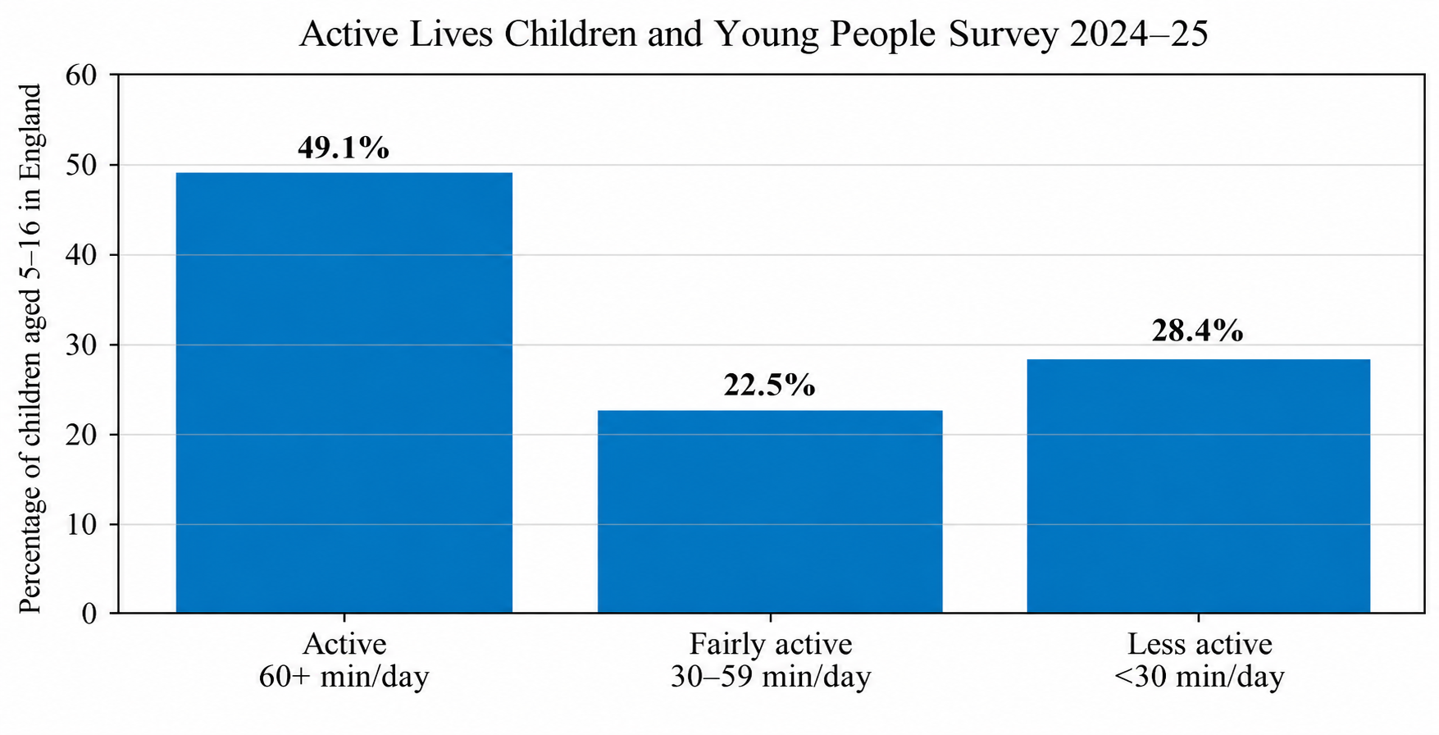
Figure 1: Latest England activity distribution.
Source: Sport England (2025); the survey covers children aged 5–16, not the full 5–18 target range.
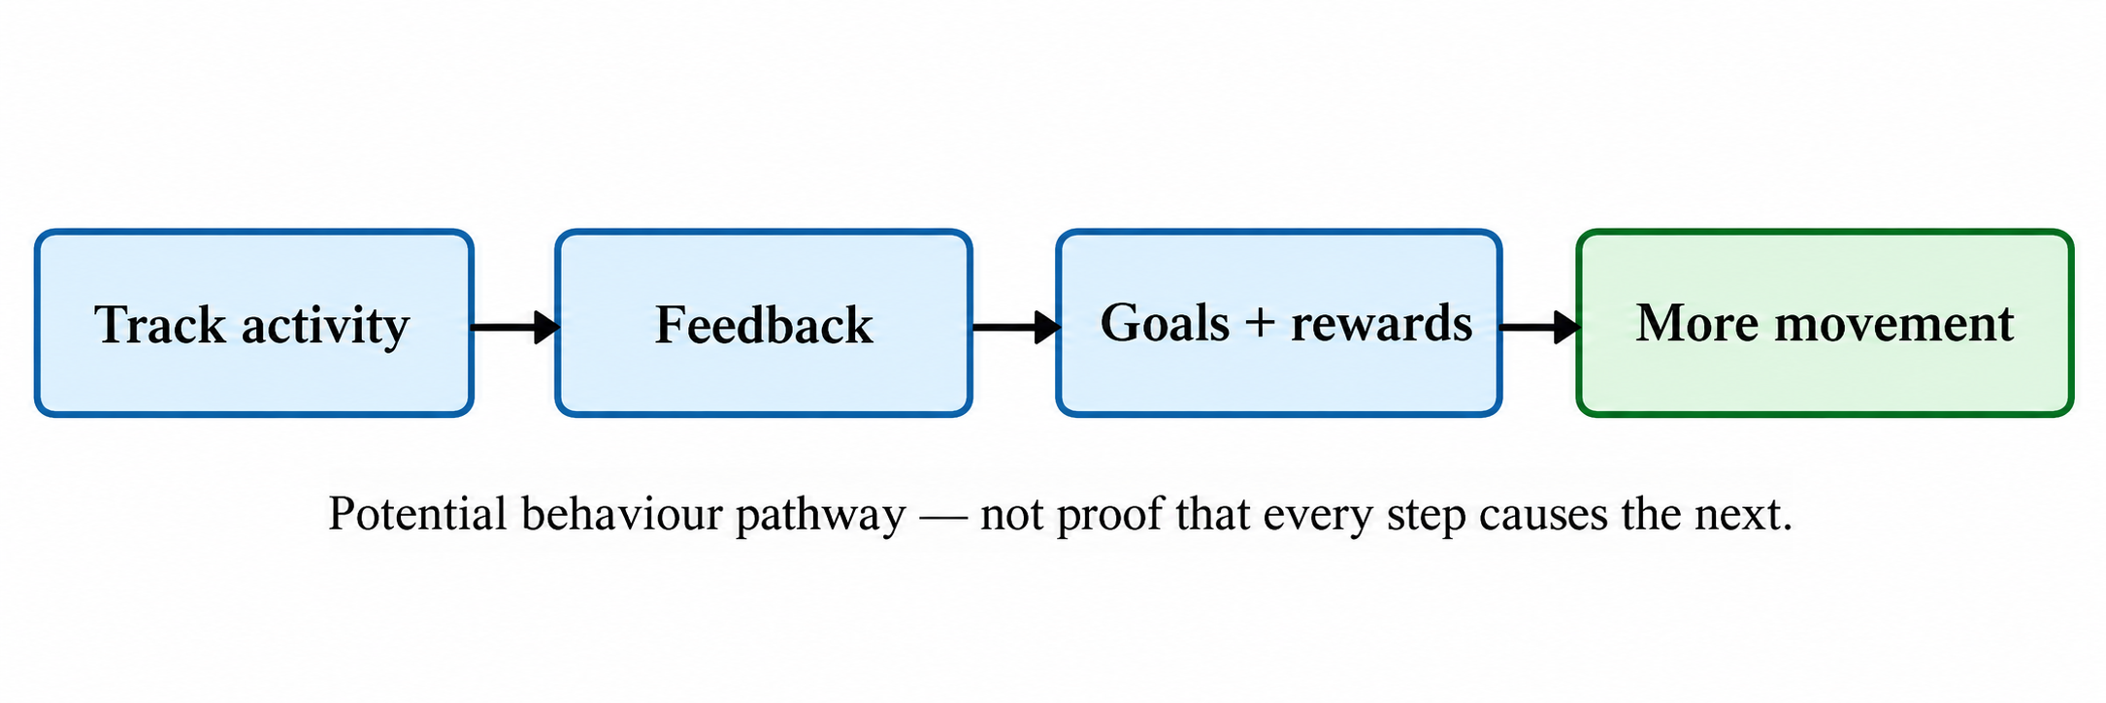(Self developed)
Figure 2: Conceptual pathway linking activity tracking behavior.

The arrows represent an intended mechanism, not established causality.
Official technology link: Garmin vívofit jr. 3 – Kids’ fitness tracker
Related video: 10 Minute Kids Quiz Workout – The Body Coach TV
Reference list – Blog 1
Au, W.W., Recchia, F., Fong, D.Y., Wong, S.H.S., Chan, D.K.C., Capio, C.M., Yu, C.C.W., Wong, S.W.S., Sit, C.H.P., Ip, P., Chen, Y.J., Thompson, W.R. and Siu, P.M. (2024) ‘Effect of wearable activity trackers on physical activity in children and adolescents: a systematic review and meta-analysis’, The Lancet Digital Health, 6(9), pp. e625–e639. Available at: https://pubmed.ncbi.nlm.nih.gov/39112110/ (Accessed on: 6 October 2026).
Creaser, A.V., Clemes, S.A., Costa, S., Hall, J., Ridgers, N.D., Barber, S.E. and Bingham, D.D. (2021) ‘The acceptability, feasibility, and effectiveness of wearable activity trackers for increasing physical activity in children and adolescents: a systematic review’, International Journal of Environmental Research and Public Health, 18(12), 6211. Available at: https://pubmed.ncbi.nlm.nih.gov/34201248/ (Accessed on: 6 October 2026).
Department of Health and Social Care (2026) Physical activity for children and young people: 5 to 18 years. Updated 16 July 2026. Available at: https://www.gov.uk/government/publications/physical-activity-guidelines-children-and-young-people-5-to-18-years/physical-activity-for-children-and-young-people-5-to-18-years-text-of-the-infographic (Accessed on: 6 October 2026).
Garmin (n.d.) Garmin vívofit jr. 3: Kids’ fitness tracker. Available at: https://www.garmin.com/en-GB/p/711538/ (Accessed on: 6 October 2026).
GearJunkie (2026) ‘The Best Kids’ Fitness Trackers of 2026’. Available at: https://gearjunkie.com/kids-gear/best-kids-fitness-trackers (Accessed on: 17 October 2026).
Michie, S., van Stralen, M.M. and West, R. (2011) ‘The behaviour change wheel: a new method for characterising and designing behaviour change interventions’, Implementation Science, 6, 42. Available at: https://implementationscience.biomedcentral.com/articles/10.1186/1748-5908-6-42 (Accessed on: 6 October 2026).
Sport England (2025) Active Lives Children and Young People Survey: Academic year 2024–25. Published December 2025. Available at: https://sportengland-production-files.s3.eu-west-2.amazonaws.com/s3fs-public/2025-12/Active%20Lives%20Children%20and%20Young%20People%20Survey%20-%20academic%20year%202024-25%20report-.pdf (Accessed on: 6 October 2026).

BLOG 2 – DESIGNED DIGITAL TECHNOLOGY
MoveQuest 5–18: Designing a Gamified Digital Health Intervention to Reduce Physical Inactivity among Children and Young People
What if digital technology stopped being a step counter and became a bridge to everyday movement? MoveQuest 5–18 is designed around that principle.
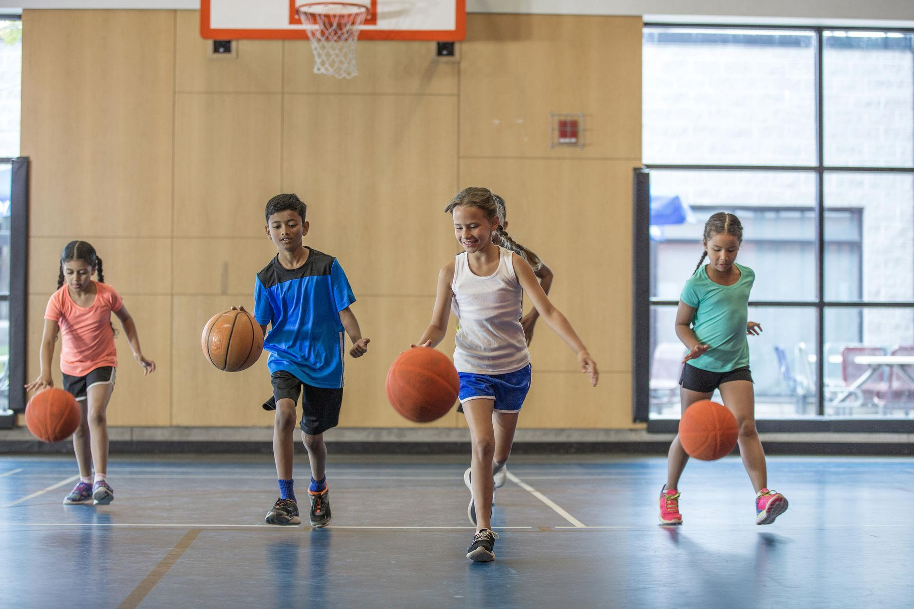
Children enjoying movement through play and group exercise (Source: https://www.gettyimages.no/detail/photo/dribbling-basketballs-up-the-court-royalty-free-image/607485814 ).
Design concept
MoveQuest 5–18 combines a child-friendly app with an optional activity wristband. It is a proposed intervention designed to address the gaps identified in Blog 1.
The problem and design rationale
MoveQuest 5–18 is intended to promote physical activity among children and young people aged 5–18 years. Sport England reported that 28.4% of children aged 5–16 years averaged under 30 minutes of activity per day in 2024–25 (Sport England, 2025), compared with an average of at least 60 minutes per day recommended by the Department of Health and Social Care for ages 5–18 years (Department of Health and Social Care, 2026).
How it works
MoveQuest works by offering a ‘child friendly app’ plus an optional activity tracking wrist band. The home screen displays active minutes and a simple goal. It offers movement quests, activity videos, includes badges and feedback, and encourages family and school challenges as well as inclusive opportunities. It also promotes low data usage and minimal data collection.
Behaviour-change mechanism
The COM-B model explores behaviour change through capability, opportunity and motivation (Michie, van Stralen and West, 2011). MoveQuest addresses capability through guidance, opportunity through family, school and community challenges, and motivation through feedback, reward and goals. The proposed mechanism is capability + opportunity + motivation → increased physical activity.
What the evidence suggests
Evidence is emerging but is far from definitive. Wang et al (2025), in a systematic review of 16 trials (7,472 participants aged 6–18 years), found that gamification increased moderate-to-vigorous physical activity, with considerable variation in effect sizes between studies according to duration, game elements, theoretical basis and setting. A meta-analysis published in 2024 concluded that mHealth interventions increased total physical activity, with more equivocal results for moderate-to-vigorous physical activity (Wang et al, 2024). MoveQuest is therefore likely to be effective, but benefits are not guaranteed.
Strengths, risks and mitigation
Its major strength is the integration of components that create a whole system: digital feedback connects to opportunities in families and schools. Its main risks relate to notification fatigue, the ‘innovation halo effect’ and inequalities in access to technology, which can be mitigated by offering flexible goals, rotating challenges, non-competitive options and offline opportunities. The example of the Bradford JU:MP, supported by NIHR Applied Research Collaboration Yorkshire and Humber, illustrates the added value of community mobilisation beyond a technological solution (NIHR Applied Research Collaboration Yorkshire and Humber, 2025).
Verdict
MoveQuest 5–18 is an interesting proposition that treats technology as an enabler rather than an intervention in itself. It warrants further study to explore whether it can increase moderate-to-vigorous physical activity, engagement and equity.
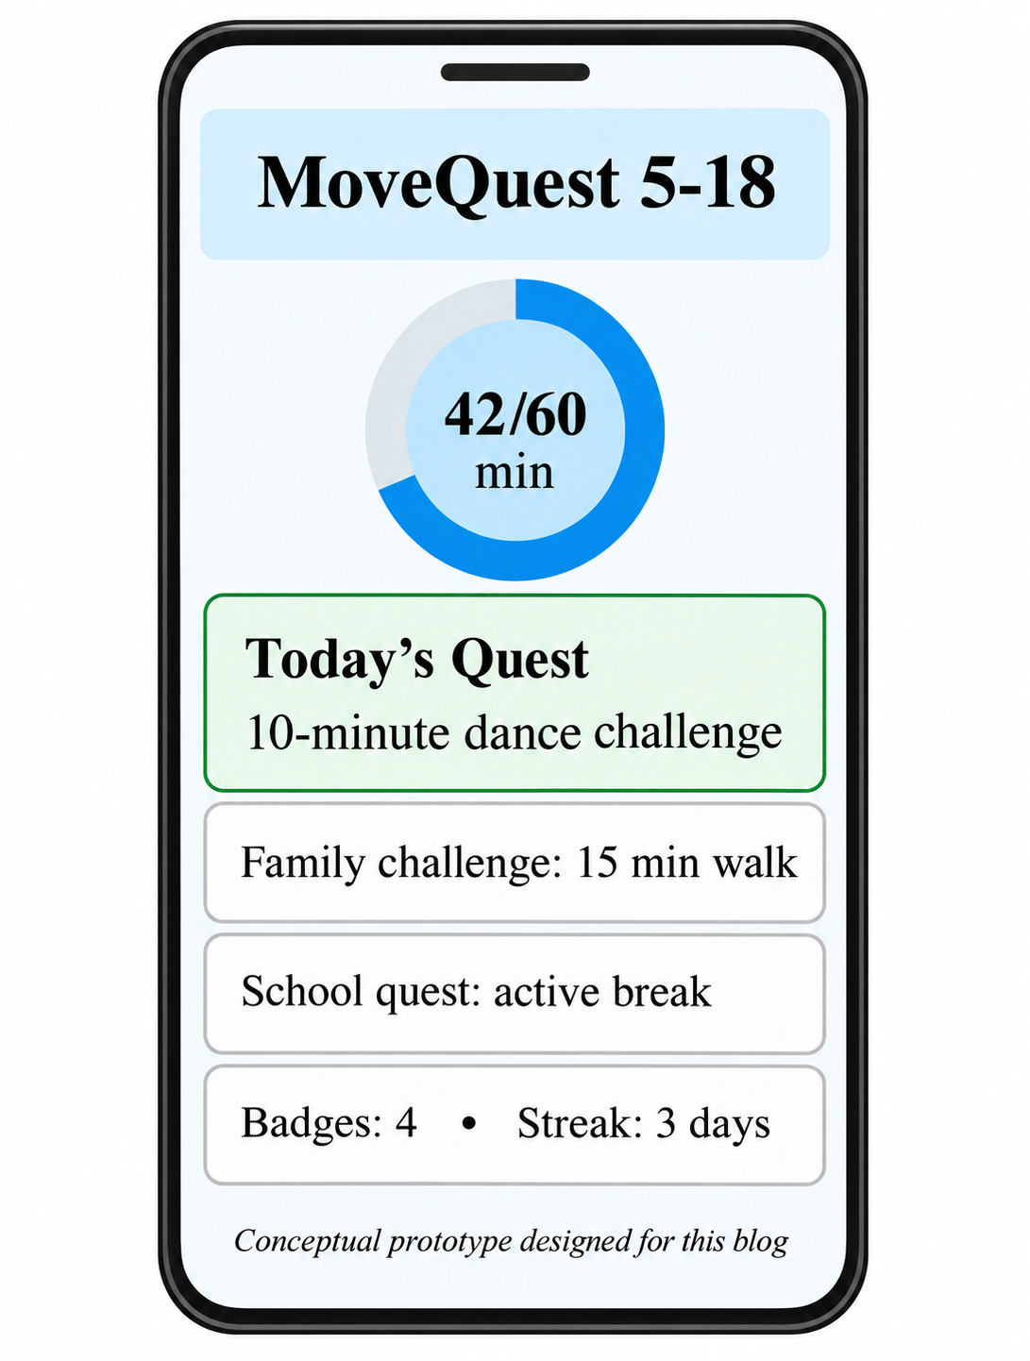
Figure 3: MoveQuest 5–18 conceptual app mock-up.

This is an original design example for the proposed intervention, not a commercial product.
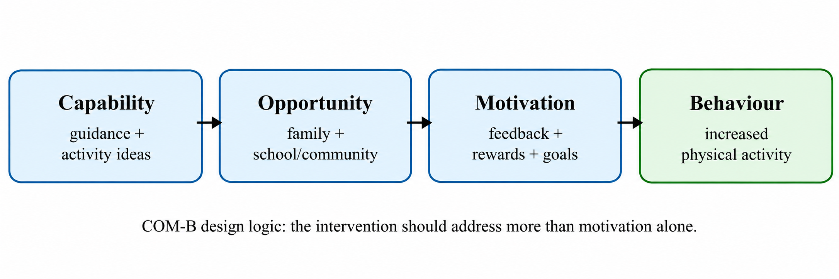
Figure 4: COM-B design map for MoveQuest 5–18. Capability, Opportunity and Motivation are linked to the proposed intervention features.

Evidence-based example: NIHR ARC Yorkshire & Humber – Bradford JU:MP children’s physical activity blog
Related video: The Body Coach TV – 10 Minute Kids Quiz Workout The Body Coach kids workout video
Reference list – Blog 2
Department of Health and Social Care (2026) Physical activity for children and young people: 5 to 18 years. Updated 16 July 2026. Available at: https://www.gov.uk/government/publications/physical-activity-guidelines-children-and-young-people-5-to-18-years/physical-activity-for-children-and-young-people-5-to-18-years-text-of-the-infographic (Accessed on: 6 October 2026).
Michie, S., van Stralen, M.M. and West, R. (2011) ‘The behaviour change wheel: a new method for characterising and designing behaviour change interventions’, Implementation Science, 6, 42. Available at: https://implementationscience.biomedcentral.com/articles/10.1186/1748-5908-6-42 (Accessed on: 6 October 2026).
NIHR Applied Research Collaboration Yorkshire and Humber (2025) ‘World-Leading Results: How Bradford’s JU:MP Programme is Transforming Children’s Physical Activity’. 9 July 2025. Available at: https://arc-yh.nihr.ac.uk/resources/blogs/world-leading-results-how-bradfords-jump-programme-is-transforming-childrens-physical-activity/ (Accessed on: 6 October 2026).
Sport England (2025) Active Lives Children and Young People Survey: Academic year 2024–25. Published December 2025. Available at: https://sportengland-production-files.s3.eu-west-2.amazonaws.com/s3fs-public/2025-12/Active%20Lives%20Children%20and%20Young%20People%20Survey%20-%20academic%20year%202024-25%20report-.pdf (Accessed on: 6 October 2026).
Wang, J.-W., Zhu, Z., Shuling, Z., Fan, J., Jin, Y., Gao, Z.-L., Chen, W.-D. and Li, X. (2024) ‘Effectiveness of mHealth app-based interventions for increasing physical activity and improving physical fitness in children and adolescents: systematic review and meta-analysis’, JMIR mHealth and uHealth, 12, e51478. Available at: https://mhealth.jmir.org/2024/1/e51478/ (Accessed on: 6 October 2026).
Wang, M., Xu, J., Zhou, X., Li, X. and Zheng, Y. (2025) ‘Effectiveness of gamification interventions to improve physical activity and sedentary behavior in children and adolescents: systematic review and meta-analysis’, JMIR Serious Games, 13, e68151. Available at: https://pubmed.ncbi.nlm.nih.gov/40966596/ (Accessed on: 6 October 2026).

