Project Management
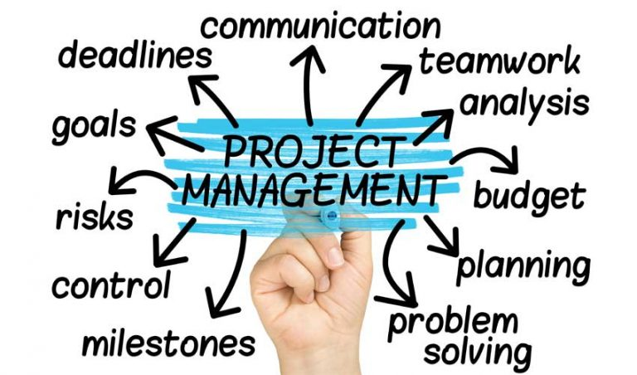

Student’s Name: Petal Charmaine Jones
Student’s #: 1812740
Module #: BMSW 5104
Module Title: Managing Projects in the Organisation
Lecturer’s Name: Dr Yajesh Kumar
BA Level 5

Table of Contents
Chapters Pages
Introduction 3
Critical assessment of project management tools and techniques 4-5
Implementation of a project within the workplace 5-14
Evaluation of my ability to manage a project 14-18
References 19
Appendices 20-24

Introduction
The purposes of this report are to: 1) “Provide a critical assessment of the usefulness of project management tools and techniques. 2) Prepare a plan for the implementation of the project and specify the relevant steps that must be followed and how the plan is going to be implemented. Communicate the project plans with appropriate colleagues and stakeholders. 3) Critically evaluate my ability to manage a project. Use feedback from others to evaluate my own ability to plan and implement a project, identifying strengths and weaknesses. Create a self-development plan to improve my own performance in managing projects.”
A project can be defined as our everyday activities. According to Pinto (2007) a project is an extraordinary endeavour with a start and end directed by individuals to meet foundation objectives inside boundary of cost, and quality. According to Project Management handbook project management has become a core competence and almost every manager in organisation are managing more than one projects. According to Islam (2020) project management is temporary with define beginning and end. He went further to say project management is the application of knowledge skills tool and techniques to project an activity to meet the project requirements and that of the client. In this report I will be introducing the opening of New Creation Hot Spot for persons with disabilities to enjoy the friendly atmosphere and services that has been offered to the customer. A project manager duty of care is to take care of the overall project and to understand and pass on all relevant information to those involved in the project by highlighting them on their respective duties and performance. Within this report it will cover all the important phases of the project, the different tools and technique that will be used in the development of the project like the Gantt Chart (see appendix 1 in appendices) and the PERT chart.

Project management tools and techniques:
- There are different tools and techniques that has been used in projects but the most frequently used one is the Gantt Chart, this chart was developed by Henry L. Gantt in 1917 to highlight how a project work has been done and how it must be done. Henry Gantt additionally underlined why execution miss the mark concerning the arrangement and by fixing the obligation regarding achievement or disappointment of the arrangement. According to Maund (2018) Gantt Charts are generally excellent apparatuses to utilize when attempting to undertake a project.
This chart is the most commonly used scheduling tools among non-professionals it is fairly easy to learn it has a modern project management software attached to it that will enable the reader in the planning and controlling of complex projects. This will reduce the risk of wasting time during the process of the project. Ouelhadj & Petrovic (2009) argued that the Gantt Chart was developed around one hundred years ago whereas the Pert and CPM has only been introduced fifty years. They further highlight that the Gantt Chart, the CPM and the PERT chart had barley undergone any changes which is important reason being these high-quality techniques can exhibit serious limitations. These tools can work together.
According to the international journal of project management being a project manager you must have all the skills and experiences to lead your team in the development process of the ongoing project in order to come up with some suggestions and feedback for the client. During the process of the project a budget plan (see appendix 2 in appendices) can also be implemented which will look specifically at the income and expenditure relating to the project that you are doing during the duration of the project having a good budget in place will help to organise the project and prevent the business from going into bankrupt a budget is very helpful when spending towards any business or project. As a project manager your duty is to cost each task in the budget to arrive at a total rather than trying to cost the whole project always provide a regular budget statement to the client and copy your team. By doing this they will be aware of what is taking place throughout the project. important aspects relating to the project is monitoring all the activities taking place and record them however, if the budget has not been monitored properly this can lead to overspending whereas the project can come to an end due to insufficient funds. Keeping records of your spending will enable you to manage the financial part of the project only necessary items should be purchased.
- The administration procedure and tasks that can be separated into very much characterized stages to shape a day to day existence cycle from beginning the undertaking to the finishing date is known as project management life cycle.
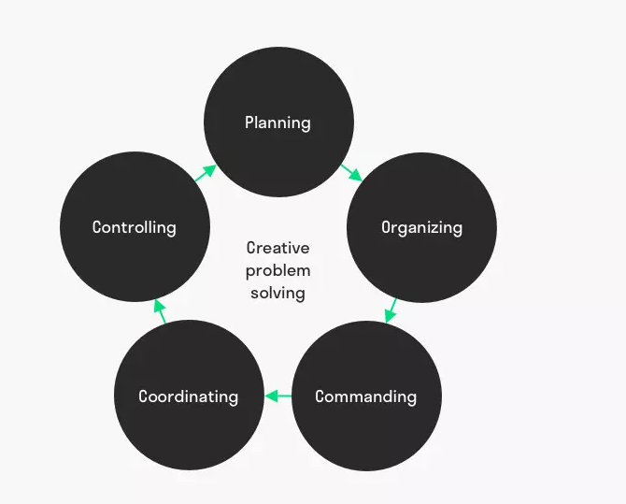
According to Henry Fayol the major functions of management are: planning, organising, command, co-ordination and control (see figure 1 below). These responsibilities will be used throughout this project. The starting up phase of the project is the initiation stage however as a project manager you have to take into consideration that a overview plan of the project must be developed and put into practice by doing this one will have a better understanding of the project achievement in light of this we will know who are the stakeholders after taking all these factors into account the project manager arrange a meeting with the key stakeholders and highlight them on what will be done and how it will be done this is where the usefulness of a mission statement falls into place being a project manager in order to understand your project properly first you need the mission statement to make ideas clear in what you are doing and then the mission to give you directions this involves the procedure of how to start the project however by doing this the project manager can go ahead and state the scope, purpose, and objectives of the project.

Figure 1: Henry Fayol, ‘The Five Functions of Management’
The sponsor for New Creation Hot Spot is Grace Kennedy company after taking into consideration and looking at the various food chains, none of them have cater for persons with disabilities I have looked at this from different perspective and decide to open the first branch in Croydon. Persons suffering with disabilities need people around them that has time and patience to look after their various needs. New Creation Hot Spot will be a privately owned company that includes a manager, two chefs, four front of house staff, a kitchen porter and a sign language speech therapy specialist who will assist with the ones having difficulties with communication. All New Creation staff will benefit from a competitive pay package.
Our first branch will be located at shop number 9 central shopping centre CRO 2JG Croydon. This is a very busy shopping location, people from near and far visit Croydon to do their shopping as it home several shops and restaurants. New Creation is a rented premise with a monthly rent of £1000 pounds per calendar month. I have managed to secure a business loan of £15,000 from my local bank with an addition of £ 8,000 from my savings account. An accountant has been employed to take care of all the business funds and bring new ideas in place when necessary. Looking at our location I can see we will have no direct or indirect competition because we will be the only business of this kind at present. There is an enormous hole in the market for business of this sort and New Creation is the first to offer this service.
Considering this I cannot identify any reason why this business should not be successful having a looked at the market. It will include people living in and around Croydon with disabilities and those that visit the area. There is a total of £24, 000 pounds that has been set for this project with an estimated finishing time of six months. On the completion day of this project we will do the close out phase and sign all the relevant documentation, after this has been done we will introduce New Creation Hot Spot to our valued customers with disabilities of all age groups. To show what the business means to accomplish, an inception record of the project plan is set out below to outline the plan of the project.
New Creation Hot Spot background
We are the number one food establishment in Croydon that will be catering for persons with disabilities and offering them a nice, friendly, and relaxing atmosphere to enjoy the services provide to them. There are several other food locations around Croydon town centre that serve food to various customers of all walk, but we are the only one with the unique touch to look after the less fortunate persons.

Purpose:
Our purpose is to prepare and serve high quality special dishes to everyone that we come into contact with by looking after their needs and wants and taking the time out to be very patient with these persons who required special care and services.
Objectives
Our objectives are:
1. To accomplish our valued customer satisfaction by offering reasonable prices of the products that has been delivered to them.
2. To provide weekly meetings to catch up with what is going on in the business
3. To have a safe and friendly working environment for everyone
Training sessions will be carried out online or face to face.
Project scope management
All staffs and partners will be remembered in the project to know what is expected from them such as time, cost, and quality.
Deliverables- This will include weekly meetings and emails between stakeholders and project managers. (See appendix 4)
Constraints and assumptions
All projects managers must take into consideration the drawbacks that can occur when managing a project. These include but not limited to:
- Gain an awful notoriety
- Funding accessibility, or if business goes over financial plan
- Products probably will not get conveyed on schedule.
- Time for the project to be completed
- Quality of services provide
Benefits of new Creation Hot Spot
With the introduction of New Creation Hot Spot for persons with disabilities, this will be a one-of-a-kind experience for them. They will have the opportunity to enjoy a nice, friendly and relaxing atmosphere with a nice meal of their choice and where special assistance is needed someone will be there for this services.
Options
Leasing of equipment with intention of buying in the near future
Cost and Timescale- The anticipated time will be a half year for the usage at an expected expense of £24,000.
Cost- See budget plan for overall cost in appendix 2
Risk that can occur.
• Mishaps or wounds
•Confrontation with management, could be a factor with employees leaving the job.
• Financial misfortune, insufficient client
• Operational risk (see appendix 3), products not being delivered
Risk prevention
- Create a safe working environment for everyone
- Speak to all employee in a professional manner

The Project Team will include:
- Catering manager- Responsible to manage all the activities taking place in the business
- Two chefs- Take care of all the food preparations
- Four front of house staff members
- Kitchen porter- The pot wash area and the cleaning of the kitchen
- Sign language and speech therapy specialist takes care of those having difficulties communicating
- Accountant looking after the financial aspect of the business
Project Sponsor
Grace Kennedy Company
New Creation Hot Spot
Deliver date and opening of the project
Bank loan approved 02/01//20
Rental agreement 02/01/20
Business registration 04/02/20
Inspection carried out 04/02/20
Staff interviews and induction training 01/06/20
Uniforms ordered and delivered 07/06/20
Grand Opening 30/06/20
Resources required for the project.
Experience workers
Material and services resources
Equipment.
Financial resources.
Agency staff
Project Control: Monitoring mechanisms
Monitoring to occur on week after week telephone call/week by week email update among managers and staffs.
Communication channels and schedule
According to Emmitt (2010) communication is of indispensable significance to everybody associated with, and affected by, ventures. Similarly, Awati (2010) expressed that communication is so critical to extend achievement that it has been alluded to as the soul of a venture by more than one individual. Project Managers need to team up, share, gather and incorporate data and information to acknowledge project targets.
According to Steyn (2008) ineffectual communication can provoke misinterpretation in respect of improvement projects. Inadequately portrayed tasks and essential strategies, weakness with respect to commitments, extension or focuses of advancement endeavours may cause improvement undertakings to miss the mark. Overseeing projects requires steady selling and trading of musings, explaining the expansion and strategies of the dare to grouped social affairs of people (individuals all in all, the heads, valuable divisions and various accomplices), bargaining or dealing with expert associations and suppliers, or wheeling and dealing to settle questions or social conflict between adventure associates or various accomplices.
The communication channel (see appendix 4 in appendices) of the project will be communicating with the stakeholders through face to face communication email and through teams also this will take place weekly to discuss the progress of the project. A communication plan should be made available before the execution of the project can be entered. This shows how partners in the venture will be educated regarding the advancement in the undertaking the Stakeholder are the representatives. The catering manager and Grace Kennedy Company, are key stakeholder in this project Kitchen Porter front of house staff, accountant and the sign and speech language therapy are also stakeholders .This part of the plan incorporates the procedures required to guarantee convenient and fitting assortment, conveyance, stockpiling, recovery, and extreme aura of undertaking data. As indicated by Goodman and Tuss (2004) representatives need communication during seasons of progress, to keep them educated this will lessen vulnerability.
Quality Control
All clients require the best from the project management team, there is no two way about this. Guaranteeing quality is likewise enrolled part of the set of working responsibilities of every representatives. The chief and workers will kill any obstacle that arrived in the method of conveying quality administrations and guaranteeing the best quality is conveyed.
The appropriateness of the business will be showed up in reports from customer analysis.
A Post-usage Review will be finished inside a half year after the re-opening of the New Creation Hot Spot.
Change management
All change solicitations will be archived, given to, and passed by the project manager and group pioneers for effect and task need preceding undertaking the executives endorsement. On the off chance that the change is affirmed the venture calendar, degree, and spending will be refreshed in like manner and imparted to proper partners as per the correspondences plan. The task the board and group will impart the affirmed change and refreshed calendar to workers responsible for executing the change.
Execution phase
Regularly where the endeavour execution is finished, while securing assets and directing assistants. Controlling/watching happens here. The quality is checked similarly as a degree creep, and cost/time dispersions are believed to keep things inside the budgetary arrangement. By taking after the endeavour plan from the organizing stage, this will permit the errand chief to balance the advancement with the undertaking disclosures and Gantt Chart/Pert to guarantee that assignments are being done in fortunate way and quality measures. The utilization of a Pert chart is altogether unique and subject to association affiliation. Bit by bit calls and messages moves up to be held between widen boss and the accessories, at each sort out of the undertaking. This will permit the Project Manager to look at any concerns and address issues without putting aside some push to really meet, when execution stage is finish, a stage study will take put to guarantee that the undertaking has met each planned spotlight on some time starting late entering the end stage.
Closing phase
According to Kloppenburg (1999) “Successful project completion is contingent upon members working together effectively as a project team.” The closing phase of the project is the final stage where the delivery process is finished and hand over to the client. The stakeholders are then informed about the process. Each task needs to end and that is the thing that venture finish is about in the last period of the undertaking life cycle. The general purpose of the undertaking is to convey what you guaranteed. Be that as it may, if the group is broken practices win, plans slip, costs overwhelm, yield quality lessens and in outrageous cases the task will fizzle. To gather feedback, the manager will lead a post usage survey to gage the viability of the task from partners and all the targets set have been met. After the opening a survey will be led inside a time span. The audit will take New creation problem area this is sufficient time for productive criticism on the cooking group.
To gather this feedback we will be using surveys that will be sent to all our valued customers and employees, however if there is a problem that need to be address the customer will have a chance in rectifying this by conducting this feedback it will allow the business to make all the necessary adjustment to become the most successful high quality catering business with customer satisfaction as a main priority.
3. The role I played in this project was the project manager. This is my first time being a manager so I was excited about the new experiences it would teach me. This job added to the experiences and thoughts on the most proficient method to open New creation hot spot services and how it would profit the hole in the market, to develop inside what is to come. I decided to use the PRINCE2 strategy. It seems to be the most popular approach. I chose this method as it is a very powerful asset to help venture supervisors in arranging and dealing with a task. According to Pawar and Mahajan (2017) “PRINCE2 is the leading project management method in the UK and it is used across the globe in both the private and public sector.” Caulking and Davies had similar points of view in 2007. They announced that the PRINCE2 approach is the most widely recognized, and it is likewise suggested by the European Union and the legislatures of the part states.
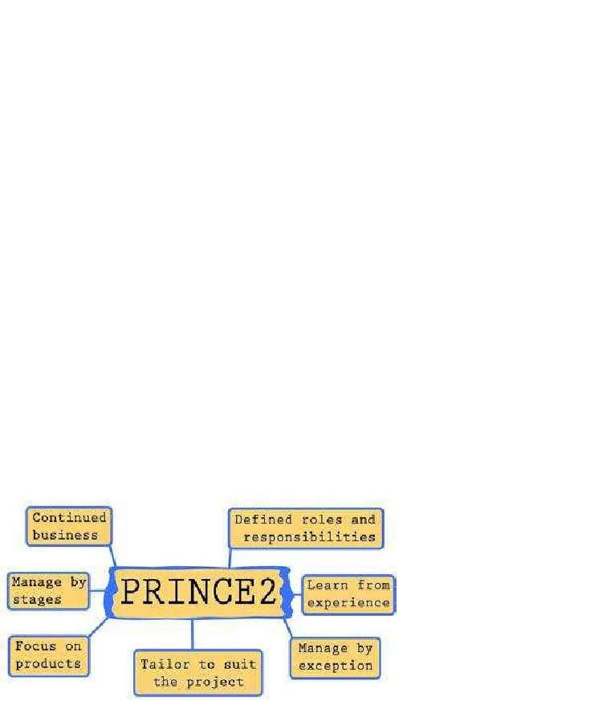
Pawar and Mahajan (2017) went further to state by utilizing PRINCE2 for project management, the project is controlled inside a cost imperative, time requirement and quality limitation. An excellent project manager sees how to make every one of the three undertaking limitations change in accordance with one another to convey project inside the degree. PRINCE2 (see figure 2 below) is a completely custom fitted project management strategy that separates businesses into stages with an unmistakably characterized start, center and end. PRINCE2 centers emphatically around the conveyance of the item that is delivered toward the finish of each project.
Figure 2: PRINCE 2 Principles
My strength all through this task was the utilization of the Gantt chart. The usage of the Gantt Chart guaranteed that the undertaking kept to orchestrate which construes the task was a ton more clear to regulate. The Gantt diagram could have been allocated into littler groupings to ease factors and have an all the more abominable arrangement.
Despite, the way that the errand was a victory it included a couple of inadequacies, the usage of the budget plan. The announcement of the extent of cash accessible to spend over set time is called a budget plan. As demonstrated by Wen, Wang and Wang (2005) a budget plan lays out the details of the cash and how it will be spent. It also gives you the details on the items the cash will be used for. It would have been even more astounding by utilizing a Cost Benefit Analysis (CBA). When compared to the budget plan, it would have been more viable to employ the Cost Benefit Analysis (CBA) as it is a straight foreword instrument to utilize. While utilizing Cost Benefit Analysis (CBA), it joins the expense to present the task, perform it and fortify the developments coming to fruition because of it. Money saving advantage Analysis (CBA) advances through the range of the undertaking, making in detail and exactness. This would have been more reasonable.
Feedback
Feedback is a significant key inside project management. To hear a legitimate point of view to audit my capacity to extend management, I will make a private survey sent to the venture group through email.
Here are a few inquiries I will pose:
• Did you feel that the endeavour was compelling by and large?
• Did you feel the endeavour boss checked out you?
• Was the undertaking chief congenial?
• Did you feel upheld all through by venture chief?
• Any other extra criticism you might want to include?
The Bruce Tuckman’s Model of Phases of Group formation will be employed for future projects. This model will be used to ensure a whole gathering at the same time. The fifth phase of this model is named the adjourning stage, at this stage the gathering's certain achievement are applauded when all endeavours are done. Giving up the social occasion structure after broad stretches of concentrated joint effort can in like manner make weakness for particular associates.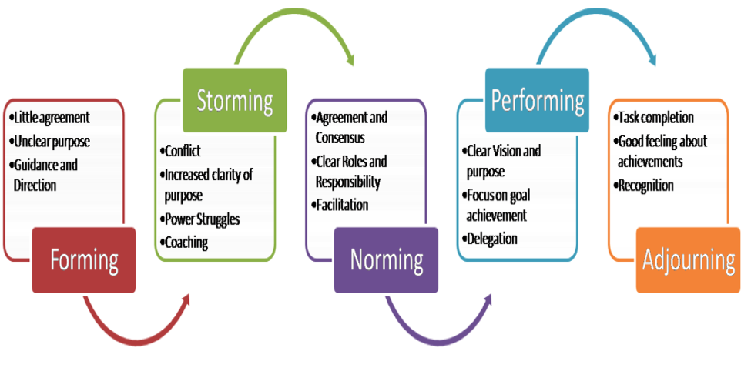Source: Tuckman and Jensen (1977).
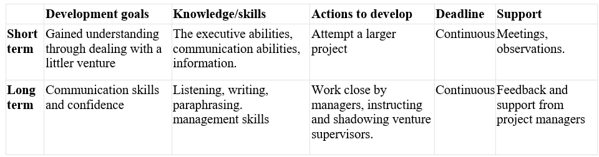
Self-development plan
Conclusion
This report campaigned everything truly coming to fruition of an undertaking. Dealing with the change procedure all through an undertaking life cycle is unimaginable and ought to be comprehended, arranged for, embedded and evaluated by the person managing the project. The truth was to build up an evaluation contraption to check to change parts over the 4 phases. The drawbacks have been identified and can get from them, at any rate the positives were found moreover. Later on, more vital complex undertakings will be rehearsed.

References
Awati, K., 2010. Obstacles To Project Communication. [online] Available at: <https://www.projectsmart.co.uk/obstacles-to-project-communication.php> [Accessed 06 August 2020].
Caulking, C., and Davies, G., 2007. PRINCE2 Process Model. Key Skills Ltd.
Emmitt, S., 2010. Managing Interdisciplinary Projects: A Primer For Architecture, Engineering And Construction.. London: Spon Press.
Goodman, J. and Truss, C., 2004. The medium and the message: communicating effectively during a major change initiative. Journal of Change Management, 4(3), pp.217-228.
Kloppenborg., T., 1999. Leadership In Project Life Cycle And Team Character Development. [online] Available at: <https://doi.org/10.1177/875697289903000203.> [Accessed 10 August 2020].
Islam, S., 2020. Definition Of Project Management: What Is Project. [online] Academia.edu. Available at: <https://www.academia.edu/31616426/Definition_of_Project_Management_What_Is_Project> [Accessed 01 August 2020].
Maund, A., 2018. BA In Leadership And Management. [Los Angeles]: SAGE, p.180.
Mspguide.org. 2020. Tuckman (Forming, Norming, Storming, Performing) | Multi-Stakeholder Partnerships. [online] Available at: <http://www.mspguide.org/tool/tuckman-forming-norming-storming-performing> [Accessed 08 August 2020].
Ouelhadj, D. and Petrovic, S., 2009. A survey of dynamic scheduling in manufacturing systems. Journal of Scheduling, 12(4), pp.417-431.
Pawar, R. and Mahajan, K., 2017. Benefits and Issues in Managing Project by PRINCE2 Methodology. International Journal of Advanced Research in Computer Science and Software Engineering, 7(3), pp.190-195.
Pinto J (2007). Project Management: achieving competitive advantage. Pearson education Inc: Upper Saddle River, HJ.
Steyn, H., 2008. Project Management: A Multi-Disciplinary Approach.. 2nd ed. Pretoria: FPM Pub.
Talukhaba, A., Mutunga, T. and Miruka, C., 2011. Indicators of effective communication models in remote projects. International Journal of Project Organisation and Management, 3(2), p.127.
Wen, W., Wang, W. and Wang, C., 2005. A knowledge-based intelligent decision support system for national defense budget planning. Expert Systems with Applications, 28(1), pp.55-66.

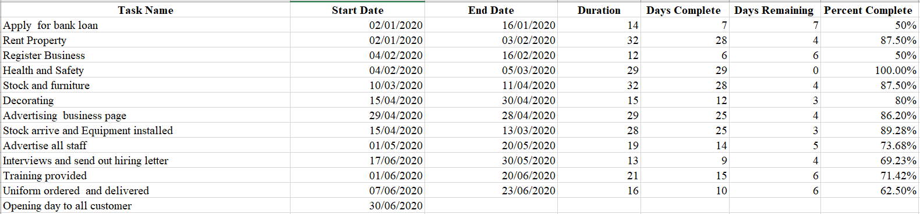
Appendices
Appendix 1: The Gantt Chart
Appendix 2
The overview of budget plan.
Project investment
Items | Costs
Set up Cost | £5,500
Premises | £ 2,500
Working Capital | £ 2,000
Marketing Expenses | £ 1,300
Preliminary Expense | £ 3,000
Total | £14,300

Setup costs: This includes the bank loan
Premises: The tenancy agreement signed requires a deposit of £1500, then £1000 per calendar month.
Preliminary costs: This include buying all the products required to start business.

Salaries

I am assuming that in the first two (2) years there will be four (4) Front of House Server, two (2) chefs, 1 kitchen porter, 1 sign language specialist, 1 part time Accountant until the business a place of belonging in the market.
Assumptions for the utility’s expenses are as follows:
Utilities | Monthly Expenses
Water | £ 500
Gas | £ 1000
Telephone | £ 200
Electricity | £ 2000
Total | £3700

Expenses | Cost
Salaries | £16,600
Utilities Expenses | £3700
Project Investment | £14,300
Total | £ 34, 600
The Overall Expenses of the project

Price List for Food items (non-vegetarians) that will be sold once the business is in operation
Food Items | Prices
 | Small | Large
Beef Lasagna | £4 | £6
Pork Gollash | £5 | £7
Chicken Curry | £4 | £6
Stew Beef | £5 | £7
Baked Chicken | £4 | £6
Fish Pie | £6 | £8
Fish Cake | £3 | £5
Sausage and mash | £3 | £5

All these will food items be served with rice, new potato and or mash potato and vegetables or salads.
Price List for Food items (vegetarians) that will be sold once the business is in operation
Food Items | Prices
 | Small | Large
Chic pea curry | £3 | £5
Fritata | £3.50 | £4.50
Vegetarian cottage pie | £3.50 | £5
Mac and Cheese | £2.50 | £4
Vegetarian Burger/Buns | £2 | £3
Halloumi Cheese/ Quinoa | £8 | £10

All these will food items be served with rice and vegetables or salads.
Price List for Hot Drinks that will be sold once the business is in operation
Hot Drinks | Prices
 | Small | Large
Drinking Chocolate | £1.40 | £2
Coffee | £1.60 | £2.50
Tea | £1 | £1.20
Price List for Cold Drinks that will be sold once the business is in operation
Cold Drinks | Prices
 | Small | Large
Smoothie | £1.50 | £2.00
Red Bull | £1.20 | £2.00
Lucozade | £1.20
Water | £1.00
Can drinks | £0.60

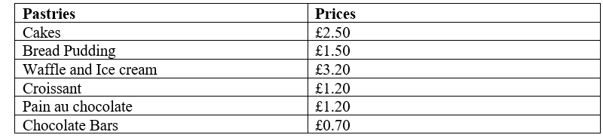
Price List for Pastries that will be sold once the business is in operation

Note well: Whole fruits and fruit salads will also be on sale.
Note well: The work hours for everyone are from 7:30 am-8:00pm. The business will be opened from Tuesdays to Sundays. They will be given half hour for lunch, fifteen minutes break for coffee and smoking.
Appendix 3
The likelihood of risks effecting the project.
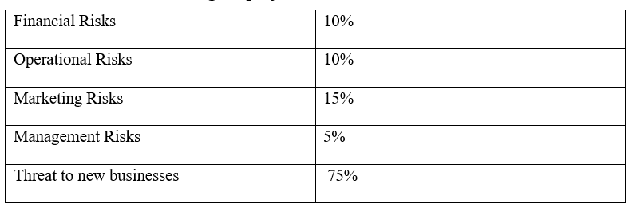

Appendix 4
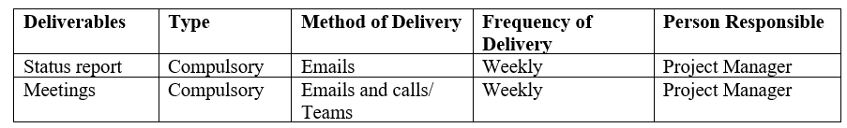
Communication channels.

