PROGRAMME: BA (HONS) BUSINESS MANAGEMENT
MODULE- DATA HANDLING AND BUSINESS INTELLIGENCE
MODULE CODE: LCBB5014
STUDEENT NAME: NICOLETA CARP
STUDENT ID: 2125547
LECTURER: DR SAID USMAN

Table of Contents
1. Introduction 4
2. Data Cleaning and Preparation 4
3. Descriptive Statistics and Summary 5
4. Trend Analysis and Visualisation 12
5. Statistical Analysis 16
6. Insights and Recommendations 19
Reference List 20

1. Introduction
The purpose of the report is to identify the trends in the food order delivered and the traffic conditions, weather conditions, type of vehicles used in the delivery process. The trends in weather pattern/conditions are identified along with the delivery person ratings and type of food ordered. Frequency of delivery is also identified along with delivery time to identify the impact of weather conditions and road traffic density on delivering the food. Through the report, there is hypothesis testing done regarding significant difference in delivery person ratings based on different weather conditions.
Regression statistics helps in generation of p-value and it has to be lower than 0.05 for validating relationship in between research variables (Bujang et al., 2018). Through help of Pearson Correlation analysis, interrelationship in between research variables is identified (Ikhwan et al., 2024). In this case, correlation in between variables such as delivery person age, delivery person ratings, road traffic density and local distance are identified. The dataset provided consisted of information regarding ratings obtained by delivery person, age of delivery persons, weather in which delivery is given, latitude and longitude of the delivery address, road traffic density, vehicle conditions. Overall, there are 1988 data points for each variable and hence, chunk of data is provided.
The objectives to be addressed by the report are as follows:
- To cleanse the dataset so that data inconsistencies can be removed and also check for missing data
- To generate descriptive statistics and identify the demographics of delivery staffs along with different variables
- To do hypothesis testing and identify whether there is a significant difference in between variables such as age of the individual delivering food and ratings or traffic congestion and distance
- To identify correlations in between variables such as age of delivery person, ratings or road traffic density and local distance
- To conduct regression analysis for deterring the predictors of ratings obtained by delivery partners

2. Data Cleaning and Preparation
There is need of making sure that in a MS Excel data set, the missing values are identified and rectified through help of a process such as imputation or removal. Imputation technique helps in replacement of the missing data points in a dataset with substitute values and is identified by doing statistical measures (Calabrese, 2018). There can also be k-NN method applied or random forest method applied for doing imputation. However, in this case there are no such missing data identified (Li et al., 2021).
There is need of checking for inconsistencies or irregularities in the data which often happens with time formats or date. However, in this case, there is no such inconsistencies identified. However, there is need of identifying the delivery time that is required to make the products reach the customers. This involved subtracting the ‘delivery picked up time’ from the ‘delivery ordered time’ and the values obtained in minutes is substituted with values. For example, delivery time of 5 minutes, 10 minutes and 15 minutes is replaced with 1,2 and 3. There is also need of estimating the distance travelled by delivery staffs to deliver the food and is done by subtracting the latitude and longitudes of the delivery location from the restaurant’s latitude and longitude. Then, there is application of the Haversine Formula to calculate the distance and is estimated for taking the distance value for further analysis.

3. Descriptive Statistics and Summary
Delivery Person Age
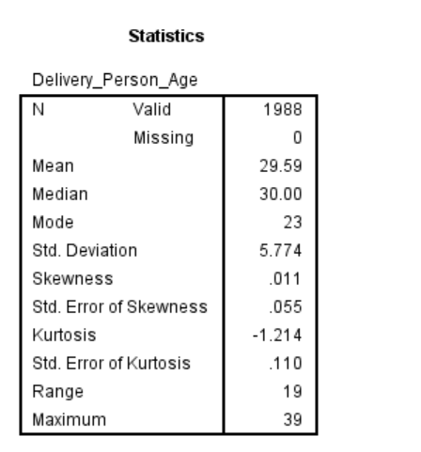
The mean age of the delivery persons making the food delivered is 29.59 and most of them are having age of 23 years (5.9%) followed by 5.7% of age 30 years and 5.6% in each category of 28 and 38 years. 5.4% of the individuals are in 24 years category followed by 5.3% of the individuals having age of 39 and 36 years.
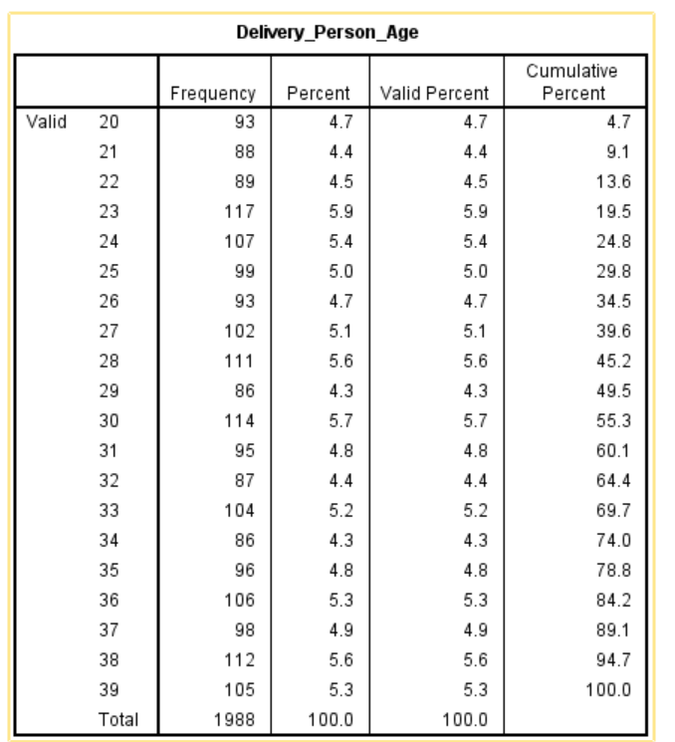
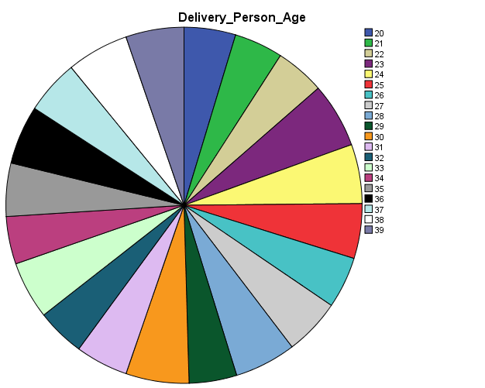

Delivery Person Ratings
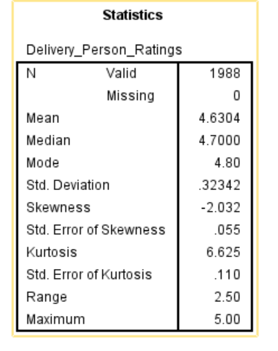
The mean value of delivery ratings obtained is that of 4.630 and this implies that on an average, the delivery staffs have obtained good feedback from customers. The minimum rating obtained is 2.50 and maximum is that of 5.00. This implied that the range estimated of the ratings is 2.50. Mode value is 4.80 indicating that in majority of the instances, the ratings received is 4.80. 7.8% of the delivery staffs obtained the rating of 5.00 and 17.6% of the respondents obtained a rating of 4.80. 16.9% of the respondents received a rating of 4.9, whereas 2.1% of the respondents obtained rating of 4.00.
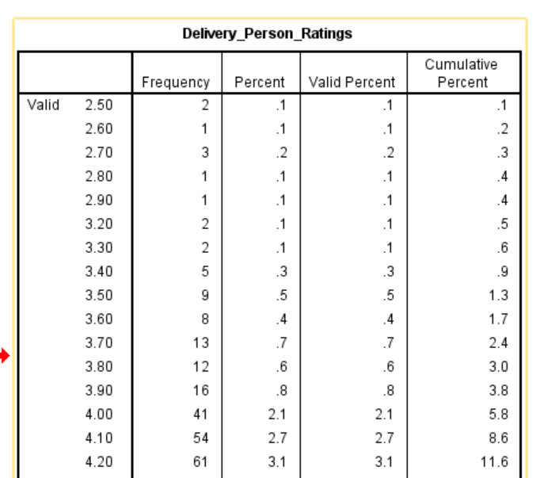
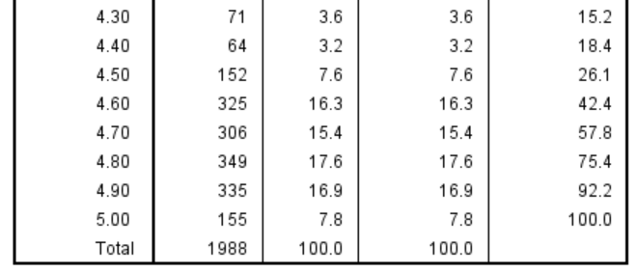
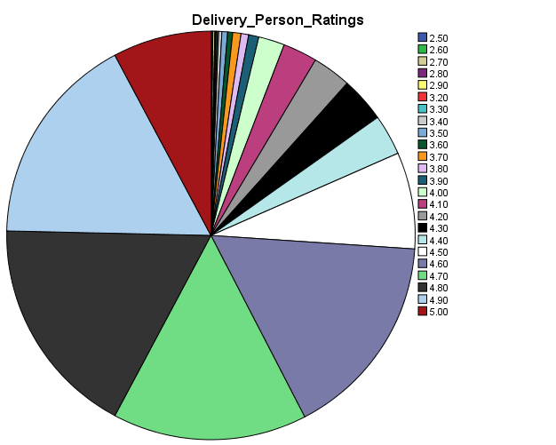

Weather
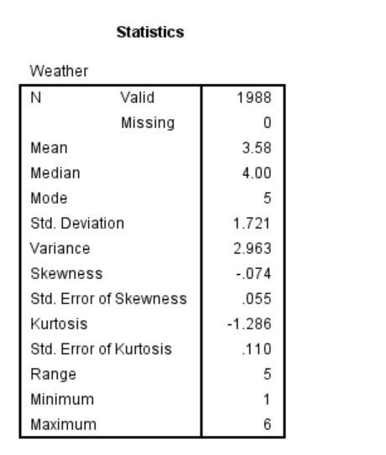
The mean value is identified to be 3.58 and mode is 5 indicating that in most of the cases, the weather remained sunny. In 18.1% of the cases, the weather remained sunny followed by another 18% occasions when the weather was windy, thereby indicating good weather conditions in most cases. In 16.2% cases, the weather was stormy followed by 16.1% cases when the weather was cloudy and another 16% in which there were sandstorms. In 15.6% cases, the weather remained foggy.
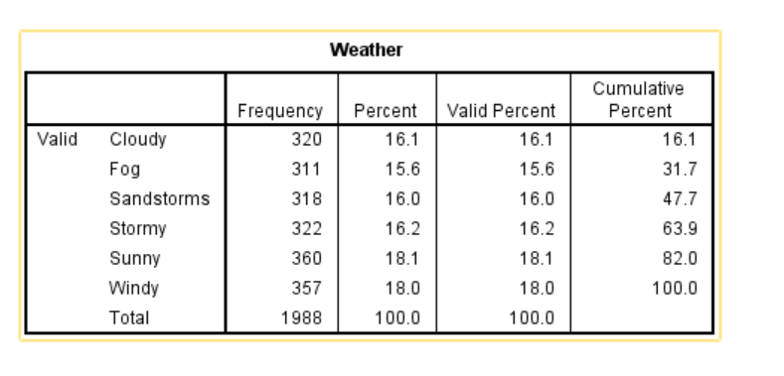
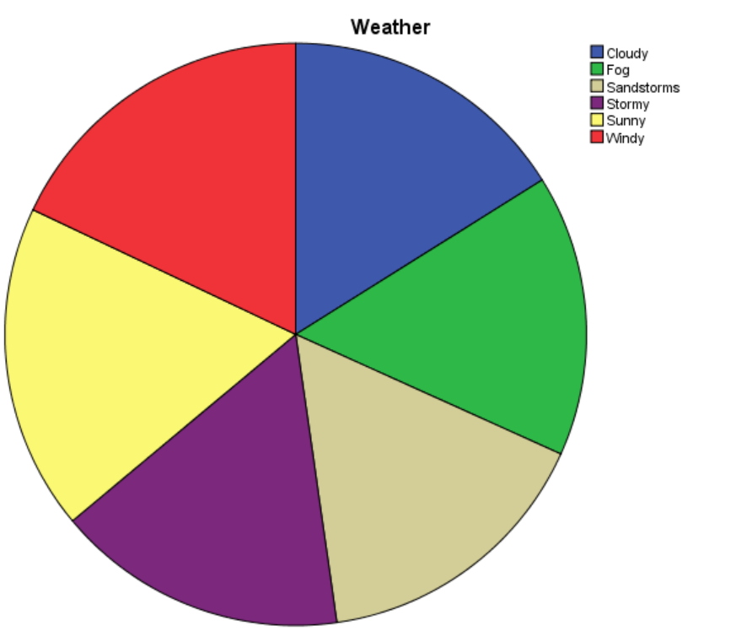
Road Traffic Density
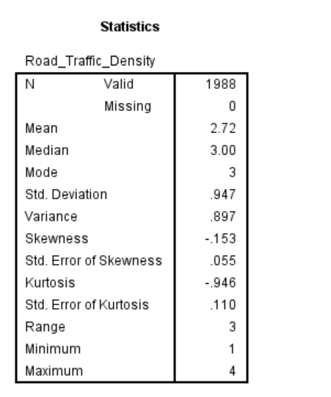
Traffic congestion plays an important role in deciding the delivery time required in giving the orders and also deters the ratings of individuals delivering the food (Chen, 2019). This is due to fact that with increase in traffic congestion, there happens delay in making the order delivered (Alvarez et al., 2018). Mean is estimated to be 2.72 and mode is 3 indicating that in most cases, the traffic density was low. In 33.7% of the cases, the traffic density was low, however, for 31.5% cases, traffic jam was faced by the delivery staffs. It led to increase in time for delivering the food orders. 24.4% of the individuals faced medium traffic congestion and remaining 10.4% faced high percentage of traffic congestion.
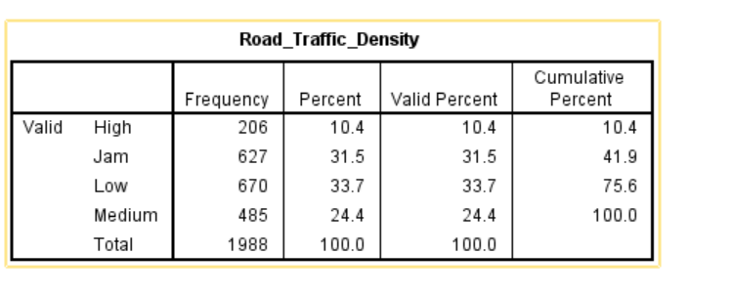
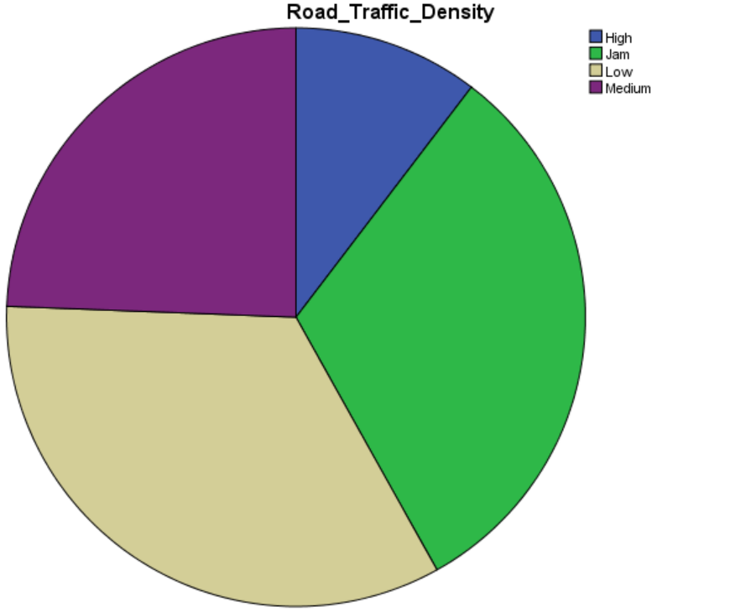
Type of Order
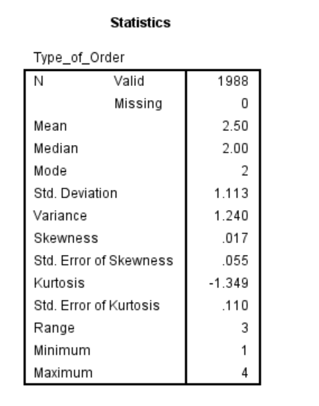
The mean value of ‘type of order’ is identified to be 2.50 and mode is 2 indicating that in most cases, the ordered food item is drinks. 26.3% of the orders given are ‘drinks’ followed by 24.9% of the people ordering snacks. 24.5% of the people order buffet food items and another 24.3% of the people ordered meals.
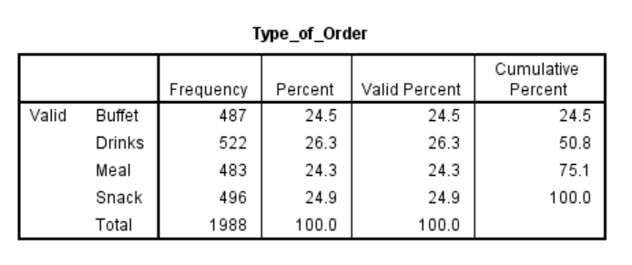
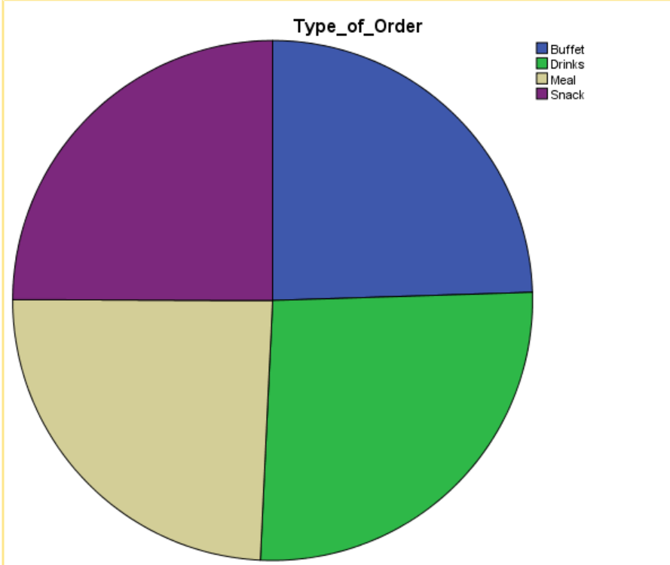
Type of Vehicle
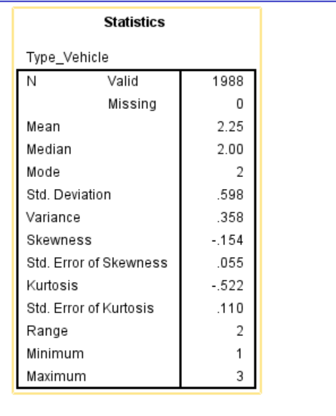
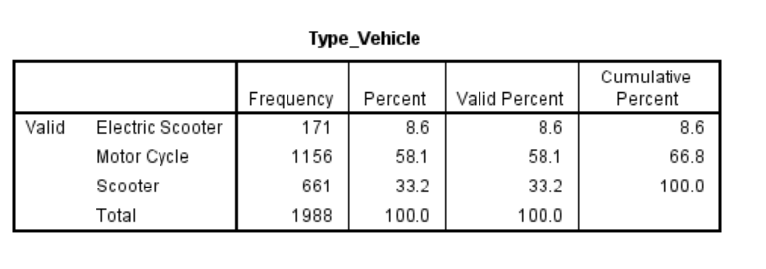
Type of vehicle plays an important role in deciding the speed of delivery of the food items as individuals using motor cycle can have faster delivery (Hapairai and Tishmack, 2020). It leads to greater satisfaction level of customers and makes them give higher ratings to the delivery partners (Liu et al., 2024). In this case, the mode value is 2 indicating that in most of the instances, the individuals use motor cycles (58.1%) followed by 33.2% of the individual using scooter. 8.6% of the people uses electric scooters for making the deliveries.
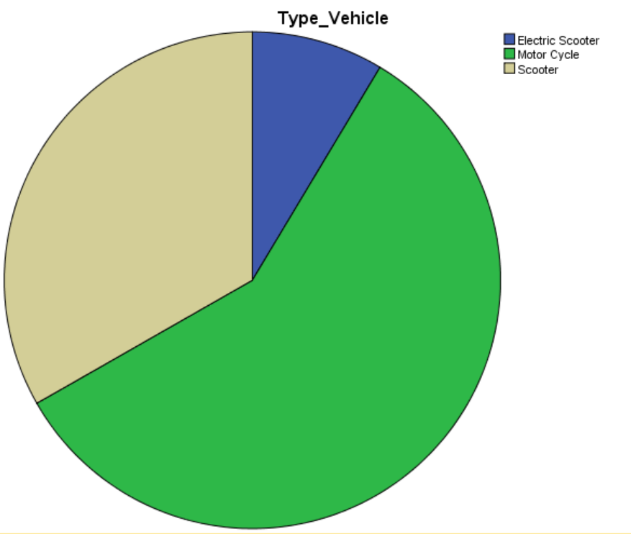

4. Trend Analysis and Visualisation
Trend lines for delivery times and delivery ratings over time
Delivery Times
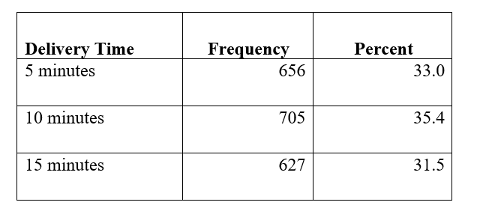
The trend analysis is done and pattern is identified regarding the delivery time that is required in most cases. It has been identified that in majority of the cases; the delivery time was that of 10 minutes as it was the case with 35.4% of the respondents. This is followed by 31.5% of the individuals taking 15 minutes time to deliver the food and 33% of the individuals took 5 minutes time to deliver it.

Delivery Ratings Over time
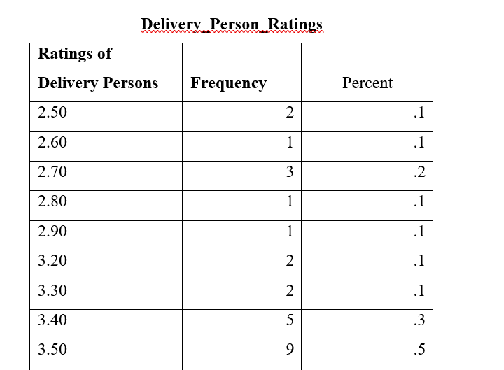
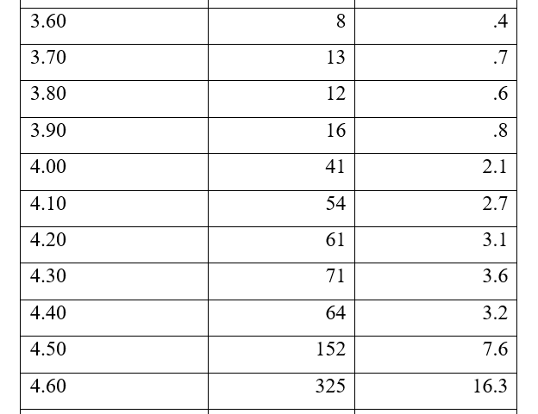
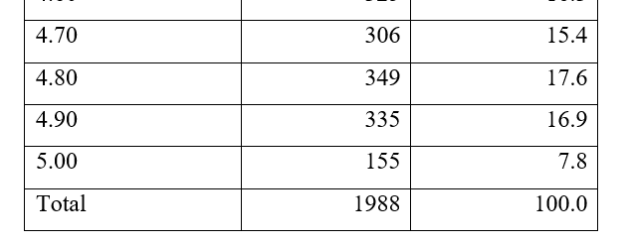
In most cases, the ratings received is 4.80 and is accounted by 17.6% of the delivery staffs followed by 16.9% of them getting 4.9 rating. 5-star ratings are received by only 7.8% of the staffs which comprises of 155 cases out of the 1988 data points obtained. 3.6% of the individuals obtained 4.3 ratings and can be considered to be doing on an average basis. 0.1% of the individuals received 2.50 ratings which is the lowest.

Relationships between weather conditions, road traffic density and delivery time
Pearson Correlation Analysis
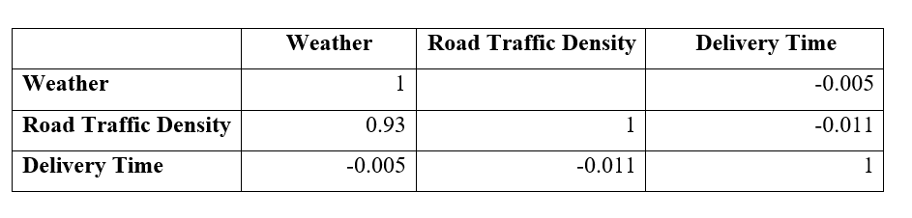
A Pearson Correlation value of +1.000 implies a strong relationship in between the variables and on other hand, -1.000 implies a weak relationship (Muhammed Al-Kassab, 2022). There is a strong relationship in between road traffic density and weather conditions indicated by the Pearson Correlation value of 0.93. This is close to 1.000 and hence, a direct relationship exists in between the variables. With bad weather conditions such as fog or storm, there is expectation that one will get more traffic jam or congestion (Xu and Sankar, 2024). The delivery time is having negative correlation with weather and traffic density as with bad weather condition, the delivery time increases and also high rate of traffic congestion causes delay in making the ordered delivered on time. This is indicated by the Pearson Correlation value of -0.005 and -0.011 which implies negative relationship in between the delivery time with weather conditions and road traffic density.

5. Statistical Analysis
Hypothesis Testing
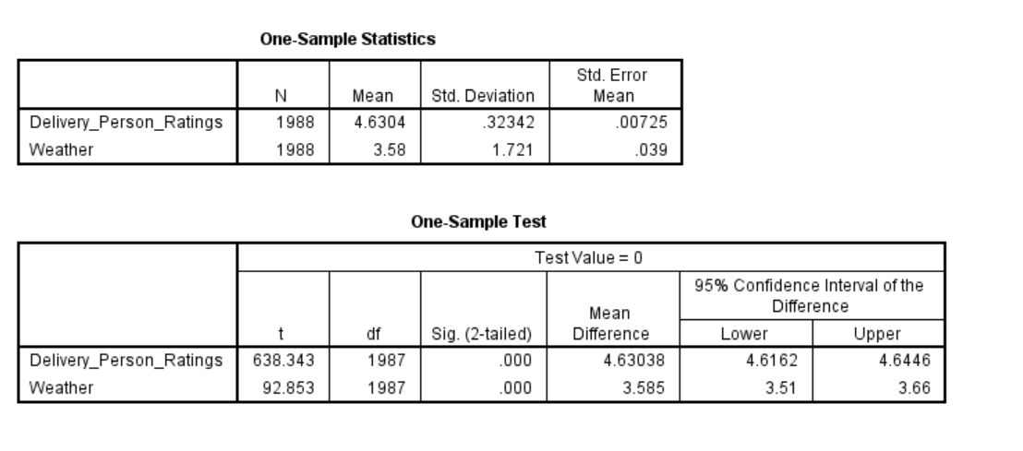
The hypothesis tested is “impact of weather conditions on Delivery person ratings” through help of t-test. A t-test is a statistical hypothesis test which is used for comparison of the means of two groups to deter if the difference in between them is statistically significant or not. In this case, the p-value is 0.039 corresponding to the t-test value of 638.343 for Delivery Person Ratings getting deterred by the weather conditions (independent variable) having a t-test value of 92.85. This implies that there is a significant relationship in between the different weather conditions and ratings received by drivers. A driver making sure that the food is delivered in bad weather conditions such as storm or heavy rain might receive a good rating (Liu, Wang and Zhao, 2022). On other hand, some customers might not understand the issues faced by the delivery partner and give a poor rating. This makes the p-value to be 0.039 which is less than the standard p-value of 0.05 and hence, alternative hypothesis is accepted.
Correlation Analysis
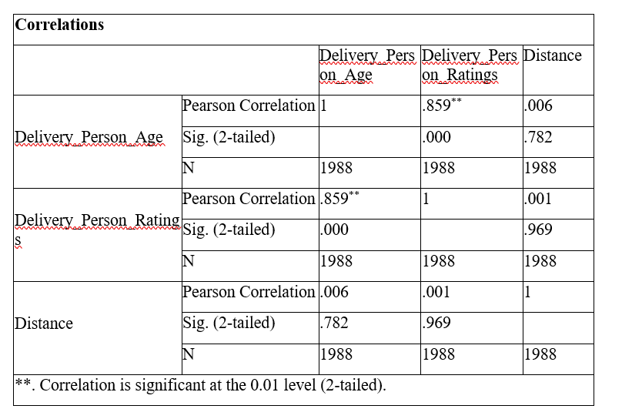
In this case, it has been identified that distance that the delivery partner has to travel shows a weak relationship with the delivery person rating as the customers are unaware of the distance that the individual has to travel or the weather conditions and traffic congestion that one may face leading to delay in the delivery of the food. There is a weak relationship indicated by Pearson Correlation value of 0.001 and also weak relationship exists in between delivery person age and distance travelled indicated by the Pearson Correlation value of 0.006. This is due to reason that the delivery of ‘food order’ task does not happen based on the age of the individual. On other hand, there is a positive relationship (strong) in between delivery person age and ratings received indicated by Pearson Correlation value of 0.859. This is due to reason that often customers connect emotionally with those individuals who are of old age or are working at a very young age to earn a livelihood and give good ratings.

Regression Analysis
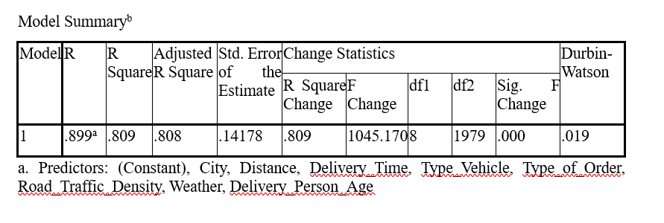
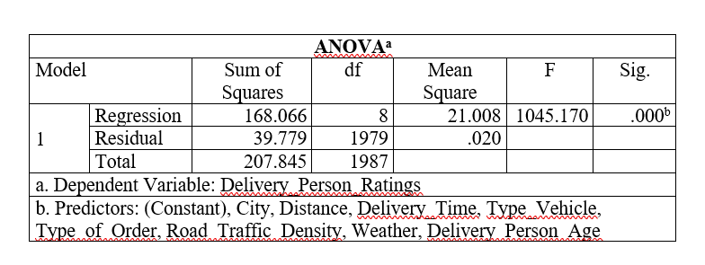
There are several reasons deterring the delivery person ratings and this involves distance that the individual has to cover, delivery time based on the location from where it is picked up and the address that it needs to deliver, vehicle type in use, type of order, traffic density, weather and age of the person. This is validated by the p-value of 0.001 which is < 0.05 and R-Squared value is 0.809 (80.9%) implying that there is a strong relationship in between the predictor and dependent variables. This is due to fact that the individuals delivering the food might get late due to high traffic congestion and might be using scooter which has low speed limit as compared to motorcycles. There were also issues related to bad weather conditions where one has to drive comparatively slowly and a high distance in between the address of delivery and pick up point might lead to delayed delivery (Xu and Sankar, 2024). It causes dissatisfaction among the customers and might lead to receiving of low rating (Liu et al., 2024). On other hand, small distance to be covered and also having a proper working or motor cycle may lead to early delivery causing greater satisfaction and thus, it gets reflected in having a higher rating.

6. Insights and Recommendations
The key insights obtained from the analysis is that with bad weather conditions and longer distance from the delivery location, there is more time required in delivering the food and it might lead to dissatisfaction among customers, leading to lower rating points. At times, the issues occur due to lack of optimised routes and delivery order tasks are allocated to individuals who are away from the delivery location. Type of vehicles also causes delay in delivering the food as someone riding a scooter will take more time as compared to an individual using motor cycle.
Recommendations:
- The food delivery application with which the delivery partners are working must strengthen the algorithm of the application so that optimised routes are shown for the drivers and they can give the delivery on time for receiving good ratings.
- In addition to this, there is also need of making sure that weather conditions are forecasted in advance and the customers are also informed about the weather conditions as well as the traffic congestion so that they can understand reason of the delay.
- Based on the distance from the delivery location and type of vehicle that the rider has, the allocation of food delivery task needs to be done.
The limitations of the data are that there is no information given on the condition of the food in which it is delivered and whether the customers are satisfied with it or not. In future, investigation can be done to understand level of customer satisfaction with that of the food delivered by generating responses from the people using such online food delivery functions.

Reference List
Alvarez, P., Lerga, I., Serrano-Hernandez, A. and Faulin, J., 2018. The impact of traffic congestion when optimising delivery routes in real time. A case study in Spain. International Journal of Logistics Research and Applications, 21(5), pp.529-541.
Bujang, M.A., Sa’at, N., Bakar, T.M.I.T.A. and Joo, L.C., 2018. Sample size guidelines for logistic regression from observational studies with large population: emphasis on the accuracy between statistics and parameters based on real life clinical data. The Malaysian journal of medical sciences: MJMS, 25(4), p.122.
Calabrese, B., 2018. Data cleaning. Encyclopedia of bioinformatics and computational biology: ABC of bioinformatics, 472.
Chen, L.W., 2019, November. Impact assessment of food delivery on urban traffic. In 2019 IEEE International Conference on Service Operations and Logistics, and Informatics (SOLI) (pp. 236-241). IEEE.
Hapairai, P.B. and Tishmack, B., 2020. Restaurants’ Partnering Behavior with Third-Party Online Food Delivery Services. In Culture, People and Technology: The Driving Forces for Tourism Cities Proceedings of 8th ITSA Biennial Conference 2020 (p. 424).
Ikhwan, M.F., Mansor, W., Khan, Z.I., Mahmood, M.K.A., Bujang, A. and Haddadi, K., 2024. Pearson correlation and multiple correlation analyses of the animal fat s-parameter. TEM Journal, 13(1), p.155.
Li, P., Rao, X., Blase, J., Zhang, Y., Chu, X. and Zhang, C., 2021, April. Cleanml: A study for evaluating the impact of data cleaning on ml classification tasks. In 2021 IEEE 37th International Conference on Data Engineering (ICDE) (pp. 13-24). IEEE.
Liu, D., Wang, W. and Zhao, Y., 2022. Effect of weather on online food ordering. Kybernetes, 51(1), pp.165-209.
Liu, H., Hao, P., Liao, Y., Boriboonsomsin, K. and Barth, M., 2024. Model-based vehicle-miles traveled and emission evaluation of on-demand food delivery considering the impact of COVID-19 pandemic. Transportation Research Record, 2678(12), pp.618-631.
Muhammed Al-Kassab, M., 2022. The use of one sample t-test in the real data. Journal of advances in mathematics, 21.
Xu, C. and Sankar, R., 2024. A comprehensive review of autonomous driving algorithms: Tackling adverse weather conditions, unpredictable traffic violations, blind spot monitoring, and emergency maneuvers. Algorithms, 17(11), p.526

