Health Assessment Report
  - Introduction to Physiology
  - Ali Akbar Khan 1715173

  - This paper is submitted as part of BSc Health and Social Care
  - Module Lecturer: Mumtaz Goolam
  - Word Count: 2177
  - Date:06/08/21

Introduction
A health assessment report typically will include a series of parameters that will allow the assessor to evaluate the current health of their participants. The assessment report will describe any medical conditions and the activities undertaken in a typical day (AHRQ, 2013). It will also have the healthcare professional’s observations, and the results of any physical examination undertaken. This collates key personal information, a brief medical history, and a patient’s current physiological state allowing for apparent areas of concern to be highlighted. Through professional training and clinical experience, a series of recommendations can be made in order to improve and manage the patient’s health-related issues (Wright, Williams, and Wilkinson, 1998). In some cases, this may necessitate referral to a number of healthcare specialists for further tests, diagnosis and support. Such a systematic approach has been hailed by the Agency of Healthcare Research and Quality (AHRQ, 2020) for collecting both the health needs of individual patients and those of the wider local population through the ease of access and privacy granted, something in-person observations struggle to achieve.

Case Study
This report commences with a review of the health care questionnaire. As per the assignment criteria, the questionnaire was completed for an individual patient, Mrs H, who’s anonymity has been maintained and consent for data to be recorded, stored, and reviewed has been granted (appendix 4). A combination of closed and open-ended questions was employed to gather critical and detailed feedback for practical communication between healthcare practitioners and patients as well as improved health practice (Dell-Kuster et al, 2014). All collected data has been treated sensitively and in accordance with UK GDPR and GMC standards.
Mrs H is a 51-year-old British Pakistani and a retired female. She first began experiencing symptoms of Functional Neurological Dystonia (FND) in 2013. FND is a movement disorder of the nervous system characterised by uncontrolled muscle contractions. Over the years, Mrs H has had numerous medical procedures that may have been an indication of underlying dystonia including a suspected stroke, biopsy of the neck for suspected TB, removal of a cyst on foot, bunion operation and in 2019 reconstruction of deformed toe, removal of adhesions with a reconstruction of the bowel (Appendix 1). In April 2021, Mrs H was admitted to hospital with with stiffness in both her legs, her back and neck, leaving her bed bound. In June 2021, her symptoms developed further where she would have jerking and shaking episodes for approximately 10 min to 1 hour, leading to her being diagnosed with generalised dystonia (not limited to a single part of the body but affects multiple muscle groups throughout the body). Her BMI of 19.4 indicates that she is of an average healthy weight, eats a good diet and was undergoing physiotherapy to relieve her symptoms. However, since her second dose of the COVID-19 vaccine, she has noticed a sharp deterioration in her symptoms leaving her unable to carry out daily tasks to such an extent where care workers have been provided to support her personal care. While she has no history of smoking, alcohol, or drugs, Appendix 2 shows she has suffered from various long term major illnesses: Thalassemia beta, B12 deficiency and adhesions. She has currently been prescribed medications: Gabepentin, Clonazepam and amitriptyline. Unfortunately, despite taking these medications and treatment regularly, Mrs H feels they have given her side effects and at times made the symptoms worse. At present, Mrs H is awaiting an improved treatment and health care plan from her neurophysiologist.

Assessment report:
Mrs. H’s life changed dramatically since her diagnosis. Dystonia is often confused with spasticity or rigidity and is even mistakenly attributed to hereditary causes, including those that are related to acquired brain lesions, or part of heredodegenerative syndromes (Tarsy and Simon, 2006). However, from these findings there is no evidence of a previous family history of dystonia, yet Hallet (2006) indicates that genetic aetiologies have identified “an increasing number of genes for primary and secondary subtypes” (p.487). These causes have been subdivided into idiopathic; meaning there is not a clear cause, genetic and acquired (Fung et al, 2013). Thus, the evolution of the concepts used to explain the aetiology of ICD exemplifies our increasing ability to recognize and demonstrate that diverse and sometimes bizarre symptoms may stem from subtle functional abnormalities of the nervous system.
In addition, National Institute of Health NINDS (2012) believes FND to be the result from an abnormality or damage to the brain regions and neurotransmitters that control movement and help cells in the brain communicate with each other. This may have explained Mrs H’s complaints of forgetfulness and memory loss since the onset of her dystonia, even though “in most cases of dystonia brain functions such as intelligence, memory and language remain unaffected” especially in younger patients (NHS, 2021). Nonetheless, one of the many symptoms of dystonia is cognitive function, where memory can be a mild or even a main problem for day-to-day living (The Epidemiological Study of Dystonia in Europe, 2000). Simply, Dystonia comes in many forms and is seen as an unpredictable condition with an outlook that can contrast from one individual to another.
FND has also affected Mrs H’s speech, so at times she is non-verbal and has communication difficulties, which are obstacles in social conversation. Due to this speech impediment speaking can become less natural, voice is often forced, strained and whispery that may lead to patients becoming socially withdrawn, anxious and depressed (NHS, 2021). However, Mrs H has still managed to be around family and friends which has had positive consequences on her physical and psychological well-being. Furthermore, her diet has also remained consistent; she is able to consume most foods. Even though Mrs H tries avoiding fizzy drinks and fried food, research suggests there is no known correlation between dystonia and diet. Rather, individuals with dystonia should have a nutritious diet sufficient with calories due to the increased muscle activity during the day and to avoid stimulants like caffeine as they may make symptoms worse (National Organisation for Rare Diseases, 2020).
In regard to the dystonia altering her gait and posture, her neurologist and GP advised her to carry out swimming and yoga exercises. Yet on these days she felt her balance worsen and the spasms increase spreading throughout her body and causing very restrictive movements, a limited base of support and extremely poor stability. Mrs H has routine home visits from her neuro-physiotherapist and GP whereby her dystonia is assessed and monitored using tactile stimulation. In her recent examination fluctuating hypertonia was found with increased spasms.

Recommendations:
Botulinum Toxin
The most common treatment for focal dystonia is botulinum toxin injection where small amounts of this chemical are injected into the affected muscles to limit how well they contract, leading to a temporary improvement in the dystonic movements (Jinnah and Factor, 2015). The effects can last for several months with injections being administered a few times a year to help in the management. Botulinum toxin injections are generally more suitable for treating dystonia’s which are limited to one or two areas of the body (Defazio et al, 2004) rather than generalised dystonia and so would be unsuitable in the case of Mrs H. However, sometimes the injections are used to treat a specific part of the body in dystonia as part of a wider treatment regime to ease day to day living. Unfortunately, after an in-depth telephone consultation with her neurologist, Mrs H’s muscle are not permanently in spasm and so botulinum toxin injections can cause more harm than improve her condition.

Medications
Many of the existing forms of medication that are prescribed for patients with dystonia work by restricting neurotransmitters in the body. While they may be prescribed by professionals, they have not been specifically approved to treat dystonia, rather they treat aspects or symptoms of the illness and effectiveness varies drastically patient to patient (Jankovic, 2013).
GABA is an inhibitory neurotransmitter in the brain and spinal cord. While the role of GABA in dystonia pathophysiology remains unclear, GABAergic drugs that regulate GABA are prescribed treatments as they have been shown to effectively cause muscle relaxation (Garibotto et al, 2011) in patients with dystonia. Mrs H is already being prescribed Gabapentin and Clonazepam both of which are GABAergic and anticonvulsant drugs.
Dopaminergic drugs act on the neurotransmitter dopamine, which helps control muscle movement and are also prescribed to patients suffering from forms of dystonia (Wichmann, 2008). Mrs H will not benefit from such drugs as they block out the effects of dopamine, such as tetrabenazine. These drugs are often used for people with a dopamine responsive dystonia which is a genetic type of dystonia and not for generalised dystonia. Caution should also be taken as they have serious side effects including weight gain, depression, and involuntary and repetitive muscle movements. Anticholinergic agents are another drug for patients with dystonia that work by blocking the effects of the neurotransmitter acetylcholine. Either trihexyphenidyl or benztropine are recommended and although they could assist Mrs H’s condition, these medications can be sedating and cause difficulties with memory (McWhirter, L., et al., 2020), something Mrs H has already mentioned is an infrequent issue.

Deep Brain Stimulation
Deep brain stimulation involves surgically implanting small electrodes that are connected to a pulse generator into specific brain regions that control movement. Controlled amounts of electricity are sent into the exact region of the brain that generates the dystonic symptoms and interfere with and block the electrical signals that cause the symptoms. It works most effectively for people who have an inherited form of dystonia and those with idiopathic primary dystonia (Thenganatt and Jankovic, 2014). As it’s offered in cases where other treatment options (such as botulinum toxin injections and oral medications) have failed to provide adequate relief, it may become a recommended option in the case of Mrs H where many avenues of treatment are being exhausted. Other surgeries which aim to disrupt pathways in the nervous system responsible for abnormal movements are available. Some intentionally cause damage to select areas of the brain while others cut nerves in the neck close to the spinal cord or at the point which they enter the contracting muscles. Comella (2015) notes these surgeries have shown some significant symptom reduction in patients.

Physiotherapy

Physiotherapy can also be beneficial in helping you manage your dystonic movements as mentioned by Jinnah and Factor (2015). A physiotherapist will analyse how you move and look at how you can strengthen weaker muscles improving your posture, which can help in dystonia management. Mrs H has had specialised physiotherapy in London in 2018 and is undergoing a course of physiotherapy in her home town. As would be recommended, once Mrs H is able to sit in a wheelchair, a neurophysiologist will start specialist physiotherapy initially at home and build up to attending the outpatient rehab unit in London.

Other Therapies
In general, most dystonia’s will be exacerbated by stress so stress management techniques are recommended– mindfulness, gentle exercise such as walks, can help. Mrs H has tried swimming and yoga but began to struggle with her balance co-ordination when doing so. The recommendation is when you are in a position that triggers your dystonia try to minimise the time in that position (Mayo Clinic, 2018) so caution is advisable and slow and steady physiotherapy would be a safer approach in this case. Speech therapy or voice therapy would also be helpful for Mrs H whose condition has caused some level of speech dysarthria.

Conclusion
Overall, treatments for dystonia offer limited effectiveness and patient satisfaction as in the case of Mrs H. While certain medications may be beneficial, it is usually not a feasible long-term solution to administer as the process of trial and error could potentially worsen such a condition (Torres and Rosales, 2017). With Mrs H relying on her carers and family for support and aids like a banana slide, waist support belts and a commode, her condition can be described as ‘deteriorating’. Though deep brain stimulation seems to be the recommended choice, it is still too early to provide an exact determination and should not be done so without careful consideration of the risks involved in conducting intrusive surgical procedures.
In aggregate, this case study has provided a comprehensive and eye-opening insight into the criticality of treating this condition despite being based around a single individual. It is certain that COVID-19 lockdown has been a negative factor contributing to Mrs H’s health, with appointments being cancelled and swimming pools being closed. What is more is that certain regional health services are applicable for funding whereas others (including West Midlands) do not have this means to fully treat Mrs H’s condition. Mrs H’s consultant has reassured they will be getting funding in the foreseeable future for research of dystonia now that it is now being understood by the authorities (Pablo-Fernandez and Warner, 2017). If this does not happen, it shall only reduce the feint chance of recovery for Mrs H and patients alike. But with cuts to funding and virtual appointments this seems like a distant hope.

References:
AHRQ (Agency for Healthcare Research and Quality). (2013) Adult Health Assessment Sample Questions. Rockville, MD. Available at: https://www.ahrq.gov/ncepcr/tools/assessments/health-ap4.html (Accessed: 19 July 2021).
AHRQ (Agency for Healthcare Research and Quality). (2020) Health Assessment Information for Patients. Rockville, MD. Available at: https://www.ahrq.gov/ncepcr/tools/assessments/health-ap10.html (Accessed: 19 July 2021).
Comella C. (2015) Treatment of dystonia. Available at: http://www.uptodate.com/home (Accessed 30 July 2021)
Defazio, G., et al. (2004) Epidemiology of primary dystonia, The Lancet Neurology, 3(11), pp. 673-678, Available at: https://doi.org/10.1016/S1474-4422(04)00907-X. (Accessed 23 July 2021).
Dell-Kuster, S., et al. (2014) Designing questionnaires: healthcare survey to compare two different response scales. BMC Medical Research Methodology 14(96) pp. 32-39.
Fung, V. S., et al. (2013) Assessment of patients with isolated or combined dystonia: an update on dystonia syndromes. Official journal of the Movement Disorder Society, 28(7), pp. 889–898.
Garibotto, V., et al. (2011) In vivo evidence for GABA receptor changes in the sensorimotor system in primary dystonia. Movement Disorders, 26(5), pp. 852-857.
Hallett, M. (2006) Pathophysiology of dystonia. Parkinson’s Disease and Related Disorders, pp.485-488.
Jankovic, J. (2013) Medical treatment of dystonia. Movement disorders, 28(7), pp. 1001-1012.
Jinnah, H. A., and Factor, S. A. (2015) Diagnosis and treatment of dystonia. Neurologic clinics, 33(1), pp. 77–100.
Mayo Clinic. (2018) Dystonia - Symptoms and causes. Available at: https://www.mayoclinic.org/diseases-conditions/dystonia/symptoms-causes/syc-20350480 (Accessed 1 Aug 2021).
McWhirter, L., et al. (2020) Functional Cognitive Symptoms – Functional Neurological Disorder (FND). Available at: https://www.neurosymptoms.org/en_US/symptoms/fnd-symptoms/functional-cognitive-disorder-functional-memory-and-concentration-symptoms/ (Accessed 2 Aug 2021).
National Institute of Health NINDS. (2012) Dystonia Fact Sheet. Available at: https://www.ninds.nih.gov/Disorders/Patient-Caregiver-Education/Fact-Sheets/Dystonias-Fact-Sheet (Accessed 23 July 2021).
National Organisation for Rare Diseases. (2020) Rare Disease Database: Dystonia Available at: https://rarediseases.org/rare-diseases/dystonia/ (Accessed 29 July 2021).
NHS. (2021) Dystonia. Available at: https://www.nhs.uk/conditions/dystonia/ (Accessed 19 July 2021).
Pablo-Fernandez, E.D., and Warner, T.T. (2017) Dystonia, British Medical Bulletin, 123(1), pp. 91–102. Available at: https://doi.org/10.1093/bmb/ldx019 Accessed (24 July 2021).
Tarsy, D. and Simon, D.K. (2006) Dystonia. New England Journal of Medicine, 355(8), pp. 818-829.
The Epidemiological Study of Dystonia in Europe. (2000) A prevalence study of primary dystonia in eight European countries. Journal of Neurology 247, pp. 787–792.
Thenganatt, M.A., and Jankovic, J. (2014) Treatment of Dystonia. Neurotherapeutics 11, pp. 139–152. Available at: https://doi.org/10.1007/s13311-013-0231-4 (Accessed 21 July 2021).
Torres, J.A.K.L. and Rosales, R.L. (2017) Nonmotor symptoms in dystonia. International review of neurobiology, 134, pp. 1335-1371.
Wichmann, T. (2008) Commentary: Dopaminergic dysfunction in DYT1 dystonia. Experimental neurology, 212(2), pp. 242-246.
Wright, J., Williams, R., and Wilkinson, J. R. (1998) Development and importance of health needs assessment. BMJ (Clinical research ed.), 316(7140), pp. 1310–1313. Available at: https://doi.org/10.1136/bmj.316.7140.1310 (Accessed: 27 July 2021).

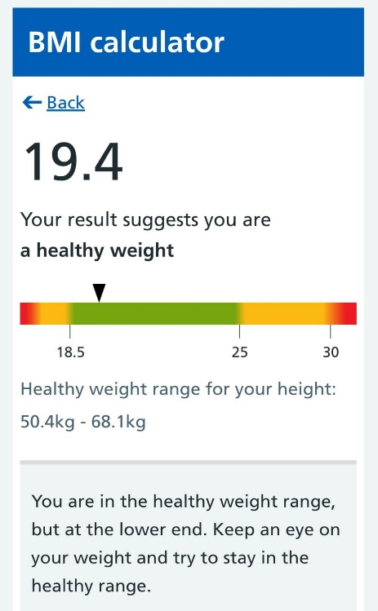
Appendix:
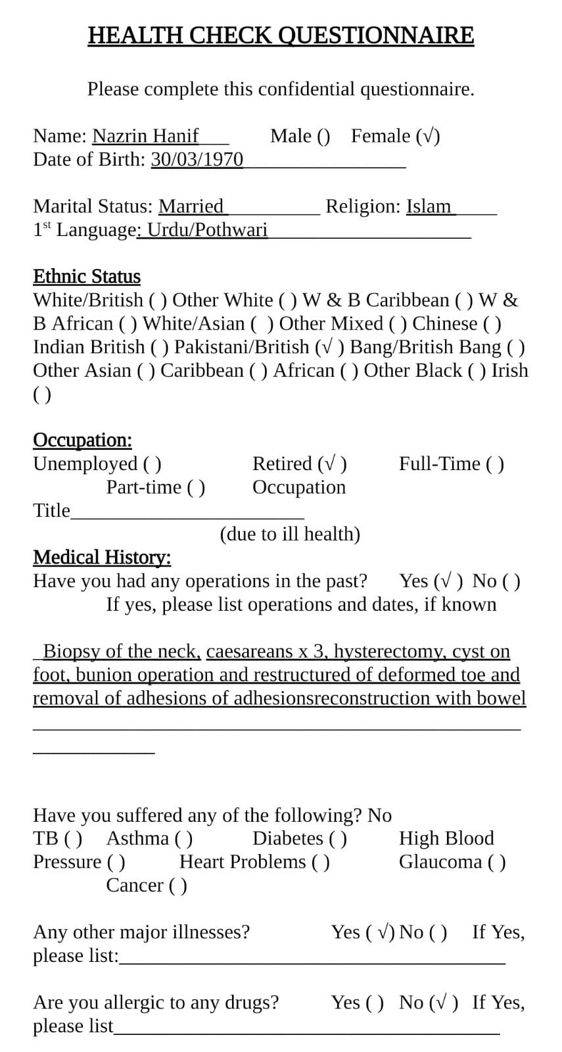
Appendix 1: Mrs H BMI indicator
Appendix 2: Health Check Questionnaire p.1
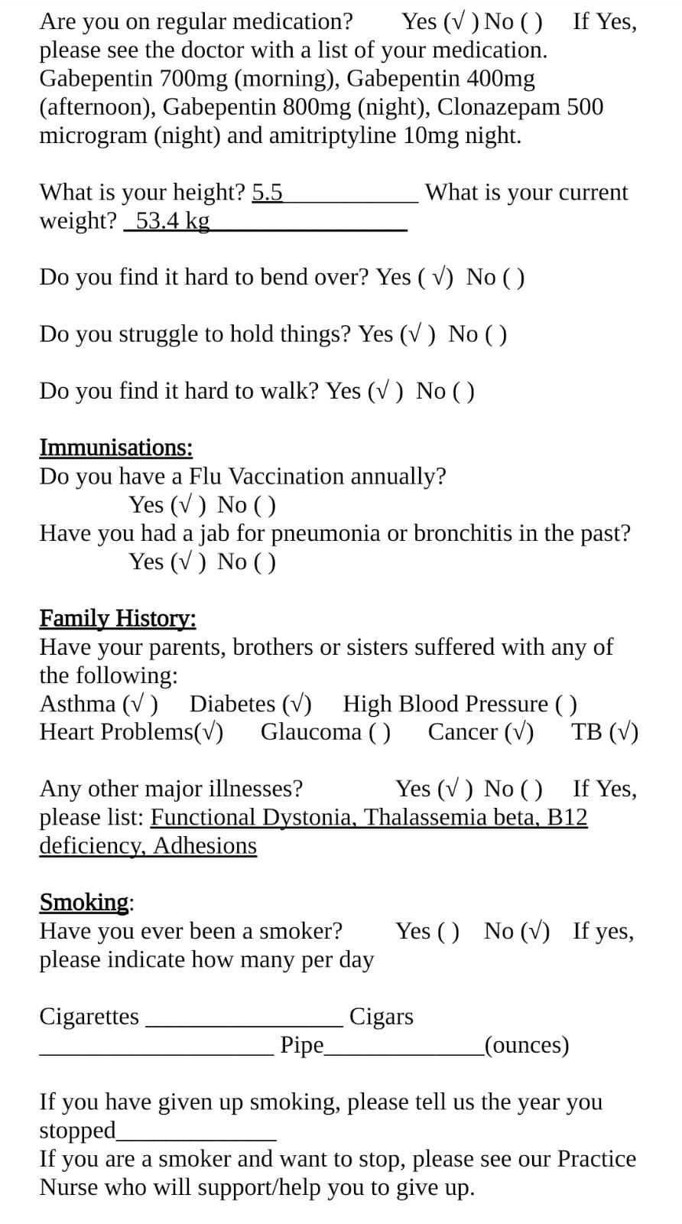
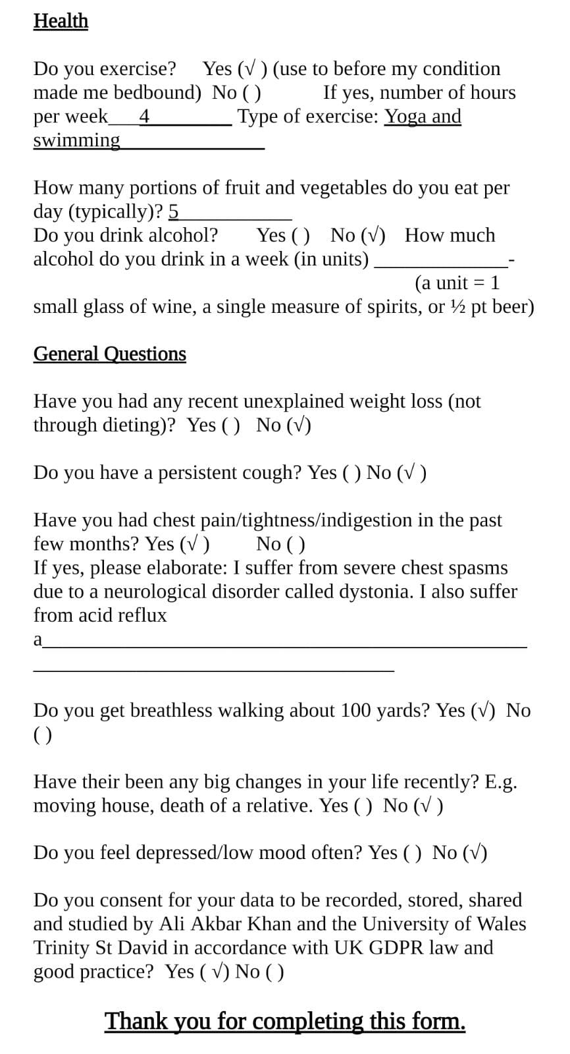
Appendix 3: Health Check Questionnaire p.2
Appendix 4: Health Check Questionnaire p.3

