module:

Digital Skills and Research Methods
assignment 2:

group task
bmsk4003

Student: Abdul Islam 1806293

Questionaire analysis
As a group we have made a questionnaire using Google Forms. The questions posed are for the purpose of market research for our business plan in module Managing Enterprise in the 21st century. We have included 11 questions. The questionnaire was distributed to other students on our course to complete. Having gathered the data, we have produced graphs and extrapolated key statistics. I have chosen two questions to analyses.
My group consits of five members:
Abdul Islam 1806293
Mamasir Miah 1805953
Shahidur Rhaman 1805953
Sanu Miah 1806892
Katarzyna kolowrocka 1805961

My login details for the web page:

Gmail: 1806293@gmail.com
Password: uwtsd123

Question 1
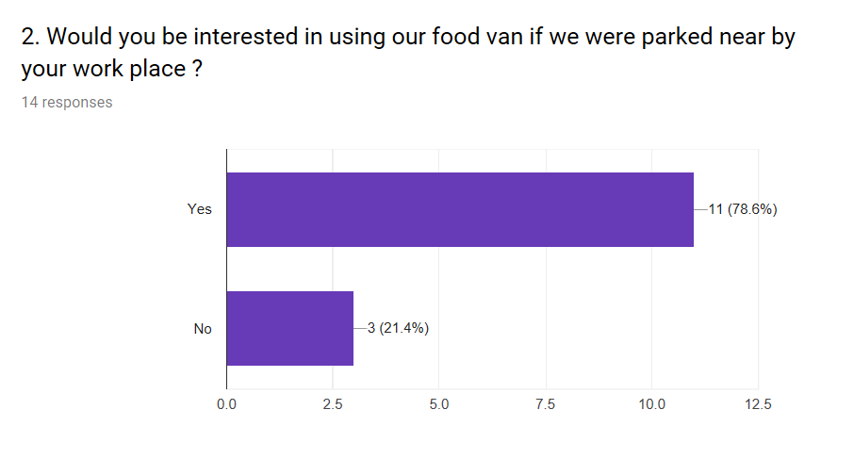
This question is a check box question so the answer can only be yes or no. it is a required field so in order to move on the next question this will have to be answered.
The information provided by this question is key to the success of the business. This question will help us understand if there is a demand for our products and services in the area.
According to the answers 78.6% of people would be interested in using our food van if it was parked near their work-place. This gives us confidence in our business idea.

Question 2
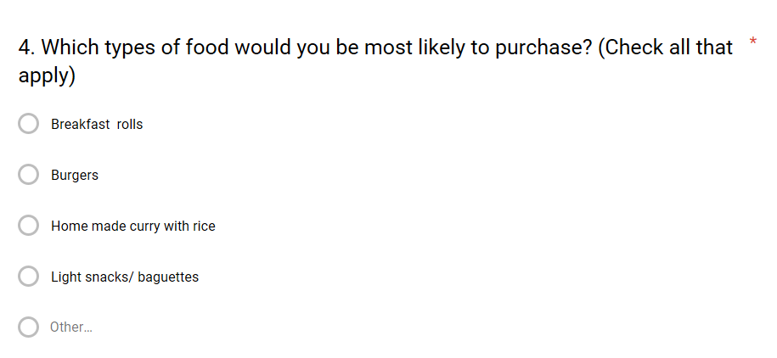
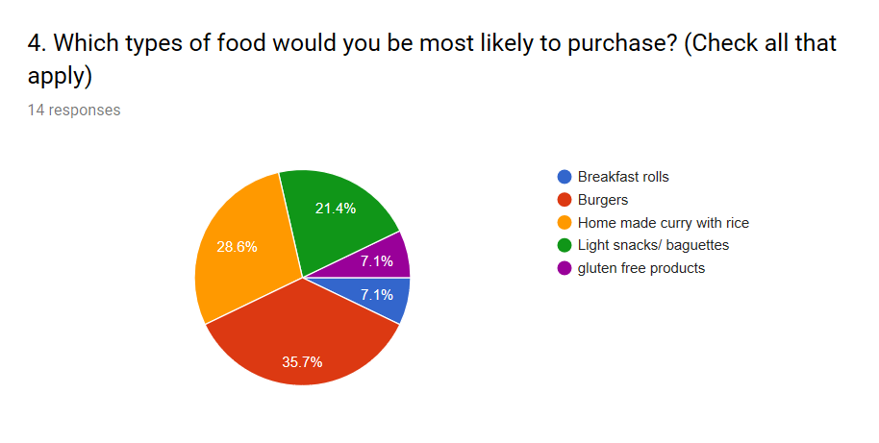

This question is a multiple-choice question so the person filling it in will have a choice on the answers they provide. it is a required field so in order to move on the next question this will have to be answered.
This question will help us understand what products potential customers will be interested in. which will enable us to stock the corect products and promote the right products. Acording to the question 35.7% of people would prefer burgers and 28.6% would like home made curry with rice so this indicates the market is demanding these products and will will have to supply and promote these.
This question enables us to understand the demand which we have to cater for.

