
Cover Page

NAME: Shabana Qamar
Module: Changemakers: Creativity and Value creation
Module: BMHP5014
Assignment Title: Component 1: online portfolio of Set Exercises
Lecturer: Parese Ahmed

Table of Contents
Task 1 – Concept Map 3
Task 2 - Self-Reflection of Group Activity 5
Task 3 - Case Study of a UK innovation 7
Task 4 - Research Task 9
Task 5 - Podcast 11
Task 6 - NHS Leadership Framework Analysis 12
Task 7 - Self-Reflection Journal Entry 14
Reference List. 15
Sources Used 19
Appendices 21

Task 1 – Concept Map

Creativity, value creation, and health and social care improvement go hand in hand with one another and contribute to positive results to service users (Pfannstiel et al, 2024). Health and social care creativity is the ability to come up with new ideas, methods or ways of doing things to handle complex issues like scarce resources, increasing demands as well as health disparities (Kosiol et al, 2024). Creative thinking enables practitioners to step out of the box of doing things traditionally and to consider new ways of doing things that are more apt to the needs of patients and service users (Evans et al, 2022).
Value creation happens when such creative ideas are converted into actual actions, which enhance quality, efficiency or experience in health and social care services. Value can be achieved by better patient outcomes, better accessibility, shortening of waiting time, or by making patients more satisfied (Vargas et al, 2022). Notably, value creation aims at individual, community and system-wide benefits as opposed to just economic profit.
The outcome of effectively implementing creativity in creating value is health and social care improvement (Ghosh et al, 2023). With implemented creative ideas, the services become more reactive, people-oriented, and sustainable. Thus, creativity is the driver, value creation is the result, and improvement is the net effect in the health and social care practice (Brooks, 2022).
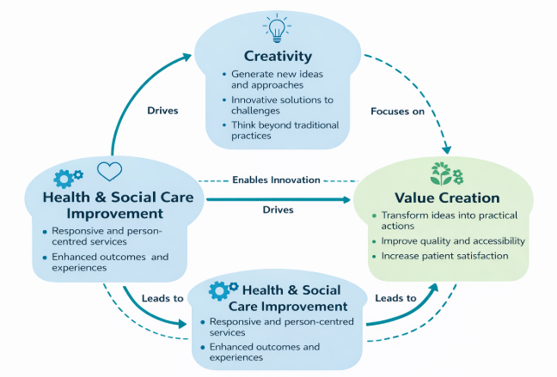
Figure 1: Health and social care improvement flowchart

Task 2 - Self-Reflection of Group Activity

Self-Reflection Using Gibbs’ Reflective Cycle

- Description:
My group undertook the paperclip thinking exercise, which involved coming up with diversified and convergent thinking on the alternative ways in which a paperclip could be used. I was active by pitching ideas and helping the group to discuss them when reducing them.
- Feelings:
I was at first afraid to introduce non-traditional concepts because I did not know how they would be perceived. But the activity continued and others were able to express themselves freely, which made me more confident and engaged.
- Evaluation:
The experiment served well to illustrate the contrast of divergent and convergent thinking. Divergent thinking enabled creativity and expansion of ideas whereas convergent thinking enabled refinement of ideas to realistic and workable ones. I provided about seven ideas and helped to determine the viability of ideas (Wigert et al, 2024).
- Analysis:
The Reflective Cycle by Gibbs facilitates the systematic reflection process as it promotes the deconstruction of experiences and determination of learning that may be applied in the future (University of Edinburgh, 2023). The application of this model enabled me to grasp how crucial it is to move between creative exploration and critical assessment in order to solve a problem effectively, especially within health and social care contexts (Scragg and Mantell, 2023).
- Conclusion:
I came to understand that creativity should be combined with evaluation to obtain significant results.

- Action Plan:
I will be able to apply the same to future group activities by posting ideas with ease and facilitating formal decision-making to boost group creativity.

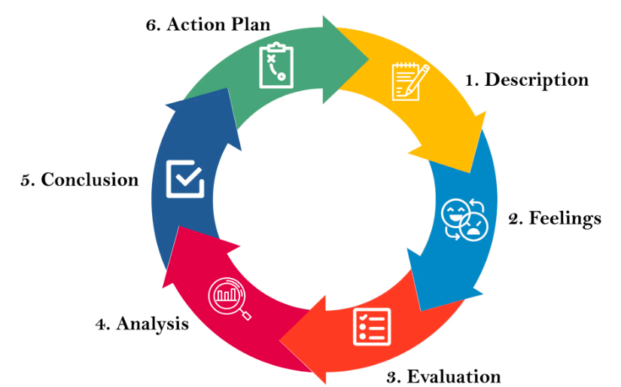
Figure 2: Gibb’s Reflective Model.
(University of Edinburgh, 2024)

Task 3 - Case Study of a UK innovation

Case Study: AI Innovation in Adult Social Care
The application of Artificial Intelligence (AI) in adult social care in the UK is one of the examples of how inventive digital innovation may change the model of service delivery and bring value to those who use the service (Shelmerdine et al, 2024). The NHS AI Knowledge Repository identifies various case studies of where AI tools and methods have been tested or adopted by nearby authorities, care providers, and technology partners in the adult social care sector (Lacey Bryant et al, 2022). The innovations are aimed at solving the long-term problems, including labor deficit, poor care coordination, and the necessity to customize care to meet complex needs.
An example can be found in creative application of AI to predictive analytics and decision support, i.e. AI algorithms on datasets based on care records can be used to identify adults in danger of worsening health or social crisis (Hopkins et al, 2024). This is because the care teams can engage in preemptive efforts to address the issue before it escalates, minimizing emergency cases, and enhancing the quality of life of the service users. Such AI application is a break from the reactive care model to proactive, scheduled assistance and reflected value creation through early intervention and improved resource distribution (Kumar and Suthar, 2024).
The other kind of innovation involves AI-assisted administrative automation in which tedious and time-intensive activities like scheduling, risk assessment, and data entry are automated (Nouis et al, 2025). This innovative use of technology liberates the time of social care professionals so that they can concentrate on direct person-centered care. The users of the service benefited with fewer waiting time to receive care assessment or adjustment (Batista, 2025).
Personal autonomy also increases with the creative application of AI in social care in adults. As an example, AI-based interventions can facilitate individualized care planning and analyses preferences and health data to develop interventions based on the individual preferences. This enhances dignity and choice among individuals receiving care which is in line with the modern policy objectives that seek to empower individuals and not merely manage their needs (Bourgeois et al, 2025).
Altogether, the intelligent innovation of AI in adult social care provides an explanation of how creative thinking, restructuring work and decisions with the help of intelligent tools, promotes value creation (MItra and Alam, 2025). It enhances the results of service users, making care more dynamic, individualized, and cost-effective and relieves a workforce that is already pressured by the increasing demand. (NHS, 2025)
(NHS, 2024)

Task 4 - Research Task

Current Issue in Health and Social Care — Mental Health Stigma.
Mental health stigma remains one of the biggest obstacles to individuals receiving proper care and support that leads to late treatment and adverse consequences of individuals with mental health disorders (Phelan et al, 2023). The following two academic studies can shed some light on the reasons behind the existence of this issue.

Source 1: Understanding and Addressing Mental Health Stigma Across Cultures for Improving Psychiatric Care: A Narrative Review (Ahmed et al, 2023).
Ahad et al. (2023) reviewed the role of stigma in psychiatric treatment and the reasons why it prevents access to and quality of treatment. Their findings revealed that stigma is associated with ingrained negative stereotypes, prejudice as well as discriminatory attitudes in society and the medical care environment. Such attitudes in society lead to the slow discovery of mental problems and lack of help-seeking behavior as it is possible that people are afraid of being judged by others or that they are discriminated against in seeking assistance. In addition, stigma may have an impact on the interaction with healthcare professionals, resulting in worse interaction with psychiatric services and reduced continuity of care. Consequently, individuals who have mental health issues can suffer more morbidities and reduced quality of life since they do not or delay receiving the required health services.

Source 2: Types of stigmas experienced by patients with mental illness and mental health nurses in Indonesia: a qualitative content analysis (Muhammad Arsyad Subu et al, 2021).
The study by Subu (2021) examined the kinds of stigma people with mental illness went through, and how these kinds of stigmas became obstacles to care. The paper has listed various types of stigmas namely, personal (negative beliefs internalized), public (societal stereotypes), family stigma and employment stigma. Both forms of stigma contribute to resistance to help internalized stigma may make a person think of him/herself as weak or incompetent, and public and family stigma may cause social exclusion or discouragement to seek treatment such a complex character of stigma implies that even in cases where services are accessible, people might not express them due to fear of being judged, discriminated against, or lose social status.

Task 5 - Podcast

Task 6 - NHS Leadership Framework Analysis

- Key Components of the NHS Leadership Framework.
The NHS Leadership Framework gives a systematic way of honing leadership competencies among the health and care workers. It concerns itself with the behaviors, knowledge and skills needed to provide high-quality and equitable care (Gulati and Weir, 2022). The NHS England leadership competency framework outlines six major areas of focus on leaders of all levels, such as establishing direction, inspiring a common purpose, working with integrity, building inclusive cultures, leading to service improvement, and achieving results through teamwork (Xu et al, 2022). The areas enable organizational objectives like better patient results, good governance and workforce growth.
Moreover, the NHS Leadership and Management Framework establish explicit expectations and norms to leaders in clinical and non-clinical jobs. It identifies the main competencies, including accountability, ethical decision-making, communication, and collaborative working with the help of development tools and appraisal guidance (Jones et al, 2022). Collectively, such frameworks highlight how effective leadership is exhibited in terms of behavior, teamwork and ongoing professional learning as opposed to formal position (Wu and Parks, 2023).

- Using ‘Inspiring Shared Purpose’ to Encourage Creativity and Improve Care.
One of the major elements of NHS Leadership Framework is the Inspiring Shared Purpose element, which is aimed at developing an understandable vision and inspiring the teams to strive towards the common goals (James et al, 2024). Inspirational leaders make the staff realize that their roles can be used to enhance patient care. Leaders promote innovative thinking by articulating the objectives to tackle the service problems. In case, leaders engage multidisciplinary teams in the shared development of solutions to decrease waiting times or enhance care pathways (Brady et al, 2024). This participative style encourages ownership and psychological safety that allows employees to freely present ideas. Consequently, creativity is facilitated and creative ideas are more likely to be created, experimented and introduced to enhance quality and patient experience (Walsh, 2022).
(NHS, 2024)
(NHS Employers, 2025)

Task 7 - Self-Reflection Journal Entry
The module has greatly enhanced my knowledge on creativity and value creation in health and social care. Earlier on, I saw creativity as an idea generation process but now I realize that creativity is a process that facilitates innovation, problem-solving and improvement of services. I have been taught that efficiency is not the only way to create value but improving patient experience, wellbeing, and outcomes. The module showed how creative thinking can create a meaningful and sustainable change when it is paired with evidence and the role of a leader. This is learning that has helped me in my professional practice because it has challenged me to think about other ways of how processes can be done versus the way they have been done before. I am now confident to make contributions in the team environment and appreciate the value of balancing creativity and critical appraisal to provide safe and productive advances in health and social care services.

Reference

Ahad, A.A., Sanchez-Gonzalez, M. and Junquera, P., (2023). Understanding and addressing mental health stigma across cultures for improving psychiatric care: A narrative review. Cureus, 15(5). Doi: https://doi.org/10.7759/cureus.39549
Batista, A.S., (2025). Transforming Clinical Practice: The Role of AI-Powered Medical Assistants in Enhancing Healthcare Efficiency and Decision-Making. Journal of Next-Generation Research 5.0. doi: https://doi.org/10.70792/jngr5.0.v1i4.121
Bourgeois, P., Allison, A. and Skerritt, C., (2025). Harnessing artificial intelligence for enhanced life care planning: Innovations, challenges, and ethical considerations. Journal of Life Care Planning, 22(1). Doi: https://doi.org/10.70385/001c.151660
Brady, A., Lloyd, A. and Evans, G., (2024). 31 North west leadership schools: inspiring and developing the healthcare leaders of the future. Doi: https://doi.org/10.1136/leader-2024-FMLM.31
Brooks, J., (2022). The art of problem solving and its translation into practice. BDJ in Practice, 35(9), pp.21-23. Doi: https://doi.org/10.1038/s41404-022-1714-y
Chukwuma, O.V., et al., (2024). A systematic review of the effect of stigmatization on psychiatric illness outcomes. Cureus, 16(6), doi: https://doi.org/10.7759/cureus.62642
Evans, J., Leggat, S. and Samson, D., (2022). A practical framework for achieving value creation and capture in healthcare through process improvement. Journal of Health Organization and Management, 36(5), pp.561-576. Doi: https://doi.org/10.1108/JHOM-01-2021-0044
Ghosh, K., Dohan, M.S., Verdandi, H. and Garfield, M., (2023). Digital transformation in healthcare: insights on value creation. Journal of Computer Information Systems, 63(2), pp.449-459, doi: https://doi.org/10.1080/08874417.2022.2070798
Gulati, S. and Weir, C., (2022). Cultural competence in healthcare leadership education and development. Societies, 12(2), p.39, doi: https://doi.org/10.3390/soc12020039
Hopkins, E., Smith, S. and Wood, H., (2024). Adoption and everyday use of artificial intelligence by NHS knowledge and library professionals in England: Part II: practical application. Journal of EAHIL, 20(2), pp.11-15, https://doi.org/10.32384/jeahil20619
James, R., Hartley, J. and Stroud, L., (2024). Bringing people together through shared purpose and identity: lessons learnt from NHS providers CEO Sir Julian Hartley. Doi: https://doi.org/10.1136/leader-2023-000938
Jones, B., Horton, T. and Home, J., (2022). Strengthening NHS management and leadership. The Health Foundation. Retrieved February 24, p.20-23.
Kosiol, J., Silvester, T., Cooper, H., Alford, S. and Fraser, L., (2024). Revolutionizing health and social care: innovative solutions for a brighter tomorrow–a systematic review of the literature. BMC health services research, 24(1), p.809. doi: https://doi.org/10.1186/s12913-024-11099-5
Kumar, D. and Suthar, N., (2024). Predictive analytics and early intervention in healthcare social work: a scoping review. Social work in health care, 63(4-5), pp.208-229. Doi: https://doi.org/10.1080/00981389.2024.2316700
Lacey Bryant, S., Bridgen, R., Hopkins, E., McLaren, C. and Stewart, D., (2022). NHS knowledge and library services in England in the digital age. Health Information & Libraries Journal, 39(4), pp.385-391 doi: https://doi.org/10.1111/hir.12457
Mitra, K. and Alam, G., (2025). AI-driven Technologies in Elderly Care: Benefits and Challenges.
Nouis, S.C., Uren, V. and Jariwala, S., (2025). Evaluating accountability, transparency, and bias in AI-assisted healthcare decision-making: a qualitative study of healthcare professionals’ perspectives in the UK. BMC Medical Ethics, 26(1), p.89. doi: https://doi.org/10.1186/s12910-025-01243-z
Pfannstiel, M.A., Kueh, C. and Palozzi, G. eds., (2024). Service Design, Creativity, and Innovation in Healthcare: Challenges, Insights, Solutions. Springer Nature.
Phelan, S.M., et al., (2023). Patient and health care professional perspectives on stigma in integrated behavioral health: barriers and recommendations. The Annals of Family Medicine, 21(Suppl 2), pp 56-60. Doi: https://doi.org/10.1370/afm.2924
Raj, C.T., (2022). The effectiveness of mental health disorder stigma-reducing interventions in the healthcare setting: An integrative review. Archives of Psychiatric Nursing, 39, pp.73-83, doi: https://psycnet.apa.org/doi/10.1016/j.apnu.2022.03.005
Scragg, T. and Mantell, A., (2023). Reflective practice in social work.
Shelmerdine, S.C., Togher, D., Rickaby, S. and Dean, G., (2024). Artificial intelligence (AI) implementation within the national health service (NHS): the southwest London AI working group experience. Clinical Radiology, 79(9), pp.665-672. Doi: https://doi.org/10.1016/j.crad.2024.05.018
Vargas, C., Whelan, J., Brimblecombe, J. and Allender, S., (2022). Co-creation, co-design, co-production for public health–a perspective on definitions and distinctions. Public Health Research and Practice, 32(2), doi: https://doi.org/10.17061/phrp3222211
Ventura, C.A.A., et al., (2023). Factors associated with internalized stigma in people with common mental disorders using services of Family Health Strategy. Archives of Psychiatric Nursing, 43, pp.57-64. Doi: https://doi.org/10.1016/j.apnu.2022.12.024
Walsh, G., (2022). Leadership that puts people first. Journal of Medical Imaging and Radiation Sciences, 53(4), pp 9-11. Doi: https://doi.org/10.1016/j.jmir.2022.09.009
Wigert, B.G., Murugavel, V.R. and Reiter-Palmon, R., (2024). The utility of divergent and convergent thinking in the problem construction processes during creative problem-solving. Psychology of Aesthetics, Creativity, and the Arts, 18(5), p.858. doi: https://doi.org/10.1037/aca0000513?urlappend=%3Futm_source%3Dresearchgate.net%26utm_medium%3Darticle
Wu, D.A. and Parks, R.W., (2023). Leadership and working in teams. Surgery (Oxford), 41(8), pp.528-534.
Xu, X., Zhang, Y., Zhou, P. and Zhou, X., (2022). Developing a leadership and management competency framework for nurse champion: A qualitative study from Shanghai, China. Journal of Nursing Management, 30(4), pp.962-972. Doi: https://doi.org/10.1111/jonm.13580
Yin, M., Li, Z. and Li, X., (2024). Family influence on stigma internalization in people with severe mental illness: A grounded theory study. International Journal of Mental Health Nursing, 33(5), pp.1575-1590. Doi: https://doi.org/10.1111/inm.13346

Sources Used

- Question 2: Self-Reflection Using Gibbs’ Reflective Cycle.
Source Used: https://reflection.ed.ac.uk/reflectors-toolkit/reflecting-on-experience/gibbs-reflective-cycle
- Question 3: Case Study: AI Innovation in Adult Social Care.
Source Used: https://digital.nhs.uk/services/ai-knowledge-repository/case-studies/ai-in-adult-social-care#:~:text=This%20collection%20of%20case%20studies%20aims%20to,is%20possible%20and%20what%20has%20already%20happened
https://www.england.nhs.uk/2024/12/nhs-ai-giving-patients-better-care-and-support/
- Question 4: Current Issue in Health and Social Care — Mental Health Stigma.
Source 1: Understanding and Addressing Mental Health Stigma Across Cultures for Improving Psychiatric Care: A Narrative Review (Ahad et al, 2023).
Ahad, A.A., Sanchez-Gonzalez, M. and Junquera, P., 2023. Understanding and addressing mental health stigma across cultures for improving psychiatric care: A narrative review. Cureus, 15(5).
https://link.springer.com/article/10.1186/s13033-021-00502-x
Source 2: Types of stigma experienced by patients with mental illness and mental health nurses in Indonesia: a qualitative content analysis (Muhammad Arsyad Subu et al, 2021).
https://pubmed.ncbi.nlm.nih.gov/37250612/
- Question 6: NHS Leadership Framework Analysis.
Source 1: Key Components of the NHS Leadership Framework
https://www.england.nhs.uk/publication/nhs-leadership-competency-framework/
Source 2: Using ‘Inspiring Shared Purpose’ to Encourage Creativity and Improve Care.
https://www.nhsemployers.org/system/files/2025-08/Q%26A%20-%20The%20new%20NHS%20Leadership%20and%20Management%20Framework.pdf
Appendices
- Health and social care improvement flowchart.
- Gibb’s Reflective Model.

