Damian Walczak (2015478)
Module
Electronics I(ACDA5002)
LEVEL 5 ASSESSMENT
B.Eng. (Hons) in Embedded Electronic Systems

Contents
Introduction 2
Research 3
Circuit design 5
Pseudocode showing the system operation 9
Simulations and testing 13
Program Screen dumbs 32
Recommendations on future work 37
Conclusion 38
Reference 39

Introduction
This assignment will focus on developing a traffic light control system that operates with precise timing intervals. It aims to regulate traffic flow effectively by implementing time-based signal changes. The system will provide a reliable and efficient solution for traffic management.
For designing the traffic light control system program proteus will be used to stimulate to prove the system works correctly before it is used in real life system. Microcontroller, outputs and inputs can be inserted and then tested through simulation. In order for simulation to work code has to be written.
To write a code MikroC program has been used for coding and compiling the code. Compiled code will be created into a .hex file and then inserted into PIC inside proteus. MikroC can be also used to debug the code.
Design will be based on this four-junction as shown on Figure 1
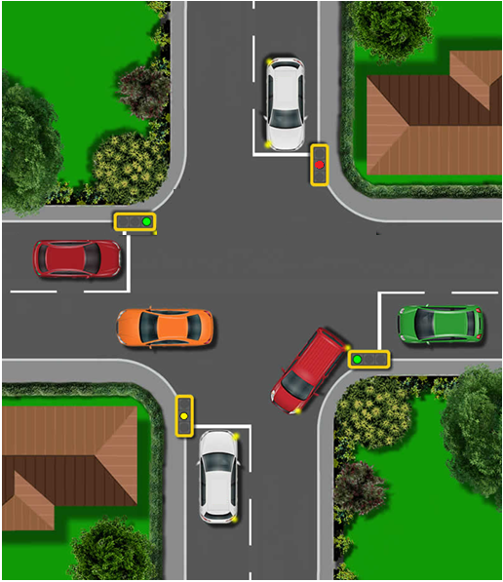
Figure 1
There are four sides of a road named east, west, north and south. Each side of the road has traffic lights, pedestrian lights and a counter. Traffic lights contains of red, yellow and green LED. 7 segment displays have been included on each side to count up to 50 seconds
To allow smooth traffic flow on each side, each side will have 10 seconds to operate. Operation will include green light of 7 seconds to allow cars through. After 7 seconds yellow light will turn ON to indicate that lights are about to turn red and this light will remain yellow for 2 seconds. This will leave enough time for cars to prepare to stop. On 9th second led will turn red. This pattern will indicate that this side has completed full cycle. Next side of the road will be initiated.
Next side of the road will turn yellow led while red led remains on for one second to indicate that driver on other side of the road can get prepared to take off, on 10th second led on this side of the road will turn green.
This process will repeat until all four junctions have been lit green. Last 10 seconds have been reserved for pedestrians to indicate crossing phase. All other lights will be red for safe crossing phase. Last 5 seconds pedestrian green will flash every second to indicate that time is running out and soon east part of the road will turn on.
After 10 seconds the cycle will start again starting from east part of the junction.

Research
Here is some information for PIC16F877A which was used in this design.
Its CPU is 8-bit PIC, it has 40 pins which have different names and different uses as seen on figure 2 but only 33 are used for I/O.
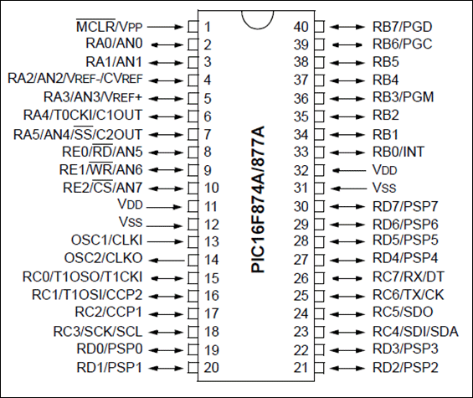
Figure 2 ref. Components101
Operating voltage is 2V to 5.5V. ADC module with 8channels and 10-bit, this means that it returns a digital output code that consists of 10 bits which is 2^10 and can give 1024 different code values with 8 pins of microcontroller that can be used to receive analog signal.
This microcontroller has 3 timer module, timer0 (8-bit), timer1 (16-bit) and timer2 (8-bit). This timer is used to measure the time to generate accurate time delay. It has 2 comparators which turns analog voltage level into a digital low or high output. It has Communication Peripherals working along with UART(1), SPI(1), I2C(1), MSSP(SPI/I2C).
External oscillator goes up to 20MHz and it’s a system clock which is more accurate than internal oscillator as it is using quartz crystal type. Main difference between internal and external oscillators is where the clock signal is coming from. External clock relies on the clock that comes from outside clock which is not inside the microprocessor
Program memory type is flash that is a type of non-volatile memory. It means that it stores data even when the power is off and only way to remove it must be electrically erased. Its memory is 14KB.
Its CPU speed is 5 Million instructions per second, Random Access Memory size is 368 bytes which is storage hardware that provides temporary storage for any data which are quickly accessible by microcontroller. Data EEPROM(erasable programmable read-only memory) is 256 bytes.

During some research about traffic lights there was some important things found to help to understand what key things need to be considered when designing safe traffic light system.
There are different types of traffic lights such as:
- Standard Traffic Lights: Consist of the red, yellow (amber), and green lights that control vehicle and pedestrian traffic.
- Pedestrian Signals: Specifically designed for pedestrian crossings, usually displaying "Walk" and "Don't Walk" indications or a countdown timer.
- Bicycle Signals: Tailored for bicycle lanes, helping to safely manage bicycle crossings at intersections.
- Special Signals: Used for trams, buses, and emergency vehicles, often providing priority passage through intersections.
- Modern traffic lights are part of complex traffic management systems and may use a variety of technologies such as:
- Fixed Time Operations: Operate on a timer system that changes lights at regular intervals.
- Vehicle Detection: Use sensors to detect vehicle presence and adjust signal timings accordingly.
- Adaptive Signal Control Technology: Adjusts traffic signal timings based on real-time traffic conditions using cameras, radar, or infrared sensors.
Ref.automate

Those benefits of Adaptive Signal Control Technology: lights help to improve safety on roads that reduces number of accidents and collisions at intersections. Its more efficient and improves congestions by smartly managing lights. They are good for environment as they lower emissions by optimizing the flow of traffic.
Some drawbacks might be that they could be expensive to set up and maintain, and they always can fail to operate which can cause confusions and accidents.

Circuit design
Figure 3 shows complete circuit of all the traffic lights with 7 segment display and pedestrian lights on each side of the road. Pedestrian lights are LEDs connected to resistor and earthed. For clear and neater way of linking all the outputs to the controller different terminals modes has been used. For leaving signal from the PIC controller output terminal modes has been used and then incoming signal for lights and display input terminal modes has been used.
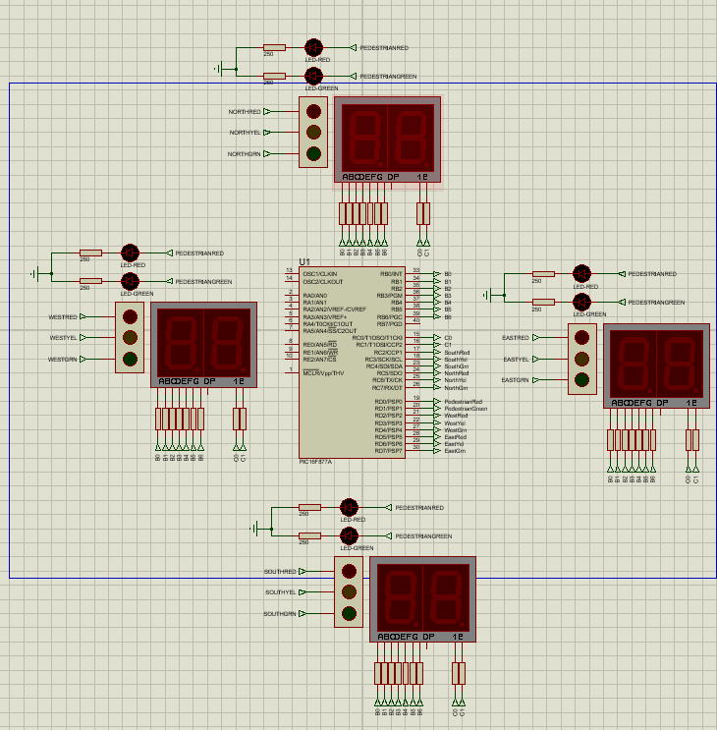
Figure 3
PIN layout and functions for PIC16F877A
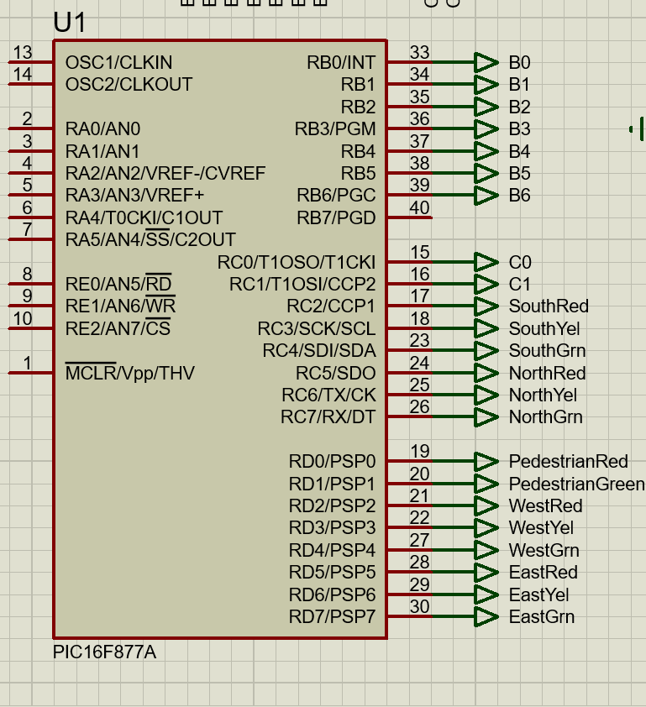

7 segment display diagram
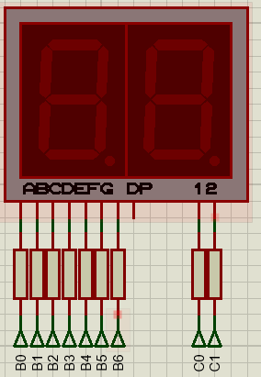
East traffic light diagram
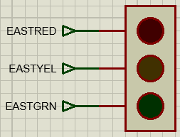
West traffic light diagram
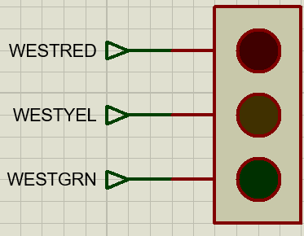
South traffic light diagram
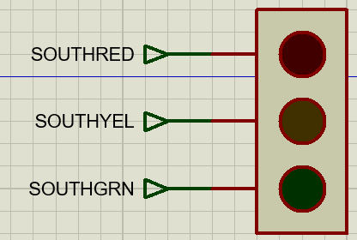
North traffic light diagram
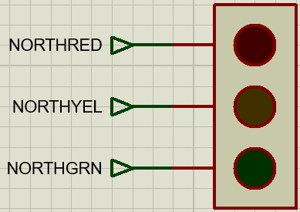
Pedestrian lights diagram
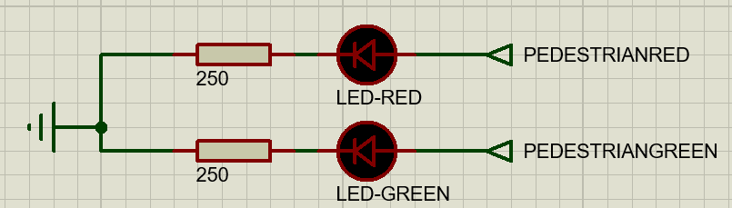

Pseudocode showing the system operation

Start
All lights red
Reset 7 segment display to “00”
Start countdown from “00” to “50” and every second display correct time on display.

Turn east red light Off
Turn east green light On

7 second delay

Turn east green light off
Turn east yellow light On

2 second delay

Turn east yellow light Off
Turn east red light On
Turn west red light Off
Turn west yellow light on

1 second delay

Turn west yellow light Off
Turn west green light On

7 second delay

Turn west green light Off
Turn west yellow light On

2 second delay

Turn west yellow light Off
Turn west red light On
Turn north red light Off
Turn north yellow light On

1 second delay

Turn north yellow light Off
Turn north green light On

7 second delay

Turn north green light Off
Turn north yellow light On

2 second delay

Turn north yellow light Off
Turn north red light On
Turn south red light Off
Turn south yellow light On

1 second delay

Turn south yellow light Off
Turn south green light On

7 second delay

Turn south green light Off
Turn south yellow light On

2 second delay

Turn south yellow light Off
Turn south red light On

1 second delay

Turn pedestrian red light Off
Turn pedestrian green light On

5 second delay

Turn pedestrian green light Off

1 second delay

Turn pedestrian green light On

1 second delay

Turn pedestrian red light Off

1 second delay

Turn pedestrian red light On

1 second delay

Turn pedestrian green light Off

Turn pedestrian red light On

Turn east red light Off

Turn east yellow light On

Repeat from start

Simulations and testing
Timer should start counting from zero turning all pedestrian lights and traffic lights red apart from east. Other lights should stay red until stated by program otherwise.
East lights will turn green for 7 seconds. Timer should start counting up to 50 and then reset. Display should change number every second to identify each second.
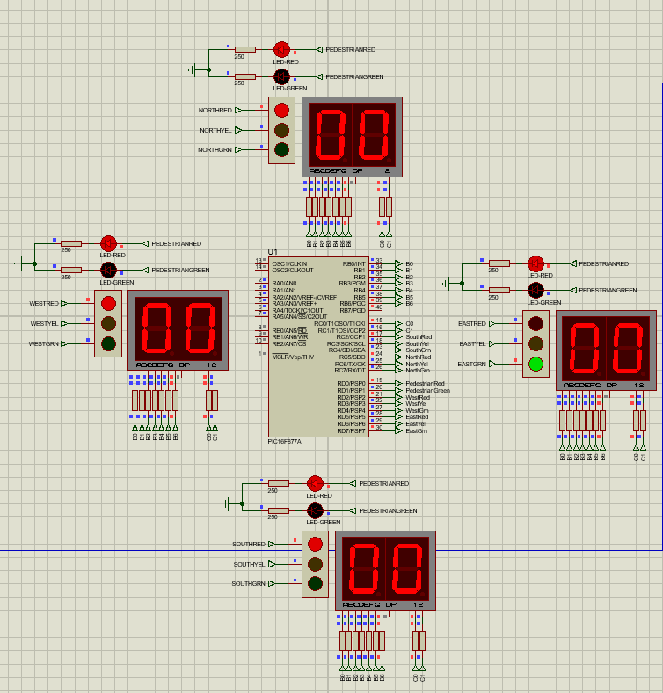
Result:
All lights are red, counter has starting counting from 0, east green light is on, display shows each second every second correctly.

After 7 second display should show number 7, red east light should turn off, east yellow light should come on and remain on for another 2 seconds.
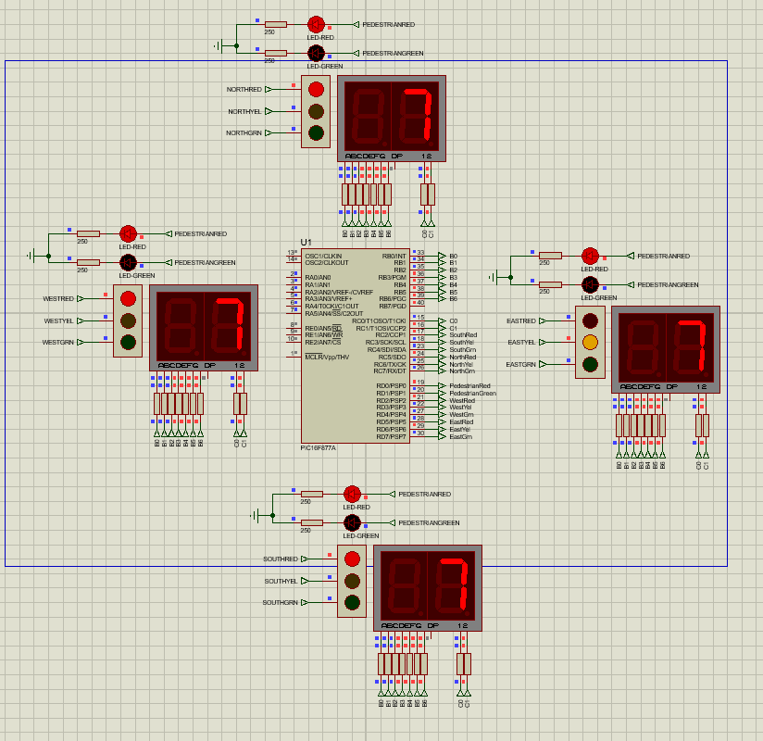
Result:
Display shows digit 7 as it reached 7 seconds, east yellow light come on and red turned off.

After another 2 seconds east yellow should turn off and east red light will come on. After red light is on quick yellow light of west part of the road will be turned on for one second. Display should indicate 9th second.
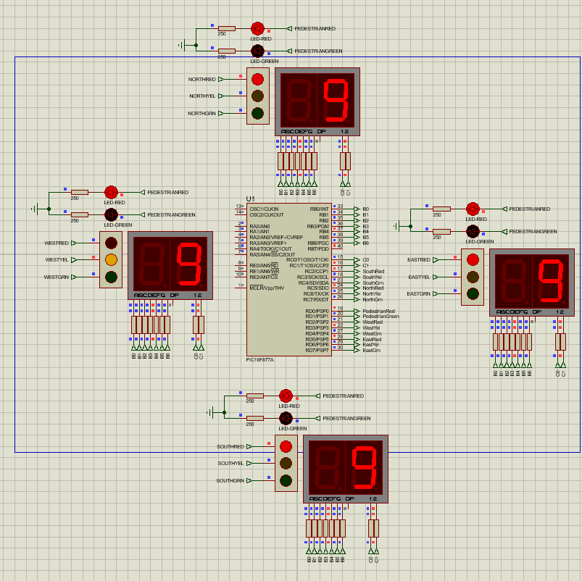
Result: East red light has come on and west yellow light has come on. Display now shows 9 second.

On 10th second display will turn to number 10 and west yellow will be tuned off as green west light will come on.
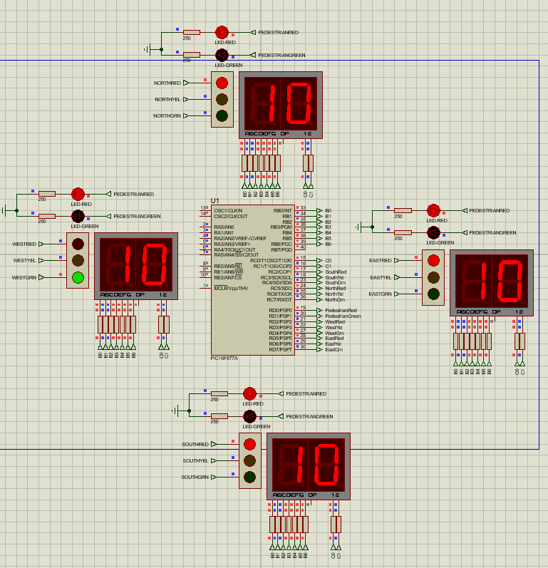
Result: Display now displays number 10 and west part of the road has now turned green as yellow switched off.

Process should now be repeated from the beginning but on the west part of the road and then turning green onto north part of the road.
On the 17th second display should be displaying number 17 on the screen, west yellow traffic light should come on and green turn off.
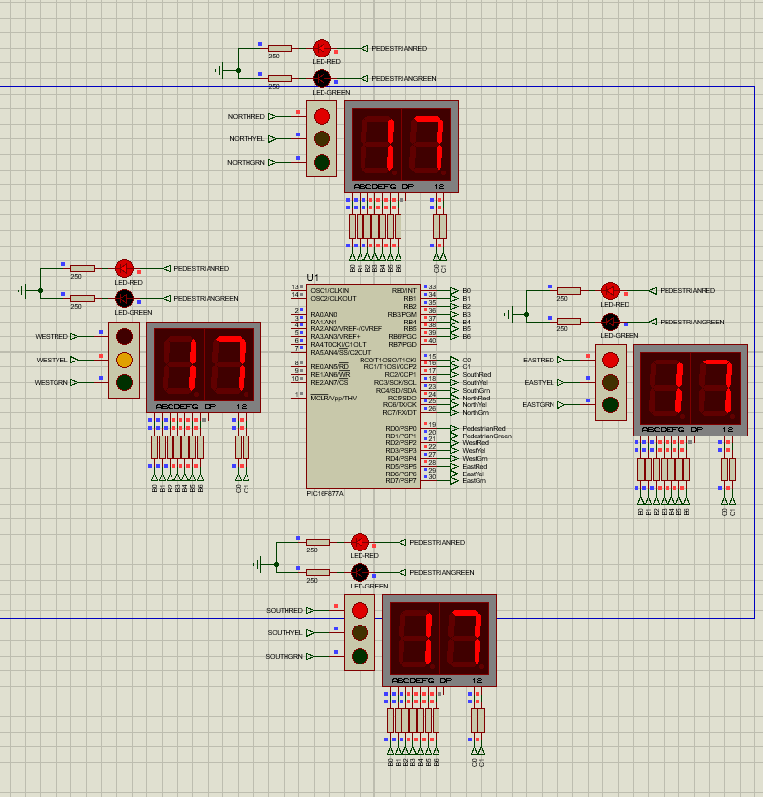
Result: Display shows number 17 on the screen, west yellow light has come on once green has been turned off.

After another 2 seconds west yellow should turn off and west red light will come on. After red light is on quick yellow light of north part of the road will be turned on for one second. Display should display that its 19th second.
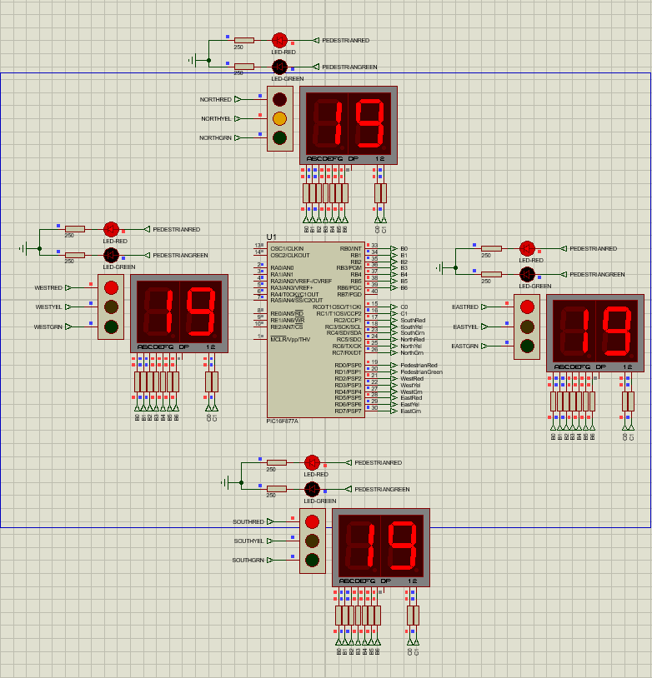
Result: Display has turned to number 19, west yellow has been turned off and west red has come on. Quick north yellow light has come on.

On 20th second display will turn to number 20 and north yellow will be tuned off as green north light will come on.
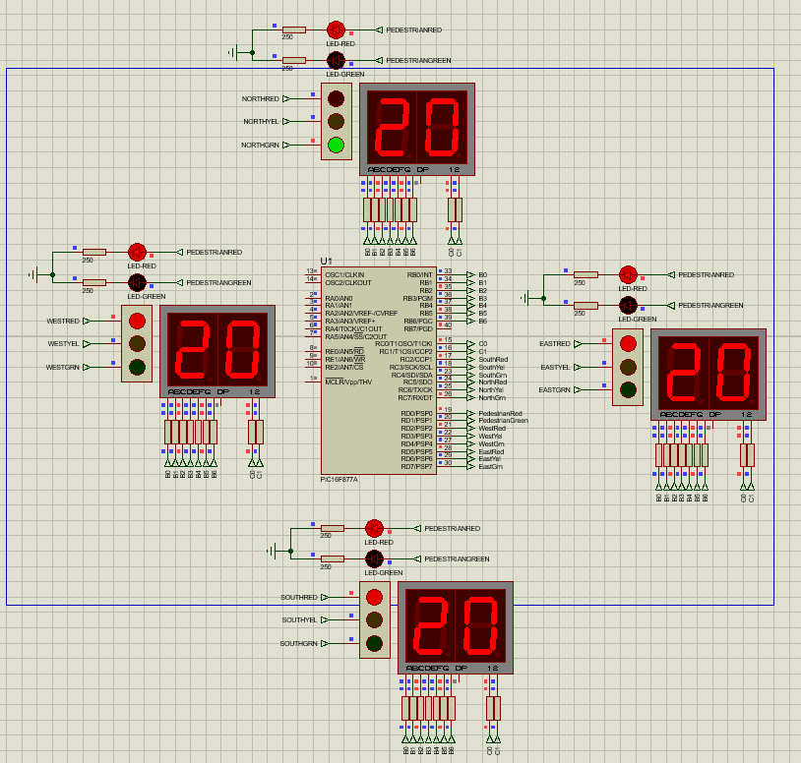
Result: Display now displays number 20 and north part of the road has now turned green as yellow switched off.

Process should now be repeated from the beginning but on the north part of the road and then turning green onto south part of the road.
On the 27th second display should be displaying number 27 on the screen, north yellow traffic light should come on and green turn off.
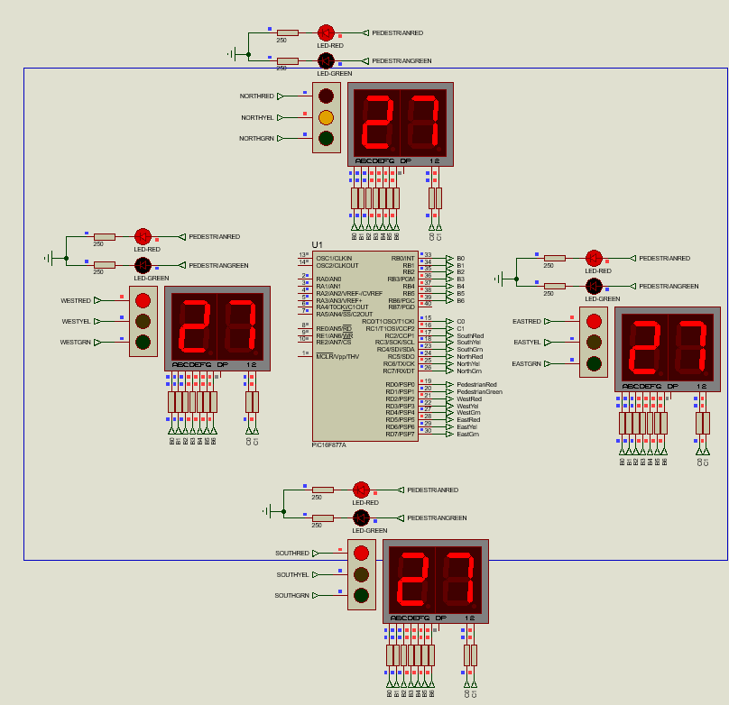
Result: Display shows number 27 on the screen, north yellow light has come on once green has been turned off.

After another 2 seconds north yellow should turn off and north red light will come on. After red light is on quick yellow light of south part of the road will be turned on for one second. Display should display that its 29th second.
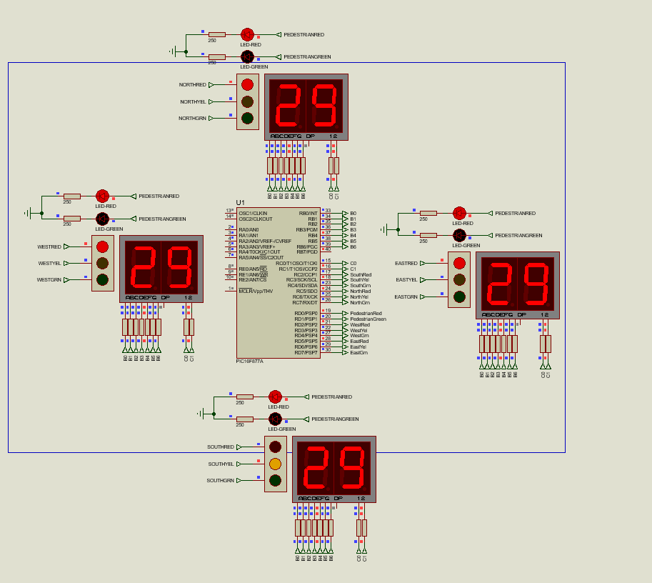
Result: Display has turned to number 29, north yellow has been turned off and north red has come on. Quick south yellow light has come on.

On 30th second display will turn to number 30 and south yellow will be tuned off as green south light will come on.
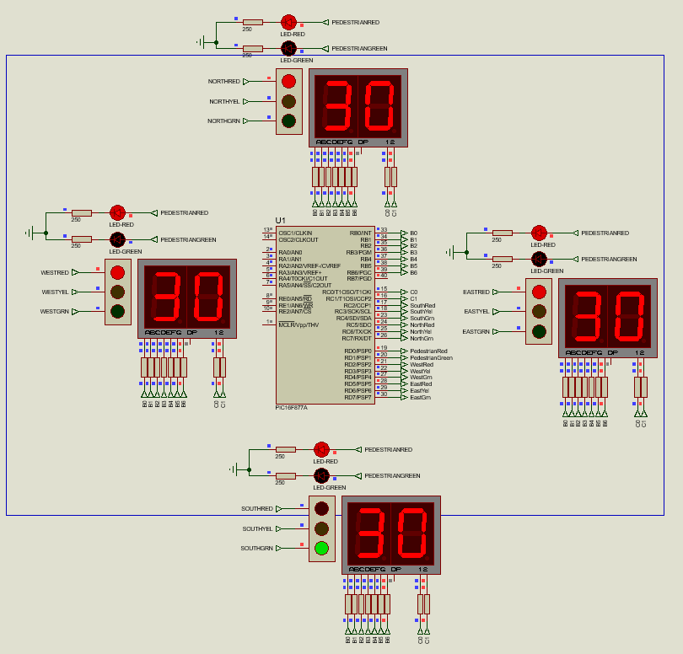
Result: Display now displays number 30 and south part of the road has now turned green as yellow switched off.

Process should now be repeated from the beginning but on the south part of the road but now net process will turn pedestrian lights on.
On the 37th second display should be displaying number 37 on the screen, south yellow traffic light should come on and green turn off.
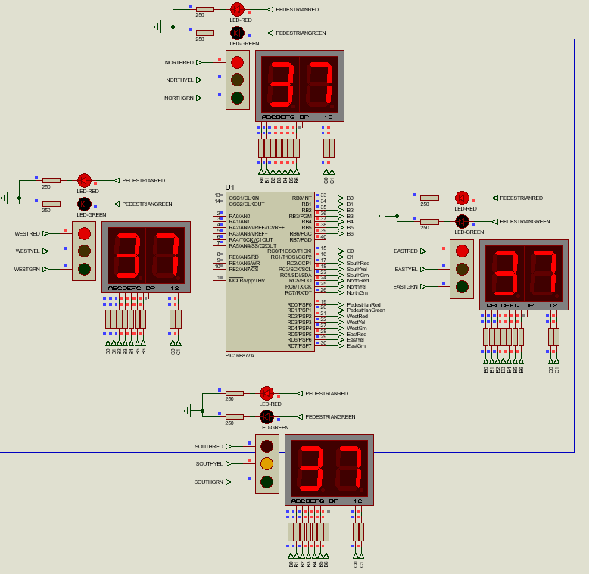
Result: Display shows number 37 on the screen, south yellow light has come on once green has been turned off.

After another 2 seconds south yellow should turn off and south red light will come on. Display should display that its 39th second.
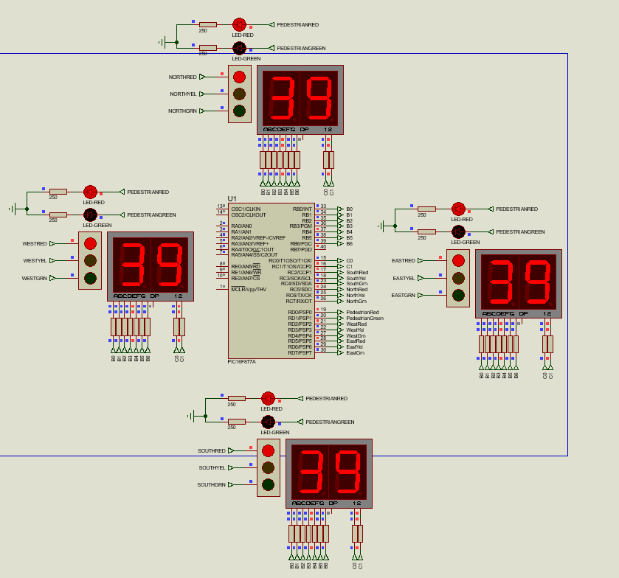
Result: Display has turned to number 39, south yellow has been turned off and south red has come on. All red pedestrian lights has turned off and green lights has come on.

On 40th second display should change to 40. After south red light has been turned on, pedestrian red lights on all parts of the junction should turn off and green should turn on.
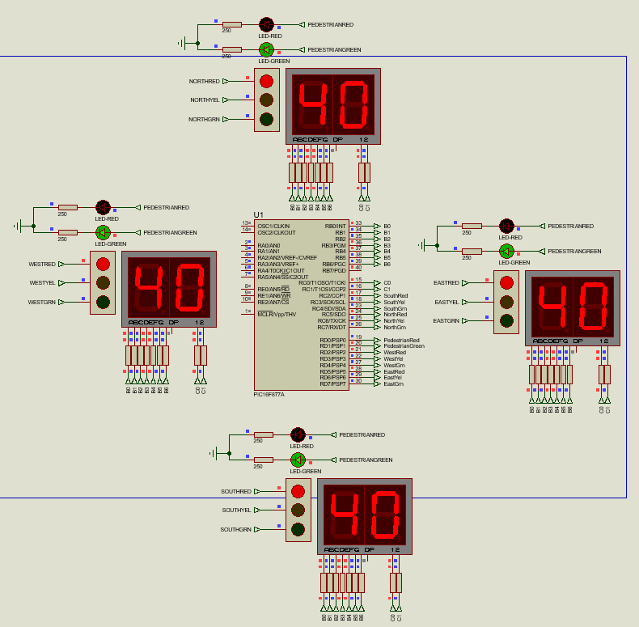
Result: Display shows number 40, all red lights for pedestrians has been turned off and green has turned on.

On the 45th second display should show number 45 and pedestrian lights should start flashing every second indicating that time is running out for safe crossing and car traffic lights will soon turn on. Green pedestrian light will turn off for a second then turn on again, off and on again displaying correct second on the display.
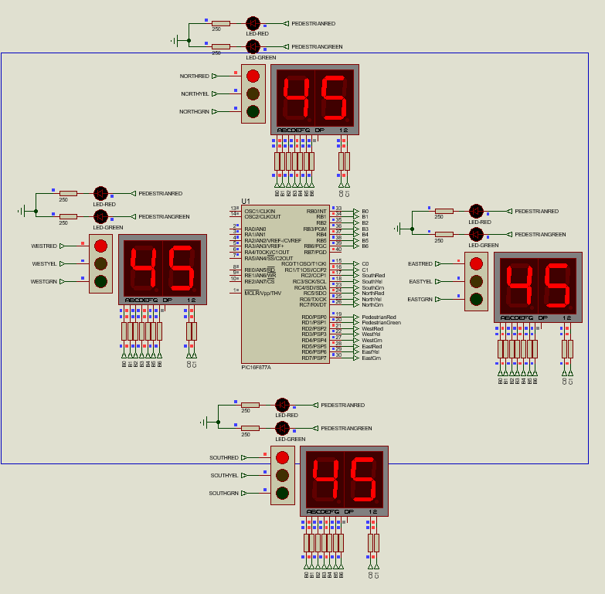
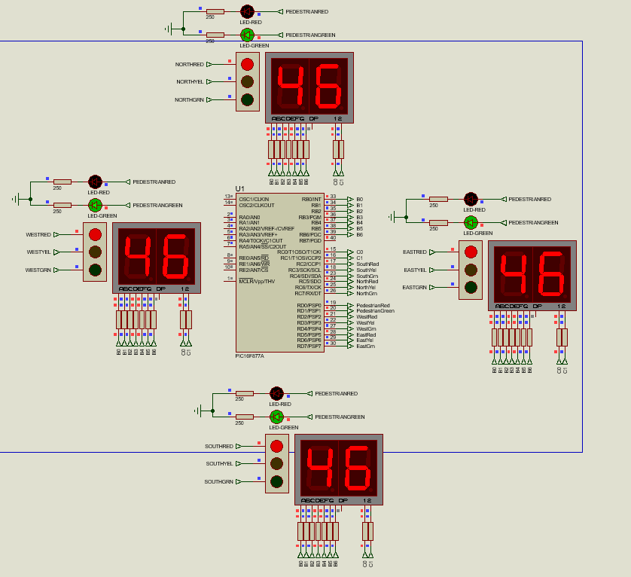
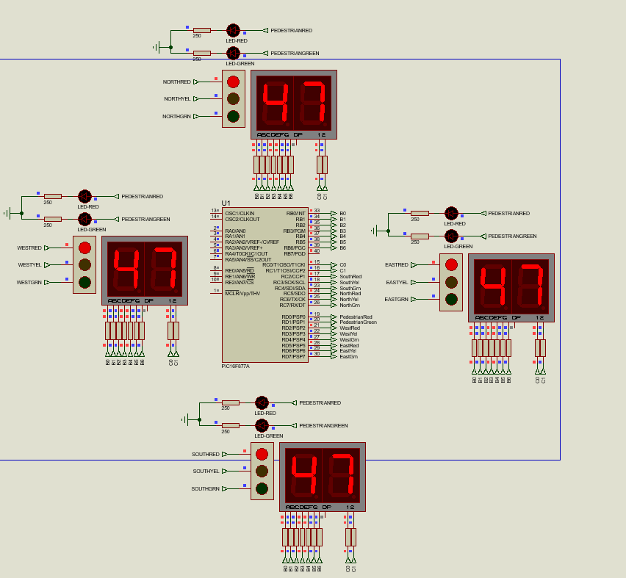
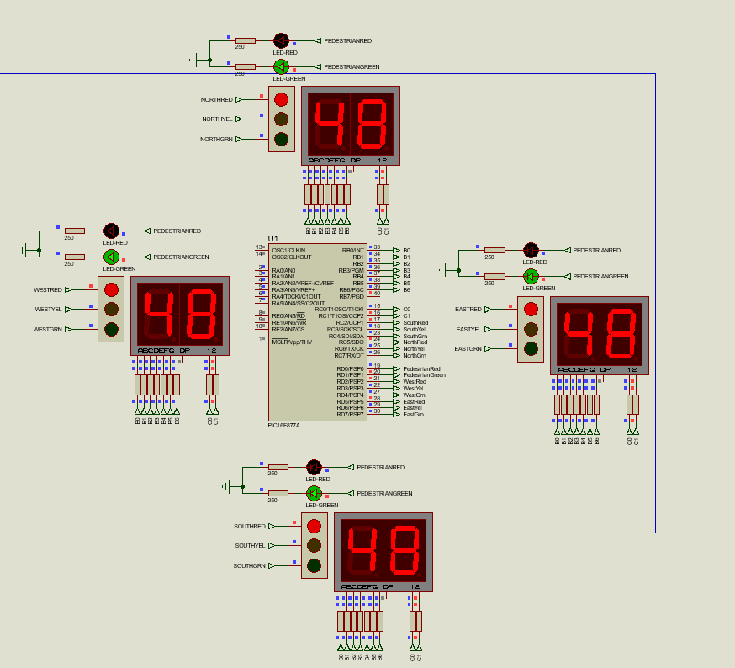
Result: Every second is displayed on screen correctly and led starts flashing from 45th second. It flashes every second until 49th second.
On the 49th second time display will show number 49. All pedestrian lights should now turn red and quick east yellow should now be turned once red is off.
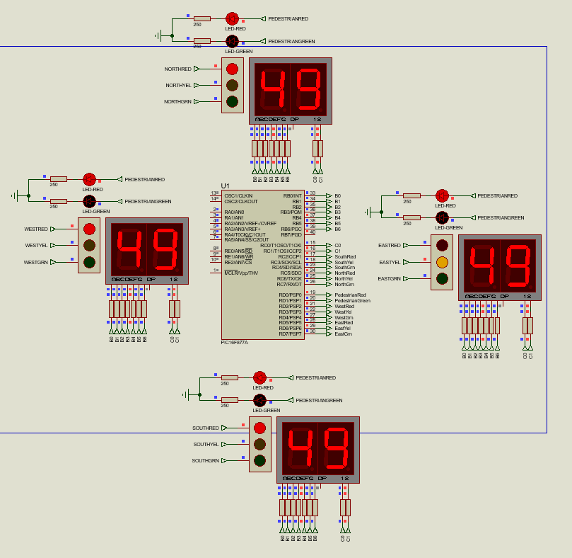
Result: All pedestrian lights are now red, east yellow light has come on and east red light turned off. Display shows number 49.

Time should go to 50 seconds display number 50 and reset to 0. East Yellow lights should continue to stay on.
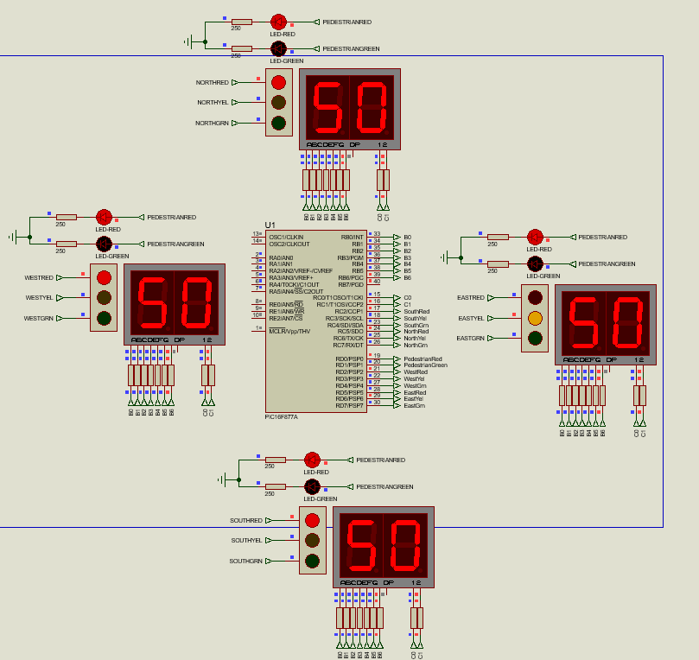
Result: Display shows number 50. East yellow continues to stay yellow

On the 50th second timer will reset to 00 and start whole process again from east side of the road turning green and east yellow turning off.
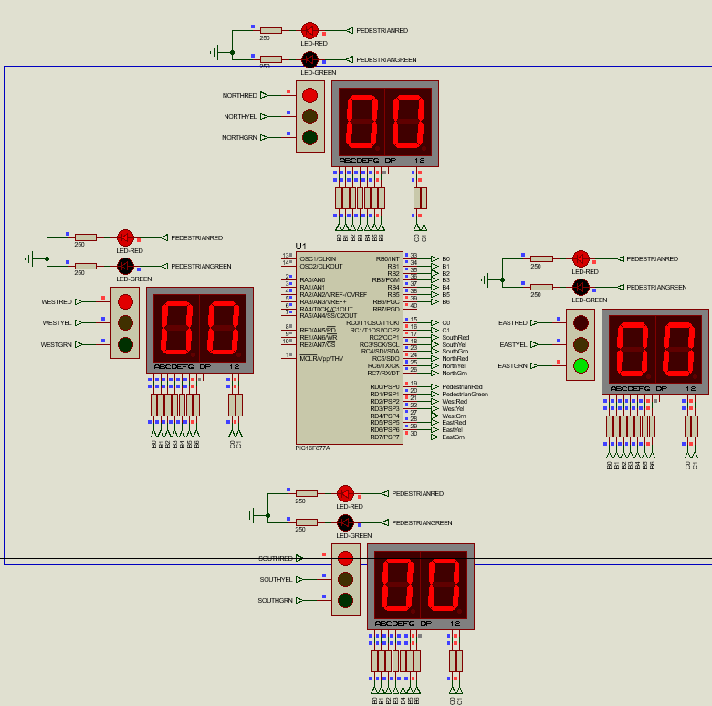
Result: Display has restarted to 00 and east green light is now on as east yellow turned off.

Program Screen dumbs
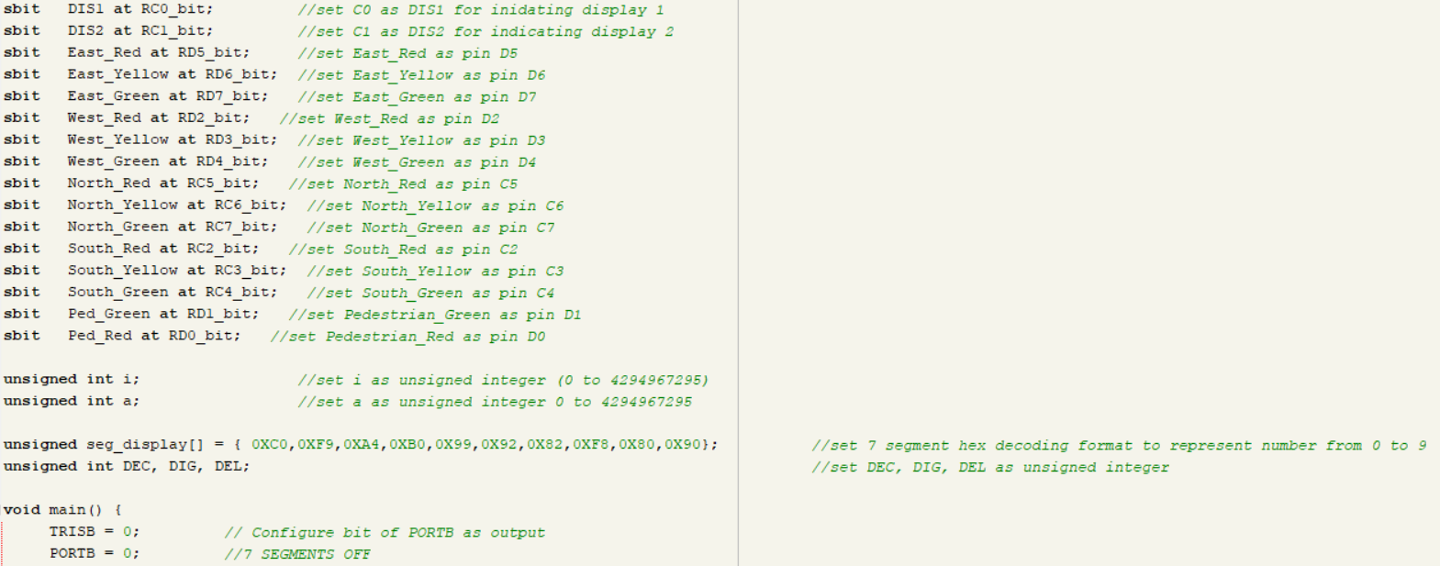
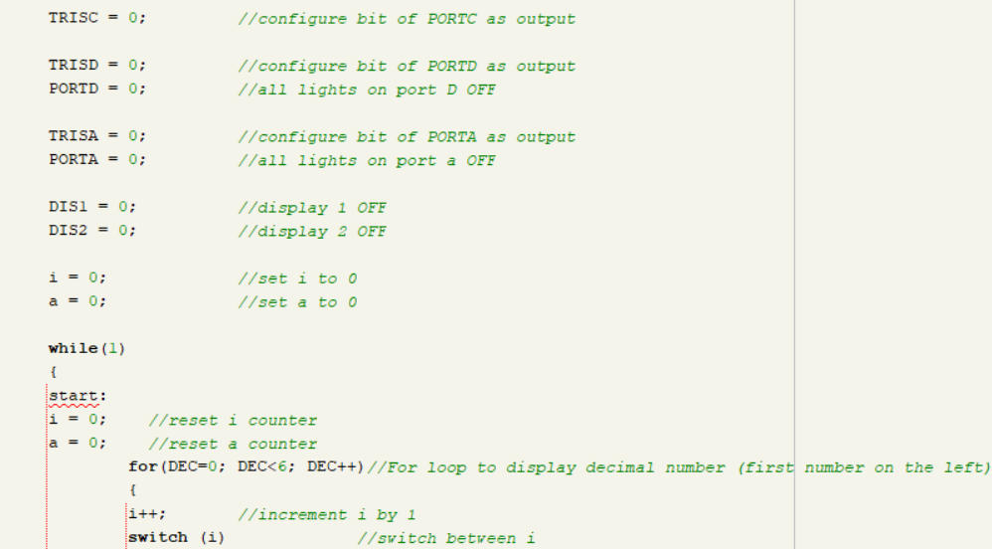
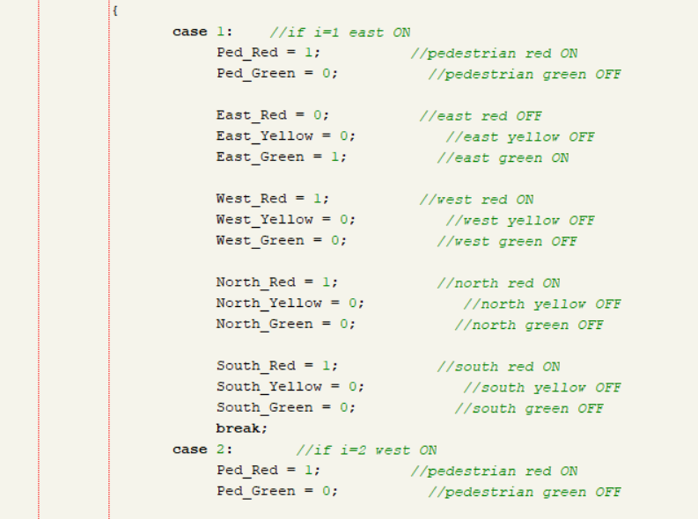
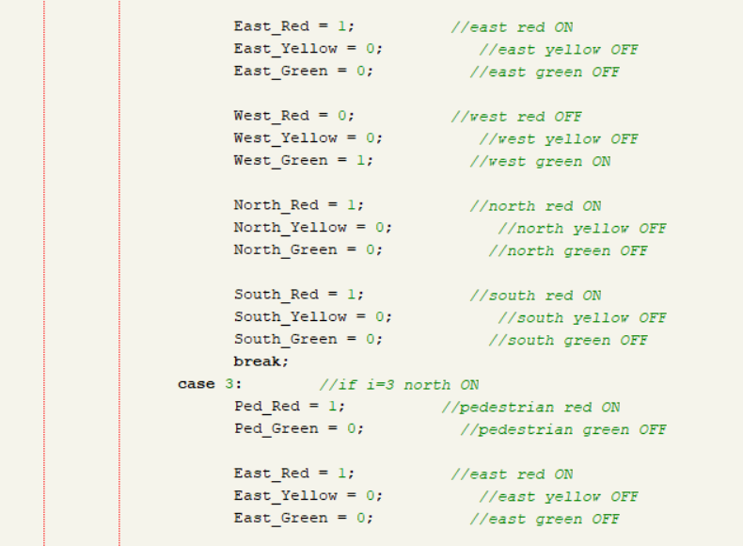
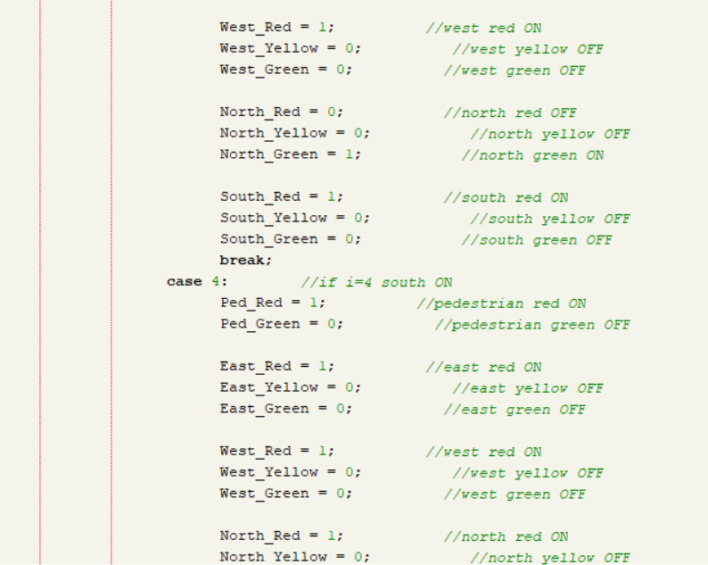
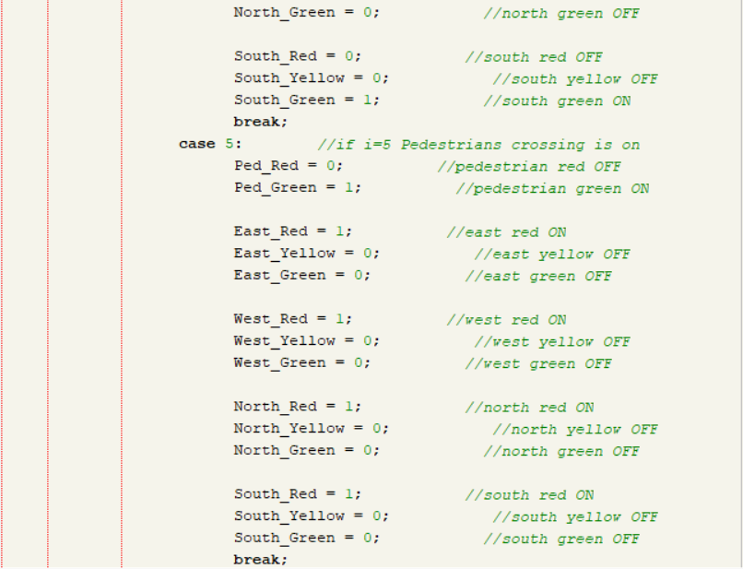
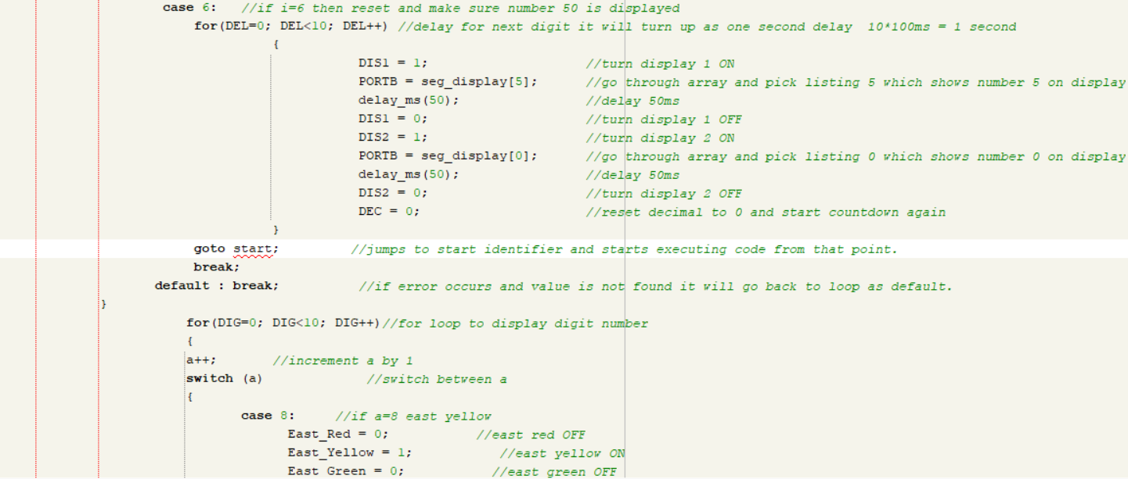
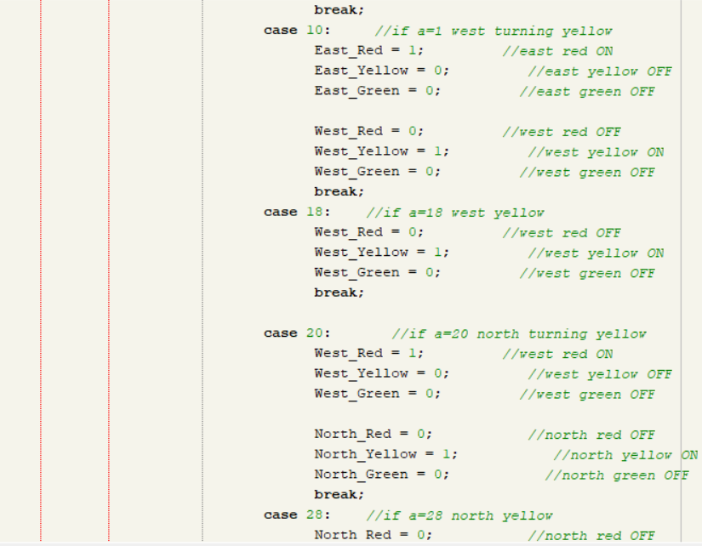
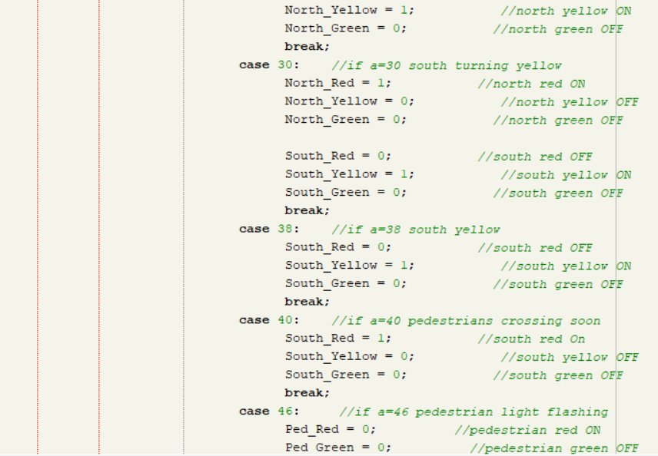
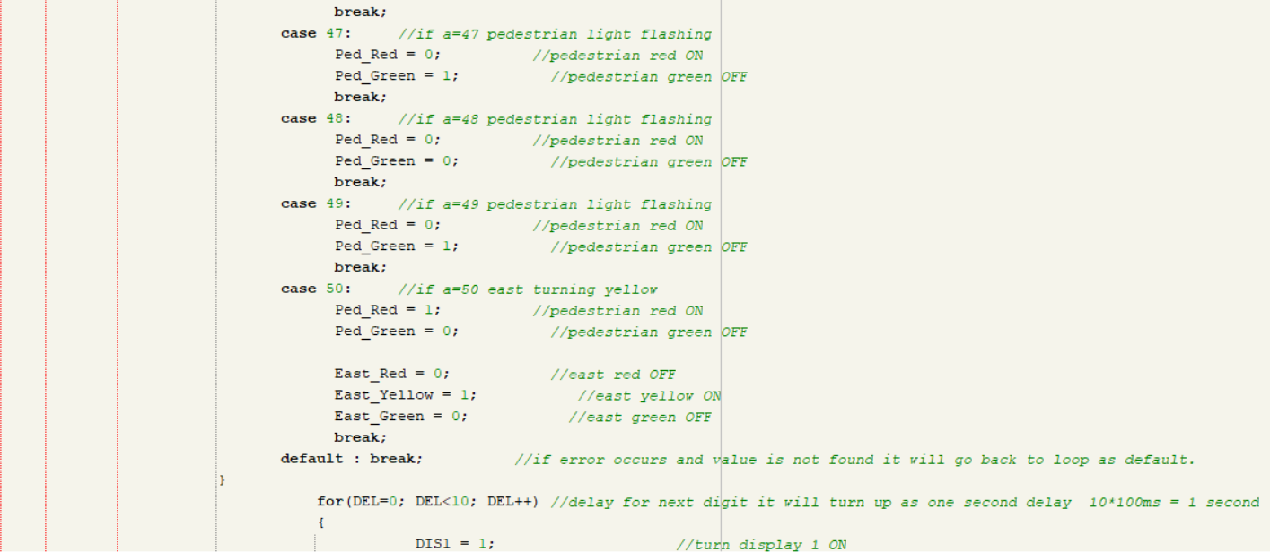
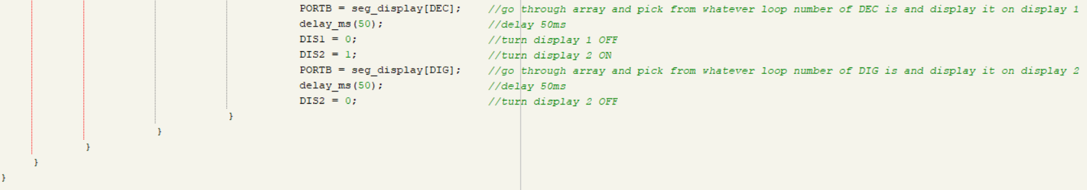

Recommendations on future work
Future projects aiming to enhance traffic light control systems could explore several areas for improvement of traffic management. Here are some potential areas:

Adaptive Signal Control Technology (ASCT): Future improvements could be based on ASCT, allowing traffic signals to adjust in real-time based on current traffic conditions rather than pre-set timing intervals. This could improve traffic flow, especially during unexpected congestion due to accidents or special events.

Machine Learning traffic lights: Machine learning algorithms could enable the system to predict traffic patterns based on historical data, weather conditions, local events, and real-time information. This predictive capability can optimize signal timings in anticipation of changes in traffic volume.

Vehicle-to-Everything (V2X) Communication: Expanding on vehicle-to-infrastructure (V2I) communication, integrating V2X communication would allow vehicles to communicate with each other and with road infrastructure. This could facilitate more efficient routing, reduce congestion, and enhance safety by alerting drivers to potential hazards.
Ref. mathworks

Pedestrian and Cyclist Considerations: Future designs should include more intelligent measures to ensure the safety and efficiency of pedestrian and cyclist crossings. This could involve sensor-based systems or AI to detect pedestrians and cyclists, adjusting signals accordingly to ensure their safety while minimizing impact on traffic flow. Pressing a button for indicating presence could also be included and then traffic lights controller could decide a quicker response for the button to initiate green light for pedestrians sooner or if no pedestrians presence let cars pass more often without a delay for pedestrian lights.

Cybersecurity Measures: As traffic control systems become more connected and reliant on data, ensuring the security of these systems against cyber threats will be important. Future projects must include cybersecurity protection against data breaches and ensure the integrity of traffic management systems.

Conclusion
In conclusion, the development of a traffic light control system is designed specifically for a four-junction layout, operating on precise timing intervals. Through planning and implementation of time-based signal changes, this system regulates traffic flow more effectively, thereby reducing congestion, minimizing delays, improving the overall efficiency of road and improving safety on roads.

The core strength of this system lies in effectively managing which side of the road has permission to pass and when to stop to minimize collisions on the road and also make sure pedestrians can cross the road safely. By optimizing the duration of green, yellow, and red lights according to real-time traffic conditions, the system ensures a smoother flow of vehicles, enhancing road safety and reducing the likelihood of accidents.

Future enhancements could include integrating smart technologies such as AI, which would enable the system to learn from traffic patterns and make predictive adjustments, further improving traffic management, this will also minimize idle times and reduce congestions, it will contribute to decrease in vehicle emissions, promoting a healthier environment. Collaboration with emerging technologies like vehicle-to-infrastructure (V2I) communication could pave the way for a more interconnected and intelligent transportation ecosystem.

In summary, the design and implementation of a precise timing interval-based traffic light control system for a four-junction layout offer a promising solution to urban way of traffic management.

Reference
Ref. Components101
https://components101.com/microcontrollers/pic16f877a-pin-diagram-description-features-datasheet

Ref.automate
https://www.automatesystems.co.uk/traffic-lights-signals-work#:~:text=Types%20of%20Traffic%20Light%20Signal%20Operations&text=There%20are%20two%20major%20kinds,no%20pedestrian%20or%20vehicle%20demands.

Ref.mathworks
https://www.mathworks.com/help/driving/ug/traffic-light-negotiation-using-v2x.html

