

Module Title: Effective Teamworking and Communication
Code: BMSW4009
Student Name: Mihaela Maxim
Student ID: 2431491
Title: Reflective Report on Teamwork in a Restaurant Setting
Word count:1096

TABLE OF CONTENTS

- INTRODUCTION...……………………………............2

  - Findings from Belbin and Kilman questionnaires....... 2

- THEORETICAL FRAMEWORK- REFLECTING ON PERSONAL EXPERIENCE ……..……………….…….. 3

  - Meredith Belbin Team Roles……………………... 4
  - Tuckman’s Model of Group Development and Adair Leadership Model……………………….…. 5
  - Betari Box Model…………………………………… 5

- CONCLUSION ………………………………….…………... 7

- ACKNOWLEDGEMENT ………………….……………….. 8

- REFERENCES………..…………………………………….. 9

Our ability to relate and communicate are critical to us being effective in any group or team setting. This means we need to know ourselves, know who we are with, and know our environment.
- INTRODUCTION
Teamwork should be thought of as a group of people working collaboratively towards a common aim, where trust, communication, and cooperation are vital for success (Mullins and Christy, 2016). In a restaurant setting, it is its foundation, from back to front-of-house service and administrative management. As a Business Administrator for our restaurants, I must promote effective communication, support staff and ensure effective overall operation.
1.1 Findings from Belbin and Thomas- Killman Questionnaires
Through Belbin’s Questionnaire, I have discovered that I align most closely with the Completer/Finisher and Implementer roles.
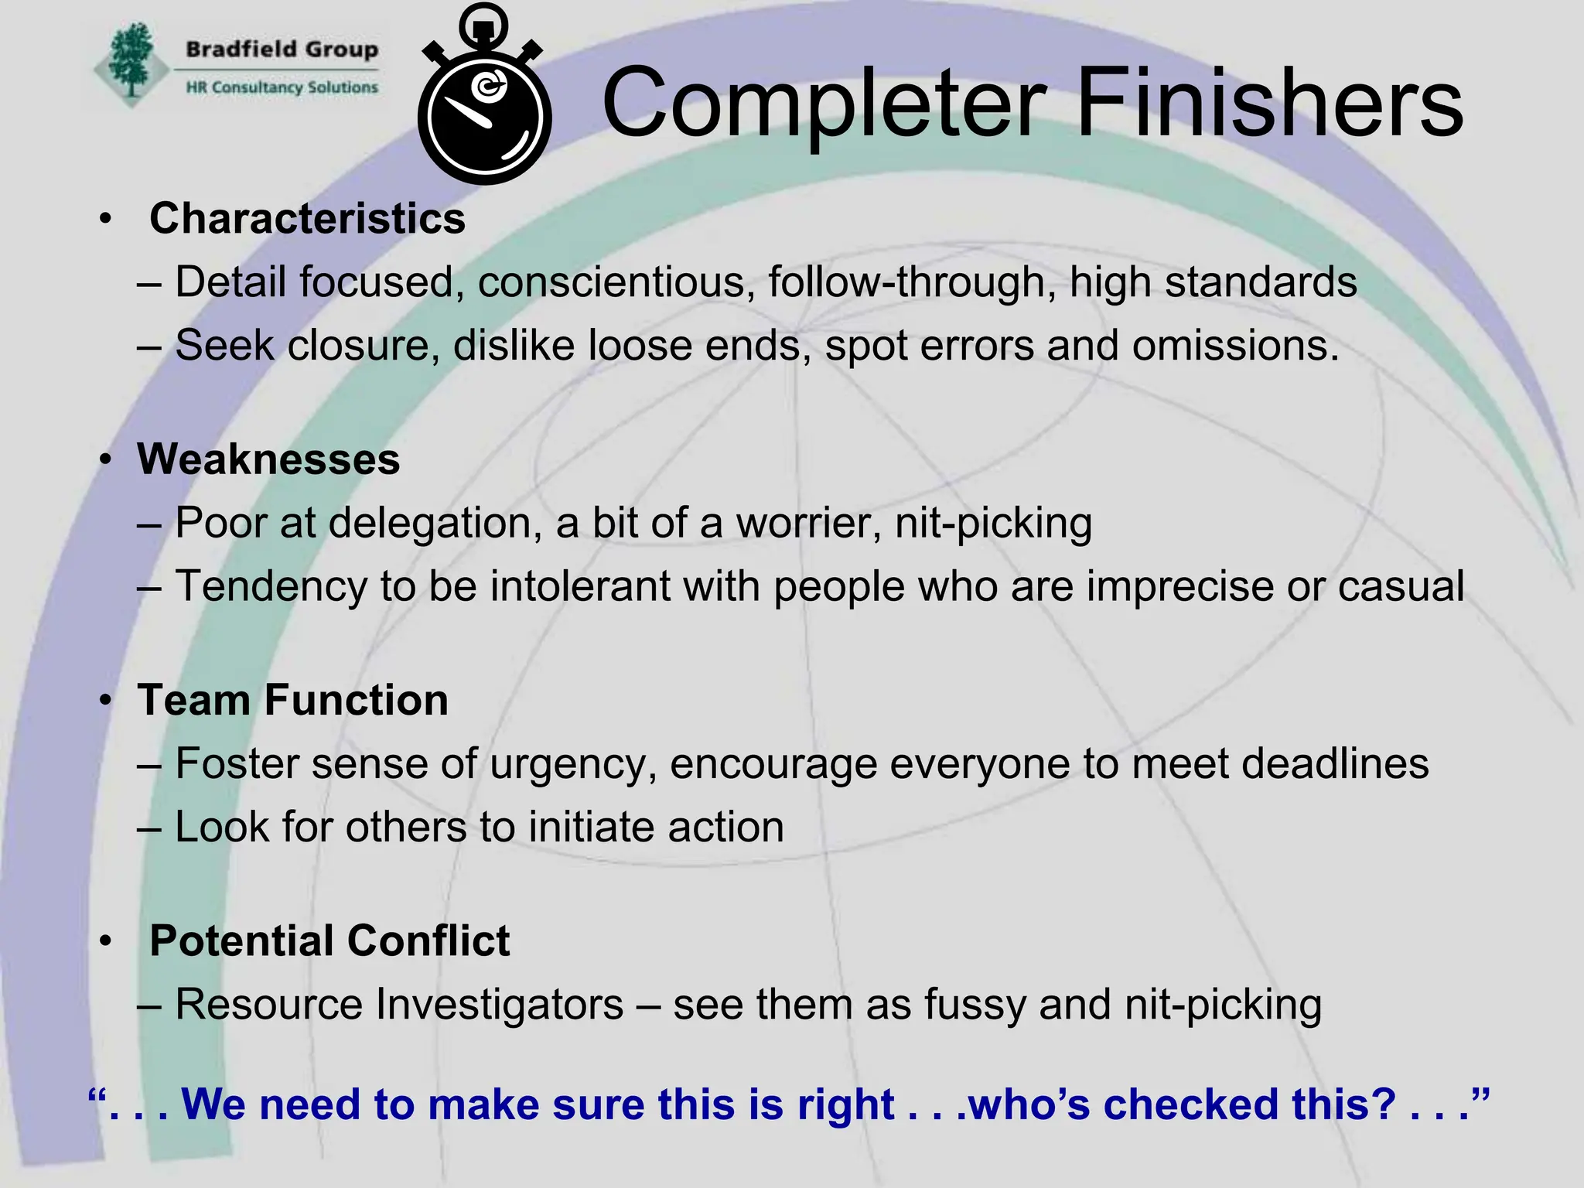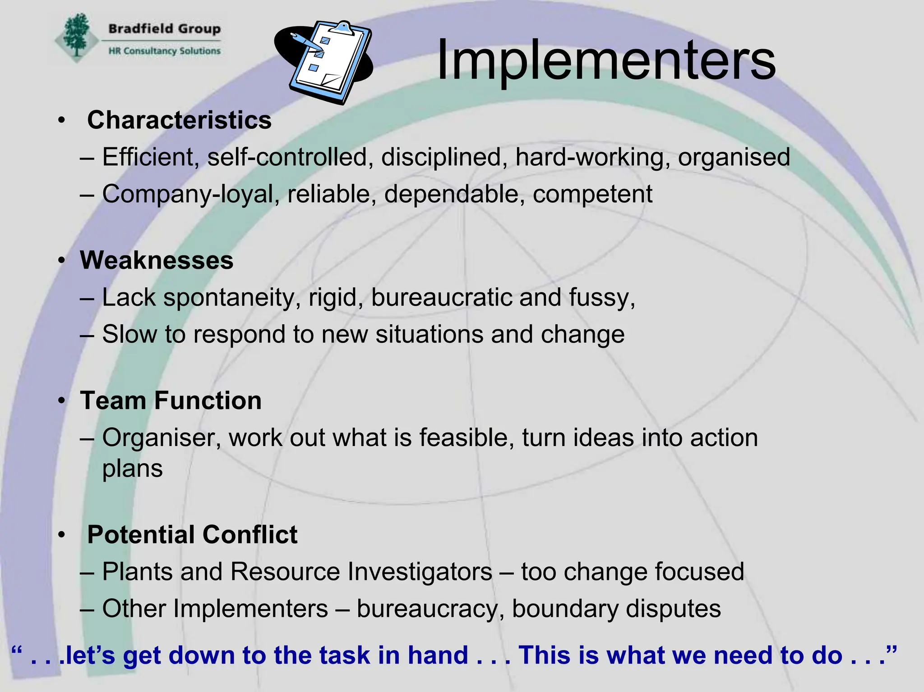
Figure 1 Figure 2
As Belbin explains (2010), Completer finishers are meticulous and ensure that tasks are completed to a high standard (Figure 1), while Implementers are effective organisers who turn ideas into actions (Figure 2). I have found these traits are essential in my role.
Moreover, based on the Thomas-Kilmann conflict styles model, I discovered that my approach to dealing with conflict is Compromising. This shows (Figure 3) that I balance assertiveness with cooperativeness, seeking solutions where both parties can benefit, where common ground can be sort. Therefore, my strengths lie as a go-between, an intermediary within the team where I value fairness, seeking mutual agreements rather than personal victories.
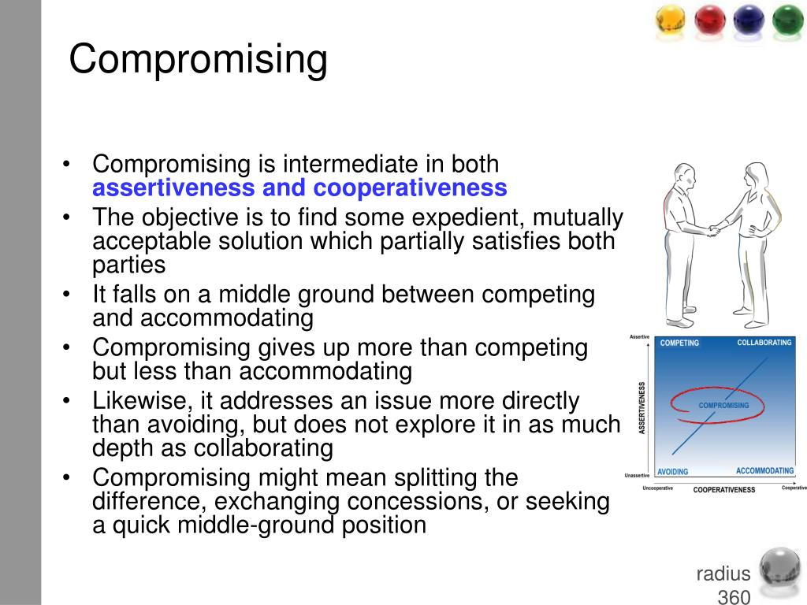
Figure 3

- THEORETICAL FRAMEWORK- REFLECTING ON PERSONAL EXPERIENCE

  - Meredith Belbin Team Roles
Belbin’s (2010) research highlights that effective teamwork is comprised of people with balancing behavioural roles. For example, during the busy summer season there were rostering issues across our three sites leading to friction between management, the kitchen and front-of-house. As the Business Administrator, I quickly organised a meeting examining the roster to reallocate staffing capabilities more effectively. By actively listening to different perspectives and facilitating clear delegation, I was able to mediate between parties, fostering compromise and restoring operational flow efficiently (Quintanilla and Wahl, 2020). This experience highlights my strengths as a Completer Finisher and Implementer and reinforces the importance of effective communication.
However, Belbin’s framework also outlined to me some weaknesses. My tendency to hyper-focus on structure and small details (traits of an Implementer and Completer Finisher) sometimes made it hard for me to work alongside the flexibility and creativity of 'Plant' types such as our head chef. According to Heffernan (2012), “for good ideas and true innovation, you need human interaction, conflict, argument, debate,” meaning that my desire for management could by mistake disrupt the open, free debate that allows teams to thrive. Having realised this, I decided to try and use a more inclusive communication style, encouraging the team to put their ideas forward before a final decision. By valuing diversity and perspective, I have discovered that stronger teams balance creativity, structure, and trust (Sinek 2023).
2.2. Tuckman’s Model of Group Development and Adair Leadership Model
Tuckman’s model (Tuckman and Harper, 2012) describes five predictable stages of development (Figure 4), and reflecting on our current restructure of management, I now understand how our team has gone through these stages.
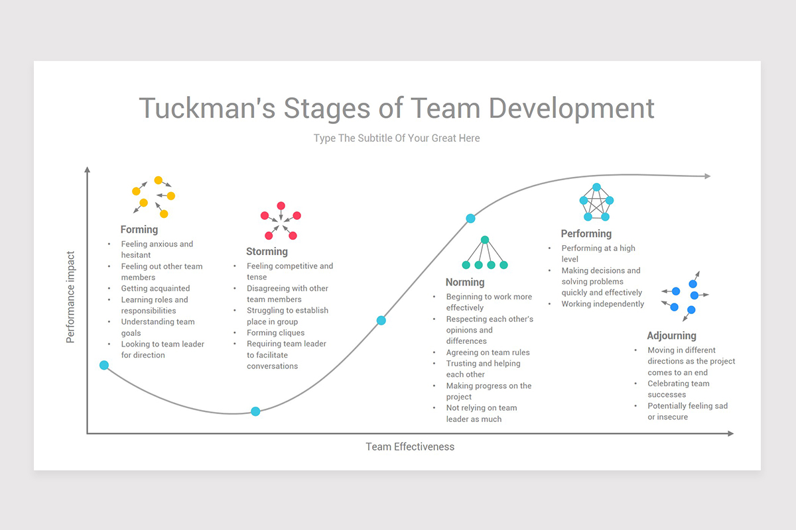
Figure 4
During the forming stage, when new managers and staff joined, the team were hesitant as relationships were formed. I played a key part in this, encouraging good communication, trust and seeking compromise. The storming phase quickly followed, as shifts to some procedures led to frustration among long-serving staff. Looking at on Stadler’s (2019) analysis of conflict, I saw immediately how people’s disagreements came from their culturally and personally differing styles of communication. I began conducting small pre-service meetings that gave opportunities to express concerns openly, enabling mutual understanding.
In the norming stage collaboration improved. I saw mutual respect and an ability to seek compromise. This reflects Adair’s (2015) idea that effective teams improve when individuals understand both their own and fellow team members roles clearly. Ultimately, the team reached the performing stage having developed clear structures, trust and with everyone working together efficiently.
Then when some of our temporary staff left at the end of the season, the adjourning stage reminded me to recognise contributions and team successes. Examining Tuckman’s theory, I can see how Mullins and Christy (2016) rightly show how team development is an evolving process demanding patience, flexibility, and crucially continuous communication and trust.
  - Betari Box Model
Lastly, the Betari Box model illustrates (Figure 5) how our attitudes and behaviours influence others in a continuous cycle (Mullins and Christy, 2016). This concept I find the most interesting as I see it all the time during the high-pressure situations of peak service.
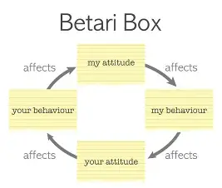
Figure 5
Occasionally communication errors lead to heightened stress between the kitchen and front-of-house. Initially, my frustration rose and I was fearful I will be impatient and upset, but using the principles of the Betari Box, I knew I must respond calmly and supportively rather than defensively. This deliberate shift helped me work with the duty manager and head chef to seek compromise and de-escalate the situation.
As Heffernan (2019) highlights, emotional awareness and psychological safety are key for team cohesion. Rightly, Kline (2002) also states that honest listening helps 'ignite the human mind,' encouraging understanding and de-escalating conflict. Therefore, these experiences reinforce the idea that my behaviour directly influences team dynamics. By demonstrating composure and respect, I can create a positive feedback loop, encouraging staff to respond constructively.
Importantly, the Betari Box has enhanced my self-awareness and emotional intelligence – qualities highlighted by Academi Wales (2018) as critical for establishing productive teams. Managing my own attitude helps to create a culture of trust, which is key to improve performance and wellbeing across the team.

- CONCLUSION/ REFLECTION ON PERSONAL EXPERIENCE
Reflecting on my experience as a Business Administrator has highlighted that teamwork is a dynamic, evolving process requiring effective communication, self-awareness and most importantly, trust. By applying Belbin’s, Tuckman’s, and Betari’s models, I have realised that, while now having an even deeper understanding of my strengths, abilities, and impact on others I still have more work to do.
I still find myself struggling with my language skills and understanding how different people operate. However, I can see a vast difference in my abilities, especially after the challenging summer at the restaurant. Understanding this, I know I still need to take actions to:
- Enhance my effectiveness as a team member and leader
Such as enhancing my emotional intelligence by maintaining self-awareness during stressful situations, applying insights from the Betari Box and Heffernan’s work on psychological safety to improve interaction with team members.
- Foster Team Diversity and Participation
Actively recognise and value different Belbin roles within the team, encouraging diverse contribution and promoting an inclusive environment that leverage each member’s strengths.
- Strengthen Communication and Trust
Align with Sinek’s (2023) and Kline’s (2002) principles by practicing active listening and openness, ensuring clear communication and building trust, especially when guiding new teams through transitions by recognising Tuckman’s stages of team development.
By following these steps, I will: foster stronger, more cohesive teams and contribute even more effectively to the organisational success of the company.

- ACKNOWLEDGEMENT

I confirm that I have not presented any AI generated text as my own work. I confirm I have copies of my drafts, notes, and other resources I used before, and after the use of AI tools which I may be asked to
provide in evidence.

- REFERENCE LIST
- Adair, J.E. (2015) Effective teambuilding: how to make a winning team. Revised edition. London: Pan Books.

- Belbin, R.M. (2010) Team roles at work. Second edition. Amsterdam ; Butterworth-Heinemann.
- Heffernan, M. (2012). Dare to disagree. [online] Ted.com. Available at: https://www.ted.com/talks/margaret_heffernan_dare_to_disagree. (Accessed: 09 November 2025).
- Heffernan, M. (2015). Forget the pecking order at work. TED. Available at: https://www.ted.com/talks/margaret_heffernan_forget_the_pecking_order_at_work. (Accessed: 09 November 2025).
- Heffernan, M. (2019). Wilful blindness: why we ignore the obvious. London: Simon & Schuster.
- ‌Kline, N. (2002) Time to Think: Listening to Ignite the Human Mind. London: Cassell.
- Mullins, L.J. (2016). Management & Organisational Behaviour. 11th ed. Harlow: Pearson.
- Sinek, S. (2023) Trust: The Basis of High Performing Teams - Search Videos. [online] Available at: https://www.bing.com/videos/riverview/relatedvideo?q=8.%09Sinek%2c+S.+(2023)+Trust%3a+The+Basis+of+High+Performing+Teams&mid=F6F37A72D5E9C2949373F6F37A72D5E9C2949373&FORM=VIRE (Accessed: 10 November 2025).
- Stadler, S. (2019) Conflict, Culture and Communication. 1st ed. Milton: Routledge.
- Tuckman, B.W. and Harper, B.E. (2012) Conducting Educational Research. 6th edn. Lanham, Maryland: Rowman & Littlefield Publishers.
- Academi Wales (2018) Trust: The Foundation of Successful Teams. [online] Available at: https://academiwales.gov.wales/repository/resource/a3ea75b8 (Accessed: 10 November 2025).

