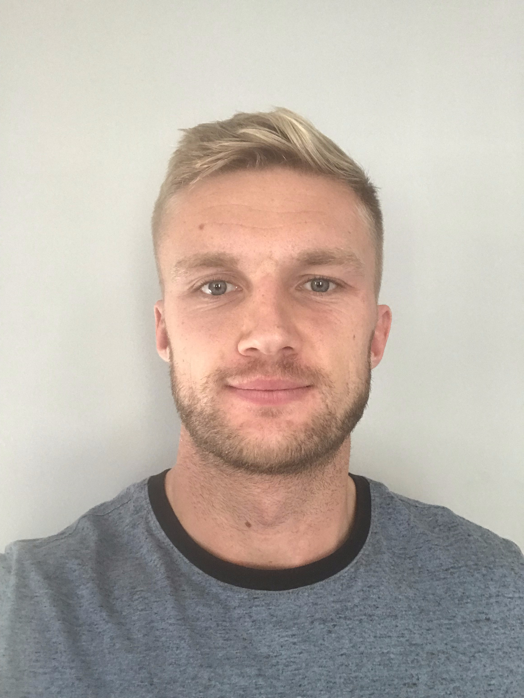

Name: James Sudale

Student number: 1903598

Student email address: 1903598@student.uwtsd.ac.uk

Contact number: 07903731250

Please use the remaining space to give a brief outline of why you have chosen your course of study and any relevant special interests or experiences:

The reason I have chosen Sports Therapy as my course of study is because I want to have a good understanding of managing an injury the correct way and to be able to recognise an injury. I have a special interest in ATFL injuries as I have experienced this injury before.

