Monday 3rd Feb 2020

VE2

Self - study

Paint squares in book x 5 – layer and layer with tracing paper (CHAOS)

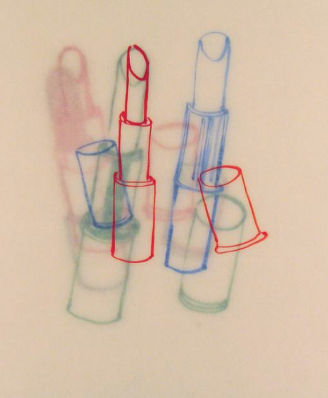

Martina Roberts

Paint squares in book x 5 – grids and frames (ORDERED)

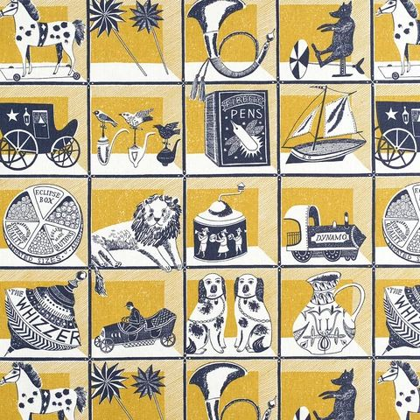

St Judes Fabrics

