ENTREPRENEURSHIP
Assessment 1: Essay
Student name: Radoslava Hristova
Student ID: 2110952
Table of Contents

Introduction 3
Main Body 4
Conclusion 13
Reference List 14

Introduction
Entrepreneurship can be explained as a range of activities in involved in a business such as creating, managing and running it (Diandra and Azmy, 2020). It is essential for the production of new products and services in the market (Indeed, 2023). Moreover, it highly depends on the skills and competencies of the entrepreneur. This study will highlight the impacts of various external environmental factors which influence the ideas of entrepreneurs. PEST Analysis and other models will be used to analyse the competitive business environment. Furthermore, this study will analyse the skills required for developing and managing a catering business.

Main Body
Write an essay that evaluates an idea you have, to become an entrepreneur in the UK. Explain, what led you, to choose this idea.
PEST Analysis
PEST Analysis is considered to be a tool used by businesses to analyse the macro-environmental factors which influence their operations and development (Kolomiets et al., 2019). These external environmental factors include political, economic, social and technological aspects which directly and indirectly impact the business. An analysis of the UK market has been given below:
Political
According to Tradingeconomics (2023), the corruption perception index score of the UK in the year 2022 was 73 out of 100. Businesses in the UK will need to resort to corrupt practices to sustain the market. Furthermore, these practices will decrease the reputation of businesses in the UK resulting in low investment from foreign investors. The catering business will face difficulty in maintaining transparency in its operations and remaining competitive in a corrupt market.
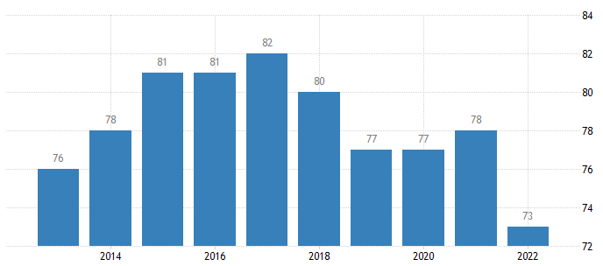
Figure 1: Corruption Perception Index of the UK
(Source: Tradingeconomics, 2023)
The Confidence Interval in the UK was observed to be 77.36% in the year 2021 (Tradingeconomics, 2023). It can be implied that terrorism is less in the economy. However, changing governments can be a major concern for the catering business. It might be negatively affected by the changes in policies and regulations brought about by the new government.
Economic
In February 2023, the inflation rate of the UK was reported to be 10.4% which increased from 10.1% in the last month (Tradingeconomics, 2023). The inflation rate is increasing in the UK meaning that there is a rise in the price level of goods and services. Moreover, purchasing power of people in the economy decreases. This will hamper the profitability of the catering business due to the increasing price of raw materials and low consumer spending.
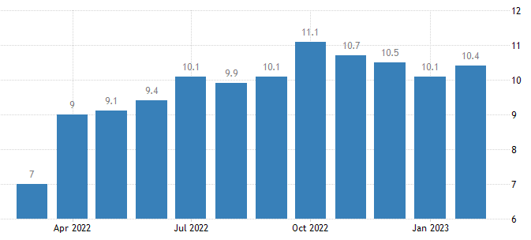
Figure 2: Inflation rate of the UK
(Source: Tradingeconomics, 2023)
On the other hand, the gross domestic product (GDP) growth rate stood at 7.5% in the year 2021 (Worldbank, 2023). It can be assessed that the catering business has the opportunity to increase its profitability and growth potential. Additionally, it gets the opportunity to increase its customer base.
Social
The unemployment rate in the UK was recorded as 3.7% in the year 2022 (ONS, 2023). The unemployment rate has been decreasing over the years meaning fewer people are leaving their jobs. Therefore, the catering business will face challenges in filling vacant positions due to the less availability of skilled employees. It will not be able to expand its operations due to a limited number of employees. Moreover, it will be hard to cater to the increasing customer base and their demands.
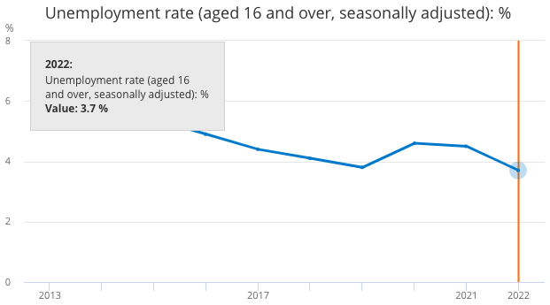
Figure 3: The unemployment rate in the UK
(Source: ONS, 2023)
The majority of the population fell into the age group of 15-64 years in the year 2021 while the population amounted to 67.26 billion people (Statista, 2023). This age distribution is favourable for businesses in the UK. Therefore, the catering business will be able to increase its sales in the market, especially to the income group.
Technological
There was an increase in investment towards the tech sector in the UK in technologies such as AI, blockchain, Quantum computing, and so on (Techuk, 2021). The catering business will be able to take advantage of the latest technologies to increase its efficiency and performance while reducing operating costs. These latest technologies may include artificial intelligence (AI), machine learning (ML) and IoT (Internet of Things) devices.
The UK government has been planning to increase its investment in research and development (R&D) to 2.4% of the GDP by the year 2027 (ONS, 2022). This implies that the catering business will be able to enhance its marketing abilities and manage costs and others while reducing the risk of uncertainty.
According to this PEST Analysis, it is feasible to implement the business idea to open a catering company. Although some external environmental factors will have a negative impact on this idea, there is a high probability that it will be successful. A high level of communication in decision-making is required for improving team performance, especially in a structure of shared leadership (Jabarzadeh et al., 2019). Since communication is important for every organisation, they need to be transparent with the employees as well as customers. However, the rising corruption level in the economy may impact the communication of information to its stakeholders. It becomes especially for customers and investors to structure organisations in a corrupt economy. On the other hand, terrorism and violence are minimum in the economy. Therefore, the catering business will be able to peacefully conduct its operations.
In the current scenario, the use of artificial intelligence (AI) for the decision-making process in organisations is increasing (Shrestha et al., 2019). However, it is easier to interpret and understand the decisions taken by humans instead of the complex algorithms produced by AI. Investment of the UK towards technological advances and R&D will foster the growth and expansion of businesses. It has been observed that through the use of technology, organisations are able to increase their efficiency and maximise profits (Nibusinessinfo, 2023). The catering business will be able to understand customer behaviour and consumption pattern to meet their changing demands. It ensures connectivity and collaboration between multiple individuals, teams and departments. Additionally, the use of technology has influenced different operations of a business such as recruitment, training, performance assessment, and so on. The recruitment process is essential for hiring skilled and talented candidates to meet present and future business objectives (Abdalla Hamza et al., 2021).
However, it will be difficult for the catering business to hire new candidates due to decreasing unemployment rate. It can be interpreted that there are only a few skilled employees in the economy who are unemployed and looking for jobs. In order to deal with such a situation, the business will need to invest in the training and development of new employees to meet their requirements. On the other hand, the age demographics of the economy are favourable for the catering business as most customers belong to the age group of 15-64 years. Moreover, it has been observed that the inflation rate of the UK has not gone down below 10% in the past few months. Rising inflation has a negative impact on businesses in an economy (Mbah et al., 2023). An increase in the price level of goods and services will also increase the cost of raw materials. Therefore, the raw materials obtained by the catering business will be high. This will impact its operating cost as well as the profit margin. Customers will spend less due to decreasing in purchasing power which will eventually reduce the sales of the catering business.

Explain how the entrepreneurial skills and knowledge you have gained from the course will help you with your start-up business and create an evidenced Professional development plan (PDP) with clear objectives
SWOT Analysis
SWOT Analysis
Strengths | Weaknesses
- The leadership skills that I possess will enable me to manage the people in the catering business and achieve the desired objectives. Good leadership has a positive relationship with the performance of organisations in the market (Hashim, 2019).  - Lack of effective communication may lead to misunderstandings and conflicts in the workplace (Owusu and Mardani, 2020). It can be implied that my communication skills will enable me to engage with employees as well as customers. This will also play a key role in improving organisational performance. | - Knowledge creation and decision-making are necessary for management in the current scenario (Bag et al., 2021). A lack of efficient decision-making skills may have a negative impact on the growth potential of the catering business.
Opportunities | Threats
- Klučka and Grünbichler (2020) observe a relationship between risk-taking and performance management. Therefore, I have the opportunity to develop my risk-taking skills to take calculated risks. Furthermore, I will be able to manage the changes in the business environment more effectively. | - Small businesses are often exposed to bankruptcy risks which determine their survival in the market (Khan et al., 2020). Due to a lack of decision-making skills, I often aim for unreasonable and unrealistic goals. This may demotivate the employees of the employees and cause burnout.
Table 1: SWOT Analysis
(Source: Created by the learner)
Skill Audit
Skill Area | Description of specific skill | Evidence of skill | How am I doing?
Leadership | This skill refers to the ability to organise individuals and teams to achieve common objectives (Indeed, 2023). | I have worked on numerous tasks in the form of groups. This helped me in identifying my leadership skills. | In the current scenario, leadership skill is one of my strengths which will help me to influence the employees after starting a catering business.
Communication | It can be explained as the ability to give and receive information (Indeed, 2023). Communication skills also include knowing when to speak and the right things to say. | I do not face issues in interacting with strangers. In addition, I am not asked to repeat what I said. | I am able to interact with people and influence them. Additionally, I am able to pass information clearly to everyone while avoiding misunderstandings.
Risk management | This skill can be explained as a combination of understanding, analysing and managing uncertainties in a business environment (Nibusinessinfo, 2023). | I have been using past experiences to deal with present challenges. It has been observed by me that I have failed in predicting changes. | At present, I am unable to take calculated risks due to a lack of confidence. This will reduce the growth potential of the catering business through creativity. However, through research and knowledge, this skill can be developed.
Adaptability | In business, entrepreneurs need to adjust to various circumstances in the process of growth (Forbes, 2023). These challenges may include changing business environments, unforeseen issues, and so on. | I require time to think and adapt to these situations and problems that arise suddenly | I am not able to deal with uncertain circumstances in an efficient way.
Decision-making | This skill is related to the ability to choose the most optimum course of action (Indeed, 2023). Consulting other people in the business is an important aspect of decision-making. | I have often failed to choose the most optimum decision from a lot of possibilities. | In the current scenario, my lack of decision-making skills affects my ability to choose the most optimum course of action. It will enable me to find a better work-life balance.
Critical Thinking | It refers to the action of understanding the roots of the problems and deciding on an effective solution (Indeed, 2022). It enables entrepreneurs to mitigate risks and quickly resolve problems. | I am not able to deeply understand problems and therefore I am unable to come to conclusions. | My critical thinking skills are not good enough to be able to understand the roots of the problems and decide on an effective solution.
Table 2: Evaluation of skills
(Source: Created by the learner)

Personal Development Plan
Development Goal | How important is it | Activities to be undertaken | Resources I need | Start Date | Target End Date | Criteria for Success
Critical thinking | It is crucial for understanding the main reason behind situations. | I will need to consider more than one point of view in every situation. | Journals | 24 March 2023 | 15 September 2023 | I will understand that I have developed the skills when I am able to think of solutions and come to conclusions.
Decision-making | It helps in saving time effort, resources, and so on. | I will try to reduce the time I take to make decisions. | Online articles | 24 March 2023 | 20 October 2023 | Being able to choose the most efficient method of completing tasks.
Adaptability | Adaptability helps in dealing with changes in the business environment. | It will be important for me to conduct research on how to adapt to different changes. | Books | 24 March 2023 | 01 January 2024 | My adaptability skills will be developed when I am able to deal with changing situations in a short time.
Risk management | It is useful to gain competitive advantages in the market. | Increase knowledge concerning the outcomes of different actions. | Case study magazines | 24 March 2023 | 18 February 2023 | Being able to successfully implement the risks taken.
Table 3: Personal Development Plan (PDP)
(Source: Created by the learner)

Conclusion
This study has assessed the influence of external environmental factors on opening a catering business. PEST Analysis has been conducted to provide a better understanding of these political, economic, social and technological factors in the UK. Additionally, the business idea of opening a catering business has been justified through this model. Self-assessment has been done with the help of SWOT Analysis. The skills required for opening a catering business have been analysed. Lastly, a personal development plan has been created in the study to improve certain skills in 6 months and 12 months.

Reference List
Abdalla Hamza, P., Jabbar Othman, B., Gardi, B., Sorguli, S., Mahmood Aziz, H., Ali Ahmed, S., Sabir, B.Y., Burhan Ismael, N., Ali, B.J. and Anwar, G. (2021) Recruitment and selection: The relationship between recruitment and selection with organizational performance. Hamza, PA, Othman, BJ, Gardi, B., Sorguli, S., Aziz, HM, Ahmed, SA, Sabir, BY, Ismael, NB, Ali, BJ, Anwar, G.(2021). Recruitment and Selection: The Relationship between Recruitment and Selection with Organizational Performance.
Bag, S., Gupta, S., Kumar, A. and Sivarajah, U. (2021) An integrated artificial intelligence framework for knowledge creation and B2B marketing rational decision making for improving firm performance. Industrial Marketing Management, 92, pp.178-189.
Diandra, D. and Azmy, A. (2020) Understanding definition of entrepreneurship. International Journal of Management, Accounting and Economics, 7(5), pp.235-241.
Forbes (2023) 15 Ways To Build Adaptability As An Entrepreneur. Available at: https://www.forbes.com/sites/forbesbusinesscouncil/2023/02/21/15-ways-to-build-adaptability-as-an-entrepreneur/?sh=1b2348eb5abb (Accessed: 23 March 2023)
Hashim, A. (2019) Leadership behaviour, entrepreneurial orientation and organisational performance in Malaysian small and medium enterprises. Unpublished doctoral dissertation]. Sultan Idris Education University. https://ir. upsi. edu. my/files/docs/2020/4796_1583729009. pdf.
Indeed (2022) What are Critical Thinking Skills and How are They used? Available at: https://uk.indeed.com/career-advice/career-development/critical-thinking-skills (Accessed: 23 March 2023)
Indeed (2023) 9 leadership skills to develop. Available at: https://uk.indeed.com/career-advice/career-development/leadership-skills (Accessed: 23 March 2023)
Indeed (2023) Decision-making skills: definition and examples. Available at: https://uk.indeed.com/career-advice/career-development/decision-making-skills (Accessed: 23 March 2023)
Indeed (2023) What are communication skills? Available at: https://uk.indeed.com/career-advice/career-development/communication-skills#:~:text=Communication%20skills%20involve%20listening%2C%20speaking,or%20through%20letters%20and%20emails. (Accessed: 23 March 2023)
Indeed (2023) What is an entrepreneur and what are the 9 types? Available at: https://uk.indeed.com/career-advice/career-development/entrepreneur (Accessed: 23 March 2023)
Jabarzadeh, Y., Sanoubar, N., Vahdat, A. and Khosravi Saghezchi, F. (2019) The role of shared leadership and communication in promoting strategic consensus and performance. Organization Management Journal, 16(4), pp.220-234.
Khan, K.A., Dankiewicz, R., Kliuchnikava, Y. and Oláh, J. (2020) HOW DO ENTREPRENEURS FEEL BANKRUPTCY? Khan, KA, Dankiewicz, R., Kliuchnikava, Y., & Oláh, J.(2020). How Do Entrepreneurs Feel Bankruptcy? International Journal of Entrepreneurial Knowledge, 8 (1), 89-101. International Journal of Entrepreneurial Knowledge, 8(1), pp.89-101.
Klučka, J. and Grünbichler, R. (2020) Enterprise risk management–Approaches determining its application and relation to business performance. Quality innovation prosperity, 24(2), pp.51-58.
Kolomiets, A., Grinchenkov, D. and Vodenko, K. (2019) November. PEST-and SWOT-analysis of university internationalization factors. In Journal of Physics: Conference Series (Vol. 1415, No. 1, p. 012003). IOP Publishing.
Mbah, R.E., Hultquist, L. and Repp, R. (2023) Inflation in North America: A Critical Review and Analysis of the. Advances in Social Sciences Research Journal, 10(2).
Nibusinessinfo (2023) Increase efficiency to maximise your profits. Available at: https://www.nibusinessinfo.co.uk/content/using-technology-improve-efficiency (Accessed: 24 March 2023)
Nibusinessinfo (2023) Risk management. Available at: https://www.nibusinessinfo.co.uk/content/risk-management (Accessed: 23 March 2023)
ONS (2022) Research and development expenditure by the UK government: 2020. Available at: https://www.ons.gov.uk/economy/governmentpublicsectorandtaxes/researchanddevelopmentexpenditure/bulletins/ukgovernmentexpenditureonscienceengineeringandtechnology/2020 (Accessed: 23 March 2023)
ONS (2023) Unemployment. Available at: https://www.ons.gov.uk/employmentandlabourmarket/peoplenotinwork/unemployment#:~:text=The%20unemployment%20rate%20for%20November,the%20latest%20three%2Dmonth%20period. (Accessed: 23 March 2023)
Owusu, E. and Mardani, M. (2020) Towards Achieving Organisational Objectives: The Role of Effective Communication. Journal of English Language Teaching and Applied Linguistics, 2(4), pp.17-25.
Shrestha, Y.R., Ben-Menahem, S.M. and Von Krogh, G. (2019) Organizational decision-making structures in the age of artificial intelligence. California Management Review, 61(4), pp.66-83.
Statista (2023) Age distribution in the United Kingdom 2011-2021. Available at: https://www.statista.com/statistics/270370/age-distribution-in-the-united-kingdom/#:~:text=In%202021%2C%20about%2017.66%20percent,to%20about%2067.26%20million%20people. (Accessed: 23 March 2023)
Techuk (2021) Tech Nation’s 2021 report shows a resilient UK tech sector despite Brexit and the pandemic. Available at: https://www.techuk.org/resource/tech-nation-s-2021-report-shows-a-resilient-uk-tech-sector-despite-brexit-and-the-pandemic.html#:~:text=The%20UK%20tech%20sector%20raised,relative%20attractiveness%20for%20investment%20improved. (Accessed: 23 March 2023)
Tradingeconomics (2023) United Kingdom – Political Stability And Absence of Violence/Terrorism: Percentile Rank, Upper Bound. Available at: https://tradingeconomics.com/united-kingdom/political-stability-and-absence-of-violence-terrorism-percentile-rank-upper-bound-of-90percent-confidence-interval-wb-data.html (Accessed: 23 March 2023)
Tradingeconomics (2023) United Kingdom Corruption Index. Available at: https://tradingeconomics.com/united-kingdom/corruption-index (Accessed: 23 March 2023)
Tradingeconomics (2023) United Kingdom Inflation Rate. Available at: https://tradingeconomics.com/united-kingdom/inflation-cpi (Accessed: 23 March 2023)
Worldbank (2023) GDP growth (annual %) – United Kingdom. Available at: https://data.worldbank.org/indicator/NY.GDP.MKTP.KD.ZG?locations=GB (Accessed: 23 March 2023)

