
MarKETING MANAGEMENT A2
Case Study of Vauxhall motors


Student name: Wafa Wajeeh Nasser
Student number: 1703942
Module Title: MBA General Management
Module Code: LCMB7001
Assignment Title: Marketing Management A2
Name of supervisor: Tushara Balendran
Table of Contents
Introduction 3
Company Description: Vauxhall Motors 3
Marketing Analysis of Vauxhall Motors 5
Macro Environment of the Vauxhall Motors 6
PESTEL Analysis for Vauxhall Motors 7
• Political Factors 7
• Economic Factors 8
• Social factors 8
• Technological Factors 8
• Legal Factors 9
• Environmental Factors 9
Porter Five Forces for the Vauxhall Motors 9
Internal Analysis of Vauxhall Motors 11
SWOT Analysis 12
• Strengths 12
• Weaknesses 12
• Opportunities 12
• Threats 13
STP for Vauxhall 13
• Segmentation 14
• Target Market 14
• Positioning 14
Product Branding Strategies 14
Marketing Mix Strategies of Vauxhall Motors 15
Pricing Strategy of Vauxhall Motors 16
Place and Distribution Strategy of Vauxhall Motors 16
Promotional Strategies of Vauxhall Motors 16
Product Strategies of Vauxhall Motors 16
Ansoff Matrix for Vauxhall Motors 16
• Market Penetration 17
• Market Development 17
• Product Development 18
• Diversification 18
Product Life Cycle Model 18
Recommendations for Future 19
• Introduce Promotional pricing Strategy (Value-Based Pricing) 19
• Introduce E-Retailing Platform 20
• Use the Digital Promotion Strategy 20
References 21

Introduction
Marketing management is considered an zorganisational discipline that mainly emphasises the practical implementation of marketing techniques, methods, and orientation to enhance its brand value in the target market (Kotler, 2016). Deepak and Jeyakumar (2019) further claimed that the organisation's marketing department entails the opportunity to contribute to the instigation of marketing activities to add value to the organization. However, it is also notable that executing marketing activity can be challenging when the external factors do not align with the company's internal factors (Belhadi et al., 2020). In this concern, this report will critically assess the company's marketing management entitled Vauxhall Motors while considering the marketing analysis to identify external factors that can affect its internal marketing activities. More importantly, recommendations are presented for the future growth and sustainability of the chosen corporation (Vauxhall Motors).

Company Description: Vauxhall Motors
Vauxhall Motors was founded in 1857 by Alexander Wilson and after about 11 years it was purchased by Andrew Brown who made the company based on crane manufacturing. Further, the company started manufacturing cars in 1903 and was later on acquired by the General Motors in 1925. The company entitled Vauxhall Motors is famous popular British car manufacturing corporation and a popular famous British car manufacturing corporation that originated in Bedfordshire, England (Coomber, 2017). It is a sister company of Opel, and it has recently become a part of Stellates. The respective automobile brand is mainly available in the United Kingdom, and it is engaged in selling passenger cars and light commercial vehicles. However, the company has also got engaged in manufacturing and selling trucks, buses, and vans. In recent times, the company also have come up with the idea of launching electric cars to become a sustainable brand (Cohan, 2017). The mission statement of the Vauxhall Motors is that “the customers are main inspiration for the cars and quality is every individual’s right, not a privilege”.

Figure: Logo of Vauxhall Motors
However, even though the company has been the 2nd largest automobile brand in the United Kingdom, its sales are decreasing due to the intense competition in the automobile industry and the business changes that have emerged after COVID-19. The past and present of the organisation are shown in the figure below:
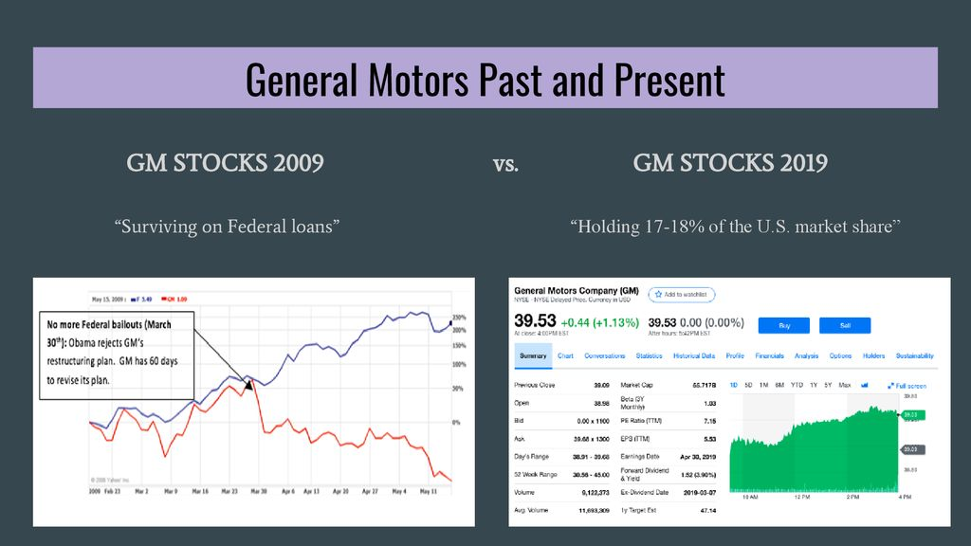
Figure 1: the financial situation of G.M. compared from 2009-2019
Source: (de Ruyter et al., 2020)
In this concern, this report aims to conduct a market analysis to identify the internal/external factors that are projected to affect the company’s profitability and reputation (Coomber, 2017). Furthermore, marketing activities will be proposed to become more lucrative and reputational in the U.K.’s automobile industry.

Marketing Analysis of Vauxhall Motors
Notably, consumers' demands are filled with the market offerings of products combined with activities that ensure strong consumer brand engagement. Park (2020) indicated that the organisation’s significance is that it tends to create value for consumers and nurture approaches to maintain strong customer engagement and brand loyalty. It is considered s specific highly essential that the organisation must explore specific segments to enhance its strategic approaches and marketing techniques to reach the intended success (De Lyon and Dhingra, 2020). Some of the crucial elements of an organisation's marketing process are illustrated in figure 1, presented below.

Figure 2: Elements of Marketing Management Activities
The figure presented above highlighted the main elements of marketing management activities, which companies must follow. Companies need first to understand consumers' demand and then implement consumer-driven marketing activities that assist the marketing department in building a stronger relationship with customers (De Propris, 2017). However, it is also notable that following this marketing management model is challenging, particularly during the COVID-19 era as it has wholly stimulated the commercial sector. In this concern, the subsequent section of this report will conduct an internal marketing analysis of Vauxhall Corporation to understand whether it succeeds in building its brand recognition and association with customers or not.

Macro Environment of the Vauxhall Motors
The internal analysis conducted above indicated that the company lacks in maintaining its sustainability due to the intensification in competition. However, certain external factors are expected to influence the business of Vauxhall Motors. This section of the report will use PESTLE Analysis and Porter Five Force Model to comprehend the industrial environmental factors that tend to influence Vauxhall's business structure and make it compulsory for the respective company to use marketing activities to gain a competitive edge.

PESTEL Analysis for Vauxhall Motors
The PESTLE analysis is conducted to assess the main external environmental factors influencing the growth and sustainability of Vauxhall Motors. The advantage of carrying out PESTLE analysis is that it helps in identifying the potential factors that can effectively impact upon the external environment of the organization. On the other hand, PESTLE analysis has a weakness that it does not evaluate the internal analysis and cannot give proper data regarding what affects the organization internally. The limitation of PESTLE analysis is that it often generates such data which is based only upon assumptions and can prove to be wrong later on (de Ruyter et al., 2020).
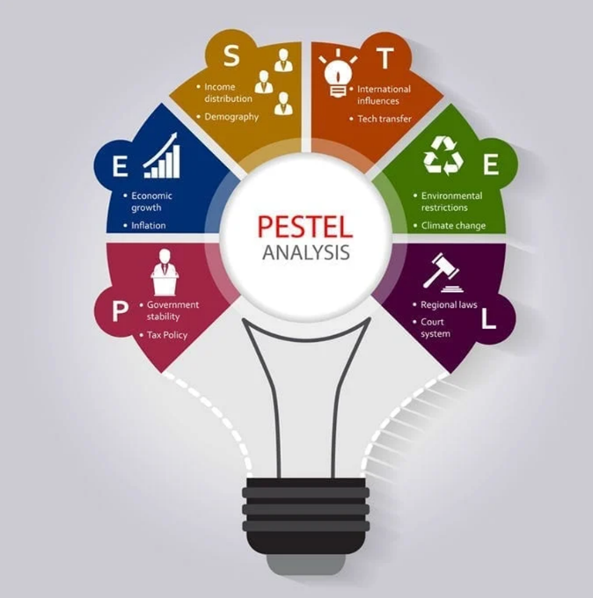
Figure 3: The macro environment of the organisation in marketing

Political Factors
The political factors of the Vauxhall Motors are mainly linked to the governmental force's policies, rules, and guidelines. In the United Kingdom, the paradigm of politics has been reshaped by BREXIT that has made a considerable impact on the commercial sector (De Lyon and Dhingra, 2020). After Brexit, the automobile sector and especially the Vauxhall Motors of the U.K. will have to revise its trading programs due to the trading barriers imposed on the export of British products to other European countries (Deepak and Jevakumar, 2019).This step is considered to be favourable because it will help the company to overcome the impact being caused by Brexit. In this concern, the chosen corporation will also focus on changing its trading process to comply with the country's political rules (de Ruyter et al., 2020).

Economic Factors
In terms of the economy, the inflation rate and unemployment have escalated across the U.K. Moreover, consumer’s spending power has decreased during the COVID-19 (Belhadi, et al., 2020). Hence, Vauxhall Motors are suggested to lower their vehicle price to make it affordable for consumers to purchase cars (Bailey, 2019). Making the prices affordable for the customers is favourable step for the company as it would allow to gain more customers who can help in stabilizing the company’s economic position.

Social factors
The social factors are allied to consumer demands and market trends. At present, consumers are highly stimulated by the spread of coronavirus. Hence, they prefer associating them with brands engaged in corporate social responsibility (CSR) activities (Belhadi, et al., 2020). Moreover, they prefer online shopping (even cars) as visiting the showroom is perilous during the COVID-19. In this concern, Vauxhall Motors are suggested to set up e-retailing websites to sell cars. This is a favourable step for the company as in this time it is important to cater the needs of the customers and socialize to the customers to acknowledge their problems and help them in making purchase online.

Technological Factors
In terms of technology, consumers demand cars that are affordable but equipped with the best technological features, such as hi-tech power steering, better audio system, auto-driving mode, electric engine/hybrid engine, etc. (Freyssenet and Jetin, 2019). Hence, Vauxhall Motors across the U.K. are suggested to elevate their vehicles' technological features to make their brand more lucrative. It is a favourable step to make the brand more lucrative as by advancement of certain features in the vehicles, the customer base would attract the brand and would be motivated to purchase it.

Legal Factors
Legal factors are linked to judicial laws and regulations required to be followed by companies in the region (Hancke and Mathei, 2021). The U.K. legislation has passed several strict human resource laws and consumer laws (Bailey and De Propris, 2017). Hence, the Vauxhall Motors has to follow the respective rules and laws; otherwise, the company’s licence can be confiscated. It is considered to be favourable for the company to follow the rules as it can ensure the safety for the company in the future.

Environmental Factors
In terms of environmental factors, automobile companies are a source of carbon emission in the region (Henry, 2019). This concern has become essential for to Vauxhall Motors to developing eco-friendly cars, such as hybrid cars and electric cars. It is a favourable step for the Vauxhall motors as it would be completing its corporate social responsibility and can reduce the carbon footprint as well.

Porter Five Forces for the Vauxhall Motors
To shape the competition in the industry, Michael Porter introduced Porter’s five forces. It is considered a strategic management tool that helps in analysing the competition faced by the organisation in the market.
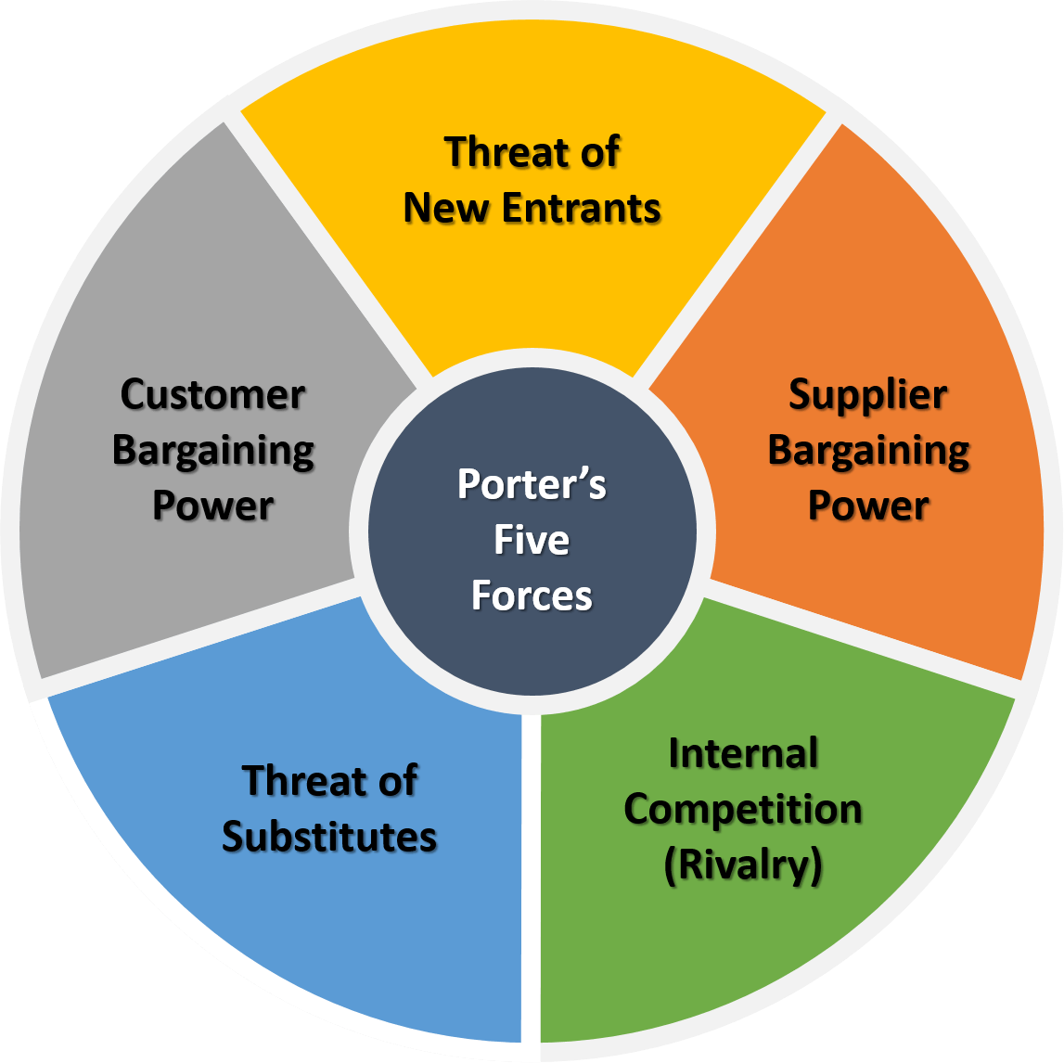
Figure 4: Porter’s five forces model
Source: (Hernandez and Garcia, 2018)
Factors | Intensity | Description
Bargaining Power of Buyers | High | In case of Vauxhall Motors, the availability of a more significant number of brands increases the bargaining power of buyers (Hernandez and Garcia, 2018)
Bargaining Power of Suppliers | Moderate | In case of Vauxhall Motors, the demand for raw materials to produce cars and deliver them to a retailing unit increase the bargaining power of suppliers (Holweg, 2019)
The threat of New Entrants | Low | For Vauxhall Motors , It is challenging for new companies to enter the automobile sector due to the higher investment and complex license acquisition
The threat of Substitute Products | High | For the Vauxhall Motors, the substitute products to cars may be based on technological level, i.e., a biofuel-based model for cars and hybrid cars (Humphreys and Munro, 2019).
Competitive Rivalry | High | For Vauxhall Motors, The availability of a more significant number of automobile brands has increased competition in the industry

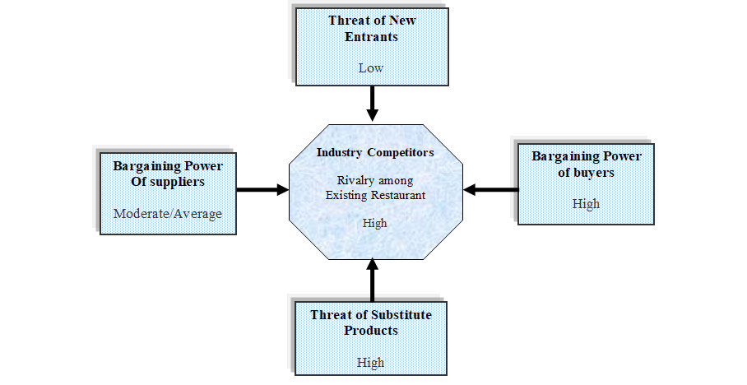
Figure 5: Porter’s Five Forces for Vauxhall Motors
Source: (Humphreys and Munro, 2019)

Internal Analysis of Vauxhall Motors
Internal analysis is considered one of the most significant aspects of the market management process (Jacobs, 2019). It highlights the brand's internal strength and value to achieve the desired target (Hernández and Garcia, 2018). Two models, which are planned to appraise the internal factors influencing the marketing process of Vauxhall Motors, are SWOT analysis and VRIO Analysis

SWOT Analysis
SWOT Analysis has been conducted to determine the main strengths of Vauxhall Motors that can be used to overcome the weaknesses. Moreover, it will assist in determining the threats that can be mitigated through the practical application of identified opportunities.

Strengths
It has a strong presence in the automobile industry
It has a contract with the British Police Agency
It is one of the largest automobile manufacturers in the U.K.
Its famous brands entail Corsa and Astra that are globally available (Kerai, 2019).
It has a workforce of more than 4000 employees.
Vauxhall Motors is also introducing mutability scheme for the disabled customers in order to provide them comfort and satisfy their needs.

Weaknesses
Regardless of global recognition, the brand mainly relies on U.K. consumers
It is less prevalent in emerging economies (Kollner, 2018)
It is not engaged in e-retailing

Opportunities
The company can expand its business in emerging Asian countries
It can produce sports cars and bikes in the future and specific certain strategies through which the organisation can reduce the carbon footprint (Park, 2020).
It can use an effective marketing strategy to enhance brand image and value in the market.

Threats
Increment in fuel prices affect the sales of Vauxhall
The intense competition from Chinese/European/Japanese manufacturers affects Vauxhall’s sustainability
COVID-19 affects the overall business revenue due to the heavy impact upon the financial condition of the targeted customers and businesses.
BREXIT affects the company’s existing strategy as the organisation can lose its current and existing customers and can have difficulty changing the policies and implementing them accordingly (Williams and Vorley, 2017).

STP for Vauxhall
The Segmentation, target market, positioning, or STP is considered a strategic approach through which the marketing of a company can be analysed effectively.
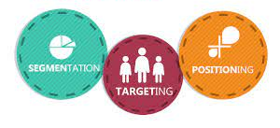
Figure 6: Segmentation, Target Market and Positioning for Vauxhall
Source: (Wang et al., 2018)

Segmentation
Segmentation identifies the customer needs and develops a persona. In the case of Vauxhall motors, the organisation introduces a wide range of affordable cars and high-end car models (Anderson et al., 2020). The car range that the company introduces is highly reliable. Demographically, the company targets customers of every age group as it designs cars that are up to the requirements of every individual.

Target Market
The target market of the Vauxhall motors is the upper-class and upper-middle class and focused mainly on the urban population.

Positioning
The positioning of the Vauxhall Motors is considered British Heritage which is for the masses. Vauxhall Motors has positioned its brand in such a way that proposes value and increases brand development.

Product Branding Strategies
By utilizing the product branding strategy known as line filling Vauxhall Motors can effectively add much more range of products to their existing product line which tends to leave to gap for the competitors (Paul, 2018). Such as, the company can add a wide range of electric cars or hybrid cars to its range that can be afforded by all the target market and does not give a chance to the rivals. It helps in attracting new customers and is also termed as Line Stretching.
On the other hand, Vauxhall Motors can also carry out the strategy of brand extension in which the company can utilize its already established brand name and introduce new products (Paul, 2018). Such as, the company can introduce hydrogen fuel or biofuel-based cars in the future by using the current name. This strategy is also known as brand stretching.

Marketing Mix Strategies of Vauxhall Motors
The marketing mix of Vauxhall motors includes the Price, Place, Product and Promotion of the brand and explains its marketing strategies (Thabit and Raewf, 2018).
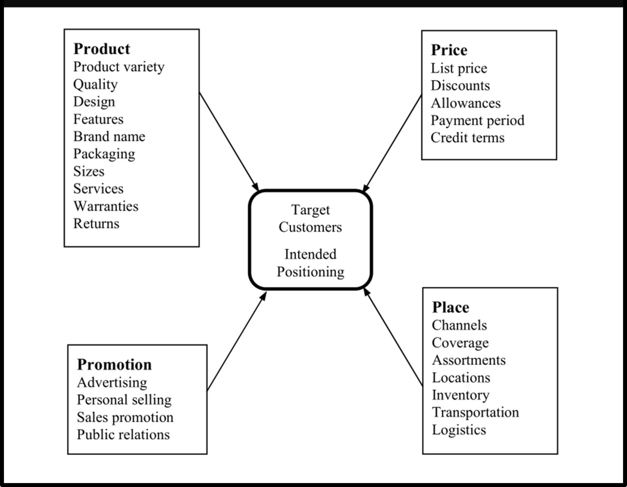
Figure: 4ps of Marketing
Sources: (Thabit and Raewf, 2018)

Pricing Strategy of Vauxhall Motors
Vauxhall Motors pricing strategy is that the company lowered the rates of its products in order to win the loyal and potential customers (Paul, 2018). The company has also re-engineered its operations for the purpose of satisfying the needs of the customers and also the customers would pay less taxes that way.

Place and Distribution Strategy of Vauxhall Motors
The Vauxhall Motors mainly has its customers in the UK. The company mainly exports about 80% of the manufactured automobiles in the Europe by means of the dealer network called Opel (Collier, 2021).

Promotional Strategies of Vauxhall Motors
Vauxhall Motors has been observed to use the 360 marketing strategy for the purpose of promoting its brand. The TV commercials are used for advertisement purposes and also the other platforms of media such as magazines and newspapers. The digital media platforms including google ad-sense is also being used by the company (Collier, 2021).
Product Strategies of Vauxhall Motors
Vauxhall Motors has a wide range of products which includes the passenger cars and commercial cars that has a variety amongst it. The company also sells used vans and cars and provides other maintenance services (Collier, 2021).

Ansoff Matrix for Vauxhall Motors
Four dimensions are utilised in the Ansoff matrix (Anderson et al., 2020). In the specific the case of Vauxhall motors, the company utilises certain strategies to maintain its stability and position in the market.

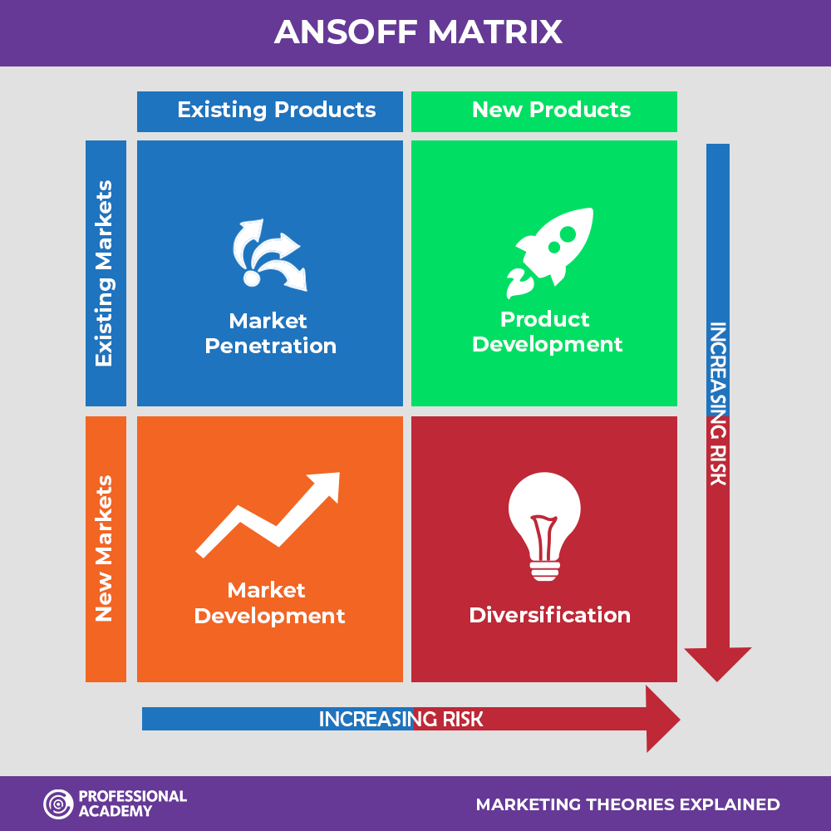
Figure 7: Ansoff Matrix
Source: (Anderson et al., 2020)

Market Penetration
In the case of G.M., it innovatively uses various market channels to launch a wide range of products. They introduce different models of cards to entice the customers and increase the competition in the market.

Market Development
The organisation is required to expand into new markets to gain a competitive advantage by introducing different price segments. However, the new models of cars can be used to target different target niches.

Product Development
By product development, the company can gain high revenues. To recover from the loss that is faced by the company due to Covid-19, it is essential to introduce value-added cars with affordable prices and better functionality.

Diversification
It is known to be the riskiest strategy. The company already uses vertical diversification. However, it can also gain benefit by investing in areas such as boats and racing cars.

Product Life Cycle Model

The product life cycle model explains the amount of time which is used by the product from being first introduced in the marketplace and then going towards the decline stage (Thabit and Raewf, 2018). Mostly all of the brands want to prevent the decline phase from occurring but sometimes its inevitable. However, in case of Vauxhall Motors, many of the products have gone through the PLC and have faced decline because due to the changing trends, the company always brought innovation and technology. In order to retain the products or a longer period of time and facing the rivals in a proper manner, there are certain attack strategies which are utilized by Vauxhall Motors where the company brings upgrades and updates into its products to fill the gaps and market its product on full-scale. As for Vauxhall Motors, there are many rivals that have often presented a great deal of competition and to fend-off these rivals and gain competitive advantage the company utilized defensive strategies. It helped the company to retain its valuable customers.

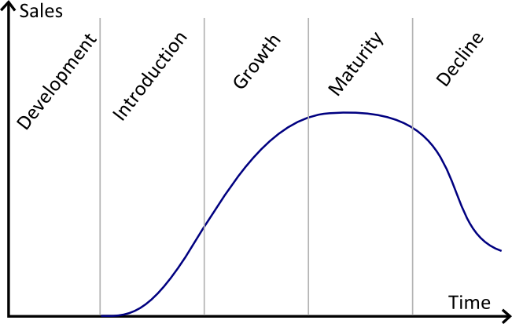
Figure: Product Life Cycle Model
Source: (Thabit and Raewf, 2018)

Recommendations for Future
Based on the above internal/external factors, it has been identified that the intense competition mainly influences Vauxhall Motors along with the changes in business attributes due to the COVID-19. Moreover, the changing demand of consumers has also influenced the company’s growth. In this concern, it has been assumed that suitable marketing activities will play a vital role in enabling Vauxhall to attain higher growth and sustainability by defying rivalry and introducing attractive promotional offers that will entice consumers. Some of the recommendations presented for Vauxhall’s marketing department are:

Introduce Promotional pricing Strategy (Value-Based Pricing)
It has been recommended that the company must introduce value-based pricing to attract consumers. In other words, the company must reduce car prices as people are unable to afford high-range cars during the COVID-19. This recommended strategy will enable the company to gain a competitive edge over rivals, and more importantly, it will entice consumers as well.

Introduce E-Retailing Platform
Notably, people during the COVID-19 do not prefer going to the showroom due to the fear of getting infected with the coronavirus. In this concern, it has been suggested that the company (Vauxhall Motors) must establish an online retailing store that will be accessible in different countries to increase the target market and thus boost sales of vehicles as well.

Use the Digital Promotion Strategy
Vauxhall Corporation is suggested to maximise the use of digitalised promotional practices in which the company should run its promotional ad campaigns on television and radio. Moreover, social media marketing should be given significant consideration as it will assist the company in targeting potential consumers. The use of advertisement campaigns will help the brand become more recognized, enticing more investors to associate with the brand. Moreover, it will encourage consumers to prefer buying cars manufactured by Vauxhall Motors. In this way, Vauxhall Motors will gain a competitive advantage over its rivals through effective promotional practices in the automobile industry.

References

- Anderson, B., Wilson, H.F., Forman, P.J., Heslop, J., Ormerod, E. and Maestri, G., 2020. Brexit: Modes of uncertainty and futures in an impasse. Transactions of the Institute of British Geographers, 45(2), pp.256-269.
- Arena, M.J., 2018. Adaptive Space: How GM G.M. and other companies are positively disrupting themselves and transforming into agile organisations. McGraw-Hill Education.
- Bailey, D. and De Propris, L., 2017. What does Brexit mean for UK U.K. automotive and industrial policy. The political economy of Brexit, pp.45-62.
- Bailey, D., 2019. Auto makers prepare to shut down again fearing No Deal Brexit disruption.
- Belhadi, A., Kamble, S., Jabbour, C.J.C., Gunasekaran, A., Ndubisi, N.O. and Venkatesh, M., 2020. Manufacturing and service supply chain resilience to the COVID-19 outbreak: Lessons learned from the automobile and airline industries. Technological Forecasting and Social Change, 163, p.120447.
- Cohan, P.S., 2017. Growth from Current or New Capabilities. In Disciplined Growth Strategies (pp. 123-163). Apress, Berkeley, CA.
- Collier, R., 2021. Strategies to promote ethical investments in the NZ market. Journal of Asia Entrepreneurship and Sustainability, 17(2), pp.55-97.
- Coomber, I., 2017. Vauxhall: Britain's Oldest Car Maker. Fonthill Media.
- De Lyon, J. and Dhingra, S., 2020. Covid-19 and Brexit: Real-time updates on business performance in the United Kingdom. Centre for Economic Performance, London School of Economics and Political Science.
- De Propris, L., Bailey (2017) Brexit and the UK U.K. automotive industry. National Institute Economic Review.
- de Ruyter, A., Hearne, D., Bailey, D., Henry, I., Li, D. and Eade, R., 2020. Regional Transport–a supply chain mapping exercise and Brexit exposure check of automotive, aerospace and rail value dependency in the WMCA region.
- Deepak, R.K.A. and Jeyakumar, S., 2019. Marketing management. Educreation Publishing.
- Esler, G., 2019. Brexit without the Bullshit. Canbury Press.
- Freyssenet, M. and Jetin, B., 2019. The deregulation of employment and finance: the Big Three in crisis.
- Grinsteins, G., Room For Growth In A Time Of Uncertainty: The UK U.K. Luxury Automotive Industry And Brexit.
- Hancké, B. and Mathei, L., 2021. Brexit, batteries and the fate of the British car industry. LSE European Politics and Policy (EUROPP) blog.
- Henry, I., 2019. Another sneak peek at Brexit book ‘Keeping the Wheels on the Road’.
- Hernández, J.G.V. and Garcia, F.C., 2018. The link between a firm s internal characteristics and performance: GPTW & VRIO dimension analysis. Revista de Administração IMED, 8(2), pp.222-235.
- Holweg, M., 2019. Death by a thousand cuts: The strategic outlook for the UK U.K. automotive industry beyond Brexit.
- Humphreys, M. and Munro, D., 2019. Brexit and the Car Industry.
- Jacobs, A.J., 2019. EU E.U. Expansion, Brexit, and Near-Term Prospects for European Car Plants. In The Automotive Industry and European Integration (pp. 405-444). Palgrave Macmillan, Cham.
- Kerai, S., 2019. Would it be feasible if everyone drove a car in the UKU.K.? Journal of Interdisciplinary Science Topics, 8.
- Köllner, C., 2018. What Brexit Means for the Automotive Industry. MTZ worldwide, 79(2), pp.8-13.
- Kotler, P., 2016. A framework for marketing management. Pearson Education Limited.
- Park, S., 2020. Marketing management (Vol. 3). Seohee Academy.
- Paul, J., 2018. Toward a'masstige'theory and strategy for marketing. European Journal of International Management, 12(5-6), pp.722-745.
- Thabit, T. and Raewf, M., 2018. The evaluation of marketing mix elements: A case study. International Journal of Social Sciences & Educational Studies, 4(4).
- Wang, L., Liu, Y., Wu, Z. and Alsaadi, F.E., 2018. Strategy optimisation for static games based on STP method. Applied Mathematics and Computation, 316, pp.390-399.
- Williams, N. and Vorley, T. eds., 2017. Creating resilient economies: Entrepreneurship, growth and development in uncertain times. Edward Elgar Publishing.

