

Module Code: ECAD6018

Assignment Title: Deepening Practice
ALN – Part 1 Journal /
Student Name: ELLE EVANS
Student Number: 2200034
BA Primary Education (QTS)

AI Acknowledgement

I confirm that I have not used any AI tools in the research and creation of this assignment.

Targets from previous module | How I have worked on these? | An example can be seen on…
Read over work. | -used the read aloud.  -Read over continuely | Throughout.

This journal will examine how I understand the role and responsibilities of the Additional Learning Needs Coordinator (ALNCo), including the main policy guidance underpinning the role, and reflect on the knowledge and practical experiences gained during my placement.

Theoretical Overview.

To support learners with additional learning needs (ALN) aged 0 to 25, the Additional Learning Needs and Education Tribunal (Wales) Act 2018 and the ALN Code for Wales (2021) place learner-centred and inclusive approaches at the centre of their framework (Welsh Government 2020). The previous SEN system has been replaced by these improvements, which also establish the ALNCo as the main leader in providing early intervention, equity and inclusion. The term “Additional Learning Needs” (ALN) identifies children and young people who require additional support to learn because of cognitive, emotional, behavioural or physical needs. The additional learning needs coordinator’s (ALNCo) job is essential to carrying out this inclusive vision (Snap Cymru, 2024).

The Additional Learning Needs Coordinator (ALNCo) play a crucial strategic role in integrating inclusive practices across the school. As outlined in the ALN Code for Wales (Welsh Government, 2021), all maintained schools are required to appoint an ALNCo, a senior staff member with the same status as the headteacher or deputy headteacher. This is strengthened by the ALNET (Wales) Act 2018, which creates a single framework for assisting students with ALN and highlighting the value of early identification, learner voice, and multi-agency collaboration.



(Powys County Council, n.d.)

The ALNCo’s leadership position enables them to influence major decisions relating to inclusive policy and provision (Welsh Government, 2020). To integrate inclusive principles into the school development plan and staff training programs, the ALNCo collaborates closely with the senior leadership team (SLT). By establishing partnerships with both staff and outside agencies, for example, Educational Psychology and CAMHS, ALNCo’s demonstrate “Collaboration” as defined by the professional standards for teaching and leadership in Wales (Welsh Government, 2017). The ALNCo also demonstrates “innovation” by adapting practices based on pupil needs and current research. This suggests that the ALNCo corresponds with national leadership standards and shapes whole-school culture by strategically and continually leading inclusive education through collaboration, innovation and evidence-based decision making.

Roles and Responsibilities of the ALNCo.

All schools must have a designated Additional Learning Needs Coordinator (ALNCo) in line with the Additional Learning Needs and Education Tribunal (Wales) Act 2018 and the ALN Code for Wales (2021). The ALNCo collaborates closely with teachers’ parents/carers, outside agencies and specialists, for example, speech and language and educational psychologists. A main aspect of the role involves advising and supporting colleagues in school to ensure that teaching methods meet a wide range of needs. This aligns with the inclusive pedagogy model developed by Florian and Black-Hawkins (2011), which supports the idea that all teachers keep responsibility for all students and that it is their job to adapt lessons to meet the needs of each child. Similarly, Mould (2021) highlights how important it is for schools to keep reflecting and modifying their teaching methods to meet the needs of all learners. The United Nations Convention on the Rights of the Child (UNCRC) emphasises the significance of a child’s right to an education (Article 28) and to have their opinions considered in decisions that impact them (Article 12). Through the use of person-centred planning and the inclusion of student voice, the ALNCo’s role reflects these values. Furthermore, Estyn's thematic review from 2024 highlights how crucial the ALNCo role has become, especially in schools where they are embedded in leadership teams and have a clear impact on outcomes and provision. The report highlights the benefits of early identification and a whole-school commitment to inclusive values. Peer and Reid (2021) further suggest that the ALNCo’s role is crucial for helping teachers in implementing inclusive practices and ensuring that resources and teaching methods are adapted for students with additional learning needs. This implies that the ALNCo plays an important role in developing teaching methods and supporting teachers to meet the needs of students.

(Early Years Matters TV, 2023)

Reflections.

Personal Understanding of the Role.

Throughout my previous three placements, I have developed a deeper understanding of the responsibilities of the Additional learning Needs Coordinator, which has greatly changed my perspective. On placement, I observed a student who struggled to concentrate and commit to daily schedules. In response, the ALNCo and class teacher collaborated to implement an Individual Development Plan (IDP), emphasising the value of early, individualised support. IDPS are crucial; teachers and parents/carers develop and approve them to support children with additional needs (Welsh Government, 2021). A visual schedule and a star chart system were two strategies I saw being used to motivate children to stay on task. This aligns with Bandura's Social Learning Theory (1977), which highlights the value of consistent visual and reward-based techniques in supporting children’s social and behavioural development through modelling and reinforcement. These interventions not only supported children’s engagement but also positively impacted children’s well-being and academic progress.

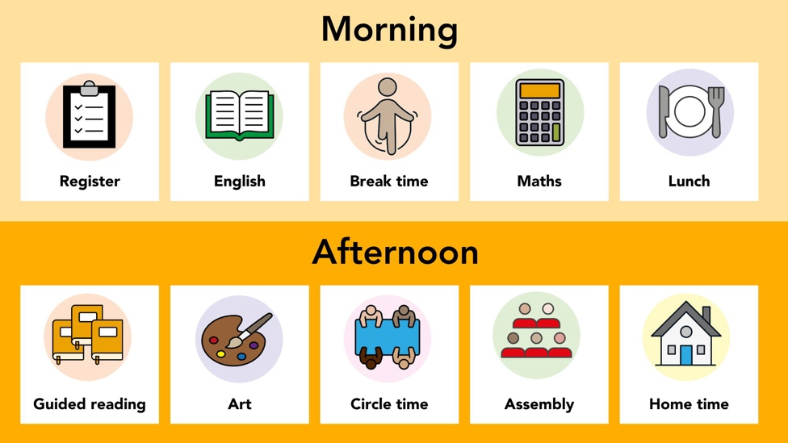
(PlanBee, 2022)

The ALNCo plays an important role in organising meetings with families, teachers and outside agencies to monitor the success of intervention and modify aims. This experience highlighted how crucial early intervention, teamwork, and communication are to promoting learners’ development. My observations have shown that the ALNCo’s job is essential in communicating with teachers, families and outside specialists to plan individualised support for each child. This aligns with Bronfenbrenner’s Ecological System Theory (1979) as the ALNCo works across microsystems, home, school and outside services, it supports the individual in a cohesive, complete manner. Hallett and Hallett (2010) position the ALNCO as a leader who impacts inclusive practices throughout the school, in addition to being a coordinator. Additionally, ESTYN (2024) emphasises how the ALNCo influences whole-school provision and staff professional development. These experiences have strengthened my understanding. I now see the ALNCo as a key advocate for inclusion and pupil well-being, ensuring that support is holistic, consistent and person-centred.
This is an example of an IDP.
 (Millhouse Primary School, 2017)

Limitations and Barriers

Boyle and Anderson (2020) state that the ALNCO’s effectiveness is restricted by several long-term problems, with ALNCo’s handling heavy caseloads, administrative responsibilities, and professional coordination, time and workloads pressures are common and frequently result in fatigue and stress. Additionally, Estyn (2018) argues that the lack of resources and staff training makes the issue worse because teachers may not feel comfortable helping students with ALN, which puts the responsibility back on the ALNCo. Curran et al. ( 2018) further argue that staff misperceptions of the ALNCo role can lead to limited collaboration and inconsistent implementation of support strategies. Furthermore, resistance or disagreement from parents may limit the effectiveness of these interventions. This implies that schools are required to deal with problems like workload, funding, staff training and parent communication if they want ALNCos to be effective.

According to Bronfenbrenner’s Ecological Systems Theory (1979), there are three levels at which barriers to inclusion can be seen, the microsystem, which is impacted by societal attitudes and policies, the mesosystem, which is the relationship between school staff and families, and the exosystem, which includes external agencies and community resources. According to the Welsh Government (2024), leadership must prioritise CPD, clearly define the ALNCo role, and provide collaboration between stakeholders to address these issues, which require support from the whole school. This implies that the ALNCo has a better chance of meeting the needs of each individual and implementing improvements when the learning environment adheres to inclusive values.

Teaching Standards and Professional Development.

According to the Children's Commissioner for Wales (2024), the ALNCo’s role in Wales requires a high level of education and continuous professional development, with a focus on inclusive practices and differentiated teaching for students with special needs.
ALNCo’s demonstrate the collaborative practices necessary for inclusive education by collaborating with teachers, parents, and outside agencies. Building on their role in implementing IDPS, ALNCo’s further promote creativity in inclusive planning and learning adaptions which guarantees that the needs of every learner are successfully satisfied.
The Curriculum for Wales (2020) highlights that the ALNCo is essential to implementing inclusive principles in the classroom. According to the ALN Code (Welsh Government, 2021), ALNCo’s deliver training and guidance to staff members, encouraging them to adjust their pedagogy to accommodate all students’ needs. ALNCos display values like teamwork, creativity and professional development that align with the Professional Standards for Teaching and Leadership in Wales (Welsh Government, 2017).
As I reflect on my own work, I see that if I were to take on the job and responsibilities of an ALNCo, I would want to deepen my knowledge of evidence-based interventions and inclusive strategies. Moreover, I would work to create an environment of professional collaboration throughout the whole school.

Conclusion
My understanding of the ALNCo’s strategic and collaborative role in advancing inclusive education throughout the school has improved as a result of this journal. The ALNCo plays an important role in guiding professional development, providing support, and ensuring the implementation of learner-centred approaches, as stated by the ALNET Act (2018) and the ALN Code (2021). My placement experiences proved how crucial early intervention, teamwork, and individual development plans are to helping children with ALN. However, barriers like staff attitudes, workload and the lack of resources could prevent progress.

References

Bandura, A. (1977) Social Learning Theory. Englewood Cliffs, NJ: Prentice Hall.

Boyle, C. and Anderson, J., 2020. Inclusive education: Navigating the new normal. In: C. Boyle and K. Topping, eds. Inclusive Education: Global Issues and Controversies. Rotterdam: Sense Publishers, pp. 1–14.

Bronfenbrenner, U. (1979) The Ecology of Human Development: Experiments by Nature and Design. Cambridge, MA: Harvard University Press.

Children’s Commissioner for Wales. (2024). ALN Policy Position - Children’s Commissioner for Wales. [online] Available at: https://www.childcomwales.org.uk/our-work/policy-positions/aln-policy-position/.

Curran, H., Moloney, H., Heavey, A. and Boddison, A., 2018. It’s about time: The impact of SENCo workload on the professional and the school. British Journal of Special Education, 45(4), pp. 337–355.

Early Years Matters TV (2023). Creating an Inclusive Early Childhood Classroom. [online] YouTube. Available at: https://www.youtube.com/watch?v=AZRWZLhiEjU.

Estyn (2018). Supporting pupils with special educational needs in mainstream schools. Cardiff: Estyn.

ESTYN (2024). The additional learning needs system: Progress of schools, settings and local authorities in supporting pupils with additional learning needs. [online] Available at: https://estyn.gov.wales/app/uploads/2024/12/The-additional-learning-needs-system.pdf. (Accessed 29 April).

Florian, L. and Black-Hawkins, K. (2011). Exploring inclusive pedagogy. British Educational Research Journal, 37(5), pp.813–828.

Hallett, F. & Hallett, G. (2010). Leading learning: the role of the SENCO. In F. Hallett & G. Hallett (Eds). Transforming the role of the SENCO: achieving the National Award for SEN Coordination (pp. 51-60). Maidenhead, UK: Open University Press.

Millhouse Primary School. (2017). What is an IEP? - Millhouse Primary School. [online] Available at: https://www.millhouseprimary.co.uk/what-is-an-iep/ [Accessed 26 Apr. 2025].

Mittler, P. (2000). Working Towards Inclusive Education: Social Contexts.

Mould, K. (2021). EEF Blog: Assess, adjust, Adapt – What Does Adaptive Teaching Mean To…. [online] Education Endowment Foundation. Available at: https://educationendowmentfoundation.org.uk/news/eef-blog-assess-adjust-adapt-what-does-adaptive-teaching-mean-to-you.

Peer, L. and Reid, G. (2021) Special educational needs : a guide for inclusive practice. Third edition. Edited by L.
PlanBee. (2022). Visual Timetable | Free KS1 and KS2. [online] Available at: https://planbee.com/pages/visual-timetable.

Powys County Council. (n.d.). ALN Transformation. [online] Available at: https://en.powys.gov.uk/article/6360/ALN-Transformation?ccp=true#cookie-consent-prompt.

Rix, J., Sheehy, K., Fletcher-Campbell, F., Crisp, M. and Harper, A. (2023) Equality, Participation and Inclusion 1: Diverse Perspectives in Education. 3rd edn. London: Routledge.

Snap Cymru. (2024). What can I expect from Health? [online] Available at: https://www.snapcymru.org/get-support/health-support/ [Accessed 1 May 2025].

Welsh Government (2018) Additional Learning Needs and Education Tribunal (Wales) Act 2018. Cardiff: Welsh Government. Available at: https://www.legislation.gov.uk/anaw/2018/2/contents/enacted (Accessed: 1st May 2025).

Welsh Government (2020). The additional learning needs transformation programme: frequently asked questions [HTML]. [online] GOV.WALES. Available at: https://www.gov.wales/additional-learning-needs-transformation-programme-frequently-asked-questions-html.

Welsh Government (2021). The Additional Learning Needs Code for Wales 2021 WG21-23. [online] Available at: https://www.gov.wales/sites/default/files/publications/2024-04/220622-the-additional-learning-needs-code-for-wales-2021%20%282%29.pdf.

Welsh Government (2024) ALNCo task and finish group: report to the Minister for Education and Welsh Language [HTML] | GOV.WALES. [online] Available at: https://www.gov.wales/alnco-task-and-finish-group-report-minister-education-and-welsh-language-html.

