STUDENT:FRIDA IZABELLA TAC (2118358)
MODULE:PROBLEM SOLVING AND DECISION MAKING BMSW4004
LECTURER: NICHOLAS WORTHINGTON
Reducing the staff shortage at proper care

ABSTRACT

This report is analysing the underlying causes which led to staff shortage within the NHS and more precisely, the adult social care section. Proper Care is an institution within that department and is facing a major staff shortage. Using the PESTLE analysis and the Fishbone diagram, this report aims to identify the causes of the staff shortage followed by solutions for these problems. The evaluation of the solutions was realised using the weighted decision matrix followed by a PMI scheme.

Table of Contents
ABSTRACT 1
1.INTRODUCTION 3
2.THE PROBLEM AT PROPER CARE 3
3.CAUSES OF THE PROBLEM 3
3.1.PESTLE ANALYSIS 3
3.2.FISHBONE DIAGRAM 5
4.POSSIBLE SOLUTIONS 7
4.1.DECISION MATRIX 7
4.2.PMI 8
5.THE PLANNING, MONITORING AND EVALUATION OF THE SOLUTIONS 10
6.CONCLUSION 12
REFERENCE LIST 13

1.INTRODUCTION

With over 1.3 million employees, the National Health Service (NHS) is the largest employer in the world (NHS Jobs - Working in the NHS, 2022). Out of the 1.3 million employees 1.65 million work in the adult social care sector. This section of the NHS had a decrease of 24.8% in employment during 2020 (Personal Social Services: Staff of Social Services Departments, England 2020 - NHS Digital, 2020). The acute decline in the employment rate within NHS has been building up for the past decade directly affecting the quality of the healthcare . If this issue will not be solved in the immediate future all the divisions within the NHS will not be able to keep up with the demand and will eventually collapse. The aim of this report is to successfully analyse the factors that are contributing to this complex problem and propose implementable solutions.

2.THE PROBLEM AT PROPER CARE
The staff shortage at Proper Care, might have multiple roots that are interconnected: healthcare careers are not attractive for the young generation, more existing healthcare professionals leaving the profession. This issue is causing negative impact on the quality of healthcare on top of adding additional stress for the existing healthcare professionals, determining more and more of them to leave.

3.CAUSES OF THE PROBLEM

3.1.PESTLE ANALYSIS
Pestle analysis was created in 1967 as a means to analyse the factors contributing to a complex problem and to enable strategic thinking. PESTLE is an acronym that stands for the types of factors taken into consideration in this tool: Politic, Economic, Social, Technologic, Legal and Environmental (Akman, 2020).
All these factors have been considered while creating the Pestle analysis for healthcare staff shortage, as seen in figure 1.
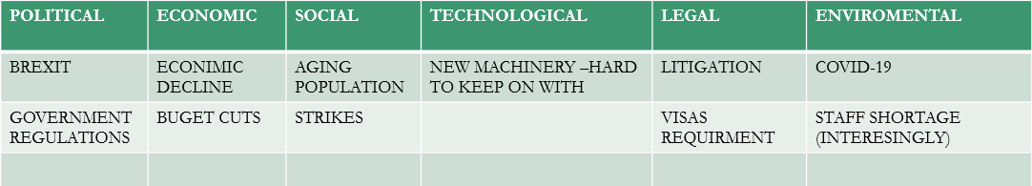
Figure 1.

BREXIT
o EU citizens are heavily relied upon to work in the UK's healthcare system. Due to Brexit, recruiting European healthcare professionals has become extremely difficult and therefore unattractive. The cost for applying, registering, and taking two competence tests for an EU certified nurse, for example, is £1,170. There could be a high cost associated with retaking the tests (Brexit and what it means for nursing and midwifery - The Nursing and Midwifery Council, 2022).

ECONIMIC DECLINE (BUDGET CUTS)
o A 3% pay increase was granted to healthcare professionals in 2021, after an initial proposal of 1% angered many. Several observers considered this to be a big victory. Despite this, the pay raise seems more like a cut disguised as an increase with inflation now at 9.0% (Readers’ poll: do NHS staff deserve a pay rise of more than 3 per cent, 2021).
AGING POPULATION
- Health assistance demands are rapidly increasing in the adult care sector, especially with the aging of the population, making it harder to manage the already understaffed sector.
NEW MACHINERY
- Health professionals are facing a lot of extra pressure with learning how to use all the new technologies designed to make their jobs easier.
LITIGATION
  - Clinical negligence claims accounted for 2% of the NHS's budget in 2018-2019. Litigation claims have increased steadily in recent years, possibly due to the stress that health professionals face due to staff shortages. Additionally, it has been found that 18% of nurses report feeling insecure about their jobs as a result of their fear of litigation ( Yau et al., 2020).

STAFF SHORTAGE

- Chronic staff shortages are causing worsening working conditions (longer shifts, more responsibilities), leading to a wave of staff departures.
COVID-19
- Studies have shown that during the COVID-19 outbreak, the frontline nurses experienced a variety of mental health challenges, especially burnout and fear for their safety along with emotion exhaustion of over 34% ( Roberts et al., 2021, p.106219)

3.2.FISHBONE DIAGRAM
By assessing the causes and sub-causes of the problem, fishbone diagram analysis uncovers all the symptoms of the issue. Thus, it is also referred to as a cause-effect analysis. In order to discover the causes of healthcare professionals’ shortage, only four categories of the causes have been incorporated: people, method, equipment and environment; as seen in Figure 2. Typically, a fishbone diagram also includes the categories “materials” and “measurement”, but due to the lack of available information regarding the subjects in correlation with this report’s problem, the two categories have been eliminated (Bose, 2012).
.

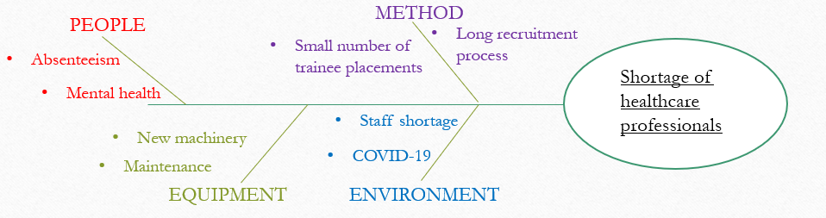
Figure 2.
The absenteeism within NHS is one of the main factors that lead towards the stress and exhaustion in the field. As it can be observed in Figure 3. The rates of absenteeism tend to go up during the winter season and go down during the summer (nhs.uk/ data-and-information, 2021).
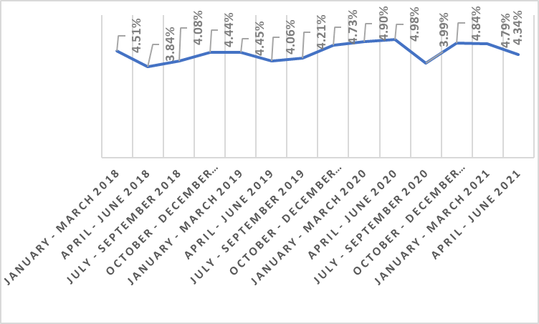
Figure 3. (nhs.uk/ data-and-information, 2021)
The mental health problems of the NHS workers caused by stress can be linked with a multitude of other factors, such as absenteeism, COVID-19 and staff shortage, as mentioned above.
The small number of trainee placement and the long process of recruiting are unveiling another side of the same problem. Not only that the NHS employees are not motivated to stay in the profession but becoming an NHS worker is extremely hard and time-consuming (Reducing the delay between job offer and start date, 2022).
In spite of the high demand for trainee placements in the NHS, the number of places is extremely low. One thousand seven hundred and fifty applicants submitted applications in September 2019, but the NHS only offered 260 trainee positions (Frequently Asked Questions (FAQs) about the GMTS, 2020).
Furthermore, a typical pre-employment program participant must wait 50-60 days before commencing their career. Consequently, participants are more likely to drop out of the program and search for other employment(Reducing the delay between job offer and start date, 2022).

4.POSSIBLE SOLUTIONS
Analysing the problems found using the PESTLE analysis and the Fishbone diagram four possible solutions were found:
Factors contributing to NHS staff shortage | Solutions
1.New machinery | Complement the staff shortage with robots
2.Long recruitment process | Reduce the recruitment process time
3.Mental health | Additional holiday
4.Absenteeism | Provide transport during winter season
Table 1.
While the new machinery is hard to keep up with, the continuous evolvement of technology could also have a positive aspect. The artificial intelligence could soon replace some of the tasks that employees have to do. The reduction of time for the recruitment process could lead to less people choosing different careers while the additional holiday could improve the work-life balance of the NHS employees, therefore reducing the stress and mental problems that they are facing. Lastly, as it can be observed in Figure 3, NHS employees tend to absent from work during winter time, which might be corelated with difficulties regarding transport due to the cold weather. Providing transport during this period could improve the absenteeism rate.

4.1.DECISION MATRIX
When considering alternatives, a weighted decision matrix allows for comparing them according to a variety of different criteria of varying importance such as cost, time employee satisfaction and feasibility. A weighting scale, which in this case was from 0.1 to 1.5, was given based on each solution’s perceived impact on the NHS and then used as a multiplier for the score of every criterion used, as it can be observed in Figure 4. After the final calculations only the last three solutions obtained a positive score, deeming the first one not fit for implementing (Domínguez et al., 2019, pp.52-59)
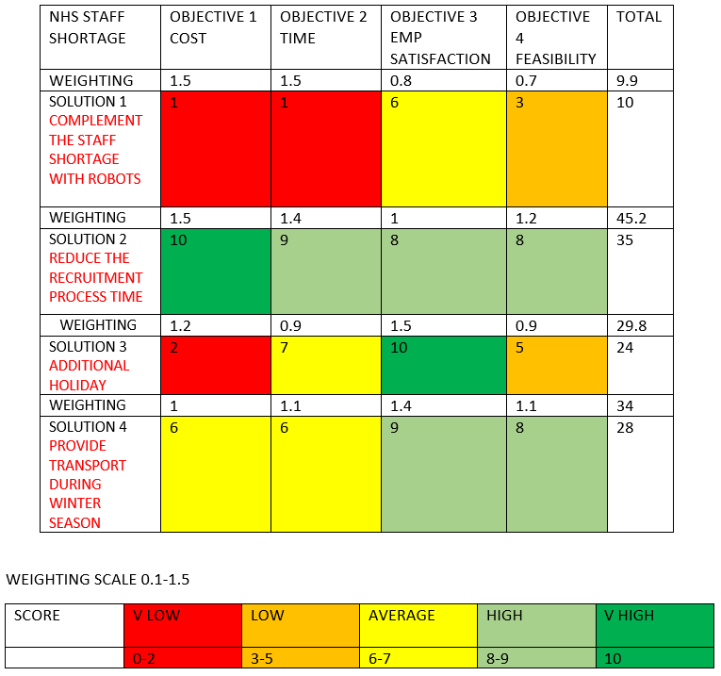
Figure 4.

4.2.PMI
A brainstorming and decision-making tool, PMI (plus, minus, interesting) facilitates creative and critical thinking. The purpose of this approach is to encourage the analysis of ideas, concepts, and experiences from different perspectives. Edward de Bono developed PMI as part of his efforts to promote lateral and critical thinking (Ritchhart and Perkins, 2005). The PMI model was used to analyse the four ideas initially proposed, considering the advantages, disadvantages and different approaches for each solution, as presented in Figure 5.
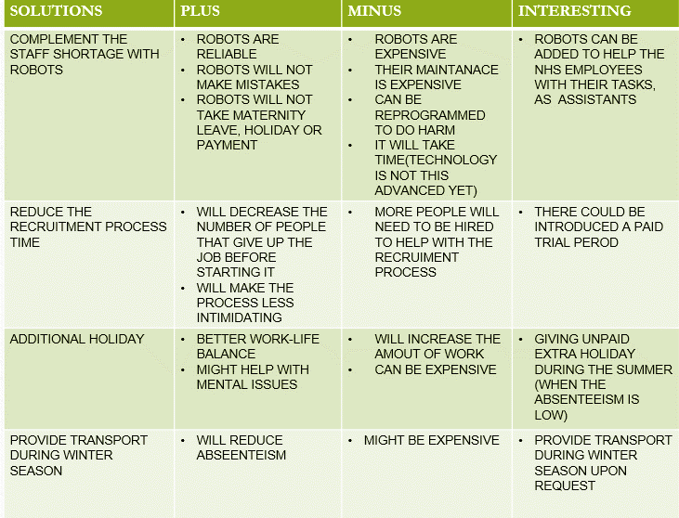
Figure 5.
Given the fact that the first solution obtained a negative score on the weighted decision matrix, and it had the most disadvantages on the PMI, “complementing the staff shortage with robots” was eliminated from the final list of solutions. Offering unpaid extra holiday during the summer, when the absenteeism is low was considered a final solution, since it would minimise the disadvantages of additional holiday while keeping the advantages. Providing transport during the winter, but only upon request would also reduce some of the costs for Proper Care while keeping the benefits.

5.THE PLANNING, MONITORING AND EVALUATION OF THE SOLUTIONS
Final solution 1- Reducing the recruitment process’ time
The first step in implementing this solution is the use of assessment centres. Healthcare support worker (HCSW) vacancies are often advertised separately, so applicants may be disoriented as to which position, they are most suitable for. A single suitable candidate may be interviewed on several occasions due to the fact that they apply to several positions at the same time, which can negatively impact the quality of each application. The use of assessment centres and/or centralized recruiting can help Proper Care optimize staff time, reduce costs, and improve candidate experience (NHS England » Maximising the effectiveness of recruiting new people to the NHS, 2022).
The NHS applicants have to undertake six mandatory checks prior to employment according to Employment standards and regulation, (2022):
- Verification of identity checks
- Right to work checks
- Registration and qualification checks
- Employment history and reference checks
- Criminal record checks & Model Declaration Forms
- Occupational health checks
The verification of these documents represents what is slowing down the process of recruitment. A collaboration with a software such as “Credential” would allow Proper Care to have access to automatic verification of documents and professional registrations. By using this software thousands of hours could be saved while reviewing applications according to Latham, (2022).
Final solution 2- Providing transport during winter season upon request
As the absenteeism rate is at its highest during winter time, this could be correlated with difficulties in transportation due to unfavourable weather. Collaboration with an agency that offers driving services along with buses hire would offer the perfect alternative. 8Rental is one such company among many and it offers a variety of vehicles to choose from depending on the needs of the company. If the requests for transport during the winter period would be numerous 8Rental offers buses for hire and if the requests would be low, there is also availability for minivans. On top of providing better work conditions for Proper Care employees, this approach would also be favourable for the environment. 8Rental is a good candidate for this partnership as is a reliable company which is collaborating with large companies such as Bayer (Rent a car, minibus, coach or limousine with driver in Europe, 2022).

Final solution 3- Offering unpaid extra holiday during the summer
Offering an additional 5 days of unpaid holiday during the summer, when the absenteeism rate is low and additionally when most people prefer to take their holidays, would be rather simple to implement without causing major disruptions within Proper Care. In order to avoid over soliciting the remaining employees the additional holiday must be requested at least 3 months in advance so it can be incorporated in the rota. Additionally, no more than 2 people on the same section can be on holiday at the same time in order to avoid becoming understaffed.
All these solutions are expected to have a positive impact on the absenteeism rate at Proper Care, which is one of the most important reasons for healthcare professionals’ shortage. In order to monitor the effects of the three solution a Key Performance Indicator(KPI) was created as a guidance for meeting specific targets after each year, as it can be observed in Figure 6.
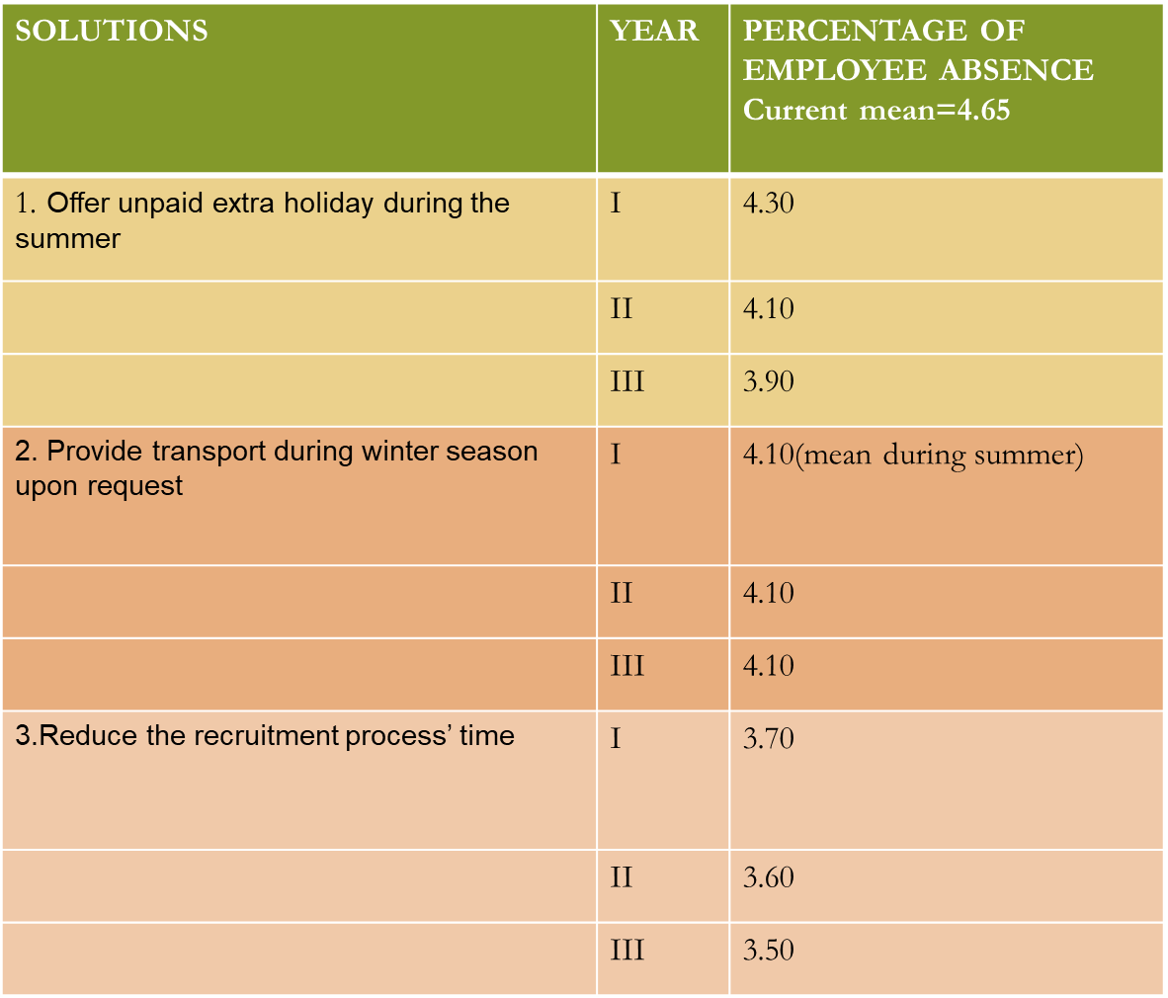
Figure 6.

6.CONCLUSION

The staff shortage issue within the NHS remains a national struggle that is threatening the first free and reliable healthcare system in the world. The problem with NHS staff shortage has two main parts: retaining the existent staff and recruiting new employees which are both failing miserably at the moment. However, each institution is free to make small changes and turn around the whole narrative by prioritising their employees and making the NHS great again.

REFERENCE LIST
- 2020. Frequently Asked Questions (FAQs) about the GMTS. [ebook] NHS graduates, Appendix 2. Available at: <https://www.iow.nhs.uk/Downloads/Education%20Centre/Leadership/081419_GMTS_March2020_Appendix2_FAQs_V0.1_TC.pdf> [Accessed 2 July 2022].
- 8rental.com. 2022. Rent a car, minibus, coach or limousine with driver in Europe. [online] Available at: <https://8rental.com/> [Accessed 24 July 2022].
- Akman, M.K., 2020. Defence Management and PESTLE analysis. Ante Portas-Security Studies, 1(14), pp.93-102.
- Bose, T.K., 2012. Application of fishbone analysis for evaluating supply chain and business process-a case study on the St James Hospital. International Journal of Managing Value and Supply Chains (IJMVSC), 3(2), pp.17-24.
- Domínguez, C.R., Martínez, I.V., Peña, P.M.P. and Ochoa, A.R., 2019. Analysis and evaluation of risks in underground mining using the decision matrix risk-assessment (DMRA) technique, in Guanajuato, Mexico. Journal of Sustainable Mining, 18(1), pp.52-59.
- England.nhs.uk. 2022. NHS England » Maximising the effectiveness of recruiting new people to the NHS. [online] Available at: <https://www.england.nhs.uk/nursingmidwifery/healthcare-support-worker-programme/attracting-people-into-healthcare-support-worker-roles/maximising-the-effectiveness-of-recruiting-new-people-to-the-nhs/> [Accessed 23 July 2022].
- Jobs.nhs.uk. 2022. NHS Jobs - Working in the NHS. [online] Available at: <https://www.jobs.nhs.uk/about_nhs.html#:~:text=The%20NHS%20%2D%20a%20rewarding%20place,GP%20practice%20or%20practice%20nurse> [Accessed 6 July 2022].
- Latham, K., 2022. NHS Recruitment Process: Everything HR Need To Know. [online] Credentially.io. Available at: <https://www.credentially.io/insights-posts/nhs-recruitment-process-for-nhs#:~:text=Ways%20to%20speed%20up%20the%20NHS%20shortlisting%20process&text=Automate%20verification%20of%20documents%20and,Automate%20evidence%20and> [Accessed 24 July 2022].
- NHS Digital. 2020. Personal Social Services: Staff of Social Services Departments, England 2020 - NHS Digital. [online] Available at: <https://digital.nhs.uk/data-and-information/publications/statistical/personal-social-services-staff-of-social-services-departments/england-2020> [Accessed 18 July 2022].
- NHS Digital. 2021. NHS Sickness Absence Rates - NHS Digital. [online] Available at: <https://digital.nhs.uk/data-and-information/publications/statistical/nhs-sickness-absence-rates> [Accessed 24 July 2022].
- NHS Employers. 2022. Employment standards and regulation. [online] Available at: <https://www.nhsemployers.org/topics-0/employment-standards-and-regulation> [Accessed 23 July 2022].
- NHS Employers. 2022. Reducing the delay between job offer and start date. [online] Available at: <https://www.nhsemployers.org/articles/reducing-delay-between-job-offer-and-start-date> [Accessed 2 July 2022].
- Nmc.org.uk. 2022. Brexit and what it means for nursing and midwifery - The Nursing and Midwifery Council. [online] Available at: <https://www.nmc.org.uk/registration/what-brexit-means-for-nursing-and-midwifery/> [Accessed 1 July 2022]
- Ritchhart, R. and Perkins, D.N., 2005. Learning to Think: The Challenges of Teaching Thinking. Cambridge University Press.
- Roberts, N.J., McAloney-Kocaman, K., Lippiett, K., Ray, E., Welch, L. and Kelly, C., 2021. Levels of resilience, anxiety and depression in nurses working in respiratory clinical areas during the COVID pandemic. Respiratory medicine, 176, p.106219
- Thetimes.co.uk. 2021. Readers’ poll: do NHS staff deserve a pay rise of more than 3 per cent? [online] Available at: <https://www.thetimes.co.uk/article/readers-poll-do-nhs-staff-deserve-a-pay-rise-of-more-than-3-per-cent-b8rh6hw0l> [Accessed 1 July 2022].
- Yau, C.W.H., Leigh, B., Liberati, E., Punch, D., Dixon-Woods, M. and Draycott, T., 2020. Clinical negligence costs: taking action to safeguard NHS sustainability. BMJ, 368.

