
Student Name | Saima Ijaz
Student ID | 2237202
Module Details | Community Care and Management of Longer-Term Conditions  (LCHS7003_BIRM)
Module Lecturer | Dr Aishat Bakre
Assignment Details | Component 1: Information Booklet of Long- term Condition Management

Rheumatoid Arthritis
Information Booklet

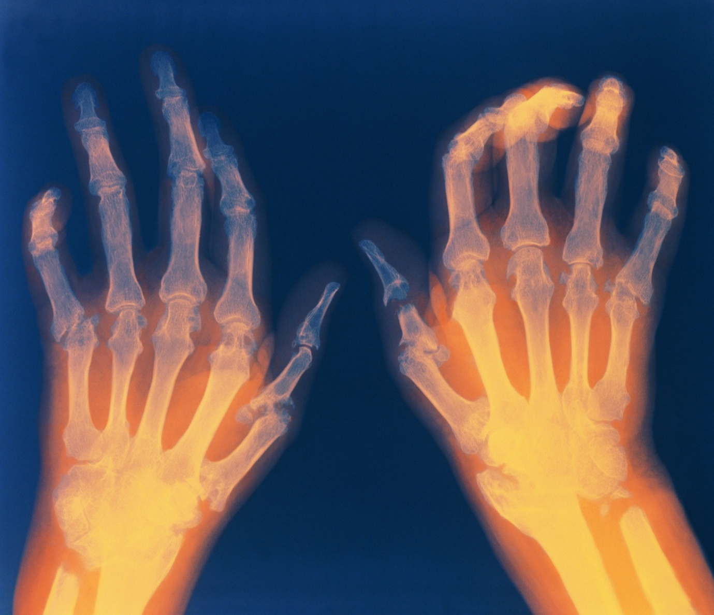
(Very Well Health, 2018)

Contents
Definition 4
Prevalence and incidence of rheumatoid arthritis UK statistics 6
Prevalence and incidence of rheumatoid arthritis worldwide statistics 6
Risk factors/aetiology of rheumatoid arthritis 7
A critical evaluation of the impact of rheumatoid arthritis with focus on physical, psychological and social implications 8
Wider implications for families involved in care provision 9
Treatments which are available in the UK through the NHS 10
Identify and investigate current theoretical perspectives including models 10
Critical examination of local and national health and social care agendas for rheumatoid arthritis management in the UK 13
Critical comparison of national and local agendas 15
Recommendations 15
References 17

Definition
Rheumatoid arthritis (RA) is a chronic long-term autoimmune inflammatory disease. The immune system which is the body’s natural self-defence system and it protects a human being from infections and illness but in RA body’s own immune system mistakenly attacks healthy tissues, rather than germs or viruses (NHS, 2026).
A joint is where two or more bones meet and it allows bending, twisting and turning freely. The joint stops bones to move far and holding them together by a capsule. In the capsule, there is an inner lining called the synovium which makes a thick fluid called synovial fluid. This fluid protects the joint.
Joint with and without Synovial lining
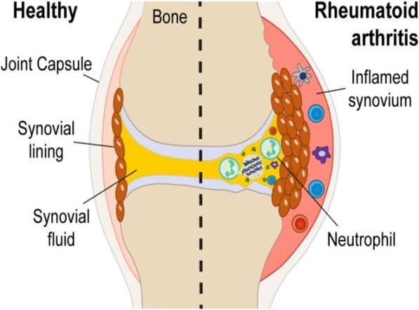
(Molecular and cellular proteomics, 2024)
A thin layer of slippery tissue called cartilage covers the end of bones. It works like a cushion, stopping bones from rubbing to each other. Body heals itself with the help of inflammation after an infection or injury but in RA body sends this inflammation mistakenly to the joints (NHS, 2026).
If RA untreated, it can damage joints, cartilage and nearby bones. It can cause pain, swelling and stiffness in the joints.
Difference between healthy bones of hand and hand affected by RA
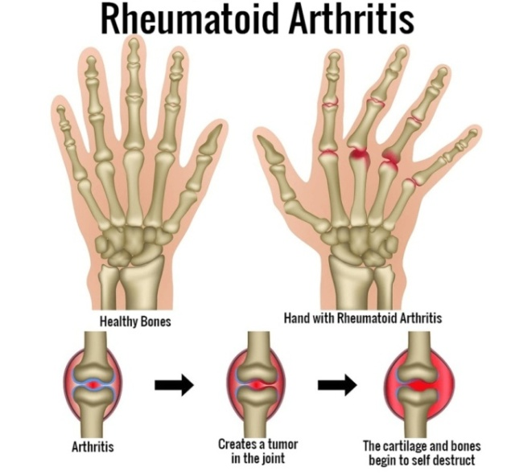
(Ratan Jyoti Group of Hospitals, 2023)
Treatment works best if RA is diagnosed earlier that’s why it is important to learn the signs and symptoms. These symptoms and signs increase during periods known as flares or exacerbations but on the other hand, remission periods which is when symptoms disappear completely (NHS, 2026).
RA is mostly common in individuals aged 40-60. Usually, Peak onset is in middle age, but it can strike at any age.

Prevalence and incidence of rheumatoid arthritis UK statistics

According to Arthritis UK (2025), the burden of RA in the UK is affecting significantly. Approximately, 1% from adult population in UK is affected by rheumatoid arthritis, which translates to around 400,000 to 450,000 adults. High prevalence in women, who are 2/3 times more likely develop the condition than men with an incidence of 3.6 women per 10,000 per year compared to 1.5 men per 10,000 per year and contributes to significant disability, co-morbidities, and societal costs. In the UK, 27,000 adults are newly diagnosed with RA each year.

Rheumatoid prevalence increases with age

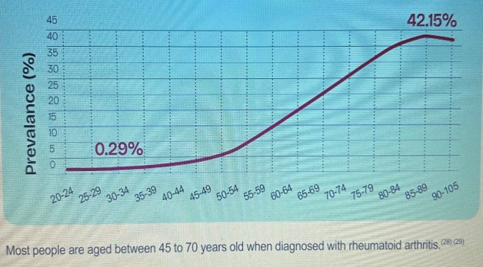
(Arthritis UK, 2025)

Prevalence and incidence of rheumatoid arthritis worldwide statistics
The Global Burden of Disease Study 2021 provides a comprehensive overview of the burden and prevalence of RA worldwide, according to this study, key statistics include:
- Global Incidence: Approximately 0.24% to 1% population is affected by RA globally.
- Prevalence: The age standardised prevalence rate (ASPR) is 222.68 per 100,000 populations, with an age standardised incidence rate (ASIR) of 144.09 per 100,000 populations.
- Mortality: The age standardised mortality rate (ASMR) is 0.13 per 100,000 populations whilst mortality rate is declining.
- Disability Adjusted Life Years (DALYs): The age standardised DALYs rate is 34.54 per 100,000 populations, with an estimated annual percentage change of -1.59.
(National Library of Medicine, 2025)
The World Health Organisation (2023), reported that approximately 18 million people worldwide were living with RA in 2019. Around 70% were women, and approximately 55% were aged over 55.
According to World metrics (2026), annual incidence of RA is 50 per 100,000 people globally.

Risk factors/aetiology of rheumatoid arthritis
There are a number of genetic and environmental factors which may increase the chance to develop RA. These factors can be divided into two groups, such as:
Non-modifiable risk factors
Genes, gender, age and ethnicity are counts in non-modified risk factors which cannot be change to prevent RA.
Genes: HLA-DR shared epitope genes and PTPN22 gene which increase the risk of RA. It is not directly inherited from parents but evidence suggests that it can run in families (Arthritis UK, 2025). North American Native groups have the highest rate up to 5-7% vs. 0.5-1% in general population due to common HLA-DR (BMJ Journals, 2010).
Gender: RA is more common in women than men. It may be due to the estrogen hormone but the connection has not been proven (NHS, 2023).
Age: RA can develop at any age but the risk increases with age. It can affect younger adults as well (National Institute for Health and Care Excellence, 2025).
Ethnicity: Ethnicity is not a direct cause of RA but may be a risk marker. Rheumatoid arthritis affects different ethnic groups at different rates, such as: studies shows that African Caribbean and South Asian often get more severe RA and in early ages than in White people (Oates, et al., 2022).
Modifiable risk factors
Smoking, unhealthy diet, obesity, exposure to air pollution and alcohol use are consider as modified risk factors which can be change for the better management of RA (World Health Organisation, 2023).
Smoking: Smoking is a preventable risk factor; long term smoking promotes inflammation and changes proteins which may trigger an autoimmune response. Research has also identified an interaction between smoking and HLA-DRB1 genetic susceptibility; this combination can increase risk (Science Direct, 2010).
Diet and Lifestyle: Eating a balanced diet and physical activity is a good way to manage weight that may helpful in the management and treatment of RA. High red meat, low vitamin D, high salt and stress may increase risk, though evidence is less strong than smoking (Arthritis UK, 2026).
Obesity: BMI over 30 increases risk especially in women under 55. Chronic low grade inflammation may influence immune system activity. Treatment and management of RA may also become an issue due to obesity. Overweight may increase the chance of developing RA (National Library of Medicine, 2023).

A critical evaluation of the impact of rheumatoid arthritis with focus on physical, psychological and social implications
Rheumatoid arthritis is not just joint pain. The impact of this long-term condition is not on physical only but individual may experience psychological distress, reduced independence, difficulties in employment as well as changes in relationships. Families who are providing unpaid care and support may experience emotional, physical and financial pressures. National Institute for Health and Care Excellence (2025) stated for the management RA effectively, a holistic and person centred approach involving medication, rehabilitation, involvement of families and psychological support should requires.
National Institute for Health and Care Excellence (2020) recommends a treat-to-target approach for the management and treatment of RA.
Physical Impacts
According to NHS inform (2026), Rheumatoid Arthritis causes pain, swelling, and stiffness in the joints, inflammation and deformity of the joints and fatigue. RA typically affects small joint symmetrically such as hands, wrists and feet as well as in elbows, knees and ankles. 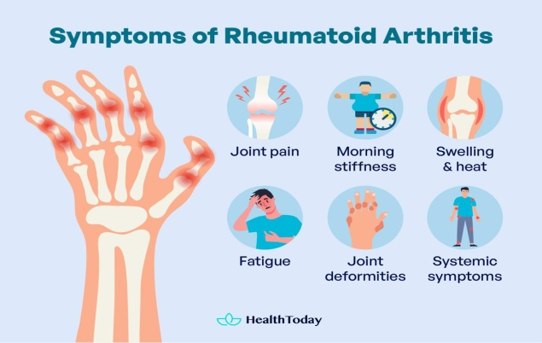 (Health Today, 2024)
Stiffness may make daily activities very difficult such as dressing, cooking, writing and bathing. Damage of cartilage, bone and tendons is leading to joint deformation and reduced mobility.
Rheumatoid arthritis may also have a greater risk of developing other complicated conditions such as: Carpal tunnel syndrome, cardiovascular disease, cervical myelopathy, joints damage and rheumatoid nodules as well as weight loss and loss of appetite during flares. It may cause inflammation in other parts of body such as; heart, eyes, lungs and blood vessels (Arthritis UK, 2026).
Psychological Impacts
Rheumatoid arthritis has major psychological effects on individuals, such as depression: 20-40% of people with this long term condition have faced depression. The prevalence of depression in people with RA is 2-3 times higher than general population (The Journal of Rheumatology, 2025).
Disease progression, future employment and independence, effectiveness of treatment may become the reason of low mood, depression and anxiety for an individual. Additionally, Pain, sleep disturbance and fatigue may reinforce emotional distress. Independency for daily task hurts the self-esteem which may cause of mental disturbance. Usually, patients feel sad, hopeless and loss interest in things that they used to enjoy in past (Healthline 2026).
Social Impacts
Rheumatoid arthritis is one of the biggest contributors to years lived with disability (YLDs), nearly 60,632 people accounts for this condition. 40 of rheumatoid patients stop work within 5 years if not treated early (Arthritis UK, 2025). Patients find difficulty in doing manual jobs such as typing, standing for long time, handling of heavy items due to pain and stiffness. People accept low paid work with no job commitment and no flexible hours which creates inequalities and unemployment becomes a reason of financial stress.
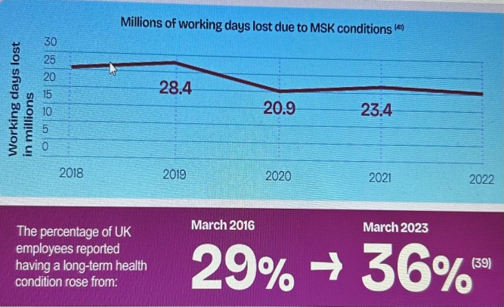
(Arthritis UK, 2025)
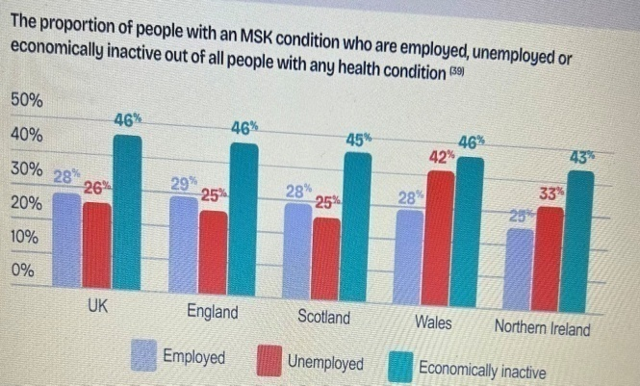
(Arthritis UK, 2025)
Individuals reduce their participation in activities and face social isolation due to physical impacts of this condition. A systematic review examined 17 studies, 2,043 people with rheumatoid arthritis. It found that positive social support was generally associated with better quality of life, while negative interactions were associated with poorer outcomes (National Library of Medicine (2022). The Equality Act (2010) condemns any discrimination due to disability.

Wider implications for families involved in care provision
When a family member has diagnosed with rheumatoid arthritis, the entire household involve in care. Family may help with daily activities such as dressing, bathing, cleaning, medication and attending appointments. During flares these needs may increase. In this way, careers often miss their daily activities, face physical strain and may be health issues later. Careers may face emotional exhaustion and burnout if care is long term without any break. Family’s social life reduced due to low mood, less interest and fatigue of patient. Families may face financial strain such as extra cost for transport, adapted equipment and gadgets, and for psychotherapy or physiotherapy. The Care Act (2014) provides a framework for assess eligible adult care and support needs and carer’s needs. Rheumatoid arthritis impact on children in the family of patient and may they need some support in their daily routines and mental wellbeing. The Children and Family Act (2014) is an important piece of legislation in UK aimed at improving the welfare and needs of children and families.

Treatments which are available in the UK through the NHS
In UK, there are three main ways to treat rheumatoid arthritis through NHS.
- Drugs
- Physical therapies
- Surgery
Drugs
Drugs used to treat rheumatoid arthritis include: painkillers, non-steroidal anti-inflammatory drugs (NSAIDs), biological treatments, conventional disease-modifying anti-rheumatic drugs (DMARDs), JAK inhibitors and steroid treatments as per need (Living with arthritis, 2026).
Physical therapies
Physical therapies may be offered to ease the symptoms and for mobility improvement. These include physiotherapy, hydrotherapy and occupational therapy (NHS, 2023).
Surgery
Surgery is not offered to everyone in rheumatoid arthritis, but sometimes surgery can be helpful to reduce pain as well as correct the shape of joint or improve mobility. It is include foot surgery, finger, hands and wrist surgery. Arthroscopy is a type of keyhole surgery which used to diagnose and treat joint problem (NHS, 2023).

Identify and investigate current theoretical perspectives including models
The House of Care Model, UK Framework
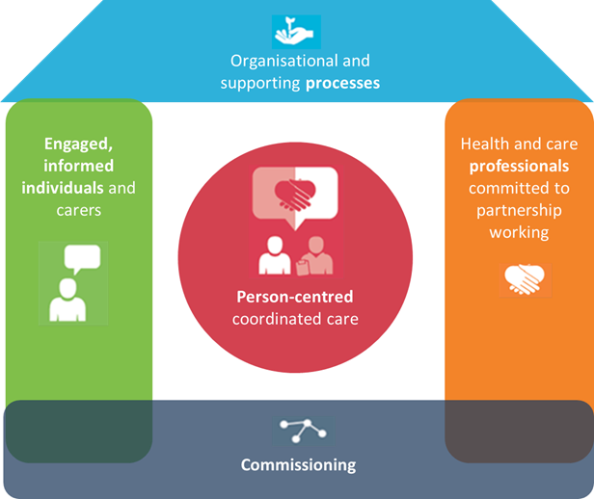
(British heart foundation, 2024)
The House of Care model supports NHS management of long-term conditions, including rheumatoid arthritis, by promoting personalised, respectful care that reflects patients’ needs and preferences. It combines shared decision-making, personalised care plans, supported self-management, social prescribing, community support and informed choices. NICE (2020) also recommends a treat-to-target approach, aiming for remission or low disease activity through regular monitoring, multidisciplinary support, patient education and assessment of Rheumatoid Arthritis impact on daily living (NHS, 2019).
The House of Care Model: application to rheumatoid arthritis
Commissioning and community support
The NHS should ensure access to treatment, rehabilitation and psychological support, underpinned by effective leadership, IT systems, resources and community services.
Engaged and informed patients
Healthcare professionals educate patients and families about Rheumatoid Arthritis, medications, pain, flare management and practical strategies for managing daily activities independently (British Journal of General Practice, 2016).
Health and care professionals working in partnership
Rheumatologists, nurses, GPs and therapists collaborate to coordinate RA care, involving patients and families in discussions, shared decisions and personalised care planning (British Journal of General Practice, 2016).
Organisational and clinical processes
The roof represents regular reviews, investigations, information sharing and care planning, helping monitor medication, assess treatment effectiveness, track disease progression and identify emerging problems (British Journal of General Practice, 2016).
As rheumatoid arthritis (RA) is unpredictable, the House of Care model supports self-management of pain, fatigue and medication while promoting psychological wellbeing. It encourages shared decision-making, personalised treatment and access to multidisciplinary professionals. This approach can help maintain mobility, independence and quality of life, while potentially reducing avoidable hospital admissions (The King’s Fund, 2013).
The strength of this model is delivering person centred care for those patients who have long term conditions and emphasises on the partnership between committed professionals and patients. The other strength of the model is supportive organisational systems and collaborative care planning.

The Chronic Care Model, International model
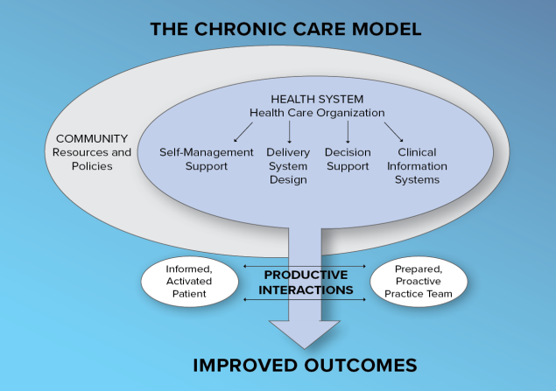
(e Clinical Works, 2017)
The Chronic Care Model (CCM) is used worldwide for long term conditions such as rheumatoid arthritis. The purpose of this model is to provide improved care for chronically ill people, moves from reactive, doctor centred, acute care to proactive, planned, person centred, team based care (National Library of Medicine, 2023).
This model explains that how persistent pain is influenced by interactions between biological processes, psychological experiences and social experiences. There are three dimensions of this model such as biological, psychological and social dimensions.
Chronic pain model: Application to rheumatoid arthritis
This model supports a combination of interventions, such as medical treatment, physical rehabilitation, psychological care and social support (International association for the Study of Pain, 2021).
Overall, the chronic pain model is most effective when combined with appropriate anti inflammatory drug treatment and rehabilitation. It improves to address direct persistent pain but it cannot replace treatment to cure from autoimmune disease (National Library of Medicine, 2023).

Critical examination of local and national health and social care agendas for rheumatoid arthritis management in the UK
National health and social care agendas shape how Rheumatoid Arthritis services are commissioned, funded and delivered. These include the NHS Long Term Plan, National Institute for Health and Care Excellence (NICE) guidelines, the NHS Core20PLUS5 to address health inequalities, the Care Act 2014 and the Equality Act 2010. Local integrated care boards, NHS trusts, local authorities and community organisations translate these agendas into services for patients.
National health and social care agendas

NICE guideline: Rheumatoid arthritis in adults (NG100)

National Institute for Health and Care Excellence guideline (2020) NG100, provides evidence-based guidance for managing rheumatoid arthritis. NICE also emphasises multidisciplinary support, including physiotherapy, occupational therapy and psychological interventions, alongside annual reviews to assess patients’ ongoing needs and improve their quality of life.

The NHS 10 Year Health Plan for England

The Gov.UK (2025), NHS 10 Year Health Plan for England, Fit for the Future sets out three major shifts in healthcare: from hospitals to the community, from analogue to digital services, and from treating illness to preventing it. For rheumatoid arthritis, these changes could improve access to community-based monitoring, digital consultations and early intervention. Preventive approaches may also help patients to manage symptoms, maintain mobility and reduce complications.
NHS Core20PLUS5: reducing health inequalities
NHS England’s Core20PLUS5 initiative aims to tackle health inequalities by focusing on the most deprived 20% of the population and other disadvantaged groups. Although RA is not included in its five main clinical priorities, the framework can help improve fairness in RA care. Local services can identify whether patients face delays in specialist appointments, limited access to rehabilitation, transport difficulties or problems understanding treatment information, then take steps to make services more accessible and inclusive (NHS England, 2021).
The Care Act 2014
The Care Act 2014 promotes wellbeing, independence and coordinated health and social care. For people with rheumatoid arthritis, local authorities may assess eligible care needs and provide support such as occupational therapy, home adaptations and assistive equipment. They can also support carers and encourage participation in employment and social activities through collaboration with NHS and community services (Legislation.gov.uk, 2014).
The Equality Act 2010
The Equality Act 2010 protects people with disabilities from discrimination and promotes equal access to services. For individuals with RA, it supports fair treatment in healthcare, education and employment. Health and social care providers should make reasonable adjustments to meet patients’ needs and help them maintain independence, dignity and participation in society (Legislation.gov.uk, 2010).
Local (Birmingham) health and social care agendas
Birmingham Health and Wellbeing Strategy 2022–2030
Birmingham’s Health and Wellbeing Strategy 2022–2030 aims to improve public health and reduce inequalities. For people with RA, it promotes access to healthcare, independence and wellbeing. Local services can help address barriers such as transport costs, financial difficulties, and unsuitable housing and employment challenges, supporting greater participation in community life (Birmingham City Council, 2025).
Birmingham and Solihull Integrated Care Strategy 2023–2033
The Birmingham and Solihull Integrated Care Strategy 2023–2033 promotes collaboration between NHS services, local authorities, social care and voluntary organisations. For people with RA, integrated care connects rheumatologists, GPs, pharmacists, physiotherapists, occupational therapists and social workers to manage symptoms improve mobility, support independence and address psychological wellbeing (Birmingham and Solihull Care 2023).

Local NHS rheumatology pathways and specialist services
Local NHS rheumatology pathways in Birmingham and Solihull promote consistent referrals and timely treatment for RA. Sandwell and West Birmingham NHS Trust offer early arthritis clinics and rehabilitation support. University Hospitals Birmingham provides specialist nursing, medication advice, disease monitoring and exercise education to improve patients’ mobility, independence and quality of life (NHS, no date).
Reducing health inequalities in Birmingham
Birmingham’s health strategies aim to reduce inequalities linked to deprivation, ethnicity and social circumstances. In RA care, barriers may delay diagnosis and treatment. Local services should provide interpreters, translated information, affordable appointment access and accessible facilities to ensure patients from disadvantaged backgrounds receive timely, appropriate and equitable care (NHS Birmingham and Solihull, no date).

Critical comparison of national and local agendas
National and local health and social care agendas play a vital role in improving rheumatoid arthritis management. Nationally, NICE guideline NG100 recommends early specialist referral, disease-modifying anti-rheumatic drugs and regular monitoring to achieve low disease activity (NICE, 2020). These evidence-based standards promote consistent, effective treatment. However, limited staffing and delays in specialist appointments may prevent patients from receiving care timely.
Locally, Birmingham’s Health and Wellbeing Strategy 2022–2030 aims to reduce health inequalities, while the Birmingham and Solihull Integrated Care Strategy encourages collaboration between NHS, social care and community services. This partnership can improve access to rehabilitation and psychological support. However, broad local priorities may not adequately address RA related needs, particularly for disadvantaged communities (NHS Birmingham and Solihull, no date).
Therefore, national guidance must be supported by effective local implementation, sufficient resources, accessible information and regular outcome monitoring. This would strengthen equitable, personalised care and improve independence and quality of life for people with RA.

Recommendations
- Healthcare professionals should involve patients in treatment decisions making such as benefits and potential risks.
- Each patient should have a regularly reviewed, personalised RA care plan covering symptoms, medication, pain and fatigue management and agreed treatment goals.
- Multidisciplinary teams should coordinate RA care by involving patients in decisions, rehabilitation, psychological support and health and social care to promote independence and wellbeing.
- Personalised self-management plans should help patients set realistic goals and manage daily activities and wellbeing through professional guidance and appropriate support.
- Healthcare services should promote reliable digital resources, symptom diaries and community organisations to support social participation while maintaining access to clinical assessment.
- Healthcare professionals should identify palliative care needs by assessing complex symptoms, treatment burdens and personal priorities.
- Healthcare professionals should support advance care planning by discussing patient’s future care preferences, treatment choices, personal priorities and cultural beliefs.
- End-of-life care for people with RA should coordinate rheumatology, primary, community, palliative and social care services to manage symptoms and review medication.

References
Arthritis UK (2025) The State of Musculoskeletal Health 2025. Available at: https://www.arthritis-uk.org/media/flpbvm2m/arthritisuk_state_of_msk_health_-report_2025.pd (Accessed: 16 October 2026).
Arthritis UK (2026) Rheumatoid arthritis. Available at: http://www.arthritis-uk.org/information-and-support/understanding-arthritis/conditions/rheumatoid-arthritis/ (Accessed: 17 October 2026).
Birmingham City Council (2025) Health and wellbeing strategy. Available at: https://www.birmingham.gov.uk/info/50119/health_and_wellbeing_board/1300/health_and_wellbeing_strategy? (Accessed: 21 October 2026).
Birmingham and Solihull Integrated Care System (2023) Our Integrated Care Strategy 2023-2033. Available at: https://www.birminghamsolihullics.org.uk/about-us/our-integrated-care-partnership/our-integrated-care-strategy-2023-2033? (Accessed: 21 October 2026).
BMJ Journals (2010) Gene–environment interaction between HLA-DRB1 shared epitope and heavy cigarette smoking in predicting incident rheumatoid arthritis. Available at: https://www.ard.bmj.com/content/69/01/54. (Accessed: 17 October 2026).
British heart foundation (2024) Person-centred care and the House of Care. Available at: https://www.bhf.org.uk/for-professionals/healthcare-professionals/innovation-in-care/person-centred-care-and-the-house-of-care (Accessed: 17 October 2026).
British Journal of General Practice (2016) Building the House of Care for people with long-term conditions: the foundation of the House of Care framework. Available at: https://doi.org/10.3399/bjgp16x684745.
British Journal of General Practice (2016) Enablers and barriers for engaged, informed individuals and carers: left wall of the House of Care framework. Available at: http://doi.org/10.3399/bjgp16x683797.
e Clinical Works (2017) CCM vs. APCM: which Care Management Model is Right for your practice? Available at: https://www.eclinicalworks.com/blog/ccm-vs-apcm/ (Accessed: 02 October 2026).
Gov.UK (2025) 10 Years Health Plan for England: fit for the future. Available at: https://www.gov.uk/government/publications/10-year-health-plan-for-england-fit-for-the-future? (Accessed: 21 October 2026).
Healthline (2026) Everything You Want to Know About Rheumatoid Arthritis. Available at: https://www.healthline.com/health/rheumatoid-arthritis (Accessed: 07 October 2026).
Health Today (2024) Symptoms and Long Term effects of Rheumatoid Arthritis. Available at: https://www.dev.healthtoday.com/be-healthy/health-a-z/long-term-effects-of-rheumatoid-arthritis (Accessed: 17 October 2026).
International Association for the study of pain (2021) Terminology. Available at: https://www.iasp-pain.org/resources/terminology/ (Accessed: 20 October 2026).
Legislation.gov.uk (2010) The Equality Act 2010. Available at: https://www.legislation.gov.uk/ukpga/2010/15/contents (Accessed: 17 October 2026).
Legislation.gov.uk (2014) Children and Families Act 2014. Available at: https://www.legislation.gov.uk/ukpga/2014/6/pdfs/ukpga_20140006_en.pdf (Accessed: 17 October 2026).
Legislation.gov.uk (2014) Care Act 2014. Available at: https://www.legislation.gov.uk/ukpga/2014/23/contents (Accessed: 17 October 2026).
Living with arthritis (2026) Rheumatoid arthritis treatment. Available at: https://www.livingwitharthritis.org.uk/conditions/rheumatoid-arthritis/treatment (Accessed: 17 October 2026).
Molecular & cellular proteomics (2024) Multitiered Proteome Analysis Displays the Hyper permeability of the Rheumatoid Synovial compartment for Plasma Proteins. Available at: https://www.mcponline.org/article/S1535-9476(24)00190-7/fulltext (Accessed: 07 October 2026).
NHS England (2019) Comprehensive model of personalised care. Available at: https://www.england.nhs.uk/personalisedcare/comprehensive-model-of-personalised-care (Accessed: 18 October 2026).
NHS England (2021) Core20PLUS5 (adults) – an approach to reducing healthcare inequalities. Available at: https://www.england.nhs.uk/about/equality/equality-hub/national-healthcare-inequalities-improvement-programme/core20plus5/ (Accessed: 21 October 2026).
NHS (2023) Causes rheumatoid arthritis. Available at: https://www.nhs.uk/conditions/rheumatoid-arthritis/causes/ (Accessed: 17 October 2026).
National Health Services (2023) Rheumatoid arthritis. Available at: https://www.nhs.uk/conditions/rheumatoid-arthritis/ (Accessed: 03 October 2026).
NHS (2026) Overview Rheumatoid Arthritis. Available at: https://www.nhs.uk/conditions/rheumatoid-arthritis/ (Accessed: 09 October 2026).
NHS (2026) Rheumatoid Arthritis. Available at: https://www.nhsinform.scot/illnesses-and-conditions/muscle-bone-and-joints/conditions-that-can-affect-multiple-parts-of-the-body/rheumatoid-arthritis (Accessed: 07 October 2026).
NHS (no date) Sandwell and West Birmingham Hospitals NHS Trust.
Available at: https://www.nhs.uk/services/acute-trust/sandwell-and-west-birmingham-hospitals-nhs-trust/RXK (Accessed: 21 October 2026).
NHS Birmingham and Solihull (no date) Rheumatology. Available at: https://www.birminghamsolihull.icb.nhs.uk/health-information/clinical-pathways/rheumatology? (Access: 21 October 2026).
National Institute for Health and Care Excellence (2020) Rheumatoid arthritis in adults: management. Available at: https://www.nice.org.uk/guidance/ng100 (Accessed: 17 October 2026).
National Institute for Health and Care Excellence (2025) Rheumatoid arthritis.
Available at; https://www.cks.nice.org.uk/topics/rheumatoid-arthritis/ (Accessed: 17 October 2026).
NHS inform (2026) Rheumatoid arthritis. Available at: https://www.nhsinform.scot/illnesses-and-conditions/muscle-bone-and-joints/conditions-that-can-affect-multiple-parts-of-the-body/rheumatoid-arthritis (Accessed: 17 October 2026).
NHS (2023) Treatment rheumatoid arthritis. Available at: https://www.nhs.uk/conditions/rheumatoid-arthritis/treatment/ (Accessed: 17 October 2026).
National Library of Medicine (2022) Association between social deprivation and disease activity in rheumatoid arthritis: a systematic literature review.
Available at: https://doi:10.1136/rmdopen-2021-002058.
National Library of Medicine (1998) Chronic disease management: what will it take to improve care for chronic illness? Available at: https://www.pubmed.ncbi.nlm.nih.gov/10345255/ (Accessed: 02 October 2026).
National Library of Medicine (2023) Epidemiology and risk factors for rheumatoid arthritis development. Available at: doi:10.31138/mjr.301223.eaf.
National Library of Medicine (2025) Global, regional and national burden of rheumatoid arthritis from 1990 to 2021, with projections of incidence to 2050: a systematic and comprehensive analysis of the Global Burden of Disease study 2021. Available at: doi:10.1186/s40364-025-00760-8.
National Library of Medicine (2023) Operationalizing the Chronic Care Model with Goal-Oriented Care. Available at: https://www.pmc.ncbi.nlm.nih.gov/articles/PMC10570240/ (Accessed: 20 October 2026).
Oates, S. A., Zemedikun, T. D., Kumar, K., Reynolds, A. J., Jain, A., Raza, K., Williams, A. J., Bravo, L., Cardoso, R. V., Gkoutos, G., Nirantharakumar, K., and Lord, M. J. (2022) ‘Early onset of immune-mediated diseases in minority ethnic groups in the UK’, BMC Medicine, vol. 20, article 346. Available at: doi.org/10.1186/s12916-022-02544-5.
Ratan Jyoti Group of Hospitals (2023) From Boundaries to Boundlessness: Embracing Joint Replacement. Available at: http://www.rjghsorted.wordpress.com/2023/07/07/from-boundaries-to-boundlessness-embracing-joint-replacement/ (Accessed: 29 September 2026).
Science Direct (2010) Impact of smoking as a risk factor for developing rheumatoid arthritis: a meta-analysis of observational studies. Available at: https://www.sciencedirect.com/science/article/abs/pii/S0003496724196598 (Accessed: 17 October 2026).
The Journal of Rheumatology (2025) Mind Matters in Rheumatoid Arthritis: The Rising Burden of Anxiety and Depression. Available at: https://doi.org/10.3899/jrheum.2024-1273.
The King’s Fund (2013) Delivering better services for people with long-term conditions: Building the House of Care. Available at: https://www.kingsfund.org.uk/insight-and-analysis/reports/better-services-people-long-term-conditions (Accessed: 20 October 2026).
Very Well Health (2018) Pictures of Rheumatoid Arthritis in Knees, Hands, and More. Available at: https://www.verywellhealth.com/rheumatoid-arthritis-explained-with-pictures-190351 (Accessed: 02 October 2026).
World Health Organisation (2023) Rheumatoid arthritis. Available at: https://www.who.int/news-room/fact-sheets/detail/Rheumatoid-arthritis (Accessed: 16 October 2026).
Worldmetrics (2026) Arthritis Statistics. Available at: https://www.worldmetrics.org/arthritis-statistics/ (Accessed: 16 October 2026).

