Assessment 2: Understanding Film Technique – Essay
- Discuss the use of visual storytelling in TWO essential texts, examining the way in which the various cinematic elements, e.g. framing, lighting, camera movement, are effective in developing the narrative.

This essay will discuss the use if visual storytelling in two different films, including The Grand Budapest Hotel and Psycho, examining if different cinematic elements are effective in developing the narrative in the films.

- The Grand Budapest Hotel
The Grand Budapest Hotel is an American-German co-production comedy drama film filmed in 2014, directed and written by Wes Anderson. The film is set in the 1930s in a fictional European country Zubrowka, and the story is about a story of a lobby boy and a concierge who are working in the Grand Budapest Hotel and they cooperate to prove Gustave's innocence, after he was blamed for murdering. [1]
Firstly, this film is a “storytelling” film, which is so much different then other film’s storytelling nowadays. At the starting scene of the film, an old writer talks about the first few lines of the film, and somehow it is similar to the “prologue” of the novel which the film is based on. On the scenes afterwards, it follows the chapters of the novel to lay out the different stories, and the film often use different lighting effects (such as spotlights) to create the effect of monologue, and also off-screen voice-over to make the film feels like a storyteller telling the story to the audiences. The whole story of the film is divided into different layers, for example, the outermost layer is the film itself and the novel held by the girl in the opening sequence, and the next layer is Zero Moustafa talking about the story of his life, and at the meantime it is based on the world of the Austrian Novelist Stefan Zweig. This is like a concept of “Story within a story”, and the story was mentioned one by one by different characters. These methods of filming can let the audience to understand the story easier with an interesting way.
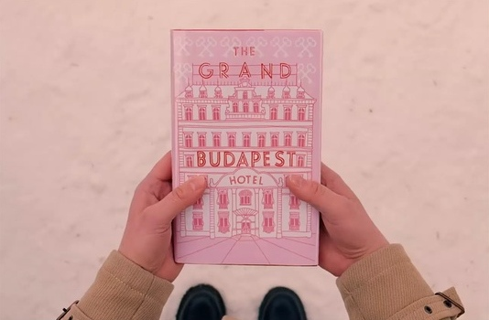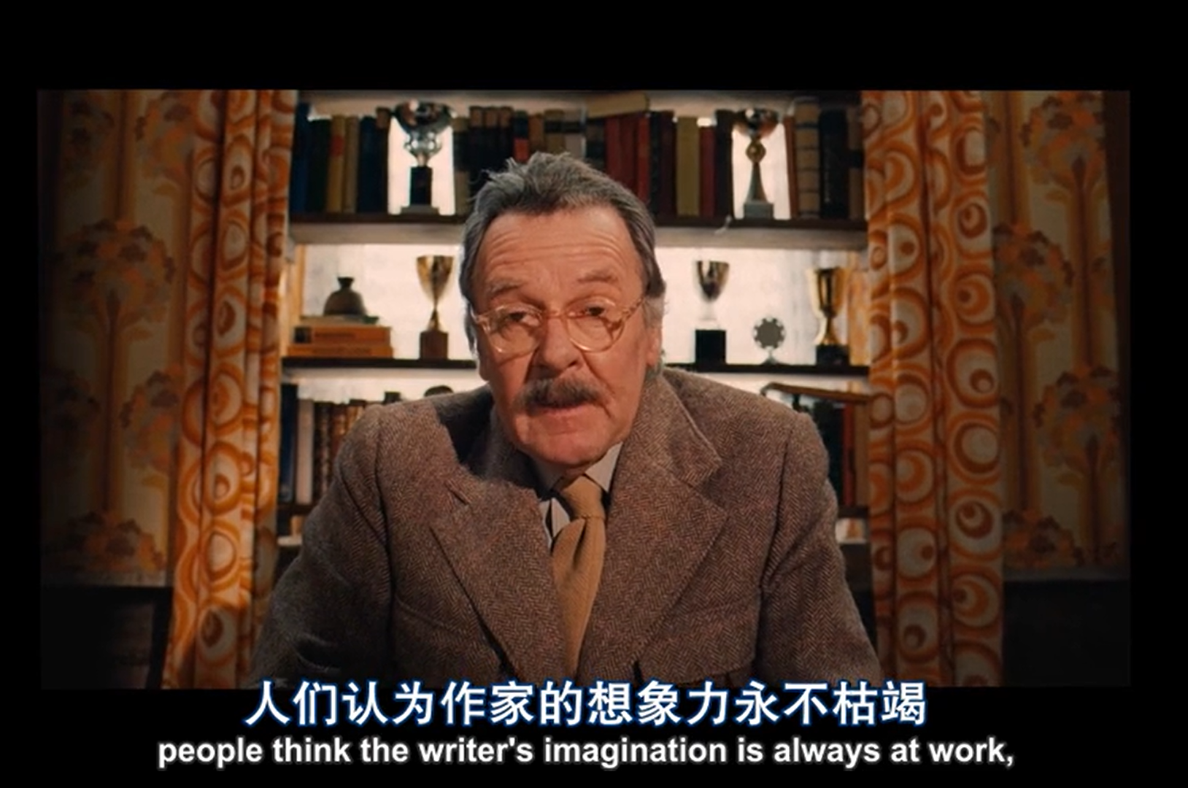
Another interesting feature in this film is the change of aspect ratio and color grading changes within the time in the film. In the 1930s in the film, the aspect ratio is 1.37:1, in the 1960s, the aspect ratio is 2.35:1, and from 1985 to the modern ages, the aspect ratio is 1.85:1. These different differences in the films represent the trend of the different eras in the film [2]. These changes in the aspect ratio shows the change of time in the film, and also let the audience to know about that the story of the film had entered another layer (as mentioned in the last section of the essay), as the change of time and aspect ratio follows the progress of the story in different eras. Though the change of the aspect ratio, audience can understand what aspect ratios are common if different era’s movie and films.
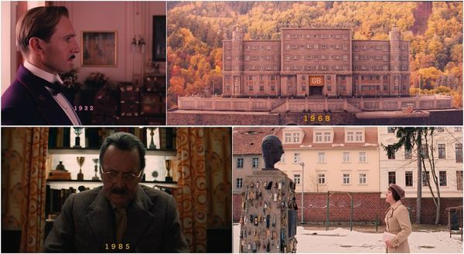
Also, a lot of scenes in this film are filmed perfectly balanced. Every item, person and structure are centered in the frame. This is one of the most famous filming method by the director of this film, Wes Anderson, and it appears in many other films directed by him. Although this is not common in other mainstream films, this can let the audience have a good memories in Wes Anderson’s film, and can easily recognize his film in the first glance on the scene’s structure.
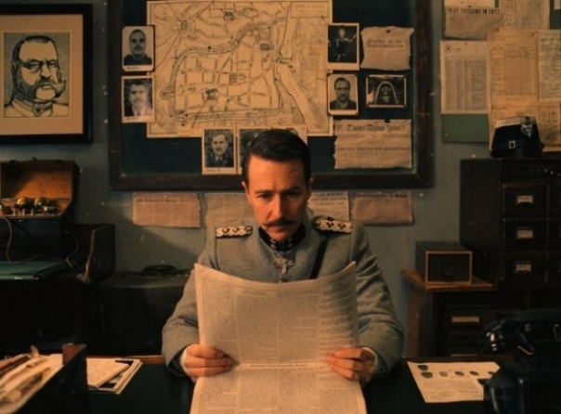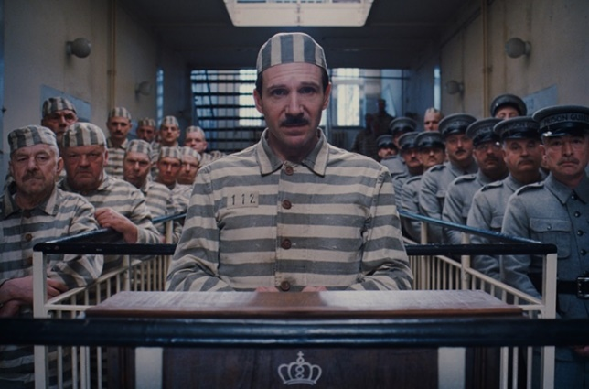
For the color grading of the film, it changes during the progression of time too. At the start of the film, a pink color style was used. It has the feeling of joyment and fantasy, which identicates that the hotel is in the golden age. It makes the whole film feel like it is in a fairly tale. However, as the times go on, the golden age of the hotel ends and the customers started to reduce. The color grading changes to a orange like color grading. It has the feeling of sad and loney. Comparing to the fantasy color in the previous parts, this color looks more to the reality. This identicates that the hotel is in a decadency and is going to be history.
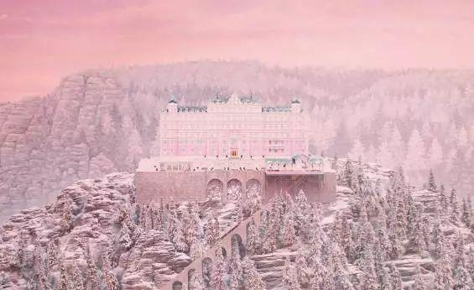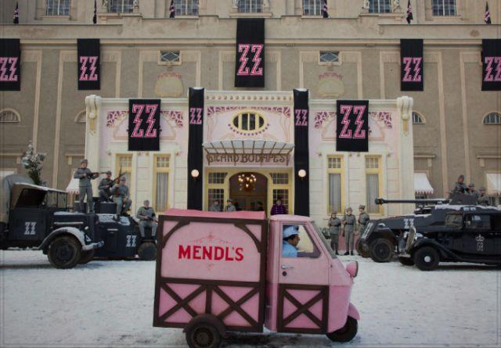
In conclusion, The Grand Budapest Hotel is a very unusual film. Every part of the film is so much different with the mainstream films. However, these differences are so unique and gave the audiences good memories on it. The visual storytelling creates such a good effect on storytelling, such as color grading, framing of the scenes and even the story itself is a good example of “film inside a film”.

- Psycho
Psycho is a psychological horror film filmed in 1960, and directed and produced by Alfred Hitchcock, and written by Joseph Stefano, and it was based on a same name novel written by Robert Bloch in 1959. [3] This film is about a secretary of a motel, Marion Crane met the motel's owner-manager, Norman Bates, and its aftermath. Although this film is an old, low budget and “black and white” film, it had been rated as one of Hitchcock's best films, or even one of the greatest films all time for its cinematic art.
After the opening sequence of the film, the camera pans the Phoenix City with a wide shot, then dissolve and zoom into the hotel room with both protagonists inside. This sequence of shots can let the audience to understand the where the location of the film is set in and who is inside the room and what they are doing.
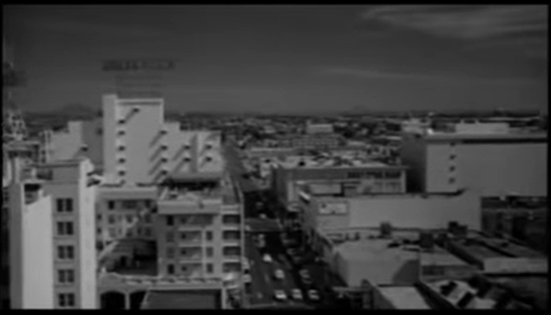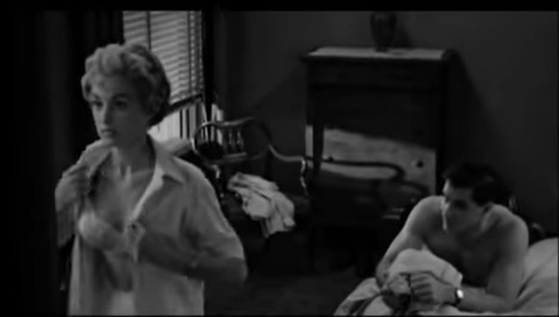

On the showering scene of Marion, it was filmed in the wide space in the shower curtain. In order to let the audiences to have some imagination of Marion, close up on the shower head and Marion’s face of relaxation is filmed. Afterwards, a wide shot with a large empty space in the screen on the left with Marion on the right. This can let the audience to think that someone or something will appear on the empty space.
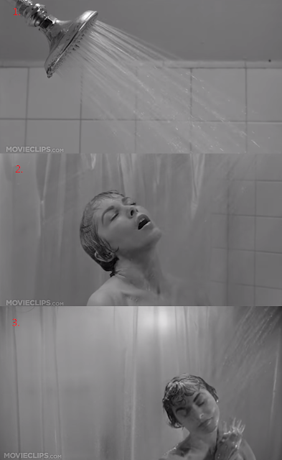
Once the murderer opens the bathing curtain, an intense and scary music sounds up. This can represent the fear and heartbeat of Marion. When the murderer attacks Marion, the shots was filmed in a fast beat, and most of the shots the filmed in a close up, such as the face with fear of Marion, the murder tries to point the knife towards Marion, and also water flowing through the shower head. This can also show the fear of Marion. Close up in this scene can show the audiences about what is happening, but without showing the whole situation inside the bathroom. One of the reasons is that naked bodies are not allowed in the movies in the 1960s. Also, the changing of shots in this scene is very quick, which synchronize with the music to create and intense and exciting effect.
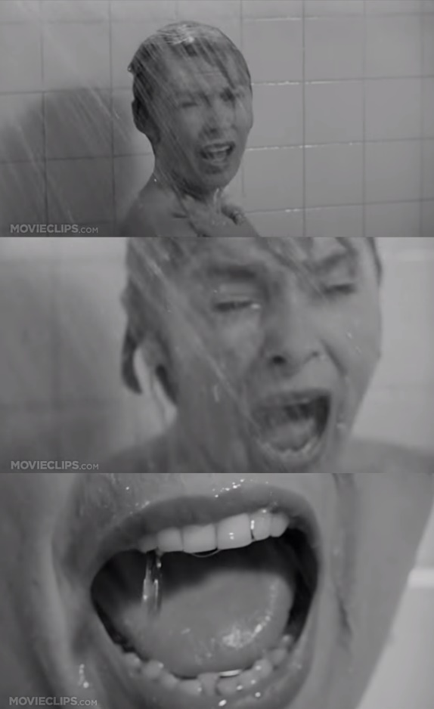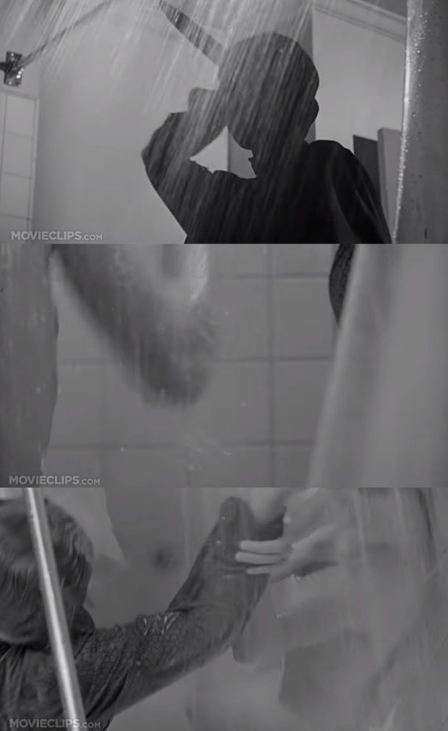
In this scene, although it is a murder scene, there is no appearance of extremely violence. Only blood flowing onto the water puddles on the floor is seen. Besides from avoiding film censorship in the 1960s, it also keeps the feeling of horror film instead of an action film. [4]

After the attack on Marion, she still tries to struggle and stand up. She catches the wall and the shower curtain to try to pull herself up, but she still fails. After she falls to the ground, her blood flows to the inlet hole. These sequences were shot in a slower speed comparing when Marion was being attack. In order to show that Marion is slowly dying. Also, in this sequence some of the shots were equivalent to the shots before she has been attacked.
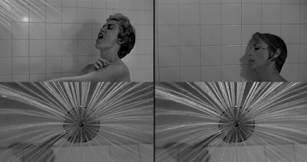
(Before attack) (After attack)
Finally, this scene ends with Marion is dead and lying on the floor, staring at the camera. One of the famous shots in this scene is that water spinning into the inlet hole of the shower, then match cuts into Marion’s eyes. These shots show that although the time is still running, but Marion is dead and will not be able to move anymore. In the meantime the music stops and ends the audience’s horror.
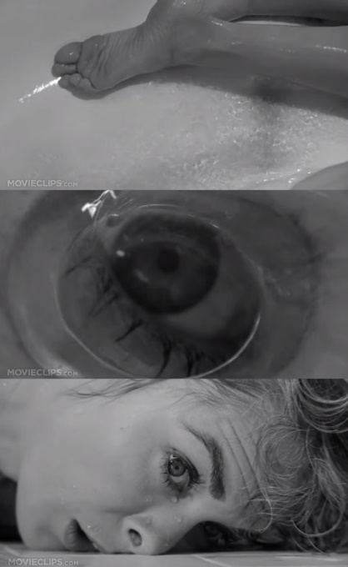
All different method of filming makes this scene one of the most famous scene of movies in all time. Although Hitchcock have to avoid the censorship of nudity and violence in the 1960s, he still manages to show a naked murder scene with limited ways.

Conclusion
Both the Grand Budapest Hotel and Psycho are unusual films comparing to mainstream films. With different structure of filming, color grading and storytelling in The Grand Budapest Hotel; and different ways to shoot the scene and music in Psycho, they can still give the audiences a very strong memory of different shots and the story of the film. Most film nowadays will tell the story to the audience very directly but will not let them to have a very strong memory. However, the Grand Budapest Hotel and Psycho use their own unusual way to let the audience to remember the story.

References
[1] Wikipedia contributors. (2019, November 5). The Grand Budapest Hotel. In Wikipedia, The Free Encyclopedia. Retrieved 00:14, November 14, 2019, from https://en.wikipedia.org/w/index.php?title=The_Grand_Budapest_Hotel&oldid=924735017
[2] David Haglund and Aisha Harris (2014) The Aspect Ratios of The Grand Budapest Hotel, Available at: https://slate.com/culture/2014/03/grand-budapest-hotel-aspect-ratios-new-wes-anderson-movie-has-three-different-widths-here-s-why.html (Accessed: 13th November 2019).
[3] Wikipedia contributors. (2019, November 14). Psycho (1960 film). In Wikipedia, The Free Encyclopedia. Retrieved 02:11, November 15, 2019, from https://en.wikipedia.org/w/index.php?title=Psycho_(1960_film)&oldid=926088501
[4] Steve Dollar (2018) Psycho's Shower Scene: How Hitchcock Upped the Terror—and Fooled the Censors, Available at: https://www.history.com/news/psycho-shower-scene-hitchcock-tricks-fooled-censors (Accessed: 13th November 2019).

