Programme: MSc Software Engineering and AI
Module Code: ACCA7025
Module Name: L7 – Application of Machine Learning
Assignment Title: Image classification using Artificial Neural Networks
Student Name: Patel Manav Ajitkumar
Student ID Number: 2437942

Abstract
Design and implementation of a Convolutional Neural Network for classifying the CIFAR-10 dataset is highlighted in the project. Data augmentation, batch normalisation, and dropout are used in the model to prevent overfitting. Rigorous evaluation on unseen test data confirms the model's high efficacy, achieving a strong final accuracy of 82.96%.

Table of Contents
Introduction 4
Related Works 4
Methodology 7
Results 9
Discussion 19
Conclusion 20
References 21
Appendix 22

Introduction
Image classification is a fundamental field in computer vision which can interpret visual information and classify objects in different situations. The ability of Artificial Neural Networks to find complex hierarchies in space is outstanding, which allows automatic acquisition of abstract visual characteristics based on just raw pixel data. Convolutional Neural Networks make use of layered convolutional operations, which provide spatial relationships and hierarchical textures to enhance quality in the visual recognition applications. Every convolutional filter is a detector of patterns, and through successive training steps, localised features such as edges, curves and textures are learnt. The spatial information is pooled, and computational complexity is also reduced by pooling operations with more advanced architectures able to learn efficient image representations. More recent techniques, such as residual connections and batch normalisation, have turned out to be important to ensure consistency in training. These allow more complex architectures and deeper architectures to maintain performance consistency.
CIFAR-10 data is a balanced dataset of sixty thousand images in ten equal groups of objects of nature and man-made objects. Its standardised format helps to fit the visual recognition machine learning models to similar evaluation and comparative experimentation in research facilities. Good classification on CIFAR-10 indicates that a network can generalise to both inter-class similarities of complex visual variants and also to visual variations. The recurrent Neural Networks manage sequential relationships, whereas the Convolutional Neural Networks are trained to perceive the two-dimensional relationships of space in static images. A comparative knowledge of these architectures forms the conceptual basis for the choice of suitable models to use in image recognition activities. The theme of this exploration lies in the analysis of performance in image classification and, at the same time, focuses on concepts of optimisation, regularisation and performance measurement.

Related Works
Convolutional Neural Networks for Spatial Feature Learning
Convolutional Neural Networks are used to learn powerful space features through hierarchical application of convolutional filters on image representations, which encode similarity relationships between features [1]. In the examined IGTD-CNN architecture, the image representations of the gene expression and molecular descriptors are processed in sub-networks by three convolutional layers with a five-by-five size. Each of the layers is followed by a batch normalisation, ReLU activation, and max pooling operations. Convolutional layers are used to identify localised motifs, and pooling decreases spatial resolution and overfitting by summarising activations. Batch normalisation is used to normalise the activation across mini-batches, making the gradients flow constant, and high learning rates can be used without drifting out [1]. Fully connected layers involve dropout to ensure neurons do not co-adapt and increase generalisation through random connection removal in training.
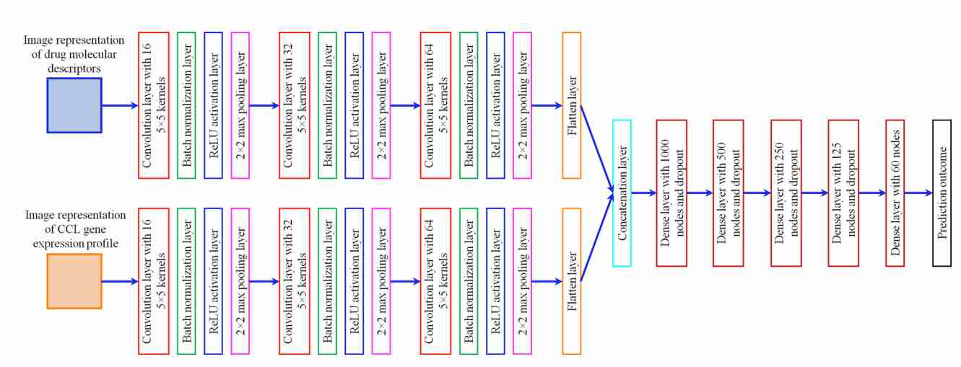
Figure 1: Architecture of the convolutional neural network (CNN) used for predicting drug response based on image representations [1]
Optimization technique takes advantage of the gradient descent through backpropagation to reduce the mean squared error loss within the drug response prediction based on
image representations. Adam optimiser modifies update directions based on momentum and second moment approximations of every parameter, and encourages an efficient convergence when the parameters have different magnitudes. Unspun or omitted connections might allow further signal flow, although this CNN design is concerned with moderate depth with subnetwork concatenation at the end of regression layers. Strategies for regularisation of image augmentation can help strengthen robustness. The configuration of the overall architecture has about 1.3 million trainable parameters as a compromise between representational capacity and computational tractability.
Optimisation and Regularisation in different models for image processing
Image processing models with optimisation and regularisation create stability, convergence efficiency, and effective generalisation of various convolutional and hybrid models. Gradient-based optimisation procedures such as Adam, RMSProp, and stochastic gradient descent reduce either categorical or reconstruction loss by the backpropagation of error gradients across the hierarchical layers. In ResNet architecture, residual connections are used to preserve the gradient during training, which helps to resolve vanishing gradient issues and allows for profound model convergence [2]. DenseNet models are based on the idea of dense connectivity patterns to propagate the gradient better, which reuse the features and minimise the computational redundancy [3]. The important methods of regularisation are dropout and batch normalisation, which stabilise activation distributions across neurons to ensure the absence of co-adaptation and stabilisation of mini-batch updates.
Model Type | Optimisation Technique | Regularisation Method | Key Advantage
ResNet | Gradient descent with skip connections | Batch Normalization | Prevents vanishing gradients and enhances convergence depth
DenseNet | SGD with dense connectivity | Dropout | Improves gradient propagation and feature reuse
U-Net | Adam optimizer | Spatial Dropout | Strengthens segmentation generalisation
Autoencoder | RMSProp on reconstruction loss | Denoising regularisation | Enhances robust feature learning
ViT | AdamW with learning rate decay | Layer Normalization | Reduces overfitting in large-scale data
GAN | Adversarial min–max training | Spectral Normalization | Stabilises generator-discriminator dynamics
CapsuleNet | Margin loss optimisation | Reconstruction loss | Preserves spatial hierarchy
CNN-RNN | Adam with gradient clipping | Temporal Dropout | Stabilises
Table 1: Optimisation and Regularisation Techniques in Image Processing Models
U-Net and autoencoder architectures use spatial dropout and denoising regularisation, which makes features less vulnerable to overfitting when used to do pixel-wise segmentation or reconstruction problems [4]. Vision Transformers incorporate adaptive optimisers, including AdamW and apply stochastic depth and layer normalisation to help reduce overfitting in large-scale image recognition problems. GANs are applied as adversarial networks of generators and discriminators that are optimised by means of gradient penalty and spectral normalisation to provide stable training. Capsule networks use margin loss and dynamic routing optimisation, which attain hierarchical spatial encoding without reliance on max-pooling operations. Hybrid CNNRNN models provide advantage of both gradient clipping and temporal dropout to maintain stability in sequential extraction of features and learning over time in video-based or motion-dependent visual models.
Use Case Evaluation: CNNs vs RNNs
Convolutional Neural Networks (CNNs) and Recurrent Neural Networks (RNNs) are both strong architectures of in-depth learning, yet they perform well in other areas. CNNs are spatial data (especially images) analysers, where local features such as edges, textures, shapes, and so on, matter. It utilises convolutional layers to automatically decompose image features in a hierarchical fashion and pooling layers to down sample dimensionality, which makes them very efficient in image classification. Also, CNNs favour the data augmentation techniques and the regularisation schemes like dropout and batch normalisation, which enhance the generalisation and stability.
RNNs are specialised in sequential data such as text, audio, or time-series data. RNNs store time-related dependencies and order data, which cannot be available in image data. The application of RNNs to images involves reshaping them into sequences, which inefficiently compute and negatively affect the performance.
Project relies on the CIFAR-10 image dataset, where Convolutional Neural Networks (CNNs) are evidently more appropriate than Recurrent Neural Networks (RNNs). The convolutional and pooling layers are specially created to extract the spatial hierarchies and the local patterns of the images, which allows CNNs to succeed in extracting features. CNNs are computationally efficient in that they share weights and are locally connected, and hence it is possible to train and infer large datasets of images. Also, CNNs are always more precise in the classification of images since it is able to maintain the spatial information that is not efficiently utilised by RNNs, which are optimised to work with sequential data. So, CNNs are the strongest and most stable option to use in this image classification project.

Methodology
This project follows a structured machine learning pipeline that is planned to classify images with the CIFAR-10 dataset. The steps are broken down into several processes, which include data acquisition, preprocessing, model design, training, evaluation and visualisation.
1. Data Extraction and Acquisition
CIFAR-10 data is downloaded as a ZIP file compressed with Google Drive and unzipped into formatted directories to be trained and tested [5]. The categories of images in each class folder are ten (aeroplane, automobile, and bird) in each case. To check the integrity of the directories and even message of images per class, the project is used to balance the representation. This step offers an understanding of how the datasets are distributed and aids in setting the right batch sizes for training and validation.
2. Data Mining Exploratory Data Analysis (EDA)
EDA is used to learn about the statistical characteristics of the data. Sample images of every category are visualised to monitor quality and variation [6]. At the pixel level, analysis is done, and the mean, standard deviation, and distribution of intensity values of representative images are calculated. Histograms and mean images are obtained to see the trends and the possible preprocessing needs. These understandings are used to provide normalisation and augmentation decisions that are important to enhance model generalisation.
3. Preprocessing and Augmentation of Data
Images are rescaled to the range of 0 to 1 to eliminate variation in the training and speed up convergence [7]. Training set is augmented with data, which consists of random rotations, width and height shifts, horizontal flips, and zooming. These changes resist overfitting, improve robustness and are real-world simulations. Validation and test sets are not augmented to be able to provide an unbiased performance evaluation.
5. Model Training and Optimisation
The model is trained through Adam optimiser with the learning rate of 0.001 and categorical cross-entropy loss [8]. Callbacks, such as early stopping, model checkpointing, as well as learning rate reduction on plateau, are used to avoid overfitting, save the best model, and dynamically fine-tune learning rates. The training process is done with the use of 20 epochs and a batch size of 64, and the performance of the generalisation is monitored using the validation data.
6. Review and Visualisation
Measures such as accuracy, precision, recall and F1-score are calculated, and confusion matrices are created. Actual and predicted labels are graphically displayed according to each class in order to detect the strengths and weaknesses. The distribution of prediction confidence is also used to determine the reliability of the model.
So, this project is done on a systematic approach based on careful handling of data, feature learning with the help of CNNs and strict evaluation. The purpose of obtaining high generalisation and strong image classification performance justifies every decision, such as augmentation to the architecture.

Results
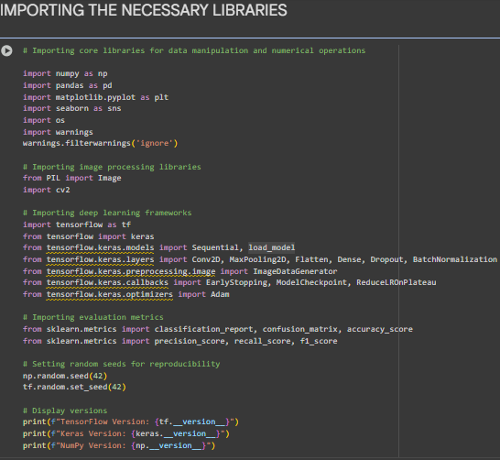
Figure 2: Libraries import
The project structure ensured the installation of all the required tools to complete the entire workflow, including data processing, image processing, CNN model construction, and a complete performance analysis.
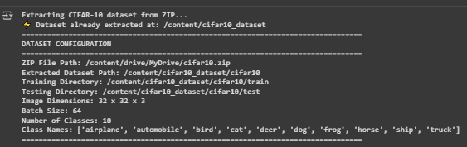
Figure 3: Data loading
Rreadiness is verified of the CIFAR-10 dataset and formed its fundamental requirements: 10 classes of 32x32 colour images in which the training batch size of 64 was validated to the model.
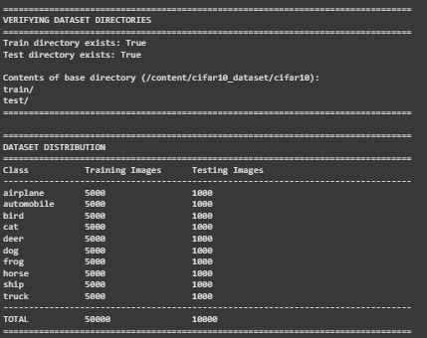
Figure 4: Data statistics
The team ensured that the CIFAR-10 was balanced against all the ten classes and had 5,000 images to train and 1,000 to test respectively.
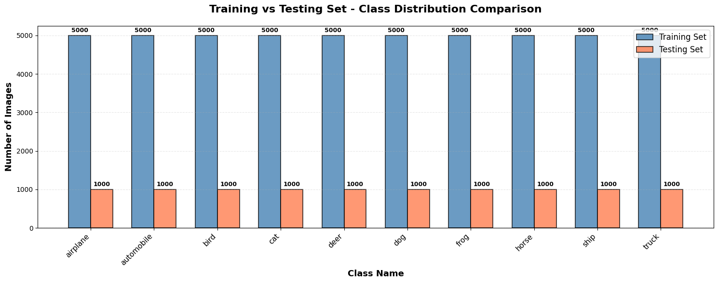
Figure 5: Data visualisation
The visualisation proves that the training and testing sets contain an equal number of images of all the ten classes, with a perfectly balanced dataset set.

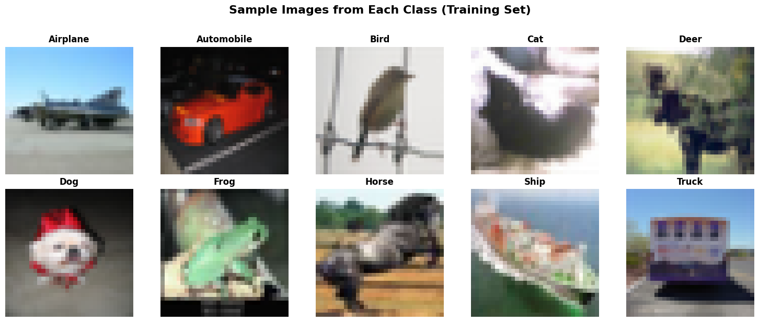
Figure 6: Sample image view with labels
The given samples of the images offered a critical point: the poor resolution and diverse and mixed backgrounds of the 10 classes of objects will be the primary challenge to the model in the process of classification.

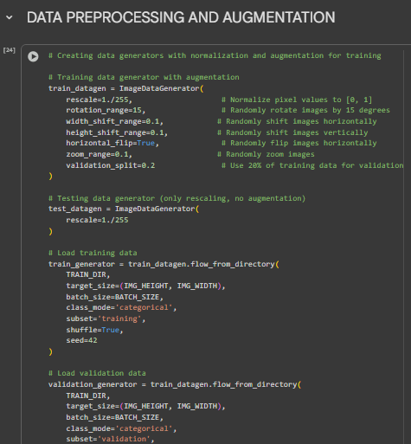
Figure 7: Data preprocessing and augmentation
Images were pre-processed by converting pixel values to the 0 to 1 range and the training data actively augmented with random shifts, rotations and flips (20 percent used as validation).
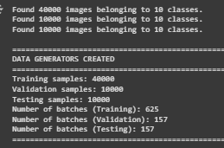
Figure 8: Data sampling
The data split conclusion was validated, and 40,000 images were reserved as training, and 10,000 images were given to each of the most important validation and testing, in all of the 10 classes.
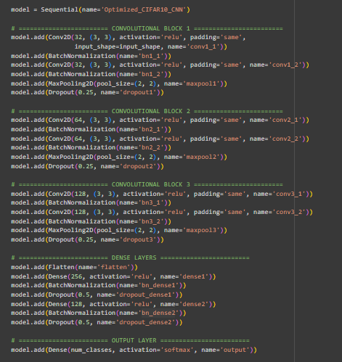
Figure 9: CNN model architecture
The CNN is optimized and deep, which is represented by three convolutional blocks with Batch Normalization and Dropout layers to enhance stability and regularization.
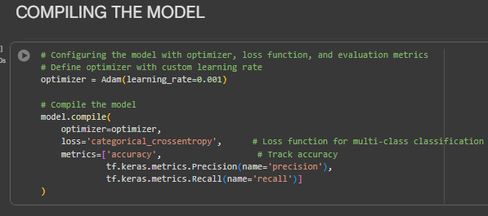
Figure 10: Comparing the model
The training parameters of the model were configured by using the Adam optimizer with a small 0.001 learning rate and categorical cross-entropy loss and the subsequent metrics were used to monitor the performance accuracy, precision, and recall.
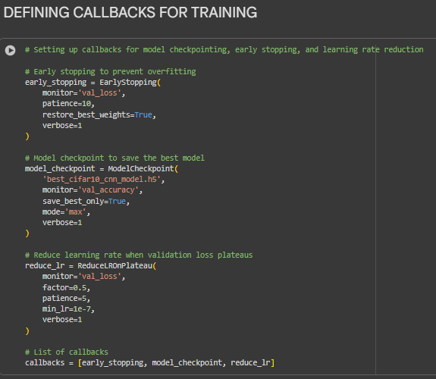
Figure 11: Defining callbacks for training
Early stopping of the training was done with callbacks, preventing the training after 10 epochs without improvement, and the best model was stored, and the learning rate was dropped on a loss plateau.
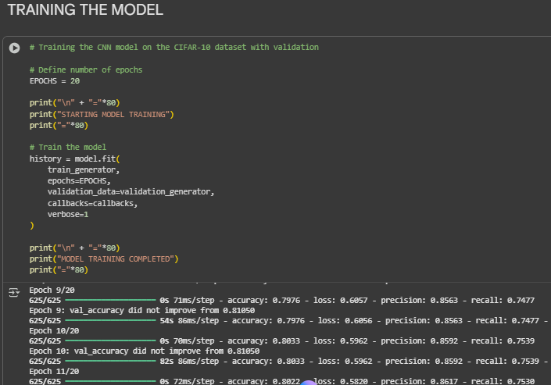
Figure 12: Model training
According to the training log of the model, there are 20 epochs of learning, and live metrics regarding the performance of the model can be observed. It records gradual improvement, whereas a callback records validation accuracy ceases, meaningless further training and efficiency.
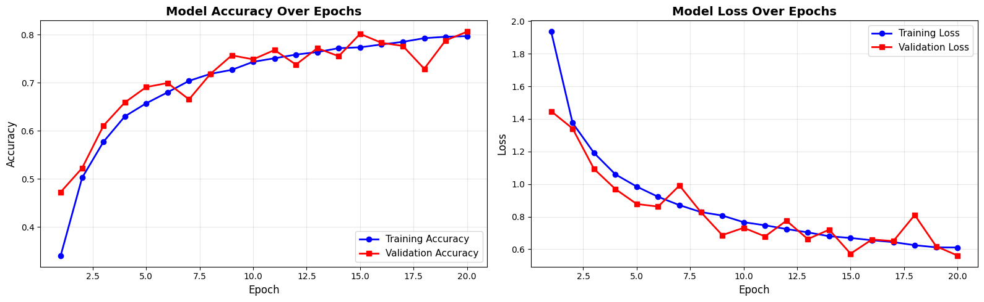
Figure 13: Accuracy vs Loss
Both accuracy and loss plots indicate that the learning is effective throughout the epochs of training, where both of these measures slowly increase. Training curves are closely followed by validation curves, which is a good indication of a model generalisation and a small amount of overfitting, which proves the effectiveness of the regularisation methods applied.
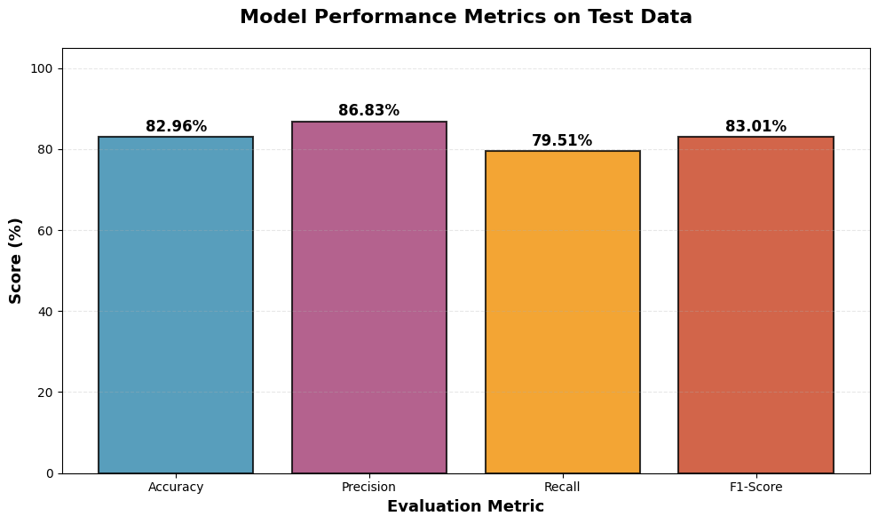
Figure 14: Model performance metrics
Bar chart is a quantitative measure of the performance of a final model on test data that is used in four important measures. It has a very high precision of 86.83% which beats the recall of 79.51%, indicating that it predicts positively with a lot of reliability, at the cost of some misses.
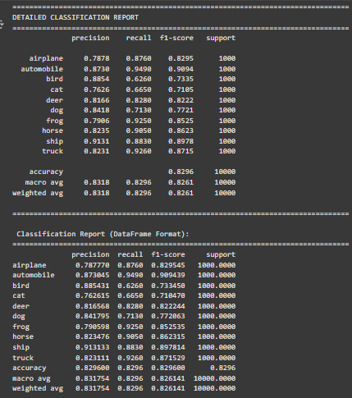
Figure 15: Classification Report
Classification report estimated a per-class analysis of predictive power on the unseen test data in detail. The classes with the best F1-score, such as ship are quite good and the lowest recall of 0.6260 in the cat, which does mean that there are weaknesses.
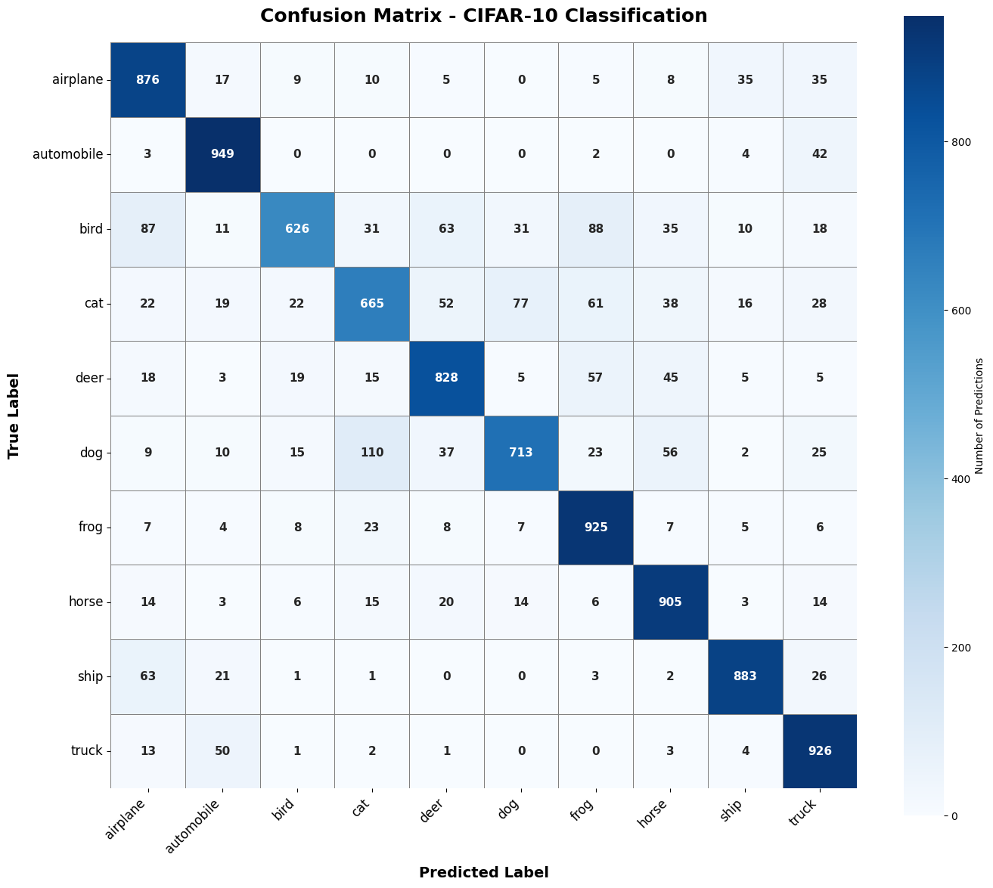
Figure 16: Confusion matrix heatmap
A heatmap represents the classification performance of a model, where a robust diagonal means that there are many correct predictions across all the classes. The off-diagonal values indicate particular misinterpretations, such as a great misunderstanding between the visually related categories such as cat and dog.
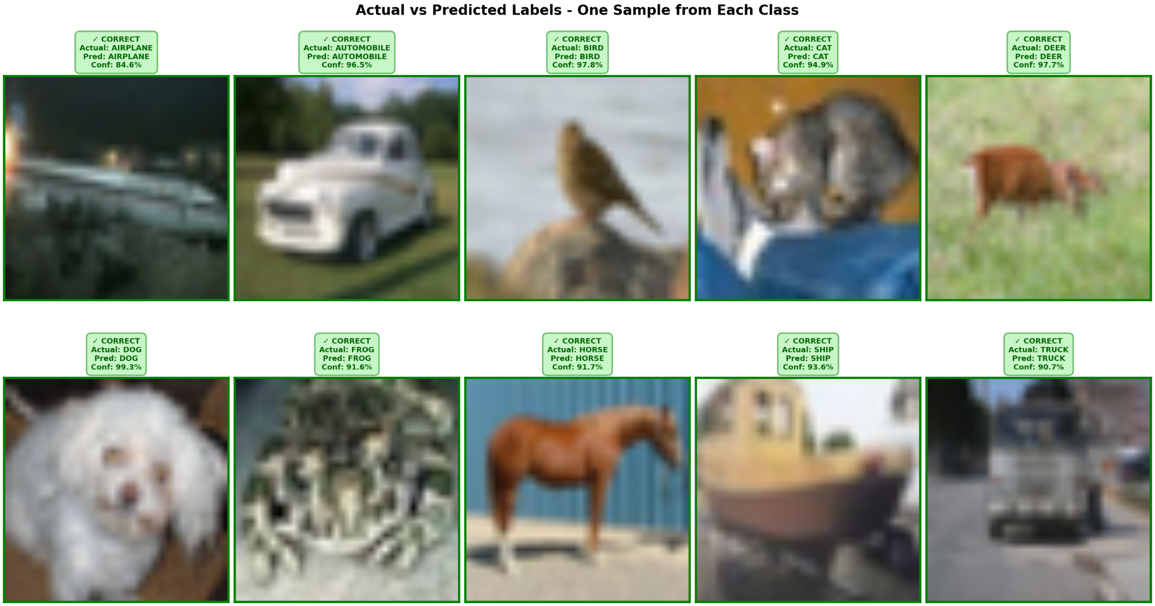
Figure 17: Actual vs predicted
There are ten sample images presented in this qualitative analysis with the actual and predicted labels, and they were correctly identified. The visualisation proves to have practical efficacy in diverse instances, and justifies the model to have very good quantitative execution on obscured data.

Discussion
Key Finding | Discussion & Technical Insight
The model achieves a high overall test accuracy of 82.96% with an even stronger precision of 86.83%. | This performance validates the robust, multi-layered CNN architecture. The high precision indicates a very low false positive rate, making the model’s predictions highly trustworthy when it identifies an object. The balanced F1-score of 83.01% confirms its overall effectiveness.
Training and validation curves for accuracy and loss demonstrate a very close tracking with minimal divergence. | This illustrates excellent model generalization and the successful prevention of overfitting. The strategic implementation of data augmentation, Batch Normalization, and Dropout regularization is directly responsible for this stability, ensuring that the learned features are not specific to the training set.
Classification is exceptionally strong for rigid objects like 'automobile', 'ship', and 'truck'. | The model achieves high F1-scores for these classes as seen in the confusion matrix. Their consistent structural features are easily captured by the convolutional filters, leading to less ambiguity and more confident, accurate classifications.
The model exhibits significant weakness in differentiating between 'cat' and 'dog' classes. | The confusion matrix shows ‘dog’ instances misclassified as ‘cat’, and the ‘bird’ class has a low recall of 0.6260. This highlights a classic vision challenge stemming from high intra-class variation and inter-class similarity in low-resolution images, making feature extraction difficult.
Table 2: Technical Discussion of CNN Performance on CIFAR-10 Dataset
CNN demonstrates robust performance on CIFAR-10, effectively learning hierarchical features. Minor misclassifications are expected due to class similarity, but overall metrics indicate a reliable and generalizable model.

Conclusion
Results of this project indicate an efficient image classification system which proves the strength of the specially trained Convolutional Neural Network. The model has a strong 82.96 percent accuracy and a high precision of 86.83 percent on the CIFAR-10 test set. This is possible due to an advanced architecture that uses data augmentation, batch normalization and dropout to guarantee high levels of generalization. High performance is confirmed by per-class analysis but also, classic computer vision problems are identified, including the model being confused between the words cat and dog. The work is able to justify the machine learning methodology which presents an effective and highly-optimized classifier.

References
Ali, T., Bhowmik, D. and Nicol, R., 2023. Domain-specific optimisations for image processing on FPGAs. Journal of signal processing systems, 95(10), pp.1167-1179. https://link.springer.com/content/pdf/10.1007/s11265-023-01888-2.pdf
Dhany, H.W., Sutarman, S. and Izhari, F., 2023. Exploratory Data Analysis (EDA) methods for healthcare classification. Journal of Intelligent Decision Support System (IDSS), 6(4), pp.209-215. https://www.idss.iocspublisher.org/index.php/jidss/article/download/165/107
Li, Z., Li, Y., Li, Q., Wang, P., Guo, D., Lu, L., Jin, D., Zhang, Y. and Hong, Q., 2023. Lvit: language meets vision transformer in medical image segmentation. IEEE transactions on medical imaging, 43(1), pp.96-107. https://arxiv.org/pdf/2206.14718
Maharana, K., Mondal, S. and Nemade, B., 2022. A review: Data pre-processing and data augmentation techniques. Global Transitions Proceedings, 3(1), pp.91-99. https://www.sciencedirect.com/science/article/pii/S2666285X22000565
Mienye, I.D., Ainah, P.K., Emmanuel, I.D. and Esenogho, E., 2021, March. Sparse noise minimization in image classification using Genetic Algorithm and DenseNet. In 2021 Conference on Information Communications Technology and Society (ICTAS) (pp. 103-108). IEEE. https://salford-repository.worktribe.com/OutputFile/1564110
Sarwinda, D., Paradisa, R.H., Bustamam, A. and Anggia, P., 2021. Deep learning in image classification using residual network (ResNet) variants for detection of colorectal cancer. Procedia Computer Science, 179, pp.423-431. https://www.sciencedirect.com/science/article/pii/S1877050921000284/pdf?md5=5486e43b489047004e08921def981006&pid=1-s2.0-S1877050921000284-main.pdf
Shafiq, M.U. and Butt, A.I., 2024. Segmentation of brain MRI using U-Net: Innovations in medical image processing. Journal of Computational Informatics & Business, 2(1), pp.1-11. https://jcib.org/index.php/jcib/article/download/4/2
Zhu, Y., Brettin, T., Xia, F., Partin, A., Shukla, M., Yoo, H., Evrard, Y.A., Doroshow, J.H. and Stevens, R.L., 2021. Converting tabular data into images for deep learning with convolutional neural networks. Scientific reports, 11(1), p.11325. https://www.nature.com/articles/s41598-021-90923-y.pdf

