BMDS7006
System Improvement Programme

Dr Andrew Shuler
2215316

CW1 draft
3rd November 2022
“End of Life Care: when it is done well families always remember,
when it is done poorly families never forget.”

Introduction
Betsi Cadwaladr University Health Board is the health board serving North Wales. It is the largest health organisation in Wales – covering approximately 6500 square kilometres and serving a population in the order of 700000.
There are Specialist Palliative Care Teams aligned with the 3 principle District General Hospitals. These teams support individuals in hospital, in hospices and in the community.
This Improvement Programme will focus on the community team based in Bodelwyddan (Rhyl, see star on map) in the “central area”. This community area covers the counties of Denbighshire and Conwy, from the coast to the foothills of Snowdonia - an area of about 2000 square kilometres with its population of over 200000.
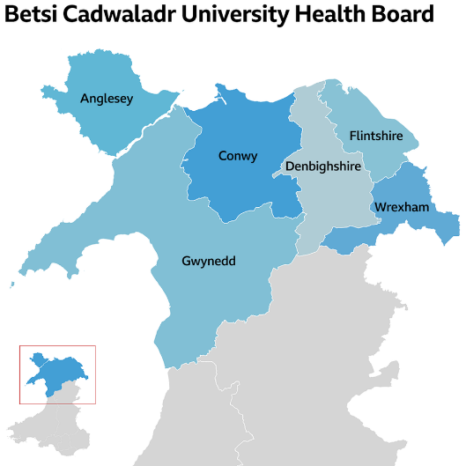
The backbone of the local community specialist palliative care team is the clinical nurse specialists. There are 8 individuals who fulfil this role within this community area.
[picture: admin, nurse manager, OT, pharmacy, patient, carer, hospice, DN, Marie Curie, H@H, end of life care team, primary care, oxygen team, SALT, PT]
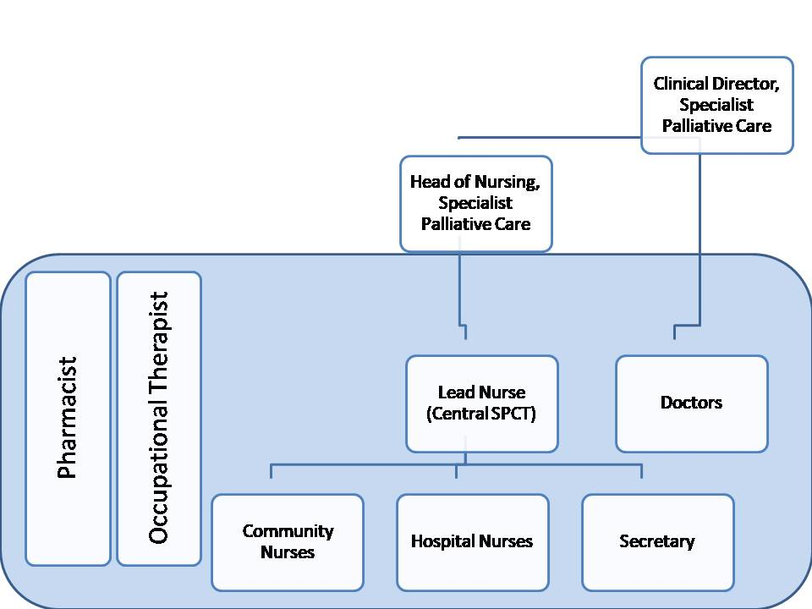
The shaded area indicates the physical team. Individuals seen within the hospital setting tend to be a captive entity as the majority are inpatients. Supporting individuals in the community can be less straight forward. Queries can arise from a range of sources; for example,
- the patient themselves
- their family, or those of significance
- GP
- District Nurses
- GP Out Of Hours service
- Paramedics
- Professional care agencies
- Care home staff
- Other community nursing services (‘End Of Life Care’ team, ‘Hospice at Home’, Marie Curie nursing service within this locality)
- Professions Allied to Medicine
  - speech and language therapist
  - physiotherapy
  - other occupational therapists
  - dietician
- Nurse specialists
  - specific cancer nurse specialists
  - heart failure nurse specialist
  - MND coordinator
  - Oxygen Assessment Team
  - lymphoedema nurse specialist
- Hospices

The business problem
The individual clinical nurse specialists largely manage their own caseloads; triaging referrals, arranging assessments, coordinating frequency of reviews (or bereavement support) and discharges from the service. This caseload management is mostly unseen; making it difficult to quantify the workload, allocate the workforce appropriately, determine performance and ultimately provide an equitable service to patients.
Furthermore any queries come to the administrator in the office who is able to do little more than relay the caller’s details given the individual control of caseloads. Even simple queries such as have individuals been referred, or had their care episodes closed, who might be involved, whether visits are planned for today (or confirmation of time) result in protracted activity.

Information system benefits
An information system will centralise a plethora of details currently being held in a number of paper based files across (at least) 8 desks. An important early declaration is that this will not impede or compromise the clinical skills of the nursing team in their triaging or reviewing. It will identify where the team are involved and this can be fed back quickly when queries are raised regarding our involvement. This may appear a minor point but the delays from those calling in, with the message being relayed and then (successful) return of call to enquirer can be notable and are not infrequent. Considering the patient population that the team supports this delay can cause (preventable) delays in care and missed opportunities in providing optimal care of the dying.
An information system will be an asset for the nurse manager with supporting the wider team. It will help in prioritising workforce activities (which can fluctuate on a weekly, if not daily, basis) and facilitate caseload reviews.
Justification
The proposal
The introduction of a centralised information system to record community patients that are being supported by the community palliative care team. An active list of “open” episodes of care
So a centralised information system will enable timely access to whether individuals are open. To whom they are known. Facilitate team management and workforce planning. Potential for shared schedule of visits which would enhance individual safety given that clinical practice is largely as lone workers.
Rationale
The Leadership Alliance for the Care of Dying People wrote a paper, in the wake of the official response to the furore surrounding use of the “Liverpool Care Pathway”, titled “One Chance to Get it Right”. For dying patients we need to minimise delays in communication and of sharing of information as, for any individual, there will not be a second opportunity to support their dying phase.
Having this information readily accessible will aid our ability to support those we are supporting at the end of their lives. Those in their dying phase often have a spectrum of professionals involved and providing timely support to colleagues helps ease the distress of these situations. The rationale for service improvement is that it will enable a more coherent and efficient service to be delivered to the right patient at the right time in the right place.

Aim
The aims of this improvement programme would be twofold:
- To provide an efficient and timely response to queries raised by callers incoming to the team.
- To quantify the demands and need of the patient population, in order to match the available workforce accordingly.
Objectives
The following objectives will be achieved within 9 months.
- The project will deliver a working information system that will digitalise caseload management.
- The project will deliver a working information system that will digitalise nursing diaries.
- Caseload management will identify individuals open to the team, and to whom.
- Nursing diaries will document planned domiciliary visits, with anticipated timings.
- Reduction in paper based messages relayed between staff members.

Leavitt's Diamond Model
Even at this early stage it is essential to consider the consequences for other parts of the service. A practical approach for weighing these consequences is with Leavitt's Diamond Model. Using this model for an early analysis will help assess the strengths of the organisation with respect to managing change. One caveat to highlight with this model, especially considering this improvement programme, is that it does not factor in the external components, or factors, which drive change.
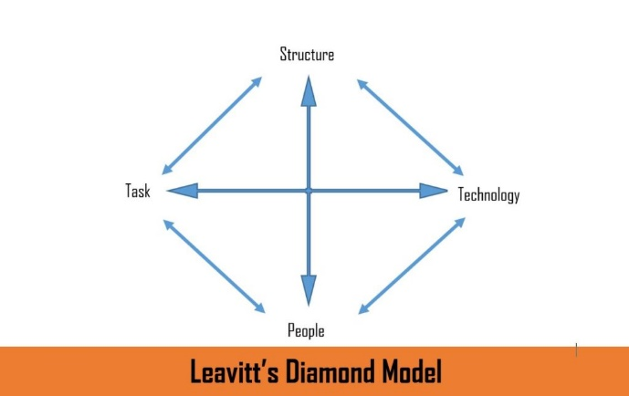
In essence, Leavitt's Diamond is based on the principle that an organisation has four major components that are all interdependent:
1. Tasks
2. People
3. Structure
4. Technology

This improvement programme is primarily pertaining to task. So, briefly, I will consider the secondary impacts on people, structure and technology. Consideration on subsequent (tertiary) consequences will not be detailed here.
The elephant in the room in considering this improvement programme is that there is significant uncontrollable demand (would be keen to at least distinguish this from individual expectation) from the service users.

People - The introduction of new and additional tasks will clearly affect the secretary and nurses within the team. Understanding the new system and gaining additional experience will enhance their expertise; but will require support and training to embed. The service user will, hopefully, receive a more fluent service (although without comparison may not fully appreciate this). A further benefactor from this improvement programme would be the nursing manager – once embedded, support, oversight and management of the nursing team should be more efficient. Finally, with the adoption of a new system there will need to be some local expertise to support the team – whether this can be incorporated within existing roles and job plans requires further discussion. There will also be support required from the IT department, which would be new and additional activity.
Structure – The tasks and functions of the individuals within the team are likely to continue, as there is no envisioned extra layer of hierarchy. The secretary is likely to have an increased authority in supporting the wider team given the increase in transparency between team members. The manager will have an enhanced awareness of the team activity, but this is an existing component of their role. The work flow will evolve and should be leaner.
Technology – This improvement programme should reduce the relaying of messages and number of phone calls needing returning. These prompts have been recorded on paper so there should be a reduction associated manual recording. Arguably there could be a less robust audit trail of conversations or messages received - this is a different conversation regarding adequate documentation of actions rather than specific to this improvement programme.

