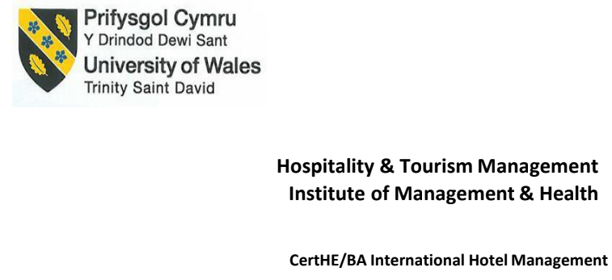
Housekeeping Team Member Development Plan

Student ID:2118842
Student Name:Claudia -Diana Balta

Table of Contents
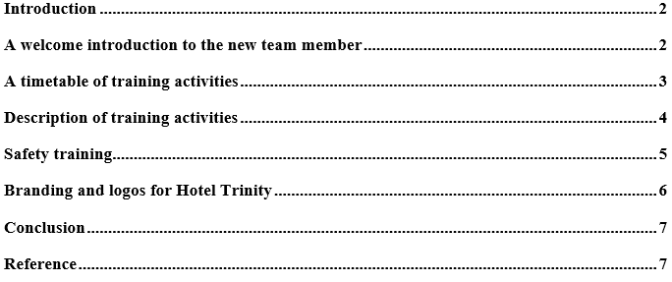

Introduction
Within the hotel, Housekeeping is all about supporting the routine activities to run the hotel perfectly. Trinity Hotel is a four-star hotel at the heart of the new beat of Dublin with all the facilities like accommodation, spa, food, beverage, etc. This report, there try to focus on the training program to train the new members of the housekeeping team as part of the responsibility of the housekeeping manager. This report will show how to train the new member with the proper effective and efficient.

A welcome introduction to the new team member
Whenever new employees are joined in the hotel or any type of organisation, the first thing that makes an employee happy is known other than the welcoming massage to assist the welcome introduction. These things are working like positive vibes and make them a part of the hotel through professional greetings (Alila et al. 2019). The welcome introduction is needed for four core reasons, among them, the first one is to create a positive impression cause the first impression creates more positive vibes, and the second one is the appreciation from the hotel to join here. The third and fourth ones gradually help to build motivating culture and increase engagement. As a housekeeping manager, the welcoming introductory speech for the new numbers of 4-Star Trinity Hotel will be,
“Welcome abroad! This is too much excitement for the team at Trinity hotel as you all are here and we are working with you as a family. We, the trinity hotel, know about your skills which is the greatest asset to us. On behalf of our entire department, best wishes to you”.

A timetable of training activities
Regardless of the hotel size and service verities, the common thing is to judge the housekeeping department as the backbone of the hotel because a high portion of revenue comes from the room revenue. Without a clean environment for the guest, they are not interested to come in the hotel the next time (Sharma and Kaushik, 2021). Not only that but also the proper skills to manage their necessity is mandatory to ensure the standard benchmark. To ensure proper housekeeping, proper training is mandatory and for that, there make a plan for the training of the team members which is shown below,
Milestone | Training Activities | Weeks
Milestone | Training Activities | 1 | 2 | 3 | 4 | 5 | 6 | 7 | 8
M1 | Works with a budget and benchmarking
M2 | Train up for Communication
M3 | Train up for Cleaning Skills
M4 | Train how to use all equipment and product
M5 | Train for Proper Guest Etiquette & Interaction
M6 | Train for Presentation Skills
M7 | Team working
M8 | Fire protocol
M9 | Health and Safety

Table 1: Timeframe of Training Activities

Description of training activities
Standardisation of the hotel depends on the framework of proper implementation of all planned work. This is possible when all the activities are done by the employees and staff. To make them skilled, the proper training should be maintained properly with the proper knowledge of these criteria. These training activities are described below,
Works with a budget and benchmarking: The first and foremost thing is to make a budget for nurturing or conducting the training session. Focusing on the budget and benchmarking point, the others activities will be decided (Olimovich, Bakhtiyorovich and Salimovna, 2020). The most important part is to forecast the success that Trinity Hotel wants to achieve. To complete this there need almost 2 weeks.
Train up for Communication: Communication is the way to express what one wants to share and this is the way to connect with others by sharing or spreading out the information. As the hotel is part of the service industry, there keeps focused on communication skills to serve the guests one to one. The housekeeping team is the presenter of the hotel and their attitude and their communication reflect the reputation of the hotel.
Train up for Cleaning Skills: One of the main key work areas of the housekeeping department is to establish a common ground in where they are engaged in cleaning (Kumar, 2022). This doesn’t mean that all the team members are highly skilled in that purpose but the thing is they have minimum knowledge to handle this for making the hotel room clean.
Train how to use all equipment and product: Similar to other skills, it is needed to ensure that the team members are familiar with all equipment and product. If they are familiar with those skills, this training session helps to improve their skills for using these and maintaining all to ensure the longest life of these.
Train for Proper Guest Etiquette & Interaction: As a service-based organisation, employees have to be trained on how to be interacted with the guest and properly behaved with them (Prabawab et al., 2019). During training, there have to learn the staff how to understand cultural differences among the guests and then how to approach to interact with all the guests around them.
Train for Presentation Skills: An employee of the hotel should be properly uniformed and presentable to the guest as they are the ambassadors of the hotel by their working Style. For that, this activity trains how to be presentable to all
Team working: As a team, an individual has to maintain how to create coordination among the team members. This activity helps how to ensure the best output as a team to satisfy the guests as per the demand.
Fire protocol: If a fire takes place, the guests seek some advice or follow them, for that, the housekeeping team has to be clear about this issue, and how they can handle it.
Health and Safety: For a long-standing hotel like Trinity Hotel, health and safety is the key that makes the guests secured to be there and also come again. It is not something, one cannot be ignored, for that entire team trained up with all the health and safety protocols.

Safety training
The term safety training is pretty common in the competitive world, not only in the hotel industry. However, the term safety training describes the activities that help to ensure safety and security with effectivity and effectiveness (Prabawab et al., 2019). Within the hotel room, guests have their assets, even though their life is more precious than their assets. To maintain this aspect, proper training in safety and security is mandatory.
- Fire safety: Fire is a dangerous threat within the hotel. The best way to keep the safe hotel from a fire accident is to train the employees they would support themselves and the guests.
- COSHH: COSHH is an acronym that stands for “Control of Substances Hazardous to Health” to control substances that are harmful to health (Kimbrough et al., 2020). The thing is, employees are the assets of the hotel, and for that this COSHH is important to protect employees.

Branding and logos for Hotel Trinity
Branding is about the issue to create an image to the guests or the world through unique attributes. In general, people think branding indicates only the name, term, symbol, or any other image that has been created by the unique features to attract customers and guests for visiting the hotel again and again. Logos are assists for branding a destination through specific terms, words, or pictures. For branding this hotel, there have to go through some processes which are,

Figure 1:Steps of Training
For the branding, the first thing is to gather information about the unique features of this trinity hotel and the next step is to conduct the proper analysation, based on the gathered information. After that there gradually select a set of alternative ways and the best suitable way to conduct the branding features (Giglio., 2020). The fifth way is to verify the branding to find out the best logo or design it with the branding concept. After the logo design, it is high time to implement those and consciously launch the logo. This logo will be like the above feature, in which their building infrastructure is told a unique story.

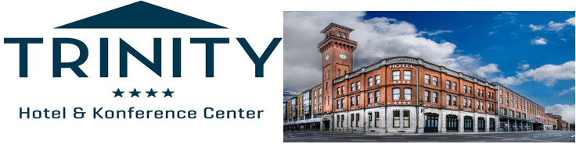
Figure 2: Logo of trinity Hotel
The last and foremost way is to think about how to maintain the branding with proper management and in that phase all the members of Trinity hotel are responsible.

Conclusion
In the report, there is a focus on the phase of training activities of the new team member to train them with the hotel’s rules, regulates, and attributes and ensures they can attain all the goals. This report found nine activities to train the employees to satisfy the guests which are working with a budget and benchmarking, skills about communication, cleaning, presentation, team working, fire protocol, health and safety, guest interaction, and equipment.

Reference
Alola, U.V., Olugbade, O.A., Avci, T. and Öztüren, A., 2019. Customer incivility and employees' outcomes in the hotel: Testing the mediating role of emotional exhaustion. Tourism Management Perspectives, 29, pp.9-17.
Giglio, S., Pantano, E., Bilotta, E. and Melewar, T.C., 2020. Branding luxury hotels: Evidence from the analysis of consumers’“big” visual data on TripAdvisor. Journal of business research, 119, pp.495-501.
Kimbrough, L.J., Oestenstad, R.K. and Beasley, T.M., 2020. Evaluation of the exposure prediction component of Control of Substances Hazardous to Health Essentials. Journal of Occupational and Environmental Hygiene, 17(2-3), pp.97-108.
Kumar, M.H., 2022.A Study on ‘’Recent Trends in Housekeeping Department in Hotel Industry’’.
Olimovich, D.I., Bakhtiyorovich, T.M. and Salimovna, N.G., 2020. Improving of personnel training in hotel bussines. Academy, (2 (53)), pp.18-19.
Prabawa, I.B.J., Sulistyawati, A.S. and Suarka, F.M., 2019. The Perception of Housekeeping Department StaffsToward Training Method at Golden Tulip Devins Hotel Seminyak. Jurnal Kepariwisataan dan Hospitalitas, 2(3), pp.155-174.
Sharma, S. and Kaushik, T., 2021. Aesthetically clean to clinically clean–A study on new housekeeping practices in Delhi hotels beyond COVID-19 pandemic. Worldwide Hospitality and Tourism Themes, 13(5), pp.646-659.

