ECEY 5005 Awe and wonder- Science, maths and the outdoors.

I have not used any AI for this assignment.

Contents

Page 1. Contents

Page 2. Part one

Page 3- 6. Part two

Page 7-9 Part three

Page 10-14 Part four

Page 15-16 reference list.

Awe and wonder: mathematics, science and the outdoors.

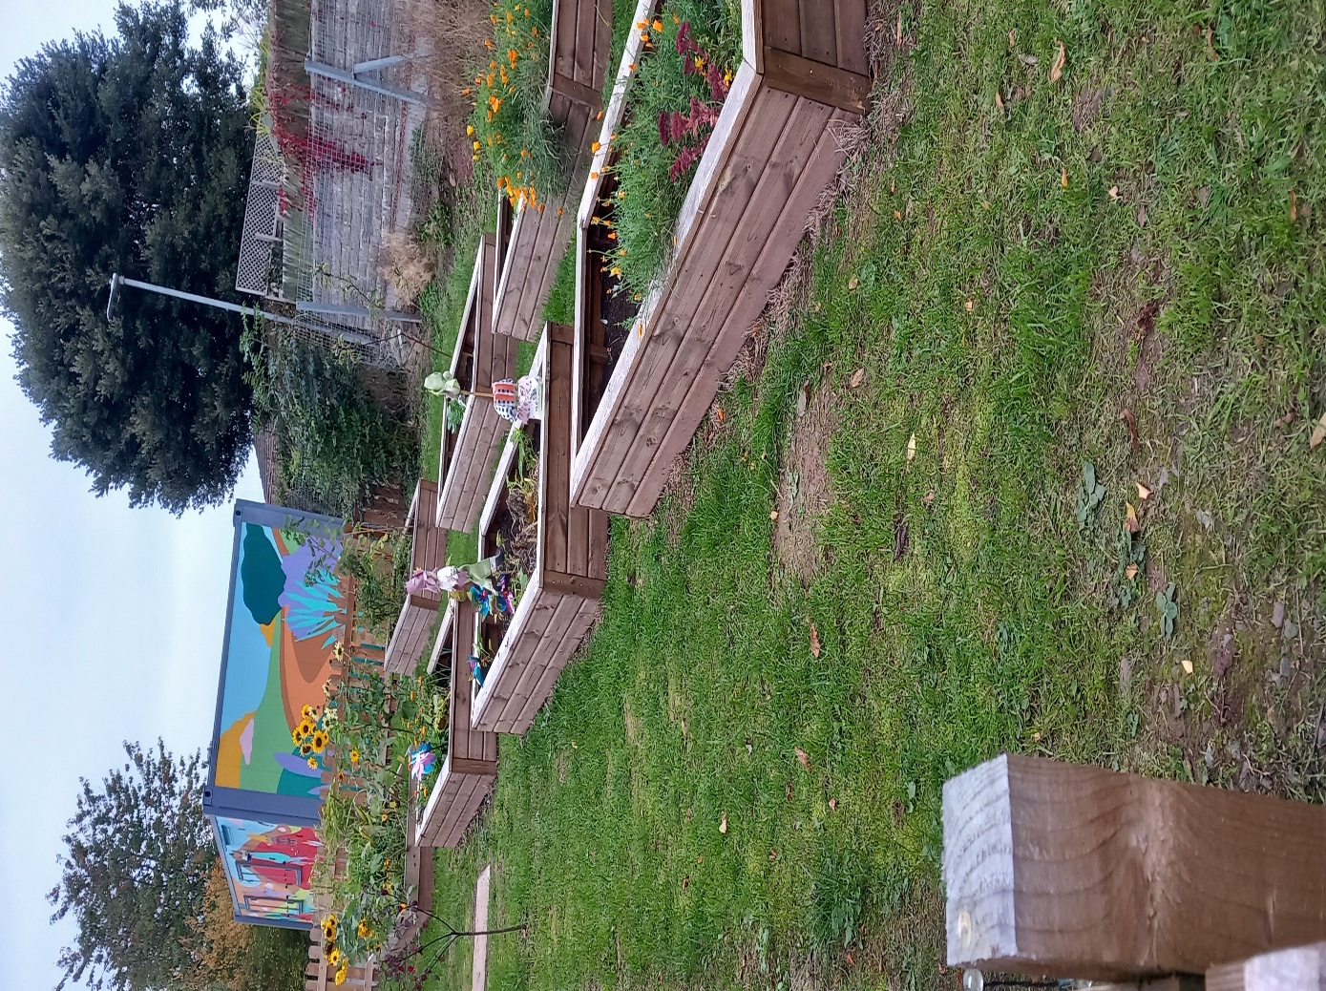

Source: Thomas, 2025.
Allotment Observation.
7th July 2025.
Today we were taking some of our new children over to see our allotment. I picked my four key children to come with us. Two are new to the setting so this will be their first visit and my other two are always so excited to visit the garden. I work in the flying start from so the children are aged between two and three years old. I changed them all into our gardening clothes, these are puddle suits so we can protect their clothes from getting muddy or dirty and wellies. Marie and I were taking eight children over. We ensured that we had the mobile phone and first aid bag in case any emergencies or accidents happen. We then attached the children to our big set of reins and off we went. The children were very excited they were pushing and pulling each other, so we had to stop and ask everyone to calm down and stop rushing. We started singing a song on the way to help with this ‘Hey, Ho, Hey, Ho it’s off to the allotment we go’. The children liked this two of them joined in the rest were just giggling away. We stopped at the end of the path to tell the children to check for any cars before we crossed over the carpark. Once we were through the gate, we ensured it was safely shut behind us and then took out their hands to release them. I looked over at Erin, and her face was beaming she was so excited to be here she began hand flapping. She said, ‘wow look’ and began pointing at all the flowers and plants. She immediately rushed over to the flowers and began telling me all the colours that she could see, ‘yellow’, ‘orange’, ‘pink’. Ben came over to join us, and he began pointing at some of the other plants and saying ‘blue’. I said, ‘well done Ben, that is a green plant’. He then repeated this. Ben then spotted the scarecrow and said, ‘man’. I told Ben that he was very clever and that it was a man and that he was there to scare away the birds from eating our plants. Rosie and Holly were calling out for me to go and see what they had found so I joined them, they were by the sunflowers and were amazed at how big they had grown. I said, ‘wow these sunflowers are very big’ and Holly pointed at one and told me that it was taller than her, which was correct. I praised her for this and called the others over and told them to look how big the sunflowers were and I said this one is taller than you all. We spent some time then looking at the different sizes of the sunflowers and I used the correct mathematical terms such as bigger, smaller, taller, shorter. The children picked this up quickly and were going around the garden looking in all the different boxes and telling us if they had big or small plants in them. I told the children that we were going to go on a colour hunt around the garden to see how many different colours we could find. The children had the digital cameras so that they could take pictures of the different colours. I had also brought over with us a paper plate with the different colours around the edge and pegs so the idea was for us to collect the different coloured flowers or objects from around the garden and peg onto our plate an example is below.
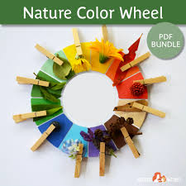Source: MotherNaturedStore, (no date).
The children had great fun exploring the garden to find the different colours to clip onto the board. They struggled with the pegs, so me and Marie helped with this part.
Erin continued going around the garden and repeating all the colours out loud. I had to explain to Erin that we don’t pick the flowers they are there for us to look at. One of our flower boxes is full of wild poppies these were all different colours red, yellow, orange and pink. This box was the children’s favourite, Rosie and Holly both said how pretty the flowers in this box looked. Erin told me that the one poppy was light pink. I praised her and told her friends to look at the poppy and see if they could tell that it was a lighter colour than the other pink ones. Ben joined in and told me that his mum’s favourite colour was pink. We all discussed our favourite colours.
Marie’s group of four children were busy running around the garden, my key children decided to join in. They were all having so much fun chasing each other around.
We have kept one of the flower beds for the children to be able explore and practice their fine motor skills by digging the soil with spades or using their hands. I got some spades out of the garden shed and placed them in this flower bed. Ben was the first to spot this he came bouncing over and picked up a spade and began digging up the soil. Erin came over to see what Ben was doing, and she began picking up the soil with her hands and watching it fall back into the flower bed. Erin said the soil felt ‘cold’, She then put some soil in her mouth, pulled a face and spat it out. I explained to the children that we do not eat anything when we are over in the allotment especially not the soil or plants. The other children were all digging in the soil and picking it up with their hands. We asked the children if they wanted to put some gloves on and Evie and Josh from Marie’s group wanted too, they don’t like to get their hands dirty. I reminded the children that we don’t throw the soil as it may go in somebody’s eyes.
Marie then came out of the shed and told the children that she had something special to show them. They all gathered around and sat down on the little log stools eagerly awaiting her surprise. She pulled out some bulbs and told the children that we were going to plant them. Marie handed out some magnifying glasses that she brought out of the shed and then gave the children a bulb to look at. She asked the children what they could see. Evie told us that the bulb looked bumpy, and Rosie said that there was a flower hiding inside the bulb. Ben told me that the bulb smelt, ‘yucky’. Marie explained that we were going to dig holes in the flower bed and then put our bulbs into them. One by one the children dug a little hole to place their bulbs in, some children were told by Marie to dig a little bit deeper into the ground. We then all counted the bulbs one, two, three all the way up to ten. Next, we all took turns to put soil on top of our bulbs to cover them over. Holly can struggle to take turns with others, so this was lovely to watch her patiently awaiting her turn. I then explained to the children that we needed to water our new bulbs, so I got the watering cans out of the garden shed and Ben said we need a tap I explained that we have a water butt in the allotment and that this collects the rain water through the pipes so we can use that to water our garden. Rosie asked what happens if it doesn’t rain so I explained that if it doesn't rain and we run out of water then we will need to use the hose pipe from nursery. The children took turns watering the plants, Erin decided to water herself instead. We all sat around the log circle and Marie showed us all the picture below of the lifecycle of the plant.
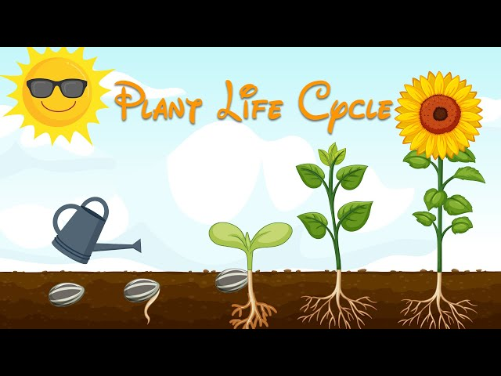 Source: Superkidzo, (2020).
Evie pointed to the sky and said the sun is out so the flowers will grow. We explained that the flowers will take some time to start growing and must be watered every day.
Just before we left to go, we checked our vegetable patch to see if anything was ready to be harvested. Erin shouted, look red tomatoes, I love tomatoes. Ben said, yuck, me not eat them. We told Erin that we need to wash them first and then she can try them at snack time. The lettuce was not ready yet so we explained that we will come back at the end of the week to see if it is ready. Holly and Rosie both aid that they remembered trying the lettuce from the garden last time and that it tasted yummy.
The colour hunt and the examining of the bulbs using magnifying glasses support the exploration pathway part of the Curriculum for non-maintained nursery settings (2022) in Wales as it encourages the children to be curious, ask questions and use their senses to explore. These activities took part in an enabling outdoor environment. Mathematical thinking was also included in this visit and this is another one of the developmental pathways from the Curriculum for Wales (2022). We used simple mathematical descriptions to explore size and quantity. We spoke about the size of the sunflowers, and we counted how many bulbs we had planted. Exploring the life cycle of the bulb helps children understand living things this is teaching them about science that is also included in the Curriculum for Wales (2022). This activity covers more than just mathematical and scientific parts of the curriculum for Non maintained nursery settings in Wales it also covers the four purposes too as it encourages the children to learn about the environment around them and taking care of real- life plants. It also helps build a sense of Cynefin as it helps strengthen their connections to their local Welsh surroundings and communities.
RISK BENEFIT ASSESSMENT

Location / Activity: | Visit to the allotment | Date: | 7/7/25
Assessor: | Emma Thomas | Review date: | 7/7/26

Experience exploring outdoor space in photograph | How will young people BENEFIT from this activity? | Hazards and associated risks | Who is at risk? | PRECAUTIONS in place to reduce the risk of injury | Overall risk after precautions  RATING: L/M/H
Digging the soil with spades, carrying watering cans. | Carrying watering cans and squatting down to dig holes in the soil will help develop their gross motor skills, balance and coordination. Digging with spades will help develop fine motor skills. Touching different materials and hearing the water pour from the watering can engage their senses all this help with brain development. | Sharp gardening tools or misuse of them. A child or adult could cut their finger if a gardening tool is damaged. If the tools are being thrown around or used as a weapon this could cause an injury. If the child has any open wounds or cuts on their finger, then getting dirt in them may cause infections. | Other children and adults. | Check over the tools to ensure no damage before use. Ensure they are child friendly/ appropriate size for children. Give a clear demonstration on how to use the tools safely and state clear boundaries on what is expected of the children. Ensure that strict ratios are always adhered to ensure that close supervision happens. Ensure that any wounds or cuts are covered with waterproof plasters before going to the allotment. | Medium.
Planting bulbs in the soil. | This will help develop their fine motor skills. Digging the holes and planting the bulbs help with hand eye coordination.  Planting the bulbs can teach the children about caring for living things can help teach children about empathy and responsibilities. The children can also learn about patience as it will take time for the bulbs to grow into something that the children will begin to recognise. The children will also take responsibility for the bulbs, so this helps build a sense ownership and pride once it starts growing. | Bacteria and contaminates from the soil. | Children. | Ensure that strict hand washing before and after the activity. Use gardening gloves to touch the soil. | Low
Learning about plant lifecycles, weather and where food comes from. | This will help their cognitive skills and give them hands on learning experiences. | Poisonous plants. | Children | Check the allotment for any poisonous plants before the visit and ensure strict supervision to avoid the children from digesting any plants. | Low
Spending time in the outdoors. | This will help benefit their emotional and mental well- being. Having the space to run and jump are essential for physical development. | Insect stings.  Sun burn/ heat stroke. | Children and staff. | Check if any allergies and if necessary, carry medication such as a EpiPen. Be aware of which insects sting. Ensure that sun cream is applied, if necessary, before leaving the setting, have a sun hat for each child and take drinking water over with you. Do not visit during peak UV hours (11am-3pm) on hot days. | Medium
Working together with their friends. | This will help encourage teamwork, sharing and turn taking skills. | If a child gets frustrated, he may throw a gardening object at another. | Children, staff | Ensure children are well supervised and if you see a child is becoming frustrated step in to deescalate the situation before anything happens. | Low
Uneven ground. | This can help teach the children about balance and help strengthen their core. | Trips or falls. |  | Ensure that children and staff have appropriate footwear on. Make sure that any pathways are clear. | Low

Evaluate how adults working with the early years children support and encourage children to engage with mathematical and scientific concepts in the outdoor environment.
Introduction
This essay is going to look at the role of the adults working with early years children and how they can support them with mathematical and scientific concepts in an outdoor environment. It will look at the benefits of outdoor learning as well as what roles the adults play to facilitate the development. This will also look at some of the theorists and different approaches used in the early years throughout when it comes to the role of the adult in supporting mathematical and scientific concepts in the outdoor environment. These theorists will include Vygotsky, Frobel and the Reggio Emilio approach and how each theory views the role of the adult in relation to this topic.
Robertson (2017) discusses the benefits that outdoor learning can have on developing a child’s mathematical skills. She suggests that using the outdoor environment can make maths more engaging and meaningful for the children. They suggest that incorporating real life experiences for the children is beneficial in making hands on learning more effective for young children. This implies that the outdoor environment is beneficial in promoting the use of maths and science for children. She also suggests that practitioners should use and encourage the use of natural resources such as collecting sticks and stones or use water play to help support a greater understanding of the mathematical and scientific concepts. Furthermore, Robertson (2017) believes that children learn better when they experience the different concepts as opposed to just hearing about them and encouraged to develop their thinking further. An example of this includes the child collecting sticks and then the adult asking how many they have, which stick is shorter or longer. This will then encourage the child to think more in depth about what they are doing and promote early learning. This would also mean the child will be able to use the everyday objects to get a real hands on learning experience. Ryder Richardson (2013) agrees with Robertson (2017) as she also believes that the outdoors environment provides great opportunities for hands on mathematical and scientific experiences to take place. She believes that the outdoors provides great opportunities to explore the environment and the changes that occur throughout. Ryder Richardson (2013) suggested that in order for these experiences to happen the adults must ensure that the environment is enabling to supports the child’s curiosity and engagement, by doing this the adult helps scaffold the child’s learning making maths and science more meaningful. This suggests that adults need to supply children with resources and environments that encourage them to explore and investigate.
Vygotskys theory
Vygotsky (1978) suggests that learning takes place through interactions with others more knowledgeable than them. He believed that social interactions played an important part in a child’s learning and development. He claimed that children need the support of someone with more knowledge than themselves to learn from, he referred to this person as the knowledgeable other. This suggests that in order for children to expand their learning and development, they need the support of others who can use their own knowledge to encourage new ways of thinking and playing. This is similar to what Ryder Richardson (2013) claims, as discussed previously, as they discuss the importance of the role of the adult in enhancing a child’s learning through meaningful and purposeful adult interactions. This aligns with Vygotsky’s idea that children learn from the more knowledgeable other, in this case the adult and that they are beneficial in a child’s development. In early years the adults can help support children’s maths and science understanding by extending the children’s learning through play-based activities (Tucker, 2014). This can include exploring the seasonal changes with the outdoor environment, looking at the colour changes in the leaves and discussing the weather and the impact this has on the flowers or plants. These types of activities can be carried out with recognition of Vygotsky’s theory as the adult may scaffold learning experiences to include counting natural objects that have been found outdoors instead of the child just examining them. The adult can help support a child’s maths and science development by asking more open-ended questions and using appropriate vocabulary that will encourage the child to think deeper and problem solve. The use of these activities and the input of the adult can further develop children’s mathematical and scientific learning, and the adult can help them to consider things that they may not have been capable of alone.
Furthermore, Tucker (2014) states that creativity plays an important role in mathematical learning because when a child is engaged and curious this drives them to want to explore more and achieve the end goal. Tucker (2014) also claims that adults can bring creative thinking into mathematical play by asking the children open ended questions. This indicates that adults should be involving themselves in childrens learning and play in order to make it more engaging and meaningful. Tucker, (2014) also says providing a range of open-ended resources can encourage maths and creativity in the early years implying that this is something early years settings should provide for children’s learning. This links to what Vygotsky says about the adult scaffolding the child’s learning and providing the experiences to develop the child’s mathematical and scientific thinking as they explain that the adult should inject themselves into the children’s play to encourage deeper thinking. Also, this relates to Vygotsky’s views on the role of the adult in children’s outdoor learning as both Vygotsky and Tucker recommend the use of encouraging the children to think more mathematical and scientific about things they are already doing naturally. This suggests that adults should be available to children in outdoor learning environments in order to motivate and demonstrate ways that they can further develop their mathematical and scientific knowledge and skills.
However, an argument against this theory comes from the Reggio Emilia approach as this is made up of different principles. These principles suggest that children should be in control of their own learning and must be able to explore this through all of their senses. The Reggio Emilia approach sees the adult’s role differently to Vygotsky. They do not see the adult’s role as an instructor to the children they see the adult as equal, stating that the adult is there to explore and learn new things alongside the children (England,2019). This implies that while Vygotsky views the adult as being a leader for the children, the Reggio Emilia approach sees them as more of an equal. Both however, do promote the importance of the adult when it comes to development highlighting the vitality of them.
Frobels approach
Another approach that has been linked to the development of mathematical and scientific skills in children is by Frobel, as Tovey (2020) states that this approach describes the outdoors as ‘a living classroom’. This suggests that the outdoor environment plays a vital role in the learning and development of children and should be incorporated into their lives as much as possible. He believes that children can learn mathematical and scientific concepts and that they can gain a better understanding of these subjects through hands on learning in the outdoor environment. These claims indicate that children are given the opportunity to develop mathematical and scientific understanding of the world around them by being outside more. Frobel created the first setting where children were allowed to develop and learn at their own pace. His work still influences practices today and settings ensure that they have nurturing, knowledgeable and supportive staff for the children. Frobel believed that children learn best through play with hands on learning (Tovey, 2020) highlighting the importance of a child’s environment providing them with the opportunity and desire to explore their surroundings (Welsh Government,2022). Also, he claims that using real materials is an important aspect of children’s learning indicating that by having access to natural objects like sticks, stones and water they can enhance their scientific and mathematical understanding. He saw children as creative and curious learners who progress better in a self-directed way with the adults around them guiding and allowing them to experiment and explore their surroundings. Frobel sees the adult’s role in enhancing their learning by providing an engaging outdoor environment and supporting and encouraging exploration of their surroundings to assist this by learning through play and interactions with nature. Frobel takes the child led approach when it comes to learning. While both this approach and Vygotsky view the outdoors as an important environment for mathematical and scientifical thinking, they have slight differences of opinion when it comes to the adult’s role. For example, with Froebel’s approach the adult takes more of an observational role in the learning process whereas Vygotsky see’s the adult’s role as the facilitator stating that the children learn through these direct social interactions with adults. However, they both agree that outdoor learning is valuable they just have different views on what the adult’s role should be. Vygotsky feels that the adult should play an important part and lead the learning process while Frobel believes that the adult should just support the child to enhance their own learning.
An example of the implementation of these views in everyday practice includes the use of loose parts. Loose parts are any objects or items that can have more than one purpose, they are open ended resources that can enhance a child’s learning, and they naturally support mathematical and scientific thinking through play (Cankaya, 2025). Loose parts allow the child the explore their curiosity and imagination. These resources can be added to an outdoor area to enhance the child’s mathematical and scientific thinking, or these can be collected from the outdoor area to be explored. Loose parts can include sticks, stones, pinecones, log slices, feathers or any natural resources. Some ways that loose parts can be bought into the learning is that the children can sort the objects by colour or size, they can compare the different sizes for example see which sticks are bigger or smaller. These loose parts can be added to play to see if they change outcomes. For example, in a mud kitchen water could be added to change the consistency of the soil. England (2019) talks about the important role that the adult plays in setting up this environment to enhance these mathematical and scientific concepts. This suggests that the adult should be providing the children with these resources in their environment for them to explore to further encourage the use of maths and science in play.

Conclusion
In conclusion, all theories and approaches discussed throughout explain that the role of the adult in supporting early years children to engage with mathematical and scientific concepts in the outdoor environment is significant. The adult plays an important role in providing engaging, rich hands-on experiences for the children to explore using their curiosity. The adult should ensure that the children’s environment provides them with lots of natural resources and opportunities to explore and investigate. They should also encourage the children to think in more depth about amounts, shapes, sizes and colours of these resources in order to promote the use of mathematical and scientifical thinking in their play.

Reference List.
Cankaya, O., Martin, M. and Haugen, D. (2025) ‘The relationship between children’s indoor loose parts play and cognitive development: a systematic review’, Journal of Intelligence, 13(5), p. 52. Available at: https://www.ncbi.nlm.nih.gov/pmc/articles/PMC12112344/ (Accessed: 25 January 2026)
England, L. (2019) looking for learning loose parts. Bloomsbury publishing plc: London.
Lindfors, E., Rönkkö, M.-L., Kiviranta, L., Yliverronen, V., Tanhuanpää, S. & Grönman, S. (2021) Outdoor Learning in Early Childhood Education: A Narrative Review, Techne serien - Forskning i slöjdpedagogik och slöjdvetenskap, 28(2), pp. 156–165. Available at: https://journals.oslomet.no/index.php/techneA/article/view/4353 (Accessed: 25 January 2026).
MotherNaturedStore, (no date). Nature colour wheel. Available at: https://www.etsy.com/uk/listing/1240463338/nature-colour-wheel-nature-color-wheel?dd_referrer=https%3A%2F%2Fwww.google.com%2F {Accessed 22 January 2026}
Robertson, K. (2017). Messy maths: A playful approach for early years. Crown house publishing LTD. Available at: https://books.google.co.uk/books?id=epwuDwAAQBAJ&printsec=frontcover#v=onepage&q&f=false {Accessed 25 January 2026}
Ryder Richardson, G. (2013) Creating a Space to Grow : Developing Your Enabling Environment Outdoors. 2nd ed. New York: Routledge. Available at: https://research-ebsco-com.uwtsd.idm.oclc.org/linkprocessor/plink?id=868a721f-4364-3afd-a400-aa98cfd8b30d {Accessed: 25 January 2026}
SuperKidzo TV, (2020). Plant Life Cycle. Available at: https://www.youtube.com/watch?v=ib5uiLMM2wY {Accessed 22 January 2026}
Tovey, H. (2020) Frobel’s principles and practice today. Available at: https://moodle.uwtsd.ac.uk/course/section.php?id=123032 {Accessed 25 January 2026}
Tucker, K. (2014). Mathematics through play in the early years. Sage publication: 3rd edition. Available at: https://r3-vlebooks-com.uwtsd.idm.oclc.org/EpubReader?ean=1781446297865# {Accessed 25 January 2026}
Welsh Government, (2022). A Curriculum For Funded Non- Maintained Nursery Settings. Available at: https://hwb.gov.wales/api/storage/b1801d78-38c3-4320-9818-d9996c21aef8/220914-a-curriculum-for-funded-non-maintained-nursery-settings.pdf {Accessed 22 January 2026}

