Name : Rhys Davies

Student: 1803152

Course: Web Development

Module: Advanced Software Development

Lecturer: Mike Dacey
Table of Contents
Introduction 2
Classes and Objects 2
What is a class? 2
What is an Object? 2
The difference between an Object and a Class. 2
How they work: 3
What is Data Encapsulation? 4
Interfaces 4
What are interfaces? 4
Subdividing of code using abstraction. 4
Comprehensive testing report 5
Testing Amendments: 15
Test 12 – Symbols in strings 15
Test 80, 88 – Searching by registration in employee search 16
Conclusion 17
Evaluation 17
Bibliography 18

Introduction
The following report will contain an explanation on classes and objects and how they contribute to the object orientated programming model followed by the difference between both a class and an object with a code snippet to show how they work and are declared. The report will also explain the term data encapsulation and the key uses for it and Interfaces along with their impact on the process of developing code. Specifically, their role in the subdivision of code through abstraction. A comprehensive testing report will be created on the program created for task 2.

Classes and Objects

What is a class?
A class is a blueprint for an object and any number of objects can be instantiated from that one class [1]. A class is a programmer defined type and give the ability to create a new type to solve a problem. These new types store and carry out the methods defined within when called. Classes are logical entities and are only there to support the physical creation of objects. Classes can also be used to stop the repetition of code as methods within a class can be repurposed elsewhere. Classes follow a 4-layer setup of attributes, constructors, properties and methods which can be shown in figure 1.
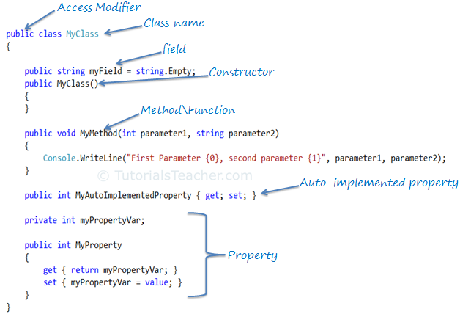
Figure 1 [2]

What is an Object?
An object is an instance of a class or what can be built from the blueprint the class has provided. Objects create physical entities that can be used within the program. An object has two main characteristics, state and behaviour. The state of an object would be class descriptors such as name, age or address. These are also known as class attributes [3]. The behaviour would be what that object can do such as walk, talk and run, which are methods.

The difference between an Object and a Class.
The difference between an object and a class is an object relies on a class for it be created as the class is a blueprint for an object to be birthed. One class can create many objects however an object can be created from only one class. Objects are based off real world objects for example a car or a chair.
Object | Class
Object is an instance of a class | A class is a blueprint to create an object
Objects can be created as many times as needed | Class is created once
Objects are physical entities | Classes are logical

How they work:
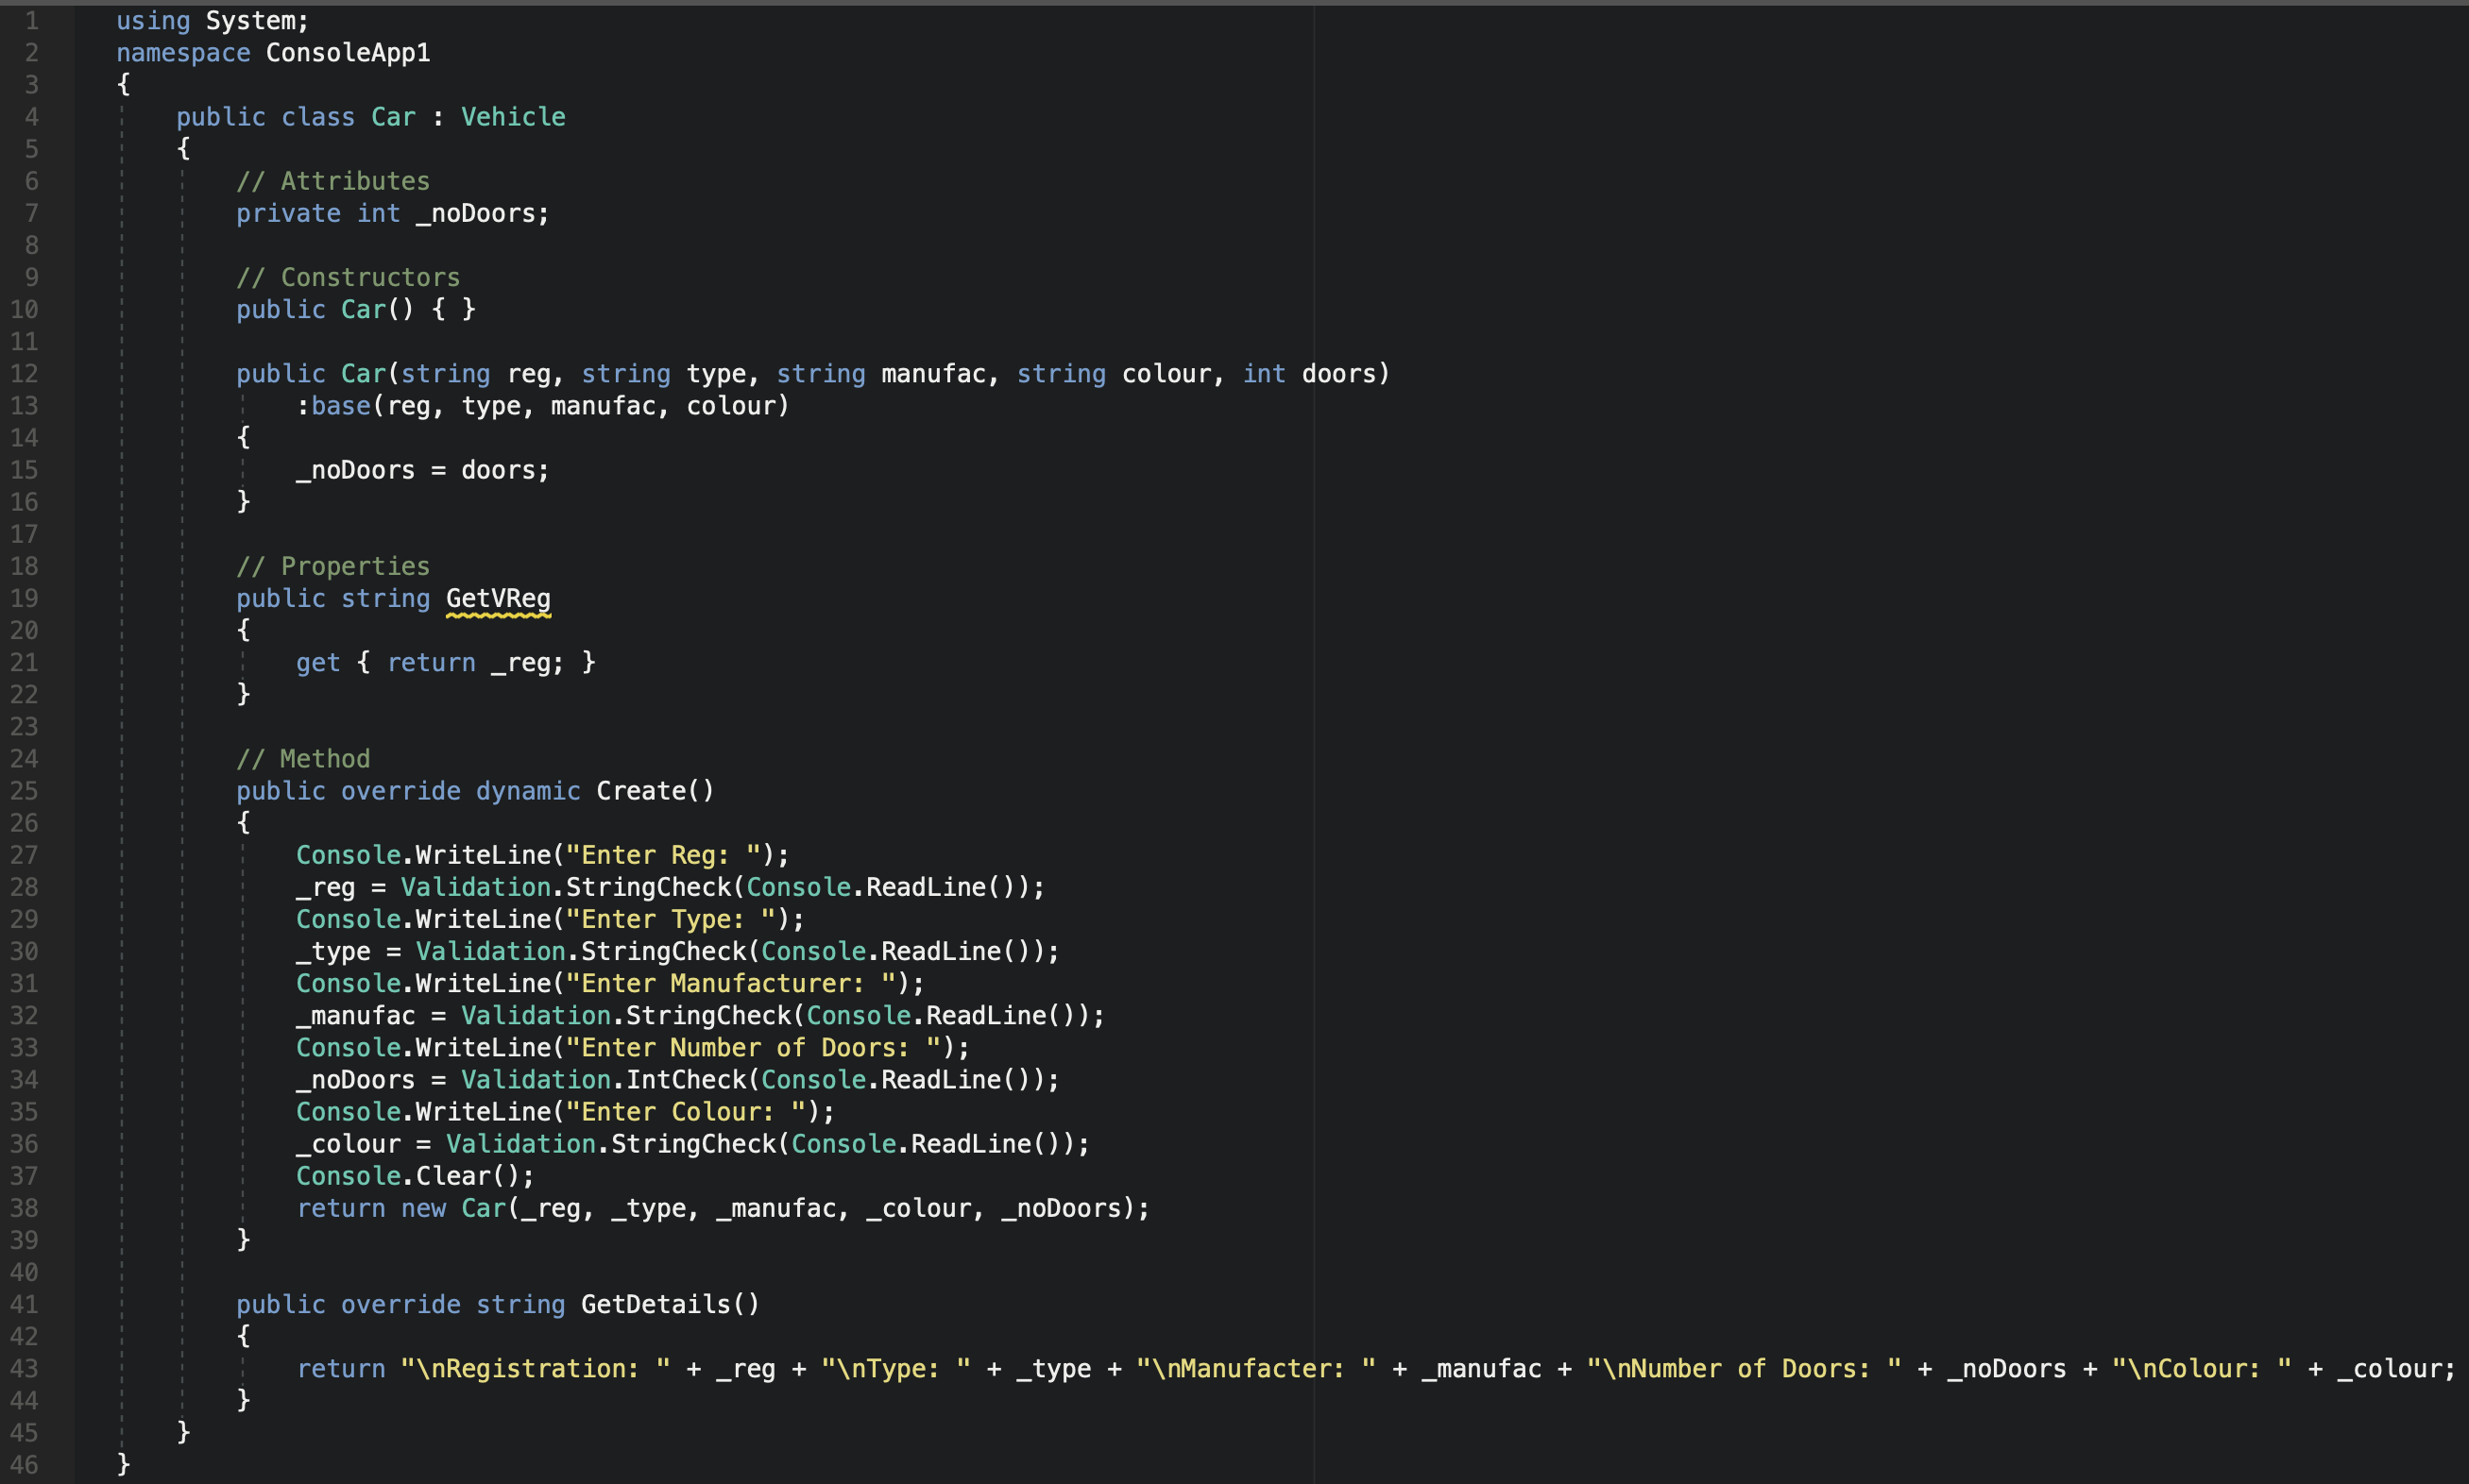
Figure 2 Shows a car class.

A class is created as shown in fig 2. The class has attributes, followed by constructors, properties and methods as mentioned above as these are the main layers for setting up a class effectively.

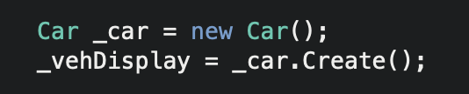
Figure 3 shows an object.

An object is created at shown in figure 3 called car. The car object is derived from the blueprint of the car class which contains the method create. This creates a car object using that method attached to that object as shown in figure 2

What is Data Encapsulation?
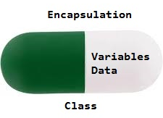
Figure 4

Data Encapsulation, as shown in figure 4, is the bundling together of data and the methods that utilise that data all within a class or capsule [4]. Encapsulation means that the attributes of an object cannot be modified except by calls to the object [5], these are called getters and setters and can be used to read or write to an attribute depending on what the access modifier granted to that class. These access modifiers define the visibility of a class by defining the class as private, public or protected. Information hiding allows for data to be hidden to certain parts of a program to which it would be unnecessary, changes made to hidden parts of a class should not affect anything outside of the class to maintain abstraction [6].

Interfaces

What are interfaces?
An interface is a contract. Contracts are always public as the methods within will always need to be accessed. Interfaces cannot be instantiated as objects as they act as abstract. Interfaces do not provide inheritance, they declare properties, indexers, methods and delegates that an implementing class will have and utilise. Interfaces can be implemented on as many classes as required, and a class can have many different interfaces implemented to it. Interfaces are used to provide common functionality between classes that are unrelated or subdivided and allow the contents of the corresponding objects to be accessed from within the interface [7].

Subdividing of code using abstraction.
Subdividing of code is making code blocks/ classes smaller by having an alternative class carry out and return the value therefore subdividing the code into subclasses. As an example, a vehicle class that can accelerate, decelerate, turn on and off. Using abstraction and creating a car, van and bus class that all inherit from the abstract vehicle class. An interface can then be used to bring all the objects created together into one interface where all the common methods like the accelerate method can be called and used per object [8].

Test No  Comprehensive testing report | Test Description | Input | Expected Result | Actual Result | Comments
Menu
1 | Testing menu item 1 opens up a create an employee menu | 1 | Shows create employee menu and asks user for ID | Shows create employee menu and asks user for ID | Works as expected.
2 | Testing menu item 2 opens up the staff search menu | 2 | Shows search for staff menu and asks for staff ID or last name | Shows search for staff menu and asks for staff ID or last name | Works as expected.
3 | Testing menu item 3 opens up Print security badge menu | 3 | Shows print security badge menu and asks for ID to print | Shows print security badge menu and asks for ID to print | Works as expected.
4 | Testing menu item 4 opens up the vehicle search | 4 | Shows search for vehicle menu and asks for registration | Shows search for vehicle menu and asks for registration | Works as expected.
5 | Testing menu item 5 exits the application | 5 | Exits the application | Exits application | Works as expected.
6 | Testing a menu item not listed on the menu | 6 | Ask user to re-enter a valid menu number | Ask user to re-enter a valid menu number | Works as expected.
7 | Testing entering no number at all | N/A | Asks user to enter a valid menu number | Ask user to enter a valid menu number | Works as expected.
Creating Employee
8 | Entering Staff ID | 1A | Accepts and move onto next requirement | Accepts and moves onto next requirement | Works as expected
9 | Leaving Staff ID blank and trying to move on | N/A | Ask user to enter valid staff ID | Ask user to enter valid staff ID | Works as expected.
10 | Entering Symbols into Staff ID | $123 | Accept and move onto next requirement | Accept and move onto next requirement | Works as expected. Technically shouldn’t accept a symbol not a major issue.
First Name Field
11 | Entering Name into First Name | Rhys | Accept and move onto next requirement | Accept and move onto next requirement | Works as expected.
12 | Entering Symbols into First Name | Rhys$ | Should reject as $ is not a valid name | Accepts and move onto next requirement | Does not work. Need to read each character as ASCII and check each individual character from the string.
13 | Entering Numbers into First Name | Rhys123 | Should reject as 123 is not a valid name | Accepts and move onto next requirement | Does not work. Same fix as above.
14 | Leave field blank and try and proceed | N/A | Reject as it is a required field | Reject as it is a required field | Works as expected.
Last Name Field
15 | Entering Name into Last Name | Davies | Accept and move onto next requirement | Accept and move onto next requirement | Works as expected.
16 | Entering Symbols into Last Name | Davies$ | Should reject as $ is not a valid name | Accepts and move onto next requirement | Does not work. Same fix as above.
17 | Entering Numbers into Last Name | Davies123 | Should reject as 123 is not a valid name | Accepts and move onto next requirement | Does not work. Same fix as above.
18 | Leave field blank and try and proceed | N/A | Reject as it is a required field | Reject as it is a required field | Works as expected.
Age Field
19 | Enter Correct Age | 20 | Accept and move onto next requirement | Accept and move onto next requirement | Works as expected.
20 | Enter age younger than 16 or older than 68 | 15, 69 | Reject and write that user is too old or young to work | Rejects. Displays Please enter a valid number. | Works as expected
21 | Enter a character | C | Reject as Char is not a valid Int | Rejects. Displays Please enter a valid number. | Works as expected
22 | Enter a symbol | $ | Reject as $ is not a valid int | Rejects. Displays Please enter a valid number. | Works as expected.
23 | Leave field blank and try and proceed | N/A | Reject as it is a required field | Reject as it is a required field | Works as expected.
Gender Field
24 | Enter gender | Male/ Female | Accepts and moves onto next requirement | Accepts and moves onto next requirement | Works as expected
25 | Enter value other than male or female | Helicopter | Reject as this is not a valid gender | Rejects. Displays Please enter Male/ Female | Works as expected.
26 | Leave field blank and try and proceed | N/A | Reject as it is a required field | Reject as it is a required field | Works as expected.
Address Field
27 | Enter address | 752 Usef Avenue | Accept as this is a valid address string | Accepts and moves onto next requirement | Works as expected.
28 | Leave field blank and try and proceed | N/A | Reject as it is a required field | Reject as it is a required field | Works as expected.
Own a Vehicle Field
29 | Enter Yes for owning a vehicle | Yes | Accepts and displays questions for owning a car | Accepts and displays questions for owning a car. | Works as expected.
30 | No for owning a vehicle | No | Displays recorded added and exits out to main menu | Displays recorded added and exits out to main menu | Works as expected.
31 | Enter Symbol for owning a vehicle | $ | Rejects and asks for the input to be entered again | Rejects and asks for the input to be entered again | Works as expected.
32 | Enter Numerical value for owning a vehicle | 123 | Rejects and asks for the input to be entered again | Rejects and asks for the input to be entered again | Works as expected.
33 | Leave field blank and try and proceed | N/A | Reject as it is a required field | Reject as it is a required field | Works as expected.
IF vehicle is Owned. What Vehicle Field
34 | Enter Car | Car | Accept and display Car details method from Car class | Accept and display Car details method from Car class | Works as expected.
35 | Enter Van | Van | Accept and display Van details method from Van class | Accept and display Van details method from Van class | Works as expected.
36 | Enter Motorbike | Motorbike | Accept and display Motorbike details method from Motorbike class | Accept and display Motorbike details method from Motorbike class | Works as expected.
37 | Enter Symbol | $ | Reject and give message to enter valid vehicle. | Reject and give message to enter valid vehicle. | Works as expected.
38 | Enter Number | 123 | Reject and give message to enter valid vehicle. | Reject and give message to enter valid vehicle. | Works as expected.
39 | Leave field blank | N/A | Reject and give message to enter valid vehicle. | Reject and give message to enter valid vehicle. | Works as expected.
Creating Car Object attached to Employee
40 | Enter registration in car section | DY10CCZ | Accept and move onto the next required field | Accept and move onto the next required field | Works as expected.
41 | Enter Symbols into car registration | DY£$CCZ | Reject and say symbols are not valid in a registration | Accepts and moves onto next field | FAIL. Same bug as above, need to check each char
42 | Leave blank in car section | N/A | Reject and say please enter a valid registration | Reject and say please enter a valid registration | Works as expected.
Entering Type
43 | Enter Type in car section | Hatchback | Accept and move onto the next required field | Accept and move onto the next required field | Works as expected.
44 | Enter Symbols into type of car | $ | Reject and say symbols are not valid in the type of car | Accepts and moves onto the next field. | FAIL. Same bug as above, need to check each char
45 | Enter numbers into type of car | 123 | Reject and say numbers are not valid in the type of car | Accepts and moves onto the next field. | FAIL. Same bug as above, need to check each char
46 | Leave type field blank in car section | N/A | Reject and say please enter valid type of car | Reject and say please enter valid type of car | Works as expected.
Entering Manufacturer
47 | Enter Manufacture in car section | Vauxhall | Accept and move onto the next required field | Accept and move onto the next required field | Works as expected.
48 | Enter symbols into manufacturer of car | $ | Reject and say symbols are not valid in the manufacturer | Accepts and moves onto the next field. | FAIL. Same bug as above, need to check each char
49 | Enter numbers into manufacturer of car | 123 | Reject and say numbers are not valid in manufacturer | Accepts and moves onto the next field. | FAIL. Same bug as above, need to check each char
50 | Leave Manufacturer field blank in car section | N/A | Reject and say please enter valid manufacturer | Reject and say please enter valid manufacturer | Works as expected.
Entering Number of Doors
51 | Enter the number of doors on car section | 3 | Accept and move onto the next required field | Accept and move onto the next required field | Works as expected.
52 | Enter a string into number of doors | Three | Reject and say please enter a valid number of doors | Reject and say please enter a valid number of doors | These work due to using try parse to check if all values are numbers
53 | Enter Symbols into number of doors | $ | Reject and say symbols are not valid in the number of doors | Reject and say symbols are not valid in the number of doors
54 | Leave number of doors field blank | N/A | Reject and say please enter valid number of doors | Reject and say please enter valid number of doors | Works as expected.
Entering Colour
55 | Enter colour in colour of car section | Blue | Accept and add employee to the list of employees and return user to the main menu | Accepts and add employee to the list of employees and return user to the main menu | Works as expected.
56 | Enter symbols into colour of car | $ | Reject and say symbols are not valid in the colour | Accepts and adds employee to the list of employees and return user to the main menu | FAIL. Same bug as above, need to check each char
57 | Enter numbers into colour of car | 123 | Reject and say numbers are not valid in the colour field | Accepts and adds employee to the list of employees and return user to the main menu | FAIL. Same bug as above, need to check each char
58 | Leave colour field blank in car section | N/A | Reject and say please enter a valid colour |  | Works as expected.
Testing from here will not include symbols or numbers in string fields due to repetitive known issue.
Creating Van Object Attached to Employee
59 | Enter registration in van section | CP03UWU | Accept and move onto the next required field | Accept and move onto the next required field | Works as expected.
60 | Leave blank in van section | N/A | Reject and say please enter a valid registration | Reject and say please enter a valid registration | Works as expected.
Entering Type
61 | Enter Type in van section | Camper | Accept and move onto the next required field | Accept and move onto the next required field | Works as expected.
62 | Leave type field blank in van section | N/A | Reject and say please enter valid type of van | Reject and say please enter valid type of van | Works as expected.
Entering Manufacturer
63 | Enter Manufacture in van section | Nissan | Accept and move onto the next required field | Accept and move onto the next required field | Works as expected.
64 | Leave Manufacturer field blank in van section | N/A | Reject and say please enter valid manufacturer | Reject and say please enter valid manufacturer | Works as expected.
Entering Height
65 | Enter the number of doors on van section | 3 | Accept and move onto the next required field | Accept and move onto the next required field | Works as expected.
66 | Enter a string into number of doors | Three | Reject and say please enter a valid height | Reject and say please enter a valid height | Works as expected.
67 | Leave number of doors field blank | N/A | Reject and say please enter valid height | Reject and say please enter valid height | Works as expected.
Entering Colour
68 | Enter colour in colour of van section | White | Accept and add employee to the list of employees and return user to the main menu | Accept and add employee to the list of employees and return user to the main menu | Works as expected.
69 | Leave colour field blank in van section | N/A | Reject and say please enter a valid colour | Reject and say please enter a valid colour | Works as expected.
Creating Motorbike Object Attached to Employee
70 | Enter registration in motorbike section | CP03UWU | Accept and move onto the next required field | Accept and move onto the next required field | Works as expected.
71 | Leave blank in motorbike section | N/A | Reject and say please enter a valid registration | Reject and say please enter a valid registration | Works as expected.
Entering Type
72 | Enter Type in motorbike section | Chopper | Accept and move onto the next required field | Accept and move onto the next required field | Works as expected.
73 | Leave type field blank in motorbike section | N/A | Reject and say please enter valid type of motorbike | Reject and say please enter valid type of motorbike | Works as expected.
Entering Manufacturer
74 | Enter Manufacture in motorbike section | Nissan | Accept and move onto the next required field | Accept and move onto the next required field | Works as expected.
75 | Leave Manufacturer field blank in motorbike section | N/A | Reject and say please enter valid manufacturer | Reject and say please enter valid manufacturer | Works as expected.
Entering Colour
76 | Enter colour in colour of motorbike section | White | Accept and add employee to the list of employees and return user to the main menu | Accept and add employee to the list of employees and return user to the main menu | Works as expected.
77 | Leave colour field blank in motorbike section | N/A | Reject and say please enter a valid colour | Reject and say please enter a valid colour | Works as expected.
Searching for Employee By ID or Last Name
78 | Enter in a search ID known to be in the list | 2 | Return back details of employee called Mark Huntly | Returned back details of employee called Mark Huntly | Works as expected.
79 | Enter Last Name of employee known to be in list | Huntly | Return back details of employee called Mark Huntly | Returned back details of employee called Mark Huntly | Works as expected.
80 | Enter Registration of employee known to be in list | DY10CCZ | Should reject as the current search is by last name and ID | Accepts and searches for the requested registration | Should not be able to search for registration in employee search. Need to subdivide the search method to search for registration separately
81 | Leave ID field blank | N/A | Reject and ask for a valid input to be entered. | Rejected and ask for a valid input to be entered. | Works as expected.
Print Security Badge
82 | Search for a known ID without a security badge printed | 2 | Should return telling user that this employee does not currently have a photo, and take one | Returns saying employee does not currently have a photo, and take one | Works as expected.
83 | Answer Yes to take a photo | Yes | Should say that the card is being printed and request used to press any button to continue | Says that the card is being printed and request used to press any button to continue | Works as expected.
84 | View if card is printed | N/A | Should display security card details with a date and time at the bottom | Displays security card details with date and time | Works as expected.
85 | If user already has photo taken does it ask to take it again? | 2 | As photo was previously taken for this employee, it should say he has a photo and prints card. | Already has photo is displayed and new card is printed. | Works as expected.
Search for Vehicle by Registration
86 | Enter Registration of employee known to be in list | DY10CCZ | Should reject as the current search is by last name and ID | Accepts and searches for the requested registration | Works as expected.
87 | Enter in an ID or last name known to be in the list | 2 | Should reject as the current search is for a vehicle | Returned back car details of employee called Mark Huntly | Should not be able to search for registration in employee search. Need to subdivide the search method to search for registration separately
88 | Leave ID field blank | N/A | Reject and ask for a valid input to be entered. | Rejected and ask for a valid input to be entered. | Works as expected.

Testing Amendments:
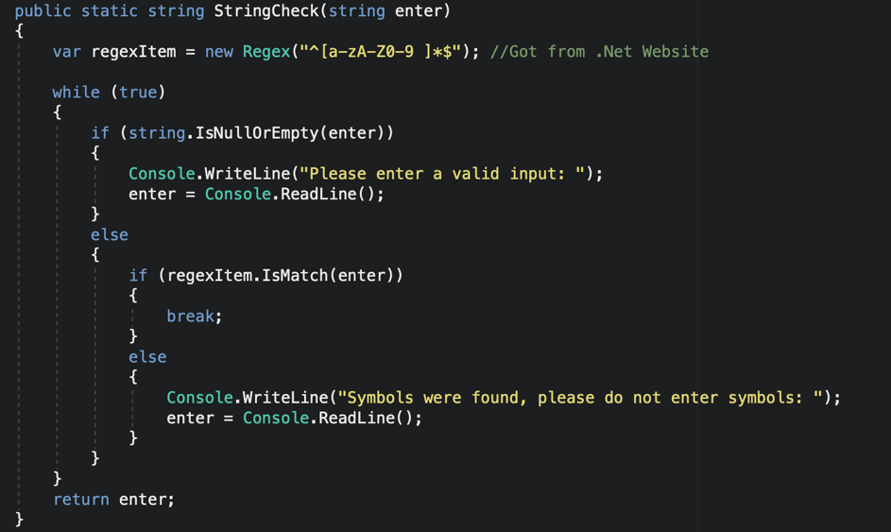
Test 12 – Symbols in strings (Plus any other tests this affected): For this fix a Regex [9] was added to the program and within the string check method. As shown in figure 5, the regex object checks for alpha and numerical values only, if anything else is entered it will ask the user to re-enter the string as symbols were found.

Figure 5
Test No | Test Description | Input | Expected Result | Actual Result | Comments
12 | Entering Symbols into First Name | Rhys$ | Should reject as $ is not a valid name | Rejects and displays that symbols were found and to re-enter | Works as expected.

Test 80, 88 – Searching by registration in employee search: For this fix the search method was subdividing into two separate searches, shown in figure 6 below. This was for the vehicle search it could be explicitly searched for on its own menu and bring up the relevant information.
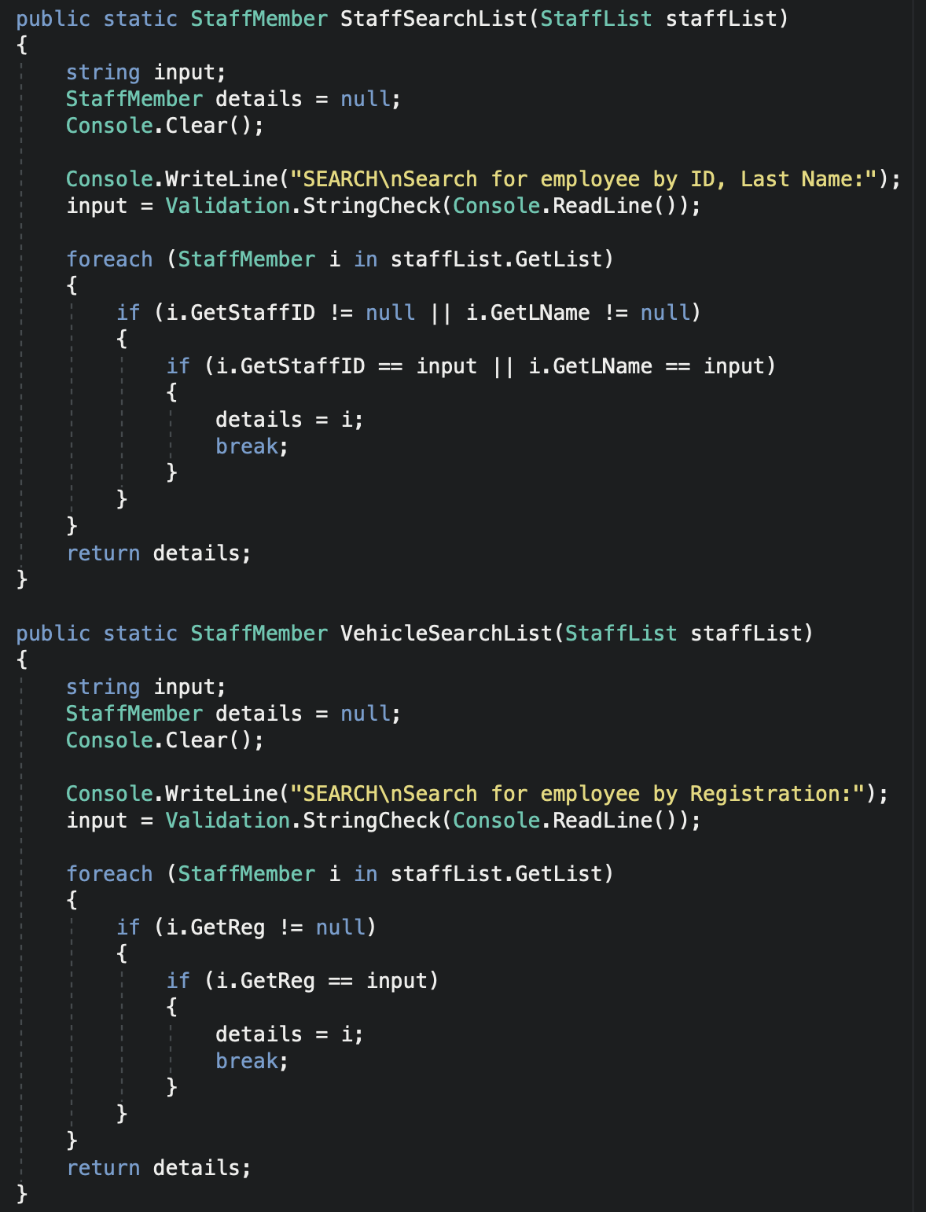
Figure 6
Test No | Test Description | Input | Expected Result | Actual Result | Comments
80 | Enter Registration of employee known to be in list | DY10CCZ | Should reject as the current search is by last name and ID | Rejects, “Employee not found” | Works as expected.
88 | Enter in an ID or last name known to be in the list | 2 | Should reject as the current search is for a vehicle | Rejects, “registration not found” | Works as expected.

Conclusion
In conclusion, the basic principles of object-oriented programming have been discussed and explained with examples of how they are used and why they are useful. Abstraction was also touched upon in relation to interfaces which also play a major role in the object orientated model. Throughout task 2 many new programming techniques were learnt developing the program, from an understanding of abstraction, interfaces, inheritance and creation objects. The Interface created was taken out of task two as it was obsolete under the circumstances however the principle and understanding still stood.

Evaluation
Further areas to explore a deeper dive into the use of interfaces and their practical assignment within programs. Explore how object orientated program is used within web development and benefits of using it.

Bibliography

[1] | J. Liberty, Programming C#: Building .NET Applications with C#, O'Reilly Media, 2005.
[2] | “C# Class,” TutorialsTeacher, [Online]. Available: https://www.tutorialsteacher.com/csharp/csharp-class.
[3] | M. Khosrow-Pour, Encyclopedia of Information Science and Technology, IGI Global, 2018.
[4] | R. Pecinovsky, Learn Object Oriented Thinking & Programming, Tomáš Bruckner, 2013.
[5] | S. Kent, “Encapsulation and Aggregation,” University of Brighton, 1995.
[6] | “Information Hiding,” Computer Science Department, University of Cape Town, 01 2011. [Online]. Available: https://www.cs.uct.ac.za/mit_notes/software/htmls/ch07s07.html.
[7] | “A Deep Dive into C# Interfaces,” [Online]. Available: http://www.idc-online.com/technical_references/pdfs/information_technology/A_Deep_Dive_into_CSharp_Interface.pdf.
[8] | W. Harrison and H. Ossher, “Subdivided procedures: a language extension supporting extensible programming,” USA, 1990.
[9] | Microsoft, “Regex Class,” [Online]. Available: https://docs.microsoft.com/en-us/dotnet/api/system.text.regularexpressions.regex?redirectedfrom=MSDN&view=netframework-4.8.

