

The understanding of Non-epileptic seizures in young people: A multi-perspectival qualitative analysis.

Alison Upstill

MA Children and Young People’s Mental Health.

University of Wales Trinity Saint David School of Psychology

2025

Declaration
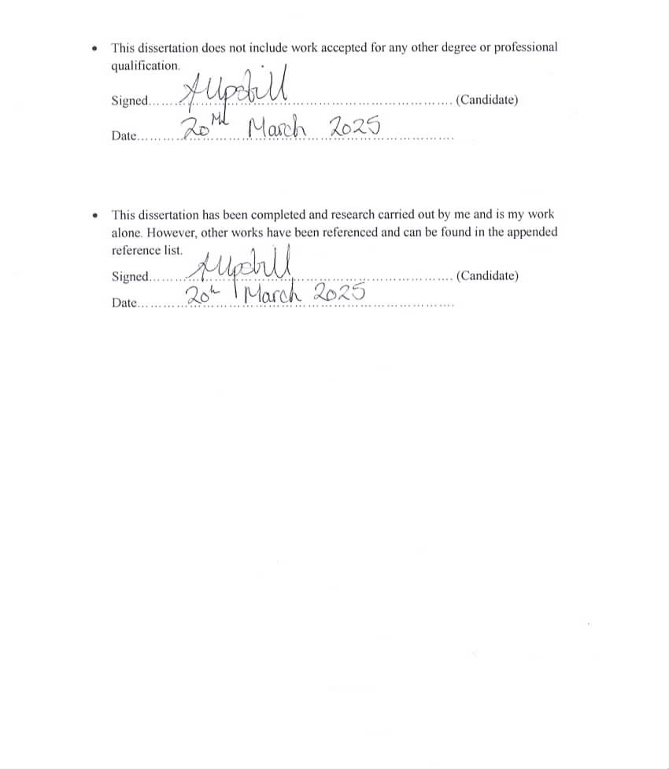

Acknowledgements

Firstly, I would like to thank the Senior lecturer in Psychology Dr Charlotte Greenway for the support and understanding over the duration of the MA Children and Young Peoples Mental Health and throughout the dissertation period, especially during the time when my Mother passed away. Dr Greenway has fully believed and pushed me to achieve my potential and always encouraged me, as the expert, when I doubted myself, in my dissertation topic. I would also like to thank my dissertation supervisor Dr Lymarie Rodriguez-Morales for her advice throughout the process of my dissertation.

Secondly, I would like to give a heartfelt thanks to those who have supported me from the UWTSD Student Support and Well-being Team, Ian Showell and Cathy Evans. As a mature student with newly diagnosed ADHD and Dyscalculia, Ian’s dedication and ease with which he has supported me with computer processes, sequencing and new technologies has been undeniably a blessing, thank you Ian. Time spent with Cathy Evans at a most challenging period in my life, losing my last parent and selling our family home was also much needed when working through the process of grief whilst studying for a masters. I honestly could not have continued without both of your support.

I thank all of the participants for their time being interviewed for my applied research dissertation, without whom this would not have been possible, even though at times specifically for the young people and their families some difficult emotions were aroused.

Finally, I would like to thank my husband and three children, who have patiently listened, encouraged, supported and whole heartedly believed that I could achieve anything that I set my mind to. Thank you.

Table of contents

Declaration i
Acknowledgments ii
Table of contents iii-iv
List of tables v

- Chapter one: Executive Summary………………………………………………..……1
1.1 Research summary…………………………………………………………....…...2
  - Applied research……………………………………………………………...........3
  - Key findings………………………………………………………………… .3 – 4

- Chapter two: Systematic Literature Review……………………………………..........5
2.1 Abstract…………………………………………………………………….......6 - 7
2.2 Introduction…………………………………………………………………....8 – 9
2.2.1 Aims………………………………………………………………….........9
2.3 Methodology………………………………………………………………..........10
2.3.1 Literature search……………………………………………………….....10
2.3.2 Inclusion and exclusion criteria………………………………………......12
2.4 Results……………………………………………………………………………14
2.4.1 Overview of results…………………………………………………...30-32
2.4.2 Management and attitudes in education………………………………35-39
2.4.3 Knowledge and understanding of NES in the health sector………......40-44
2.4.4 Terminology, ‘what should we call it?’…………………………….....45-47
2.5 Summary……………………………………………………………………...48-49
2.6 Limitations……………………………………………………………………….49

- Chapter three: Research Report………………………………………………………50
3.1 Abstract……………………………………………………………………….51-52
3.2 Introduction…………………………………………………………………...53-54
3.3 Methodology……………………………………………………………………..55
3.3.1 Design…………………………………………………………………….55
3.3.2 Setting…………………………………………………………………….55
3.3.3 Sample………………………………………………………………...55-56
3.3.4 Recruitment………………………………………………………….........56
3.3.5 Data collection……………………………………………………………56
3.3.6 Data analysis……………………………………………………………...57

3.4 Results…………………………………………………………………………...60
3.4.1 Overview of themes………………………………………………………60
3.4.2 Theme 1: Explanations of NES…………………………………….…….61
3.4.3 Sub-theme 1: Medical explanations…………………………………...62-63
3.4.4 Sub-theme 2: “I researched myself and then I have to explain it!”…...63-64
3.4.5 Theme 2: The impact of NES…………………………………………64-65
3.4.6 Sub-theme 1: The impact on the young person…………………….....65-66
3.4.7 Sub-theme 2: How does NES impact on the family and carers?……...66-67
3.4.8 Theme 3: “Who’s going to help me?”…………………………………68-69
3.4.9 Sub-theme 1: Support systems………………………………………........70
3.4.10 Sub-theme 2: Self-understanding and well-being……………………….71
3.5 Discussion…………………………………………………………………….72-75
3.6 Limitations………………………………………………………………….........75
3.7 Conclusion and implications………………………………………………… 76-77

- Chapter four: Reflective Chapter…………………………………………………78-86
- Appendices………………………………………………………………………87-134
- References……………………………………………………………………...135-149

List of Tables

Table 2.1: List of databases and search terms/keywords……………………………………..11
Table 2.2: A list of inclusion and exclusion criteria………………………………………….13
Table 2.3: A diagram showing the results of the literature search……………………………14
Table 2.4: List of the included papers (n = 15)…………………………………………...15-29
Table 2.5: A table of the themes and sub-themes to be discussed………………………...33-34
Table 3.1: A table of participant characteristics…………………………………………..58-59
Table 3.2: A table of developed themes and sub-themes……………………………………..60

Chapter one:
Executive Summary

1.1 Research summary

Non-epileptic seizures, also known as psychogenic non-epileptic seizures or functional seizures, can look like epilepsy or affect changes in behaviour, although there is no change in brainwave activity when a video-electroencephalogram (V-EEG) is carried out (Myers et al., 2022).This means that Non-epileptic seizures are a physical response to psychological internal or external stress and are not epilepsy.
Half of the people who go to accident and emergency with a severe seizure are later diagnosed with Non-epileptic seizures (NHS, 2017) and the most affected are females in late adolescence or early adulthood (Reuber & Brown, 2017). Non-epileptic seizures have a negative impact on many aspects of the person’s life including education, employment and relationships. A lot of stigma is attached to the disorder, diagnosis can take years and the social consequences far-reaching. Explanations and treatment are inconsistent due to healthcare professionals’ lack of knowledge of the disorder (Jennum, Ibsen & Kjellberg, 2019; Peacock et al., 2023).
There is limited research on Non-epileptic seizures, and little is available on the experiences of young people between the age of 18-25 years from a multiple-perspective viewpoint and none in Wales, UK at all.

1.2 Applied research
- A qualitative multi-perspective approach examined the experiences of non-epileptic seizures in young people, the perceptions of their parents, and the knowledge and understanding of professionals who work with them. Online semi-structured interviews took place, and transcriptions were analysed using thematic analysis.
- A systematic literature review was carried out to investigate previous literature about non-epileptic seizures.
- In conclusion, the experiences of young people and their parent/carers in this study echoed previous literature. The knowledge and understanding of the disorder by professionals working with young people in the health and well-being sector was limited and therefore support systems could not be adequately given.
1.3 Key findings
- Themes developed from the interviews identified that young people and their families had inconsistent or no explanations of Non-epileptic seizures. They educated themselves and then explained the disorder to educational staff and other health professionals.
- All aspects of young peoples and their families’ lives were negatively impacted by non-epileptic seizures including changes in work, isolation, inability to drive and additional mental health disorders including anxiety and depression.
- Young people developed better understanding of themselves, and the family was their main support system. National Health Service care after diagnosis was inadequate leaving families to pay privately for therapy. Therapists had limited knowledge of the disorder. Young people’s teachers and lecturers were all accommodating and made adaptations to educational access although they had no knowledge of the disorder.
- The professionals in this study all worked in the health and well-being sector. Four of the five professionals had little or no knowledge of Non-epileptic seizures. There was little knowledge of first aid procedures for epilepsy and none for Non-epileptic seizures, relying on the client to tell them what they needed. One professional could explain what non-epileptic seizures were but not the cause.
- Further research is needed on Non-epileptic seizures in Wales, UK. Psychoeducation is reported to be of value in the reduction of seizures after diagnosis and support groups improve well-being for young people.
- Professionals working with young people in the health and well-being sector require training to improve knowledge and understanding of the disorder and therefore positive outcomes for young people.

Chapter two:
Systematic Literature
Review.

The experiences of Non-epileptic seizures in young people and professionals’ interactions and understanding of these patients: A systematic literature review

2.1 Abstract

Aim: Exploring the experiences of those with non-epileptic seizures (NES) is essential in understanding the disorder to inform treatment and support systems. Therefore, the aim of this study was to review previous literature relating to patients’ lived experiences of NES and healthcare professionals’ understanding of the disorder.
Methods: Fifteen papers were identified for inclusion following searches in ProQuest Central, ScienceDirect, Elsevier, Sage Complete, Wiley Online and Directory of Open Access Journals. Search terms included non-epileptic seizures, functional seizures, psychogenic seizures and adolescent, young people (YP), parent and professional and qualitative.
Results: Due to the paucity of qualitative papers on the experiences of YP with NES and the knowledge and understanding of professionals, a broader search was required to include adults and children, parents, medical and healthcare professionals. Papers included five qualitative studies on the experiences of non-epileptic seizures in YP and adults plus parents’ perspectives, two qualitative studies on school nurses and psychiatrists’ experiences of YP with NES, six papers, the views of professionals with regards terminology, diagnosis and experience and two studies relating to the links between autism spectrum disorder and NES. Three superordinate themes emerged: Management and attitudes in education, knowledge and understanding of NES in health services and finally, terminology, ‘what should we call it?’
Conclusion: NES is a complex multifaceted disorder which impacts the patient’s life. Knowledge and understanding of the disorder is limited across the health sector and there is no multi-perspective research on the experiences of NES in young people, warranting further exploration of this area in order to inform future pathways to diagnosis, treatment and care.

2.2 Introduction

Psychogenic non-epileptic seizures (PNES), functional seizures (FS), non-epileptic seizures (NES), dissociative seizures (DS) and non-epileptic attack disorder (NEAD) are all one of many names given to a disorder, which in the Diagnostic and Statistical Manual of Mental Health Disorders 5th Edition (DSM-5) comes under conversion disorder (functional neurological symptom disorder) with attacks or seizures (F44.5) (American Psychiatric Association, 2013). This literature review shall use the term non-epileptic seizures (NES) purely to denote the non-organic nature of the disorder in relation to epilepsy and other brain disorders which have biological rather than psychological origins (Peacock et al., 2023).
NES are complex heterogenous events which may appear to look like epileptic seizures and can include changes to behaviour and awareness (Sawchuk, Buchhalter, & Senft, 2020; Anzellotti et al., 2020). However, on medical examination, these seizures do not occur with any abnormal electrical brain activity and diagnosis for the exclusion of epilepsy is confirmed after many typical electroencephalographs (EEG’s) (Morgan & Buchhalter, 2015a) and normal video-electroencephalograph (v-EEG) (Deli et al., 2021).

Figures indicate 1 in 6 children and young people (YP) suffer with a diagnosable mental health disorder including NES, with a noticeable increase post Covid-19 pandemic (Welsh Government, 2024). Prevalence rates of NES have previously been noted at 2-33 per 100,000 (Benbadis et al, 2004). However, indications in epilepsy clinics perceive these rates to be higher with NES being diagnosed in 1 in 5 patients (Angus-Leppan, 2008). Additionally, half of patients arriving in emergency care with suspected serious epilepsy are later diagnosed as having NES (NHS, 2017). More recently, a study in Norway examined prevalence rates of NES between 2010-2019 and found it disturbingly high amongst 15–19-year-olds at 59.5/100,000 (Villagrán et al., 2021), however, no reliable data exists for YP, as too their outcomes (Appleton, 2022). Due to the difficulty in distinction between NES and epilepsy, many patients are misdiagnosed and receive subsequent iatrogenic treatments prior to a lengthy pathway to NES diagnosis (Anzellotit et al., 2021).
2.2.1 Aims
Therefore, the aim of this review is to
- Examine the literature relating to the experiences of those with NES.
- Examine professionals’ interactions and understanding of these complex patients.
This review was informed by the ENTREQ Framework (Tong et al., 2012), as the aim is also to inform current practice.

2.3. Methodology

2.3.1 Literature search

The search process was carried out though The University of Wales Trinity Saint David (UWTSD) library catalogue. Databases included: Proquest Central, ScienceDirect, Elsevier, IngentaConnect, Directory of Open Access journals (DOAJ), Sage Complete and Wiley Online Library. Search terms included: non*epileptic seizures OR “functional seizures” OR “psychogenic seizures” AND any field containing: you* OR adolescen* OR “young people” AND any field containing: professional* OR paren*. An additional search was also carried out with the added “qualitative*” search term. The asterisk boolean code was added in the search terms to generate more results, such as parent or parents (see Table 2.1).

The purpose was to examine the qualitative literature relating to people’s lived experiences of having NES, additionally, the understanding by healthcare professionals such as nurses, psychiatrists, consultants and educational staff. Qualitative research enables a deeper understanding of a phenomenon through participant interaction by interviews, focus groups or questionnaires (Aspers and Corte, 2019). The objective was to examine whether patients’ lived experience of having non-epileptic seizures correlates to a single pathway of diagnosis and care and whether those working with these people have the knowledge and understanding of the disorder in order to provide positive ongoing support.

Table 2.1
List of databases and search terms/keywords. Search was carried out July-August 2024.
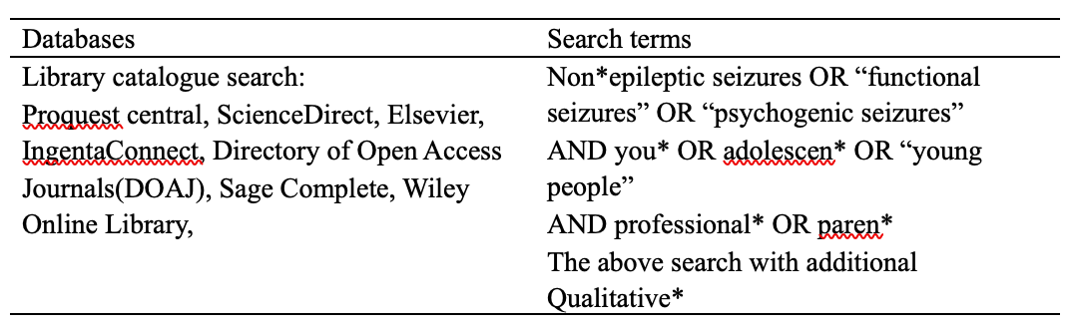

2.3.2 Inclusion and Exclusion (see Table 2.2)
Searches were refined to include only peer reviewed articles and terminologies, for example, Conversion Disorder and PNES. Potential studies were also searched manually in article reference lists. A time scale of 10 years between 2014 and 2024 was included to capture the most recent lived experience of people with NES, perceptions of parents and professionals’ knowledge and understanding of non-epileptic seizures in a contemporary world. In total 15 articles were gathered for analysis (n = 15) (see Table 2.4). Of these were: qualitative studies on the experiences of YP, their parents and adults (n = 5 ), qualitative research on school nurses and psychiatrists experience of nonepileptic seizures (n = 2), views of professionals with regards to terminology, diagnosis and experience of working with children and YP with non-epileptic seizures (n = 6) and articles specific to autistic YP with an additional diagnosis of non-epileptic seizures (n = 2). Due to the limited research data on the experiences of YP with non-epileptic seizures, four articles included YP and three were the experiences of adults (see Table 2). The term ‘young people’ includes a variant of ages from paper to paper. For the purpose of this review due to the lack of research available, young people means anyone between the age of 0 – 25 years.

Table 2.2
A List of Inclusion and exclusion criteria.
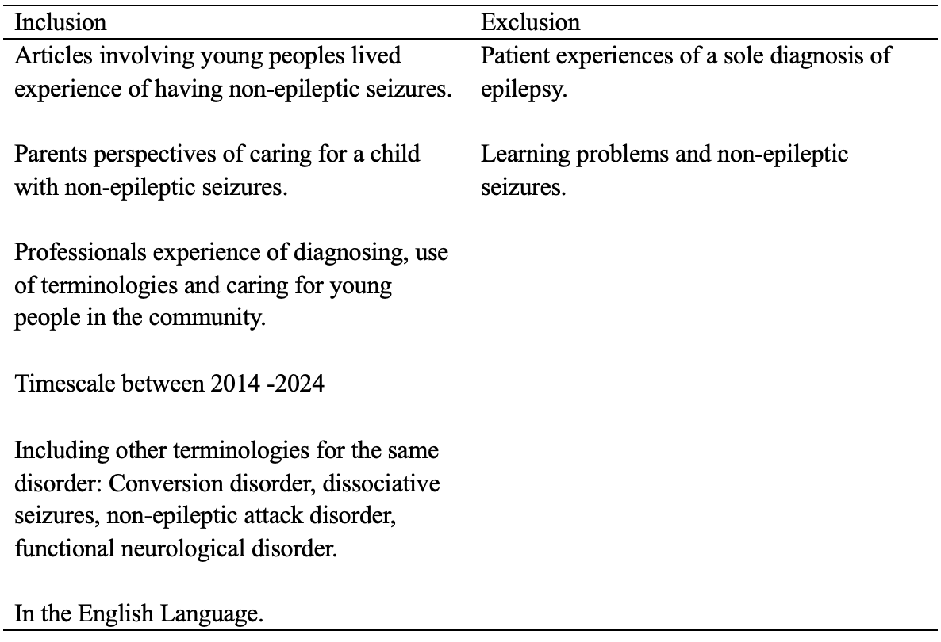

  - Results
Table 2.3
A diagram showing the results of the literature search. Fifteen studies were included in this review.
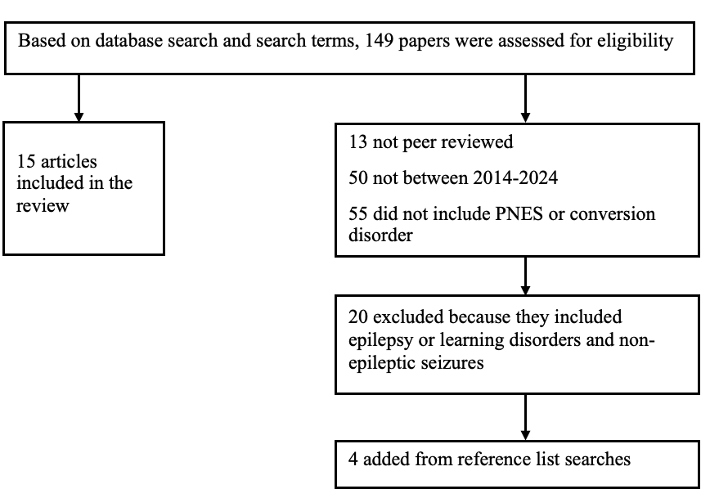
Table 2.4. List of the included papers (n=15)
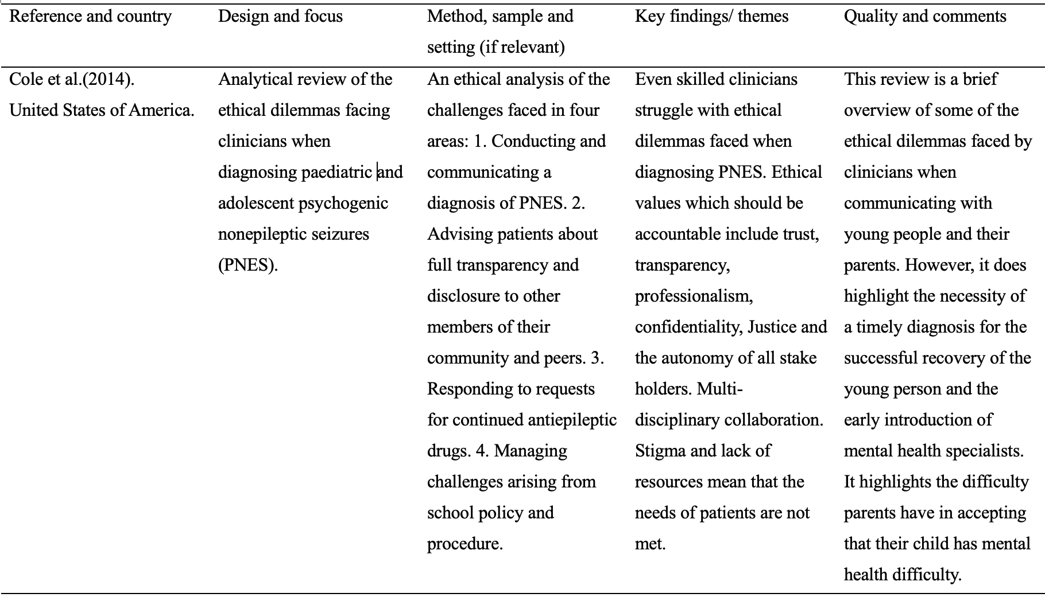
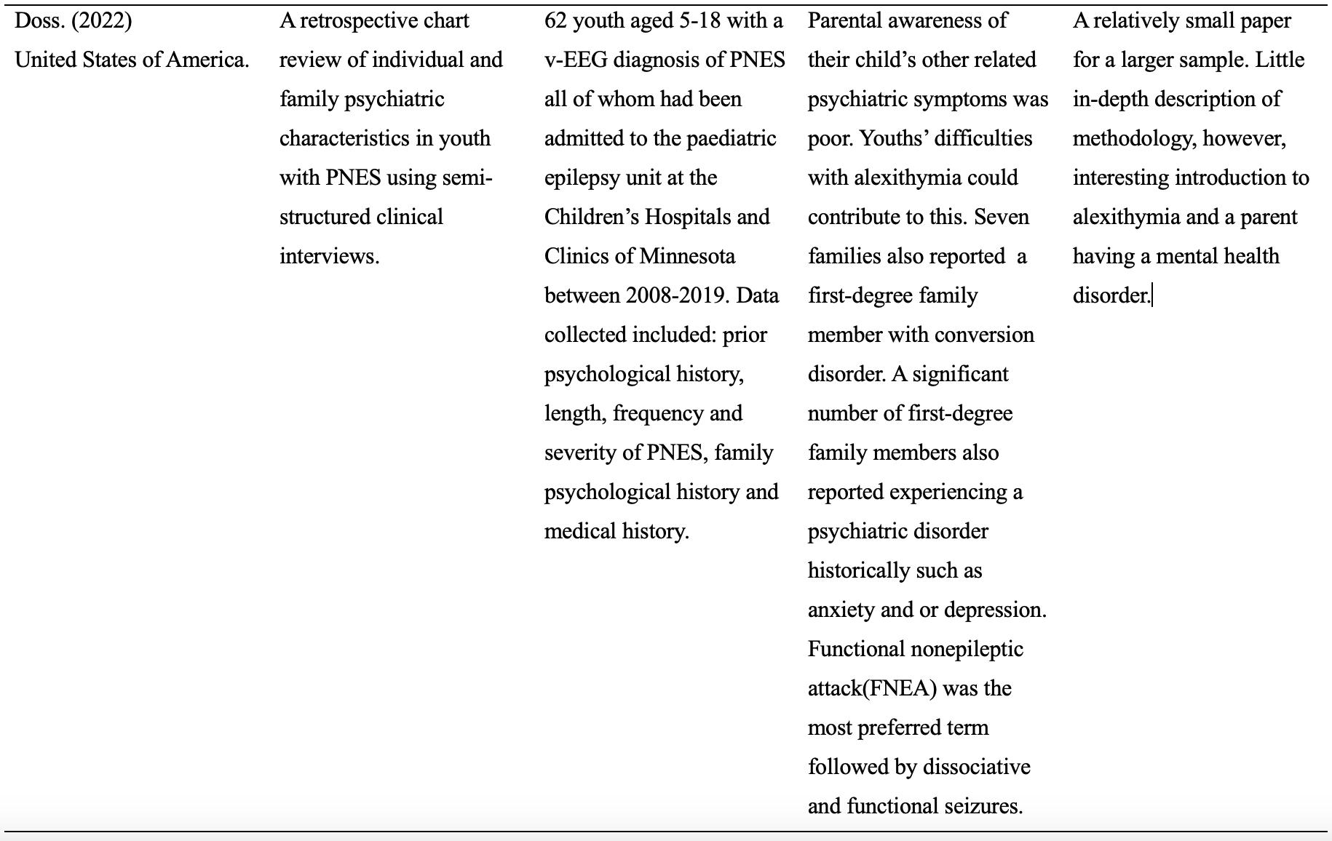
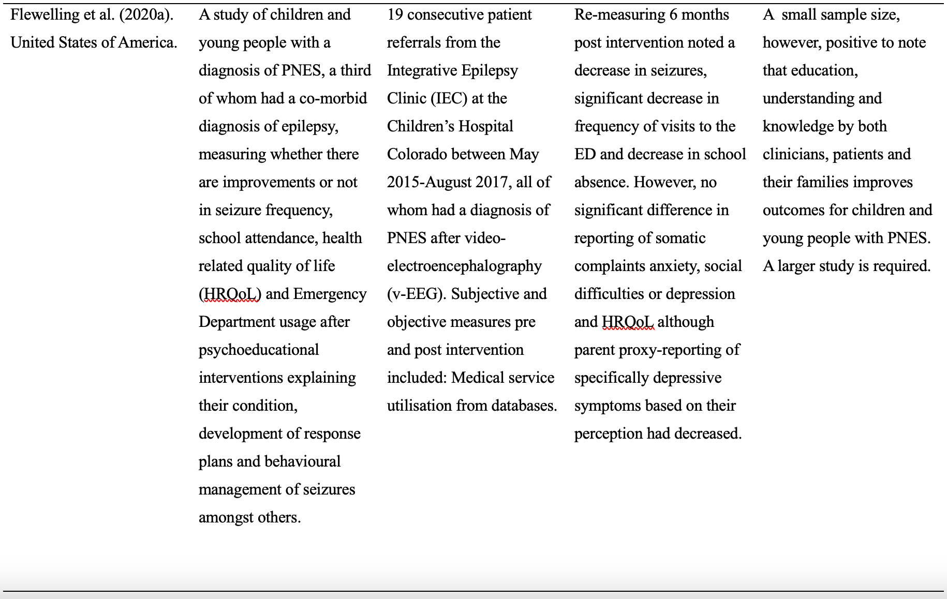
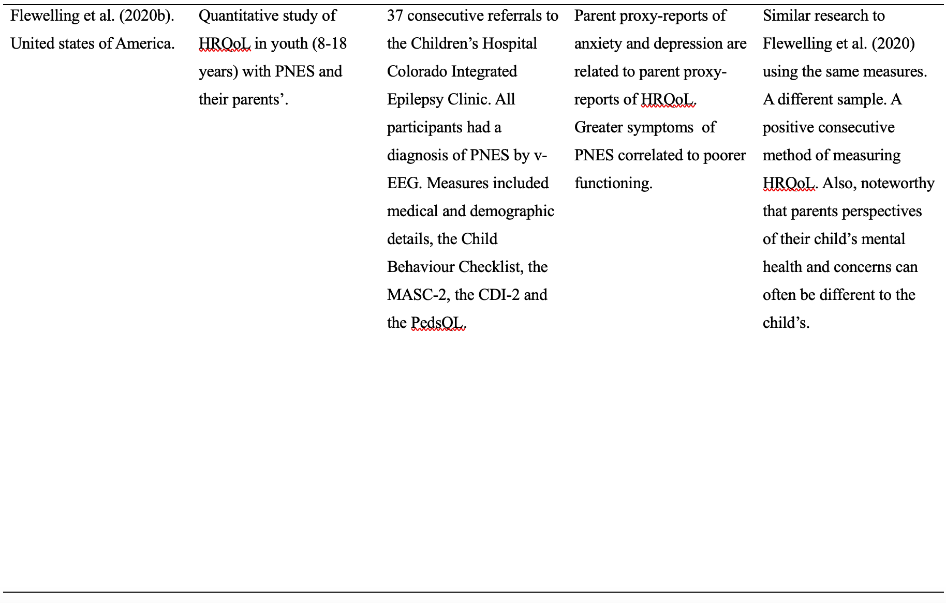
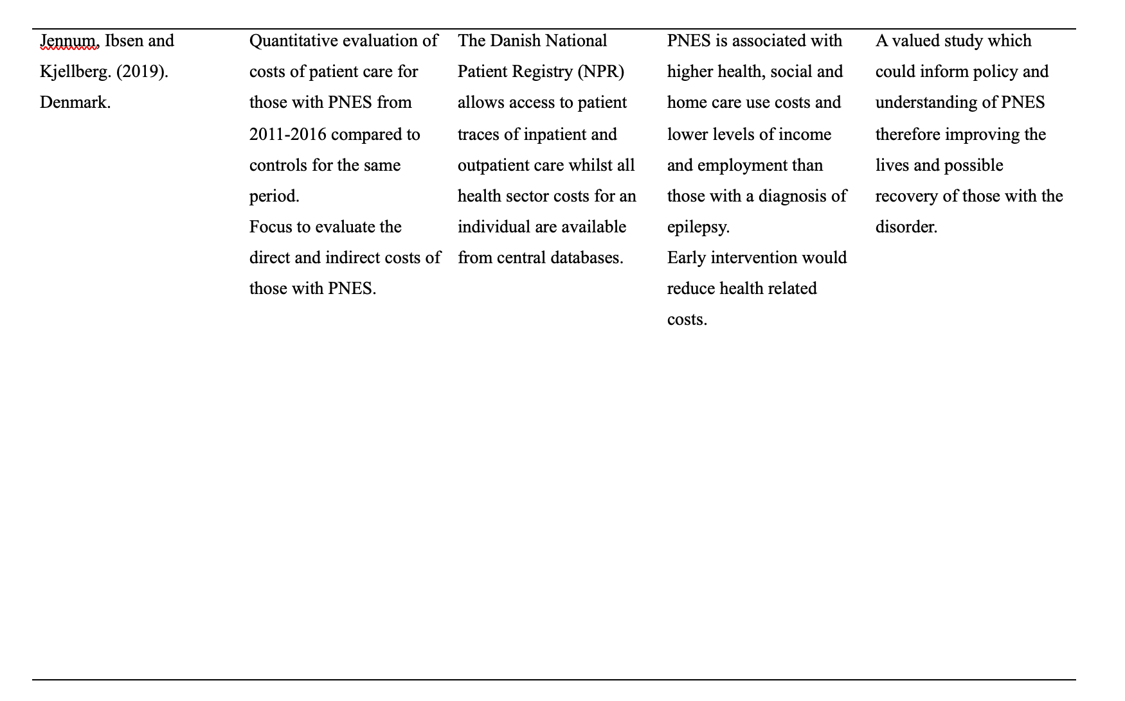
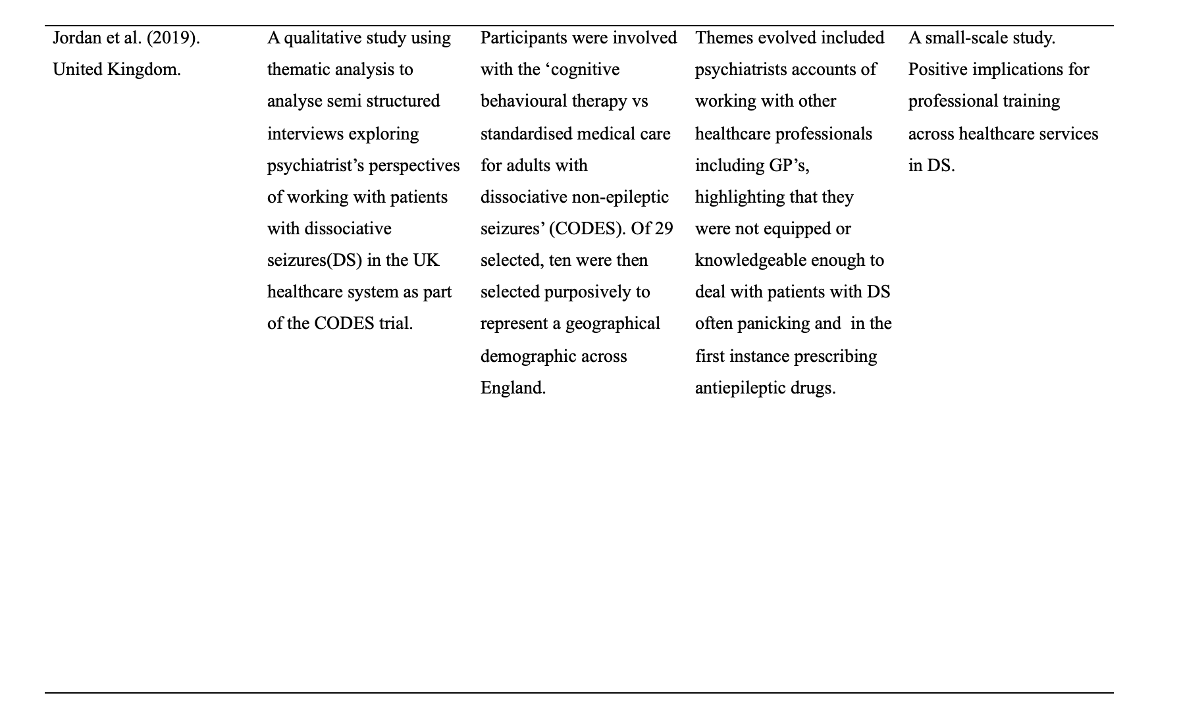

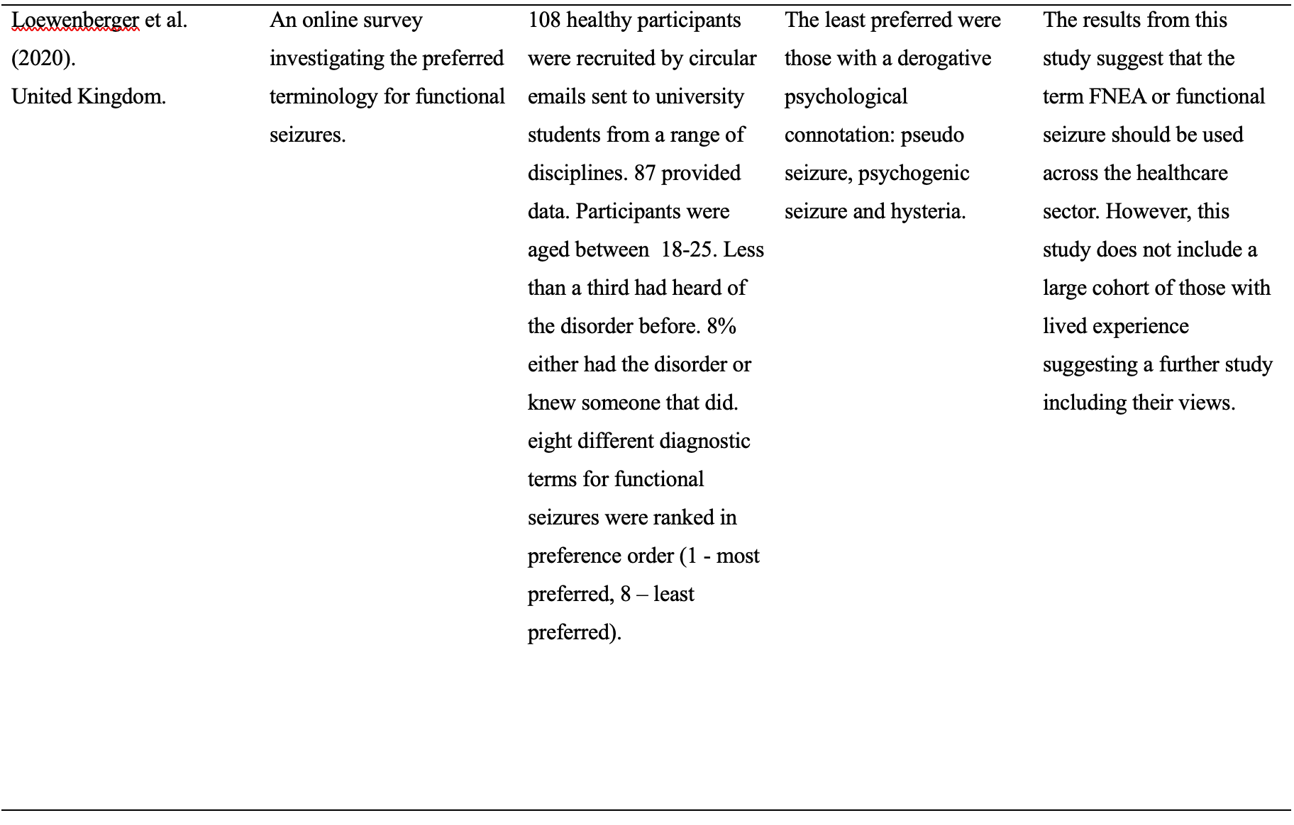
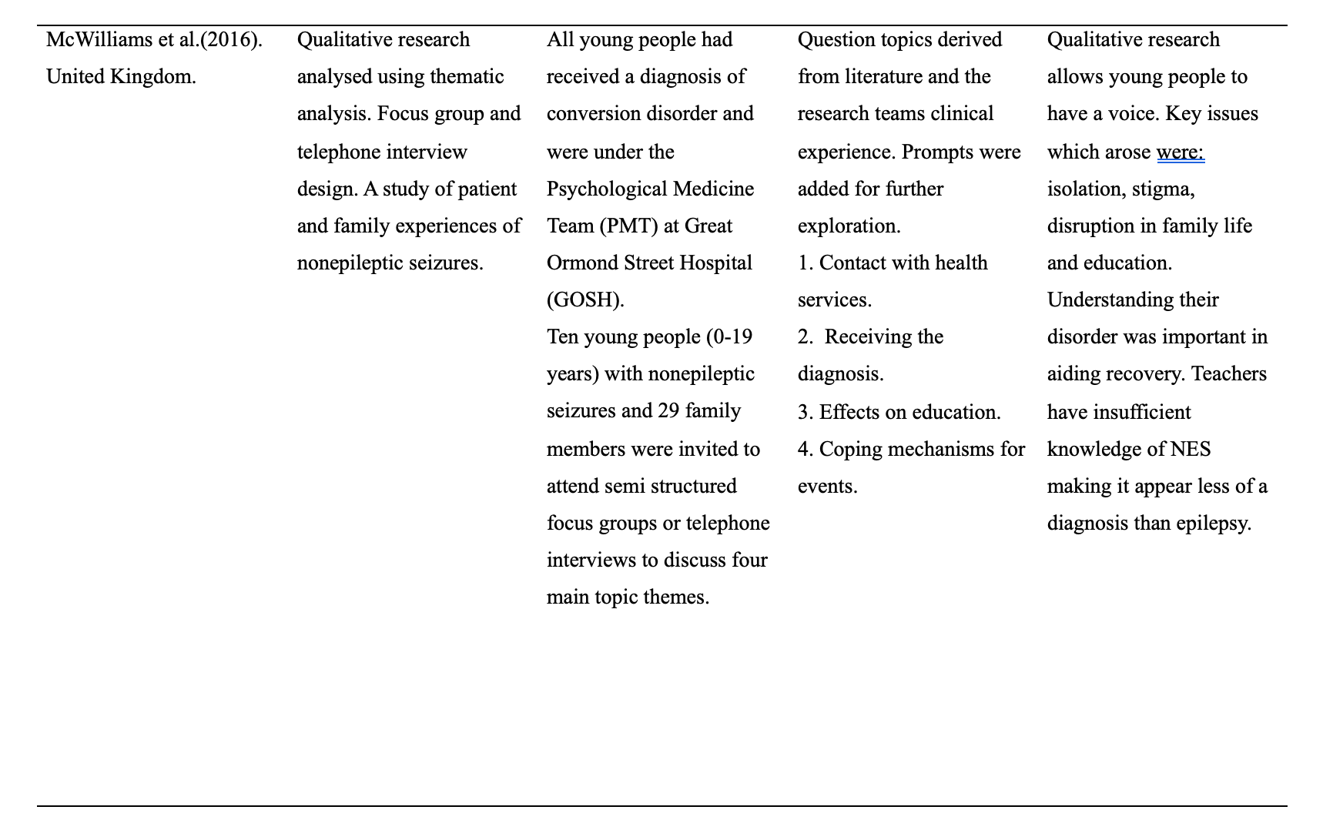
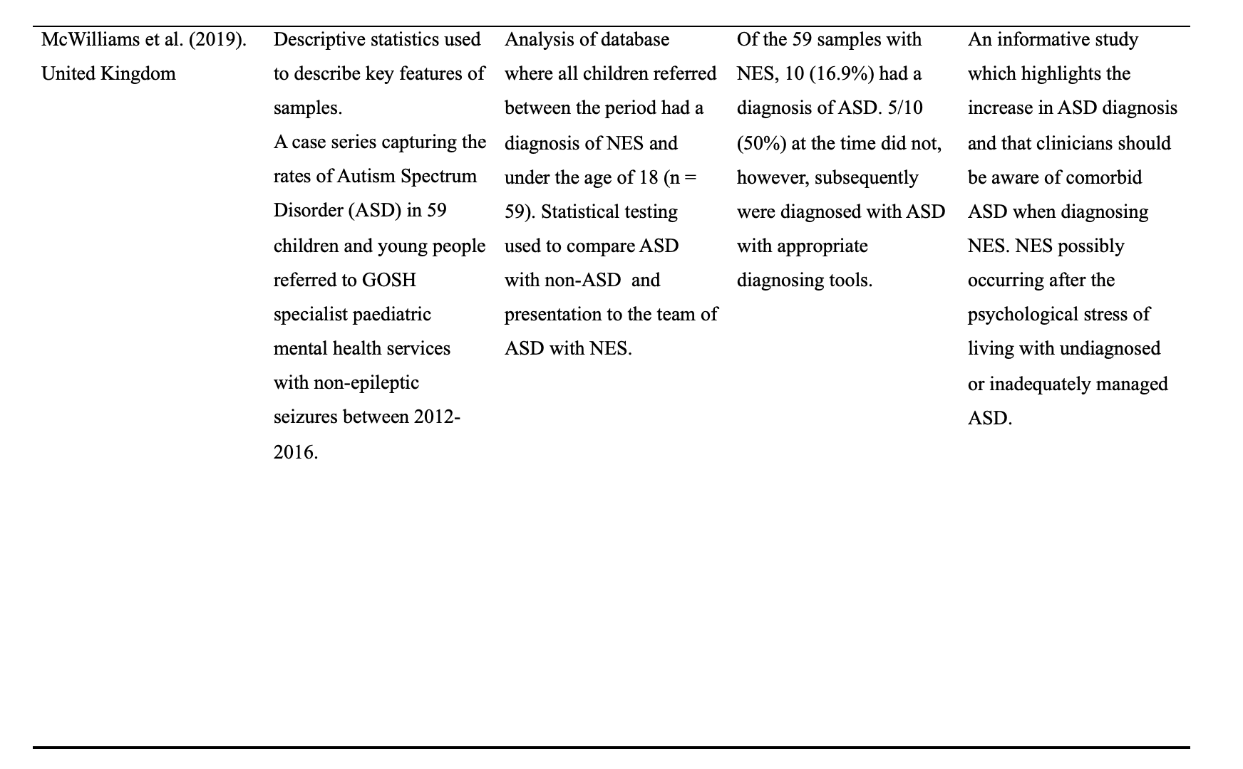
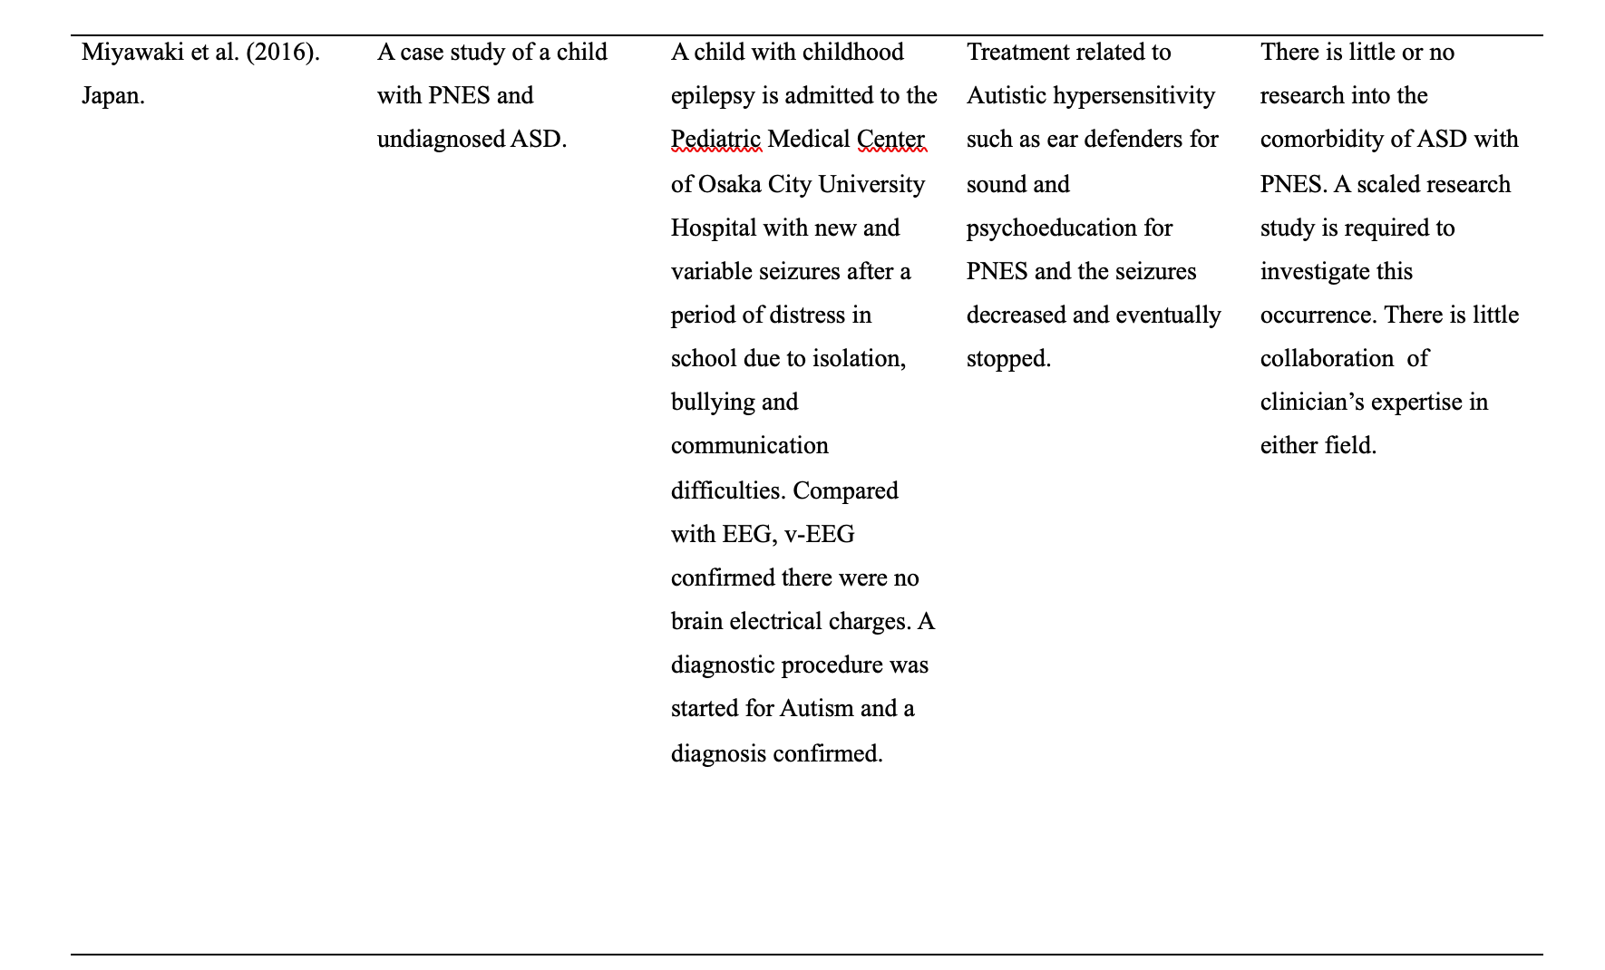

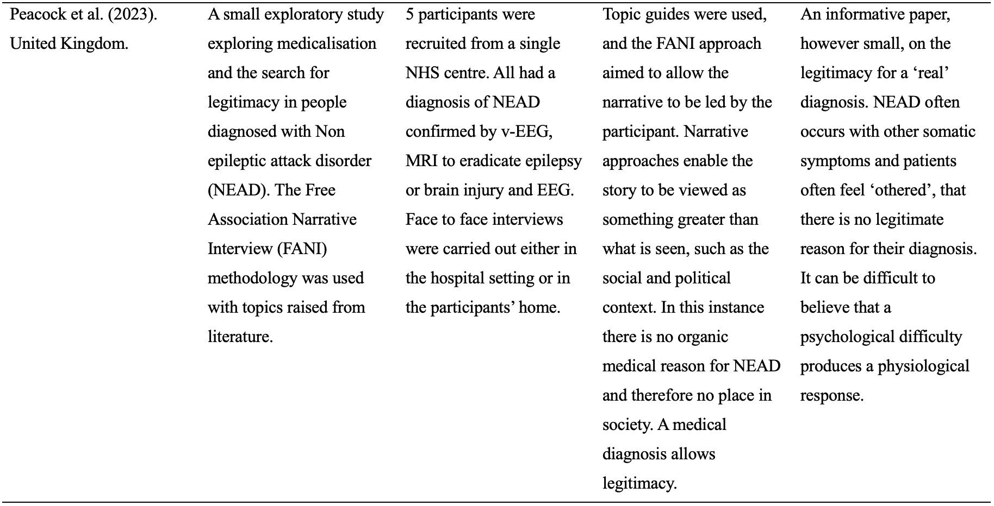
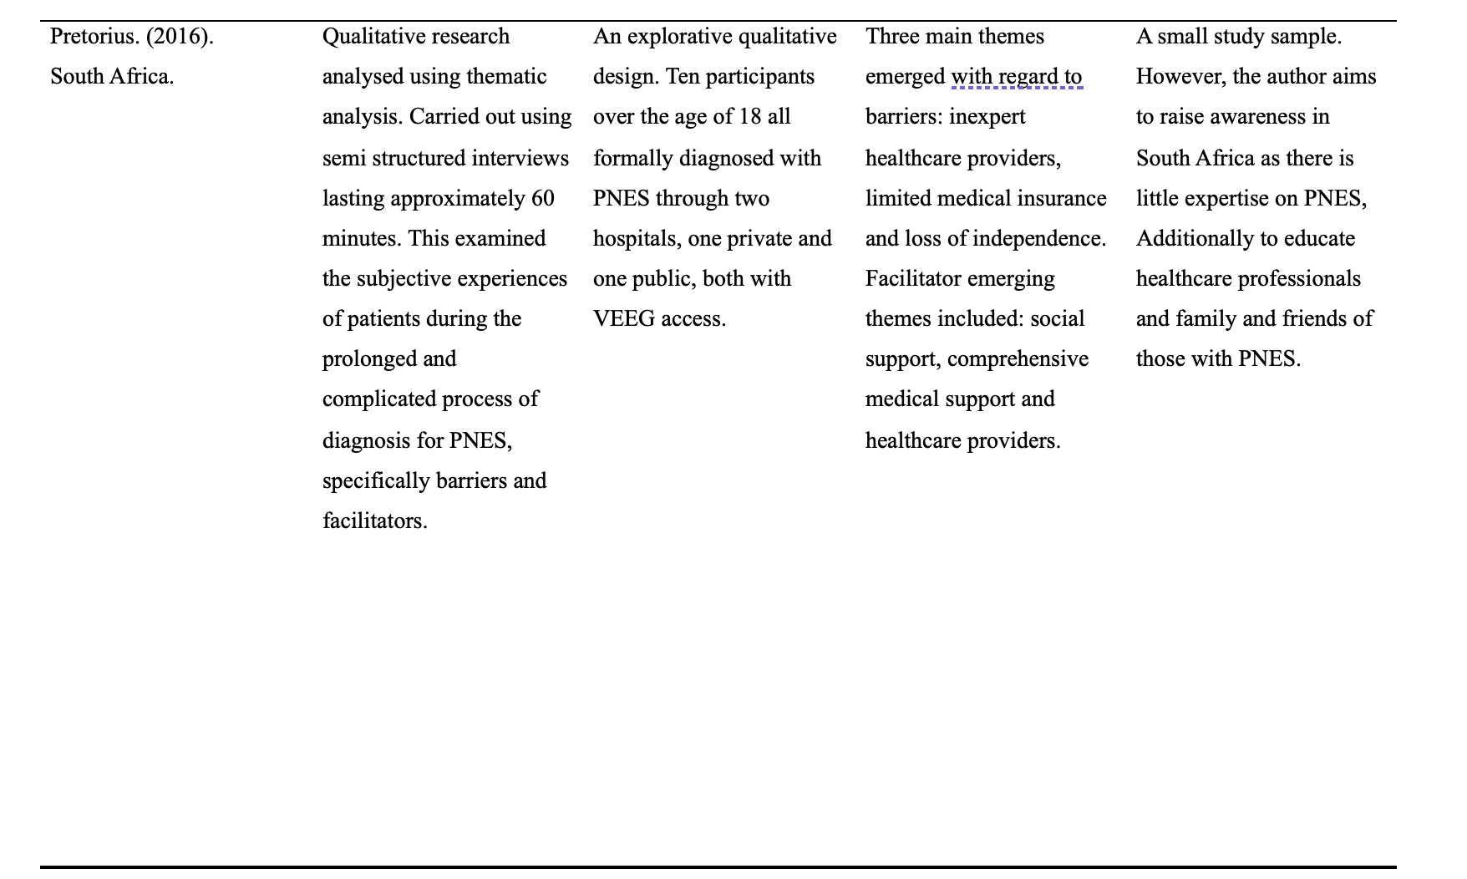
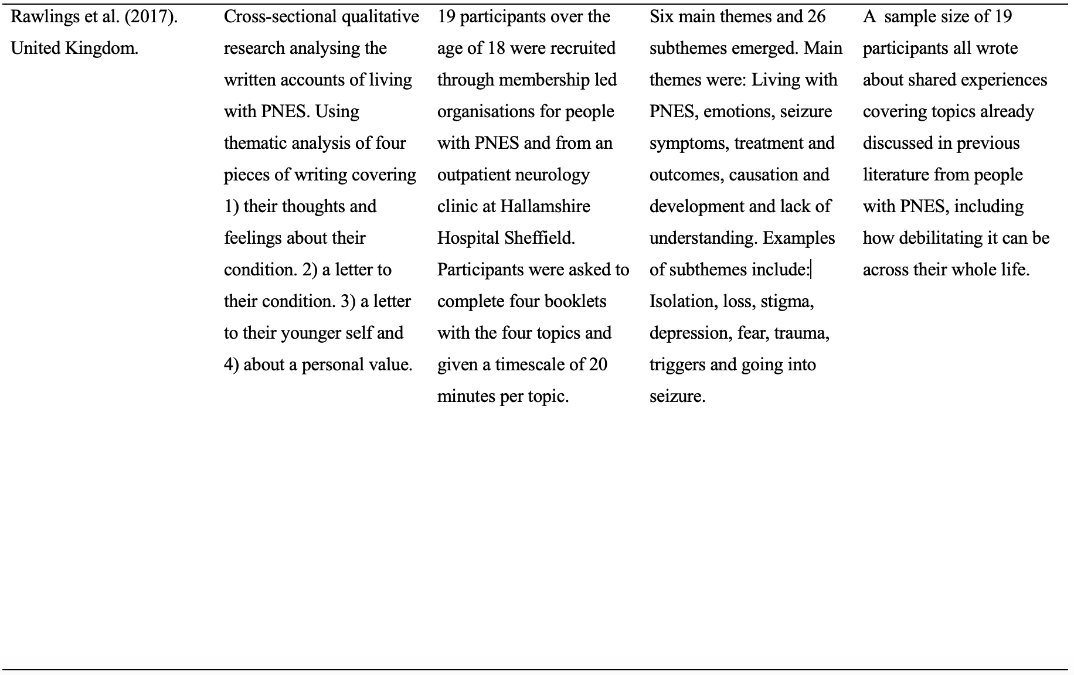
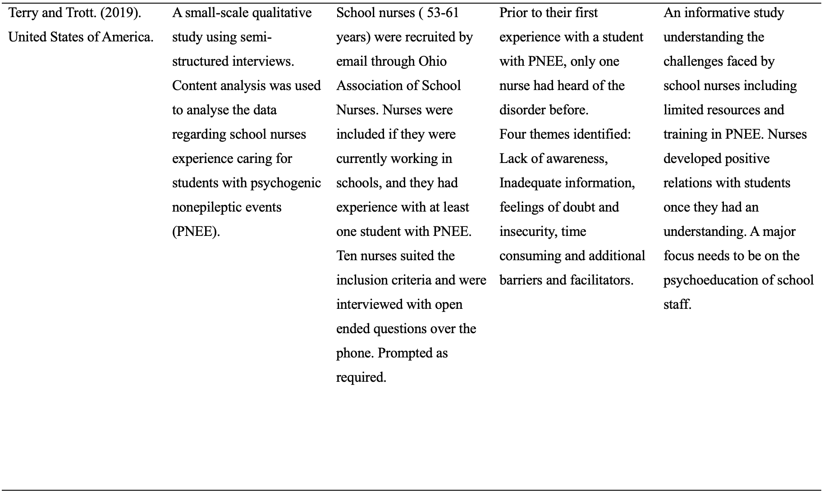
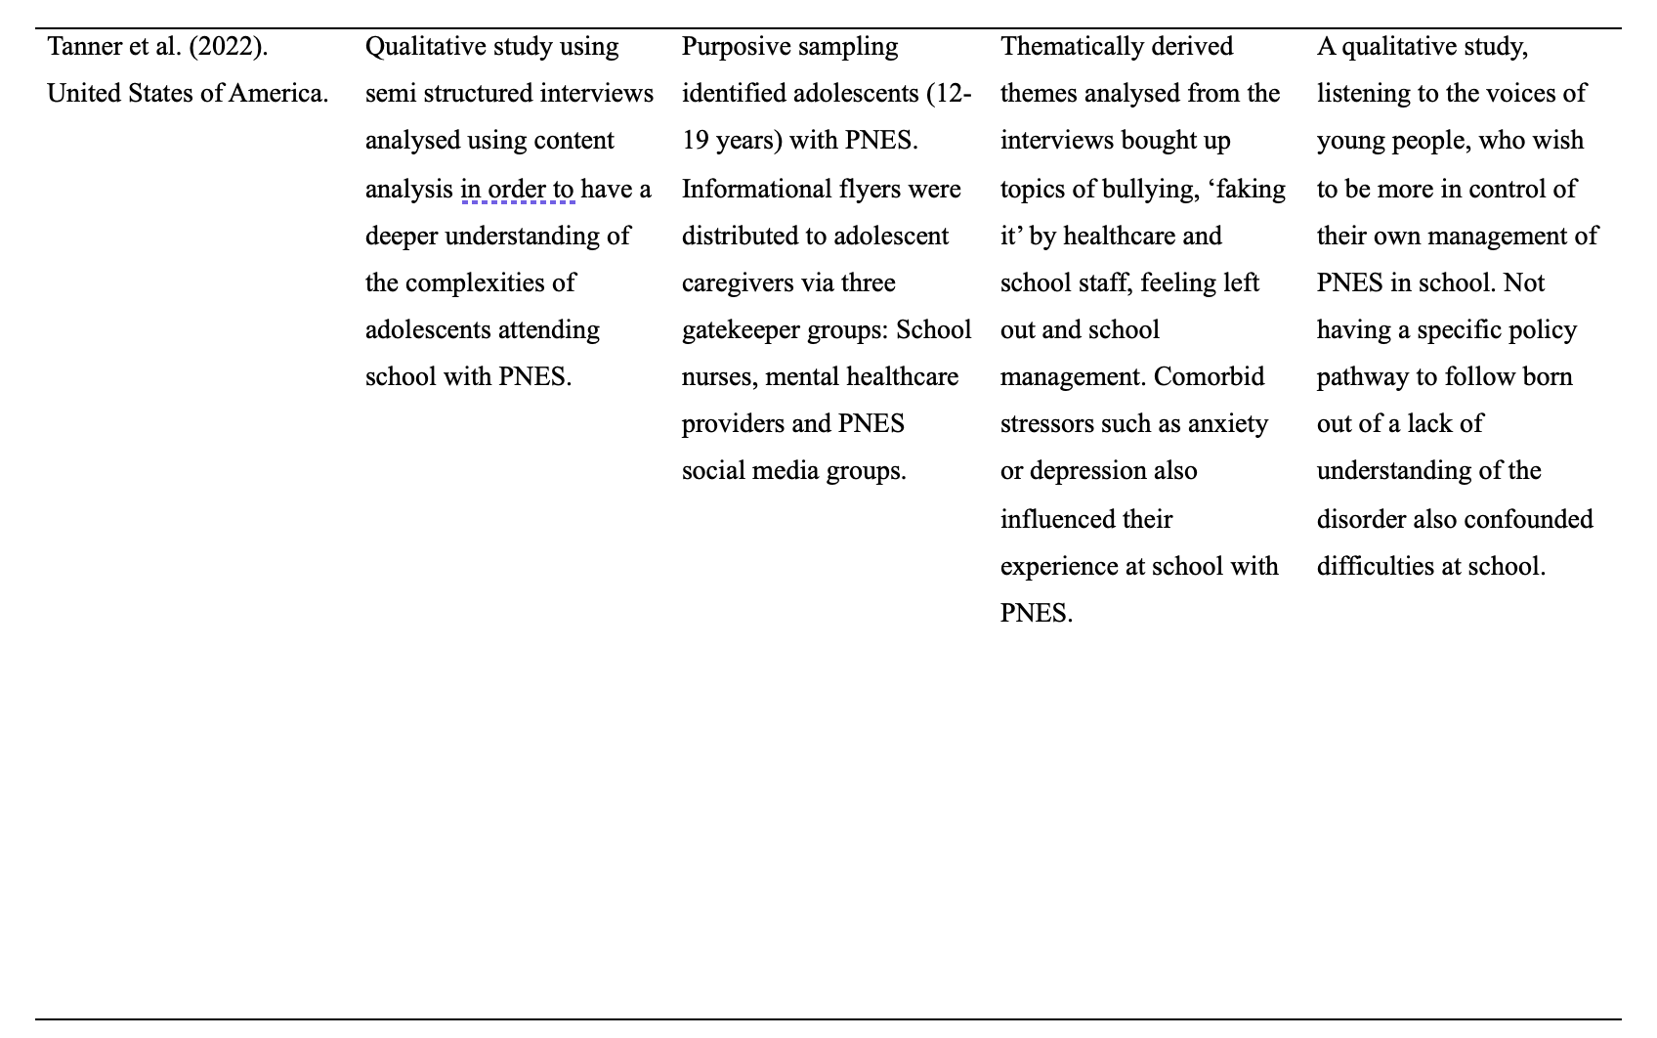
2.4.1 Overview
All 15 articles met the criteria for this literature review. However, due to limited data on the experiences of YP with NES this review required a broader search in its investigation, hence the inclusion of parental perspectives and the knowledge and understanding of those professionals working with patients with NES including consultants, neurologists, primary healthcare professionals and educational staff.
Four studies utilised thematic analysis (Pretorius, 2016; McWilliams et al., 2016; Rawlings et al., 2017; Jordan et al., 2019) and two content analysis (Terry & Trott, 2019; Tanner et al., 2022). One study (Peacock et al., 2023) used the Free Association Narrative Interview approach with five women who had a diagnosis of NEAD. One study (Flewelling et al., 2020a) was an observational study on parent-proxy reporting and self-report measures of psychological functioning and Health Related Quality of Life (HRQoL) in 19 youths (9-17 years) pre and post-psychoeducational sessions for YP with PNES and their families, with recommendations for accommodations and response plans in their educational settings.
Two articles discussed the recent interest in Autism Spectrum Disorder (ASD) and the co-occurrence of PNES and NES in YP (Myawaki et al., 2016; McWilliams et al., 2019) whilst one author (Flewelling et al., 2020b), with a particular interest in HRQoL in YP with Psychogenic Non-epileptic Seizures, investigated the correlates of HRQoL with parent-proxy and self-reported symptoms of anxiety and depression in relation to seizure frequency, somatic complaints and social difficulties. Doss (2022) discussed the individual and family mental health characteristics of YP with PNES and whether this plays a part in the onset of their seizures. In relation to societal challenges for those with NES, one study examines the ethical dilemmas for clinicians when diagnosing and treating pediatrics and adolescents with PNES (Cole et al., 2014) while Jennum, Ibsen & Kjellberg (2019) investigate the welfare consequences in people diagnosed with NES both from an employability and benefits aspect.
Throughout this overview there is a noticeable difference in terminologies for NES; for example, Loewenburger et al. (2020) investigates the preferred terminology for FS in 87 healthy adults. This has been included in this literature review due to the historical confusion and medical difficulty in arriving at a single terminology for diagnosis.
Three key themes emerged. The first theme, ‘Management and Attitudes in Education’ was found across several papers (Cole et al., 2014; Flewelling et al., 2020a; McWilliams et al., 2019; McWilliams et al., 2016; Peacock et al., 2023; Tanner et al., 2022; Terry & Trott., 2019). Discussions involved YP’s experiences with NES with both negative and limited positive attitudes from school staff and inconsistent response plans for seizures due to lack of knowledge. The second theme, ‘Knowledge and Understanding of NES in health services’, was found in ten of the 15 papers (Cole et al., 2014; Jemmum, Ibsen & Kjellberg, 2019; Jordan et al., 2019; Loewenberger et al., 2020; ; McWilliams et al., 2016; Peacock et al., 2023; Pretorius, 2016; Rawlings et al., 2017; Tanner et al., 2022; Terry & Trott., 2019).
The third theme, Terminology, ‘what should we call ‘it?’ occurs across seven of the 15 papers (Cole et al., 2014; Jemmum, Ibsen & Kjellberg, 2019; Loewenberger et al., 2020; McWilliams et al., 2019; McWilliams et al., 2016; Peacock et al., 2023; Tanner et al., 2022). where specific reference is made to the many differing terminologies for the same disorder and the contentious nature of the diagnostic process and treatment pathway.
Within themes one and two, four subthemes arose: Theme one, management and attitudes in education, included the subthemes: Inconsistent response plans and negative attitudes from school staff. Theme two, knowledge and understanding of NES in healthcare, included the subthemes: primary and secondary care (see Table 2.5).

Table 2.5 A summary of themes and subthemes to be discussed.
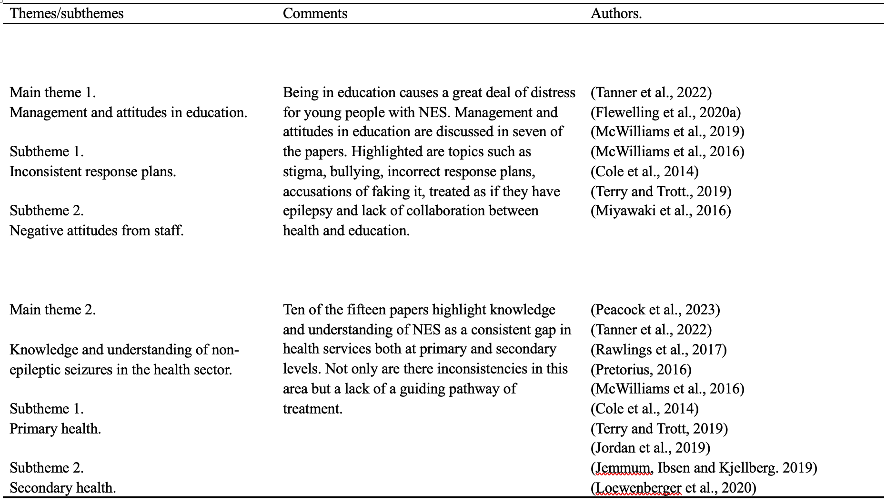

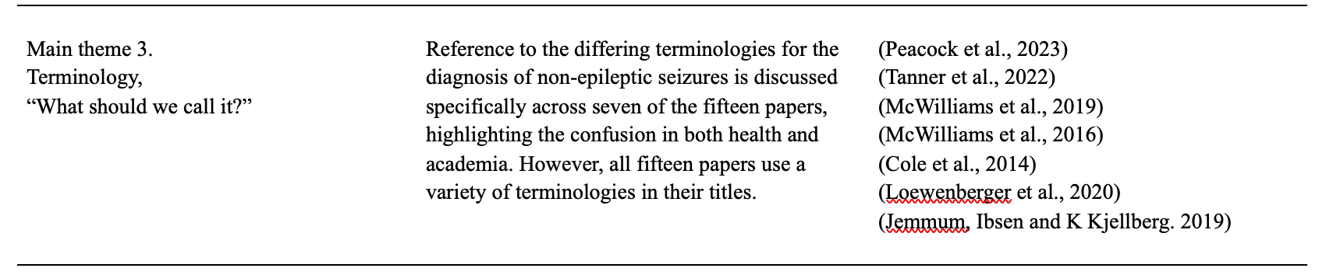

2.4.2 Management and attitudes in education.

Young people with NES often underachieve and their attendance is low. They have difficulties with relationships and losing friendships and are on the receiving end of negative attitudes from teachers (Dunne et al., 2019) all of which can exacerbate pre-existing anxiety and depression disorders (Fredwall et al., 2021). A recent retrospective study of 52 inpatient YP receiving treatment for PNES between 2012-2020 reported that 49(94%) had found education difficult due to their seizures and ten (19%) had left school altogether. 36 (69%) had received adapted education and the conclusion was that HRQoL for YP with NES is determined by personally adapted treatments and accommodations at the earliest opportunity (Karterud et al., 2024).
Across the literature, YP stated consistently that they had difficulties within their educational settings. Participants in the study by McWilliams et al (2016) reported being separated from their peers in class and not allowed to attend trips, often being sent home from school post seizure through the school’s lack of understanding about their condition. Some schools decided that the YP could not attend school and alternative arrangements were made for home educating. YP were accused of fabricating their seizures by pupils and staff and McWilliams et al (2016) summarised that YP with NES often felt stigmatised by the inappropriate handling of their seizures by schools, that they called an ambulance when told not to, had no policy in place and there was little or no collaboration with health. Additionally, YP describe school-related stress originating from within the environment, such as the pressure of missing school deadlines and hearing inappropriate talk about them from students and staff (Cole et al., 2014; Tanner et al., 2022).When discussing management by schools, YP stated that response plans for their seizures were often ‘guessed’, teacher-led, and fear driven. Furthermore, management was led by liability measures resulting in inappropriate medical intervention from ambulance calls and hospitalisations. However, outcomes for YP with NES improve when management plans for seizures are developed (Flewelling et al., 2020a) and there is collaboration between paediatrics and educational settings (McWilliams, Reilly & Heymen, 2017).
Difficulties for families when choice-making between disclosure and non-disclosure to education are reported in Cole et al. (2014). The legitimacy of a diagnosis of epilepsy has long been accepted within education, therefore families of YP feel it is easier to disclose an incorrect diagnosis of epilepsy with less stigma attached, than that of a mental health disorder. However, the difficulties for YP with NES are compounded when response plans for epilepsy are followed resulting in invasive and inappropriate medical care such as anti-epileptic drugs (AED’s) which can cause iatrogenic harm (Campbell et al., 2019). A review of literature (Morgan & Buchhalter, 2015b) found that although the semiology for NES is similar to that of epilepsy, once identification and a diagnosis of NES has been made, it is important that collaboration between school administrators, teachers and well-being staff is promoted and a plan for future NES events developed. This decreases unnecessary hospital visits, diagnostic tests and medication intervention. Additionally, educating other students in the YP’s friendship group or class, can eliminate fear and stigmatisation.
As part of the management team and at the forefront of health services in education, are school nurses. They may be the first to identify students with difficulties in physical, emotional, psychosocial and mental health areas. Additionally, an increase in mental health disorders in YP post Covid-19 Pandemic has led to recognising the need for investment in mental health services in all educational settings (Worsley, Pennington & Corcoran, 2022). However, nurses may have a broader knowledge base rather than specific understanding of complex individual presentations (Skundberg-Kletthagen & Moen, 2017). A small-scale study of ten school nurses from the review literature (Terry & Trott, 2019) examined school nurses experiences of caring for students with PNES. Lack of awareness was raised as a theme. Only one nurse had heard of the disorder before caring for a child in their own setting, and there was an additional lack of understanding of the diagnosis from the school staff. Nurses had feelings of doubt and insecurity as to how to respond to seizures, with little collaboration and information from healthcare professionals. Nurses were unsure of what they were doing and conducted their own research into NES in their own time, although medical information on the internet was limited too. Furthermore, nurses developed their own response plans to YP seizures, with little help from psychiatrists or mental health staff. They also reported that caring for a YP having a NES was time-consuming and difficult to deal with when staff and students felt the YP was ‘faking it’. Nurses also felt torn when they could not attend to other students in medical need. However, they did feel a sense of pride and leadership when they were more confident and able to train and educate staff on NES and response plans.
A study of 284 public health nurses working in schools in Norway (Moen & Skunfberg-Kletthagen, 2017) found that 25% of their time was spent with students with emotional and psychological needs, however, there were fewer referrals to specialist mental health services by those nurses with a post-graduate qualification in mental health compared to those with a single nursing degree. Nurses with a mental health qualification were more able and confidant to provide support and interventions to improve YP mental health outcomes. Furthermore, a review in the United States (Tanner et al., 2019) on school-based mental health interventions and the implications for students with PNES found that, although the school nurses’ role was recognised by The American Epilepsy Society (2018) as the first responder to NES events and in training staff, their role in the continued application of interventions for YP with NES in education was limited. Additionally, their role in the continuing care of YP with NES has not been recognised by authors in paediatric literature (Doss & Myers, 2023), although interventions such as parental education, cognitive behaviour therapy (CBT) and clear and concise information regarding the diagnosis have been found to reduce NES events in YP (Rawat et al., 2015).

Two studies in the review literature discuss possible links between ASD and NES (McWilliams et al., 2019; Myawaki et al., 2016). Rates of Autism diagnosis in Wales have risen from 0.2% in 2003/2004 to 1% by 2012/2013 (Holtem et al., 2016) and The National Autistic Society states that there are now 1 in 100 people in Wales on the autistic spectrum (Sakhuja, 2024). Additionally, a comorbid diagnosis of epilepsy occurs in 6-37% of those with ASD with an additional likelihood of NES occurring in 22% of those with epilepsy (Freedman et al., 2022). McWilliams et al. (2019) suggest that medical professionals working with YP with ASD should be aware of NES, and a consideration of ASD should not be dismissed in those YP with NES. They also state that the psychological stress of living with undiagnosed ASD and lack of accommodations in education could precipitate the onset of NES. The case report of a 10-year-old girl in Myawaki et al. (2016) with undiagnosed ASD and NES concluded that her NES ceased post-diagnosis, with psychoeducational understanding and educational accommodations put in place.

2.4.3 Knowledge and understanding of non-epileptic seizures in the health sector.
Across the literature, in both primary and secondary sectors, knowledge and understanding of NES by medical professionals was inconsistent. Three studies (Rawlings et al., 2017; Tanner et al., 2022: Terry & Trott, 2019) report participants’ experience of inadequate understanding of their disorder by primary healthcare professionals, including, nurses, school nurses, paramedics and GP’s. Fourteen of the 19 participants in Rawlings et al. (2017) highlight lack of understanding, support and awareness from healthcare professionals and paramedics, with those in emergency departments being the worst. Participants were often accused of ‘faking it’ and felt failed by doctors. A scoping review (Reilly et al., 2023) of literature confirms that awareness and understanding of the disorder by professionals in health is deficient; however, health professionals did report a need for a single pathway of assessment, diagnosis and treatment.
Adolescents participating in one study (Tanner et al., 2022) describe doctors talking in front of them in hospital disclaiming their seizures as fake so they could be discharged, while another school nurse accused them of putting on seizures in front of certain people. A study of 135 participants with NES who had experienced medical interactions which were stigmatising (Robson & Lian, 2017) reported many negative responses from medical practitioners. One participant had water thrown over them mid-seizure by one doctor, whilst another was punched and pinched by a nurse trying to get her seizure to stop. In conclusion, Roberts and Lian (2017) reported that the treatment and care of people with NES required an urgent update with lack of knowledge and understanding from medical professionals as an overriding causation of patients’ stigma and medical trauma. Terry and Trott (2019) conclude from their qualitative study on school nurses experience of NES that nurses have an increasing number of challenges to face in schools, with mental health conditions taking up much of their time. However, more awareness and education needs to be provided to nurses in their preliminary training with concise and clear guidance from healthcare providers when facilitating a student with NES (Huff et al., 2024).
A scoping review (Welsh Government, 2019) found that school nurses’ skill and expertise was variable in different areas of Wales. Several nurses interviewed for the review also reported that they did not have the specialism to deal with mental health disorders of children and YP, although essential for their care.
Several articles in the literature (Cole et al., 2014; Jemmum, Ibsen & Kjellberg, 2019; Jordan et al., 2019; Loewenberger et al., 2020; Peacock et al., 2023) report patient and clinical staff experiences of confusion and lack of clarity in pathways for the diagnosis and treatment of those with NES. A study of ten psychiatrists (Jordan et al., 2019) found they too experience inconsistencies with the treatment and aftercare of those with NES from all healthcare providers. They felt that GPs should have better understanding and healthcare providers were unskilled to deal with patients with DS. Psychiatrists felt there were gaps within the NHS where even Neurologists were continuing to prescribe AEDs for NES when families could not understand a non-organic diagnosis. Cole et al (2014) report there are many ethical considerations surrounding the diagnosing of a patient with NES. However, many Neurologists often lean towards a diagnosis of epilepsy first with prescribed AED’s and then apply the process of elimination resulting in a diagnosis of NES. Wichaidit, Østergaard & Rask (2014) found inconsistencies with coding of diagnosis for NES including ‘syncope and collapse’ and ‘unspecified convulsions’, causing confusion amongst families and patients and a lack of clarity for direction in diagnosis for doctors. Additionally, McWilliams, Reilly and Heyman (2017) study of 66 psychiatrists confirmed a self-reported lack of coordinated services and standardised care access for patients with NES further disengaging doctors from these patients.
An increase in mental health disorders in YP has led to a greater proportion attending accident and emergency departments when in crisis (Cozzi & Barbi, 2018). Additionally, it is more common that children and YP present with physiological somatic symptoms for psychological difficulties. (Chun, Mace & Katz, 2016). A recent study (Morabito et al., 2021) found the over medicalisation of children and YP used in a search for answers for somatic symptoms including hospital admissions and unnecessary medical procedures. This is further discussed in Peacock et al. (2023), using narrative interviews with five patients with NEAD, the conclusion being that the only legitimate pathway was through an organic or medical diagnosis. Psychological and stress-based explanations for NES, as well as not providing legitimacy, can give rise to personal and perceived stigma of mental health disorders attached to social position and identity (Billings, 2020). Furthermore, Jennum, Ibsen and Kjellberg (2019) discuss the direct and indirect welfare consequences of living with PNES in a comparative study of 1057 people of all ages in Denmark matched with a control of 2113. Results showed that people with PNES had lower income levels than controls whilst social care costs and hospitalisations were higher. Additionally, compared to those with epilepsy, the healthcare costs for patients with PNES were considerably higher, €25,523 compared to €11,223 for those with epilepsy. In conclusion a diagnosis of PNES is associated with lower levels of employment and higher health and social related costs (Teagarden et al., 2020).
A non-organic diagnosis for a presenting physical disorder can be difficult to convey for clinicians and for some parents and patients hard to accept ( Malas et al., 2017). Furthermore, as discussed in Loewenberger et al (2020), a process of the elimination of a diagnosis of epilepsy can sometimes be viewed by patients and families as derogatory when a communication of a ‘non’ disorder is relayed. However, having families and YP engaged with clinicians after a diagnosis with a psychological causation promotes recovery (Wiggins et al., 2022). When parents fully accept a diagnosis, the YPs chances of recovery are 17 times higher than those whose parents do not (Gao et al., 2018).
Finally, two studies (Pretorius, 2016; McWilliams et al., 2016) echo the same conclusion. To inform a standardised and streamlined pathway to diagnosis and treatment, further understanding is required from the lived experience of those with NES. Additionally, many healthcare providers in all medical settings have limited expertise of the disorder, therefore an introduction to NES as a standard module in nursing and healthcare training could be a positive addition. Furthermore, additional studies on the characteristics and triggers of NES in YP could prevent further NES events and the way in which a diagnosis of NES is communicated as well as the subsequent treatment of the disorder can affect the frequency of seizures and aid complete recovery (Gurcan et al., 2022).

2.4.4 Terminology, “what should we call it?”
The terminology of functional phenomena or NES, prior to a scientific distinction, has been described as ‘hysteria’ (Bruno, Machado & Auxéméry, 2021). After the development of scientific work in magnetics in the 1870s by Jean-Marie Charcot (1825-1893) a distinction between epilepsy and NES was made, that being the presence of differing electrical brain activity of those with epilepsy when experiencing a seizure (Beghi et al., 2015). Currently, the DSM-5 (APA, 2013) places NES or PNES under the terms of Conversion and Functional Disorders; on-the-other-hand, The Classification of Mental and Behavioural Disorders Clinical Descriptions and Diagnostic Guidelines ICD-10 (World Health Organisation, 1992) categorises dissociative convulsions (pseudo seizures) under the term of Dissociative (conversion) disorders (F44). The confusion over a valid terminology for NES still exists and is noted by The Epilepsy Society in its guidance for NES describing the differing terminology’s healthcare professionals use such as DS, NEAD and PS (Epilepsy Society, 2023).
Seven of the literature review papers (Cole et al., 2014; Jennum, Ibsen & Kjellberg, 2019; Loewenberg et al., 2020; McWilliams et a;., 2016; McWilliams et al., 2019; Peacock et al., 2023; Tanner et al., 2022) denote difficulty in deciding which name to call the disorder. Cole et al. (2014) draw attention to differing terminology which can impact the outcome of a patient’s treatment, whilst McWilliams et al. (2019) state the ‘many alternative names and varying semiology’s’. However, Peacock et al. (2023) comment that their preferred terminology of NEAD was the most widely used term in the UK at the time of their study, despite the unresolved medical and social framing of the disorder. Additionally, Tanner et al. (2022), whilst choosing to use the term ‘psychogenic’ in their paper, also mention terminologies of functional or dissociative seizures. The term psychogenic can, in itself, cause offence to those diagnosed, as it implies that the patient is ‘psycho’ or symptoms are ‘all in their head’. This denotes a medical disengagement between the psychological cause and the physical symptoms even more difficult to comprehend as YP with NES can feel that they do not have a mental health difficulty, but a medical disorder (Koslowska et al., 2017).
As many as 15 different diagnostic names exist for NES and the translation of the disorder can have a profound effect on its acceptance by the recipient, especially if they have previously been misdiagnosed with epilepsy (McWilliams et al., 2016; Reilly, McWilliams & Heyman, 2014). Furthermore, whilst Jennum, Ibsen and Kjellberg (2019) state that presentations of functional neurological symptoms and conversion disorder are common in emergency rooms, they still use the term PNES in their paper, implying a ‘psych’ disorder rather than NES, a ‘non’ disorder. A study of neurologists in Italy (Tinazzi et al., 2021) examined the preference for terminology when explaining a diagnosis to patients. 1057 responses were recorded, the two most frequent being ‘Functional Neurological Disorder’ (n=374) and ‘Somatization Disorder’(n= 68) followed by ‘Non-Organic Disorder’ (n=134). The preferred causation was described to patients as a “disorder due to the abnormal functioning of the nervous system” (n=284), with several choosing ‘Psychogenic Disorder’ (n=104) and ‘Absent Neurological Disorder’ or ‘Stress’. A previous study carried out by Stone et al. (2003) of ‘offensive’ terminology for, what was then known as ‘pseudo seizures’, concluded that the most offensive term was, ‘symptoms all in the mind’, ‘hysteria’ or ‘pseudo seizures’ and the most accepted, epilepsy. More recently a study by Loewenberger et al. (2020), examined the opinions of 87 healthy individuals on the terminology for NES. They concluded the three most accepted terms to be ‘Functional Neurological Attack Disorder,’ ‘Dissociative seizures’ and ‘Functional seizures’ with the three most offensive still being ‘Pseudo Seizures’, ‘Conversion Disorder’ and ‘Hysteria’.
The decision for one singular terminology for NES is a worldwide controversy, as different nations draw on different medical specialities for guidance. However, patients’ wellbeing is not only defined by their illness but from the label they are given (Asadi-Pooya, et al., 2020). Further research, including all specialities and stakeholders, is needed to improve pathways to diagnosis and treatment and a better understanding of the disorder.

2.5 Summary
The aim of this study was to examine the literature relating to the experiences of those diagnosed with Non-Epileptic Seizures and the interactions of medical professionals with these patients. Fifteen articles were explored. Of these, five included the lived experience of adults, children and YP and their parents, two articles researched the experiences of school nurses and psychiatrists when working with patients with NES and other health professionals, six examined the views of professionals with regard to diagnosis, terminology and working with children and YP with NES, and two examined the links between Autism and NES.
Findings from the literature suggest that those with NES have reduced HRQoL (Woodward et al., 2023) and often experience lengthy periods of time to diagnosis. They can be accused of ‘making it up’, whilst also having difficulty either attending education or fulltime work. Compounding people’s perceptions of their disorder are healthcare professionals’ attitudes, lack of knowledge and confusion over terminology, along with differing pathways to diagnosis and lack of support thereafter.
Although, the disorder can present at any point in a person’s life, there is a stronger female prevalence of NES and generally, events appear to initially occur in early adulthood (Asadi-Pooya & Sperling, 2015). The Welsh Government define a YP as being aged between 16-25 years old (WG, 2023); however, there is a paucity of research in both studying YPs lived experience with NES (Doss, 2022; Karterud, Risør & Haarvet, 2015; Smith, 2014; Valani and Gledhill, 2021) and the perspectives of those caring for them, as well as professionals working within this age range. There is also, little research in England and Scotland within this field and currently, none in Wales (J. Stone, personal communication, July 24, 2024; H. Cook, personal communication, August 12, 2024), therefore warranting further exploration in order to inform practice and more positive outcomes for YP with NES.
  - Limitations
There are some limitations to this review. To capture a contemporary perspective on peoples and professionals experience of NES, the time scale explored was 2014-2024, however, there was limited data in both qualitative research and exploring the understanding of healthcare professionals, especially in the UK. A wider timescale may have been useful in producing more studies. Additionally, the criteria surrounding the age range was difficult to define as various studies used different ages for children, adolescents, YP and young adults, rendering the author to use the age 0-25 for review paper criteria. The Welsh Government define a YP to be anyone between the age of 16-25 years, enabling a specific age group to be justifiable for future research in Wales. Finally, due to the paucity of research for this age group it is difficult to draw firm conclusions on both the experiences of YP and the understanding of healthcare professionals.

Chapter three:
Research Report.

Understanding the experience of Non-Epileptic Seizures in young people:
A multi-perspectival qualitative analysis.

This manuscript has been written for the submission to the Elsevier Journal of Epilepsy and Behaviour following the journal’s instructions to authors.

3.1 Abstract
Purpose: To use a qualitative multi-perspectival approach to explore the understanding of Non-epileptic seizures (NES) in young people (YP).
Objective: To understand the experiences of young people (18-25 years) diagnosed with non-epileptic seizures (or other terminology), the perceptions of their parent/carers (P/Cs) and the knowledge and understanding of NES from professionals working with YP in the health and well-being sector. Topics explored included diagnostic process, how NES was explained, treatment and support, accommodations, impact and knowledge and understanding.
Method: Thirteen participants took part in online semi-structured interviews. Data was analysed using thematic analysis.
Results: Four YP diagnosed with NES, Four P/Cs and five professionals took part. Three superordinate themes developed: explanations of NES, the impact of NES and “who’s going to help us?”. YP discussed not having an adequate explanation of NES from health professionals and having to research the disorder themselves. P/Cs talked about how their lives had changed and the accommodations they had to make. Professionals discussed their lack of knowledge on the disorder and felt it was too specialised for them to know about.
Conclusions: Throughout their illness, YP had consistently poor experiences with healthcare professionals, with little understanding or explanation from medical professionals. However, most had positive experiences of accommodations in education although staff had no knowledge of the disorder. P/Cs had little support and researched NES themselves. All YP and P/Cs reported close familial bonds. Professionals working with YP had little or no knowledge of NES, were unaware of first aid protocols and could not provide a ‘safe space’. The research suggests a need for a psychoeducational approach to the diagnosis of NES incorporating explanations, causation and self-management, including for education and health and well-being professionals.

3.2 Introduction
Non-epileptic seizures (NES) or psychogenic non-epileptic seizures (PNES) are physical events which involve changes in behaviour, cognition, awareness and often appear like epileptic seizures, however, there is no equative change in electrophysiological brain activity (McWilliams et al., 2016). There are many differing terminologies for the disorder including dissociative seizures (WHO, 1993) and conversion disorder (APA, 2013; Asadi-Pooya., et al). This paper uses the term NES to emphasise the non-organic nature of seizures which lie in psychological origins rather than biological (Peacock et al., 2023). The ‘gold star’ pathway to diagnosis for NES is video-electroencephalogram (V-EEG) (Kanemoto et al., 2017).
Due to the challenges in differentiating between epilepsy and NES, the latter can often be misdiagnosed as epilepsy (Toffa, Poirier & Nguyen, 2020). Almost 50% of severe cases presenting with epilepsy to emergency care result in a later diagnosis of NES (NHS, 2017). This can lead to a lengthy diagnosis process’ of up to 7 years and mismanagement of the disorder due to iatrogenic anti-seizure medication being used instead of cognitive behaviour therapy (CBT) or psychoeducation. These therapies have been found to be the most positive treatment of NES along with psychotropic medications (Kerr et al., 2017).
NES can affect people of all ages, however, a study in Norway found prevalence rates to be higher amongst 15–19-year-olds at 59.5/100,000 (Villigrán, et al., 2021). The age group most likely to have NES being between 15-24-years-old, and those most affected female (75-85%) (Hansen et al., 2020).
Being a multi-faceted biopsychosocial disorder, there is no one causative element (Perez & La France Jr, 2016). However, the impact on a person’s day-to-day life is multifarious, effecting education, employment, familial and social relationships plus healthcare interactions. Additionally, having further consequences for physical and mental health (Karterud, et al., 2024; Sarudiansky et al., 2017; Walsh et al., 2024).
Previous studies have examined the experiences and outcomes of children and adolescents (Doss, 2022; Flewelling et al., 2020a and b; McWilliams et al., 2016) with NES, as well as adults. (Peacock, et al., 2023; Pretorius, 2016), along with the perspectives from medical professionals (Cole et al., 2014; Jordan et al., 2019). However, there is little research in the UK and none in Wales incorporating a multi-perspective approach on the experiences of YP between 18-25 years old, the perceptions of their P/Cs and the knowledge and understanding of professionals who work with them.
Therefore, the aim of this research study is to examine possible disparity between the experiences of YP with NES, the perceptions of their P/Cs whilst navigating the health and education systems, and whether professionals who work with YP have knowledge and understanding of the disorder.

3.3 Methodology
3.3.1 Design
The research carried out was a qualitative study utilising thematic analysis of 13 interviews exploring the experiences of YP with NES, the perspectives of their P/Cs and the knowledge and understanding of professionals working with this group. Research ethics were approved by The University of Wales Trinity Saint David (see Appendix A).
3.3.2 Setting
Interviews were carried out via Microsoft Teams for recording and transcription purposes. YP participated from their own home with a parent/carer nearby. If they felt unwell or distressed they were advised they could take a break or reconvene on a different day. Professionals undertook their interviews from their workplace.
3.3.3 Sample
Purposive sampling was used because it provides meaningful and unique information (Etikan, Musa & Alkassim, 2016). It was carried out between September and October 2024 and included four YP, all female, between 18-25 years of age, with variably termed diagnoses of NES, four parents, siblings or carers of those YP and five professionals working with YP in the health and well-being sector. Of the five professionals, three were from a medically trained background. Two were trained as Mental Health Nurses with thirty and 4-years’ experience respectively and were now a university Well-being Advisor and Specialist Autism Practitioner. The third, was a Specialist Psychiatrist with eleven years’ experience. One professional had worked as a counsellor in a university setting for 25 years and the last was an On-line Counsellor for YP for twelve years.
3.3.4 Recruitment
YP and their parent/carers were initially recruited via social media and followed up with an ‘invitation to participate letter’ (see Appendix B) and consent form (see Appendix C). Professionals were contacted via their place of work and all participants were given pseudonyms to protect their identities.
3.3.5 Data collection
Semi-structured interviews included a differing range of questions for each participant group (see Appendix D). Questions were decided from previous interview schedules relating to literature on the experiences of children and YP with NES (McWilliams et al., 2016), their families, and the understanding of professionals on the disorder (Terry and Trott, 2019).
Demographic information collected relating to YP included: whether the YP had ongoing NES, treatment, time delay to diagnosis, and length, frequency and presentation of their seizures. For carers: who they cared for, their work and their YP’s diagnosis. Professionals were asked for their job role, duration and previous roles (see Table 3.1).

3.3.6. Data Analysis
Braun and Clarke’s (2006) six-stage process of thematic analysis offers a systematic way of generating patterns of codes and themes in a pliable and academically sound way enabling flexibility with the questioning, data collection, sample size and creation of meaning generation.
Interview recordings were transcribed and hardcopies printed. Recordings were then deleted. For the first stage, familiarisation, the scripts were read several times for a deeper level of understanding and notes were taken by pen on any presenting evocation (see Appendix E). The second stage, generating initial codes, highlighter pens were used to systematically read through each line of each interview to highlight codes or areas of interest (see Appendix F). A list of 113 variable codes were generated for stage three (see Appendix G) and a pattern of themes started to immerge for stages four (see Appendix H) and five (see Appendix I), generating and reviewing themes. The finalised themes were transposed to a thematic analysis results table (see Table 3.2) ready to be discussed in the written-up research report at stage six.

Table 3.1
Participant characteristics
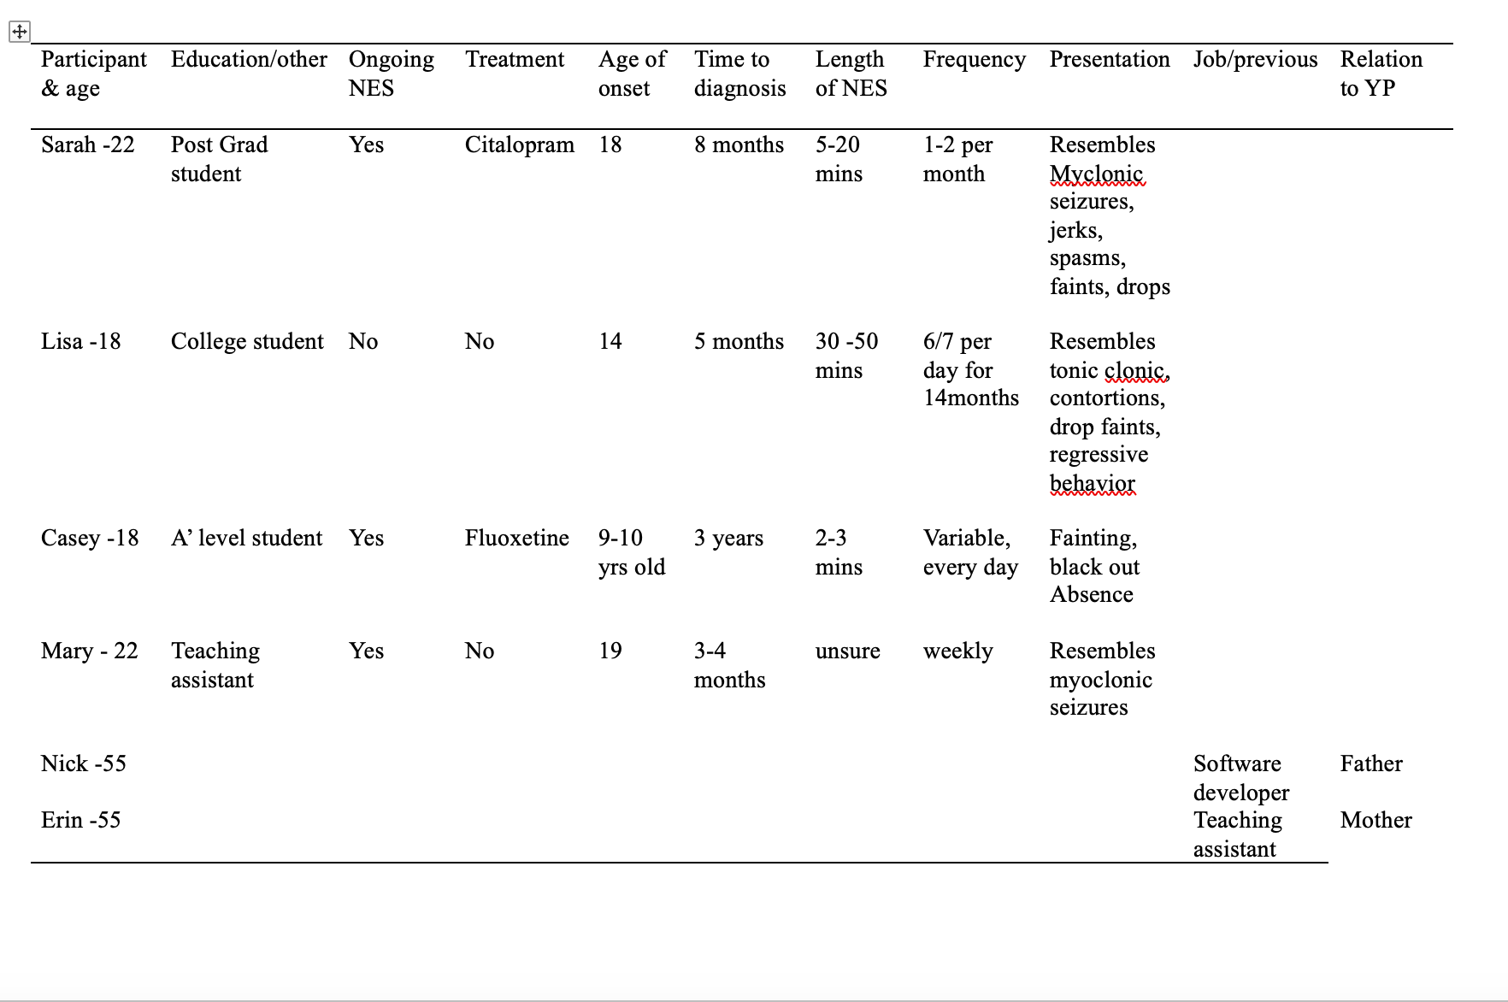
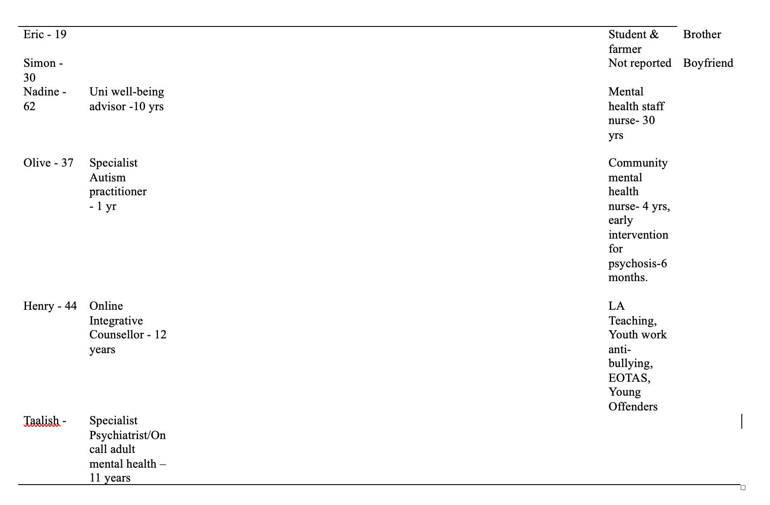

3.4 Results.
3.4.1 Overview of themes.
Three distinct themes and six sub-themes emerged: explanations of NES, the impact of NES and “who’s going to help me?” (See Table 3.2). There were consistent negative experiences from the YP and their families and self-reported lack of knowledge or understanding of NES from professionals. However, YP felt closer to their families because of the experience of NES and reported positive experiences of accommodations from educational settings. Professionals reported that they knew little about the disorder and that attention had been drawn to their lack of first aid and seizure policy knowledge.

Table 3.2
Themes and subthemes
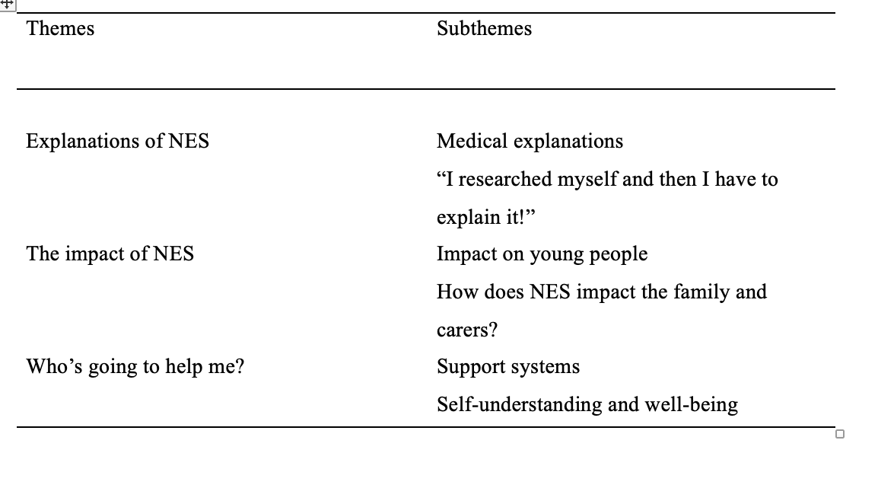

3.4.2 Theme 1. Explanations of NES.
A strong theme across all 13 participants was, ‘Explanations of the disorder’. All four YP felt that they had not had an explanation of the disorder and had relied on self-education from online sources or from parents who had researched for themselves. In the following quote Sarah explains.
“Well to be honest I don’t think a medical professional actually ever explained it to me. It was me and my family that did the research… experienced Counsellors that don’t even know what the definition of Dissociative seizures is then meaning I’m actually having to explain that to them” (Sarah, p2, 34-37).

One YP was given her diagnosis by her mother when she was nine years old as she was too young to comprehend at the time. Information leaflets had been given to two pairs of YP and their P/C without verbal explanation.
Only one professional, the Specialist Psychiatrist, could explain NES whilst the others had little or no knowledge of the disorder. Nadine, a university well-being advisor states.
“I’ve got to say, I’ve got to be truthful, I don’t know much about it really”(Nadine, p3, 106-107).

3.4.3. Sub-theme 1. Medical explanations.
Explanations of NES to YP and their families from medical professionals were inconsistent across the participants. YP often felt confused after consultation. Some had no memory of an explanation from anyone.
“I was told little or no information about the seizures and left in the dark” (Mary, p1, 22-24)
P/Cs also had inconsistent experiences of explanations from medical professionals. On occasions a diagnosis took months and for one YP this was after a misdiagnosis and treatment for epilepsy.
“We were under the assumption that they were Epileptic seizures round about 2020 and possibly caused by photosensitivity…there wasn’t a lot of information which was quite a big barrier for us to kind of understand”(Nick, p1, 16-18, 24-27).

However, one parent had a more positive experience, although again, after a lengthy process of investigation for narcolepsy.
“She just came over and she went ‘right’, she said. ‘I know exactly what this is’ she said. ‘This is something called Non-epileptic Attack Disorder”(Erin, p4, 127-129).

Explanations of NES for two participants were given by other family members, or they were unsure where their understanding had come from, relying on secondary information.
“When she <YP> came back she explained it to me along with giving me a booklet which helped explain the situation and how I can help” (Simon, p2, 36-37).
“I don’t really know exactly where my understanding of it today has come from, I can’t remember exact conversations of being explained it” (Eric, p2, 62-63).

The professionals had 93 years’ experience between them working in the mental health sector. However, only one could explain NES, although not why it happened.
“So, psychogenic mean that it does not have an organic base. If you do EEG which you do with Epilepsy, there are some changes which are not visible for this young person, yeah, so why we use the term psychogenic”(Taalish, p2, 66-68).

Four professionals had limited or no knowledge of NES, although there had been YP using their service with the disorder and one had personal experience of a sibling with a misdiagnosis of epilepsy, later diagnosed as NES.
“ I don’t think it was explained enough what the alternative was” (Olive, p3, 103-104).
“I had a client recently that was suffering with, suffering with [sic] that when she first came to me … it’s not my area, specifically in terms of that, I know my limitations” (Henry, p2, 52-57).

3.4.4 Sub-theme 2. “I researched myself and then I have to explain it!”.
Without an explanation from medical professionals YP, parents and carers educated themselves online to understand the disorder.
“I came home and then looked it up and that’s how I got information on it and my Mum looked into it a lot as well”(Lisa, p2, 39-40)”.
“Having researched it, I know now that a lot of people that are first diagnosed with epilepsy have got this not epilepsy”(Erin, p5, 145-146).
Finding on-line explanations for NES has enabled YP to explain to others what they have and what they need. YP want to reassure those around them that they are fine, and others do not need to panic when they have a seizure.
“I quite happily say, ‘this is what I have and this is what I need’…It’s important to be open because I would never want a seizure to happen and someone else feel stressed or worried”(Sarah, p6, 193-197).
“I mainly say, I have this thing, it’s called Non-epileptic Attack Disorder or NEAD and I’m completely fine when it happens…when I was explaining it, I had to explain it to Teachers so I’d say so like I can still hear things you know” (Casey, p7, 244-248).
“ when you describe non-epileptic seizures, people just hear the seizure bit and just assume it’s Epilepsy or something similar to that”(Nick, p4 138-144).

3.4.5 Theme 2. The Impact of NES
For all YP in this study having NES had an impact on their lives physically, emotionally and socially, as well as on their family members. Seizures ranging from syncope, or tonic clonic resemblance, altered states of consciousness or regressive changes in behaviour which lasted minutes or hours many times a day, left YP feeling exhausted, isolated and unable to function both physically and cognitively. However, three of the YP endeavoured to continue their education whilst managing this complex disorder. One YP was unable to return to education and left at 14 years old. Another had two years intermittently in and out of education, whilst two were attending university.
Whilst YP attended educational settings, well-being and medical professionals still felt the disorder was too rare and specialised, even though they had all had contact with a YP with the disorder at some point.
“Probably I think more training or more, [Sic] should be provided for us. I think that is because I have seen not many, but I’ve seen a few…I think that would be helpful for people who work in mental health” (Taalish, p5, 174-178).

3.4.6 Sub-theme 1. Impact on the young person.
The impact of NES on two YP was significant enough for them to stop going to school. One lost all contact with their friends and was isolated from society for nearly 3 years.
“I got sent home so much that the school were essentially like, ‘we can’t deal with this, we can’t deal with you passing out all the time, so we’re going to get you on this home school thing”(Casey, p3, 70-80).
“I lost contact with all my friends and all my social skills have pretty much gone…because I was so isolated and unable to do anything for so long it has kind of delayed things in my life quite a bit”(Lisa, p5, 157-160).

NES not only impacts YP when they are having seizures, but once the seizures have stopped, other somatic symptoms affect the YP’s life.
“Even though I don’t have seizures anymore… I get fatigued very easily and sometimes my brain can completely shut down. I get muscular tics and spasms. I had surgery on my stomach when I was young so now I tend to get stomach tics, as well as facial ones” (Lisa, p5, 148-152).

YP felt their lives were different to their peers, some of whom did not believe their seizures were real.
“And I still think to this day that they <friends> don’t fully understand it, I have explained, but sentences are used such as like ‘oh not proper seizures’ or ‘not real seizures’ it’s like those words can be quite demoralising as to the disorder I do have” (Sarah, p4, 140-143).

Learning to drive was not an option for three of the YP who still had seizures. YP with NES have to think before going out, in case of triggering environments.
“My life has been hugely affected by NES. I am unable to drive…Most of the time I am stuck at home. I often miss out on plans because I’m unable to get there or if I’ve had seizures or unable to attend…It affects my mental health, I feel anxious a lot and I’m often worried about having seizures”(Mary, p2, 70-73).

Being Autistic and experiencing overwhelm and sensory overload was also acknowledged as being impactful for onset of NES.
“This is probably being attached to the Autism and stuff, but I definitely think I have to be more aware when it comes to working to not overdo it” (Sarah, p4, 129-132).
“Being in crowded corridors is one of my triggers… my Mum and I recently learnt that people with Autism are more likely to have this thing and my friends been telling me for years I’ve got Autism”(Casey, p3, 96, p11, 397-399).

Professionals noted that they had experience of the impact of NES on YP within their settings, however, were not aware of how to respond. Nadine commented,
“I think we had one person, well, yeah, she was having one of those…she ended up staying on the couches…I mean it’s above the ground . I mean, easily she could fall off” (Nadine, p3, 104-105; p 4, 136-138).

Responding to a question relating to knowledge of first aid treatment for NES, Olive responded, “none, no idea” (p4, 124).

3.4.7 Sub-theme 2. How does NES impact the family and carers?
Family members said that NES had directly impacted their family life. Two mothers had not been able to work whilst caring for their YP.
“As far as work is concerned, I didn’t work whilst all this was going on, I couldn’t so I didn’t…then I just started part time at a local school…my husband he’s now, he’s working nights so he can help go and get her if he needs to”(Erin, p8, 252-262).
“My Mum had to quit her job to care for me and I’d say now my Mum has quite a lot of stress going on”(Lisa, p7, 221-222).

One sibling discussed whether he had missed out on occasions with his friends or not been able to have friends over.
“If my mates were out doing something or asked if I wanted to go, the immediate answer is no, I need to check first. I need to make sure I’m able to because having someone at home with my sister was the important thing.”(Eric, p5, 161-164).

Participants raised topics of difficult relationships within the family, feelings of frustration, guilt and disagreements about management or understanding NES.
“There are sometimes where my Dad is, that he, I don’t know if he knows how to express his emotions or he well, so sometimes I’ll be passing out all day and then he’ll come and pick me up and he’ll kind of like shout at me about it”(Casey, p5, 175-177).
“It’s been hard, really hard. You know it has caused disagreements. The way I deal with it and the way my husband deals with it. He wants to solve it and I know that it probably won’t be solved”(Erin, p8, 267-270).

3.4.8 Theme 3. Who’s going to help me?
YP and their families had mixed experiences of support. However, teachers and lecturers, although not understanding NES, had listened and made accommodations for access to education. All YP noted that family gave the most positive support, although there were incidences of disparity. Lack of external support systems were reported by all YP, parents and carers. Treatment for NES was inconsistent due to lack of referrals to mental health services, misdiagnosis, and lack of understanding from therapeutic professionals. Those who were referred and offered CBT stated that they did not find it helpful.
“Whilst I did it [CBT] my seizures didn’t improve. My mentality didn’t really improve…They didn’t focus on the bits that gave me PTSD or brought me to where I am, so I personally don’t think CBT, or how CAMHS did CBT helped me” (Lisa, p10, 289-293).

However, two YP were taking anti-anxiety medications which they felt reduced their seizure frequency and three paid privately for psychotherapy. Throughout their experience, YP reported areas of personal growth and noted that doing things that made them happy lessened seizure frequency and promoted well-being. One YP stated that having a seizure made her feel better.
“I am now more able to control seizures even though I don’t know how…Sometimes having a seizure feels like a release valve from just coping”(Mary, p3, 75-78).

Support could not be given to YP by four of the professionals due to lack of understanding of the disorder and discussions that it was too specialist.
“ We did discuss…what was best for her, and she identified that she’d like to talk to somebody who, you know, is more raised in that, you know…so that she can have that support with someone who is more specialised in that”(Henry, p4, 141-146).
“If I’m honest, I wouldn’t really be working with <a YP> that affected” (Angela, p4, 120).

3.4.9. Sub-theme 1. Support systems.
Family was reported by all the YP to be their main support system.
“All in all, it bought us very close, we’re a very tight knit family”(Lisa, p7, 222-223).
However, one YP reported frustration from a parent, and another felt their family could never really understand.
“My family will listen and be empathetic, but they don’t fully understand what I’m talking about” (Mary, p2, 36-37).
“They have been very supportive of me, It’s the main annoyance from Dad comes from when he has to pick me up from school…’oh why did you do, you know, why are you donking <seizures> so much?’…I’m just like this is why and then he’s like Ok and then we just don’t talk anymore” (Casey, p6, 199-201).

Educational settings were reported to be accommodating and supportive for all YP whether they were able to be in the setting or not.
“They were very good at being like, ‘what adjustments can we make to make the classroom more better for you…in a different room, better lighting, where there’s less classmates”(Sarah, p6, 209-212).

YP were intermittently able to attend and although one was not, they were offered Education Other than at School (EOTAS) however, they were too unwell to participate. Additionally, one YP still experienced stigmatisation and hostility from staff members.
“When I’m passed out I can still slightly hear and I heard them <Teachers> talking about it…I just felt really guilty”(Casey, p4, 118, 124).
3.4.10. Sub-theme 2. Self-understanding and well-being.
Throughout the process of acceptance of NES and for one YP, recovery, YP reported that doing things that made them happy lessened the possibility of seizures. Self-analysis and understanding the root cause enabled YP to take control of their lives.
“Through counselling, I learned to self-analyse why certain things that gave me anxiety or PTSD and then I also learnt to communicate it…If I like notice something about how my brain works or how my body reacts cause, I tend to have very physical reactions to anxiety” (Lisa, p10, 297-298, 319-320).

For some of the YP there was an air of submission that they had NES.
“I had to accept that all this is probably going to be in my life for quite a while now…just to re-find what I enjoy, going out and going to places you feel grounded and that make you happy…gives you good emotions as opposed to…focusing on bad emotions definitely helps more as well” (Sarah, p3, 95, p8 259, 268-270).

Although professionals had no knowledge of NES, they all advocated listening to their client and having a person-centred approach to well-being.
“Because that’s the most important thing is you know what’s gonna make her feel safe while she’s here you know?” (Nadine, p4, 126-127).
“It would be a priority to think about what the student would need from me, the student would be able to tell me, this is what I would need”(Angela, p7, 229-230).

3.5. Discussion
This is one of the first multi-perspectival qualitative studies to explore the experiences of YP with NES, and the first on this topic in Wales UK. Although a small sample of three different groups, it was possible to find common themes which correlate with previous literature (Cole et al., 2014; Dunne et al, 2019; Hinton & Kirk, 2018).
Thwarted by experiences of lengthy diagnostic times, misdiagnosis and lack of explanations, the YP and P/Cs in this study showed resilience adjusting to the far-reaching impact of NES and the reliance on ‘self’ as a tool for meaning making (Pretorius & Sparrow, 2015).
The YP in this study attend educational settings when they are able, are not in receipt of NES specialised treatment and pay for private therapy when public health professionals have limited understanding of the disorder. Chew, Carpenter & Haase (2018) found through positive, collaborative, familial bonds, YP develop resilience to cope with their adverse experiences. The families in this study reported similar experiences of positive, supportive family relations.
The YP and carers emitted feelings of “confusion” “bewilderment” and then resignation that there is no support, nobody understands, and they just ‘get on with it’. This is reiterated in the developed themes; “Explanations of NES”, The impact of NES and “Who is going to help us?”. Across the trajectory of their illness, interactions with healthcare professionals gave little reassurance to YP and their families of a positive prognosis due to their limited understanding of the disorder, lack of treatment options and support systems. One YP had experienced seizures for nine years and another for four, the latter was initially misdiagnosed with epilepsy and had visited several therapists who had no knowledge of NES.
However, research has shown that YP with a chronic illness attempt to normalise their lives if possible in the context of education and develop strategies to cope (Ferguson & Walker, 2014). Additionally, YP with a chronic illness such as NES take an increasing role in the self-management of their disorder whilst also negotiating integration into their day-to-day lives with their tutors and peers who may not always understand (Flick & Röhnsch, 2024; Lerch & Thrane, 2019). The YP in this study took control of their own education of the disorder, coping strategies and management of NES by researching, explaining to others, understanding themselves and what they can cope with, such as work limits, missing out on events and having to rest.
The professionals reported having limited or no understanding of NES, believing it to be too rare or specialised a condition for them to know about irrespective that all professionals had had contact, or heard of students, clients or family with the disorder. Previous literature has reported that people with NES often experience poorer quality of healthcare and gaps in understanding and knowledge (Annandale, Vilyte & Pretorius, 2022). For example, a systematic synthesis of 21 qualitative studies of patients experiences of NES (Rawlins & Reuber, 2016), found that negative experiences of healthcare professionals’ knowledge and understanding were common and expected by patients and this reiterates the experiences in this study.
Although at risk of elevated negative outcomes (De Aveirio et al., 2024), the legitimacy of an organic diagnosis of epilepsy promotes better social and professional understanding (Peacock et al., 2023), however, an NES diagnosis leads to experiences of stigma and exclusion because of limited research, training and therefore understanding (Karakis et al., 2020; Rawlings, Brown & Reuber 2017). All the YP and their P/Cs had experience’ of stigma and exclusion due to the lack of understanding and knowledge of others, for example one parent reported the assumption that their YP had epilepsy when they mentioned seizures and another YP was told by friends’ that their seizures were “not real seizures”.
None of the YP and P/Cs in this study experienced explanations of NES which left them fully understanding the disorder and its causation, however, clarification of a diagnosis and clear explanations conveyed in a way which is meaningful for the recipient affect the way in which a diagnosis of NES is accepted (Karterud, Risør & Haavet, 2015), and can affect future engagement with healthcare professionals (Smith, 2014). The use of psychoeducation when delivering a diagnosis empowers the patient, their families and carers through education about their disorder and enables them to make informed decisions about pathways to recovery (Oliveira & Dias, 2023).

When psychoeducation is used to explain and promote the self-management of NES, seizures may diminish or cease altogether (Mayor et al., 2013). Additionally, previous studies ( Cope et al., 2017; Gurcan et al., 2022) suggest that psychoeducation at the earliest opportunity promotes understanding, confidence when explaining the disorder to others, better management and outcomes and less emergency service use.
3.6 Limitations
Some limitations existed within this study. This was a small sample size, 13 in total, within that were sub-sample groups. YP included four females and therefore as NES is a heterogeneous disorder there were limited representation of symptoms or differentiation in experience, due to size and gender. Additionally, the study took place in a small area of Wales and experiences could differ between health boards. Finally, due to the limited knowledge and understanding of the small sample of professionals it was problematic to compare and contrast experiences between the groups.

3.7 Conclusion and implications
This study on NES is the first in Wales, UK. Four YP were interviewed about their experiences of NES, four P/Cs their perceptions, and five health and well-being professionals their knowledge and understanding of the disorder. Three key themes emerged: Explanations of NES, the impact of NES and “who’s going to help me?”.
YP had consistently poor experiences with healthcare professionals throughout the course of their illness due to limited explanations, treatment and knowledge of the disorder. YP and their families sought their own education about NES, and found they had to explain it to others, including teachers, lecturers, counsellors and peers. This was reiterated from the limited knowledge and understanding from the health and well-being professionals despite them having contact with clients with NES. However, this study highlighted to professionals the limitations of their knowledge and lack of a ‘safe space’ for care.
Although NES impacted YPs’ mental health, feelings of isolation and ‘being different’ to their peers, YP developed positive levels of self-understanding and developed strategies to cope with everyday life. Additionally, although their primary support network was their family, apart from one YP who had a supportive friendship group throughout, there was no external opportunity or psychoeducational support for YP with NES and their families to improve YPs’ outcomes.
This relatively common yet poorly understood disorder, often misdiagnosed as epilepsy (Huff, Lui. & Murr, 2024) warrants further investigation in order to provide education to those working with YP with NES in the health and well-being sectors. Additionally, the provision of psychoeducational support systems for YP and their families would improve outcomes and aid recovery.

Chapter four:
Reflective Chapter.

This chapter is a reflective piece about the process of my master’s dissertation research using Gibb’s Reflective Model (1988) as a framework. It follows the whole process and draws upon my experiences and emotions as the researcher. This was an applied research study and therefore involved recruiting and interviewing members of the public who met the criteria for my chosen topic. Initially, my title was:
‘The experiences of young people (YP) with Non-epileptic seizures (NES), the perceptions of their parents and the knowledge and understanding of professionals who work with them’. However, this felt like a longwinded title and so after discussions with my supervisor, I decided on the title,
‘Understanding the experience of Non-epileptic seizures in young people: A multi-perspectival qualitative analysis.’
I have not come across a multi-perspectival approach in any papers throughout my literature search, or previous study, so I was pleased that I could research from a different angle. Additionally, after communications with two medical experts in the field of neurology and functional disorders in the UK, I discovered there is no research on NES in Wales and this reiterated to me that I had chosen the right topic.
I had decided previously that I was going to use a qualitative approach to research in order to gain deep and meaningful insight into the experiences of YP with NES and their family’s perspective, whilst also examining what the level of understanding was from medical and well-being professionals. After recruiting participants through social media and approaching relevant professionals via their workplace, I used semi-structured interviews to collate data and thematic analysis to analyse. For some participants discussing their own personal mental health difficulties and those of their family, semi-structured interviews allowed an element of flexibility to give truly authentic results (Clarke and Braun, 2017).
Drawing attention to Gibbs’ section on feelings I will now describe how I felt throughout the process. Initially, I felt that one of the most difficult decisions for me was, what am I going to call the seizures from both an academic and socially acceptable viewpoint? A lot of the research I had already read used variable terminologies for the disorder, as had people I had met, leaving me to feel confused as to which terminology to use. Terminologies read included but were not limited to: Non-Epileptic Attack Disorder, Psychogenic Nonepileptic seizures and Dissociative seizures. I decided on Non-epileptic seizures purely so that the reader could note that the seizures, ‘were not epileptic’. They had a psychological origin and not an organic basis.
I was excited about starting the process. Due to personal experiences, I already had some knowledge and was enthusiastic in furthering my learning via the University library. My own experience had shown me that there are young people trying to cope in society with this disorder with little or no support and so it was very important that I did not allow any bias to affect my ability to research. After ethical approval had been met, I was keen to get started. I felt that I was very well prepared as I am an organised person and spent September and October of 2024, making connections with YP, their family members and professionals via social media and workplaces. One thing that I found difficult, and frustrating was that I could not give professionals a true explanation of the topic for their interviews as I did not want them to Google NES if they did not know what it was. I had to explain that I was researching around mental health disorders, and all would become clear in the interview. I felt really conflicted by this as I did not want to appear deceptive. I discussed this with my supervisor and a previous research lecturer, and they reassured me that I was not being deceptive as I wanted a true baseline account of their knowledge and understanding of NES.
I was pleased that YP were keen to share their experiences. I had the impression that they wanted someone to talk to who understood what non-epileptic seizures were. I was also relieved that I did not have to chase people to participate, and it did not take too long for consent forms to come back. I ended up with 13 participants, which was adequate purposive sampling for a qualitative study (Vasileiou et al., 2018).
There were a couple of occasions when I felt anxious, and this took me by surprise. I knew already that I have difficulties with computer processes and sequencing as I have Dyscalculia and so, having not done online interviews before, which involved recording and then transcribing on Microsoft Teams, this made my heart race, and I could feel panic rising. I practiced a few times prior to my first interview so that I felt more confident. However, the first time I had to do an interview I felt anxious. I decided to use calming techniques and read up about massaging either side of your ears as I had read this calms the Vagus Nerve. I closed my eyes, did the box breathing method too and thankfully this worked for me, and I was able to continue with the interviews, prepping myself in this way each time.
Interviewing YP with a chronic illness and their families could be classed as highly emotive, especially because of my own family experience of NES. For some interviewers it may be very difficult to remain focused, objective and yet still express empathy. I felt that I was able to do this well and this is, in part, due to my therapeutic work as a Play Specialist Support Worker with toddlers with complex and additional needs and their families. This requires a certain amount of objectivity in order to achieve positive outcomes for the child. This does not mean that I do not care or am not emotionally moved by the experiences I witness; it means that I am able to listen, make a connection, whilst remaining objective and focused on the aims for both the child I am working with, and the YP I am interviewing. However, at times it made me feel sad to hear of the impact of NES on the lives of YP and their families. Additionally, the negative way in which young people were spoken to sometimes, due to the lack understanding of the disorder and that it was still affecting the YP many years after onset. The isolation they felt, the loss of time learning and developing at one of the most important times of their lives was equally unsettling, as too was hearing about related family disagreements and frustration.
It was also very interesting listening to the young people talk about their seizures and how different the presentations were for each person. The more I read about the disorder, the more I understood about somatic symptoms and a person’s physiological response to psychological trauma. I felt in awe of the young people as they tried to navigate their way through their lives with little support.
Alternatively, interviewing the professionals was enlightening yet disturbing to me. Between them the five professionals had many years’ experiences of working in the mental health sector both medically and in the health and well-being of YP. The limited knowledge of professionals on, not only NES, but seizures, care of, point of contact for first aid and their settings policies for processes of care was eye-opening. In comparison to my own line of work in the early years sector, where it is mandatory to have a Safeguarding and First Aid qualification, as well as continuing professional development in Prevent, Encompass and Adverse Childhood Experiences (ACE’s), I felt quite perturbed that this level of attention to detail is not carried out within all educational and health settings where vulnerable children and young people are educated or cared for.
Once I had completed the interviews, I spent most of December transcribing the scripts. My preferred method was to have hard copies of scripts, a pencil and highlighters so that I could make notes in the margins. Following Braun and Clarkes (2006) thematic analysis stages, I read and re-read to familiarise myself with the scripts. Over this period, I often found myself waking up at nighttime with thoughts I needed to jot down, or I would make notes on my phone. I started to realise that I had taken on a really big job interviewing three groups and soon there were a lot of topics developing. In order to develop themes after the scripts had been coded, I drew mind-maps to help me visualise. Initially I ended up with seven themes! These were all relevant and all with supporting literature; however, some of these topics such as treatments, and Autism and NES warranted having their own paper and research, especially in Wales. I had to make a decision about how I could balance the data I had from the YP and their families with the equating or contradictory data I had from the professionals. I was eventually able to condense themes to three which reflected the main areas discussed by my sample group whilst also incorporating some of the other topics developed.
When evaluating and analysing my research, in line with Gibbs third and fourth sections, I feel that I was able to remain consistent in my time management throughout the whole research process. My passion motivated me. Themes raised were compatible with previous literature for children, adolescents and adults with NES (Jordan et al., 2019; McWilliams et al., 2016). However, one theme stood out for me which differed. The YP I interviewed had all had good educational support systems, even though NES was not understood. Support systems were bespoke, and person centred. This had not been the case in the literature I had read previously (Flewelling et al., 2020a; Tanner et al., 2022) and I wondered if this may be due, in part, to the recent Additional Learning Needs and Educational Tribunal (Wales) Act 2018. It could be possible that educational staff in Wales have robust systems and pathways of support but not the medical or additional needs knowledge.
I am pleased that I remained determined in being specific with my age group of 18-25 years as this age group had not been studied. Also, I am glad that I was able to compare professionals’ knowledge and understanding of NES with YP’s experiences. When I think about what worked well, I believe I was able to make a good connection with YP and their families when they were being interviewed. I felt attuned to their needs and this in turn enabled them to open-up to me fully, giving good in-depth data.
On reflection, the main area I would do differently would be to consider my questions for interview. I feel that the broad range of my questions for YP and their families invited too much scope for answers and therefore themes, there was so much I could have discussed, and it was difficult to limit this and be concise. The amount of information was actually quite overwhelming, and I could have focused on a more specific line of questioning. However, because it was qualitative semi-structured interviews and therefore flexible, I understand that one can never predict where the participants’ answers will go and how much they will want to talk.
In conclusion, for stage five of this reflection, I have been proud of myself in undertaking the topic of NES for my applied research dissertation and been consistently determined to learn and understand as much about the topic as I can. As discussed earlier, I feel that I did go into this research with a possible preconceived idea from the research I had read of how YP were going to talk about school, college and university support. This has taught me that one should never approach research with a preconceived idea, the researcher must always be non-biased.
Finally, for future students doing an applied research dissertation I would recommend deep thinking about a topic you passionately want to research at the earliest opportunity as this drives your motivation and wish to read and learn. It also enables you to stay within your time constraints and not procrastinate.
Throughout the process of my dissertation, I have been acutely aware that the people that I have been working with in my study, especially the young people and their families, are really lacking in access to support and opportunities for knowledge and understanding of non-epileptic seizures. I have come to understand myself, that I personally have an opportunity, if not a duty, to use the knowledge I have gained in order to better the lives of those affected and to educate those who do not understand, especially those with access to helping and supporting young people. With this in mind, I have wavered between either doing a PhD to promote further research on this topic in Wales, or to work directly with young people with mental health disorders and non-epileptic seizures to aid their recovery and improve their outcomes. Additionally, I am thinking I would like to promote and provide education and training to professionals who work with young people in the health and well-being sector.
Moving forward, I shall be using the research skills and knowledge learnt to train to be a psychotherapist specialising in adverse experiences, trauma and Non-epileptic seizures whilst promoting awareness and understanding of the disorder. I have already had conversations with a leading Doctor in psychogenic seizures and prolonged exposure therapy in New York, America who runs successful programmes on this disorder and invites clinicians from Europe and the UK to shadow her work in this field.

Appendix
Appendix A
A copy of the application for ethical approval.

APPLICATION FOR ETHICAL APPROVAL

RESEARCH STUDENTS
This form is to be completed by the student within SIX months for full-time students and TWELVE months for part time students, after the commencement of the research degree or following progression to Part Two of your course.

Once complete, submit this form via the MyTSD Doctoral College Portal at (https://mytsd.uwtsd.ac.uk).

This document is also available in Welsh.

RESEARCH STAFF ONLY
All communications relating to this application during its processing must be in writing and emailed to pgresearch@uwtsd.ac.uk , with the title ‘Ethical Approval’ followed by your name.

STUDENTS ON UNDERGRADUATE OR TAUGHT MASTERS PROGRAMMES should submit this form (and receive the outcome) via systems explained to you by the supervisor/module leader.

In order for research to result in benefit and minimise risk of harm, it must be conducted ethically. A researcher may not be covered by the University’s insurance if ethical approval has not been obtained prior to commencement.

The University follows the OECD Frascati manual definition of research activity: “creative work undertaken on a systematic basis in order to increase the stock of knowledge, including knowledge of man, culture and society, and the use of this stock of knowledge to devise new applications”. As such this covers activities undertaken by members of staff, postgraduate research students, and both taught postgraduate and undergraduate students working on dissertations/projects.

The individual undertaking the research activity is known as the “principal researcher”.

Ethical approval is not required for routine audits, performance reviews, quality assurance studies, testing within normal educational requirements, and literary or artistic criticism.

Please read the notes for guidance before completing ALL sections of the form.

This form must be completed and approved prior to undertaking any research activity. Please see Checklist for details of process for different categories of application.

SECTION A: About You (Principal Researcher)
1 | Full Name: |  | Alison Upstill
2 | Tick all boxes that apply: |  | Member of staff: | ☐ | Honorary research fellow: | ☐
 | Undergraduate Student | ​​☐​ | Taught Postgraduate Student | ​​☒​ | Postgraduate Research Student | ​​☐​

3 | Institute/Academic Discipline/Centre: | Psychology and Counselling
4 | Campus: | Carmarthen
5 | E-mail address: | 1806935@student.uwtsd.ac.uk
6 | Contact Telephone Number: | 07788 721045
 | For students:
7 | Student Number: | 1806935
8 | Programme of Study: | Masters Children and Young People’s Mental Health
9 | Director of Studies/Supervisor: | Dr Lymarie Rodriguez-Morales

SECTION B: Approval for Research Activity
1 | Has the research activity received approval in principle?  (please check the Guidance Notes as to the appropriate approval process for different levels of research by different categories of individual) |  | YES | ​​☒​ | NO | ​​☐​
 |  |  |  |  | Date
2 | If Yes, please indicate source of approval (and date where known): Approval in principle must be obtained from the relevant source prior to seeking ethical approval | Research Degrees Committee |  | ​​☐​
2 |  | Institute Research Committee |  | ​​☐​
2 |  | Other (write in)  Lymarie Rodriguez (supervisor) |  | ​​☒​ | 08.08.2024

SECTION C: Internal and External Ethical Guidance Materials
 | Please list the core ethical guidance documents that have been referred to during the completion of this form (including any discipline-specific codes of research ethics, location-specific codes of research ethics, and also any specific ethical guidance relating to the proposed methodology). Please tick to confirm that your research proposal adheres to these codes and guidelines. You may add rows to this table if needed.
1 | UWTSD Research Ethics & Integrity Code of Practice | ​​☒​
2 | UWTSD Research Data Management Policy | ​​☒​
3 | BPS Code of Human Research Ethics (2014)  BPS Code of Ethics and Conduct (2018)  BPS Guidelines for Internet-Mediated Research (2021) | ​​☒​

SECTION D: External Collaborative Research Activity
If there are external collaborators then you should gain consent from the contact persons to share their personal data with the university. If there are no external collaborators then leave this section blank and continue to section E.
1 | Institution
2 | Contact person name
3 | Contact person e-mail address
4 | Is your research externally funded? |  | YES | ​​☐​ | NO |  | ​​☐​
5 | Are you in receipt of a KESS scholarship? |  | YES | ​​☐​ | NO |  | ​​☐​
6 | Are you specifically employed to undertake this research in either a paid or voluntary capacity? | Voluntary | YES | ​​☐​ | NO | ​​☐​
7 |  | Employed | YES | ​​☐​ | NO | ​​☐​
8 | Is the research being undertaken within an existing UWTSD Athrofa Professional Learning Partnership (APLP)? | If YES then the permission question below does not need to be answered. | YES | ​​☐​ | NO |  | ​​☐​
9 | Has permission to undertake the research has been provided by the partner organisation? | (If YES attach copy)  If NO the application cannot continue | YES | ​​☐​ | NO |  | ​​☐​

Where research activity is carried out in collaboration with an external organisation
10 | Does this organisation have its own ethics approval system? | YES | ​​☐​ | NO | ​​☐​
 | If Yes, please attach a copy of any final approval (or interim approval) from the organisation (this may be a copy of an email if appropriate).

SECTION E: Details of Research Activity
1 | Indicative title: | Understanding the experience of non-epileptic seizures in young people: A multiperspectival qualitative study
2 | Proposed start date: | 28th October 2024 | Proposed end date: | 28th March 2025
Introduction to the Research (maximum 300 words per section)
Ensure that you write for a Non-Specialist Audience when outlining your response to the points below:
- Purpose of Research Activity
- Proposed Research Question
- Aims of Research Activity
- Objectives of Research Activity
Demonstrate, briefly, how Existing Research has informed the proposed activity and explain
- What the research activity will add to the body of knowledge
- How it addresses an area of importance.
3 | Purpose of Research Activity  The purpose of this research is to examine the lived experience of young people (18-25 years) living with non-epileptic seizures (NES) in Wales. 1 in 6 children and young people suffer with a diagnosable mental health disorder with a noticeable increase post Covid-19 pandemic (Welsh Government, 2024). Included in this is non-epileptic attack disorder or functional seizures. Although data on adults indicates a prevalence of 2-30/100,000 and nearly half of patients arriving in emergency care with suspected serious epilepsy are later diagnosed as having non-epileptic seizures (NHS, 2017), no reliable data exists for young people, as too their outcomes (Appleton, 2022). Although terminologies such as ‘pseudo seizure’ are still used by some professionals today, the inconsistency and ambiguity of a diagnosis of any of the above terminologies can lead a person feeling offended and left in limbo, neither treated by neurologists or psychiatrist. (Loewenberger et al., 2021). Prior to lengthy diagnosis and due to the similarity in presentation, NES are often misdiagnosed as epilepsy, although, the seizures do not co-occur with any electrophysiological changes in the brain (McWilliams et al., 2017). Misdiagnosis can lead to damaging medical intervention resulting in increased seizures from unnecessary anti-epileptic drugs and traumatic hospitalisation (Dunne et al., 2019).  Interest in the experience and perception of those living with a seizure disorder and those who care for them is increasing due to the insight which can be given (Rawlings et.al., 2018) and the implications from these experiences on future diagnosis, treatment and outcomes (Reuber and Rawlings, 2016). However, there is little research into non-epileptic seizures in the paediatric population and although research has been done on the experiences of children and families living with epilepsy, there is only one qualitative study (Karterud, Risør and Haavet, 2015) which examines the receiving of a diagnosis of NES for young people (14-24 years) (McWilliams et al., 2016).  Therefore, this study aims to explore the experiences of young people with NES, the perceptions of their parents and the knowledge and understanding of professionals who work closely with them.  Appleton, R. (2022). Psychogenic non-epileptic seizures (PNES) a refresher. Paediatric Epilepsy Current Awareness Service, 16(2). https://www.epilepsy.org.uk/app/uploads/2022/10/PECAS_EA_June2022.pdf  Dunne, A., Carolan, R., Swords, L., & Fortune, G. (2019). Patient and family perspectives of paediatric psychogenic non-epileptic seizures: A systematic review. European Journal of Epilepsy, 71, 271-285. https://www-sciencedirect-com.ezproxy.uwtsd.ac.uk/science/article/pii/S1059131119303036  Karterud, H. N., Risør, M. B., & Haarvet, O. R. (2015). The impact of conveying the diagnosis when using a biopsychosocial approach: A qualitative study among adolescents and young adults with NES (Non-epileptic seizures). Seizure, 24, 107-113. https://www.sciencedirect.com/science/article/pii/S105913111400257X  Loewenberger, A., Davies, K., Agrawal, N., Poole, N., & Cope, S. R. (2021). What do patients prefer their functional seizures to be called, and what are their experiences of diagnosis? A mixed methods investigation. Epilepsy and Behaviour, 11, https://www-sciencedirect-com.ezproxy.uwtsd.ac.uk/science/article/pii/S1525505021000512  McWilliams, A., Reilly, M. B., McFarlane, F., & Heyman, I. (2017). 94 A study of psychogenic non-epileptic seizures in children and adolescents; Characteristics and experiences of a case series. Archives of Disease in Childhood, London, 102, A29. https://www.proquest.com/docview/1946175888/fulltextPDF/AF165EF05DB64B07PQ/1?accountid=130472&sourcetype=Scholarly%20Journals  Morgan, L. A., & Buchhalter, J. (2015). Psychogenic paroxysmal events in children: A review. Pediatric Neurology, 53(1), 13-22. https://www.sciencedirect.com/science/article/abs/pii/S0887899415001575  National Health Service. (2017). Non-epileptic attacks, a short guide for patients and families, Information for patients’ neurology and psychotherapy services. https://www.sth.nhs.uk/clientfiles/File/Epilepsy/pil1038.pdf  Rawlings, G. H., Brown, I., & Reuber, M. (2018). Narrative analysis of written accounts about living with epileptic or psychogenic non epileptic seizures. European Journal of Epilepsy, 62, 59-65. https://www.sciencedirect.com/science/article/pii/S1059131118304771  Reuber, M., & Rawlings, G. H. (2016). Non-epileptic seizures, subjective phenomena, in M. Hallet, J. Stone & A. Carson. (Eds), Handbook of Clinical Neurology: Elsevier.  Welsh Government. (2024). Research in Wales making a difference to the mental health of Welsh children and young people. Health and care Research Wales. https://healthandcareresearchwales.org/about/news/research-wales-making-difference-mental-health-welsh-children-and-young-people  (this box should expand as you type)
4 | Research Question  - What are the lived experiences of young people with non-epileptic seizures in Wales?  - What are the lived experiences of parenting a young person with non-epileptic seizures in Wales?  - What is the knowledge and understanding of non-epileptic seizures from professionals working with young people in Wales?  (this box should expand as you type)
5 | Aims of Research Activity  The aim of the study is to explore the experiences of young people with NES, the perceptions of their parents and the knowledge and understanding of professionals who work closely with them.  (this box should expand as you type)
6 | Objectives of Research Activity  - To understand the experiences of young people with non-epileptic seizures in Wales.  - To contribute to qualitative research on non-epileptic seizures as there is a gap in the research literature.  - To understand the depth of knowledge and understanding of non-epileptic seizures from professionals working with young people.  (this box should expand as you type)
Proposed methods (maximum 600 words)
Provide a brief summary of all the methods that may be used in the research activity, making it clear what specific techniques may be used. If methods other than those listed in this section are deemed appropriate later, additional ethical approval for those methods will be needed. You do not need to justify the methods here, but should instead describe how you intend to collect the data necessary for you to complete your project.
7 | The research to be carried out will be a small-scale qualitative study utilising a thematic analysis approach. Data collection will consist of 15 semi-structured interviews. Qualitative research interviewing techniques will be used in order to gain a deeper understanding of participants views and experiences (Islam & Aldaihani, 2022) of non-epileptic seizures either from a patient, carer or professional perspective.  Participants  The intended participant number is 15: a) 5 young people aged 18 -24 years, diagnosed with a non-epileptic seizure disorder for at least 6 months before participating in the study, b) 5 parent/carers, and c) 5 professionals working with young people (e.g., school nurse, pastoral/wellbeing officer, counsellor, teacher).  A purposive sampling method shall be used to recruit the intended participant young people and their parent/carers. They will be recruited via social media (pending on the approval from the Centre of Psychology & Counselling), as an initial form of contact, followed with an informative email or letter of invitation with consent form and expressed permission specific to the young people.  Professionals will initially be contacted through a telephone directory or contact website by phone through their place of work as a contact point and then further informed by email or letter. This shall be through local colleges, schools, UWTSD wellbeing department, health department, IAS and counsellor directory. Letters of invitation for professionals shall be worded using ‘mental health disorders’, not non-epileptic seizures. This enables the researcher to gauge a true baseline level of understanding and knowledge of the disorder without any pre-interview research on the topic.  Data collection  Interviews will be carried out either face-to-face in a room booked at UWTSD Carmarthen campus or via Microsoft Teams, Zoom or telephone, whichever is more convenient for the participant. Face-to- face interviews will either be recorded using a Dictaphone or laptop recording system.  Interviews will consist of 7-10 open ended questions with some added prompts to achieve a detailed response. Interviews should take between 45 minutes to 1 hour approximately. Questions for young people will explore their experiences of how their seizures manifest and when they started, their process of diagnosis, treatment and how their disorder has affected their life, including the attitudes and understanding of others.  For parents, the questions will examine what their support network has been, the effects on the family and whether they have been able to navigate both the health and education systems for understanding and accommodations for their child.  For professionals working with young people questions shall be about their understanding, knowledge and experience of non-epileptic seizures. Additionally, what their workplace seizure policy is, whether for epilepsy or non-epileptic seizures.  An interview schedule will be developed for each of the above groups based on the current research literature. The schedules will be pilot tested to ensure they are appropriate and reliable.  Data analysis  Braun and Clarke (2006) six stages of thematic analysis shall be used to collect data from the transcribed interviews. Codes and themes will be generated from printed, hard copies using highlighter pens after thorough deeper level reading is completed. By the end of stage five after systematic reviewing of transcripts, evolved themes and subthemes will be ready to be recorded in a thematic analysis table ready for stage six, the write up of the report, results and discussion. All interview transcripts will be anonymised and participant will not be idenfiable.  Braun, V., & Clarke, V. (2006). Using thematic analysis in psychology. Qualitative Research in Psychology, 3, 77-101. https://www-tandfonline-com.ezproxy.uwtsd.ac.uk/doi/abs/10.1191/1478088706qp063oa  Islam, M. A., & Aldaihani, F. M. F. (2022). Justification for adopting qualitative research method, research approaches, sampling strategy, sample size, interview method, saturation and data analysis. Journal of International Business and Management, 5(1), 1-11. https://www.researchgate.net/profile/Md-Islam-394/publication/357352896_Justification_for_Adopting_Qualitative_Research_Method_Research_Approaches_Sampling_Strategy_Sample_Size_Interview_Method_Saturation_and_Data_Analysis/links/61c9ed5ab8305f7c4b05d50c/J  this box should expand as you type)
Location of research activity
Identify all locations where research activity will take place.
8 | Interviews will either take place face-to-face in a room booked at University of Wales Trinity Saint David (UWTSD) Carmarthen campus or online on Microsoft Teams or Zoom.  (this box should expand as you type)
Research activity outside of the UK
If research activity will take place overseas, you are responsible for ensuring that local ethical considerations are complied with and that the relevant permissions are sought. Specify any local guidelines (e.g. from local professional associations/learned societies/universities) that exist and whether these involve any ethical stipulations beyond those usual in the UK (provide details of any licenses or permissions required). Also specify whether there are any specific ethical issues raised by the local context in which the research activity is taking place, for example, particular cultural and/or legal sensitivities or vulnerabilities of participants. If you live in the country where you will do the research then please state this.
9 | NA  (this box should expand as you type)

10 | Use of documentation not in the public domain: Are any documents NOT publicly available? | NO | ​​☒​
10 |  | YES | ​​☐​
11 | If Yes, please provide details here of how you will gain access to specific documentation that is not in the public domain and that this is in accordance with the current data protection law of the country in question and that of England and Wales.  (this box should expand as you type)

 | Does your research relate to one or more of the seven aims of the Well-being of Future Generations (Wales) Act 2015? | YES | NO
12 | A prosperous Wales | ​​☒​ | ​​☐​
13 | A resilient Wales | ​​☒​ | ​​☐​
14 | A healthier Wales | ​​☒​ | ​​☐​
15 | A more equal Wales | ​​☒​ | ​​☐​
16 | A Wales of cohesive communities | ​​☐​ | ​​☒​
17 | A Wales of vibrant culture and thriving Welsh language | ​​☐​ | ​​☒​
18 | A globally responsible Wales | ​​☒​ | ​​☐​
19 | If YES to any of the above, please give details:
Young people, including those with non-epileptic seizures are the future of Wales. A prosperous, resilient, healthier Wales puts value on the skills of its young people, highlighting the importance of soft skills and flexible working for those with disabilities which is becoming more desirable in a digital generation. Young people with non-epileptic seizures find it challenging to attend educational settings for many reasons, their academic performance is poor and they face challenges with relationships (Tanner et al., 2022).
(this box should expand as you type)

SECTION F: Scope of Research Activity
 | Will the research activity include: | YES | NO
1 | Use of a questionnaire or similar research instrument? | ​​☐​ | ​​☒​
2 | Use of interviews? | ​​☒​ | ​​☐​
3 | Use of focus groups? | ​​☐​ | ​​☒​
4 | Use of participant diaries? | ​​☐​ | ​​☒​
5 | Use of video or audio recording? | ​​☒​ | ​​☐​
6 | Use of computer-generated log files? | ​​☐​ | ​​☒​
7 | Participant observation with their knowledge? | ​​☐​ | ​​☒​
8 | Participant observation without their knowledge? | ​​☐​ | ​​☒​
9 | Access to personal or confidential information without the participants’ specific consent? | ​​☐​ | ​​☒​
10 | Administration of any questions, test stimuli, presentation that may be experienced as physically, mentally or emotionally harmful / offensive? | ​​☐​ | ​​☒​
11 | Performance of any acts which may cause embarrassment or affect self-esteem? | ​​☐​ | ​​☒​
12 | Investigation of participants involved in illegal activities? | ​​☐​ | ​​☒​
13 | Use of procedures that involve deception? | ​​☐​ | ​​☒​
14 | Administration of any substance, agent or placebo? | ​​☐​ | ​​☒​
15 | Working with live vertebrate animals? | ​​☐​ | ​​☒​
16 | Procedures that may have a negative impact on the environment? | ​​☐​ | ​​☒​
17 | Other primary data collection methods. Please indicate the type of data collection method(s) below. | ​​☐​ | ​​☒​
 | Details of any other primary data collection method:  (this box should expand as you type) | ​​☐​ | ​​☒​
If NO to every question, then the research activity is (ethically) low risk and may be exempt from some of the following sections (please refer to Guidance Notes).

If YES to any question, then no research activity should be undertaken until full ethical approval has been obtained.

SECTION G: Intended Participants
If there are no participants then do not complete this section, but go directly to section H.

 | Who are the intended participants: | YES | NO
1 | Students or staff at the University? | ​​☒​ | ​​☐​
2 | Adults (over the age of 18 and competent to give consent)? | ​​☒​ | ​​☐​
3 | Vulnerable adults? | ​​☐​ | ​​☒​
4 | Children and Young People under the age of 18? (Consent from Parent, Carer or Guardian will be required) | ​​☐​ | ​​☒​
5 | Prisoners? | ​​☐​ | ​​☒​
6 | Young offenders? | ​​☐​ | ​​☒​
7 | Those who could be considered to have a particularly dependent relationship with the investigator or a gatekeeper? | ​​☐​ | ​​☒​
8 | People engaged in illegal activities? | ​​☐​ | ​​☒​
9 | Others. Please indicate the participants below, and specifically any group who may be unable to give consent. | ​​☐​ | ​​☒​
 | Details of any other participant groups:  (this box should expand as you type) | ​​☐​ | ​​☒​

Participant numbers and source
Provide an estimate of the expected number of participants. How will you identify participants and how will they be recruited?
10 | How many participants are expected? | Anticipated participants number is 15 as described in section E.7.  (this box should expand as you type)
11 | Who will the participants be? | 5 young people aged 18-25 years with a diagnosis of a non-epileptic seizure disorder.  5 parents or carers of the above young people.  5 professionals working with young people.  (this box should expand as you type)
12 | How will you identify the participants? | Young people will be recruited through word-of-mouth (e.g. social media, flyers), and educational and health settings providing relevant services.  Parent/carer of the above participants will be invited to take part.  Professionals providing support to young people with NES, identified in the relevant public directories and word-of-mouth – e.g., UWTSD wellbeing team, mental health nurses, school teachers, and counsellors providing services in Wales.  (this box should expand as you type)

 | Information for participants: | YES | NO | N/A
13 | Will you describe the main research procedures to participants in advance, so that they are informed about what to expect? | ​​☒​ | ​​☐​ | ​​☐​
14 | Will you tell participants that their participation is voluntary? | ​​☒​ | ​​☐​ | ​​☐​
15 | Will you obtain written consent for participation? | ​​☒​ | ​​☐​ | ​​☐​
16 | Will you explain to participants that refusal to participate in the research will not affect their treatment or education (if relevant)? | ​​☐​ | ​​☐​ | ​​☒​
17 | If the research is observational, will you ask participants for their consent to being observed? | ​​☐​ | ​​☐​ | ​​☒​
18 | Will you tell participants that they may withdraw from the research at any time and for any reason? | ​​☒​ | ​​☐​ | ​​☐​
19 | With questionnaires, will you give participants the option of omitting questions they do not want to answer? | ​​☐​ | ​​☐​ | ​​☒​
20 | Will you tell participants that their data will be treated with full confidentiality and that, if published, it will not be identifiable as theirs? | ​​☒​ | ​​☐​ | ​​☐​
21 | Will you debrief participants at the end of their participation, in a way appropriate to the type of research undertaken? | ​​☒​ | ​​☐​ | ​​☐​
22 | If NO to any of above questions, please give an explanation
Note: For participants wishing to do the interview on the phone or Teams/Zoom, informed consent will be obtained electronically. The relevant details will be provided in the following sections.

(this box should expand as you type)

 | Information for participants: | YES | NO | N/A
24 | Will participants be paid? | ​​☐​ | ​​☒​ | ​​☐​
25 | Is specialist electrical or other equipment to be used with participants? | ​​☐​ | ​​☒​ | ​​☐​
26 | Are there any financial or other interests to the investigator or University arising from this study? | ​​☐​ | ​​☒​ | ​​☐​
27 | Will the research activity involve deliberately misleading participants in any way, or the partial or full concealment of the specific study aims? | ​​☐​ | ​​☒​ | ​​☐​
28 | If YES to any question, please provide full details
 | (this box should expand as you type)

SECTION H: Anticipated Risks

Outline any anticipated risks that may adversely affect any of the participants, the researchers and/or the University, and the steps that will be taken to address them.

If you have completed a full risk assessment (for example as required by a laboratory, or external research collaborator) you may append that to this form.
1 | Full risk assessment completed and appended? |  | Yes | ​​☐​
1 |  |  | No | ​​☒​
2 | Risks to participants  For example: sector-specific health & safety, emotional distress, financial disclosure, physical harm, transfer of personal data, sensitive organisational information
 | Risk to participants:  There may be some element of emotional risk for young people when discussing their disorder. However, some may be pleased they are being listened to.  Parents may feel overwhelmed from the experience they have been through with their young person when talking.  Professional participants may or may not know about non-epileptic seizures, there is potential for them to be embarrassed or uncomfortable. This is not the intention of the researcher.  There is an element of risk when transporting interview data and with data protection when using a laptop.  Privacy risk when interviewing.  (this box should expand as you type) | How you will mitigate the risk to participants:  Young people will be provided with detailed information about the study including an information sheet. They will be able to stop the interview if they feel unwell or emotionally distressed. They may wish to take a break or continue the interview on another occasion. They may want to withdraw from participation altogether if it is too much. In order for the participants to be comfortable to speak, transparency and confidentiality as well as anonymity are paramount from the start from myself as the researcher. The interview schedule will be check and approve by an experienced researcher (dissertation supervisor) working with vulnerable young people in Wales. The Principal Researcher is a qualified and experienced Play Specialist, and is familiar with the relevant safeguarding protocols when working with young people.  Similarly, parents/carer will be provided with detailed information of the study (participant information sheet) and will be reassured about the right to confidentiality, anonymity and their right to withdraw from the study. If parents are not aware of any support groups, they can be signposted to FND Hope, a charity for patients and carers of those with functional disorders including seizures. MIND and YOUNGMINDS are also available for family support. They will be assured at the beginning of the interview that they are able to take a break and reconvene on a different occasion.  The same procedures as describe above will be applied and adapted accordingly when interviewing professionals.  My aim is to conduct myself with integrity in line with the UWTSD Research Ethics & Integrity Code of Practice 4.1. (UWTSD, 2022, p4).  The laptop I shall be using will be password protected. Additionally, my UWTSD account is password encrypted. There shall be no access for anyone else on this laptop. GDPR shall be adhered to and once transcribed original audio recordings of interviews shall be deleted.  If interviews take place face-to-face, a private room shall be booked at UWTSD campus. There will be no interruptions. Online interviews will take place in a closed room in my home and I shall wear earphones to maintain privacy.  GDPR shall be adhered to at all times, with particular reference to the rights of participants when processing personal data, rights to access by participants and rectification of any details in line with the Data Protection Act 2018 Part one, section 2 (Legislation. Gov, 2024).  Data Protection Act 2018. Part 1 § 2 et sec. (2024). https://www.legislation.gov.uk/ukpga/2018/12/contents/enacted/data.htm  University of Wales Trinity Saint David. (2022). Research ethics and integrity code of practice: 4.1 research integrity. file:///Users/lilasupstill/Downloads/REICoP-July-2022.pdf  (this box should expand as you type)
3 | If research activity may include sensitive, embarrassing or upsetting topics (e.g. sexual activity, drug use) or issues likely to disclose information requiring further action (e.g. criminal activity), give details of the procedures to deal with these issues, including any support/advice (e.g. helpline numbers) to be offered to participants. Note that where applicable, consent procedures should make it clear that if something potentially or actually illegal is discovered in the course of a project, it may need to be disclosed to the proper authorities
When anticipating the disclosure of sensitive or embarrassing topics, the participant shall be notified of the potential for any third-party involvement in the informed consent literature. Although I am not anticipating any activity which may be deemed illegal, it is advisable to be aware of a procedure. If there is an element to the conversation where either the safety of the participant or others may appear to be unsafe, I would have to involve a third party relevant to the disclosure. Whether it be safeguarding or a criminal activity. For example, If I became aware that a participant had been drinking and was going to drive, I would stop the interview and notify the Police or if a participant disclosed to me they had been abused as a child, I would ask them if they had received any support, and recommend third party agencies for support such as Mind or Carmarthen Domestic Abuse Service (CARMDAS), speaking to their GP or the Police.

https://www.carmdas.org/

https://fndhope.org/

https://www.mind.org.uk/

https://www.youngminds.org.uk/

(this box should expand as you type)
4 | Risks to the investigator  For example: personal health & safety, physical harm, emotional distress, risk of accusation of harm/impropriety, conflict of interest
 | Risk to the investigator:  When approaching a topic for research which has had little understanding for participants, there may be an element of searching for answers when discussing their experience.  The subjective nature of the topic may evoke some distressing personal experiences from participants which could have an emotional effect on me as the researcher.  Participant may have a seizure.  (this box should expand as you type) | How you will mitigate the risk to the investigator:  I will make a point of letting participants know that I am not a scientist nor an expert in this area, so I cannot give medical advice on their disorder. I am there as a researcher, and in a listening and understanding capacity.  Working as a Play Specialist support worker with young children with additional and complex needs for eight years. I have been able to remain objective in circumstances which can sometimes be challenging. I have learnt that although empathy can be shown, being objective receives the most rewarding outcome. I’ll liaise with my dissertation supervisor if I feel my wellbeing is being impacted by the research activities.  If interviewing in person with a participant, it would be responsible of me to ask them how they would like me to respond if they have a seizure. I am also first aid trained and seizure aware having worked with children who have seizures or suspected Epilepsy. If online, I should make sure that they have another person in the vicinity who can help them. If I am interviewing in person on campus, I shall also notify my supervisor.  (this box should expand as you type)
5 | University/institutional risks  For example: adverse publicity, financial loss, data protection
 | Risk to the University:  Adverse publicity  Poor representation  Loss of data  (this box should expand as you type) | How you will mitigate the risk to the University:  In line with UWTSD Research Data Management Policy (2022) and GDPR (2018) sharing of research data and information is prohibited, therefore it would be illegal to share data, opinions, speak publicly about any research I am involved in.  As a student of UWTSD, I am representing the university therefore, I have a responsibility to the university to act with professionalism, integrity and rigour at all times during the research process in order to uphold the university’s highest standards. All individuals who are subject to the university’s ethical code of practice must comply with it. (UWTSD, 2022).  All Data and participant details shall be stored correctly and be password protected on my laptop. I shall not use multiple devices for research to limit any data breech.  UWTSD. (2022). Research data management policy.  UWTSD. (2022). Research ethics and integrity code of practice.  (this box should expand as you type)
6 | Environmental risks  For example: accidental spillage of pollutants, damage to local ecosystems
 | Risk to the environment:  None  (this box should expand as you type) | How you will mitigate the risk to environment:  None  (this box should expand as you type)

 | Disclosure and Barring Service
 | If the research activity involves children or vulnerable adults, a Disclosure and Barring Service (DBS) certificate must be obtained before any contact with such participants. | YES | NO | N/A
7 | Does your research require you to hold a current DBS Certificate? | ​​☐​ | ​​☒​ | ​​☐​
8 | If YES, please give the certificate number. If the certificate number is not available please write “Pending”; in this case any ethical approval will be subject to providing the appropriate certificate number.

SECTION I: Feedback, Consent and Confidentiality

1 | Feedback  What de-briefing and feedback will be provided to participants, how will this be done and when?
Immediate debriefing shall be given straight after interview to all participants including verbal reassurance and thanks. Additionally, because of the nature of the topic, I shall also notify young people that I will contact the young people specifically after one week, to make sure they are still happy with how the interviews went and with how they feel.
(this box should expand as you type)
2 | Informed consent  Describe the arrangements to inform potential participants, before providing consent, of what is involved in participating. Describe the arrangements for participants to provide full consent before data collection begins. If gaining consent in this way is inappropriate, explain how consent will be obtained and recorded in accordance with prevailing data protection legislation.
I shall notify the young people and parents of the intention of the study through an invitation letter
and information sheet detailing what is required prior to consent. They shall be informed that the study involves completing an interview either face-to-face or online where a range of open-ended questions will be asked requiring as much detail as possible from them about their lived experience of non-epileptic seizures and caring for a young person with NES. The right to withdraw at any point during the research shall be made clear.

For professionals, an alternative range of questions relating to their possible contact with and
knowledge and understanding of the disorder will be sought. The wording of the research shall be slightly different and will involve the terminology of mental health disorders and not non-epileptic seizures to examine their base level knowledge of NES without any prior research.

Participants shall also be reassured that participation in the study is voluntary, and they
may withdraw from the study at any point.

Informed consent shall be sought in writing or digitally. One copy of consent shall be kept by the researcher and one copy by the participant with the researchers contact details should they have any further questions about the research. Informed consent shall follow the British Psychological Code of Human Research Ethics Guidance (2021) and in doing so consent shall be documented that the participant has read and understood
the research process and validity.

(this box should expand as you type)
3 | Confidentiality / Anonymity  Set out how anonymity of participants and confidentiality will be ensured in any outputs. If anonymity is not being offered, explain why this is the case.
Confidentiality and anonymity of participants and any information shared by them will be assured and of paramount importance as per British Psychological Society Guidance. All Dictaphone interviews will be transcribed and then deleted as too Microsoft Teams interviews. Information gathered from participants is confidential and when transcribing interviews any personal information shall be removed so that participants cannot be identified. Pseudonyms will be used to safeguard their anonymity.

(this box should expand as you type)

SECTION J: Data Protection and Storage

 | Does the research activity involve personal data (as defined by the General Data Protection Regulation 2016 “GDPR” and the Data Protection Act 2018 “DPA”)? | YES | NO
1 | “Personal data” means any information relating to an identified or identifiable natural person (‘data subject’). An identifiable natural person is one who can be identified, directly or indirectly, in particular by reference to an identifier such as a name, an identification number, location data, an online identifier or to one or more factors specific to the physical, physiological, genetic, mental, economic, cultural or social identity of that natural person. Any video or audio recordings of participants is considered to be personal data. | x | ☐
 | If YES, provide a description of the data and explain why this data needs to be collected:
2 | The check box is not working in this part of section J. The response is YES.  As the researcher, I shall have access to participants contact details. These shall be kept on a locked laptop with personal and UWTSD passwords. I shall either be using the laptop in my own home or at UWTSD Carmarthen Campus. Nobody else will have access to my laptop. Some recordings of interviews may be on a Dictaphone. This will be kept in my own home when not in use with no access by other persons. Once transcribed, audio recordings shall be deleted. Section 39(1), Chapter 2 of the General Data Protection Regulation 2018 states that data be kept no longer than it is deemed necessary. For the purpose of this research personal contact data shall be kept for a period of four months after dissertation submission or after notification of possible publication or rejection so that participants can be notified. Also noted in the UWTSD Research Data Management Policy 2022, that personal details can be kept in non-anonymised form no longer than deemed necessary for the processing of data.  UWTSD (2022) Research data management policy. 5.7 Retention periods, 13.  Legislation.Gov. (2024). Data Protection Act 2018. Chapter 2, 39(1).  https://www.legislation.gov.uk/ukpga/2018/12/part/3/chapter/2/enacted  (this box should expand as you type)
 | Does it involve special category data (as defined by the GDPR)? | YES | NO
3 | “Special category data” means sensitive personal data consisting of information as to the data subjects’ –  (a) racial or ethnic origin,  (b) political opinions,  (c ) religious beliefs or other beliefs of a similar nature,  (d) membership of a trade union (within the meaning of the Trade Union and Labour Relations (Consolidation) Act 1992),  (e) physical or mental health or condition,  (f) sexual life,  (g) genetics,  (h) biometric data (as used for ID purposes), | x☐ | ☐
 | If YES, provide a description of the special category data and explain why this data needs to be collected:
4 | The study intends to recruit participants diagnosed with NES. Express permission on the use of anonymised data concerning mental health and non-epileptic seizures shall be requested from participants in accordance with the special category data collection Research Data Management Policy (UWTSD, 2022).  (this box should expand as you type)

 | Will data from the research activity (collected data, drafts of the thesis, or materials for publication) be stored in any of the following ways? | YES | NO
5 | Manual files (i.e. in paper form)? | ​​☒​ | ​​☐​
6 | University computers? | ​​☐​ | ​​☒​
7 | Private company computers? | ​​☐​ | ​​☒​
8 | Home or other personal computers? | ​​☐​ | ​​☒​
9 | Laptop computers/ CDs/ Portable disk-drives/ memory sticks? | ​​☒​ | ​​☐​
10 | “Cloud” storage or websites? | ​​☒​ | ​​☐​
11 | Other – specify: Dictaphone | ​​☒​ | ​​☐​
12 | For all stored data, explain the measures in place to ensure the security of the data collected, data confidentiality, including details of backup procedures, password protection, encryption, anonymisation and pseudonymisation:
All stored data will follow GDPR and University Research Data Management Policy Guidelines. Manual files such as interviews and consent forms, if on paper, shall be scanned and stored in UWTSD OneDrive account (i.e. encrypted files) with an additional UWTSD password. Any paper copies shall then be burned in my log burner. A Dictaphone may be used for some interviews, recordings will be deleted once transcribed onto my secure laptop or I may use the Microsoft Teams available on my UWTSD account. Anonymisation will occur during transcription when I make sure that there are no personal details or names whereby the participant could be identified. I shall also adhere to confidentiality regulations and will not name or discuss any of my research participants details or information so that they could be identified.
(this box should expand as you type)

 | Data Protection
 | Will the research activity involve any of the following activities: | YES | NO
13 | Electronic transfer of data in any form? | ​​☒​ | ​​☐​
14 | Sharing of data with others at the University outside of the immediate research team? | ​​☐​ | ​​☒​
15 | Sharing of data with other organisations? | ​​☐​ | ​​☒​
16 | Export of data outside the UK or importing of data from outside the UK? | ​​☐​ | ​​☒​
17 | Use of personal addresses, postcodes, faxes, emails or telephone numbers? | ​​☒​ | ​​☐​
18 | Publication of data that might allow identification of individuals? | ​​☐​ | ​​☒​
19 | Use of data management system? | ​​☒​ | ​​☐​
20 | Data archiving? | ​​☐​ | ​​☒​
21 | If YES to any question, please provide full details, explaining how this will be conducted in accordance with the GDPR and Data Protection Act (2018) (and any international equivalents, where appropriate):
13. At times I will be required to share data and continuing work on my dissertation with my UWTSD Supervisor Dr Lymarie Rodriguez. This data shall only be shared through the UWTSD email system using the UWTSD Data Management System from my password protected laptop and password protected UWTSD account.
17. For the purpose of this research I will need to contact participants with regards arranging dates and times for interviews, sending of informed consent details and providing feedback. These details shall be kept secure on my password protected laptop.
19. The data management system for the University shall be used when transferring data to my supervisor.

(this box should expand as you type)
22 | List all who will have access to the data generated by the research activity:
The principal researcher Alison Upstill
My University supervisor Dr Lymarie Rodriguez-Morales
Dissertation examiners
(this box should expand as you type)
23 | List who will have control of, and act as custodian(s) for, data generated by the research activity:
Alison Upstill

(this box should expand as you type)
24 | Give details of data storage arrangements, including security measures in place to protect the data, where data will be stored, how long for, and in what form. Will data be archived – if so how and if not why not.
Data shall be stored in UWTSD OneDrive which is password protected and encrypted and on my UWTSD student account. I use this laptop in my home and at UWTSD Carmarthen campus. I do not travel on public transport with it nor use it for work purposes outside of my home. Personal data shall be stored until 4 months after dissertation submission in March 2025 in order to contact participants for feedback and whether they would like copies of the dissertation or research report.

(this box should expand as you type)
25 | Please indicate if your data will be stored in the UWTSD Research Data Repository (see https://researchdata.uwtsd.ac.uk/ ). If so please explain. (Most relevant to academic staff)
No

(this box should expand as you type)
26 | Confirm that you have read the UWTSD guidance on data management (see https://www.uwtsd.ac.uk/library/research-data-management/) | YES | ​​☒​
27 | Confirm that you are aware that you need to keep all data until after your research has completed or the end of your funding | YES | ​​☒​

SECTION K: Declaration
The information which I have provided is correct and complete to the best of my knowledge. I have attempted to identify any risks and issues related to the research activity and acknowledge my obligations and the rights of the participants.

In submitting this application I hereby confirm that I undertake to ensure that the above named research activity will meet the University’s Research Ethics and Integrity Code of Practice which is published on the website: https://www.uwtsd.ac.uk/research/research-ethics/
1 | Signature of applicant: | Alison Upstill | Date:  23rd September 2024

For STUDENT Submissions:
2 | Director of Studies/Supervisor: | Dr Lymarie Rodriguez-Morales | Date: 24.09.24
3 | Signature: |  | Date: 24.09.24

For STAFF Submissions:
4 | Academic Director/ Assistant Dean: |  | Date:
5 | Signature: |  | Date:

Checklist: Please complete the checklist below to ensure that you have completed the form according to the guidelines and attached any required documentation:
​​☐​ | I have read the guidance notes supplied before completing the form.
​​☒​ | I have completed ALL RELEVANT sections of the form in full.
​​☒​ | I confirm that the research activity has received approval in principle
​​☐​ | I have attached a copy of final/interim approval from external organisation (where appropriate)
​​☐​ | I have attached a full risk assessment (where appropriate) ONLY TICK IF YOU HAVE ATTACHED A FULL RISK ASSESSMENT
​​☒​ | I understand that it is my responsibility to ensure that the above named research activity will meet the University’s Research Ethics and Integrity Code of Practice.
​​☒​ | I understand that before commencing data collection all documents aimed at respondents (including information sheets, consent forms, questionnaires, interview schedules etc.) must be confirmed by the DoS/Supervisor, module tutor or Academic Director.

RESEARCH STUDENTS ONLY
Once complete, submit this form via the MyTSD Doctoral College Portal at (https://mytsd.uwtsd.ac.uk).

RESEARCH STAFF ONLY
All communications relating to this application during its processing must be in writing and emailed to pgresearch@uwtsd.ac.uk , with the title ‘Ethical Approval’ followed by your name.

STUDENTS ON UNDERGRADUATE OR TAUGHT MASTERS PROGRAMMES should submit this form (and receive the outcome) via systems explained to you by the supervisor/module leader.

Appendix B
A copy of the invitation to participate letter for young people, parent/carers and professionals.

Dear Invitee,
My name is Alison Upstill. I am a master’s student at University of Wales Trinity Saint David (UWTSD). I am kindly requesting your participation in a research study that I am conducting titled:
Understanding the experience of non-epileptic seizures in young people: A multiperspectival qualitative study.
Before you decide to take part in this study, it is important that you understand what it involves and why the study is needed. Please read the information below and discuss with others before you decide to take part.
Purpose of the study
The purpose of this study is to examine the experiences of young people who have or have had non-epileptic seizures (NES), differences in diagnosis terminology, treatment and aftercare. Also, the perceptions of parent’s or caregivers when caring for a young person with NES and their experience of parental support. Additionally, I will be seeking the understanding of the disorder by those professionals who work closely with young people i.e., teachers, pastoral carers, therapists, well-being officers and healthcare professionals.
1 in 6 children and young people suffer with a diagnosable mental health disorder with a noticeable increase post Covid-19 pandemic (Welsh Government, 2024). Included in this is non-epileptic attack disorder or functional seizures. Although data on adults indicates a prevalence of 2-30/100,000 and nearly half of patients arriving in emergency care with suspected serious epilepsy are later diagnosed as having non-epileptic seizures (NHS, 2017), no reliable data exists for young people (Appleton, 2022).

Interest in the experience and perception of those living with a seizure disorder and those who care for them is increasing due to the insight which can be given (Rawlings, Brown and Reuber, 2018) and the implications from these experiences on future diagnosis, treatment and outcomes (Reuber and Rawlings, 2016). However, there is little research into non-epileptic seizures in the paediatric population, and although research has been done on the experiences of children and families living with epilepsy, there is only one qualitative study (Karterud, Risør & Haavet, 2015) which examines the receiving of a diagnosis of NES for young people (14-24 years) (McWilliams et al., 2016). Therefore, this study aims to explore the experiences of young people with NES, the perceptions of their parents and the knowledge and understanding of professionals who work closely with them.
What does the study involve?
The study involves completing a recorded interview either face-to-face or online where a range of open-ended questions will be asked requiring as much detail as possible from you about your lived experience of either having the disorder or caring for someone who does. Ethical approval has been received from the University of Wales Trinity Saint David.
Procedure
If you agree to take part in this study, you will be asked to:
- Complete a brief demographic description including: Age, what stage you are at in your diagnosis (e.g., diagnosed, awaiting, what is your diagnosis?); How long have you been having your seizures?
- Participate in a recorded interview lasting approximately 30 minutes - 1 hour. This can be online or face-to-face. The interview will consist of 7-10 open ended questions. The questions can be made available to you on request prior to the interview.
Will it be confidential?
Participation in the study is completely voluntary, and you may withdraw from the study at any point. There will be no reimbursement or payment for time. Your decision as to whether or not you wish to participate will be respected entirely. The study is also anonymous, no one will know if you did or did not participate. Any detail which could be identifiable as you in the transcript shall be removed, and participants shall be numbered, not named. All recordings once transcribed shall be deleted. The study is also confidential, and all information will be kept on a password-protected laptop. If you decide to participate now, you can always change your mind at a later date. You may withdraw at any time.
Risks and benefits of participating in the study:
This type of study may present some element of emotional discomfort whilst relaying the experiences of your disorder. If this is the case and any element of this study is found to be triggering, the interview may be stopped and continued on a date which is convenient for you.
The benefits of this study include voicing your thoughts and concerns regarding the process of your diagnosis and the treatment and support you have received. This study aims to examine any disparities or positives between your experiences as a young person with non-epileptic seizures or as a carer, and the knowledge and understanding of professional adults you may have encountered in both health and education.
Contact and questions
If you have any further questions with regards to this research, please feel free to contact me, Alison Upstill at 1806935@student.uwtsd.ac.uk
This study is supervised by Lymarie Rodriguez-Morales who can be reached at,
lymarie.rodriguez@uwtsd.ac.uk
Should you wish to participate in this study please contact me at the above email, confirming that you wish to participate with a signed consent form, also attached.
Your participation in this research will be greatly appreciated and important in assisting in the education and understanding of this little-known disorder to inform and provide positive, consistent experiences for young people’s care.
Thank you for your time and participation.
Kind Regards
Alison Upstill, BA Hons, M.A. student, UWTSD

Dear Invitee

My name is Alison Upstill. I am a master’s student at University of Wales Trinity Saint David (UWTSD). I am kindly requesting your participation in a research study that I am conducting on mental health disorders in young people aged 18-25.
Before you decide to take part in this study, it is important that you understand what it involves and why the study is needed. Please read the information below.

The Purpose of the Study
The intention is to examine the experiences of young people who have or have had a diagnosis of a mental health disorder and differences in diagnosis terminology, treatment and aftercare. Also, the perceptions of parent’s or caregivers when caring for a young person with a mental health disorder. Additionally, I will be seeking the understanding of mental health disorders by those professionals who work closely with young people ie, teachers, pastoral carers, therapists, well-being officers and healthcare professionals.
What does the study involve
The study involves completing an interview either face-to-face or online where a range of open-ended questions will be asked requiring as much detail as possible from the young person with the lived experience. For professionals, an alternative range of questions relating to their possible contact with and knowledge and understanding of mental health disorders will be sought. Ethical approval has been received from the University of Wales Trinity Saint David.

Will it be confidential?
Participation in the study is completely voluntary and you may withdraw from the study at any point. There will be no reimbursement or payment for time. Your decision as to whether or not you wish to participate will be completely respected. The study is also anonymous, no one will know if you did or did not participate. Any detail which could be identifiable as you in the transcript shall be removed, and participants shall be numbered, not named. All recordings once transcribed shall be deleted. The study is also confidential, and all information will be kept on a password protected laptop. If you decide to participate now, you can always change your mind at a later date. You may withdraw at any time.

Contact and Questions
If you have any further questions with regards this research please feel free to contact me, Alison Upstill, at 1806935@student.uwstd.ac.uk
This study is supervised by Lymarie Rodriguez-Morales who can be reached at,
Lymarie.rodriguez@uwtsd.ac.uk
Should you wish to participate in this study please contact me at the above email (alupstill@gmail.com), confirming that you wish to participate with a signed consent form, also attached.
Your participation in this research will be greatly appreciated and important in assisting in the education and understanding of mental health disorders in young people in order to inform and provide positive, consistent experiences for young people’s care.
Thank you for your time and participation.
Kind Regards
Alison Upstill, BA Hons, M.A. student, UWTSD
Appendix C

A sample of consent forms for professionals, young people and parent/carers.

Consent Form – Professionals

Title: The experience and understanding of mental health disorders in young people.

Please read the following statements and tick ‘yes’ or ‘no’ depending on your answer.

- I have had the details of the study explained to me and my questions have been answered to my satisfaction. | Yes | No
- I understand that I may ask further questions at any time. | Yes | No
- I understand that I will remain anonymous, and that all the information I give shall be treated with the utmost confidentiality. | Yes | No
- I understand that I can withdraw my consent at any point during participation and up to one month later. | Yes | No
- I understand that I may decline to answer any particular questions. | Yes | No
- I agree to the interview being recorded for transcription purposes. | Yes | No
- I understand that I have the right to ask that the recording be turned off at any point during the interview. | Yes | No
- I understand that some parts of the interview shall be used in publications, and I shall not be identifiable. | Yes | No
- I confirm that I am over 18 years of age. | Yes | No

Name_______________________ Signature__________________________ (Participant)
Name______________________ Signature __________________________ (Researcher)There should be two copies, one retained by the participant, and one for the researchers’ records.

Consent Form – Young People/carer

Title of study: Understanding the experiences of non-epileptic seizures in young people: A multiple perspectival study.

Please read the following statements and tick ‘yes’ or ‘no’ depending on your answer.

- I have had the details of the study explained to me and my questions have been answered to my satisfaction. | Yes | No
- I understand that I may ask further questions at any time. | Yes | No
- I understand that I will remain anonymous, and that all the information I give shall be treated with the utmost confidentiality. | Yes | No
- I understand that I can withdraw my consent at any point during participation and up to one month later. | Yes | No
- I understand that I may decline to answer any particular questions. | Yes | No
- I agree to the interview being recorded for transcription purposes. | Yes | No
- I understand that I have the right to ask that the recording be turned off at any point during the interview. | Yes | No
- I understand that some parts of the interview shall be used in publications, and I shall not be identifiable. | Yes | No
- I confirm that I am over 18 years of age. | Yes | No

Name_______________________ Signature__________________________ (Participant)

Name______________________ Signature __________________________ (Researcher)There should be two copies, one retained by the participant, and one for the researchers’ records.
Appendix D
Copies of interview schedules for young people, parent carers and professionals.

Questions for Interview (young person)
Demographic/characteristics
Age:
Education/work/other:
Ongoing NES at time of study:
Treatment at time of study:
Age of onset:
Time delay to diagnosis:
Average length of seizure:
Frequency:
What duration has it been? (years/months)
Presentation:

- When you first received a diagnosis of non-epileptic seizures, how was it explained to you and who explained it to you?
Prompts if needed:
What name was used for your diagnosis?
Where were you when you received it?
How was the cause of the seizures explained to you?
What did you think and feel about it?

- Can you think about what happened before you got your diagnosis? think about any different doctors or nurses you saw, maybe about any tests or examinations? The run up to your diagnosis.

- What were your thoughts and feelings going through this period of your life?

- Can you tell me a bit about how you managed with school/college/uni/work? How did they understand and how did they help/accommodate you at that time?

- When you think about your life now, can you talk me through how having non-epileptic seizures has affected you both with friends and family and with any other aspects of your life?
Prompts:
Relationships with your family members, friends, teachers or work colleagues.

- Can you think about when you meet someone for the first time or you are going to a new setting, how do you decide whether to disclose or not to disclose to them about your non epileptic seizures? What do you think and feel about this and how do you explain it?
Prompts:
If you have started a new college, Uni or workplace, met some new friends or new relationship.

- Now can you think about, when you are in your school/college/workplace, if you have a seizure, how does that setting help you?
Prompts:
Policy’s, procedure’s, how do teachers/friends react? Can you describe their knowledge and understanding of your condition

- Now can you tell me a little bit about your life now living with NES. What has helped to improve the seizures or helped you to live with them? Also tell me about the things that have not helped.
Prompts: treatments, aed’s, cbt, psychoeducation, counselling

- Finally, can you tell me what your hopes and aspirations are for your future and living with NES?

Prompts: When you think about your future, can you describe how you feel about what you want to do and accommodating NES.
Questions for Interview (parent/carer)
Demographic/characteristics
Age:
Age of YP:
Relation to YP:
Employed:
Name of YP diagnosis:

- Can you think about when your YP had their first seizure, what your thoughts and what your feelings were? What were the circumstances? And what did you do?
Prompts: were they taken to hospital, call 999, take to the Dr. were they somewhere else?

- Now can you think about what happened after that? Was there a process of tests and consultations?

- Can you remember your YP being given a diagnosis of NES? Who explained it to you both and how did they explain the cause of it?

Prompts: how long they would last, what they could look like, that they may change presentation

- Can you think about how you were told to care for your YP when they were having a seizure?
Prompts: First aid, when to call for an ambulance

- If your YP was in education, can you describe to me how you communicated what was happening with your child, what was their settings understanding and how did they accommodate your child both educationally, emotionally and physically?
Prompts: seizure policy, ambulance, sent home, educating staff

- How has your child’s NES affected both you and your family? Can you describe your thoughts and feelings about the effects.

Prompts: work, holidays, trips, relationships

- Can you explain to me what type of support you have received/found to help understand your child’s diagnosis? And for you as a carer? Or maybe you have not found any?
Prompts: Social media, psychoeducation, family support, DLA/PIP, groups,

Questions for Interview (professionals)
Demographic/characteristics
Age:
Role:
Length of time:
Past roles:

- In your role as a ……. Can you please think about and describe to me the mental health experiences of the YP you work with?
Prompts: What type of disorders or difficulties do you find yourself dealing with?

- Can you tell me a bit about your experience and knowledge of dissociative disorders?
Prompts: derealisation, depersonalisation, dissociation

- Now can you think about and explain to me your knowledge and understanding of non-epileptic seizures/ dissociative/ psychogenic specifically?
Prompts: Diagnosis, terminology, treatment, presentation

- What is your experience of having a student with non-epileptic seizures?

- Could you explain to me what you would do to care for a YP having a seizure in your care?
Prompts: First aid protocol for epilepsy and non-epileptic seizures.
- Can you describe for me what your settings policy is for somebody who has epilepsy and somebody who has non-epileptic seizures.
Prompts: length of time before an ambulance is called, health and safety
- If you had a YP come to you who had a diagnosis of non-epileptic seizures can you describe how you would alleviate that YP’s concerns about them being in your setting/Care (if you had no knowledge of the disorder?)

Appendix E.
Stage one: Familiarisation notes
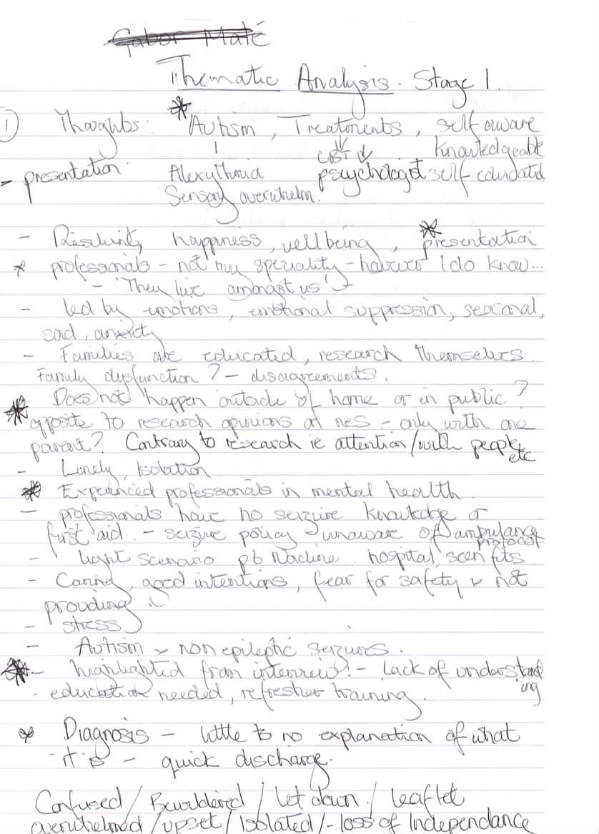
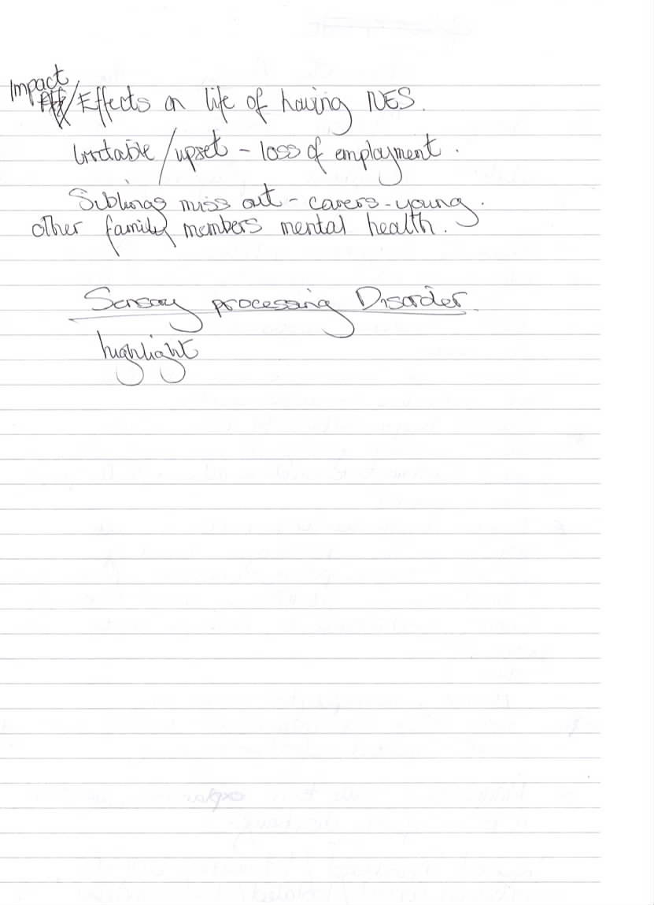

Appendix F
Stage two: A sample of a coded interview for young person Lisa.
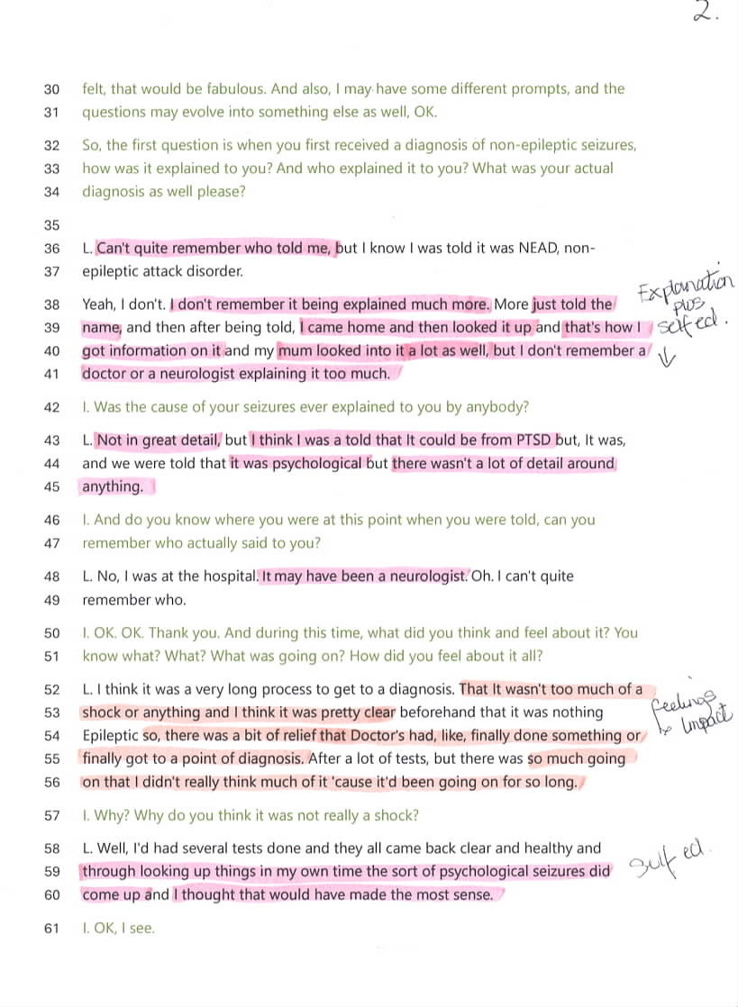

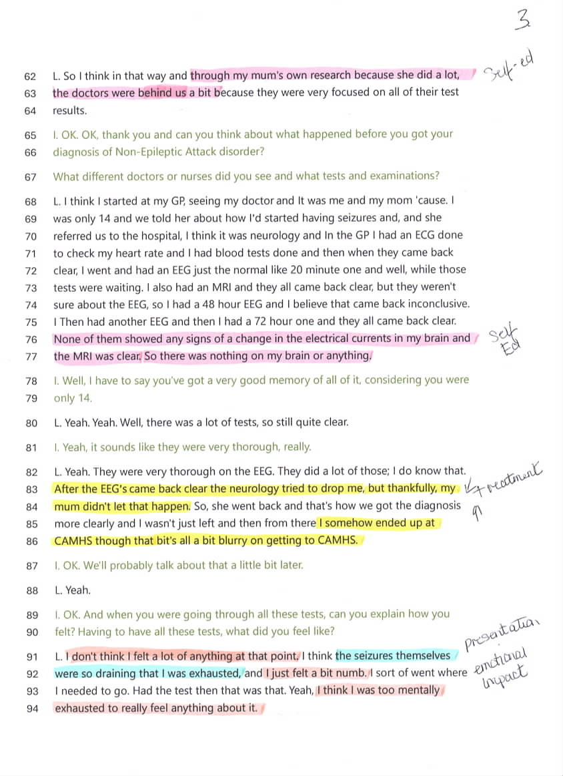

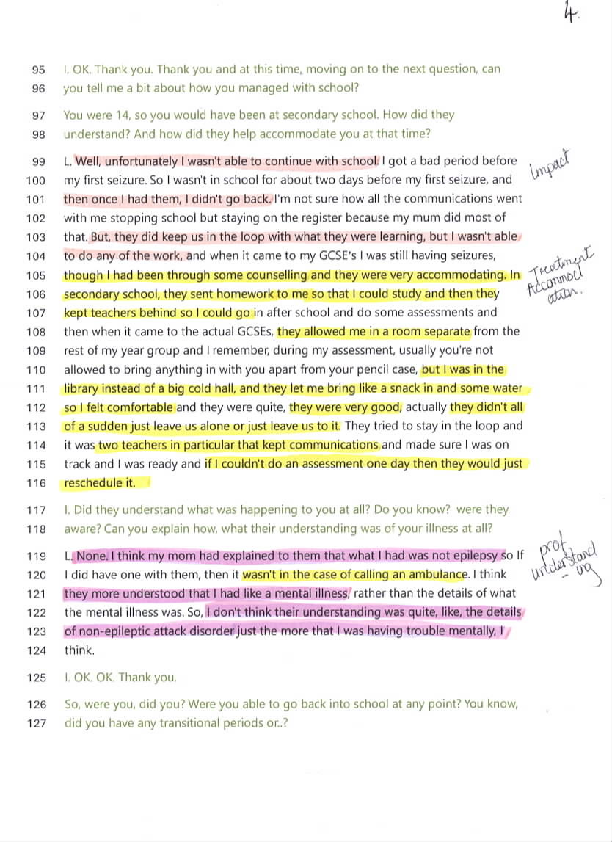

A sample of coded interview for parent Erin.
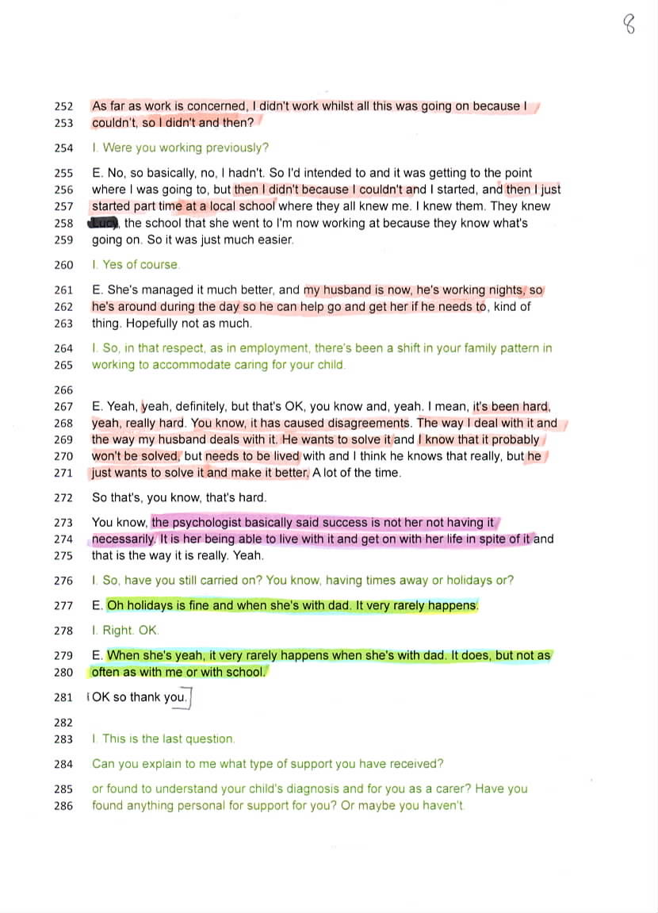

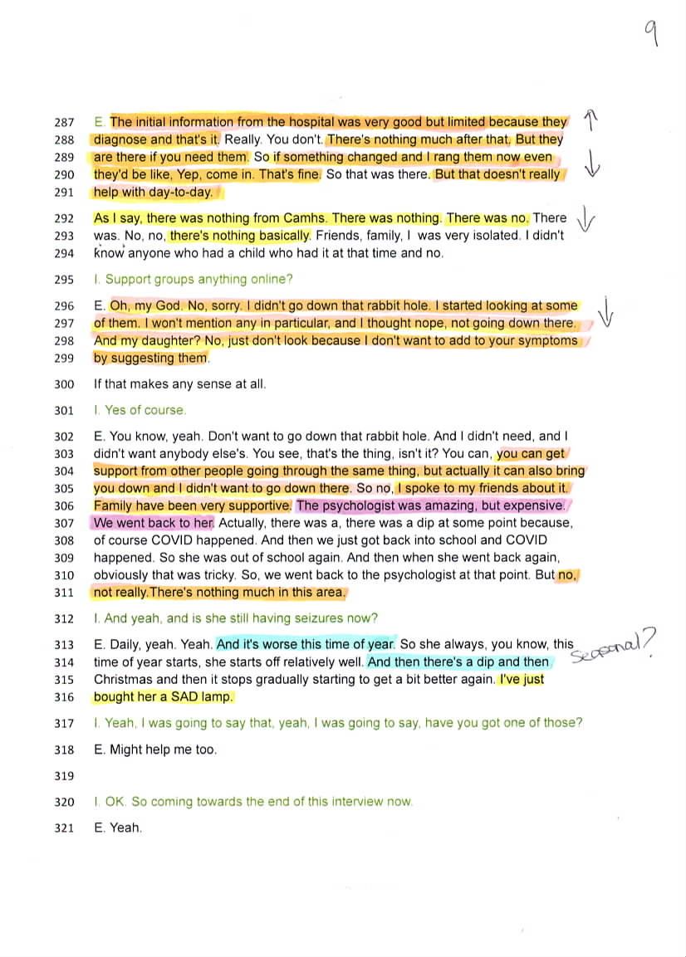
A sample of coded interview for professional Nadine
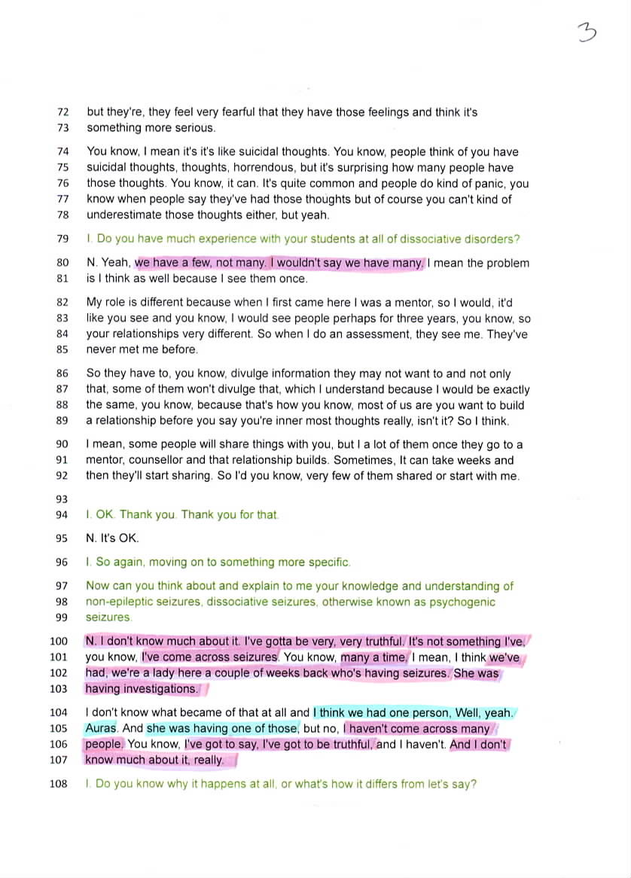
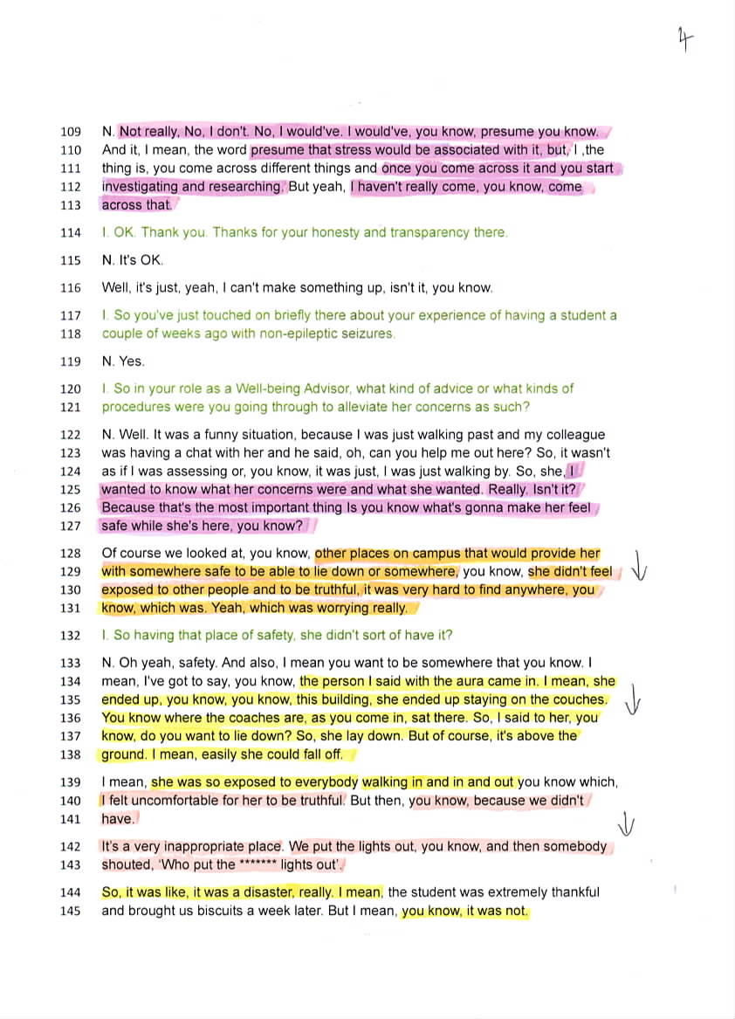

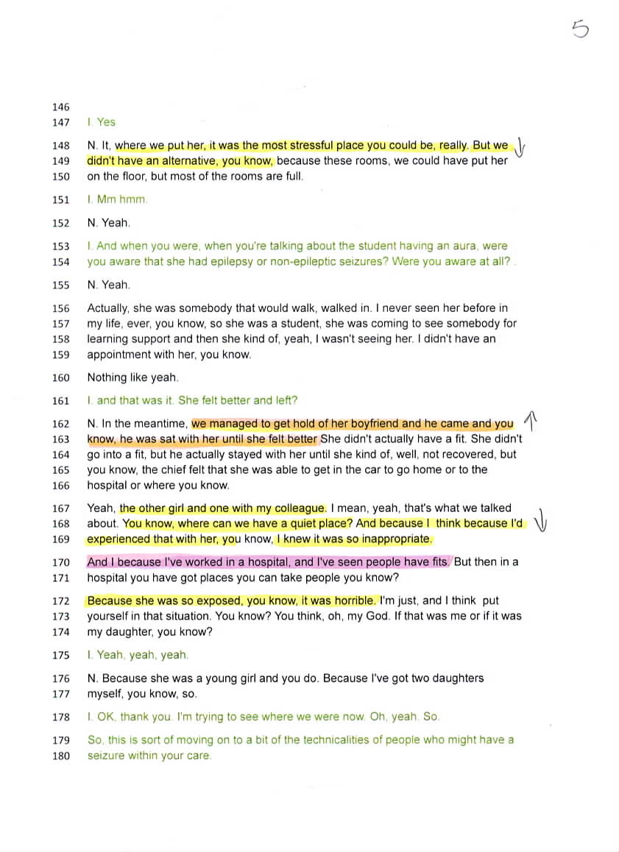

Appendix G
Stage three: A sample of codes
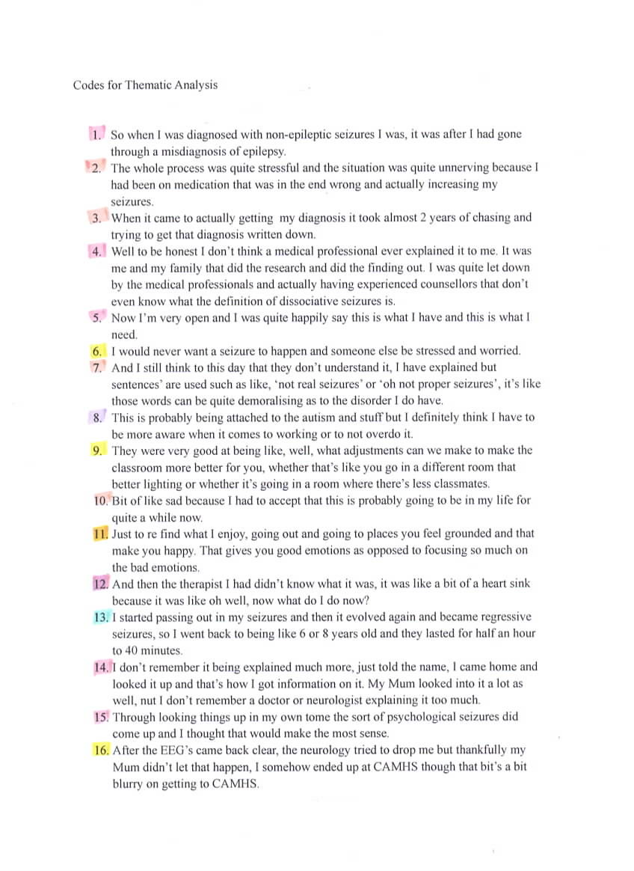

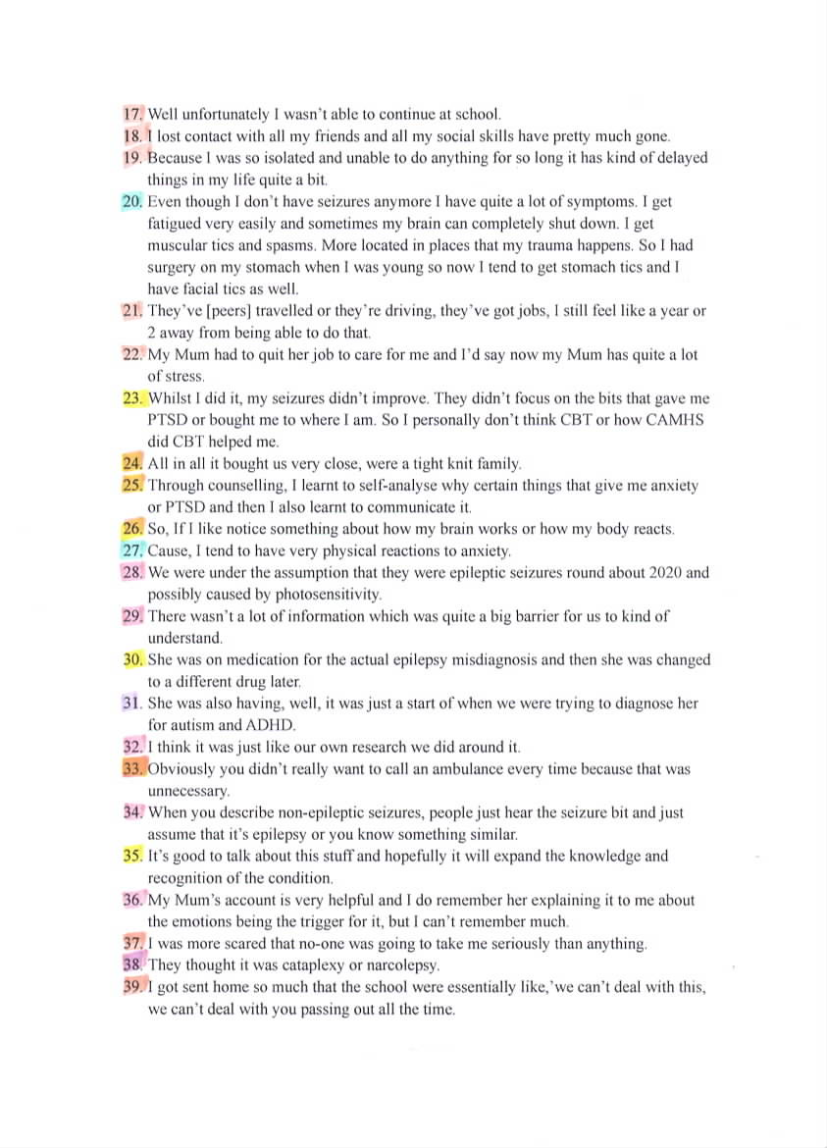

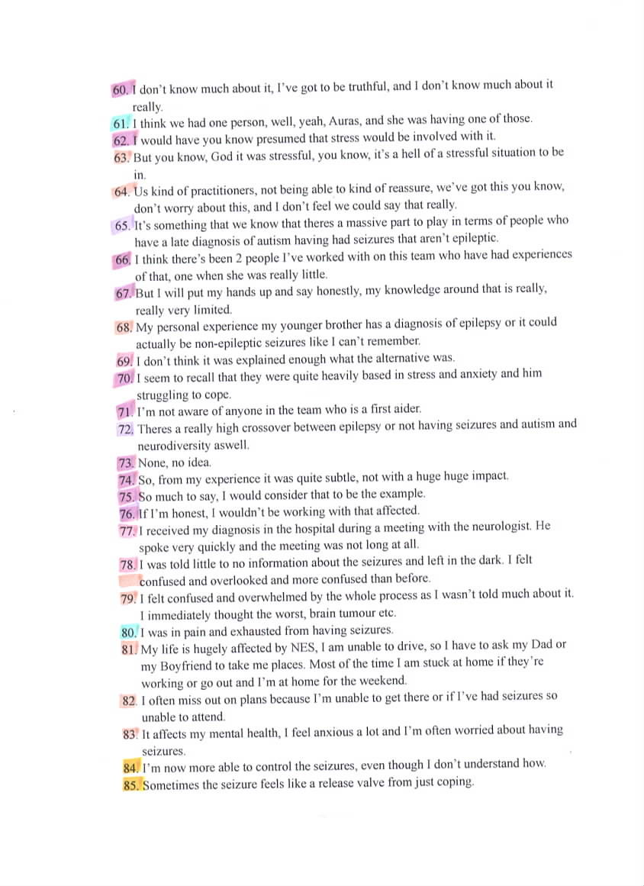

Appendix H
Stage four: Reviewing themes
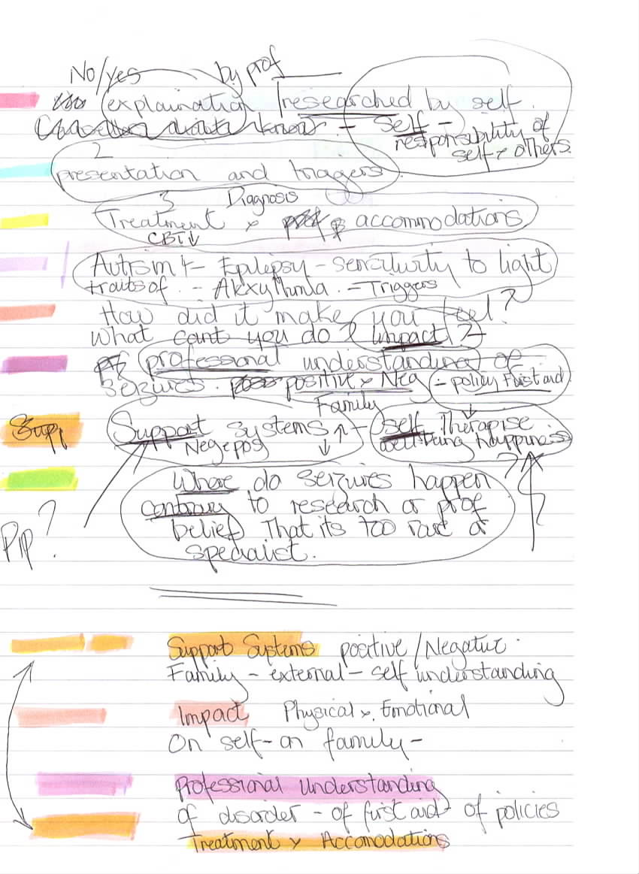
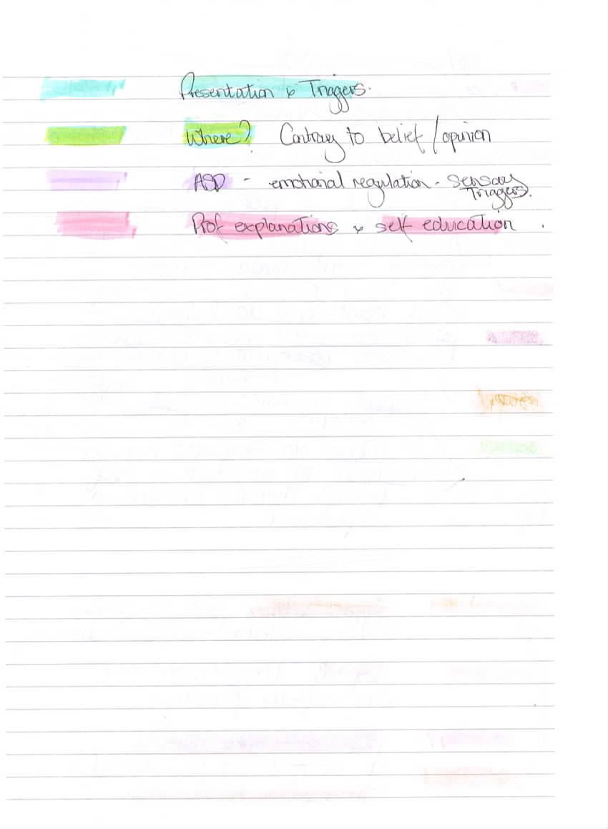

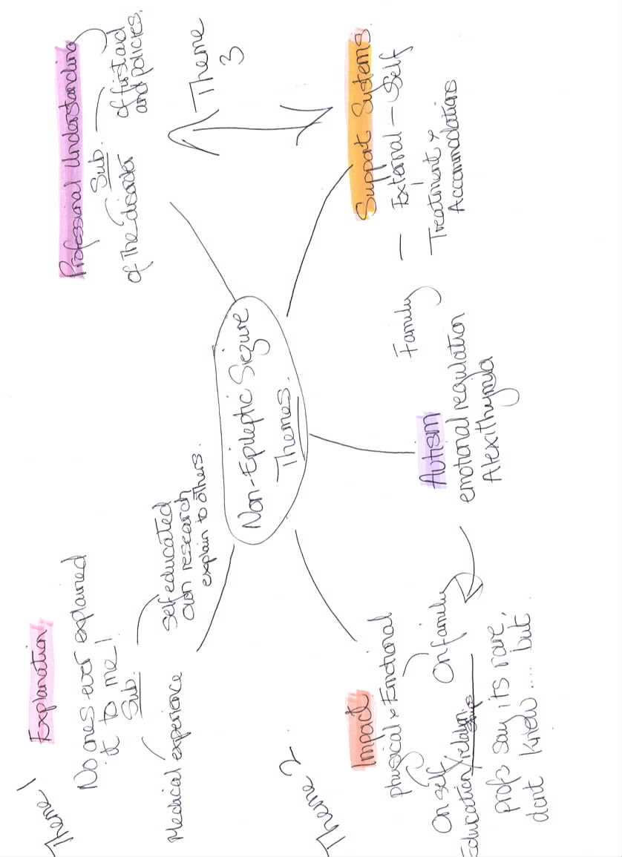
Appendix I.
Stage five: Defining and naming themes.

References.
American Epilepsy Society. (2018). Psychogenic non-epileptic seizures (PNES) for mental health professionals, information sheet. https://www.aesnet.org/docs/default-source/pdfs-clinical/5-pnes-for-mental-health-profs-final.pdf?sfvrsn

American Psychiatric Association. (2013). Diagnostic and statistical manual of mental health disorders: DSM-5. 5(5). Washington DC, American Psychiatric Association.

Ananndale, M., Vilyte, G., & Pretorius, C. (2022). Stigma in functional seizures: A scoping review, Seizure: European Journal of Epilepsy, 99, 131-152. https://www.sciencedirect.com/science/article/pii/S1059131122001200

Angus-Leppan, H. (2008). Diagnosing epilepsy in neurology clinics: A prospective study. Seizure, 17(5), 431-436. https://www.sciencedirect.com/science/article/pii/S1059131108000022

Anzellotti, F., Dono, F., Evangelista, G., Di Pietro, M., Carrarini, C., Russo, M., Ferranti, C., Sensi, S. L., & Onofj, O. (2020). Psychogenic non-epileptic seizures and pseudo-refractory epilepsy, a management challenge. Frontiers in Neurology, 11. https://www.frontiersin.org/journals/neurology/articles/10.3389/fneur.2020.00461/full

Appleton, R. (2022). Psychogenic non-epileptic seizures (PNES), a refresher. Paediatric Epilepsy Current Awareness Service, 16(2), https://www.epilepsy.org.uk/app/uploads/2022/10/PECAS_EA_June2022.pdf

Asadi-Pooya, A. A. & Sperling, M. R. (2015). Epidemiology of psychogenic nonepileptic seizures, Epilepsy and Behaviour, 46, 60-65. https://www.sciencedirect.com/science/article/pii/S1525505015001201?casa_token=M3-_Faf_ieYAAAAA:d4Eybd6cbTtiahQ_BFWk11d_Vwh_OsRbgGXAGVaxZjWFceK50BZAQPbHsGAyAepZywphiySLmBU

Asadi-Pooya, A. A., Brigo, F., Mildon, B., & Nickolson, T. R. (2020). Terminology for psychogenic nonepileptic seizures: making the case for “functional seizures”. Epilepsy & Behaviour, 104,

Aspers, P., & Corte, U. (2019). What is qualitative in qualitative research. Qualitative Sociology, 42(2), 139-160. https://link.springer.com/article/10.1007/S11133-019-9413-7

Beghi, M., Beffa Negrini, P., Perrin, C., Peroni, F., Magaudda, A., Cerri, C., & Cornaggia, C. M. (2015). Psychogenic non-epileptic seizures: So called psychiatric co-morbidity and underlying defense mechanisms. Neuropsychiatric Disease and Treatment, 11, 2519-2597. https://www.tandfonline.com/doi/full/10.2147/NDT.S82079#d1e173

Benbadis, S. R., O’Neill, E., Tatum, W. O., & Heriaud, O. (2004). Outcome of prolonged Video-EEG monitoring at a typical referral epilepsy center, Epilepsia, 45(9), 1150-1153. https://onlinelibrary.wiley.com/doi/10.1111/j.0013-9580.2004.14504.x

Billings, K. R. (2020). Stigma in class: Mental illness, social status and tokenism in elite college culture. Sociological Perspectives, 64(3), https://www.researchgate.net/publication/341648692_Stigma_in_Class_Mental_Illness_Social_Status_and_Tokenism_in_Elite_College_Culture

Braun, V., & Clarke, V. (2006). Using thematic analysis in psychology. Qualitative Research in Psychology, 3(2), 77-101. https://www.proquest.com/docview/223135521/fulltextPDF/FD3CA0B0F48047EEPQ/1?accountid=130472

Brigo, F., Tinazzi, M., & Trinka, E. (2015). In response: terminology of pnes over time – the terms they are a-changin. Epilepsia, 56(6), 979-980.

Bruno, J., Machado, J., & Auxéméry Y. (2021). From epileptic hysteria to psychogenic non epileptic seizure: Continuity or discontinuity for contemporary psychiatry. European Journal of Trauma and Dissociation, 5(1). https://www.sciencedirect.com/science/article/pii/S2468749920300715?casa_token=VDC2AcP5XWcAAAAA:fDMyZld8rnyLLt_1njDBgCBPht5oyXjHowzJVUKaueUPY7U-xAZvqtFd720XSH8_bziixWj5dbE

Campbell, J., Walker, E., No, L., & Sundram, F. (2019). Non-epileptic seizures in Individuals attending neurological services in New Zealand, Epilepsy and Behaviour, 101, Part A. https://www.sciencedirect.com/science/article/pii/S1525505019308005#bb0055
Chew, J., Carpenter, J., & Haase, A. M. (2018). Young peoples’ experience of living with epilepsy: The significance of family resilience. Social Work in Healthcare, 57(5), 332-354. https://www-tandfonline-com.ezproxy.uwtsd.ac.uk/doi/full/10.1080/00981389.2018.1443195#abstract

Chun, T. H., Mace, S. E., & Katz, E. R. (2016). Evaluation and management of children with acute mental health or behavioural problems. Part ll: Recognition of clinically challenging mental health related conditions presenting with medical or uncertain symptoms. Pediatrics 138(3), https://doi.org/10.1542/peds.2016-1573

Clarke, V., & Braun, V. (2017). Thematic analysis. The Journal of Positive Psychology, 12(3), 297-298. https://www.tandfonline.com/doi/full/10.1080/17439760.2016.1262613

Cole, C. M., Falcone, T., Caplan, R., Timmons-Mitchell, J., Jares, K., & Ford, P. J. (2014). Ethical dilemmas in pediatric and adolescent psychogenic nonepileptic seizures, Epilepsy & Behavior, 37, 145-150. https://www-sciencedirect-com.ezproxy.uwtsd.ac.uk/science/article/pii/S152550501400225X

Cope, S. R., Smith, J. G., King, T., & Agrawal, N. (2017). Evaluation of a pilot innovative cognitive behavioral therapy-based psychoeducation group treatment for functional non-epileptic attacks. Epilepsy & Behavior, 70, Part A, 238-244. https://www-sciencedirect-com.ezproxy.uwtsd.ac.uk/science/article/pii/S152550501630676X

Cozzi, G., & Barbi, E. (2018). Facing somatic symptom disorder in the emergency department. Journal of Pediatrics and Child Health, 55(1), 7-9. https://onlinelibrary.wiley.com/doi/10.1111/jpc.14246

De Averio, B., Winsor, A., Davies, J., Nicholson, T. R., Pal, D. K., Richardson, M. P., & Pick, S. (2024). Mental health and neurodevelopmental patent-reported outcome measures (PROM’s) for children and young people with epilepsy: A systematic review. Epilepsy & Behavior, 153, https://www.epilepsybehavior.com/article/S1525-5050(24)00052-0/pdf

Deli, A., Huang, Y. G., Toynbee, M., Towle, S., Adcock, J. E., Bajorek, T., Okai, D., & Sen, A. (2021). Distinguishing psychogenic non-epileptic, mixed and epileptic seizures using systemic measures and reported experiences. Epilepsy & Behaviour, 116.
https://www-sciencedirect-com.ezproxy.uwtsd.ac.uk/science/article/pii/S1525505020308647

Doss, J. (2022). Psychogenic non-epileptic seizures in youth: Individual and family psychiatric characteristics. Frontiers in Psychiatry, 15(13). https://pmc.ncbi.nlm.nih.gov/articles/PMC9798111/

Doss, J. (2015). Psychogenic non-epileptic seizures in youth: Individual and family psychiatric characteristics. Frontiers in Psychiatry, 13. https://www.frontiersin.org/journals/psychiatry/articles/10.3389/fpsyt.2022.1068439/full

Doss, J., & Myers, L. (2023) The psychogenic non-epileptic seizures pocketbook, Independant edition, New York, Amazon.

Dunne, A., Carolan, R., Swords, L., & Fortune, G. (2019). Patient and family perspectives of paediatric psychogenic non-epileptic seizures: A systematic review. European Journal of Epilepsy, 71, 279-285. https://www.sciencedirect.com/science/article/pii/S1059131119303036

Epilepsy Society. (2023). Non-epileptic seizures: Seizures that are not due to epilepsy. https://epilepsysociety.org.uk/sites/default/files/2023-08/Non-epilepticseizuresAugust2023_0.pdf

Etikan, I., Musa, S. A., & Alkassim, R. S. (2016). Comparison of convenience sampling and purposive sampling. American Journal of Theoretics and Applied Statistics, 5(1), 1-4.

Ferguson, P., & Walker, H. (2014). ‘Getting on with life’: Resilience and normalcy in adolescents living with chronic illness. International Journal of Inclusive Education, 18(3), 227-240. https://www.tandfonline.com/doi/full/10.1080/13603116.2012.676082#d1e132

K. D., Koehler, A., Shaffer, J., & Dill, E. J. (2020a). Medical and psychosocial outcomes of youth with psychogenic nonepileptic seizures: An observational study. Epilepsy & Behaviour, 112, https://www-sciencedirect-com.ezproxy.uwtsd.ac.uk/science/article/pii/S152550502030562X

Flewelling, K. D., Koehler, A., Shaffer, J., & Dill, E. J. (2020b). Correlates of health-related quality of life in youth with psychogenic non-epileptic seizures. Seizure: European Journal of Epilepsy, 83, 203-207. https://www.sciencedirect.com/science/article/pii/S1059131120303034

Flick, U., & Röhnsch, G. (2024). Young adults living with chronic illness: disclosure strategies and peers’ understanding. Disability and Rehabilitation, 1-12. https://www.tandfonline.com/doi/full/10.1080/09638288.2024.2400598

Freedman, D. A., Terry, D., Enciso, L., Trott, K., Burch, M., & Albert, D. V. F. (2022). Brief report: Psychogenic nonepileptic events in pediatric patients with autism or intellectual disability. Journal of Autism and Intellectual Disorders, 53, 2928- 2932. https://link.springer.com/article/10.1007/s10803-022-05479-1

Fredwall, M., Terry, D., Enciso, L., Burch, M. M., Trott, K., & Albert, D. V. F. (2021). Outcomes of children and adolescents 1 year after being seen in a multidisciplinary psychogenic non-epileptic seizure clinic. Epilepsia, 62(10), 2528-2538. https://onlinelibrary.wiley.com/doi/full/10.1111/epi.17031

Gao, X., McSwiney, P., Court, A., Wiggins, A., & Sawyer, S. M. (2018). Somatic symptom disorder in adolescent inpatients. Journal of Adolescent Health, 63(6), 779-784. https://www.sciencedirect.com/science/article/abs/pii/S1054139X18302660

Gurcan, L., McAllister, E., Gilmour, J., Green, D. J., McFarlane, F. A., Hadji-Michael, M., Heyman, I., & Stark, D. (2022). Improved understanding of non-epileptic seizures and reduced emergency healthcare usage following a single psychoeducational group for children and their parents. Seizure: European Journal of Epilepsy, 101, 1-7. https://www.sciencedirect.com/science/article/pii/S1059131122001546

Hansen, A. S., Rask, C. U., Rodrigo-Domingo, M., Pristed, S. G., Christensen, J., & Nielson, R. E. (2020). Incidence rates and characteristics of pediatric onset psychogenic nonepileptic seizures. Pediatric Research, 88, 796-803. https://www.nature.com/articles/s41390-020-0945-z

Hinton, D., & Kirk, S. (2015). Families’ and healthcare professionals’ perceptions of healthcare services for children and young people with medically unexplained symptoms: A narrative review of the literature. Health and Social Care in the Community, 24(1), 12-26. https://onlinelibrary.wiley.com/doi/10.1111/hsc.12184

Huff, J. S., Lui, F., & Mui, N. I. (2024). Psychogenic non-epileptic seizures. In StatPearls [Internet], StatPearls Publishing. https://www.ncbi.nlm.nih.gov/books/NBK441871/

Jennum, P., Ibsen, R., & Kjellberg, J. (2019). Welfare consequences for people diagnosed with nonepileptic seizures: A matched nationwide study in Denmark. Epilepsy & Behavior, 98, 59-65. https://www-sciencedirect-com.ezproxy.uwtsd.ac.uk/science/article/pii/S1525505019301933

Jordan, H., Feehan, S., Perdue, I., Murray, J., & Goldstein, L. H. (2019). Exploring psychiatrists' perceptions of working with patients with dissociative seizures in the UK healthcare system as part of the CODES trial: A qualitative study. BMJ Open, 9(5). https://bmjopen.bmj.com/content/9/5/e026493

Kanemoto, K., La France Jr, W. C., Duncan, R., Gigineishuili, D., Park, S. P., Tadokoro, Y., Ikeda, H., Paul, R., Zhou, D., Taniguchi, G., Kerr, M., Oshima, T., Jin, K., & Reuber, M. (2017). PNES around the world: Where are we now and how can we close the diagnosis and treatment gaps- an ILAE PNES taskforce report. Epilepsia Open, 2(3), 307-306

Karakis, I., Janoko, N. J., Morton, M. L., Groover, O., Teagarden, D. L., Villarreal, H. K., Loring, D. W., & Drane, D. L. (2020). Stigma in psychogenic nonepileptic seizures, Epilepsy & Behaviour, 111. https://www-sciencedirect-com.ezproxy.uwtsd.ac.uk/science/article/pii/S1525505020304480

Karterud, H. N., Risør, M. B., & Haarvet, O. R. (2015). The imapct of conveying the diagnosis when using a biopsychosocial approach: A qualitative study among adolescents and young adults with NES (Non-epileptic seizures). Seizure, 24, 107-113. https://www.sciencedirect.com/science/article/pii/S105913111400257X

Karterud, H. N., Nakken, K. O., Lossius. M. I., Tschamper, M., Ingebrigtesen, T., & Henning, O. (2024). Young people diagnosed with nonepileptic seizures (PNES) years ago – How are they now? Epilepsy and Behaviour, 157, https://www.sciencedirect.com/science/article/pii/S1525505024002555#b0055

Kerr, W. T., Janio, E. A., Le, J. M., Hori, J. M., Patel, A. B., Gallardo, N. L., Bauirjan, J., Chau, A. M., D’Ambrosio, S. R. D., Cho, A. Y., Engel, J., Cohen, M. S., & Stern, J. M. (2016). Diagnostic delay in psychogenic seizures and the association with anti-seizure medication trials. Seizure, 40, 123-126. https://www.sciencedirect.com/science/article/pii/S1059131116300784?via%3Dihub

Kozlowska, K., Chudleigh, C., Cruz, C., Lim, M., McClure, G., Savage, B., Shah, U., Cook, A., Scher, S., Carrive, P., & Gill, D. (2017). Psychogenic non-epileptic seizures in children and adolescents: Part II- explanations to families, treatment and group outcomes. Clinical Child Psychiatry and Psychology, 23(1). https://journals-sagepub-com.ezproxy.uwtsd.ac.uk/doi/full/10.1177/1359104517730116

Lerch, M. F., & Thane, S. E. (2019). Adolescents with chronic illness and the transition to self-management: A systematic review. Journal of Adolescents, 72(1), 152-161. https://onlinelibrary-wiley-com.ezproxy.uwtsd.ac.uk/doi/full/10.1016/j.adolescence.2019.02.010

Loewenbereger, A., Cope, S. R., Poole, N., & Agrawal, N. (2020). An investigation into the preferred terminology for functional seizures. Epilepsy & Behavior, 111. https://www.sciencedirect.com/science/article/pii/S1525505020303620?casa_token=8wFIpOySwnsAAAAA:Mi7iTziGtn1bwj8if9QP_GQJJe2jS6Z-RGMsMWchWhlta22AeR8P5V31L1e66tMtEYzXYd-9JcyP_A
Malas, N., Ortiz-Aguayo, R., Giles, L., Ibeziako, P. (2017). Pediatric somatic symptom disorders. Current Psychiatric Reports, 19(11). https://link-springer-com.ezproxy.uwtsd.ac.uk/article/10.1007/s11920-017-0760-3

Mayor, R., Brown, R, J., Cock, H., House, A., Howlett, S., Smith, P., & Reuber, M. (2013). A feasibility study of a brief psycho-educational intervention for psychogenic non-epileptic seizures. Seizure 22(9), 760-765. https://www-sciencedirect-com.ezproxy.uwtsd.ac.uk/science/article/pii/S1059131113001878#bib0065

McWilliams, A., Reilly, C., McFarlane, F. A., Booker, E., & Heyman, I. (2016). Nonepileptic seizures in the pediatric population: A qualitative study of patients and family experiences. Epilepsy & Behaviour, 59, 128-136. https://www-sciencedirect-com.ezproxy.uwtsd.ac.uk/science/article/pii/S1525505016001554

McWilliams, A., Reilly, C., & Heyman, I. (2017). Non-epileptic seizures in children: Views and approaches at a UK child and adolescent psychiatry conference. Seizure, 53, 23-25. https://www.sciencedirect.com/science/article/pii/S1059131117306143

McWilliams, A., Reilly, C., Gupta, J., Hadji-Michael, M. (2019). Autism spectrum disorder in young people with non-epileptic seizures. Seizure: European Journal of Epilepsy, 73, 51-55. https://www.sciencedirect.com/science/article/pii/S1059131119304662

Miyawaki, D., Iwakura, Y., Seto, T., Kusaka, H., Goto, A., Okada, Y., Asada, N., Yanagihara, E., & Inoue, K. (2016). Psychogenic nonepileptic seizures as a manifestation of psychological distress associated with undiagnosed autism spectrum disorder. Neuropsychiatric Disease and Treatment, 185-189. https://www.tandfonline.com/doi/full/10.2147/NDT.S98698#d1e175

Moen, Ø. L., & Skundberg-Kletthagen, H. (2017). Public health nurses’ experience, involvement and attitude concerning mental health issues in a school setting. Nordic Journal of Nursing Research, 38(2), 61-67. https://journals-sagepub-com.ezproxy.uwtsd.ac.uk/doi/full/10.1177/2057158517711680?utm_source=summon&utm_medium=discovery-provider

Morgan, L. A., & Buchhalter, J. (2015). Psychogenic paroxysmal events in children: A review. Pediatric Neurology, 53(1), 13-22. https://www-sciencedirect-com.ezproxy.uwtsd.ac.uk/science/article/pii/S0887899415001575
Morabito, G., Barbi, E., Ghirado, S., Bramuzzo, M., Conversano, E., Alessandro, V., & Cozzi, G. (2021). Mental health problems in children admitted with physical symptoms. European Journal of Pediatrics, 180, 1611-1655. https://link-springer-com.ezproxy.uwtsd.ac.uk/article/10.1007/s00431-021-03938-y

Myers, L., Gray, C., Roberts, N., Levita, L., & Reuber, M. (2022). Shame in the treatment of patients with psychogenic non-epileptic seizures: The elephant in the room. Seizure: European Journal of Epilepsy, 94, 176-182. https://www.seizure-journal.com/article/S1059-1311(21)00346-0/pdf

National Health Service. (2017). Non-epileptic attacks, a short guide for patients and families, Information for patients’ neurology and psychotherapy services. https://www.sth.nhs.uk/clientfiles/File/Epilepsy/pil1038.pdf

Oliveira, C. D. T., & Dias, A. C. G. (2023). How can psychoeducation help in the treatment of mental disorders? Estudos de Psicologia, (Campinas), 40. https://www.scielo.br/j/estpsi/a/RSsdDzgtqCQYSR8cKdRhmFM/?lang=en&format=pdf

Peacock, M., Bissell, P., Ellis, J., Dickson, J. M., Wardrope, A., Grünewald, R., & Reuber, M. (2023). ‘I just need to know what they are and if you can help me’: Medicalization and the search for legitimacy in people diagnosed with non-epileptic attack disorder. Epilepsy & Behaviour, 148. https://www.sciencedirect.com/science/article/pii/S1525505023004043

Perez, D. L., & La France Jr, W. C. (2016). Nonepileptic seizures: An updated review. CNS Spectrums, 21(3), 239-246. https://www.cambridge.org/core/journals/cns-spectrums/article/abs/nonepileptic-seizures-an-updated-review/6A8B635284BF19F2794851DACE68C383

Pretorius, C., & Sparrow, M. (2015). Life after being diagnosed with psychogenic non-epileptic seizures (PNES): A South African perspective. Seizure, 30, 32-41. https://www.seizure-journal.com/article/S1059-1311(15)00128-4/pdf

Pretorius, C. (2016). Barriers and facilitators to reaching a diagnosis of PNES from the patients’ perspective: Preliminary findings. Seizure, 38, 1-6. https://www.sciencedirect.com/science/article/pii/S105913111600073X
Rawat, V. S., Dhiman, V., Sinha, S., Saga, K. J. V., Thippeswamy, H., Chaturvedi, S. K., Srinath, S., & Satishchandra, P. (2015). Co-morbidities and outcome of childhood psychogenic non-epileptic seizures - An observational study. Seizure, 25, 95-98. https://www.seizure-journal.com/article/S1059-1311(14)00262-3/pdf

Rawlings, G. H., Brown, I., Stone, B., Reuber, M. (2017). Written accounts of living with psychogenic nonepileptic seizures: A thematic analysis. Seizure, 50, 83-91. https://www.sciencedirect.com/science/article/pii/S1059131117301875

Rawlings, G. H., Brown, I., & Reuber, M. (2017). Deconstructing stigma in psychogenic non epileptic seizures: An exploratory study. Epilepsy & Behavior, 74, 167-174. https://www-sciencedirect-com.ezproxy.uwtsd.ac.uk/science/article/pii/S1525505017303414

Rawlings, G. H., & Reuber, M. (2016). What patients say about living with psychogenic non-epileptic seizures: A systematic synthesis of qualitative studies. Seizure, 41, 100-110. https://www.sciencedirect.com/science/article/pii/S1059131116301169?ref=pdf_download&fr=RR-2&rr=90f3982c89faef36#bib0235

Reilly, C., Jette, N., Johnson, E. C., Kariuki, S. M., Meredith, F., Wirrel, E., Mula, M., Smith, M. L., Walsh, S., Fong, C. Y., Wilmshurst, J. M., Kerr, M., Valente, K., & Auvin, S. (2023). Scoping review and expert-based consensus recommendations for assessment and management of psychogenic non-epileptic (functional) seizures (PNES) in children: A report from the pediatric psychiatric task force of the international league against epilepsy. Epilepsia, Official Journal of the International League Against Epilepsy, 64(12), 3160-3195. https://onlinelibrary.wiley.com/doi/full/10.1111/epi.17768

Reilly, C., McWilliams, A., & Heyman, I. (2014). What’s in a name? Psychogenic non-epileptic events in children and adolescents. Developmental Medicine and Child Neurology, 57(1), 100-101. https://onlinelibrary.wiley.com/doi/full/10.1111/dmcn.12605

Reuber, M., & Brown, R. J. (2017). Understanding psychogenic non-epileptic seizures-Phenomenology, semiology and the integrative cognitive model. Seizure, 44, 199-205. https://www.nestreatmentucd.org/wp-content/uploads/2021/05/Understanding-psychogenic-nonepileptic-seizures.pdf

Robson, C., & Lian, O. S. (2017). “Blaming, shaming and humiliation”: Stigmatising medical interactions among people with non-epileptic seizures. Wellcome Open Research, 2(55). https://www.ncbi.nlm.nih.gov/pmc/articles/PMC5664997/

Sakhuja, R. (2024). Autism diagnosis in Wales. https://www.topdoctors.co.uk/medical-articles/autism-diagnosis-in-wales

Sawchuk, T., Buchhalter, J., & Senft, B. (2020) Psychogenic non-epileptic seizures in children – psychophysiology and dissociative characteristics. Psychiatry Research, 294. https://www-sciencedirect-com.ezproxy.uwtsd.ac.uk/science/article/pii/S0165178120332054

Skundberg-Kletthagen, H., & Moen, Ø. N. (2017). Mental health work in schools' health services and school nurses' involvement and attitudes, in a Norwegian context. Journal of Clinical Nursing, 26 (23-24). 5044-5051. https://onlinelibrary.wiley.com/doi/full/10.1111/jocn.14004

Smith, B. J. (2014). Closing the major gap in PNES. Epilepsy Currents, 14(2), 63-67. https://pmc.ncbi.nlm.nih.gov/articles/PMC4010877/

Tanner, A. L., Miller, W. R., von Gaudecker, J. V., & Buelow, J. M. (2019). An integrative review of school-based mental health interventions and psychogenic nonepileptic seizures. The Journal of School Nursing, 36(1). https://journals-sagepub-com.ezproxy.uwtsd.ac.uk/doi/full/10.1177/1059840519854796

Tanner, A. L., von Gaudecker, J. R., Buelow, J. M., Oruche, U. M., & Miller, W. R. (2022). “It’s hard”: Adolescents’ experience attending school with psychogenic nonepileptic seizures. Epilepsy & Behaviour, 132, https://www-sciencedirect-com.ezproxy.uwtsd.ac.uk/science/article/pii/S1525505022001731

Teagarden, D. L., Morton, M. L., Janocko, N. J., Groover, O., Villareal, H. K., Evans, L., Drane, D. L., & Karakis, I. (2020). Socioeconomic disparities in patients with psychogenic non-epileptic seizures and their caregivers. Epilepsy and Behavior, 110, https://www.sciencedirect.com/science/article/pii/S1525505020303395?casa_token=Sig-Ea6764cAAAAA:ydbouV1tPrsW2SrtMkrkzzz6p0yhGOrIXWtSCP6YT3_3O3vQyvkcpDtAfvxKiKYBkI8_GKVo70tjjw

Terry, D., & Trott, K. (2019). A qualitative analysis of school nurses’ experience of caring for students with psychogenic nonepileptic events. The Journal of School Nursing, 37(6), 441- 448. https://journals-sagepub-com.ezproxy.uwtsd.ac.uk/doi/full/10.1177/1059840519889395

Tinazzi, M., Fiorio, M., Berardelli, R., Bonetti, B., Bonifati, D. M., Burlina, A., Cagnin, A., Calabria, F., Corbetta, M., Cortelli, P., Giometto, B., Guidoni, S. V., Lopiano, L., Mancardi, G., Marchioretto, F., Pellegrini, M., Teatini, F., Tedeschi, G., Tesolin, L., ...Moratta, A. (2021). Opinion, knowledge and clinical experience with functional neurological disorders among Italian neurologists: Results from an online survey. Journal of Neurology, 269, 2549-2559. https://link.springer.com/article/10.1007/s00415-021-10840-y

Toffa, D. H., Poirier, L., & Nguyen, D. K. (2020). The first line management of psychogenic non-epileptic seizures (PNES) of adults in the emergency: A practical approach. Apto Epileptologica, 2(1), 7. https://link.springer.com/article/10.1186/s42494-020-00016-y

Tong, A., Flemming, K., McInnes, E., Oliver, S., & Craig, J. (2012). Enhancing transparency in reporting the synthesis of qualitative research: ENTREQ. MBC Medical Research Methodology, 12(181). https://bmcmedresmethodol.biomedcentral.com/articles/10.1186/1471-2288-12-181

Vasileiou, K., Barnett, J., Thorpe, S., & Young, T. (2018). Characterising and justifying sample size sufficiency in interview-based studies: Systematic analysis of qualitative health research over a 15-year period. BMC Medical Research Methodology, 18(1), 148. https://purehost.bath.ac.uk/ws/portalfiles/portal/188461391/2018_Vasileiou_et_al._Sample_size_paper.pdf

Velani, H., & Gledhill, J. (2021). The effectiveness of psychological interventions for children and adolescents with non-epileptic seizures. Seizure, 93, 20-31. https://www.sciencedirect.com/science/article/pii/S1059131121003046

Villagrán, A., Eldøen, G., Duncan, R., Aaberg, K.M., Hofoss, D., & Lossius, M. I. (2021). Incidence and prevalence of psychogenic nonepileptic seizures in a Norwegian county: A ten-year population-based study. Epilepsia, 62(7), 1528-1535. https://onlinelibrary.wiley.com/doi/full/10.1111/epi.16949

Velani, H., & Gledhill, J. (2021) The effectiveness of psychological interventions for children and adolescents with non-epileptic seizures. Seizure, 93. https://www.sciencedirect.com/science/article/pii/S1059131121003046

Walsh, G., Wilson, C. E., Hevey, D., Flyn, C., Breheny, E., & O’Keeffe, F. (2024). “This is real” “this is hard” and “I’m not making this up”: Experience of diagnosis and living with non-epileptic attack disorder. Epilepsy & Behaviour, 154. https://www.epilepsybehavior.com/article/S1525-5050(24)00134-3/fulltext

Welsh Government. (2017). A school nursing framework for Wales. https://www.gov.wales/sites/default/files/publications/2019-03/a-school-nursing-framework-for-wales-may-2017.pdf

Welsh Government. (2019). School nursing services in Wales-Scoping research report. https://www.gov.wales/sites/default/files/statistics-and-research/2019-12/school-nursing-services-in-wales-scoping-report.pdf

Welsh Government. (2023). The young person’s guarantee: Help and support for young people to gain a place in education or training and to get into work or self-employment. https://www.gov.wales/young-persons-guarantee-html

Welsh Government. (2024). Research in Wales making a difference to the mental health of Welsh children and young people. Health and Care Research Wales. https://healthandcareresearchwales.org/about/news/research-wales-making-difference-mental-health-welsh-children-and-young-people

Woodward, J., Asadi-Pooya, A. A., Mildon, B., & Tolchin, B. (2023). Work difficulties, work restrictions, and disability benefits in people with functional seizures: A survey study. Epilepsy and Behaviour Reports, https://pmc.ncbi.nlm.nih.gov/articles/PMC10460675/

World Health Organisation. (1992). The ICD-10 classification of mental and behavioural disorders: Clinical descriptions and diagnostic guidelines. https://cdn.who.int/media/docs/default-source/classification/other-classifications/9241544228_eng.pdf

Worsley, J. D., Pennington, A., & Corcoran, R. (2022). Supporting mental health and well-being of university and college students: A systematic review of review-level evidence of interventions. PLoS one, 17(7). https://journals.plos.org/plosone/article?id=10.1371/journal.pone.0266725

Wichaidit, B. T., Østergaard, J. R., & Rask, C. U. (2017). Diagnostic practice of psychogenic nonepileptic seizures in the pediatric setting. Epilepsia, 56(1), 58-65. https://onlinelibrary.wiley.com/doi/full/10.1111/epi.12881

Wiggins, A., Raniti, M., Gaafar, D., Court, A., & Sawyer, S. M. (2022). Pediatric somatic symptoms and related disorders: Parent acceptance influences recovery. The Journal of Pediatrics, 241, 109-114. https://www-sciencedirect-com.ezproxy.uwtsd.ac.uk/science/article/pii/S0022347621009574

