University of Wales Trinity Saint David
Wales Institute of Science & Art

Technical Report

Introduction to Automotive Engineering ACHA4009

Alexander Miles

2103213
April 2022
The following report covers the Lexus LFA and how each topic was crucial in its development and design to make the car what it is now.

​

Contents
1 Introduction 3
2 Impact of Topic 4
2.1 Manufacturing processes 4
2.2 Aerodynamics 5
2.3 Materials 6
2.4 Electronic systems 7
2.5 Data Analysis 8
2.6 Computational engineering 9
2.7 Emissions 10
2.8 Why was it made 11
3 Current state of industry 12
4 Conclusion 13
5 References 14

Table 1
Figure 1: Lexus LFA Nürburgring package 4
Figure 2: Lexus LFA in CFD 5
Figure 3: LFA active wing and gurney flap 5
Figure 4: Carbon fiber diffuser 6
Figure 5: Carbon fiber interior 6
Figure 6: LFA cockpit 7
Figure 7: LFA on Nürburgring track 8
Figure 8: Carbon fiber loom 10
Figure 9: Euro 1-6 Emission standards 11
Figure 10: Lexus LFA 12

Introduction

The Lexus LFA is a two-seat supercar that went into production in 2010 and completed production by 2012. Only 500 of them were produced, 450 being stock cars Equipped with a 4.8L V10 co developed by Yamaha, the Lexus LFA makes 553 horsepower and 354 pound-feet of torque. 50 of them were made with the Nürburgring package which was more of a variant. The Nürburgring package made the LFA more track based with more carbon fibre and some aerodynamic tweaks.

Impact of Topic

Manufacturing processes

Assembled in Toyotas Motomachi plant in Japan, the Lexus LFA was approximately 45 times more labour intensive than any other standard road going vehicle and was ultimately a money losing project for Toyota officials who are not keen on repeating the process. Although Toyota lost money on every LFA they made, they did this because they wanted to make an amazing car for their first model super car. The Motomachi manufacturing facility includes one of the only carbon fiber-weaving looms in the world which mostly sits idle but still produces spares for the exotic supercar. At a normal assembly facility one worker would typically be assigned to four or five tasks whereas at the LFA works, one person will be assigned 150 tasks or more and the team were assigned to create one LFA every day. As well as that, every V10 is signed and assembled by a single engineer. It is believed that Toyota lost

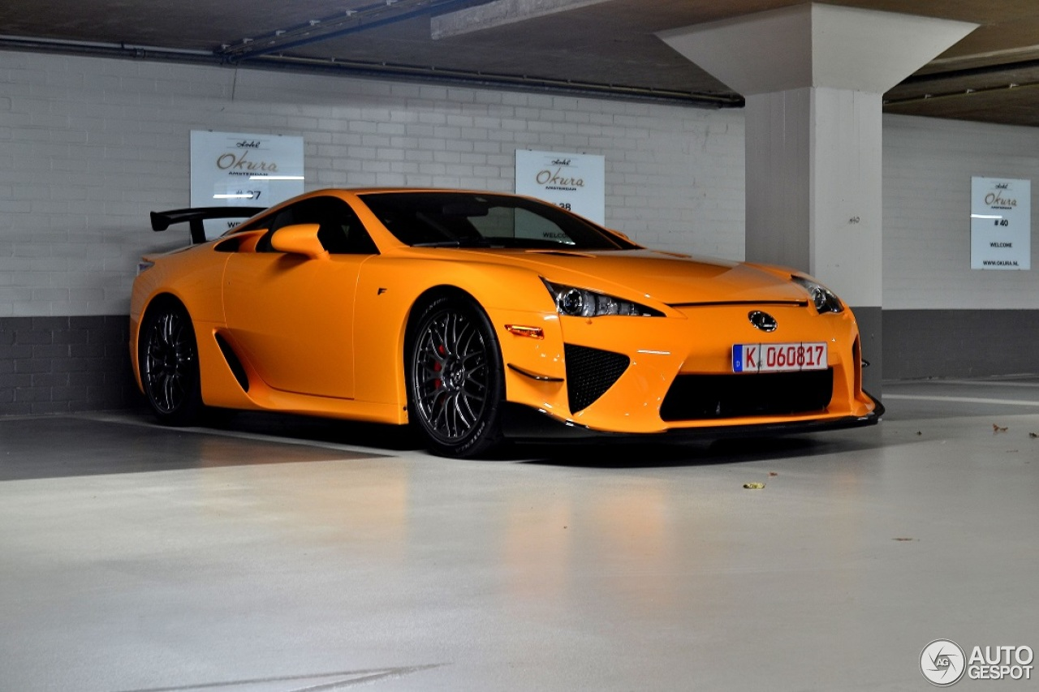

Figure 1: Lexus LFA Nürburgring package

Aerodynamics

The LFA boasted supercar class-leading aerodynamics for its time to produce drivetrain cooling as well as premium high-speed handling and stability. Thorough wind tunnel testing was carried out on the LFA to produce a cutting-edge profile with an amazing drag coefficient of 0.31 which is a big achievement considering the amount of downforce the car created at high speeds.
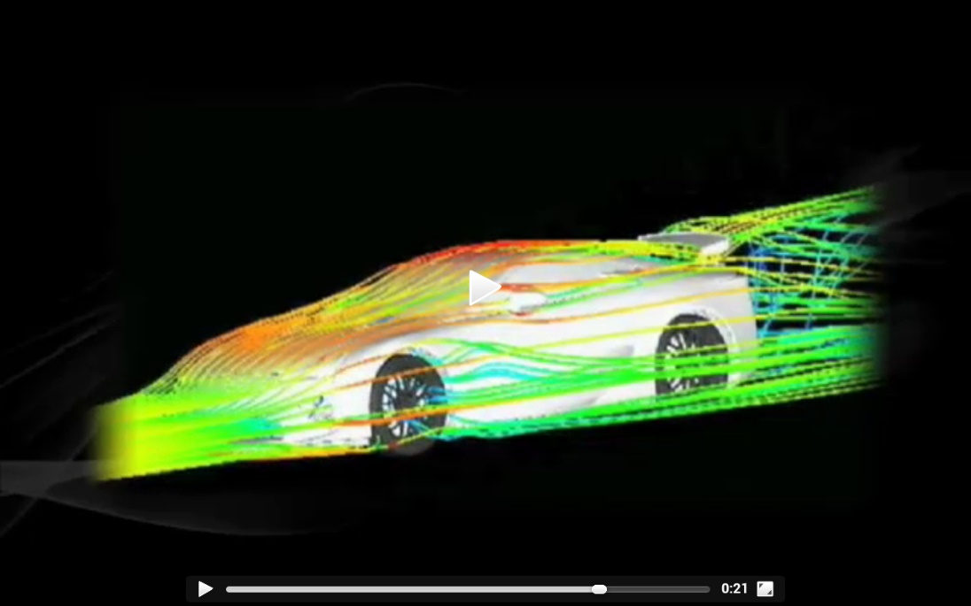
Figure 2: Lexus LFA in CFD
The airflow was controlled over, underneath and around the car to ensure maximum efficiency. Its carbon fibre rear diffuser and its flat underbody created crucial downforce paired with the active rear wing and gurney flap.

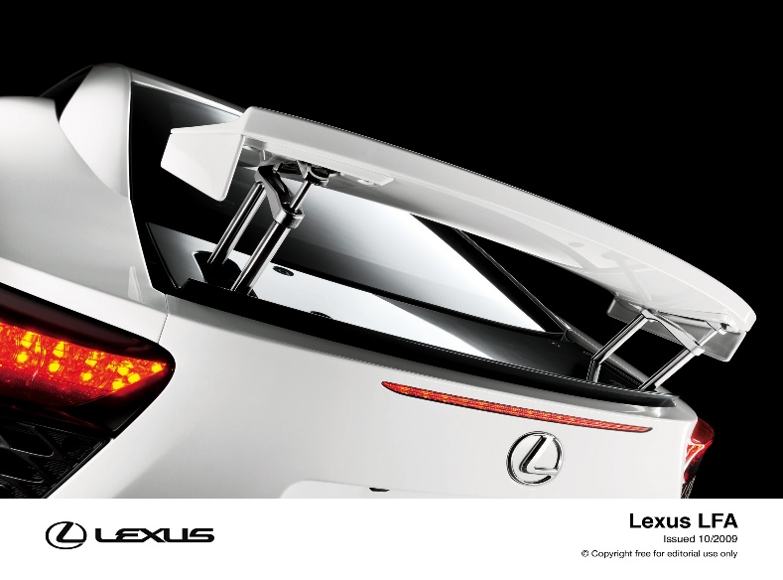

Figure 3: LFA active wing and gurney flap

Materials

Lexus went all out on the LFA and to do so they needed to keep the cars weight to a minimum whilst still maintaining its power and handling. They switched from using aluminium for the chassis and bodywork to advanced carbon fibre reinforced plastic (CFRP).
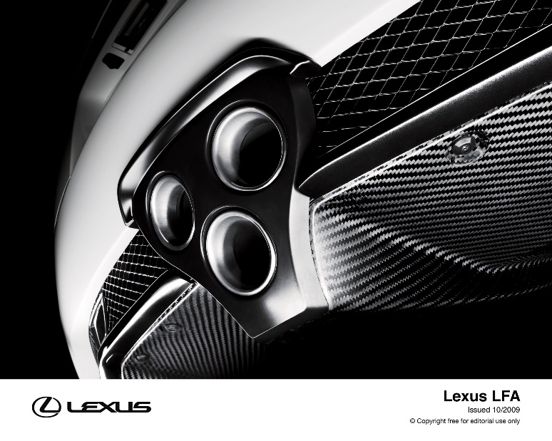
Figure 4: Carbon fiber diffuser
Lexus then decided that their CFRP should be made in house which is why their facility still has the carbon fiber-weaving loom and a laser system which monitored the strength of the material under pressure. The result was that CFRP was four times the strength of aluminium and gave the LFA a very sturdy structure as well as a 100kg weight loss compared to the aluminium body. 65% of the body is made up of CFRP and the remaining 35% was aluminium alloy. Lexus were making the body of the LFA out of the same material which was favoured by aerospace programmes because of its weight and strength properties.

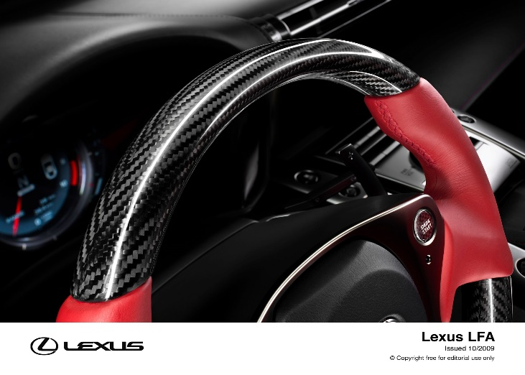

Figure 5: Carbon fiber interior

Electronic systems
Electronics were a must have on the LFA as an analogue speedometer couldn’t keep up with its speed, so Lexus upgraded to a digital speedometer which had a precise speed monitoring system. The LFA’s LCD display was programmable to turn yellow or green when its revs reached a user selected mode and its dial also featured a gear indicator, transmission mode, vehicle-controlled data, trip information and a track-ready stopwatch system. Apart from this the LFA’s display can also provide information on oil and water temperatures, oil pressure and fuel level.
The LFA also came with Lexus’s vehicle dynamic integrated management system which controls the operation of its ABS, traction control and the stability of the vehicle when its being pushed to its limits which is all based on data that comes from brake performance, separate wheel speed, yaw and roll and lateral or vertical acceleration.

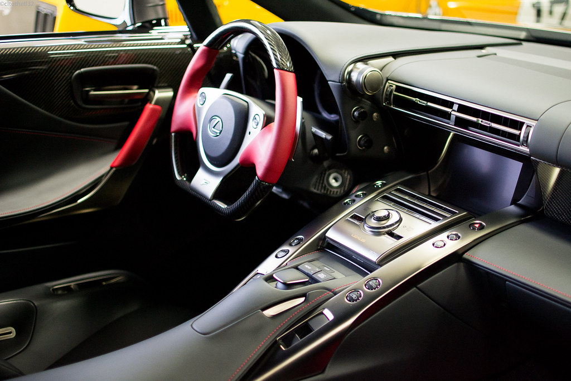
Figure 6: LFA cockpit

Data Analysis
From 2010 to 2012 the Lexus LFA was produced and equipped with a 4.8L V10 Which made 552-562hp. At a length of 14.75ft, width of 1895mm, height of 49.8inches and a wheelbase which was 102.56 inches, and the Lexus LFA did 0-60 in 3.7 seconds. The Audi R8 had a 5.2L V10 with 518hp and an all-wheel drive system which set a 0-60 in 3.9 seconds. This goes to show that despite the fact the LFA was a rear-wheel-drive car, Lexus did extensive research on the LFA to help put its power down incredibly well and outperform rivals. The Audi R8 also put down a drag coefficient of 0.36 where as the LFA’s supreme body shape made 0.31. Lexus also made the LFA capable of 354lb-ft whereas the R8 made 317.

In every way the Lexus LFA pushed boundaries that had never been pushed before with its cutting-edge aerodynamics and outstanding track performance, setting a blistering 7:14:64 lap time on the Nürburgring track.


Figure 7: LFA on Nürburgring track

Failure and change of design.
Halfway through the development of the LFA, Lexus realized that the car weighed too much, and they needed it to be lighter therefore the decision was made to switch from its aluminium chassis to carbon fibre. Although it was a big set back the decision was made based purely off genuine engineering and performance advantages. Carbon fiber, compared to aluminium is extremely tough and notably lighter. At the time however, the technology to weave carbon fiber into complex shapes did not exist and so Lexus produced a unique circular loom to overcome this problem. The loom allowed for each strand of carbon fiber to be woven into singular components directly. The loom became so famous that it is alongside 3D printing as a major step in revolution in mass production.
The material had a three step, expensive and labour-intensive process that required great amounts of attention detail. At first, the carbon fiber sheets are prepared by being impregnated with liquid thermosetting resin which are formed, heated and moulded to size. Then, dry carbon fiber which is heated and cured is impregnated by the liquid resin. Finally, short fiber materials are heat-pressed in a die.

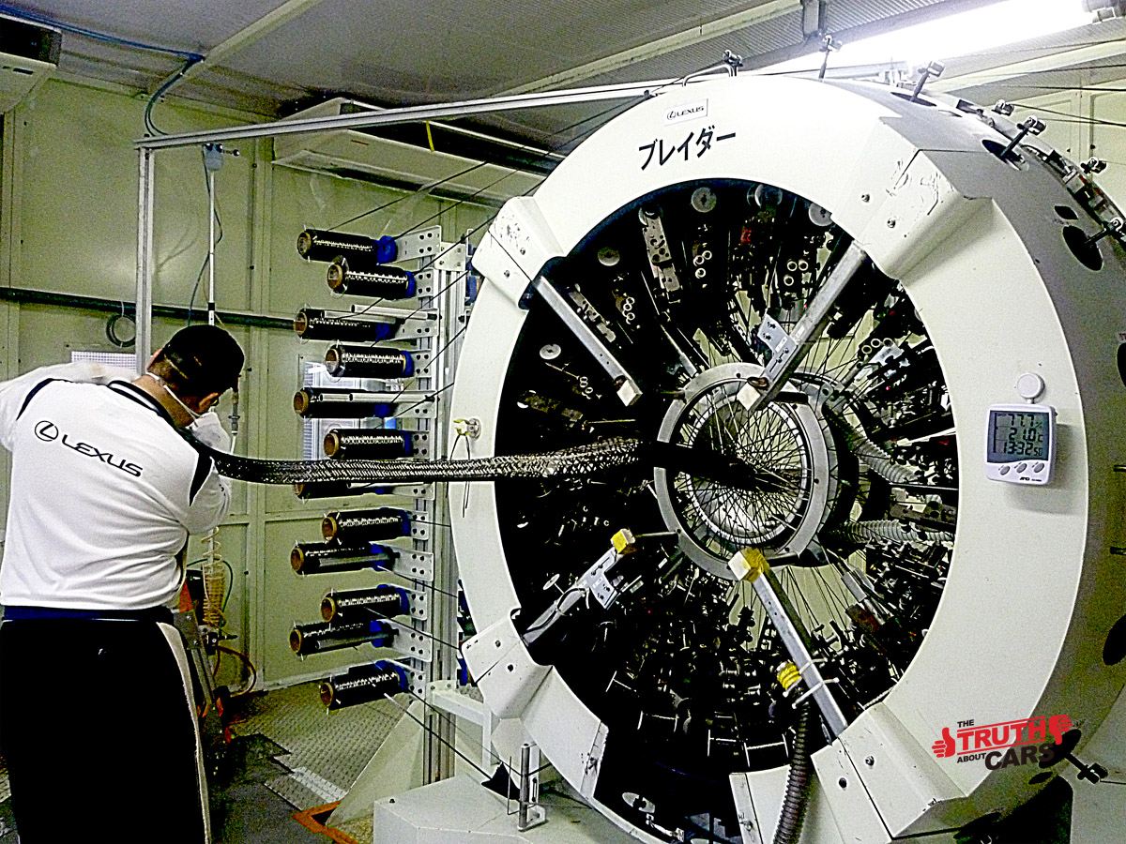
Figure 8: Carbon fiber loom

Emissions

Euro 5 standards of emission testings were met for the Lexus LFA in 2011. Euro 5 was the introduction of particulate filters for vehicles with diesel engines. This also meant that new cars from September 2013 onwards had a new limit of particulate numbers. Particulate filters were fitted to every new diesel car and needed to capture 99% of particulate matter. Cars that met the Euro 5 standard emitted the equivalent of one grain of sand per km. This became a challenge for a V10 supercar however Lexus managed to pull it off with the LFA making 379g of CO2 per km.

The worst feature about the Lexus LFA is its fuel consumption of 11mpg in a city area and 16mpg on a highway which makes its combined efficiency 13mpg.

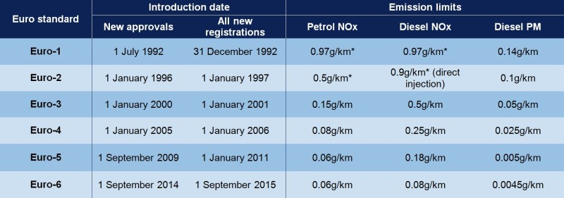
Figure 9: Euro 1-6 Emission standards

Why was it made
The Lexus LFA went into production because senior leaders at Toyota and Lexus felt as if they had to prove something to the world. Japanese car manufacturers are mostly well known for their reliability which motivates consumers to buy their product, however some consumers are thrill seeking and Toyota was aiming to target exactly that. Senior leaders decided that they wanted to make a car which would showcase the extent of their ability and create a vehicle with exceptional performance and craftmanship. Toyota brought a lot of its experience and expertise with it to make the LFA, combined with the help of Yamaha who co-developed the project. The LFA was lightweight, strong and very powerful as well as carbon fiber being used for everything from the interior to the frame. Although the LFA performed without a doubt and had very positive feedback, they were unable to maintain an interest in the market and therefore only 500 units were made.

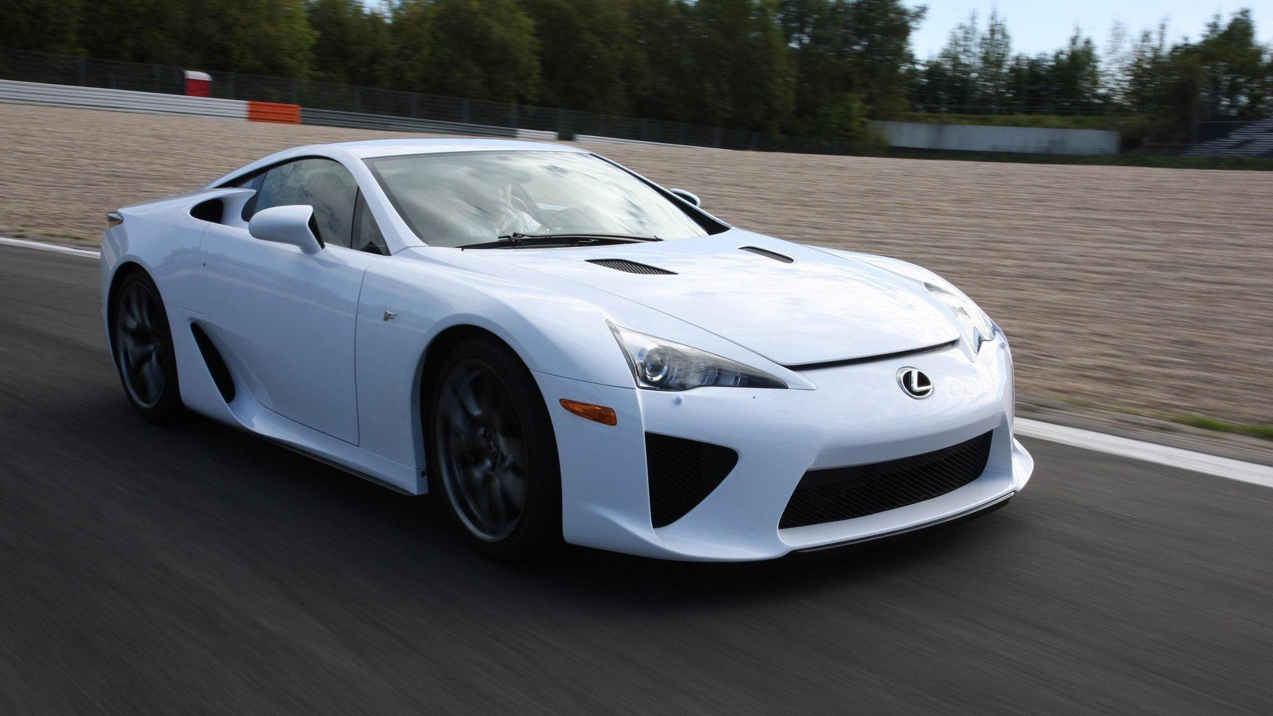
Figure 10: Lexus LFA

Current state of industry

In the industries current state, the Lexus LFA is still very much a competitor with other vehicles and most definitely on the track despite the fact it’s an 11-year-old car, it has the standard and capability of modern supercars today. Its drag coefficient of 0.31 is extremely impressive for its time and even modern-day supercar-based brands like Ferrari have cars like the Ferrari 458 which have a drag coefficient of 0.35. The time and effort put into the LFA with each engine signed by the single engineer that built it is a desirable factor. However, because of the way things are headed today, the V10 is less desirable to a consumer due to the current road regulations and the surroundings in the automotive and motorsport industry regarding its eye watering price when it was first released of 375,000 dollars. petrol prices should also be considered, and electric vehicles are becoming more appealing whilst taking over.

Conclusion

In conclusion the LFA will forever go down in history as one of the best performance cars and most history rich projects ever between the special wiring looms created, the redesign of the car, wind tunnel testing, engine and exhaust tuning in collaboration with Yamaha and Toyota being behind it all. The LFA was overall a money losing project, but it had its time and place however as the automotive industry progresses as rapidly as it is today, with electric powered vehicles taking over very soon, The LFA ultimately will be left behind but always remembered and treasured by car collectors as the vehicle will continue to appreciate in value because of its status and presence in the history of automotive vehicles.

References
Yamaha Creates Acoustic Design for Engine of the Lexus LFA Super Sports Car - 2009 - News Release - Yamaha - Global. (n.d.). Retrieved April 24, 2022, from https://archive.yamaha.com/en/news_release/2009/20091021.html
Lexus LFA - Nürburgring Package Market - CLASSIC.COM. (n.d.). Retrieved April 24, 2022, from https://www.classic.com/m/lexus/lfa/lfa-nurburgring/
Lexus LFA’s Complex Carbon Fiber Production Process To Be Used For Other Models. (n.d.). Retrieved April 11, 2022, from https://www.motorauthority.com/news/1081481_lexus-lfas-complex-carbon-fiber-production-process-to-be-used-on-other-models
Lexus LFA Manufacturing | Lean Sensei. (n.d.). Retrieved April 24, 2022, from https://leansensei.wordpress.com/2011/01/23/lexus-lfa-manufacturing/
Lexus LFA Nürburgring Edition - 17 March 2015 - Autogespot. (n.d.). Retrieved April 24, 2022, from https://www.autogespot.com/lexus-lfa-nurburgring-edition/2015/03/17
the LFA in CFD. (n.d.). Retrieved April 24, 2022, from https://www.carthrottle.com/post/lilUwe/
Lexus LFA - Lexus Media Site. (n.d.). Retrieved April 24, 2022, from https://media.lexus.co.uk/lexus-lfa/
Lexus LFA Interior | CLtotheTL32 | Flickr. (n.d.). Retrieved April 25, 2022, from https://www.flickr.com/photos/44946921@N07/12906544335
2010 Lexus LFA 4.8 V10 (560 Hp) Automatic | Technical specs, data, fuel consumption, Dimensions. (n.d.). Retrieved April 25, 2022, from https://www.auto-data.net/en/lexus-lfa-4.8-v10-560hp-automatic-24498
AUSmotive.com » Lexus LFA NÃ¼rburgring claims Ring record. (n.d.). Retrieved April 25, 2022, from http://www.ausmotive.com/2011/09/08/lexus-lfa-nurburgring-claims-ring-record.html
2011 Audi R8 Pricing, Review, Pictures and Specs | CARHP. (n.d.). Retrieved April 25, 2022, from https://www.carhp.com/audi/r8-2011
Lexus and the carbon fibre wonder-weave - Lexus UK Magazine. (n.d.). Retrieved April 25, 2022, from https://mag.lexus.co.uk/lexus-and-the-carbon-fibre-wonder-weave/
Euro 1 to Euro 6 – find out your vehicle’s emissions standard | RAC Drive. (n.d.). Retrieved April 25, 2022, from https://www.rac.co.uk/drive/advice/emissions/euro-emissions-standards/
UK Car Emissions Testing - SMMT. (n.d.). Retrieved April 25, 2022, from https://www.smmt.co.uk/industry-topics/emissions/testing/
Remembering The Short Lived Lexus LFA. (n.d.). Retrieved April 25, 2022, from https://moneyinc.com/remembering-the-short-lived-lexus-lfa/
(166) Pinterest. (n.d.). Retrieved April 25, 2022, from https://www.pinterest.com/pin/462252349256031911/
597HP Ferrari 458 Speciale Takes Frankfurt by Storm [w/Videos] | Carscoops. (n.d.). Retrieved April 25, 2022, from https://www.carscoops.com/2013/09/597hp-ferrari-458-speciale-takes/

