
Applied Leadership and Management in the Workplace
Module Assignment Submission
Student Name: | Alexandra Williams
Student Number: | 2126654
Module No: | BMSK4013
Module Title: | Management Communication

Statement of Confirmation of Authenticity
By the act of making this submission, the student declares that this is the work of the student named above. The work has not, in whole or in part, been knowingly presented elsewhere for assessment, or where assessment has been built on a previous assessment, this has been identified. Where materials have been used from other sources it has been properly acknowledged. If this statement is untrue, the student acknowledges that an assessment offence has been committed.
Attention is drawn to the plagiarism and unfair practice policies of both the University and of ILM.

Table of Contents
Introduction 2
Exploring the Theory Behind Communication 2
Shannon & Weaver (Linear) 2
Berlo (SMCR) (Linear) 3
Basic Communication Cycle (Circular) 3
Schramm (Circular) 4
Summary of the four example communication models above – Circular v Linear 4
My Workplace Communication Method 5
Types of Communication 5
Table 1. An evaluation of communication models 5
Barriers within the Communication Process 6
Table 2. common barriers to the communication process 6
Communication in My Workplace 7
Influences on Workplace Performance and Motivation 8
Table 3. An Evaluation of Motivational Models 8
References 10
Appendices 11
Appendix A: Personal Development Plan 12
Appendix B: Questionnaire 13

Introduction

Effective communication from managers to employees is essential for the success of any company. Managers use different communication models to share information which used correctly can motivate employees and encourage teamwork. Good communication helps everyone understand their tasks and responsibilities and can make decision making easier using appropriate models, for example circular or linear communication models.
Unclear communication can lead to misunderstandings and lower productivity (Brewer & Holmes, 2016). This assignment will look at the main parts of management communication, including the ways it is done, common challenges, barriers and ways to improve how managers and employees communicate. The report will investigate and show research and examples of different communications, motivational and barrier models. There will also be some real examples from my workplace, a self-evaluation and a personal development plan which will identify areas that I may need to work on to enhance my working practice and awareness.

Exploring the Theory Behind Communication
Throughout this report, various communication theories will be explored, with a focus on four key communication models. While there are many models available, the ones chosen for this report differ slightly for different workplace roles. The type of model used depends on the job role and its communication needs. For example, the Linear Model is more suitable for roles like writers or newsreaders, where the aim is to deliver a message without expecting a response. The circular model is more suited for job roles such as counsellors, teachers, team leaders, or managers who would benefit more from two-way communication through feedback and active listening (sender and receiver). Each model has its strengths and weaknesses, which are described in the table below. Circular models are beneficial because they allow for ongoing feedback, helping to build understanding, while linear models can be limiting in roles that require interaction. Using the wrong model can lead to miscommunication or confusion. However, all communication models have similarities which include a sender, a message, and a receiver. Some models show how barriers such as noise or misunderstanding can affect how messages are received (Van Ruler, 2018).

Shannon & Weaver (Linear)
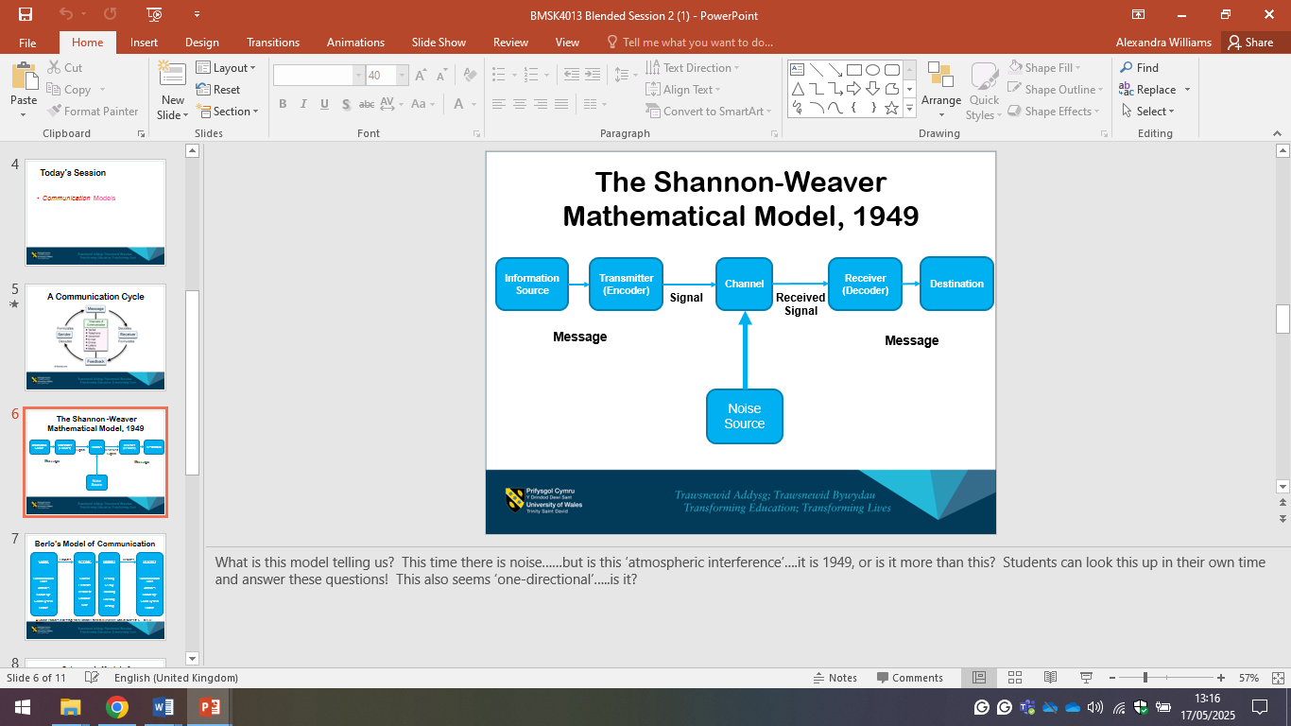
This model is a basic way to show how communication works. It works as a one-way process, where a sender creates a message, sends it through a channel (such as talking, texting, emails), and the receiver receives it. It also includes noise, which is anything that can block or confuse the message, like bad signal, background noise, or misunderstanding.

Pros:
- Easy to understand.
- Shows how messages can be interrupted (noise).
- Good for explaining phone or digital communication.
Cons:
- Only shows one-way communication (no feedback).
- Doesn’t include body language or emotions.
- Too simple for real conversations.

(Shannon and Weaver, 1939)

Berlo (SMCR) (Linear)

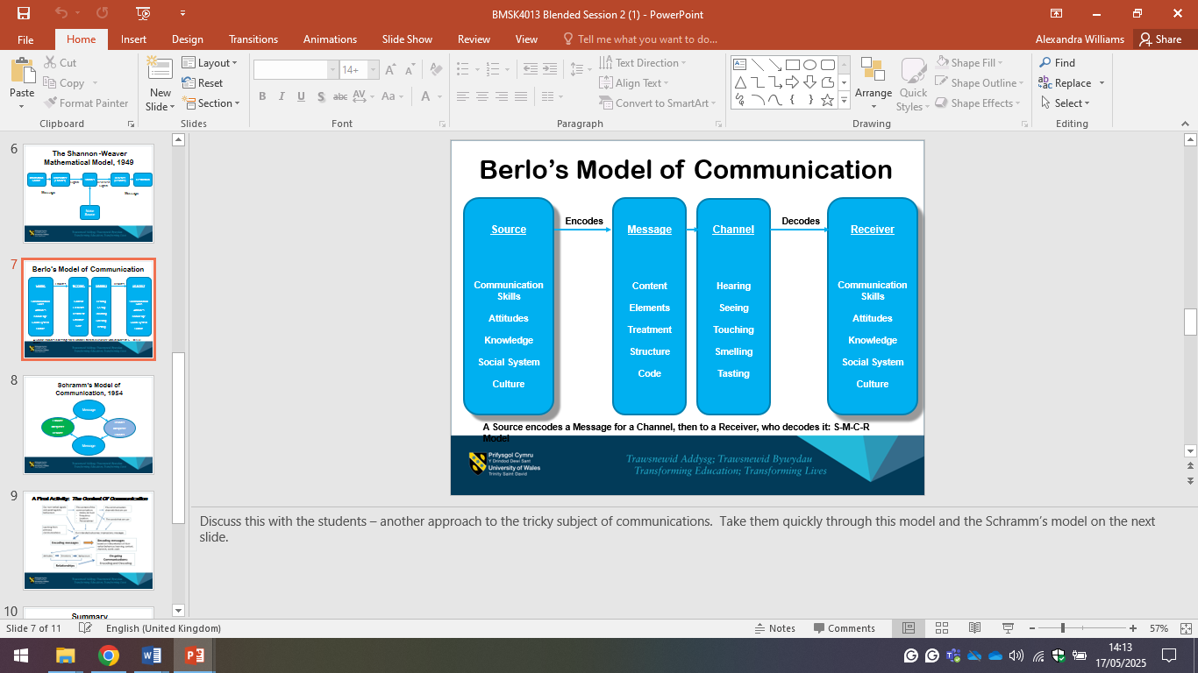
Berlo’s SMCR Communication Model (1960) explains communication using four elements: Source, Message, Channel, and Receiver. It focuses on how personal factors like communication skills, attitudes, and knowledge affect how messages are sent and received.

Pros:
- Simple and easy to understand
- Highlights the role of personal skills and emotions
- Identifies the importance of communication i.e. tone and body language

Cons:
- There is no feedback – only one-way communication (due to linear model)
- Assumes sender and receiver have a similar understanding

Basic Communication Cycle (Circular)

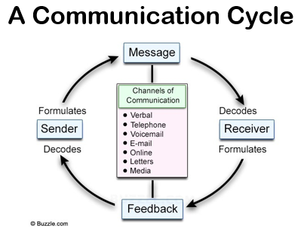
Michael Argyle’s (1972) Communication Cycle, explains that communication is a two-way process. In this model, one person sends a message and the other responds with feedback. This helps both people check that the message was understood correctly. Communication can happen through speech, emails, phone calls, or writing. The sender creates the message, the receiver works out what it means, and then responds. This ongoing exchange helps improve understanding and teamwork between employers, employees, and other agencies.
Pros:
- Helps avoid misunderstandings
- Clearer and more effective feedback and understanding
- Better teamwork
Cons:
- Tone of emails/voice can be misinterpreted
- Time management/breaks in responses, which can lead to timeframes being missed
(Argyle, 1972)

Schramm (Circular)
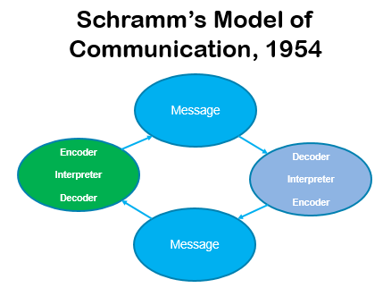
As explained by Blythe (2009), the Schramm Model of Communication is a two-way process where the sender gives a message, the receiver understands (decodes) it and gives feedback, which the sender then decodes. This cycle keeps repeating. It works best when both people have similar knowledge or experience, which makes communication smoother. However, barriers like noise, language differences, or low literacy can affect how clearly messages are understood.
Pros:
- Two-way process between sender (encoder) and receiver (decoder)
- Feedback helps people check their understanding of a message/instruction
- Backgrounds and experiences help better understanding of communication
- Works well for various types of communication, providing both parties have similar knowledge i.e talking, emails.
Cons:
- Assumes sender (encoder) and receiver (decoder) in the circle of communication have similar knowledge, which may not always be the case
- Not ideal for groups

Summary of the four example communication models above – Circular v Linear

All the communication models discussed, include a sender, a message, and a receiver. The main differences between them are how the message is understood, whether there are barriers, and if feedback is included. Circular models, like the Basic Communication Cycle and Schramm, are more effective in the workplace because they allow for feedback, which helps build stronger relationships and clearer understanding. However, even these models have limitations. For example, in the Schramm model, communication may break down if the sender and receiver don’t share similar knowledge or experiences, and barriers like noise or misunderstanding can still affect how the message is received. Linear models such as Shannon and Weaver and Berlo’s SMCR model are less effective in workplace settings because they only show one-way communication. These models do not include feedback, which means there is no way to check if the message has been understood. This can lead to confusion, mistakes, or poor teamwork, especially in fast-paced or collaborative work environments where clarity and two-way interaction are essential.

My Workplace Communication Method
Within my workplace, the Basic Communication Model works best. This is because not only do I communicate with colleagues of similar knowledge, which Schramm would work for, but I work with multi-agency, parents, and outside agencies, therefore, the Basic Communication model is a clearer method of communication in my workplace setting. This model allows feedback, so if there are any misunderstandings, this can be identified and dealt with in a timely manner between the sender and the receiver (Burgess et al., 2018).

Types of Communication
There are many types of communication models (see Table 1.)

Table 1. An evaluation of communication models
Communication Type | Definition | Pros | Cons
Verbal (Spoken) | Spoken words used face-to-face or via calls. | - Fast and direct  - Shows tone and emotion  - Instant feedback | - Can be misunderstood  - Not always recorded  - Relies on listening skills
Non-verbal | Body language, gestures, facial expressions, posture. | - Adds emotion and meaning  - Supports or replaces speech | - Can be misread  - Varies across cultures  - Lacks detail
Written | Written words like letters, texts, reports, emails. | - Clear record  - Good for complex info  - Easy to share | - No instant feedback  - Risk of misreading  - Can be time-consuming
Visual | Use of images, charts, videos to share info or data. | - Easy to understand  - Engaging  - Explains data well | - May need extra explanation  - Not always detailed
Digital (Electronic) | Communication via digital tools like apps or emails. | - Quick and accessible  - Can track receipt  - Multimedia sharing | - May be unclear  - Can lack personal touch  - Security concerns
Formal | Professional, structured communication (e.g. reports, emails). | - Clear and consistent  - Can be referenced  - Maintains professionalism | - Slower process  - Less expressive  - Can delay actions
Informal | Casual everyday communication (e.g. chats with colleagues). | - Quick and adaptable  - Builds trust  - Encourages openness | - Not official or referenceable  - Risk of confusion  - May be inconsistent

Table 1. explains various methods of communication and gives examples of their differences.
Choosing the right communication style for your audience helps build better relationships, whether in a team setting or during casual conversations. Formal and informal communication should be used appropriately. According to Robbins and Judge (2019), formal communication is structured, clear, and professional, and often used in academic or workplace settings and backed by written records. Keyton (2011) explains that informal communication is more casual and based on social connections, such as friendships or relaxed work relationships.
In my workplace, I mostly use formal communication with staff, parents, governors, and visitors through meetings, emails, agendas, and other documents. With pupils, I switch to informal communication by adjusting my tone, body language, and language to be more friendly and approachable.

Barriers within the Communication Process
There are some common barriers to the communication process which have been identified by Seek (2023) and it is therefore important to identify strategies and procedures to overcome these barriers in the workplace (see Table 2.)

Table 2. common barriers to the communication process
Barrier Example | Brief Description | Examples | Possible Solutions
Language & Cultural | Using complex or unfamiliar language, grammar, or tone can cause misunderstandin especially across cultures. | - Difficult grammar or accents  - Misinterpreted tone  - Unclear written/spoken language | - Use simple, clear language  - Offer translations or follow-ups  - Use tools like Grammarly
Organisational | Barriers from unclear roles, poor communication systems, or lack of guidance. | - Messages lost or misunderstood  - No feedback channels  - Lack of policy or role clarity | - Clarify roles/policies  - Encourage feedback  - Provide training and mentoring
Physical | Environmental issues that affect communication or access to information. | - Noise, poor lighting  - Broken tech or internet  - Hearing or speech difficulties | - Provide quiet zones/lighting  - Upgrade tech  - Use assistive tools (e.g., speech-to-text)
Psychological | Emotions like stress or low confidence that prevent effective communication. | - Fear of judgment  - Low confidence  - Avoiding difficult conversations | - Manage workloads  - Provide training/support  - Use positive feedback and involve staff in decisions

Table 2. shows how communication barriers can affect how well instructions or information is understood, for example when giving and receiving messages by way of verbal, written or body language. It is important that both sender and recipient are aware of the barriers and try to overcome them, as this can improve understanding, strengthen teamwork and relationships, and help prevent misunderstandings or negative outcomes.

Communication in My Workplace
In my workplace, cultural diversity creates communication challenges, particularly regarding language, tone, and body language. To overcome these barriers, I make a conscious effort to communicate clearly and use simple English. For more complex conversations, I occasionally use tools such as Google Translate to support understanding, while recognising the limitations and possible inaccuracies of such tools. I am also mindful that tone and body language can carry different meanings across cultures. To avoid misinterpretation, I aim to keep gestures neutral and respectful, ensuring that communication remains inclusive and professional.

When posting messages on the school communication platform, I use straightforward language and a clear format so that families can easily translate the content using conversion apps if needed. However, when communicating with the headteacher and staff, I adapt my approach. In these situations, where there is a shared level of understanding, I use formal written methods such as emails, reports, and letters, alongside verbal methods such as meetings, minutes, and feedback sessions. Regular use of feedback mechanisms in our workplace also helps to identify and address communication barriers, reinforcing clarity and understanding.
One of the main weaknesses in this area is that language barriers can lead to misunderstandings or misinterpretations, particularly when English is not the first language of colleagues or families. However, a strength is that this diversity promotes greater cultural awareness and sensitivity. My use of clear, simple English supports understanding, while translation tools can assist in more complex cases. Yet, their limitations highlight the importance of further support mechanisms, such as multilingual colleagues who can help with sensitive or detailed communications. This not only improves accuracy but also builds trust and inclusion.
Tone and body language also present challenges. What may seem like a friendly tone or gesture in one culture can be interpreted differently in another, and the risk of unintentionally offending someone is a clear weakness. To manage this, I minimise expressive body language and adopt a respectful, neutral tone, which demonstrates consideration for cultural differences. Improvements could be made by including clarification questions in written communication, particularly with families and colleagues whose English is limited. This would invite feedback and confirm understanding, helping to reduce miscommunication.

Overall, effective communication in the workplace is a vital tool that prevents mistakes, builds stronger relationships, and promotes teamwork. By tailoring communication to the audience—whether employee, employer, or family—understanding is improved, and misunderstandings are reduced. Good communication also makes it easier to share ideas, solve problems, and keep everyone informed. Ultimately, this builds trust, motivates staff, and contributes to a happier, more productive workplace.

Influences on Workplace Performance and Motivation
The table below is an example how each motivation model is used, pros and cons of each and areas of practice.

Table 3. An Evaluation of Motivational Models
Model | Pros | Cons | Best uses of model
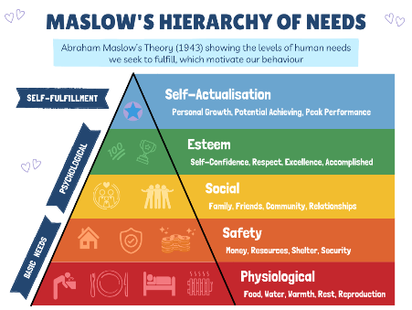  Maslow’s Hierarchy of Needs  Maslow’s Hierarchy of Needs (1943) is a model with five levels. Each level must be mostly met before a person can focus on the next one, which becomes their new main motivation (Stewart, Nodoushani & Stumpf, 2018). Levels within this are: Physiological needs, Safety needs, Love and Belonging, Esteem, and finally Self-Actualisation. | Easy to understand  Refers to the whole person i.e. from the top to bottom tiers  Can be used by a wide audience i.e. different disciplines from employer to employee as it helps support or encourage yourself and others  Focus on growing, progression  Simple and easy to follow | Not appropriate for all cultures.  Real life situations do not always fit or appropriate  Not every individual is at the same level of understanding  Not easy to measure own fulfilment needs | Career Development  Can be used in identifying why employees are not engaging  A positive tool for recognition, job / pay progression  Team working  Motivation and engagement
McClellands Three Needs Theory  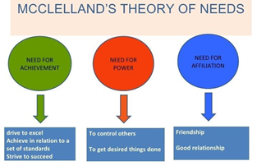  This theory suggests three main motivation areas such as, need for achievement, need for lead or authority and need for friendly interpersonal working relationships | Focuses more on individual motivation  Potential for leadership growth (future progression i.e. managerial  Employee being job satisfied and understanding own needs | Doesn’t allow for own needs i.e. pay or job security  Difficulty measuring needs without monitoring | Helps find what motivates employees and matches them to the right role for job satisfaction.  Team building reduces conflict and improves teamwork.  Can spot future leaders through training and development.  Works well for roles like project managers and accountants.
Herzberg’s Two Factor Theory  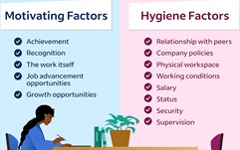  Dartey-Baah & Amoako (2011) explain that according to Hertzberg’s theory, job satisfaction comes from two types of factors. Extrinsic factors like pay and conditions don’t motivate but can cause dissatisfaction if bad. Intrinsic factors like recognition and growth truly motivate and improve performance. Fixing the basics avoids problems, but motivators drive real job satisfaction. | - Understanding what motivates people helps improve satisfaction and performance.  - Intrinsic motivation—like feeling valued and having opportunities to grow—leads to better engagement.  - This approach is simple, practical, and can increase staff retention.  - It also supports job redesign by adding responsibility, recognition, and chances for personal development. | Employee needs and reaction can be more difficult than suggested  Doesn't factor individual differences i.e. motivation can differ with cultures and personalities.  Can be less effective for lower skilled jobs or routine as intrinsic motivators are hard to bring into roles | Enrichment, enhancing by adding i.e. recognition and meaningful tasks  Performance Managment (PDP)  Retention strategies  Management tools to aid them to identify hygiene and motivator factors for employees
McGregor’s Theory X and Theory Y  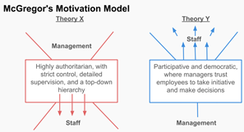  (McGregor, 2015) talks about Theory X and Theory Y.  Theory X sees people as disinterested and needing strict control, which can lower motivation.  Theory Y believes people enjoy work, want responsibility, and can motivate themselves. | X Theory  A clear structure helps people work faster on routine tasks.  It’s useful when close supervision is needed for deadlines or safety  Y Theory  Boosts motivation, trust, and growth for staff personally and the organisation. | X Theory  Can lower motivation and trust, cause staff to leave, and limit creativity.  Y Theory  Doesn’t work well if staff aren’t skilled or motivated.  Takes more time and effort from managers. | X Theory  For simple, repetitive jobs or roles needing strict control, like manufacturing or safety.  Y Theory  For creative jobs and teams, and companies that want to grow and develop workers.  Best suited to management

References

Allison and Harbour (2009) The Coaching Toolkit a Practical Guide for Your School. SAGE Publications Ltd.
Berlo, D. K. (1960). The process of communication: An introduction to theory and practice. Holt, Rinehart and Winston.
Blythe, J. (2009). The Schramm model of communication. In The Schramm Model of Communication (pp. 178-180). SAGE Publications Ltd, https://doi.org/10.4135/9781446221617.n46
Brewer, E. C., & Holmes, T. L. (2016). Better communication = better teams: A communication exercise to improve team performance. IEEE Transactions on Professional Communication, 59(3), 288–298. https://doi.org/10.1109/tpc.2016.2590018
Burgess, A., van Diggele, C., & Mellis, C. (2018). Mentorship in the health professions: a review. The Clinical Teacher, 15(3), 197–202. https://doi.org/10.1111/tct.12756
Dartey-Baah, K., & Amoako, G. (2011). Application of Frederick Herzberg’s Two-Factor theory in assessing and understanding employee motivation at work: a Ghanaian Perspective. https://www.academia.edu/23387578/Application_of_Frederick_Herzbergs_Two_Factor_theory_in_assessing_and_understanding_employee_motivation_at_work_a_Ghanaian_Perspective
Foulger, D. (2004). Models of the communication process. https://d1wqtxts1xzle7.cloudfront.net/45035040/comm-libre.pdf
Keyton, J. (2010). Communication and organizational culture: A key to understanding work experiences. Sage Publications.
Lim, J., & Yazdanifard, R. (2012). The difference of conflict management styles and conflict resolution in workplace. Business & Entrepreneurship Journal, 1(1), 2241–2312. https://www.scienpress.com/Upload/BEJ/Vol%201_1_9.pdf
Mcgregor, D. (2015). Douglas Mcgregor: theory x and theory y. Thinker 026» Introduction» key theories. https://static1.squarespace.com/static/60bddec1a93337235ecfdbcf/t/6205165bca24ea4adc4943df/1644500572175/McGregor_Thinker.pdf
Robbins, S. P., & Judge, A. T. A. (2019). Organizational Behavior. 18th Editi. New York City, NY.
Ronquillo, Y., Ellis, V. L., & Toney-Butler, T. J. (2023, July 3). Conflict management. National Library of Medicine; StatPearls Publishing. https://www.ncbi.nlm.nih.gov/books/NBK470432/
Seek (2023) 12 examples of communication barriers and how to overcome them. https://www.seek.com.au/career-advice/article/12-examples-of-communication-barriers-and-how-to-overcome-them
Stevens, G. (2024). Maslow’s Hierarchy of Needs: Strengths, Weaknesses & Examples. https://academic-writing.uk/maslows-hierarchy-of-needs/
Stewart, C., Nodoushani, O., & Stumpf, J. (2018). Cultivating employees using Maslow's hierarchy of needs. Competition Forum, 16(2), 67–75. https://www.proquest.com/openview/064449085a557cc2456df8989345f7e8/1?pq-origsite=gscholar&cbl=3980 1
Van Ruler, B. (2018). Communication theory: An underrated pillar on which strategic communication rests. International Journal of Strategic Communication, 12(4), 367–381. https://doi.org/10.1080/1553118X.2018.1452240

Appendices

Appendix A: Personal Development Plan

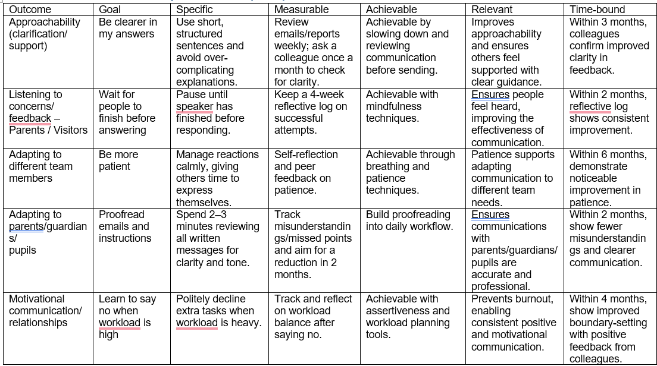

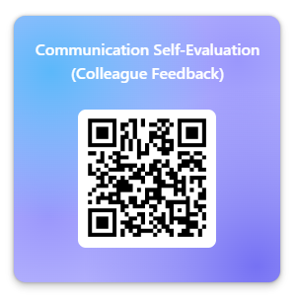
Appendix B: Questionnaire
https://forms.office.com/e/M2PAPFM6tZ

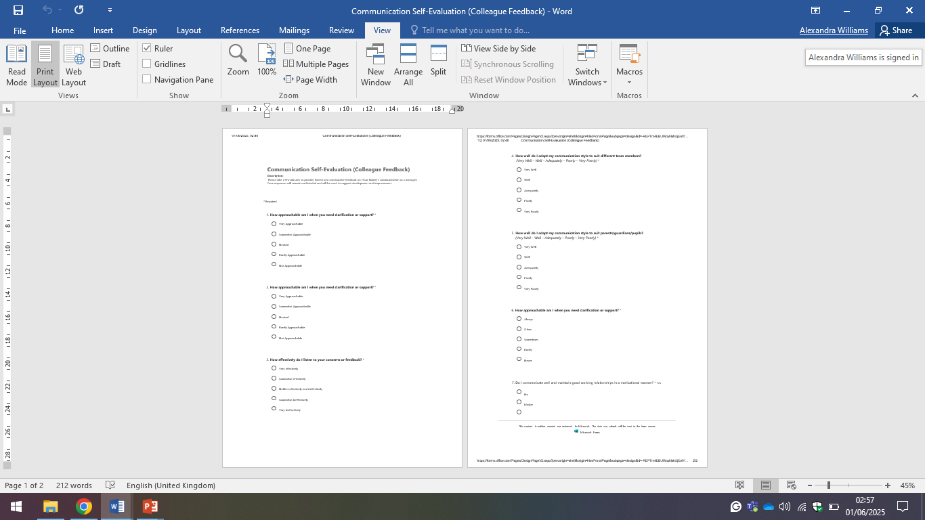

Communication Self-Evaluation (Colleague Feedback)
Description:
Please take a few minutes to provide honest and constructive feedback on Alex's communication as a manager. Your responses will remain confidential and will be used to support development and improvement.
When you submit this form, it will not automatically collect your details like name and email address unless you provide it yourself.
Required

1.How approachable am I when you need clarification or support?

Very Approachable
Somewhat Approachable
Neutral
Rarely Approachable
Not Approachable

2.How effectively do I listen to your concerns or feedback?

Very effectively
Somewhat effectively
Neither effectively nor ineffectively
Somewhat ineffectively
Very ineffectively

3.How well do I adapt my communication style to suit different team members?
(Very Well – Well – Adequately – Poorly – Very Poorly)
Very Well
Well
Adequately
Poorly
Very Poorly

4.How well do I adapt my communication style to suit parents/guardians/pupils?
(Very Well – Well – Adequately – Poorly – Very Poorly)
Very Well
Well
Adequately
Poorly
Very Poorly

5.Do I communicate well and maintain good working relationships in a motivational manner?

Yes
No
Maybe

