Entrepreneurship
LCBB5001
Task 2 – Report
Mihaela Boicu
Student ID: 2223393

Contents
Mark Cuban: A Journey Through Innovation and Success 3
Early Life and Beginnings 3
Rise of an Entrepreneur 4
Achievements and Ventures 5
Motivations Behind Success 6
Entrepreneurial Traits to Develop 7
Conclusion 8
References 9

Mark Cuban: A Journey Through Innovation and Success
Mark Cuban, an American businessman, investor, and television personality, is one of the most influential people in the business world. As an enthusiastic investor and philanthropist, Cuban rose from a humble background to a billionaire, and his story can inspire many tycoons (Pifer et al., 2020). This paper examines Cuban's background, accomplishments, reasons behind his success, and benchmark traits of an entrepreneur.

Figure 1: Mark Cuban (Tikkanen, 2024)

Early Life and Beginnings
Mark Cuban was born on July 31, 1958, in Pittsburgh, Pennsylvania. Born into a low-middle-income family, Cuban has always had a business-minded attitude. His first business venture was when he was 12 years old, and he once had to sell garbage bags to get a pair of shoes he desired. From this early experience, Cubans learned the power of salesmanship and the essence of assertiveness (Tikkanen, 2024).
Cuban attended Pittsburg University and later transferred to Indiana University Bloomington, where he obtained his degree in Management from the Kelley School of Business. His college years were full of business experiments, including starting a bar and hosting dance parties, which developed his basic business skills (Tikkanen, 2024).

Rise of an Entrepreneur
After leaving Cuba several years later, Cuban stepped into the technological world when he relocated to Dallas, Texas. He founded his software firm called MicroSolutions in 1982 and was engaged in system integration and software resale business. With his vision of new technologies and aggressive focus on customer service, MicroSolutions expanded a lot. Cuban sold the company in 1990 for $6 million, his first big success (Sanders, 2020).
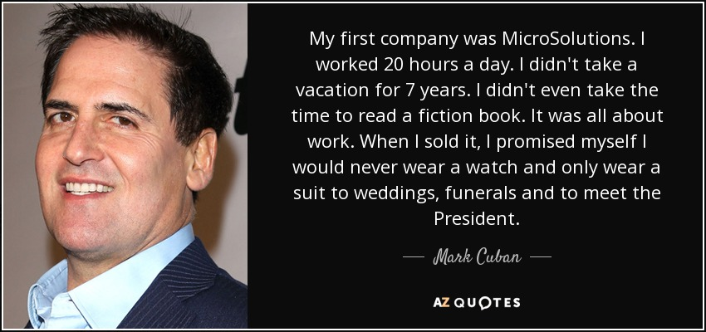
Figure 2: MicroSolutions as first company of Mark (AZ Quotes, 2024)
In general, it can be stated that the key moment in Cuban's career emerged in the mid-1990s with the Internet. In recognising the value of digital streaming, Cuban co-founded Broadcast.com company, which deals with internet radio, in 1995. It rapidly expanded, and in 1999, the firm was acquired by Yahoo! While still in college, Cuban began investing in stocks. By 1989, his investments totalled $7 billion, thus turning him into a billionaire. It is still considered one of the most famous dot-com deals and proved that Cuban could estimate and profit from technological advancements (Ramsey, 2022).
Cuban regards the decision to learn computer programming as perhaps one of the most important incidents in his early career (Shinneman, 2021). This self-taught skill enabled him to present more complex solutions to clients at MicroSolutions than his competitors, thus giving him and his firm an advantage. Cuban's thirst for knowledge, along with his venture into the realm of science without any prior background of formal education, showcases how Cuban was proactive about his endeavors (Sanders, 2020).

Achievements and Ventures
Beyond Broadcast.com, that Cuban's activities as an entrepreneur have been both broad and dynamic. In 2000 he bought the basketball team, the Dallas Mavericks turning them into the championship team. The Cuban management share ownership has been proved effective for the Mavs for he spends in player talent and enhancing the fans comforts thus making the Mavs one of the more successful franchises (Schoenfeld, 2023).
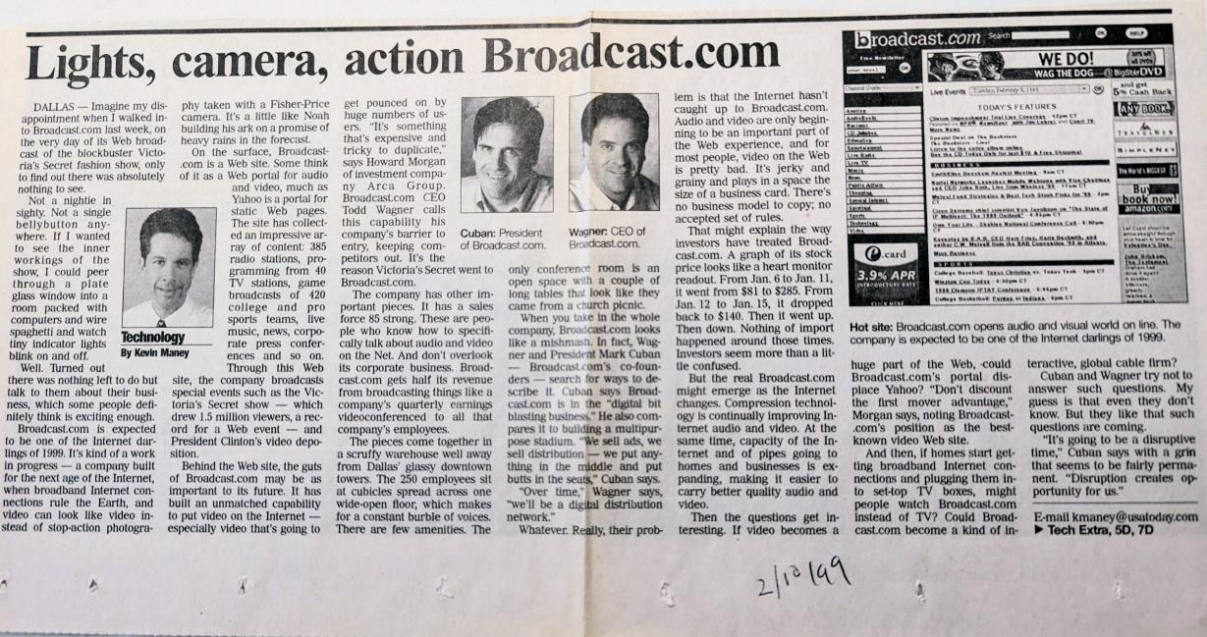
Figure 3: Broadcast.com (Maney, 2023)
Communication is also one of the areas in which Cuban's involvement is amplified: media and entertainment. He formed 2929 Entertainment, which has stakes in movie production and distribution, television and film studios, and cinema chains. His investments in the media sector depict his understanding of the technological realm and entertainment business as being on a continuum, a path that has defined the consumption of content in today's society (Goel, 2024).

Figure 4: 2929 Entertainment owned by Mark Cuban (Ranker, 2024)
Also, Cuban is one of the smart investors in the 'Shark Tank' show, through which he invests in new business entities. This role has exposed him to the general public and helped fund and support many businesses and receive valuable training. Cuban's approach to investing is inventive and efficient and follows a hierarchy, which is very much in tune with the man himself (Tomlinson, 2020).
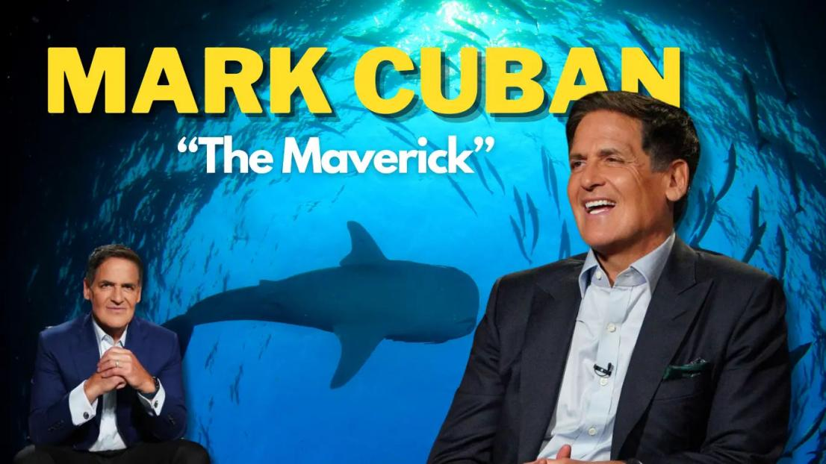
Figure 5: Richest shark on Shark Tank (Sharktank Season, 2024)
Buying the Dallas Mavericks was not only an achievement in owning a team but a business decision that benefited Cuban greatly. He built new, modern stadiums, engaged fans through new technologies, and substantially raised the asset's value for the team. Then, there is his impressive way of perceiving ownership based on methods of increasing clients' satisfaction as a tool for enterprise development. Also, Cuban's operations in other industries, such as in the media sector of producing the best movies, show a good propensity in the identification and mentoring of creatives (Goel, 2024).

Motivations Behind Success
Another example of an entrepreneurial drive is Mark Cuban, who established his success because of egoism, hi-tech fascination, and the intent to change something. From early childhood, his hard work and desire for financial freedom were apparent and are the driving forces throughout his practice. Cuban has underlined autonomy, where a person is a master of his own fate, which has informed his business ventures (Shinneman, 2021).
Cuban is also highly interested in technology and its applications in different industries. His investment and majority shares tend to be linked to his fondness for new technologies in society, such as digital streaming and artificial intelligence. This passion is not just the flame of dollars but also the fire of the saddle and being the ones to make the changes happen (Ramsey, 2022).
Moreover, all these concentrations of Cuban in sports, media service, and philanthropy denote another angle of purpose – the direction of cultivating a favourable culture in society. His philanthropic ventures, including education and health care, imply an understanding of the need to give back and utilise the earnings to fix problems affecting society. The motivational drive of Cuban is not just to set up a business and achieve materialistic gains, but to become who you want to be. He supports different civil rights and often speaks about the freedom of speech and privacy. This advocacy results from his assertion that materialism and wealth ought to be complemented by philanthropy, thus asserting that one has power should be used to improve others' lives (Sanders, 2020).

Entrepreneurial Traits to Develop
Visionary Thinking: Inventing the future, especially in the IT arena, has proved vital in business, something Cubans have effectively embraced. Such future businessmen can be informed about the state of the industry and thus be ready to adjust to changes before they happen.
Risk-Taking: Cuban's career is united by arbitrary decisions, starting with his reinvestment in the Mavericks and ending with the creation of Broadcast. com. For all its rationality, his impulsiveness is something that he should cultivate as nine times out of ten, such an attitude results in a handsome payoff (Raz, 2020).
Adaptability: Due to the fast advancement in technology one has to be flexible in their working. So, the change Cuban makes from software to digital streaming and then to media shows his versatility. New information and improved environmental conditions need to be incorporated into entrepreneurial decisions and plans, which means that managers should develop the capacity for strategic improvisation.
Resilience: Cuban did not have a smooth ride throughout his business deals, but he was determined never to be knocked out by failures. One characteristic that defines the process of developing resilience is that business owners have to prepare for various hurdles in creating companies.
Customer Focus: Cuban has always believed in being close to the customer and meeting and managing the customers' needs. This focus on the customer actually has been central to the success of his businesses and, perhaps, is one of the most important qualities for an aspiring businessman (Khan and Iqbal, 2020).
Mentorship and Giving Back: Cuban's part in "Shark Tank", plus actions and charitable endeavours, highlights the importance of having great skills and supporting others. Young people who want to become successful should learn from this that it is positive to share ideas and help others.

Figure 6: Mentorship given by Cuban (Sharktank Season, 2024)

Conclusion
Mark Cuban has been a great entrepreneur who has shown that even when all odds are against can come up with something new and unique. Consequently, Cuban has shown himself to be an impressive business constructor who might be a media mogul at present but who started as a simple computer shop owner. The figure's accomplishments across technology, sports, and media indicate that the man was a polymath in terms of entrepreneurship. Thus, Cuban's visionary thinking, risk-taking and perseverance inspire those dreamers who want to leave their imprint in the business world.
Cubans' experience can be used to understand a strategic role in the organisation, where it is always important to anticipate change and be ready for it, as well as focus on customers. It equally depicts the importance of helping others, passing on knowledge, and charity since wealth belongs to the entities and individuals who are given an opportunity to become successful. It is, therefore, for Cubans to continue the innovation and investment for future generations aspiring to be entrepreneurs to learn from him.

References
AZ Quotes. (2024) Mark Cuban. AZ Quotes. Available at: https://www.azquotes.com/quote/1293516 (Accessed: 2 August 2024).
Goel, M. (2024) Triumphs Amidst Trials. OrangeBooks Publication.
Khan, S. and Iqbal, M. (2020, June) AI-Powered Customer Service: Does it optimize customer experience?. In 2020 8th International Conference on Reliability, Infocom Technologies and Optimization (Trends and Future Directions)(ICRITO), pp. 590-594. IEEE.
Maney, K. (2023) The Time I Watched a Victoria's Secret Fashion Show Melt Mark Cuban's Servers. Substack. Available at: https://kevinmaney.substack.com/p/the-time-i-watched-a-victorias-secret (Accessed: 2 August 2024).
Pifer, N. D., Mastromartino, B. and Zhang, J. J. (2020) Selling fun and making a fortune: An examination of Mark Cuban’s impact on sport and business. Sport in Society, 23(9), pp. 1535-1545.
Ramsey, D. (2022) Baby Steps Millionaires: How Ordinary People Built Extraordinary Wealth--and How You Can Too. Ramsey Press.
Ranker. (2024) List of Films. Ranker. Available at: https://www.ranker.com/list/film-companies/reference (Accessed: 2 August 2024).
Raz, G. (2020) How I Built this: The Unexpected Paths to Success from the World's Most Inspiring Entrepreneurs. Houghton Mifflin.
Sanders, S. (2020) The Economic Reason. Springer International Publishing.
Schoenfeld, B. (2023) Game of Edges: The Analytics Revolution and the Future of Professional Sports. WW Norton & Company.
Sharktank Season (2024) The Success Story Of The Richest Shark on Shark Tank US Mark Cuban. Sharktank Season. Available at: https://sharktankseason.com/posts/the-success-story-of-mark-cuban (Accessed: 2 August 2024).
Shinneman, S. (2021) Dunking On Big Pharma: Mark Cuban, billionaire owner of the Dallas Mavericks, has teamed up with an angry polymath to change the high-priced game of prescription drugs. Texas Monthly, 49(12), pp. 77-82.
Tikkanen, A. (2024) Mark Cuban. Brittanica.com. Available at: https://www.britannica.com/money/Mark-Cuban (Accessed: 2 August 2024).
Tomlinson, E. C. (2020) Stasis in the shark tank: Persuading an audience of funders to act on behalf of entrepreneurs. Journal of Business and Technical Communication, 34(3), pp. 221-249.

