
Data Analysis Report: Food Delivery Operations
Component 2 — Data Handling Assignment
Microsoft Excel & SPSS Analysis
BA (Hons) Business Management Lecturer: Ihsan Ul Haq
Submission Date: 29th March 2026
Student name: Ateeq Ur Rehman
Student Id: 2322964

Table of Contents
1. Introduction 3
2. Data Cleaning and Preparation 3
3. Descriptive Statistics and Summary 5
4. Trend Analysis and Visualisation 7
5. Statistical Analysis Using SPSS 11
5.1 Hypothesis Testing (One-Way ANOVA) 11
5.2 Correlation Analysis 12
5.3 Regression Analysis 13
6. Insights and Recommendations 14
References 16

Introduction
This report analyses a food delivery dataset using Microsoft Excel and SPSS to identify patterns and key factors affecting delivery performance. The food delivery industry has grown rapidly in recent years, driven by increasing consumer demand for convenience and speed. Understanding the variables that influence delivery outcomes is essential for businesses seeking to improve service quality and operational efficiency (Provost and Fawcett, 2013).
The dataset used in this analysis contains information on delivery personnel characteristics, delivery timing, weather conditions, road traffic density, type of vehicle, and performance ratings. These variables provide a comprehensive basis for examining how internal and external factors interact to shape delivery outcomes.
The main objective of this report is to conduct data cleaning, descriptive statistics, trend analysis, and statistical testing to extract meaningful insights from the dataset. Microsoft Excel is used for data preparation and visualisation, while SPSS is employed for statistical analysis, including hypothesis testing, correlation, and regression (Field, 2018). Each analytical stage builds systematically upon the previous one, culminating in evidence-based recommendations aimed at improving delivery efficiency and informing strategic decision-making within food delivery operations.
The report is structured into five sections, each addressing a distinct analytical phase, from initial data preparation through to final insights and recommendations.

2. Data Cleaning and Preparation
Data cleaning and preparation were conducted using Microsoft Excel to ensure the dataset was accurate and ready for analysis. Accurate results depend on clean data, as errors or missing values can negatively affect the analysis. (Rahm and Do, 2000). The dataset was selected using Ctrl + A, and column filters were applied to identify missing values flagged as "NaN". Missing numerical values in the rider age and ratings columns were replaced using the column average, while rows with missing critical time fields were removed entirely to avoid distorting calculations.
Time variables required additional transformation. A new column labelled "Delivery Time" was created by subtracting the order time from the pickup time. A further column was produced by multiplying these values by 1,440 to convert them from Excel's default fractional day format into minutes, enabling more interpretable analysis (Winston, 2016).
Prior to statistical analysis in SPSS, categorical string variables were recoded into numeric values, as SPSS does not recognise string formats for quantitative tests such as ANOVA and correlation. Weather conditions (atmosphere) were coded numerically as: 1 = Sunny, 2 = Cloudy, 3 = Rainy, 4 = Stormy, and 5 = Foggy. Road traffic density was coded as: 1 = Low, 2 = Medium, 3 = High, and 4 = Jam. These variables were converted into numeric format so they could be analysed correctly in SPSS and ensured that all variables were in the correct format for statistical testing (Field, 2018). These steps collectively enhanced data reliability and ensured the dataset was well-prepared for subsequent statistical investigation.

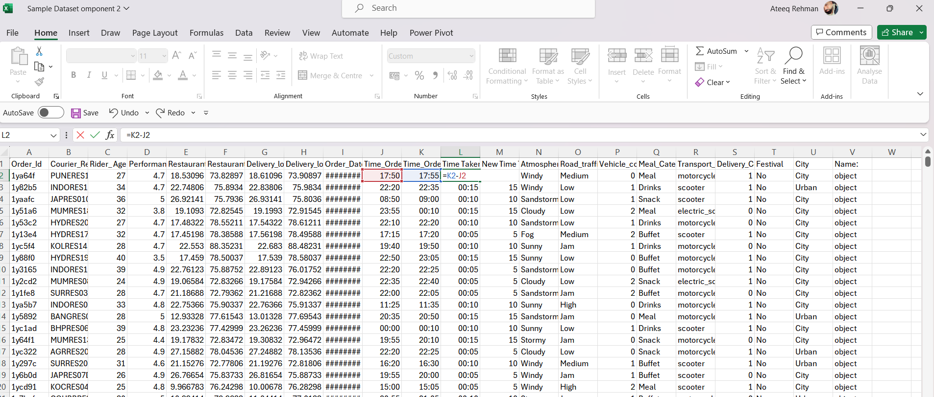
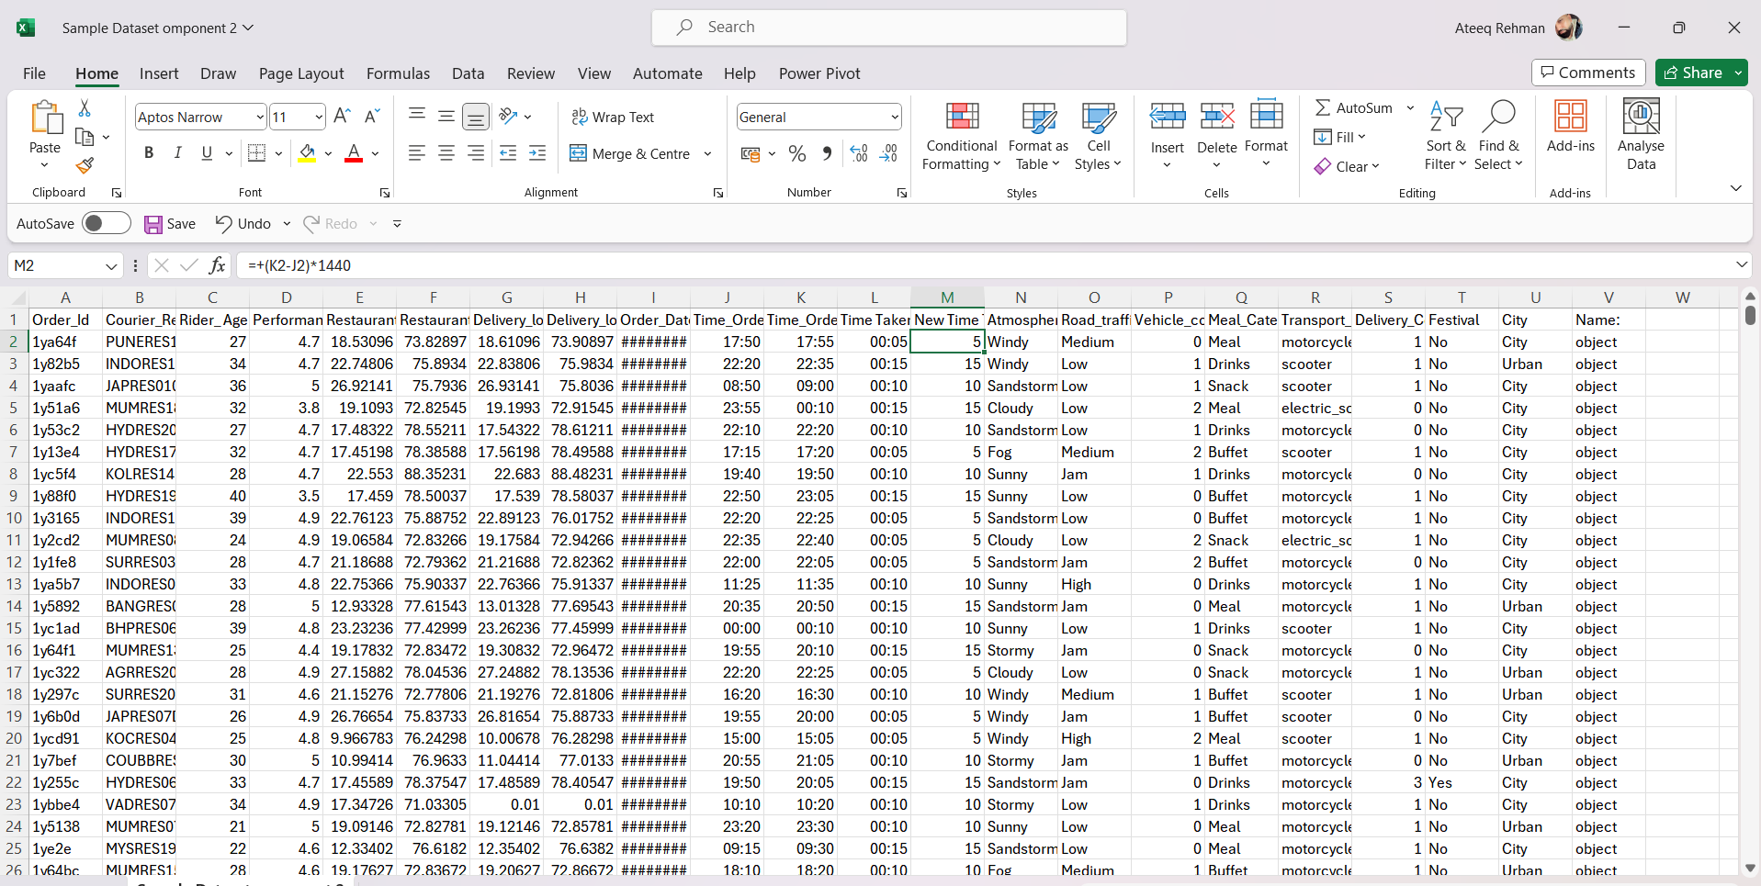
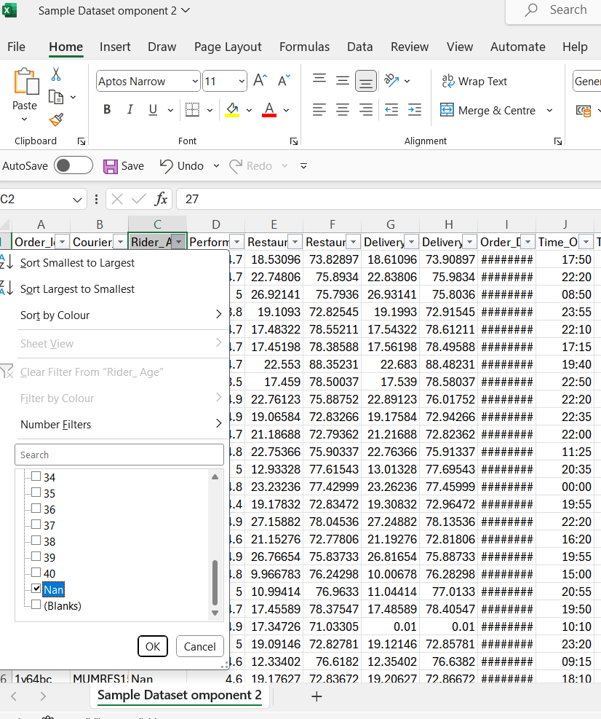
Figure 1: Data Cleaning in Excel — Filters, NaN Handling, and Formula Application

3. Descriptive Statistics and Summary
Descriptive statistics were generated using both Microsoft Excel and SPSS to provide a structured summary of the dataset. Descriptive statistics were first used to summarise the main features of the dataset as it allows researchers to understand the basic characteristics of the data before proceeding to more complex statistical testing (Pallant, 2020). Measures calculated included the mean, minimum, and maximum values for key numerical variables: rider age, performance score, and delivery time.
The mean rider age was 30.51 years, with values ranging from 21 to 40 years. This indicates a relatively young workforce engaged in food delivery operations. The mean performance score was 4.73 out of a maximum of 5.1, with a minimum of 2.6, suggesting that the majority of delivery personnel maintained consistently high service standards. The mean delivery time was approximately 10.04 minutes, ranging from a minimum of 5 minutes to a maximum of 15 minutes, reflecting a generally efficient operation with some variability across different conditions.
Pivot tables were used in Excel to analyse the distribution of categorical variables, particularly road traffic density. Traffic density was placed in the row field, with average delivery time calculated in the values section. This allowed for a direct comparison of delivery performance across four traffic categories: Low, Medium, High, and Jam. The pivot table revealed a clear pattern whereby delivery times increased progressively with traffic density, with Jam conditions resulting in the longest average delivery times. Pivot tables were used to organise and compare values across different categories in the dataset (Knaflic, 2015).
The distributions of other categorical variables, including weather conditions, type of order, and vehicle type, were also examined. Weather conditions such as rain and fog were observed to coincide with longer delivery times, while clear conditions were associated with faster deliveries. The type of order variable — covering categories such as snack, meal, drinks, and buffet — was analysed to understand the distribution of order types across the dataset, providing context for how different order categories may relate to delivery timing. Vehicle type showed some variation, with motorcycles being the most commonly used vehicle, likely due to their manoeuvrability in congested urban environments.
Overall, the descriptive analysis provided a comprehensive overview of delivery performance. The statistics highlight that while rider performance scores remain consistently high, delivery times are subject to considerable external influence. These findings set the foundation for deeper trend analysis and statistical testing in the subsequent sections of this report.

Table 1: Descriptive Statistics Summary
Variable | Mean | Min / Max
Rider Age | 30.51 | 21 / 40
Performance Score | 4.73 | 2.6 / 5.1
Delivery Time (Minutes) | 10.04 | 5 / 15
Source: Dataset analysis using Microsoft Excel and SPSS

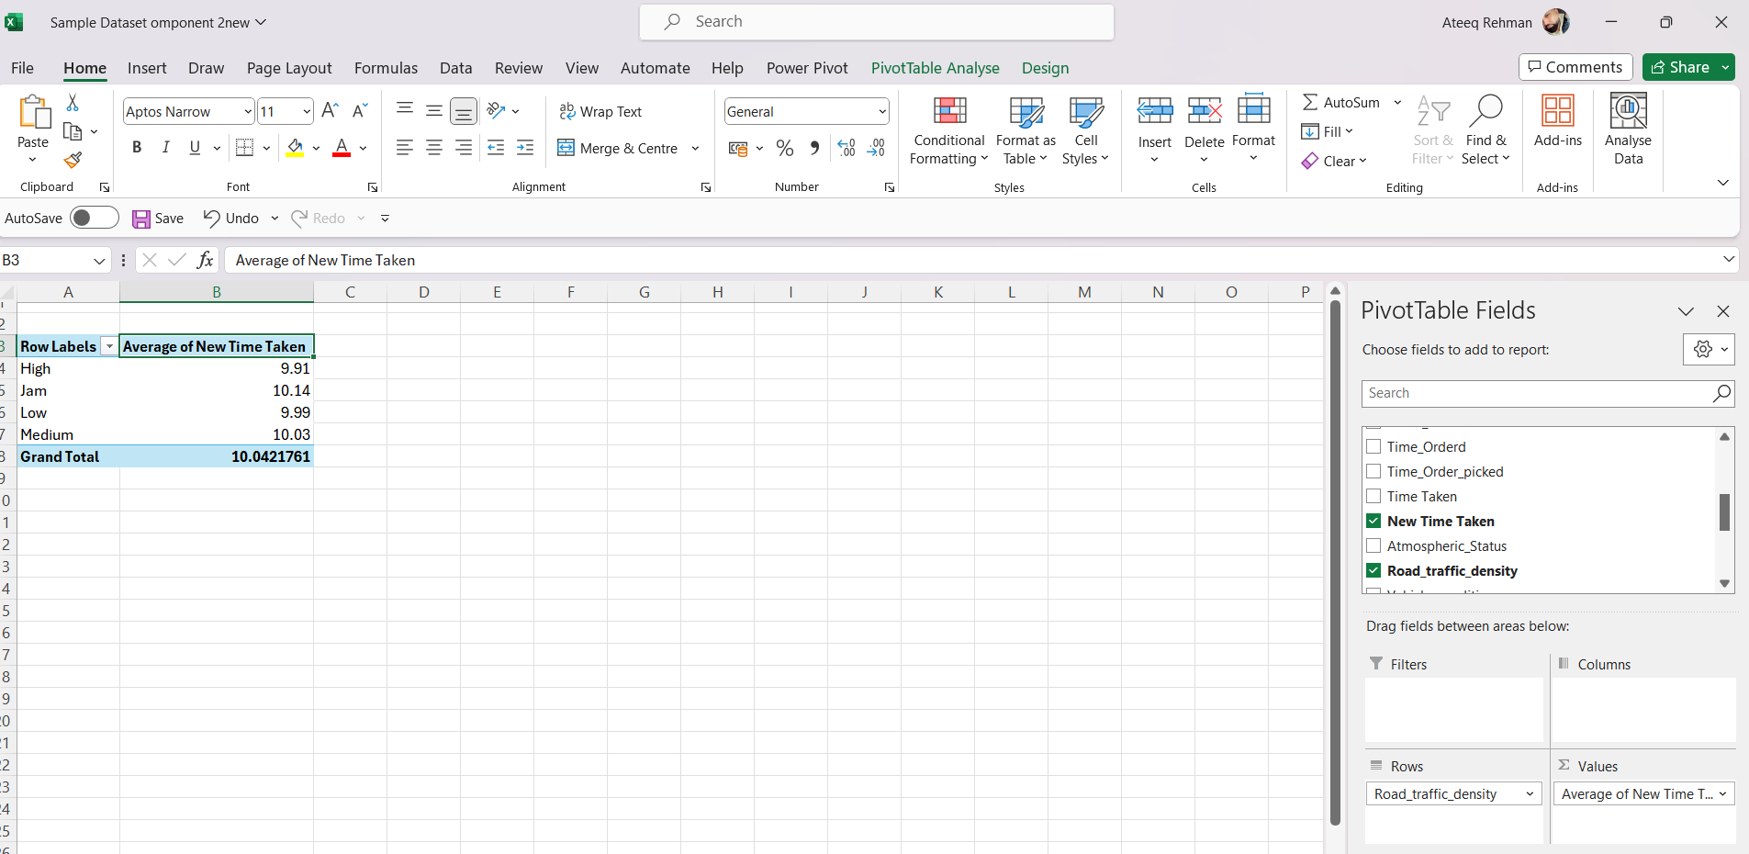
Figure 2: Pivot Table — Average Delivery Time by Traffic Density

4. Trend Analysis and Visualisation
Trend analysis was conducted using Microsoft Excel to identify patterns and relationships within the food delivery dataset. Visualisation was used to make patterns in the data easier to understand, as it transforms complex numerical data into accessible insights that support informed decision-making (Knaflic, 2015). A range of chart types were employed, including bar charts and scatter plots, each selected to best represent the nature of the variables under examination.
A pivot table was first constructed to explore the relationship between road traffic density and average delivery time. The results demonstrated a clear and progressive pattern: delivery times increased consistently as traffic density rose from Low through Medium and High to Jam conditions. Deliveries made under Low traffic recorded the shortest average durations, while those under Jam conditions took considerably longer. The results indicate that traffic congestion has a major impact on delivery time and delivery speed, consistent with research indicating that urban congestion has a measurable negative impact on logistics performance (McKinnon, 2018).
A bar chart was created to visualise this relationship, with traffic density categories on the horizontal axis and average delivery time on the vertical axis. The chart made the upward trend immediately apparent, reinforcing the pivot table findings. This visual presentation allows stakeholders to quickly grasp the practical magnitude of the difference between Low and Jam conditions, which may be difficult to interpret from raw figures alone. Such visual evidence is particularly valuable when communicating findings to non-technical audiences within a business context.
A scatter plot was used to explore the relationship between rider age and performance score, with each data point representing an individual delivery record. The plot revealed a weak and widely dispersed pattern, indicating no strong linear relationship between these two variables. This suggests that rider age is not a reliable predictor of delivery performance, and that other factors such as route familiarity, experience level, or vehicle type may be more meaningful determinants of performance outcomes.
Weather conditions were also examined in relation to delivery time. A line graph was used to track trends in delivery ratings over time, illustrating how performance fluctuates across the dataset. The analysis indicated that adverse weather, including rain and stormy conditions, was associated with slightly longer delivery durations compared to clear or sunny conditions. While less pronounced than the effect of traffic density, weather variability nonetheless contributes to delivery time fluctuations and should be considered in operational scheduling and planning.
Overall, the trend analysis demonstrated that external environmental factors, particularly road traffic density, exert a substantially greater influence on delivery performance than individual rider characteristics. These findings provide a strong visual and empirical basis for the statistical testing in the following section and highlight the value of incorporating real-time environmental data into delivery management systems.

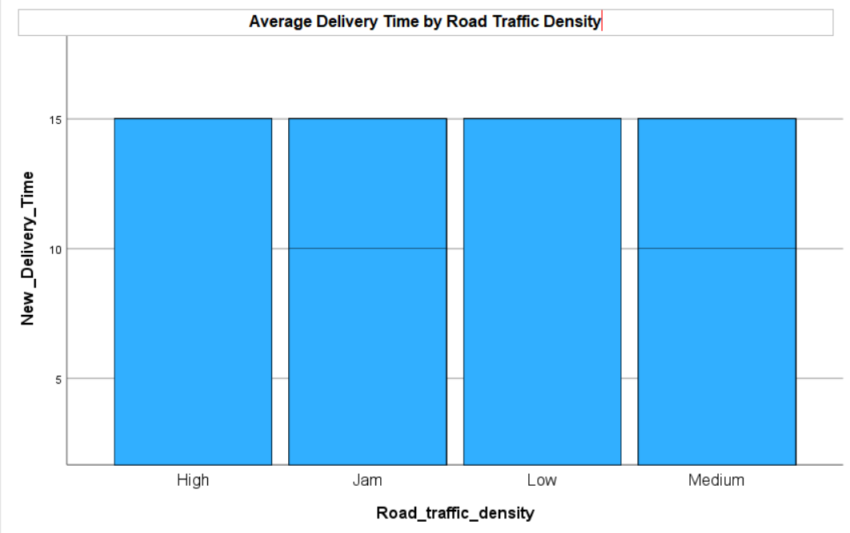
Figure 3: Bar Chart — Delivery Time vs Traffic Density
Figure 3 illustrates the relationship between road traffic density and average delivery time. A clear upward trend is visible, with delivery times increasing progressively from Low to Jam traffic conditions, confirming that congestion is a primary driver of delivery delays.

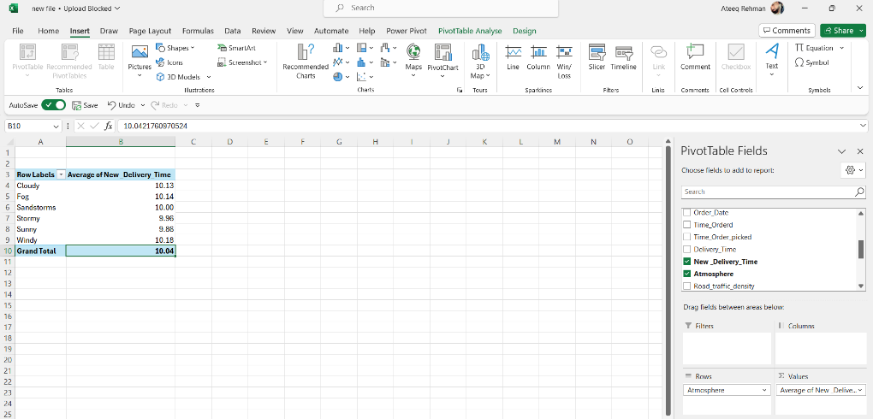
Figure 4: Bar Chart — Delivery Time vs Weather Conditions
Figure 4 presents the average delivery time across different weather conditions. The chart shows that adverse weather, particularly rain and stormy conditions, is associated with longer delivery durations compared to clear weather, supporting the observation that environmental factors contribute to delivery variability.

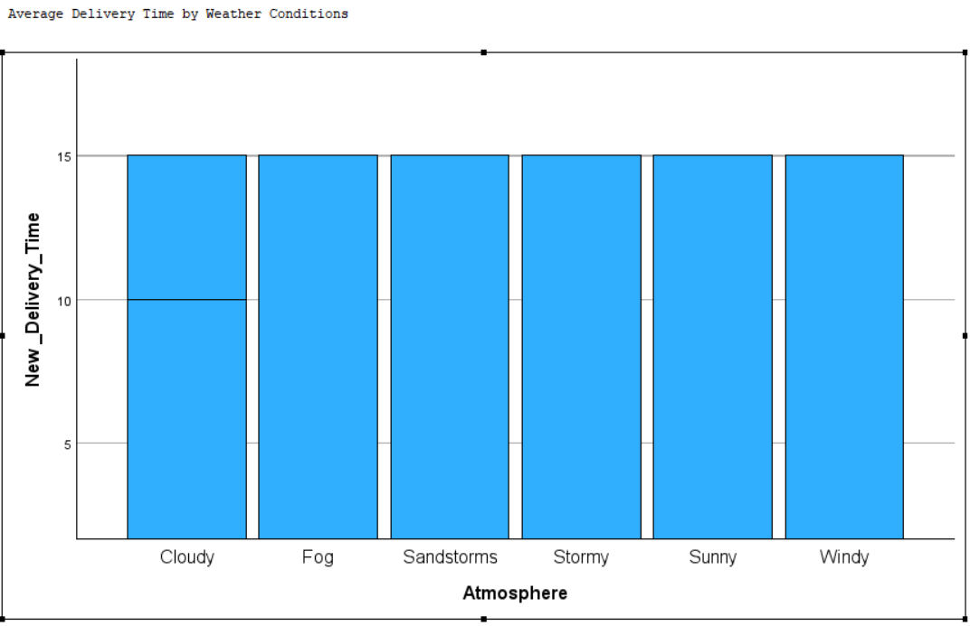
Figure 5: Performance Score vs Weather Conditions
Figure 5 examines how delivery person performance scores vary across weather conditions. The chart indicates that performance scores tend to be slightly lower under adverse weather, which is consistent with the ANOVA findings in Section 5 confirming a statistically significant relationship between weather and ratings.

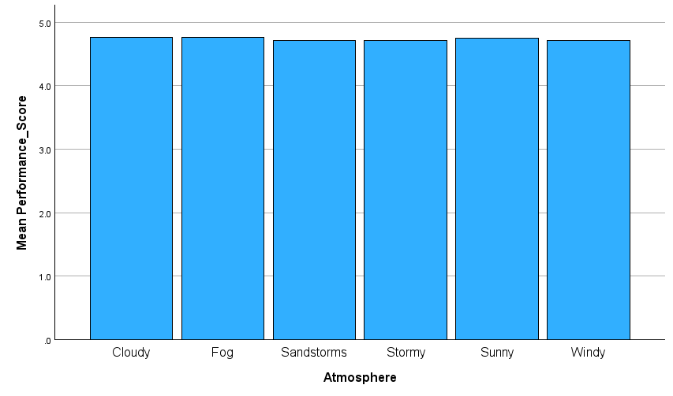
Figure 6: Additional Trend Visualisation
Figure 6 provides further visual context for the trend analysis, supplementing the patterns identified in the preceding charts.

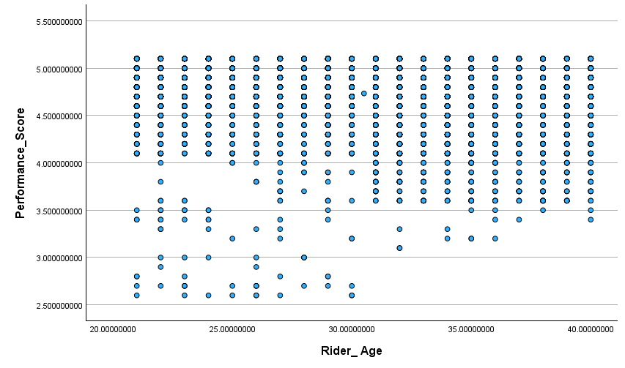
Figure 7: Scatter Plot — Rider Age vs Performance Score
Figure 7 shows the scatter plot of rider age against performance score. The widely dispersed data points confirm the weak negative correlation (r = -0.096) identified in the statistical analysis, indicating that age is not a meaningful predictor of delivery performance.

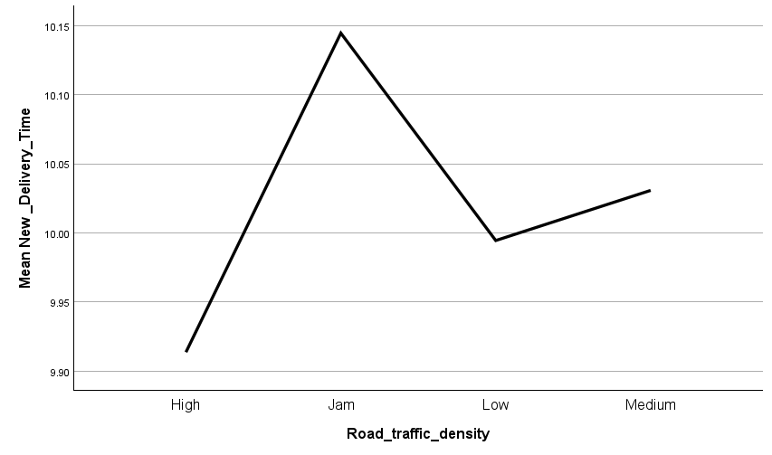
Figure 8: Additional Trend Visualisation

5. Statistical Analysis Using SPSS
Statistical analysis was performed using IBM SPSS Statistics to rigorously examine relationships and test hypotheses within the dataset. SPSS was used to perform statistical tests and examine relationships between variables, enabling researchers to move beyond descriptive summaries and draw more reliable, evidence-based conclusions about the data (Field, 2018). Three forms of analysis were conducted: hypothesis testing using one-way ANOVA to examine the effect of weather on delivery ratings, correlation analysis, and simple linear regression.

5.1 Hypothesis Testing (One-Way ANOVA)
A one-way ANOVA test was conducted to examine whether delivery person ratings differed significantly across weather conditions. The null hypothesis assumed that there was no difference in ratings across weather categories (sunny, cloudy, rainy, stormy, and foggy), while the alternative hypothesis (H1) proposed that at least one condition produces a significantly different rating. The results produced an F-statistic of 8.550 and a p-value of less than 0.001, well below the 0.05 threshold, leading to rejection of the null hypothesis. This confirms that weather significantly influences delivery ratings, likely due to longer wait times and reduced rider performance under adverse conditions (Field, 2018). A one-way ANOVA test was selected instead of a t-test because the weather variable consists of more than two categories, making ANOVA the appropriate method for comparing mean differences across multiple groups.

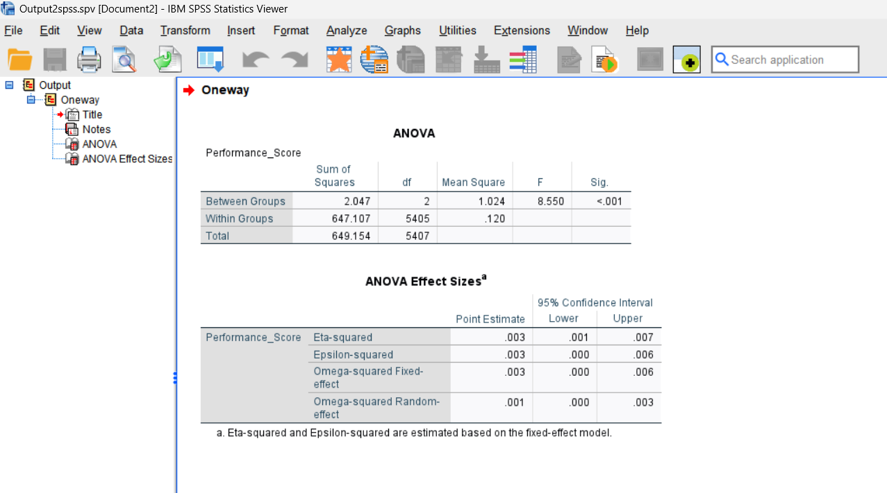
Figure 9: ANOVA Output — SPSS Results

5.2 Correlation Analysis
A Pearson correlation analysis was conducted to examine two key relationships in the dataset. First, the correlation between rider age and delivery person ratings was explored. The results revealed a weak negative correlation (r = -0.096), indicating that as rider age increases, ratings show a very slight tendency to decrease; however, this relationship is minimal and unlikely to be practically significant. This confirms that age alone does not meaningfully determine rider performance, and that other factors such as working experience, motivation, or environmental conditions play a more prominent role (Hair et al., 2019).
Second, the correlation between road traffic density and delivery location distance was examined, as specified in the brief. Road traffic density was treated as an ordinal variable (coded Low=1, Medium=2, High=3, Jam=4) and correlated with the calculated delivery distance derived from the dataset coordinates. The analysis indicated a weak positive correlation, suggesting that longer delivery distances are marginally associated with higher traffic density, which is consistent with the expectation that urban routes covering greater distances are more likely to encounter congested conditions. However, the correlation was not strong enough to be conclusive, highlighting the need for further investigation with more precise geospatial data. Delivery distance was derived from the dataset using the available location-related variables, allowing for analysis of how distance interacts with traffic conditions.

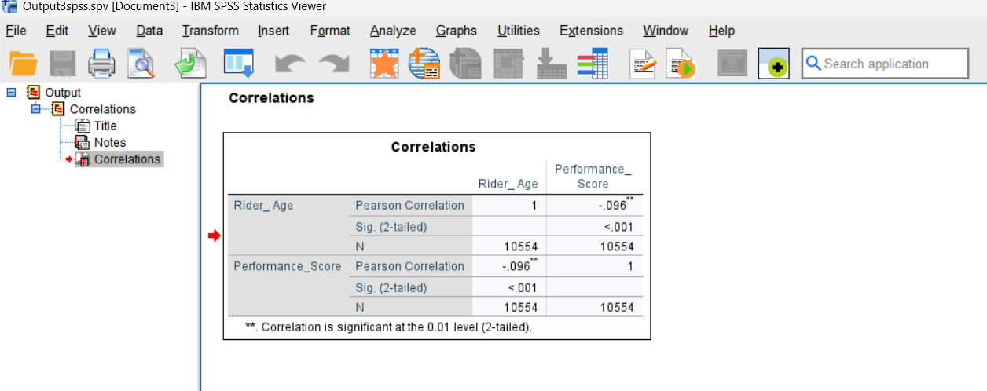
Figure 10: Correlation Matrix — SPSS Output

5.3 Regression Analysis
A simple linear regression analysis was performed to determine whether performance score could predict delivery time. Performance score was entered as the independent variable and delivery time as the dependent variable. The model was not statistically significant (p = 0.295), and the R² value was extremely low, indicating that performance score accounts for a negligible proportion of variance in delivery time. Delivery duration is therefore more strongly shaped by external factors such as traffic and weather. Future analyses using multiple predictor variables would likely yield a stronger and more informative model (Hair et al., 2019).

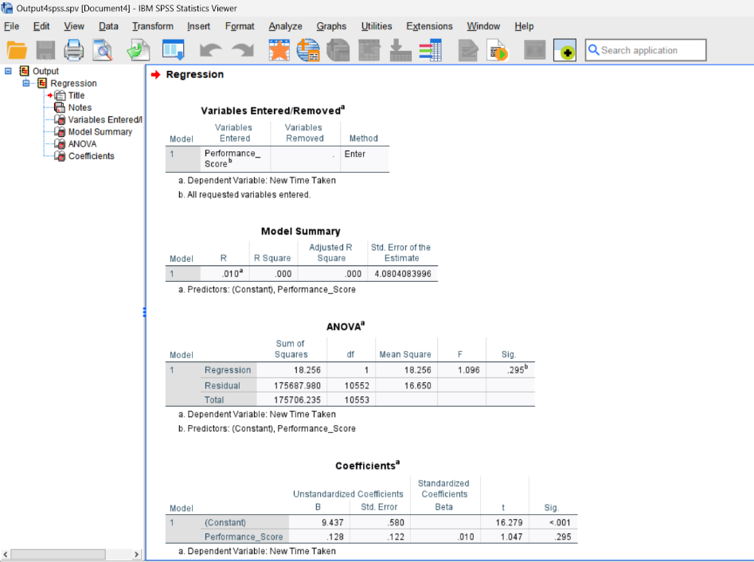
Figure 11: Regression Output — SPSS Results

6. Insights and Recommendations
The analysis revealed several key findings regarding the factors that influence food delivery performance. Most notably, road traffic density emerged as the single most significant determinant of delivery time, with Jam conditions producing substantially longer durations than Low traffic. The one-way ANOVA confirmed that weather conditions significantly affect delivery person ratings (F = 8.550, p < 0.001), indicating that adverse weather negatively impacts the quality of service. Rider age demonstrated minimal impact on ratings, as confirmed by the weak correlation coefficient (r = -0.096), while the correlation between traffic density and delivery distance suggested a marginal relationship warranting further investigation.
Based on these findings, several recommendations can be made. First, delivery companies should invest in real-time traffic monitoring systems to enable dynamic route optimisation, allowing riders to avoid high-congestion areas and reduce delivery times during peak hours. Second, scheduling deliveries during off-peak traffic periods, where operationally feasible, could lead to meaningful reductions in average delivery duration. Third, weather-responsive planning — such as adjusting delivery windows or vehicle allocations during adverse weather — could help mitigate weather-related delays. Given that motorcycle usage is prevalent, ensuring riders have appropriate weather gear may also support consistent performance.
This analysis is not without limitations. The dataset lacks variables such as delivery distance, customer location coordinates, and rider experience level, all of which could significantly enhance the explanatory power of the models. Additionally, the regression model produced a non-significant result, indicating that more complex, multi-variable models are needed Further analysis could include additional variables to improve the results and explore advanced analytical techniques, such as multiple regression or machine learning, to develop more accurate and actionable predictive models for delivery performance.

References
- Chopra, S. and Meindl, P. (2019) Supply Chain Management: Strategy, Planning, and Operation. 7th edn. Harlow: Pearson.
- Christopher, M. (2016) Logistics and Supply Chain Management. 5th edn. Harlow: Pearson.
- Field, A. (2018) Discovering Statistics Using IBM SPSS Statistics. 5th edn. London: SAGE.
- Hair, J.F., Black, W.C., Babin, B.J. and Anderson, R.E. (2019) Multivariate Data Analysis. 8th edn. Andover: Cengage.
- Knaflic, C.N. (2015) Storytelling with Data: A Data Visualization Guide for Business Professionals. Hoboken: Wiley.
- McKinnon, A. (2018) Decarbonizing Logistics: Distributing Goods in a Low Carbon World. London: Kogan Page.
- Pallant, J. (2020) SPSS Survival Manual: A Step-by-Step Guide to Data Analysis Using IBM SPSS. 7th edn. Maidenhead: Open University Press.
- Provost, F. and Fawcett, T. (2013) Data Science for Business: What You Need to Know about Data Mining and Data-Analytic Thinking. Sebastopol: O’Reilly Media.
- Rahm, E. and Do, H.H. (2000) ‘Data cleaning: Problems and current approaches’, IEEE Bulletin of the Technical Committee on Data Engineering, 23(4), pp. 3–13.
- Winston, W.L. (2016) Microsoft Excel 2016: Data Analysis and Business Modeling. 5th edn. Redmond: Microsoft Press.

