Taste of Nigeria: Street Food & Culture Festival Full Marketing Report

Name: favour obi
Student id: 2502853
Assignment title: niche Marketing and Events Report/Plan to effectively promote an event
Lecturer name: Chris Wilkins
Submission date: 12th of December
Word count: 1,584
Module code: BMTP4014
Module name; niche marketing and socia media

1. Introduction

This report explains a full marketing plan for an event I have chosen, the event “Taste of Nigeria: Street Food & Culture Festival,” which will take place in Brixton, London, in 2026. The purpose of this report is to show how the event can be promoted successfully using simple but effective marketing methods, niche marketing, and digital communication tools. The plan follows the SOSTAC framework, which includes: Situation, Objectives, Strategy, Tactics, Action, and Control.

The report also uses the RACE digital marketing model and the 7Ps of the marketing mix. It includes analysis of the event’s environment, target customers, competitors, partners, and the wider external world. This helps us understand what opportunities and challenges the event may face.

Taste of Nigeria is a cultural festival that celebrates Nigerian food, music, and traditions. The festival will attract people who enjoy unique cultural experiences, especially Gen Z (ages 16–25) and Millennials (ages 25–40), because these groups are active on social media, love food festivals, and enjoy sharing experiences online.

The marketing plan focuses strongly on social media promotion, especially TikTok, Instagram, YouTube, and influencer partnerships, as these are the platforms where the target audience spends most of their time.

2. SOSTAC – Situation Analysis

2.1 Event Overview

Taste of Nigeria is a new one-day festival created to celebrate the richness of Nigerian street food, Afrobeats music, and African culture. The event will include food stalls, music performances, cooking demonstrations, cultural dances, small business vendors, and interactive activities such as dance workshops.

London has a growing interest in African culture, especially Nigerian entertainment like Afrobeats, which has become popular worldwide. Because of this, the festival fits well with current cultural trends. Brixton is the chosen location because it is known for African and Caribbean communities, multicultural food markets, and a strong street culture identity. This makes it a perfect place for a festival like this.

2.2 SWOT Analysis

Strengths
• The festival has a unique Nigerian theme, which makes it stand out.
• It offers authentic food, music, and culture.
• There is strong support from the Nigerian community.
• African culture is becoming more popular in the UK.

Weaknesses
• It is a new event with no previous audience data.
• The budget is limited.
• London weather may cause problems for outdoor activities.
• The festival depends on small vendors who may have limited capacity.

Opportunities
• African food and Afrobeats are trending on TikTok and Instagram.
• More people are interested in cultural experiences.
• Partnerships with influencers can increase visibility.
• London has a diverse audience looking for new festivals.

Threats
• Competition from other food festivals.
• The cost-of-living crisis might reduce spending.
• Event rules and safety regulations could cause delays.
• Social media algorithms may reduce post reach.

2.3 Customer Analysis (Segmentation)

To market the event successfully, we must understand the target customers. Segmentation breaks customers into groups based on characteristics.

Demographics
• Main age group: 18–35 (young adults)
• Secondary group: 35–55 (families)
• Students and young professionals
• Middle-income earners

Psychographics
• People who love food, culture, and new experiences
• Social media users who enjoy posting pictures and videos
• People who enjoy music, events, and festivals
• Curious people who enjoy trying global foods

Generational Segments
• Gen Z: likes TikTok trends, street food, and unique experiences
• Millennials: enjoy weekend activities, travel, culture, and food events

Behavioural Trends
• They search for events online
• They use Instagram, TikTok, and Google to find things to do
• They buy tickets online
• They trust influencers more than traditional advertising
• They enjoy digital content such as videos, reviews, and hashtags

2.4 Competitor Analysis

The festival has several competitors in the London food event market:
• London African Food Festival
• Brixton Night Market
• London Street Food Fiesta

These festivals offer food from many cultures, while Taste of Nigeria focuses on one country only. This makes the event more niche, which means it appeals strongly to people who want something more specific and authentic.

A perceptual positioning map (shown in the appendices) places Taste of Nigeria as high authenticity and high cultural focus, while others are more general.

Using Bowman’s Strategy Clock, the event falls under the Differentiation Strategy, which means it offers a unique experience that competitors do not provide.

2.5 Collaborators

Collaborators are partners who help make the festival successful. These include:
• Nigerian restaurants and food trucks
• Afrobeat DJs and musicians
• TikTok food creators
• Instagram bloggers
• Brixton Council
• Travel influencers
• Cultural dance groups
• Local markets and small businesses

These partners help with promotion, authenticity, content creation, and event operations.

2.6 PESTLE Analysis

Political:
• Rules about food safety
• Licensing for music and large gatherings

Economic:
• High living costs may affect ticket sales
• Food vendor prices might increase if food costs rise

Social:
• Afrobeats and African culture are growing in popularity
• People want authentic travel and food experiences

Technological:
• Online ticket systems
• QR code entry
• Social media promotion
• Contactless payments

Legal:
• GDPR rules for collecting customer data
• Health and safety requirements

Environmental:
• Waste management plans needed
• Recycling and sustainable packaging encouraged

3. Objectives

The objectives are SMART: Specific, Measurable, Achievable, Realistic, Time-bound.
• Reach 200,000 online impressions before the event
• Gain 10,000 social media followers
• Sell 80% of tickets before event day
• Get 40+ influencer posts promoting the festival
• Achieve 90% positive reviews after the event
• Build a customer database of 5,000 subscribers

These goals help measure the success of marketing activities.

4. Strategy

The strategy focuses on reaching Gen Z and Millennials through a digital-first approach.

Key Strategy Points
• Use TikTok and Instagram as the main promotion channels
• Position the event as “London’s most authentic Nigerian street food and culture festival.”
• Use a mix of paid ads, organic posts, and influencer content
• Build excitement using short-form videos, food content, and Afrobeats soundtracks
• Use social proof from influencers to build trust
• Attract food lovers, festival-goers, and culture seekers

The aim is to make the festival feel exciting, unique, and worth attending.
5. Tactics (RACE + 7Ps)

5.1 Marketing Mix – 7Ps

Product:
Nigerian street food, DJs, live music, cooking demos, dance shows, workshops, photo areas.

Price:
Tickets £10–£20. Early-bird discounts, student discounts, and family bundles.

Place:
Outdoor Brixton location known for cultural diversity and food markets.

Promotion:
Ads on TikTok and Instagram, influencer marketing, posters, PR, emails.

People:
Friendly staff, skilled vendors, experienced performers.

Process:
Easy online booking, QR entry, fast queueing system, help desk at event.

Physical Evidence:
Event branding, banners, cultural decorations, high-quality photos and videos shared online.
5.2 RACE Framework

Reach:
• TikTok ads and Instagram ads
• Influencer content
• Press releases to local newspapers
• Flyers in Brixton

Act:
• Food challenges on TikTok
• Instagram polls
• Interactive landing page
• Behind-the-scenes videos

Convert:
• Early bird ticket deals
• Simple online checkout
• VIP ticket option
• Countdown reminders

Engage:
• Hashtag campaigns (#TasteOfNigeria2026)
• Post-event surveys
• Email newsletters
• Highlight videos shared online

6. Action Plan

The action plan explains what will happen and when.
• TikTok + Instagram posts daily, starting 8 weeks before event
• Influencer partnerships begin 6 weeks before
• Email newsletters every week
• PR and press outreach 2 months before
• Street posters and flyers in Brixton 4 weeks before
• Vendor and performer announcements weekly
• Final week: heavy ads, countdown videos, last-chance tickets

A full Gantt chart is included in the appendices to show the schedule visually.

7. Control

To measure success, the following KPIs (key performance indicators) will be used:
• Social media follower growth
• Engagement (likes, comments, shares, views)
• Ticket sales numbers
• Website visits and bounce rate
• Influencer promo code usage
• Customer satisfaction from surveys
• Event attendance
• Financial performance and overall profit

Appendix A – Gantt Chart
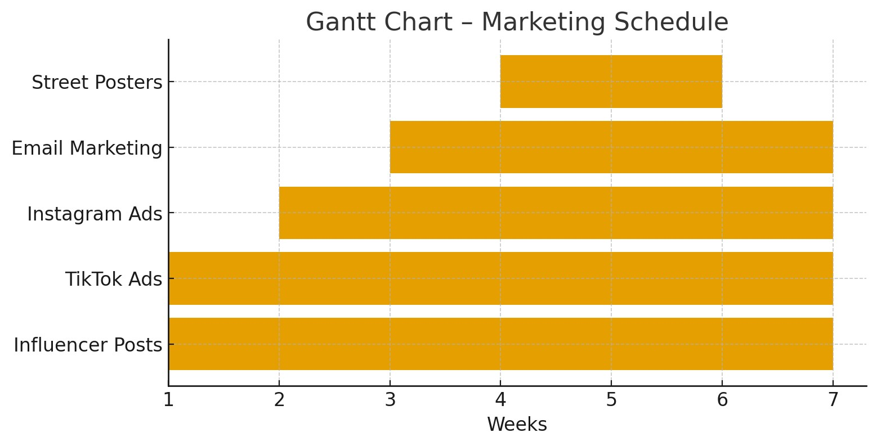

Appendix B – Perceptual Positioning Map
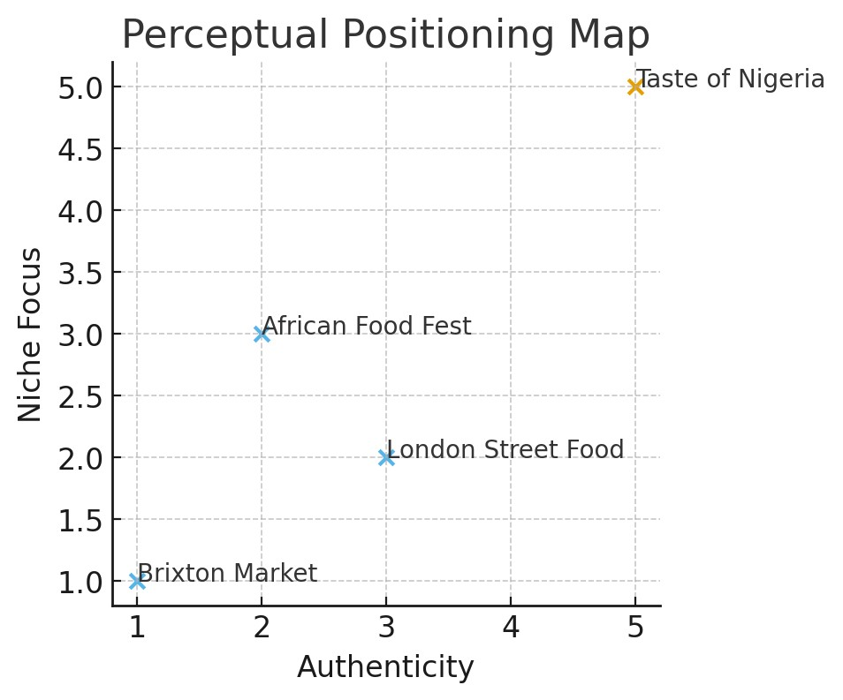

Appendix C – Bowman's Strategy Clock

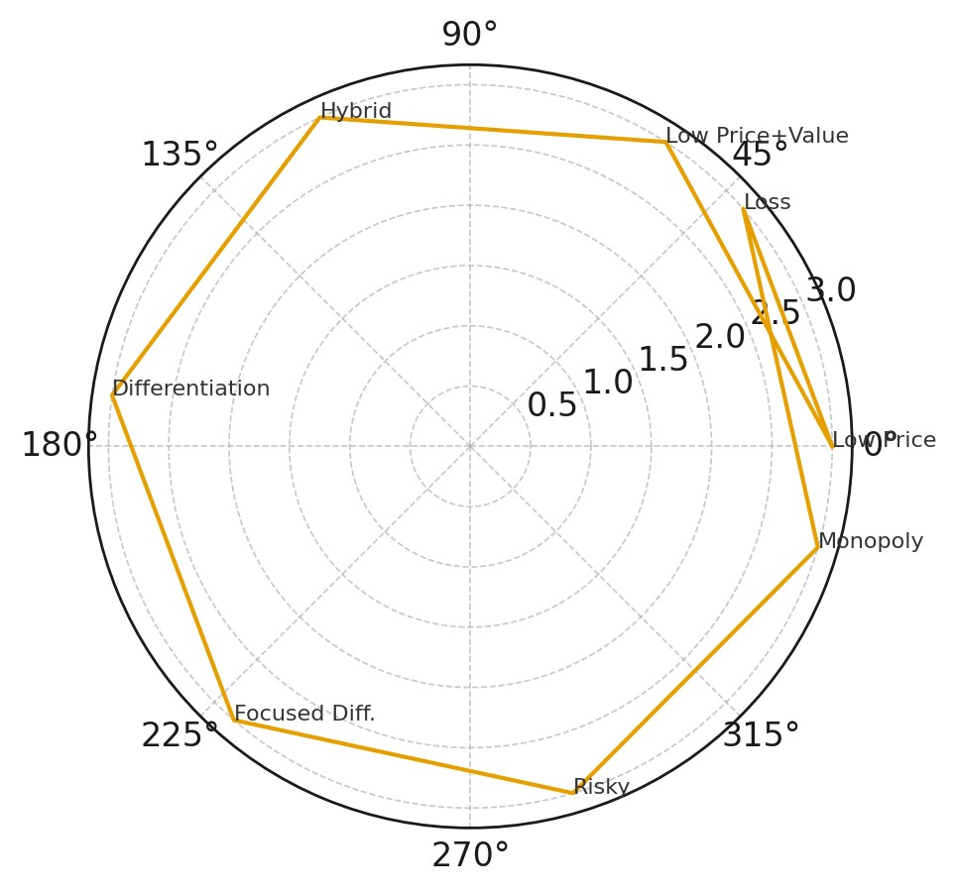

Reference

- Street Food Hub (2025) Most Popular Street Foods in the UK Summer 2025. Available at: https://www.streetfoodhub.co.uk/most-popular-street-foods-uk-2025/ (Accessed: 12 December 2025).
- Street Food Expo (2025) Trends and Figures Defining UK Street Food in 2024. Available at: https://www.streetfoodexpo.co.uk/news/trends-and-figures-defining-uk-street-food-in-2024 (Accessed: 12 December 2025).
- VisitBritain (2024) Looking ahead: Britain’s 2025 food and drink festivals. Available at: https://www.visitbritain.org/news-and-media/destination-news-and-inspiration/looking-ahead-britains-2025-food-and-drink (Accessed: 12 December 2025).
- We Are Social UK (2025) Digital 2025: How Social Media Is Used Across the UK. Available at: https://wearesocial.com/uk/blog/2025/02/digital-2025/ (Accessed: 12 December 2025).
- Metricool (2025) 2025 UK Social Media Statistics. Available at: https://metricool.com/uk-social-media-statistics/ (Accessed: 12 December 2025).
- Sprout Social (2025) Social Media Statistics UK 2025. Available at: https://sproutsocial.com/insights/social-media-statistics-uk/ (Accessed: 12 December 2025).
- TikTok User Statistics UK (2025) TikTok has 23.3m UK users. Available at: https://www.limelightdigital.co.uk/tiktok-user-statistics/ (Accessed: 12 December 2025).
- Visit Nigeria Week (2025) Nigeria Week in London to showcase rich cultural heritage. Available at: https://guardian.ng/news/nigeria/metro/nigeria-week-in-london-to-showcase-rich-cultural-heritage/ (Accessed: 12 December 2025).
- Nigerian Festival UK (2025) Official Nigerian Festival UK event page. Available at: https://nigerianfestivaluk.org/ (Accessed: 12 December 2025).
- Sibaya Home (2025) Top African Diaspora Events UK 2025 – Culture, Music & Food Guide. Available at: https://sibayahome.com/blogs/african-diaspora-events-1/top-african-diaspora-events-uk-2025-culture-music-food-guide (Accessed: 12 December 2025).
- Wikipedia (2025) Notting Hill Carnival. Available at: https://en.wikipedia.org/wiki/Notting_Hill_Carnival (Accessed: 12 December 2025).
- National Geographic Traveller (2025) UK Food Festival (National Geographic Traveller). Available at: https://foodfestival.natgeotraveller.co.uk/ (Accessed: 12 December 2025).
- FestivalInsights (2024) Trends driving UK festival food & drink experiences. Available at: https://www.festivalinsights.com/2024/11/togather-reveal-2024-festival-fb-trends/ (Accessed: 12 December 2025).
- ClassiAds (2025) Street Food in the UK: Top Markets to Visit in 2025. Available at: https://classiads.co.uk/street-food-uk-markets-2025/ (Accessed: 12 December 2025).
- Guardian (2025) Britons watch YouTube 51 minutes a day, says Ofcom. Available at: https://www.reuters.com/business/media-telecom/britons-watch-youtube-51-minutes-day-regulator-ofcom-says-2025-12-10/ (Accessed: 12 December 2025).

