2118883

Abstract
Full report on the Atterberg Limit Test, Sieve Analysis Test and The Constant Head Permeameter Test.
Geotechnical Assignment

Table of Contents
1.0 Atterberg Limit Test 3
1.0 Introduction 3
1.1 Methodology 3
1.1a Collect the sample
1.1b Preparation of Test / Soil Sample
1.1c Liquid Limit Test - Mixing Procedure
1.1d Liquid Limit Test - Setting up for test
1.1e Liquid Limit Test – Record
1.1f Liquid Limit Test – Repeat
1.1g Shrinkage Limit Test – Containers
1.1h Shrinkage Limit Test – Clay Samples
1.1i Shrinkage Limit Test – Rolling the samples
1.1j Shrinkage Limit Test – Wet soil content
1.1k Shrinkage Limit Test – Moisture Content
1.2 Calculate Plasticity Index
1.3 Result
1.4 Result and Analysis 5
1.4a Number of Blows
1.4b Comparison of Wet + Dry soil
1.4c Moisture content
1.5 Conclusion of Atterberg Limit Test 5

2.0 Sieve analysis 6
2.1 Introduction 6
2.2 Methodology 7
2.2a Collect the sieves
2.2b Sieve size and weight
2.2c Stack sieves
2.2d Start sieving process
2.2e Weight of material
2.2f Calculate particle size
2.2g Analyse results
2.2h Repeat test if required
2.3 Results and Analysis 8
2.3a Reporting Results
2.3b Analysis of Test
2.4 Conclusion 9

3.0 Constant Head Permeameter Test 9
3.1 Introduction 9
3.2 Methodology 10
3.2a Collect sample and prepare
3.2b Pour water into the test
3.2c Record water and time
3.2d Hydraulic Gradient
3.3 Results and Analysis 12
3.4 Conclusion 12

4.0 References 13

1.0 Atterberg test limit

1.0 Introduction
The Atterberg test involves determining the plastic limit, liquid limit and shrinkage limit of a soil sample. The plastic limit is the moisture content of a soil sample and the time it starts to behave like a plastic material, that involves rolling it into a long shape without it cracking. The liquid limit is the moisture content in the soil sample flows like a liquid and at a point that it is unable to be moulded to allow it to break. The shrinkage limit is the amount of moisture content of the soil sample at the point no further volume reduction causes a loss of moisture. (Backus, B. (2019).

The main instrument for the Atterberg limit test is carried out using a Casagrande apparatus. This is a device that has a brass cup, a crank operated handle and a grooving tool. The Atterberg limit test involves a series of procedures to carry out the test for the three Atterberg limits of the soil sample.

The results of the test help predict the behaviour of the soil under different types of loading conditions such as shear strength, compaction and settlement.

1.1 Methodology

1.1(a) Collect Sample
An area of the soil sample needs to be collected that represents accurately the area to be investigated. Once collected, needs to be in airtight storage.

1.1(b) Preparation of test / Soil Sample
Once sample is established airtight, crush any large clumps by placing the sample through a 4.75mm sieve. To ensure uniformity, mix the soil sample meticulously.

1.1(c) Liquid Limit Test – Mixing procedure
Take the soil sample and add water to the sample. For around 250g of soil sample, it needs to be mixed thoroughly with a very small amount of water, approximately 1-2ml. To ensure this is mixed correctly, use a spatula to stir and chop through the soil.

1.1(d) Liquid Limit Test – Setting up for the Test
The consistency process is trial and error until the correct amount is reached. This will be known as the soil will take approximately 30-35 blows to separate 12mm. Once correct consistency is made, place a portion of the mix into the cup bowl. The mixture is to be smooth in the bowl. Once smoothened, use the groove tool to scrape a line through the middle of the mixture to the base of the cup. This normally takes 3 scrapes.

1.1(e) Liquid Limit Test - Record
The cup bowl handle is now ready to be turned to check the number of blows required before it separates 12mm. Before starting the test, set the apparatus to zero so it will count exactly how many turns it took to separate. To start the test, rotate the crank handle on the side of the cup bowl at a speed of two full rotations per second. When the mixture is opened to 12mm, record the number of blows it took to receive this gap. Each sample of the mixture needs to be stored.

1.1(f) Liquid Limit Test – Repeat
Repeat the Liquid Limit Test four times. Each time you do this test, gradually increase the amount of water to the mixture by 1-2ml. This will increase the moisture content of the mixture and lead to the number of blows to decrease. When you get to the 4th Liquid limit test, you should notice that the number of blows for each mixture can range from 5 – 35 blows. On Completion of all four mixtures, this is now sent off to be dried in the oven and then weighed to determine moisture content. The British standard to make sure this is done with accordance is BS 1377-2:1990. (Soil Properties (n.d.).

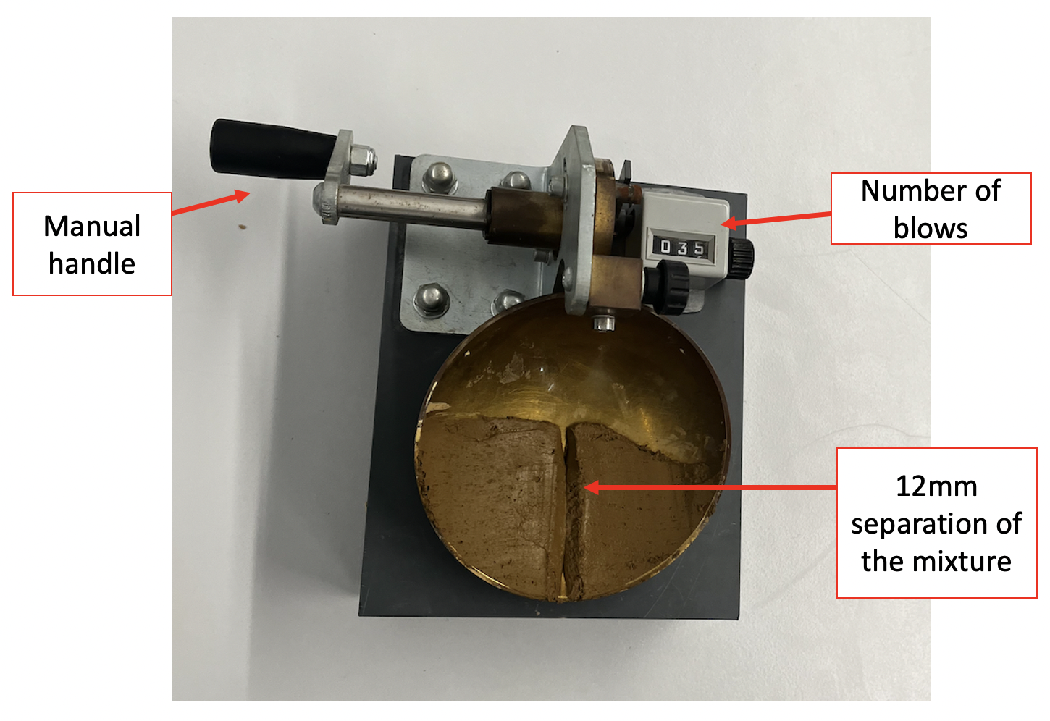
Figure 1: Showing the Casagrande apparatus. (Joe O’Donnell, 2023)

1.1(g) Shrinkage Limit Test - Containers
Choose three containers, mark and weigh them. Record the weight of each of the containers.

1.1(h) Shrinkage Limit Test – Clay Samples
Thoroughly massage the clay sample and if required add dried clay to adjust the moisture content or add a very small amount of water. Mould into a small ball by rolling it in your hands to encourage the mixture to dry out slowly. This is caused by the warmth of your hands. When cracks start to appear, divide the ball into 3 parts that weigh approximately 10g each.

1.1(i) Shrinkage Limit Test – Rolling the samples
Using the glass rod, roll each ball individually into a long thread on the glass plate. This thread is to be rolled 6mm diameter thick. Using an unwavering rolling pressure (this needs to be maintained at a similar amount of the pressure throughout the test), roll this thread to around 3mm with the palm of your hand or even with fingertips. This process needs to be repeated until the thread starts to crumble at 3mm.

1.1(j) Shrinkage Limit Test – Wet Soil content
Once the sample starts to crumble, this is from the lack of moisture content left in the mixture. This crumbling point is the Plastic Limit moisture content. Gather any crumbs made and place them on the container and weigh the wet soil and container together. Repeat the process for all three samples gathered.

1.1(k) Shrinkage Limit Test – Moisture Content
Dry the sample inside the oven. Once dried, calculate the moisture content by weighing the dry soil and container together. Average your results to get an accurate moisture content. This average moisture content is the Plastic limit moisture content indicator.

1.2 Calculate Plasticity Index
To calculate the plasticity index, subtract the plastic limit from the liquid limit. This gives an indication of the soil’s ability to deform before it cracks.

1.3 Results
The results from the Atterberg limit test are used to clarify the soil according to its plasticity. Depending on if the soil is low or high in plasticity will confirm if it’s a sandy soil to a clay soil.

1.4 Result and Analysis

The results of the test for both the Liquid Limit Test and the Plastic Limit Test are below in Table 1.

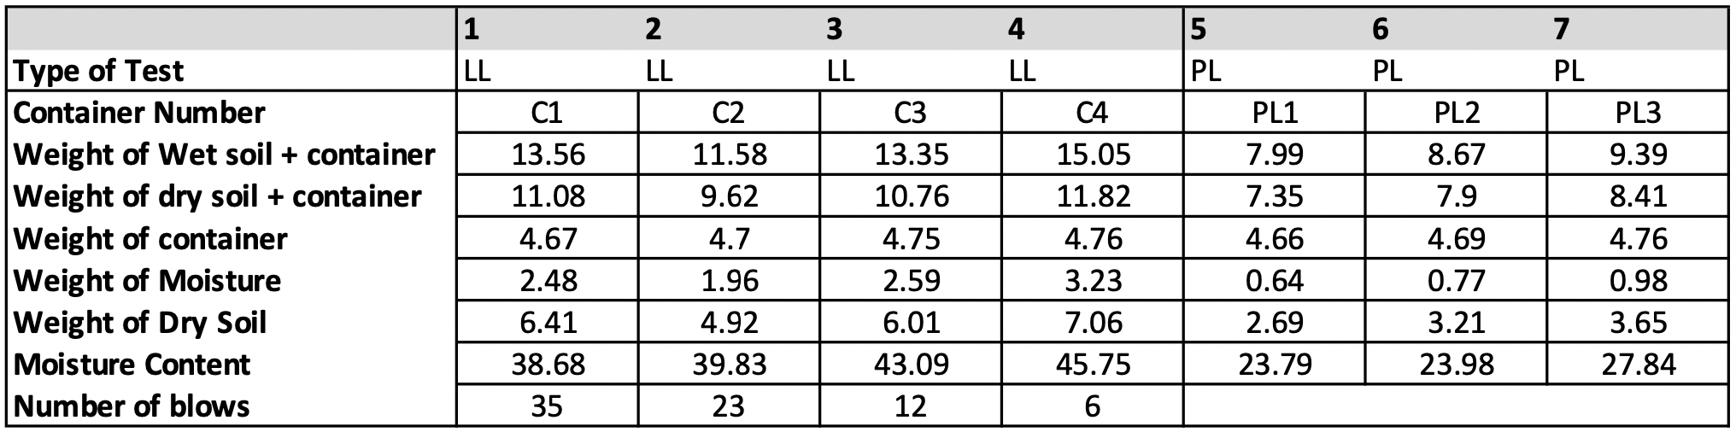
Figure 2. Highlighting the results from the Atterberg Limit Test

1.4(a) Number of Blows
The first set of analysis examine the impact of increasing the amount of water in the mixture effects the number of blows it took to separate the mixture to 12mm. When 1-2ml of water was increasingly added to the containers, it was noticed that the number of blows significantly decreased. The first container (C1) took 35 blows to get to the 12mm separation and the last container (C4) took only 6 blows to get to the same separation.

1.4(b) Comparison of Wet soil & Dry soil
Changes in weight of wet soil and dry soil (including containers for both) were compared for each of the containers. By using the calculation, Weight of Wet soil – Weight of Dry soil, this will give an answer to the weight of moisture for Liquid Limit Test & Shrinkage Limit Test. Reflecting on the results in the table above, the weight of moisture naturally increased on containers C1, C3 and C4 as water was added to the mixture. In the Plastic Limit Test, the weight of moisture increased as well, but the amount it increased was a lot less.

1.4(c) Moisture Content
The moisture content for each test was carried out by averaging the results for each container to get an accurate answer on the amount of moisture in the soil sample. The moisture content is worked out by a percentage. This equation is (weight of moisture / weight of dry soil) x 100)). For the Liquid Limit test, the moisture content percentage ranged from 38.68% to 45.75%. This gave an average of 40% moisture content for the four containers. The Plastic Limit test moisture content ranged from 23.79% to 27.84%, averaging at 26% moisture content.

Figure 3: Diagram of the liquid limit analysis.

1.5 Conclusion
The experiment carried out was successful as it provided an answer to the test as research found out that the soil is uniform.
There was a significant positive correlation between the increase in water led to an increase in the amount of moisture content in both the Liquid Limit Test and the Plastic Limit Test. A Limitation to the Liquid Limit test was the amount of water added was not measure as accurate as it should be. This is shown in the lack of increase in results comparing container C1 & C2. To improve on this in the future, it is strongly recommend using as syringe to accurately measure the amount water in ml that is added to the mixture. The test for both the Liquid and Plastic limit test also tells researchers about the stability of the soil from the Plasticity Index. The plasticity index (PI) of a soil exhibits the shear strength and resistance. Depending on its PI Level will give a clear indication of whether it has strong or weak resistant. Soils with a high Plasticity Index tend to have a strong shear resistance and strength stability in comparison to low Plasticity index. Soils with a high plasticity index are less likely to be vulnerable to slope failures than low plasticity index. (Okendro, M. (2017).

2.0 The Sieve analysis

2.1 Introduction
The sieve analysis is a test used to analyse particle distribution sizes of granular materials. This is carried out by separating particle sizes as the pass through a series of different size sieves that progressively get smaller in size.
The equipment required for the sieve analysis is a set of sieves that have different mesh sizes. These will be fixated on a sieve shaker that encourages the particles to separate. A pan will be used to collect materials the pass through each of the sieves. A hard brush will be required to help extract any particles stuck in-between the mesh.
The sample for the experiment is placed in the top sieve as this sieve has the largest mesh. The stack of sieve is shaken for certain amount of time that is decided before starting. Normally, 1 or 2 minutes. The amount of time shaken will be done the same throughout each seize and will determine the average particle size.
Sieve analysis is used in a variety of different industries such as construction, mining and agriculture. It helps these industries provide quality and consistency of their products. It is mainly used for environmental studies to analyse soil samples. The sieve analysis test is covered in the British Standard ISO 3310-2, this covers the different types of sieve plates and their sizes. (Dream Civil. (2020).

2.2 Methodology

2.2(a) Collect the sample
Collect a sample for the test that represented the entire area that you want to know the particle sized for. The sample for the area should be approximately 1kg in weight. It is important that the sample used represents the batch as it will lead to false results. Mix and split the results in a tray evenly into 4 different areas.

2.2(b) Sieve size and weight
All sieves need to be of the different mesh sizes that will be suitable for the particle sizes. The most used sizes range from 600 microns to 75 microns ranging from 6-8 sieves. Weigh the sample and record the weight prior to pouring the sample into the first sieve to the nearest 0.1g. Most sieves have their weight stamped on them on a label on the side of them.

2.2(c) Stack sieves
Stack the sieves in order of their sizes. The top sieve needs to be the sieve with the largest mesh at the top going to the shortest mesh at the bottom. This ensured the particle sizes for each sieve are in their accurate category.

2.2(d) Start sieving process
Place the entire sample into the top sieve. Once poured, make sure the brackets on each side of the sieve are screwed on tightly. Once tightened, turn on the mechanical shaker for the set amount of time that was decided for each of the sieves. The time shaken needs to stay accurate for each sieve. The mechanical shaker should shake the soil sample for 2 minutes.

2.2(e) Weight of material
Weigh the amount of particle sizes collected from each sieve. Ensure to brush any particles that are stuck in the mesh into the next lower sieve to reduce loss of materials using a bristle brush. The weight of each sieve is to the nearest 0.1g. Repeat this process for each sieve until completion.

2.2(f) Calculate particle size
The weight of distribution for each particle size from the individual sieves need to be checked. This is carried out by taking the weight of material from each sieve, away from the total soil sample. Once this is done a percentage of each sieve can be worked out from the total amount.

2.2(g) Complete results
Asses the particle distribution to understand average and mean particle size for the batch sample carried out.

2.2(h) Repeat test if required
If required, repeat the test to get more accurate results. This can be done by changing the length of time when shaking the sieves. If there is a significant loss of sample noticed, the test needs to be repeated.

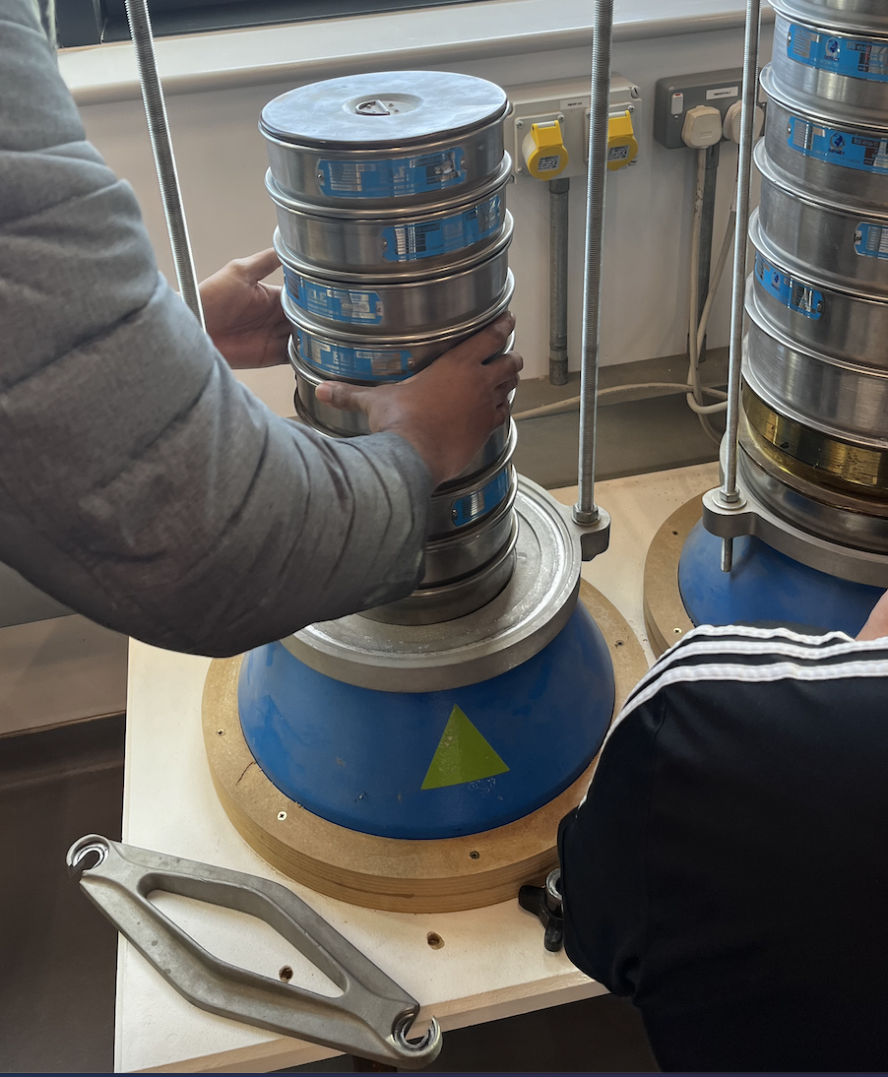
Figure 4: Showing the Sieve getting stacked into correct sizes of sieves

2.3 Results and Analysis
The set of results examined for the sieve analysis test gave an accurate result for the soil sample tested as there was less than 0.2% lost in passing. Please see the table and diagram below in Figure 3 and Figure 4.

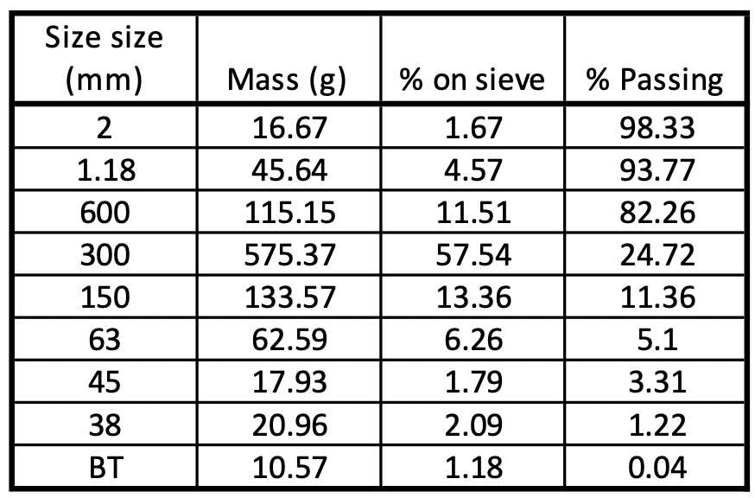
Figure 5: Table of Sieve Analysis

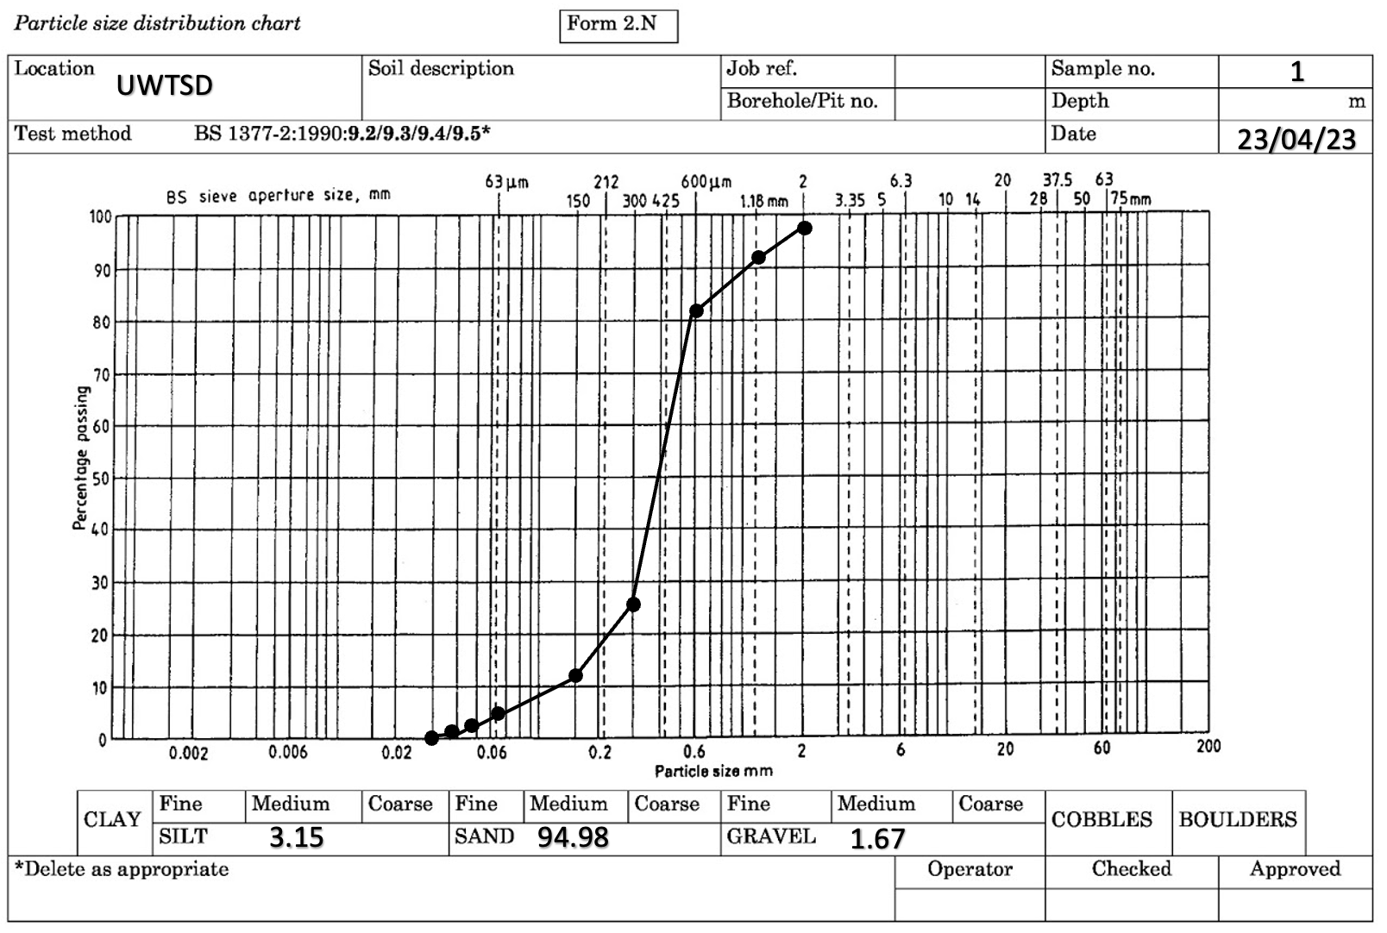
Figure 6: Diagram of Sieve Analysis

2.3(a) Reporting Results
The table above in Figure 5 showed that most of the granular size stopped passing through sieve size 600mm and decreased significantly once the soil sample reached the 300mm sieve. From the results received, this allowed the researchers to report how much silt, sand and gravel made up the soil sample by the number of particles that get through each sieve. The diagram in Figure 6 above, highlights a notable drop in the percentage passing from 600 to 300 sieve size. It is apparent from this table that most of the soil sample is sand, with a small amount of gravel and silt.

2.3(b) Analysis of Test
The test for the sieve analysis helped provided the researchers with the amount of clay, sand and silt in the report. There were no significant differences found from the sieve sizes 63mm to the bottom tray. The particle distribution chart shows that 94.98% of the sample area is made up of sand. This correlates to the explanation of 82.26% passing between third and fourth sieve sizes.

2.4 Conclusion
The main goal of the current test was to determine the distribution of particle sizes from the soil sample tested. This test gave a clear indication of percentages of the different types of soil from the sample and appeared that most of the soil is made up of sand. The research extended the knowledge of the area so that depending on the reason for the use of the land (i.e., construction project) will have better understanding of what type of soil they are working with. There are limitations to the test that can be improved for next time such as the plastic sheet still used to gather particle distribution still had dust recorded on it. This meant that small particles were lost from the test. Cross contamination also effected the test as it was noticed that small parts of the brush were in the particles from the brushing of the sieves. The environment of where the test was carried out can also play a part in the test due to humility levels. A recommendation for the test would be for the research to do a humility test in the building they’re planning to do the experiment to ensure it did not affect the results.

3.0 Constant Head Permeameter Test

3.1 Introduction
Constant head permeameter is a laboratory test used for soils with higher permeability. It is a device that measure the hydraulic conductivity of soil. A constant head of water is maintained whilst doing the test. Once the equilibrium flow has been reached the rate of the flow is measured. Once this is measured, the coefficient of permeability (K) is calculated. This is calculated by K = (Q x L / A x h x t). To ensure accuracy of the test, there cannot be air in the sample as this would incorrectly measure the permeability. Prior to starting the test, this needs to be checked. This test will provide the soil property and the rate at which water passes through the soil. Please see the diagram below present the constant head permeameter test. (The Constructor (2018). Please see below in Figure 7 a highlighted drawing of the constant head permeameter test:
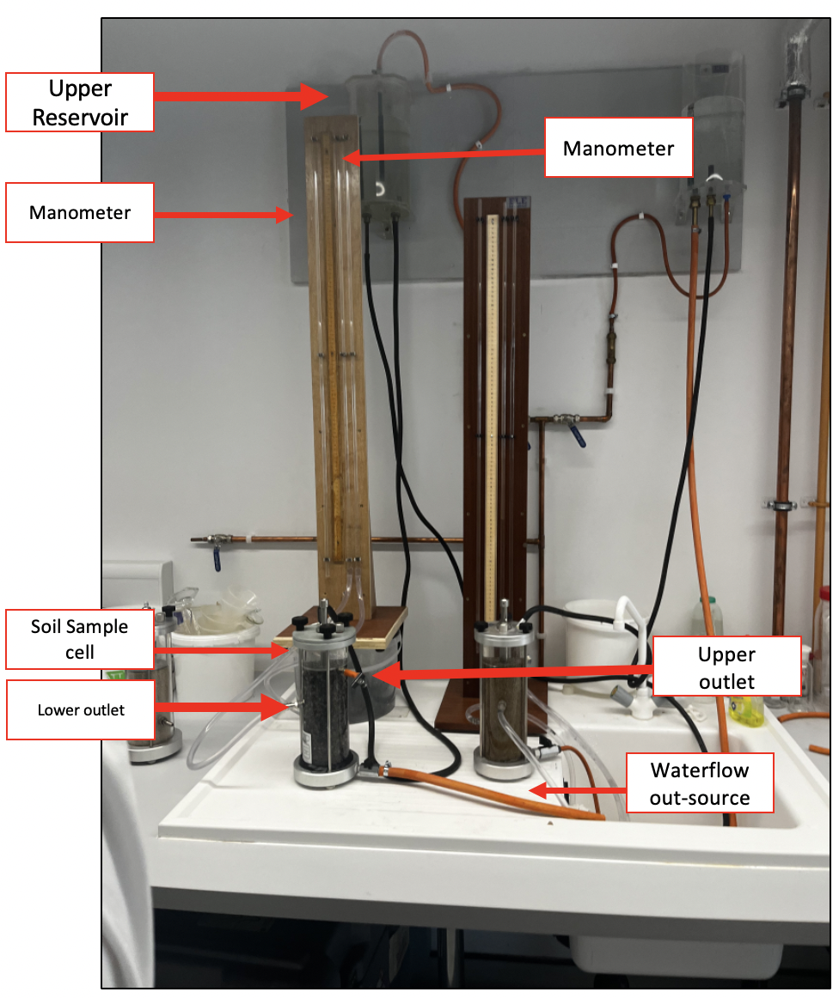
Figure 7: Representation of the constant head permeameter test (Joseph, O’Donnell, 2023)

3.2 Methodology
3.2(a) Collect sample and prepare
Collect a representation of the soil sample and remove any debris. Crush any large particles to ensure a uniform particle size distribution. Place the soil sample into the test cell and make sure the test cell is very compacted with the soil with no voids.

3.2(b) Pour water into the test
Fill the cell with water and allow it to saturate the soil sample using a constant head of water that is maintained throughout the test. Open the valve to initiate the difference in the hydraulic head (h).

3.2(c) Record water and time
Record the amount of water passing through the sample and have the amount of time consistently done using a graduated cylinder. This should be either 30 seconds or 1 minute.

3.2(d) Hydraulic Gradient
The hydraulic gradient can be measured by the difference in the two manometer tubes. This is then divided by the height between the manometer connections to the cell sample.

3.3 Results and Analysis
At the start of the test the difference in height was measured first of the manometer tubes and it was found to be 40mm in difference connecting to the cell sample. The diameter of the vessel was measured by three different researchers and was confirmed 79.3mm. The time used to measure the water passing through the sample was 30 seconds and this was completed five times. This ranged from 128ml to 150ml. During the test, the amount of water sampling through reached 145ml three times out of five. From these results, the coefficient of permeability (K) is measured at 9.076x10-7. The workings out are below:

t = 30 seconds
h = 0.041m (converted into metres)
A = 4.939m ($A=πr^{2}$)
L = 0.070m (converted into metres)
Q = ${4.83}^{-6}$ (145ml / 30 seconds = 4.83ml/s, converted to m/3)

K = (4.83⁻⁶ x 0.070) / (4.939 x 0.041 x 30)
= 9.075511635x10⁻⁷
= 9.076x10⁻⁷m/s

3.4 Conclusion
This report provided the calculations to the constant head permeameter test and can be used directly for geotechnical engineers to carry out similar work to area that they want to sample. The limitations to the constant head permeameter test are that the test assumes the
flow of water through the sample is laminar. Whilst carrying out the test, the researchers did not set up the constant head permeameter, therefore it was assumed that it was tested correctly and secured. Also, the time tracking the flow could had been done more accurately as the start time was delayed multiple times and restarted. Overall, the test was an accurate experiment, as it was successful in providing the coefficient of permeability.

4.0 References
Backus, B. (2019). Atterberg Limits: A Quick Reference Guide. [online] GlobalGilson.com. Available at: https://www.globalgilson.com/blog/atterberg-limits-a-quick-reference-guide.

Dream Civil. (2020). Sieve Analysis | 4 Types Of Sieves | Lab Procedure | Advantages & Disadvantages Of Sieve Analysis. [online] Available at: https://dreamcivil.com/sieve-analysis/.

Okendro, M. (2017). Physical Properties of Soil and Its Implication to Slope Stability of Nungbi Khunou, NH-150, Manipur. International Journal of Geosciences, 08(11), pp.1332–1343. doi:https://doi.org/10.4236/ijg.2017.811077.

Soil Properties (n.d.). Available at: https://www.abg-geosynthetics.com/wp-content/uploads/ABG_Soil_Properties___Atterberg_Limits_TECH_NOTE.pdf.

TheConstructor (2018). Permeability of Soil by Constant Head Permeameter - Objectives & Procedure. [online] The Constructor. Available at: https://theconstructor.org/geotechnical/soil-permeability-test-constant-head/2993/.
‌

‌

