1/11/2021
Web Development and Database Concept
Gower College Swansea
Task 2:Report
Daniel Thomas Jenkins JEN15826622

Assignment Title
Contents Page
Introduction 3
Requirements 4
Implementation 4
Screenshots 5
Index page 5
Beaches Page 5
Swansea City Page 6
Attractions Page 6
Contact Page 7
Validation 8
HTML 8
Index.html 8
Beaches.html 9
City.html 10
Attractions.html 10
Contact.html 11
CSS 11
Evaluation 11
Usability 12
Improvements 12
SEO 13
Type of SEO used 13
Tags Used 13
Accessibility 15
References 16

Introduction
To introduce the report that makes up the total of Task 2, I will need to look back onto the website that I have created in Task 1.
This would include the headings which have been listed in the table of contents therefore explaining the details of the website’s requirements, implementation, screenshots and development of the website, the validation for the website and the evaluation.
The requirements section of Task 2 will explain everything that was previously required for usage on the website which will contain key points for discussion such as the website’s target audience or the potential topic that the website is based on.
The implementation section of Task 2 will consist about the details regarding the actual webpages that have been featured on the website and will also contain the required validation for the website which is what validates its accessibility.
And finally the evaluation section which consists of looking back on my previously created website and explaining they main points for discussion regarding the website’s accessibility, if the website can be found via a search engine and if the website is overall useful for the target audience.

Requirements
To begin with discussing the requirements for this website, I would have taken into deep consideration regarding the potential target audience of people which may be interested in visiting Swansea for a holiday or maybe to potentially pique their interest in moving there.
To fully describe the purpose of this website, its main purpose would be a method to help introduce and to invite visitors from different parts of the world to Wales and to help further improve the public image of Swansea.
One way to view the overall usefulness of the website would be to consider it a form of advertisement for potential tourists which are looking for a new location to visit, and by doing so it would bring more beneficial factors to Swansea and Wales such as more money coming into both Wales and Swansea. Tourism would also help to provide more jobs for people in Swansea, especially for smaller and larger businesses. [1] This would become possible for the advertisement which is featured on the website and briefly mentions the usage of businesses in Swansea which would be generally good for the economy.
One of the main essential points that need to be considered with the requirements for the website, it will need to have accessibility features for many aspects of the website. This would be entirely relevant for people that may be disadvantaged and may require some specialised software to help them read and understand the contents of the website. This will include accessibility features such as alternative text for images, this will be essentially useful for users which have problems with their vision.

Implementation
To discuss the implementation which I needed to consider for this website, I would’ve had to consider how I would’ve used a feature on the website such as the usage of images as well as a mouseover function on the website.
One of the other main key points that I had to consider would be any potential accessibility features that I had to consider using on my website and to understand the importance of the contrast on the website for user which may have some issues with their vision..

Screenshots

Index page
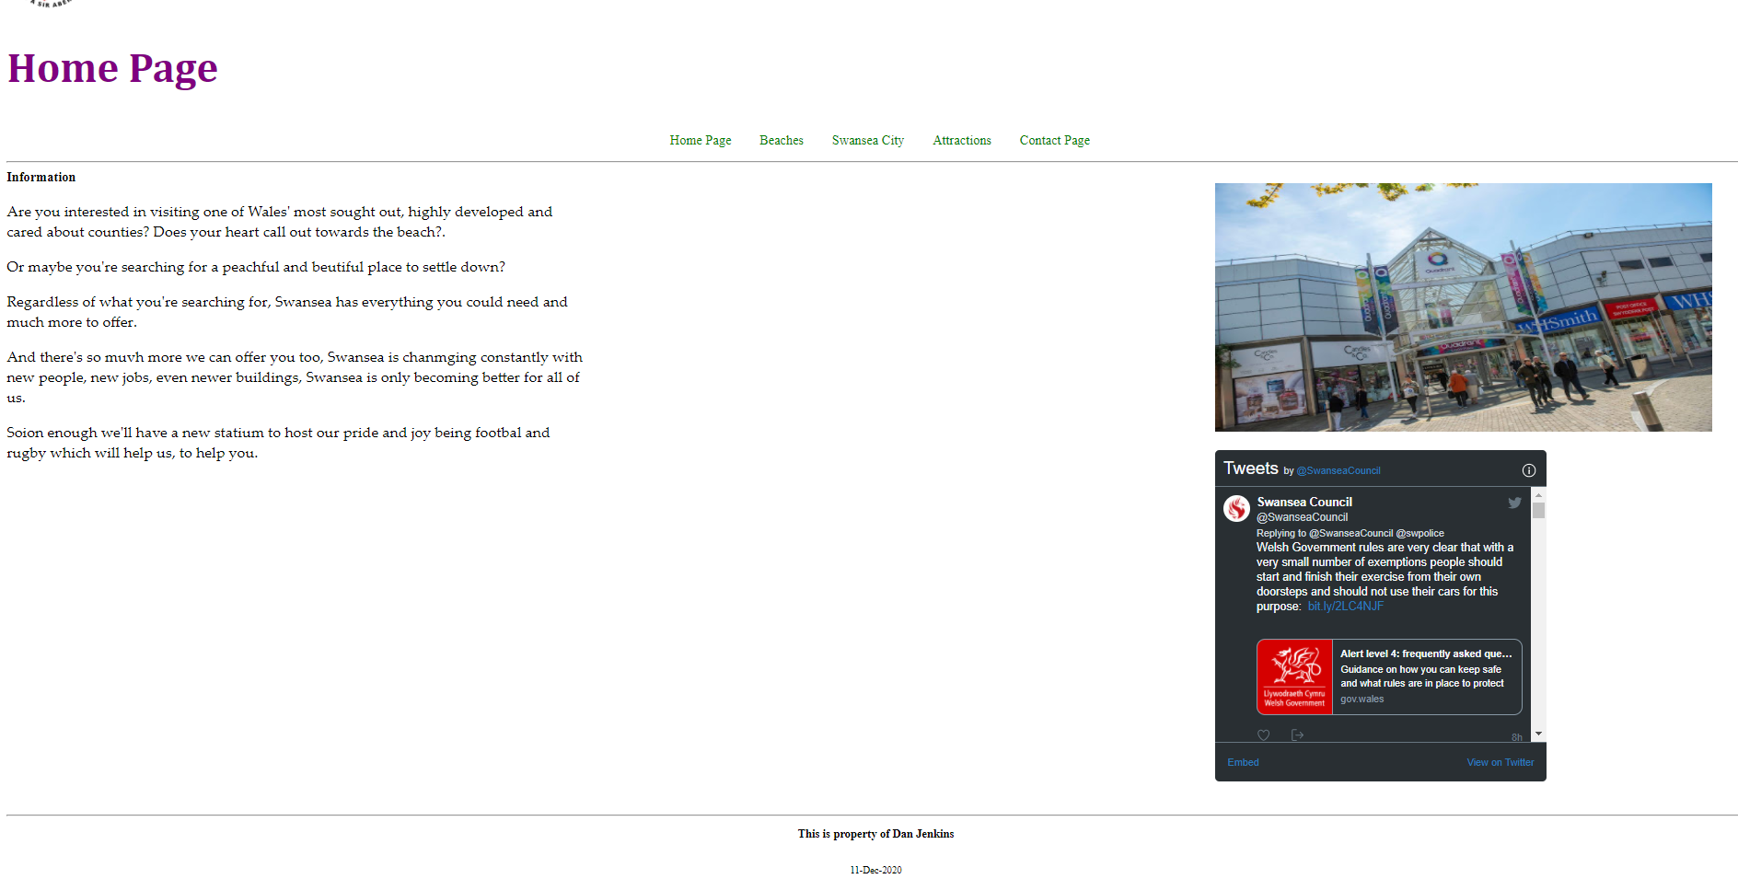
The index page is the first page that the user sees and is designed to give them a brief welcome to the website.

Beaches Page
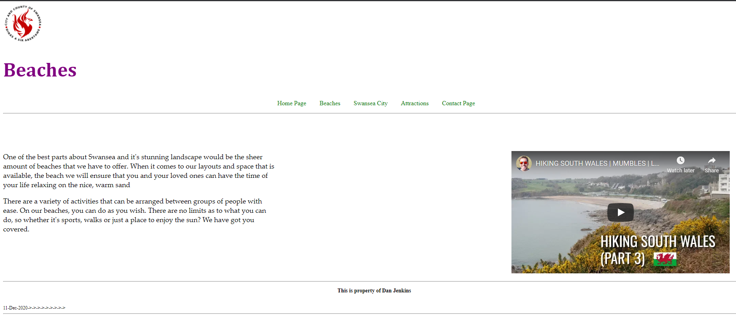
The beaches page would be primarily used to help advertise the beaches and other locations that people can spend their time in Swansea, this is also supported by a YouTube video by Simon Heyes where he showcases the beaches of Swansea in a vlog. [2]

Swansea City Page
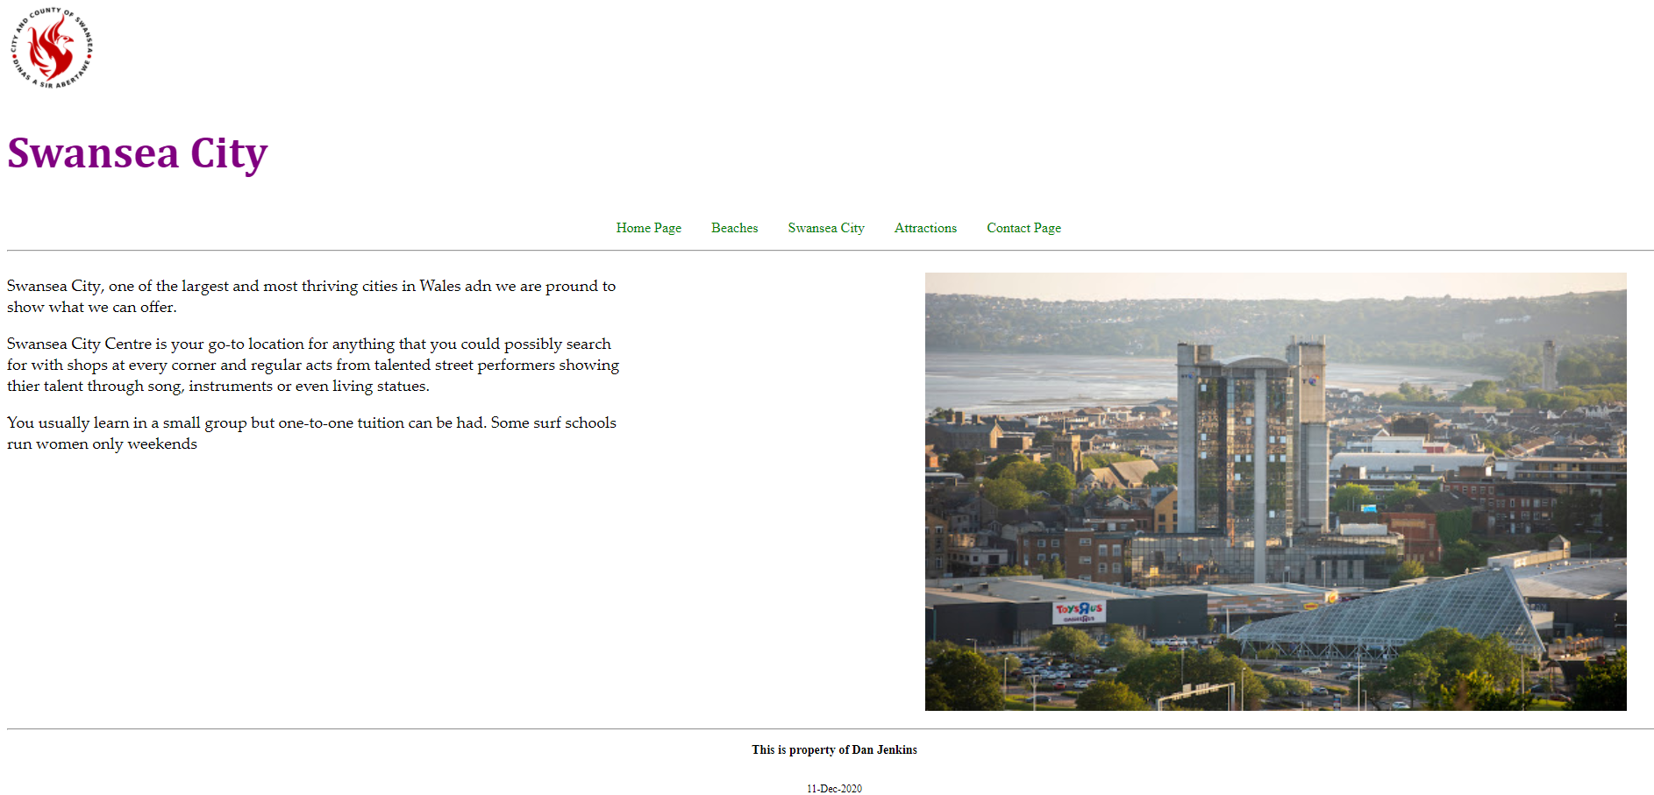
With the Swansea City Page, it’s mainly designed to talk about the shops and other services which are available in Swansea, it also has a mouseover image which allows the user to switch between two different pictures on a website.

Attractions Page
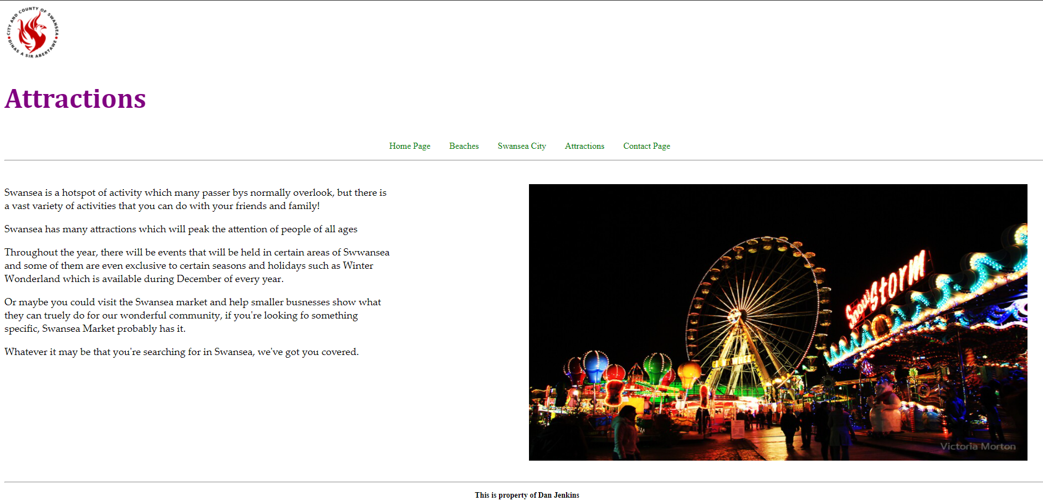The attractions page is dedicated to showing what Swansea has to offer and by highlighting some of the most important areas that Swansea has to offer as well as to talk about the activities that happen around Swansea.

Contact Page
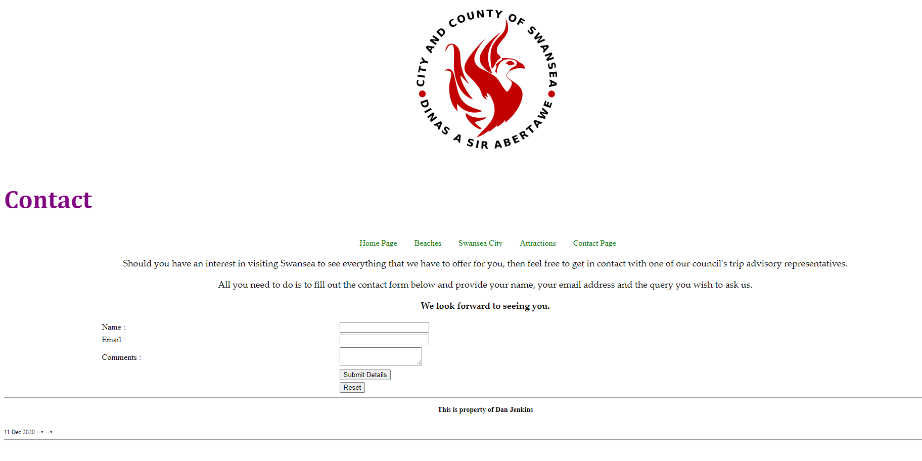
The main purpose of the contact page is as a way for users to get into contact with the owner of the website to ask any additional questions they may have about Swansea.

Validation

HTML
To properly validate the HTML code I will have used a tool created by W3C which checks through your HTML code and highlights any key points that need to be looked at. [3]

Index.html
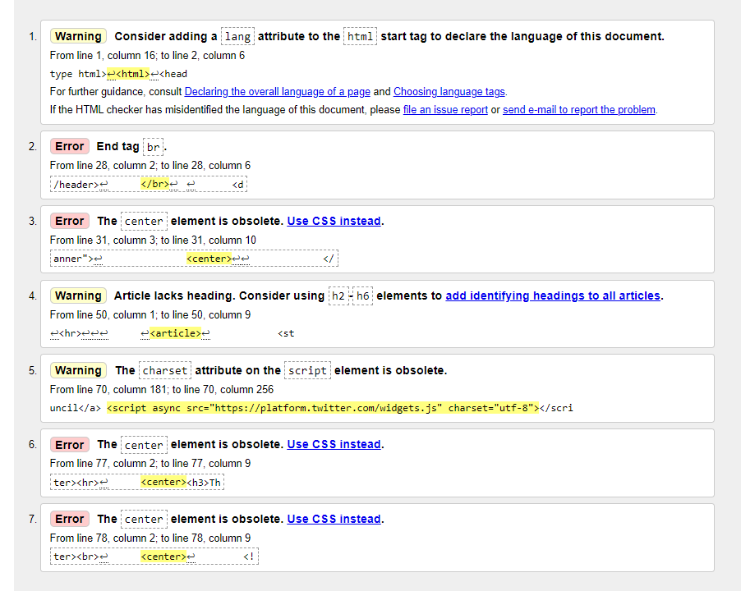
Considering that the majority of the errors that are present in my Index page are very minor mainly being the result of a few misplaced tags which aren’t necessary, I have removed the tags which no longer have any purpose. The warnings about parts of the HTML being obsolete I haven’t altered since some elements are essential such as the code for the Twitter feed.

Beaches.html
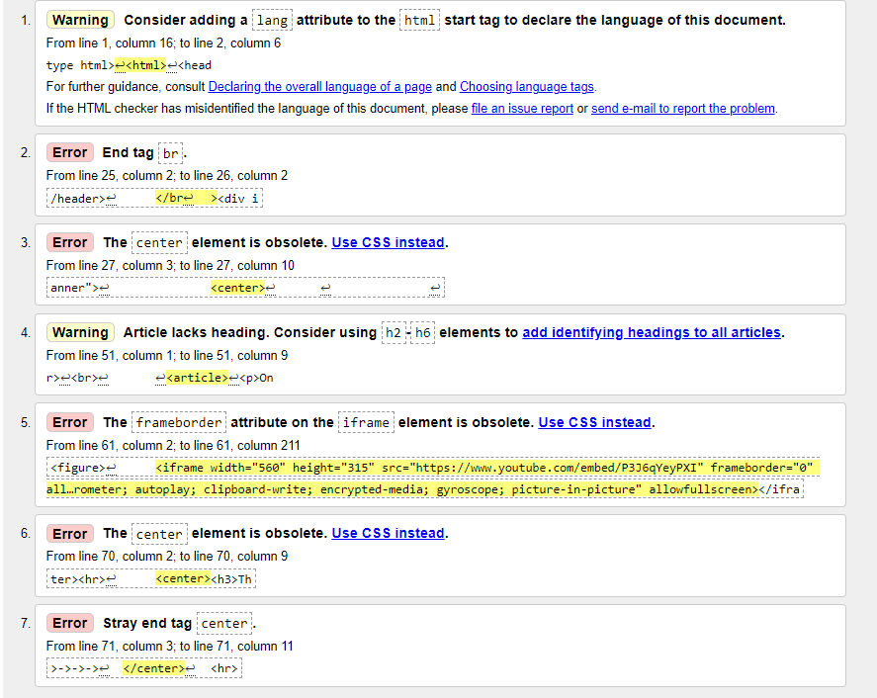
With the Beaches page, I will have done the exact same tasks I did with the previous page by removing the code which wasn’t essential and left the other parts as they were.

City.html
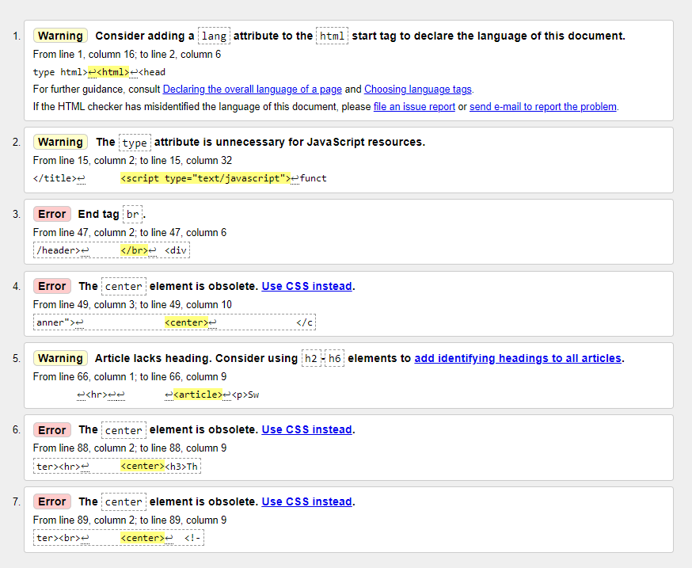
Much like with the other pages, I have removed any code which no longer has any usage and left the rest of the code as it was.

Attractions.html
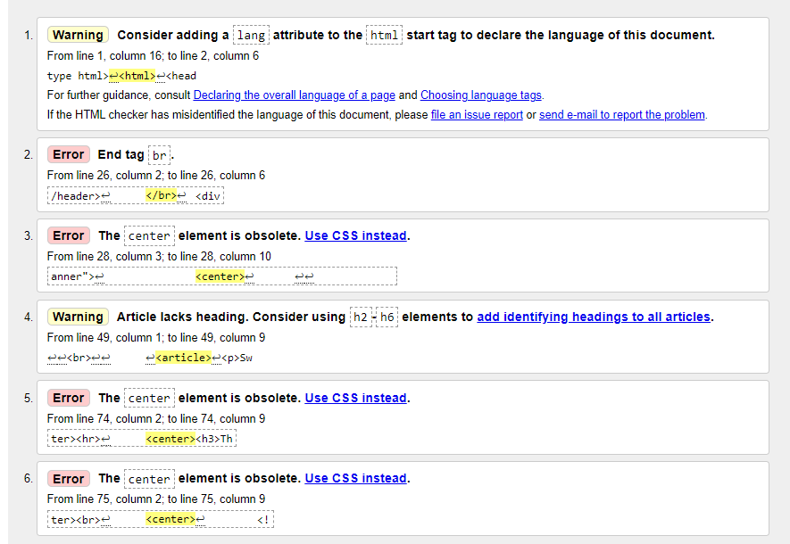
Much like with the other pages, I have removed the code which no longer has any use and left the rest of the HTML code as it was before.

Contact.html
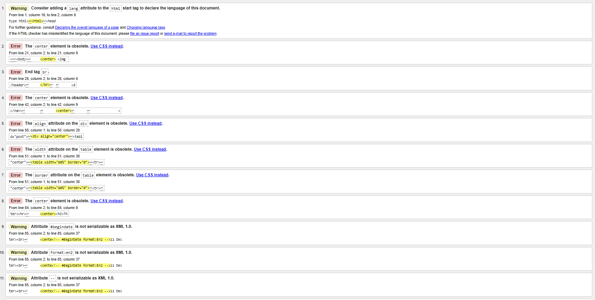
AS I have repeated with the rest of the pages, I have carefully removed any HTML which isn’t required and left the rest of it how it was before to avoid the risk of affecting the contact form.

CSS
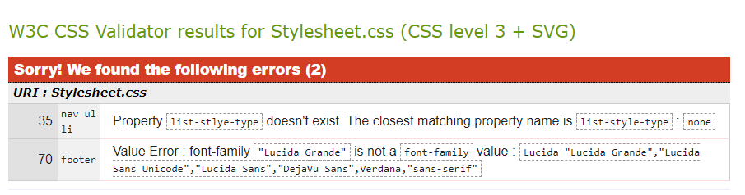
Considering that my Stylesheet in CSS only has two errors, this makes repairing the errors easier to do. With the first error it mentions is about the property name, was changed to the suggested term as suggested on the error report.
The second error mentions that the font I’ve used on the website doesn’t exist, I have amended that by changing the font to Arial which is a font which is valid.
This was made possibly via the usage of W3C’s CSS Validation service. [4]

Evaluation
When evaluating the usability of my created website, there are a variety of good points to make, and there are some other points to further discuss improvements which can be made to the website which would be beneficial for future modifications.

Usability
To begin with discussing the general usability of my website, it is fully capable of allowing the potential user to freely navigate around the different pages which are available on the website, each of the links that are in the navigation work as they are intended to do so by directing the user to the correct pages rather than to not work at all.
Figuring out the navigation wasn’t a challenging task for the website as the code was reusable on the other webpages that are on the website, this was done as a method to reduce the overall time that it would take to create the website. The same would’ve applied for the HTML required to place the navigation in its intended location on previously mentioned webpages.
On the website, I have also decided to use a variety of images to help my encourage my target audience to visit Swansea, all of the images I have decided to use are relevant to the website’s topic since all the images were taken somewhere in Swansea.
To discuss the information which I have decided to use for my hand-made website, I have personally written the text which has been used on each of the webpages. I have ensured that the information I have used is relevant to their designated webpages which causes no further issues to the website’s design or content.
I have also ensured that the text that I have typed for each webpage is both informative but remains brief in order to allow the potential users to further explore the rest of the website. This would be increasingly beneficial for my specified target audience because they would be searching the website for a brief but informative description which is specifically designed to persuade the users to consider visiting Swansea.
But one of the main features which I have decided to use on my website would be the usage of a live Twitter feed for the official Swansea council account. The usage of the embedded Twitter feed would allow users to have some link to the Swansea Council’s twitter account where they can see any important updates that they may need to take note of regarding any potential large events that can take place in Swansea as well as any important COVID-19 news in the Swansea area. The Twitter feed was able to be implemented into the website via Twitter’s official embedding tool which was used to allow the feed to be present. [5]

Improvements
When discussing the potential improvements that I could consider for this website will mainly go into the more aesthetic side of the website instead of the technical functionality of the website.
The aesthetic side of the website is very lacking in the general detail on the website which is genuinely the area which requires the most attention for improvement due to amount of detail which is present on the website.
The colour scheme which is used is very plain using white and red which isn’t the most visually appealing design for the website. Whilst the rest of the website is fully functional in the features that are present, they would be more effective to the target audience since the website would both look pleasant and being functional too.
But with most users including people that are planning their next potential holiday destination, a website which lacks aesthetic qualities will likely cause them to leave the website to find another one which looks more aesthetically pleasing regardless of whether the information that is present may be the field that the rival website is lacking in.

SEO

Type of SEO used
Meta tags

Tags Used
Webpage | Keywords
Index.html | Swansea  Information  Home Page  Swansea City  Wales  Swansea Council
Attractions.html | Swansea  Mariana  City Centre  Quadrant  Winter Wonderland  Events
Beaches.html | Swansea  Beaches  Langland  Rhossilli  Tourism
City.html | Swansea  Swansea City  Wales  Shops  Town
Contact.html | Swansea  Council  Swansea City  Contact  Form  Questions  Support

With the SEOs (Search Engine Optimisation) that I have used on my website, I have used a variety of keywords which are relevant to both the webpage and the content which is present on the page. This was done by using the “meta” tag which is what helps search engines and web crawlers to pick up keywords in the HTML code for the website. [6]

Accessibility
When discussing the accessibility of the website, it will be important to consider all possible precautions to consider to make sure that your website is suitable and understandable for anyone who may have some form of disability of any potential issues with seeing or reading the text.
One of the main points for accessibility to take into consideration for creating the website would be to understand the importance of contrast in the website. A reference form the Bureau of internet accessibility states “Website users who have low vision, low contrast vision, or vision deficiency will require choices that adhere to the Web Content Accessibility Guidelines (WCAG)” which would suggest that the contrast on a website would need to go through extensive measures to ensure that all users are capable of reading and understanding the website. [7]
There are a few tools which are capable of assisting you with meeting the WCAG 2.1 guidelines, one of the main tools that I have personally used to check if my website is suitable for all users would be Contrast checker by Acart Communications which is a tool which allows you to enter in the colours that you have used on your website therefore telling you how suitable the contrast of colours are on your website. [8]
Another tool that I have used to help me figure out if the contrast that I have used is acceptable for all users would be Juicy Studio’s “Luminosity Colour Contrast Ratio Analyser” which works in a very similar way to the Contrast Checker by Acart, you still need to enter the background colour and foreground colours that you have used. [9]
Considering that I haven’t exactly used too many colours for the website, which has made my website acceptable since I also used black text on a white background therefore making the text readable. But to add on to some of the other features that I have implemented into my website, I have also used alternative text for the images that are present on the website which would be essential for someone who is visually impaired therefore preventing them from seeing the contents of an image. This would often be used with software which narrates the text on a website.
One of the many potential valid examples of software which could be used would be Natural Reader which is a text to speech software which has its own dedicated “WebReader” to read the text that is on screen, this is also suitable for all users since it requires “No coding knowledge or experience needed.” This would be essential for users which don’t’ know what they’re doing so a software that’s as simple to use as this would be essential. [10]

References

[1] | Y. Yehia, “GlobalEdge,” 3/26/2019. [Online]. Available: https://globaledge.msu.edu/blog/post/55748/the-importance-of-tourism-on-economies-a#:~:text=Tourism%20boosts%20the%20revenue%20of,many%20different%20areas%20is%20significant..
[2] | S. Heyes, “YouTube,” 24 04 2019. [Online]. Available: https://www.youtube.com/watch?v=P3J6qYeyPXI.
[3] | W3C, “Markup Validation Service,” W3C, 2013. [Online]. Available: https://validator.w3.org/#validate_by_upload.
[4] | W3C, “The W3C CSS Validation Service,” W3C, 2014. [Online]. Available: http://jigsaw.w3.org/css-validator/validator.
[5] | Twitter, “Twitter/publish,” Twitter, [Online]. Available: https://publish.twitter.com/#.
[6] | K. Morris, “Moz,” Moz, 24th July 2019. [Online]. Available: https://moz.com/blog/the-ultimate-guide-to-seo-meta-tags#:~:text=Meta%20tags%20provide%20information%20about,search%20engines%20and%20web%20crawlers..
[7] | Bureau of Internet Accessibility, “boia.org,” 1 10 2018. [Online]. Available: https://www.boia.org/blog/the-basics-and-importance-of-color-contrast-for-web-accessibility#:~:text=Color%20contrast%20refers%20to%20the,can%20be%20read%20by%20everyone..
[8] | Acart Communications, “Contrast Checker,” Acart Communications, 2017. [Online]. Available: https://contrastchecker.com/.
[9] | Juicy Studio, “juicystudio.com,” Juicy Studio, 2000. [Online]. Available: https://juicystudio.com/services/luminositycontrastratio.php.
[10] | NaturalReader, “NaturalReaders,” NaturalReader, 2020. [Online]. Available: https://www.naturalreaders.com/.

