Developing workplace critical thinking BMSW 5101
Critical thinking and beliefs, attitudes, and value systems on workplace behavior at Grodzinski Bakery
Student name: Andreea Esanu
Student number: 1713835
Lecturer name: Dr Gregory Cowan



Table of Contents
Introduction 2
Grodzinski background 2
Company`s beliefs, attitudes and value systems 3
What are beliefs? 3
What are values? 4
What are attitudes? 4
Workplace critical thinking and problem solving 6
Critical thinking at workplace 6
Problem solving at workplace 8
RED Model of Critical Thinking 8
Contingency Theory 10
Workplace changes for the post-COVID mindset 11
Conclusion 14
References 15

Introduction
Workplace is one of the most common places where people are facing problems which entails more than the skills of logic analysis in order to resolve the conflicts. Employees must be ready to act and think differently, and those who can engage in critical thinking are reflective, independent and competent. Individuals and teams who are practicing critical thinking are more effectively in diagnosing problems and identify possible solution that aren’t entirely obvious at first. Because they logically connect ideas, finding inconsistencies and errors in the work of others, solving the problems and engage in reflection.
This report critically analyses the beliefs, attitudes, and value systems of the Grodzinski Bakery, and discuss their impact on workplace behaviour, supported by critical thinking and management theories such as RED Model, De Bono`s 6 Thinking Hats, and Contingency Theory. Therefore, all these topics will be connected to the current world situation, meaning the changes that have taken place for the post-COVID mindset.

Grodzinski background
In 1888, immigrants Harris and Judith Grodzinski arrived in England, fleeing Czarist persecution. Judith set to work making bilkelech (sweet rolls) in a rented bakery, and Harris took them to market each morning. Business flourished, and the couple soon opened their own bakery in the East End, the heart of Jewish settlement in the late 19th-century England (British Baker, 2006).
By the mid-1960s Grodzinski was the largest kosher bakery in Europe, preparing both fine pastries and a range of breads, and adding to their retail business a thriving wholesale operation distributed through such British institutions as Selfridges, Marks & Spencer and Harrods.
During his mayoral campaign, on Thursday 5 April 2012, Boris Johnson visited Stamford Hill and made stop at Grodzinski`s Bakery (Hackney Citizen, 2012). He also visited the other branches, in Golders Green (see the picture below), where after that he wrote on his twitter that he had made “some ‘Get Brexit Done’ donuts at a wonderful bakery in Golders Green”, thanking to everyone who came to say hello.
Even with the current situation that world has been through (COVID 19) the bakery has not been closed even for one week. Because it is placed in middle of a big Jewish community, they have their own specific religious traditions and values that do not allow them to behave and act like others. However, this topic will be discussed the following points of the report.
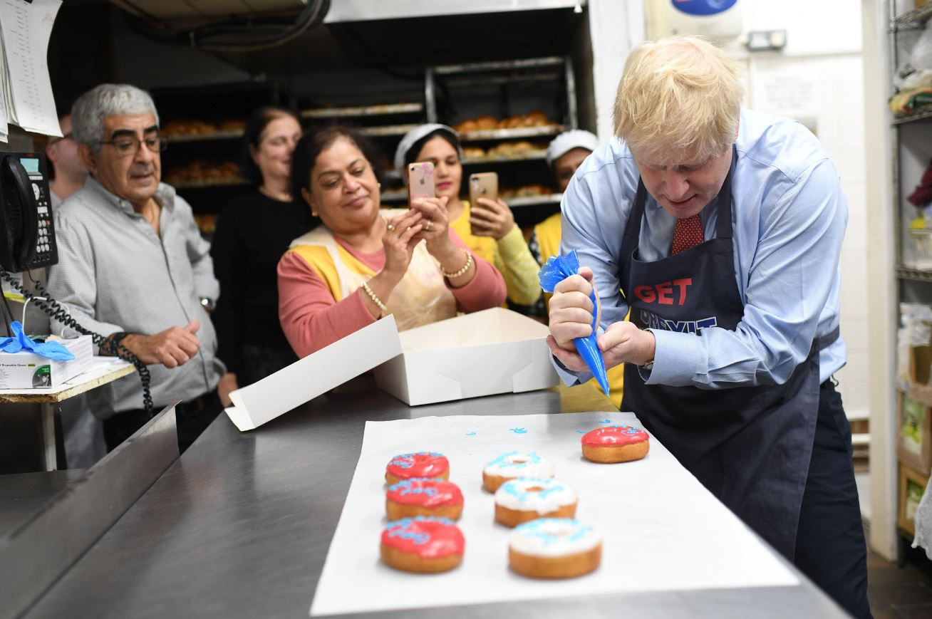
Source: https://jewishnews.timesofisrael.com/boris-johnson-ices-doughnuts-to-woo-jewish-voters-in-key-marginal

Company`s beliefs, attitudes and value systems

What are beliefs?
Beliefs came from real experiences or experiments. A belief is an idea that an individual holds on as being true or real, for example faith in God. According to Shealy (2016) “beliefs are at the very heart of why we humans do what we do, and who we say we are, to ourselves, others, and the world at large, from politics, religion, education, and the arts, to marriage, family, gender, and sexuality” the most interesting thing is the different opinion that we express on such topics whether this beliefs is true or that value is wrong.
Working as a sales assistant in Grodzinki Bakery, wasn’t an easy workplace environment. Due the fact that bakery`s working hours are between 7am until 1am, there was always conflicts between morning shift and night shift. For example, the colleague X which works in morning shift thinks that it is better to keep the container of salad behind the counter in the small fridge, because it will be easy to take when it will be busy in the shop, and here comes the colleague Y which thinks that it better to be put the container in the bigger fridge together with the other containers of vegetable because you will see what else do you need and sometimes, the colleague X forgets the salad there.
Even if they spoke about this incident, there was no change regarding the colleagues` behaviour and they continued to do the same thing. This situation has been reported to the manager who decided that as long there is salad when is needed, it doesn’t really matter if it is from the small fridge or big fridge. So, everyone it is different and raised in the way they think it`s better for them with own beliefs and opinions.

What are values?
Values are defined as important things for an individual based on loyalty and determine his/her priorities. These values guide the way a person lives the live and the decisions there are made, together with the things that that motivate the person, helping to grow and develop in day by day life. Many of judgements that we make are influenced by values and can have an impact on the support we give to others. As you moving through life, your value may change, such as on the beginning of your career, your top priority can be the success measured by money, but after you have a family, work-life balance may be what you value more (Mindtools, 2020). For example, someone who`s an art collector may feel that one single piece of art worth thousand of pounds. And some individual who is not involved in such a hobby may fell that such a purchase will be a waste of money. Because, if you spend money on goods or services, you expect satisfaction from that exchange of resources. It is determined to be a good value if the person exchanging resources feels that he or she received a fair return. This determination of fairness is subjective (Moore and Asay, 2012).
Therefore, companies have to create values for their employees and customers, partners and unions, in order to become great at creating happiness and inordinate value for their shareholders and investors, for attracting the best talent and retain the high value customers (Mahajan, 2016).

What are attitudes?
Basically, an attitude is the way of acting or feeling toward a person, thing or situation. Sir Winston Churchill has said that,” Attitude is a little thing that makes a big difference”. Attitude can be defined as the connection between your value and beliefs, being the primarily response to people, places, or any other things or events in life. It is important to know that there are different types of attitude which can have positive or negative impact, especially employees` attitude on the workplace. Our behaviour at work depend on how we feel about being there. It depends also on your personality and the positivity as a big part of your happiness. It is needed a good fit with the job and company in order to create and develop good relationship with your colleagues. If the job makes you unhappy you and if there is a small chance of solving the problems, you have to know when to leave.
As we can see in the image below, there are few characteristics contributing to job satisfaction and organizational commitment:
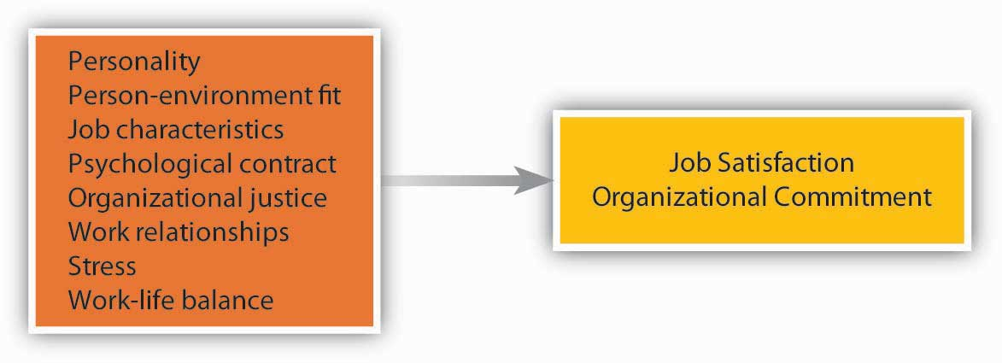
Image source: https://2012books.lardbucket.org/books/an-introduction-to-organizational-behavior-v1.0/s08-01-work-attitudes.html
All these factors contribute to your satisfaction with your job and developing commitment to you company, for a successful business environment, the people pay attention at the way they are treated, and the relationships formed with managers and colleagues.
An employee's attitude has a potential to impact his interactions with others and his individual work performance. Attitude affects an employee's reactions to others, including colleagues, supervisors and customers. Also, attitude can affect his perception of his job and his value to the organization. If an employee's work tasks involve collaboration with others, his attitude can affect the success or failure of the group. Therefore, here is one example of a negative attitude and how this change the work environment.
Working in a bakery isn’t` an easy job, considering the fact that is a Jewish bakery and every employee must pay attention to the customers, because they have some restrictions regarding their religion and culture. Being busy in the majority of time, especially when they have a specific holiday, every employee is trying to do their task and in the same time to pay attention to the serve the customers. One of the new employees (which was in training) after one or two weeks, became very stressful and with a negative attitude, affecting the rest of his colleagues. He was always complaining by being tired, disrespectful with customers. Even if he understood his responsibilities, he wasn’t self-motivated. His behaviour affected the whole workplace environment and because all employees were closed to each other, none of them reported the issue to the managers, because he was still in training and everyone was waiting for him to adapt, but the situation became uncontrollable and we asked the manager to deal with. The manager tried to find out if there is a certain reason, he`s behaving like this, and what is making him so negative at the workplace. He made sure that he was specific about what is causing this behaviour, trying to find a resolution that works for both. In the end the manager decided, after he discussed with every staff member, that if his behaviour is not changing, he will be fired, because these negative attitudes could be a result of home or mental health issues that already were affecting the work life.
Analysing this situation, I can conclude that organisational beliefs, attitude and value systems can affect the workplace behaviour by not paying attention to the employees behaviour and the staff might suffer imbalanced life from practicing organisational values, such as hardworking as organisational value.
Organisational values ensure everyone in organisation is working towards the same goals in accordance with the same principles and sticking to the same standards.

Workplace critical thinking and problem solving

Critical thinking at workplace
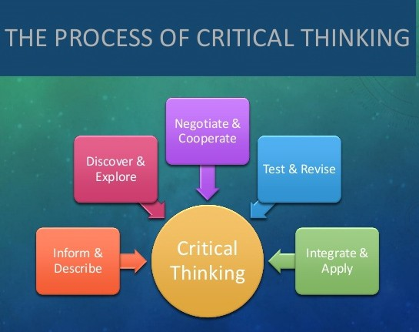
Source: medium.com/@hariskakakhel94/problem-solving-and-critical-thinking-f2623ea8b7b8
Maund (et all, 2017) says that “to think critically and solve problems creatively, we must first understand how decisions are made and the factors influencing our decision-making process”. As we can see in the image above, there is a process to follow for an effective critical thinking. Critical thinking is the ability to use knowledge, data and in order to solve the problems effectively. The skills of critical thinking and problem solving are very needed in every organisation because among these skills is the ability to use logic, such as inductive logic and deductive logic (see the image below).
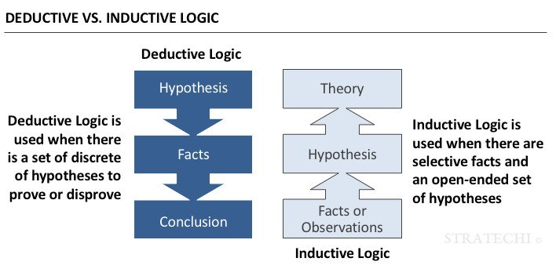
Source: https://www.stratechi.com/deductive-inductive-logic/
The image is showing the difference between the inductive logic and deductive logic. Deductive logic is based on hypothesis, facts and conclusion. Is used when there are facts or hypothesis to prove or disprove something. To be more specific, here is one example of deductive logic at workplace. The manager said the person with the most sales would get a promotion at the end of the year. So, if I generated the most sales, means that I am looking forward to a promotion. On the other hand, the inductive logic is a type of reasoning that involves selective facts and an open-ended set of hypotheses in order to draw a general conclusion widening specific premises out into broader generalizations. I want to mention here, that an inductive argument is also the main type of reasoning in academic life. Here is one example of inductive reasoning from my workplace: All the people that came in the bakery are Jewish, means the bakery is only for Jewish, or the customers are only Jewish.
Therefore, we use inductive and deductive logic every day in our life, helping us to build an understanding of the world.

Problem solving at workplace
Every day, whether we are talking about managers and leaders or employees, each are involving themselves in planning and accomplish their tasks with a large number of team members. And with lack of communication this process can fail and impact the organization from being successful. Daily we are facing, at workplace, tons of situation which needs to be handle properly, like making right decisions, solving problems, managing conflicts, leading efficiently, generating ideas and many more. Each step at workplace demands proper communication that stems from creative thinking which defines the existence and sustainability of an individual working in an organization (Tripathy, 2018). For a better understanding about critical thinking and problem solving, we will discuss in the next chapter of the report.

RED Model of Critical Thinking
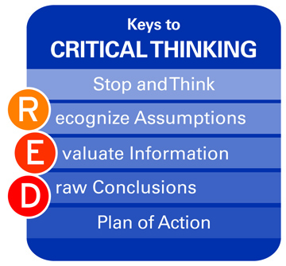
Source: https://thegrowthandresiliencenetwork.net/2012/01/15/a-model-for-critical-thinking/
RED Model of Critical Thinking was introduced in Pearson’s Watson-Glaser II Critical Thinking Appraisal, as the most widely used assessment of critical thinking in business today. The RED Model is a powerful and critical thinking tool used as a systematic process for analysing issues, events, people, guiding an individual to be more effective critical thinker. As image above shows us, the meaning of the “RED” is following: R stands for “Recognize assumptions”, E stands for “Evaluate information”, and D stands for “Draw conclusion”.
- Recognize assumptions: an opinion or a belief about a person or place. Recognize assumptions allows you to differentiate the fact from opinion, helping you to identify information gaps, once there are recognized, assumptions should also be examined through the eyes of different people, from different perspectives.
- Evaluate arguments: is the key part of critical thinking. Arguments are defined as a set of statements that are intended to convince people that your opinion about something is correct. This part of the RED Model teaches you to recognize the tendency to look for and agree with information that confirms prior beliefs known as a confirmation-bias, a key role in recognizing and separating out the emotion (Davis, 2013).
- Draw conclusion: is a quality decision characterised as a good judgement, because people who has developed this skill do not inappropriately generalize beyond the evidence.
Connecting the RED Model with the workplace and the current circumstances of the global situation (COVID 19) that we`ve been through, we can say that many companies were forced to adapt to new guidelines, prioritizing employee’s wellness, including mental health. Therefore, Grodzinski Company had to do extra hygiene procedures, and additional verification of existing controls and the managers had to ensure that food handlers received the appropriate supervision – how to work safely in the food manufacturing sector during the pandemic time. I consider that, RED Model of Critical Thinking is a very important model for each company, because this model gives and improves skills that helps leaders to make smarter decisions no matter how stressful the situation is.

Contingency Theory
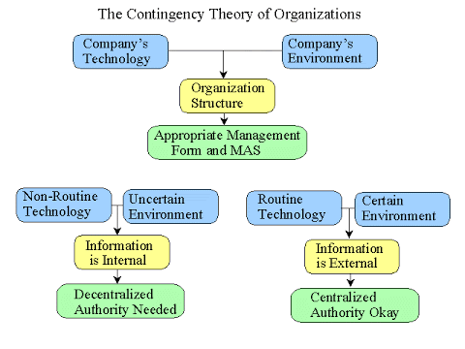
Source: https://sites.google.com/site/misresearch001/home/contingency-theory
Contingency theory is a recent contender for the position of the integrating concept that will hold everything together, and has grown from the realities of organizational life, since much in management and organizational life is situational (Longenecker & Pringle, 1978). The contingency theory explains that there are specific situational factors that can affect the direct relationships between independent and dependent variables in the study of organizational behaviour. As we can see in the image above there are so many factors that needs to be taken in consideration in order to keep everything together for an effective organisation. Company structure is formed by company`s technology and company`s environment, and decisions taken by the appropriate management form. Contingency theory is helping you to identify your leadership style, understand your situation (member relations, task structure and position power, and find the right leadership style (if you have the right style for the situation you`re facing), examining how best you run your team or the organization given different situations.
For example, at my workplace (Grodzinski Bakery) the top manager asked one of the colleagues from the morning shift (we are working in night shift) to supervise the team in his place. In this scenario we are facing the following situation: the high staff turnover, being a bit difficult for the person in this position to build relationships and being new in this position the trust of your team won’t be easy to gain. Also the task in this position is high because in night shift we have different procedures to follow ( like how to bake different kind of pastries when the shop becomes busy, how to finish the cleaning and serve the customers in the same time to be ready to close the shop in time etc). Being in this position the person had the power to send someone home or to be reported to the top manager in case one of the staff member will not comply with the given requirements. Contingency theory says that there is not just one best way to structure your organization and lead your team. That’s why someone with different beliefs and values might interpret the theory differently because has his own leadership style, based on his personality and business type. In order to identify the values of others, make sure that you understand your own values and for a successful organisation you need to identify people who will fit best with its culture and values. After that you can train people to cover skills gaps, and you can help people gain experience.
In conclusion, contingency theories are related to a person`s beliefs, attitudes, and values. Most people can be coached to adapt to a new working culture, some professionals will find it hard to shift their priorities, but for some people may be hard to changed their deeper values and beliefs which can become a big issue for the company effectiveness.

Workplace changes for the post-COVID mindset
As we were discussing above about how to adapt to the situations and changes at the workplace, we have to mention that COVID-19 is one of the biggest changes that happens in workplace but also in our life. The COVID-19 crisis has caused many of us to question our values and what we stand for as human being. Regarding the strategies at the workplace, many employers are making harsh decision about staff reduction, being basically forced to do it, in order to continue to have a functional business. Even if the employers know that sustaining trust and acknowledging employees’ efforts are critical to employee’s engagement, well-being and effectiveness, in this situation employees and employers are hands tied.
Hundreds of millions of people have lived through lockdowns and many have made the abrupt shift to working from home, and millions have lost jobs (BBC Worklife, n.d). The future looks uncertain and everyone must design a workplace environment that respond not just to anxiety and mental health, but also the behaviours and attitudes that we developed through the pandemic crisis. Due this global pandemic situation, there is an unmistakable necessity for Critical Thinking, therefore all businesses require reasoning and analytical skills to face the uncertainties. The important thing that employers can do is to let employees know that no one is alone in this situation and it is crucial that they share information and encourage healthy debates to make the team brainstorm about a situation. We must stay positive and we will face the challenges in an easy way. As we can see in image below, we must find the fun in every difficult situation.
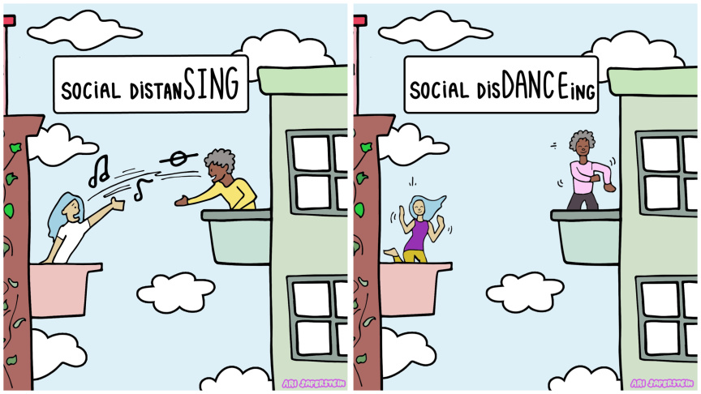
Source: https://laist.com/2020/03/19/your_no-panic_guide_am_i_doing_social_distancing_right.php
At my workplace we are like a family there and during this crisis we encouraged each other, and we tried to make a good experience in reshaping the workplace. We were already used to hygienic environment and we had just to adapt in wearing a face mask and using hand sanitiser. Even though was a bit difficult because we had to interact with customers and some of them were paying cash, we manged the situation. Working in team we tried practising critical thinking and we developed analytical skill to create an effective workplace environment.
Even though there’s no quick way to teach critical thinking, exercises and practices together can adequately improve and cultivate it. In crisis situations, it is through Critical Thinking at Work During COVID-19 can help organisations establish efficient remote work as a team to recover adequately to be ready for post-crisis business activities (Bacha, 2020).
No one can predict the next crisis, but I think all businesses will be prepared for it. Whether we`re are talking about political events, virus outbreaks or weather, every organisation needs to develop a business continuity plan to make sure that is business can continue, no matter what the disruptions are. Businesses can take several measures to build resilience, such as:
- To prepare a crisis management plan of a new risk scenarios created by COVID 19 outbreak
- To take in consideration the mitigation of potential impact of reduced sales, home working arrangements
- Maintain employee’s performance
Business resilience is the ability to rapidly adapt and respond to all types of risks, while maintaining continuous business operations.

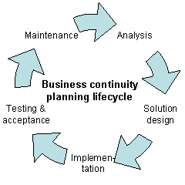
Source: https://en.wikipedia.org/wiki/Business_continuity_planning#/media/File:BCPLifecycle.gif
As we can see in the image above there is planning lifecycle in order to maintain a business continuity. First, the employer should start analysing the situations and not to put the company and employees in the same conditions. At this point you can challenge yourself in the process. Creating some tension can help you see if your company is prepared for significant business disruption. And after a critical analyse of the situations, there must be already possible solutions to the problem, that benefits everyone well-being and mental health. After this step and after you re-evaluate the solutions design with other people, you may start the implementation. The next process will prove you by testing and acceptance if everything is working and how the changes that has been made impact in a positive or negative way your company. If the changes have a good impact as you wanted, you can keep it practical and actionable.
In conclusion, workplace changes happen all the time, but you can control the risks and disruptions by understanding the organization’s operating environment and business needs and designing solutions that can drive value.

Conclusion
In the final analysis, I can say there can be nothing better in a society where a majority of people have good values and they follow the ethical norms, even though the organisational beliefs, attitudes, and values systems can impact the workplace behaviour. It is important to know how to face the workplace problems, by finding the best solutions and by critically analysing the root of the problem. And in this time of crisis such as COVID-19 high pressure and time constraints can create tension and anxiety resulting in decision-makers losing their own critical reasoning skill. However, critical thinking can be taught and developed and in order to be successful at your workplace you should be investing a lot more time and energy in learning it, to be able to create an environment of trust, humility, openness, and moral courage to allow it to prosper and create more resiliency.
In the end, I can only suggest that for a healthy workplace environment you must use a range of established techniques, keeping a positive attitude and be creative in finding the best solutions, because this global pandemic hit us like a hammer in the back of the head, revealing skills we didn’t know we had and used them to the fullest.

References
Bacha, Z. (2020, May 7). STRAMMER Lead the way. Retrieved December 13, 2020, from Improving Critical Thinking Within The Workplace: https://strammer.com/en/critical-thinking-at-work-during-covid-19/
BBC Worklife. (n.d.). Retrieved December 13, 2020, from Coronavirus: How the world of work may change forever: https://www.bbc.com/worklife/article/20201023-coronavirus-how-will-the-pandemic-change-the-way-we-work
British Baker. (2006, January 6). Retrieved December 3, 2020, from Baking for Generations: https://bakeryinfo.co.uk/news/baking-for-generations/608016.article
Craig, N. S. (2016). Making sens of beliefs and values: Theory, Research, and Practice. New York: Springer Publishing Company, LLC.
Davis, S. (2013, July 23). Government Executive. Retrieved December 10, 2020, from How the R.E.D Model Can Make You a Better Leader (and Thinker): https://www.govexec.com/management/2013/07/how-red-model-can-make-you-better-leader-and-thinker/67301/
Hackney Citizen. (2012, April 20). Retrieved December 4, 2020, from Boris Jonhson visits Stamford Hill: https://www.hackneycitizen.co.uk/2012/04/20/boris-johnson-visits-stamford-hill-hackney/
Leornad, K. (2019, March 6). Chron. Retrieved December 13, 2020, from Contingency Approach Use in Business: https://smallbusiness.chron.com/contingency-approach-use-business-33893.html
Longenecker, J. G., & Pringles, C. D. (1978). The illusion of contingency theory as a general theory. Briarcliff Manor, United States : Academy of Management. Retrieved December 10, 2020, from https://search-proquest-com.ezproxy.uwtsd.ac.uk/scholarly-journals/illusion-contingency-theory-as-general/docview/230027614/se-2?accountid=130472
Mahajam, G. (2016). Value Creation The Definitive Guide for Business Leaders. SAGE Publication.
Mitashree, T. (2018). Role of creative thinking as an imperative tool in communication at workplace. Journal of Organizational Culture, Communication and Conflict. Retrieved December 9, 2020, from https://search-proquest-com.ezproxy.uwtsd.ac.uk/docview/2177045878/fulltextPDF/A4DCB42126EF4C4BPQ/1?accountid=130472
Moore, T. J., & Asay, S. M. (2012). Family Resource Management. SAGE Publication .

