Component 1 Task 1- Blog Task 2- Poster
Student Name: Mileen Bhagwan Patil
Student ID: 2321878
Module Code: LCHS7007
Module Title: Population Health and Digital Health Promotion
Lecturer’s Name: Ping Wu

Task 1 Blog 2 Entries
Blog 1- Digital Health Promotion: The Impact of Mobile Apps on Smoking Cessation
- Introduction
According to a report by Sakthisankaran et al. (2024), tobacco use continues to be a major public health issue, resulting in over 8 million deaths annually worldwide. According to Lewis (2017), smoking costs the NHS approximately £2.4 billion annually and accounts for approximately 78,000 deaths in the UK alone.
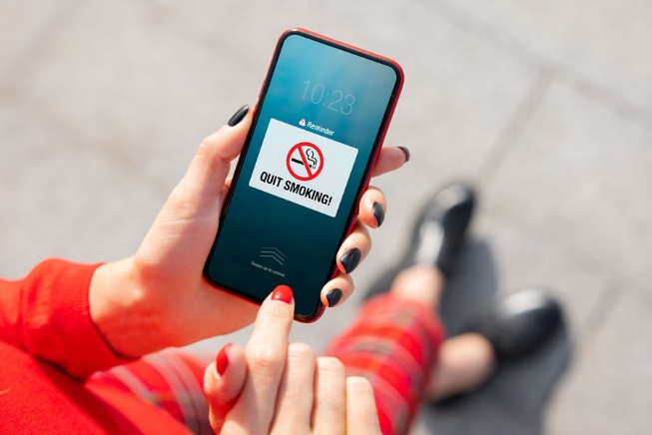
- The Rise of Mobile Apps for Smoking Cessation
Mobile apps have emerged as a promising digital technology for smoking cessation interventions. Personalised quit plans, craving management tools, progress tracking, and motivational messages are all common features of these apps. The Smokefree app, supported by the NHS and downloaded more than 500,000 times (NHS Digital, 2024), is a notable example.
- Effectiveness of Smoking Cessation Apps
Apps for quitting smoking may be effective, according to evidence. Krishnan et al. (2021) conducted a meta-analysis and found that, in comparison to minimal support, phone-based interventions increased the likelihood of long-term smoking cessation by 1.5 times. In addition, a study by Xie et al. (2023) found that app users were twice as likely as non-users to stop smoking after three months.
- Limitations and Challenges
- Accessibility and Affordability: These apps are easily accessible and economical.
- Variable Effectiveness: The effectiveness of mental health apps can vary greatly.
- Low Engagement Rates: Users often exhibit low engagement with these apps.
- High Attrition: High dropout rates are common among users.
- Quality and Evidence-Based Concerns: Only 4% of smoking cessation apps adhere to clinical practice guidelines, indicating questionable quality and evidence base of many commercial apps.

- Future Directions
Developers should concentrate on incorporating strategies supported by evidence and enhancing user engagement through personalization and gamification to address these deficiencies. These apps may also be more effective with professional support and integration with healthcare systems. Long-term studies that examine ways to reach and engage diverse populations, particularly those with limited digital literacy, should be given priority in future research.
Blog 2- Digital Health Promotion: AI-Powered Mental Health Chatbot for University Students
According to Kohls et al. 2021, one in three university students has clinically significant symptoms of depression or anxiety, indicating that mental health issues among students have reached alarming levels. This crisis has become even worse as a result of the COVID-19 pandemic, which has resulted in a 50% increase in campus demand for mental health services (Frampton and Smithies, 2021). To provide accessible and timely support, this situation urgently necessitates creative solutions.

To meet this challenge, I created "MindMate," an AI-powered chatbot about mental health for college students. MindMate provides 24/7 personalized support, mood tracking, and evidence-based cognitive behavioural therapy (CBT) techniques through the use of natural language processing and machine learning algorithms.
- Features and Integration of MindMate

- Immediate Support and Triage: MindMate offers instant support for students facing mental health issues.
- Risk Identification: The app identifies students who are at risk of mental health problems.
- Coping Strategies: Provides strategies to help students cope with stress and mental health challenges.
- Escalation of Serious Cases: Serious mental health cases are escalated to human professionals for further assistance.
- Guided Meditation: Includes guided meditation sessions to help reduce stress and improve mental well-being.
- Sleep Hygiene Advice: Offers advice on improving sleep hygiene to promote better sleep patterns.
- Stress Management Exercises: Contains exercises aimed at managing and reducing stress.
- Potential Impact of MindMate
MindMate has a lot of potential to have an effect. The issue of lengthy wait times for traditional counselling services is addressed by its round-the-clock availability. The anonymity it provides may encourage students who are hesitant to seek face-to-face assistance (Wong et al., 2018). The app could facilitate early intervention that could stop mental health issues from getting worse.
- Challenges
- Privacy Concerns: Issues related to the privacy of user data.
- Ethical Ramifications: Ethical concerns about using AI in mental health care.
- Risk of Over-Reliance: Potential over-reliance on digital solutions, reducing human interaction.
- Limited Effectiveness: Chatbots may be less effective in handling complex mental health issues.
- Recommendations 
To address these deficiencies, transparent AI ethics guidelines and stringent data protection measures will be implemented. The app will be made to complement human-led mental health services rather than replace them. It will be relevant and effective if it receives regular updates based on user feedback and the most recent research on mental health. Importantly, users will be informed in detail about the app's capabilities and limitations.

References
Bricker, J., Miao, Z., Mull, K., Santiago-Torres, M. and Vock, D.M., 2023. Can a single variable predict early dropout from digital health interventions? Comparison of predictive models from two large randomized trials. Journal of medical Internet research, 25, p.e43629. Available at https://www.jmir.org/2023/1/e43629/
Denecke, K., Abd-Alrazaq, A. and Househ, M., 2021. Artificial intelligence for chatbots in mental health: opportunities and challenges. Multiple perspectives on artificial intelligence in healthcare: Opportunities and challenges, pp.115-128. Available at https://link.springer.com/chapter/10.1007/978-3-030-67303-1_10
Frampton, N. and Smithies, D., 2021. University mental health: life in a pandemic. Student Minds, 64. Available at https://www.improvingthestudentexperience.com/library/covid19/Student_Minds_full_report.pdf
Huberty, J., Green, J., Glissmann, C., Larkey, L., Puzia, M. and Lee, C., 2019. Efficacy of the mindfulness meditation mobile app “calm” to reduce stress among college students: Randomized controlled trial. JMIR mHealth and uHealth, 7(6), p.e14273. Available at https://mhealth.jmir.org/2019/6/e14273
Kohls, E., Guenthner, L., Baldofski, S., Brock, T., Schuhr, J. and Rummel-Kluge, C., 2023. Two years COVID-19 pandemic: Development of university students' mental health 2020–2022. Frontiers in psychiatry, 14, p.1122256. Available at https://www.frontiersin.org/articles/10.3389/fpsyt.2023.1122256/full
Krishnan, N., Gu, J. and Abroms, L.C., 2021. Mobile phone-based messaging for tobacco cessation in low and middle-income countries: a systematic review. Addictive Behaviors, 113, p.106676. Available at https://www.sciencedirect.com/science/article/pii/S0306460320308066
Lewis, H.I., 2017. Improving ascertainment and treatment rates of chronic viral hepatitis (Doctoral dissertation, Queen Mary University of London). Available at https://qmro.qmul.ac.uk/xmlui/handle/123456789/30632
NHS, 2024. Quit smoking- better health. Available at https://www.nhs.uk/better-health/quit-smoking/
Sakthisankaran, S.M., Sakthipriya, D. and Swamivelmanickam, M., 2024. Health Risks Associated with Tobacco Consumption in Humans: An Overview. Journal of Drug Delivery and Therapeutics, 14(5), pp.163-173. Available a https://jddtonline.info/index.php/jddt/article/view/6523
Seo, S., Cho, S.I., Yoon, W. and Lee, C.M., 2022. Classification of smoking cessation apps: quality review and content analysis. JMIR mHealth and uHealth, 10(2), p.e17268. Available at https://mhealth.jmir.org/2022/2/e17268
Wong, K.P., Bonn, G., Tam, C.L. and Wong, C.P., 2018. Preferences for online and/or face-to-face counseling among university students in Malaysia. Frontiers in psychology, 9, p.64. Available at https://www.frontiersin.org/articles/10.3389/fpsyg.2018.00064/full
Xie, J.H., Qiu, Y.F., Zhu, L., Hu, Y., Chang, X., Wang, W., Zhang, L.M., Chen, O.Y., Zhong, X., Yu, X. and Zou, Y., 2023. Evaluation of the smoking cessation effects of QuitAction, a smartphone WeChat platform. Tobacco-induced diseases, 21. Available at https://www.ncbi.nlm.nih.gov/pmc/articles/PMC10088363/

Task 2- Poster


