A marketing plan is written for
Premier Inn Hotel

Zakia Shirin Nishai
Student ID: 2208336
Marketing Essentials BMIH4005
Lecturer’s name: Luciana Suardi

Introduction
Marketing planning and process play a significant role in developing business orientation for the creation of a productive business environment. The main purpose of the marketing plan is to attract a large number of audiences for the maximization of sales volume. The marketing plan has been prepared for Premier Inn Hotel which has been reflected by the analytical framework of SWOT to define its microenvironment, PESTLE to analyse its Macro environment, Marketing Mix to determine the Marketing strategy and Bowman's strategy clock to determine its pricing structure.

Situation Analysis
Company: SWOT analysis

Strength | Weakness | Opportunity | Threat
Premier Inn Hotel includes a large number of hotel sites enabling better customer satisfaction. | Premier Inn Hotel is limited to global presence as compared to other hotel chain enterprises. | Premier Inn Hotel is expensively developing its business operations by developing brand names in their operating countries. Hence, they can work on the expansion of the business by adding other countries in the list (Ryan, 2012). | Premier Inn Hotel is facing emerging factors of the competitors in the hospitality industry by raising competition on services and marketing orientation.
Numerous services are easily accessible to provide a better operation for the ease of meeting the financial needs of the customers. | The hotels are providing sophisticated hospitality services for which the quality and efficiency of the skilled labour lack in the operation. | The subsequent factor to add for the development of multitudes of operation functions by adding other more operation functions which can incorporate with the hotel and hospitality industry such as travel and tour, transformation, restaurants and many more (Keeble, 2022). | Data breach is the main concern for the company which has been observed in the last few years by attending to the complaints lodged by customers.

Customers: Segmentation and Targeting/ Customer profiles
The marketing planning process of Premier Inn Hotel constitutes numerous strategic approaches of which Market segmentation and Targeting are two of them. The targeting marketing approach developed by Premier Inn Hotel is more focused on a specific subset of their potential customers who are particularly involved in travelling and seek hotels nearby an airport or conference centres (Kotle et al., 2017). Segmentation marketing of Premier Inn Hotel is considerably focused on the approach to developing a particular hotel room for travellers, families, business persons and many more.

Customer persona
Customer Type | Detail Analytics
Gender | No Gender Specification
Age | All Age Group
Location | Mostly UK, Ireland, Germany, United Arab Emirates (UAE), and Qatar
Citizenship | People around the world
Personal Income | High-class, middle class and low class
Values | The sophisticated environment with efficient hospitality services
Problem and Frustration | The problem-solving approach to booking, hygiene and sanitation

Competitors: Porter’s Five Forces Analysis
Supplier Power | Buyer Power | Competitive Rivalry | Threat of substitution | The threat of new entry
Ability to force down the price of Premier Inn Hotel | A classified group of people are included to avail of the service of Premier Inn Hotel (Fearn, 2022). | Premier Inn hotel is developing differentiated room tariffs and pricing structures. | Premier Inn Hotel is subjective to its services for the development of better customer experiences. | Premier Inn Hotel has been operating its business since 9187 and they have its own reputation for developing better posting in the market.
A large number of suppliers are involved in Premier Inn Hotel | Demand for services provided by the company is dependable as per the customer’s wants and desires. | Attendant of better customer experience is creating better relationships with the customers. | Represents the better customer engagement procedure by developing connection and relationship | The involvement of potential suppliers and chain marketing systems is helping them to establish their own business environment.

Collaborators
B2B Relationships: developed by Premier Inn are mostly operated through the involvement of third-party operators Such as Ibis Hotels and Travelodge (Ghauri, 2014).
Partnership: The partner range of Premier Inn Hotel is mostly the travel and tourism operator and the most known partners are Business Travel Association (BTA), Emirates Group, Hotel Runner, Premier Inn MENA, and Sami Hotel (Slade et al., 2022).
Franchise: Premier Inn hotel is not operating its franchise and doesn't have any franchise units.

Climate:
Political | Premier Inn hotel is mostly operating in hospitality services in the UK and its political conditions will influence the business operation.
Economical | The increasing cost of labour is affecting its business operation in the UK and changes in economic conditions due to global crises such as Covid 19 has affected its revenue (Clow and Baack, 2013).
Social | The delivery of all levels of services provided a sophisticated environment in the Hotel and Hospitality industry by meeting the social expectations of people around the world.
Technological | Premier Inn Hotel is using the most advanced technology to track down its accounting affairs and the use of technology is helping to operate its business by allowing customers to book hotels online and provide financial facilities (Chaffey and Ellis- Chadwick, 2019).
Environmental | Cleanliness, Hygiene, carbon emission and many other environmental-centric interventions are the moto developed by the Premier Inn Hotel management through their effective waste management system.
Legal | Premier Inn Hotel abided by the illegitimate rules and regulations by considering the lawsuits for town planning, building regulation, health and safety rules and human rights procedure.

Objectives
SMART target
Premier Inn Hotel appeals to the business, personal and family market segments by holding a good brand strategy through a sophisticated business environment and exclusive hospitality services to provide a better customer experience (Morrison, 2022).

Strategy
The marketing process planning and business strategy developed by Premier inn Hotel provide all levels of hospitality services to people around the world with their diverse and comprehensive methods of operating hospitality service by developing customer experiences (Kotler et al., 2020).

Bowman’s strategy clock
The effect of decision-making trends and then measuring the actual behaviour to manage cost in the operation has been radically managed by Premier Inn hotel in reflection with Bowman’s Theory. All measures of Bowman's strategy Clock over low price and low value added is met by developing a strategy to allocate budget hotel room seekers in their segmented marketing strategy (Smith and Zook, 2020). Differentiation can be highlighted through its quality service and availability of rooms for all levels of the audience, focused differentiation is covered through the utmost price levels in a different class of audience, Risky High Margins are developed in both short-term and long-term temporary supply market, Monopolistic pricing is delivered through developing management to operate in low-cost involvement. Loss of market shares is considerable to safeguard the brand image which has been followed by Premier Inn Hotel by setting a standard range of prices.

Tactics
Marketing mix:
Product - Premier Inn hotel is currently offering destinations Mostly the UK, Ireland, Germany, United Arab Emirates (UAE), and Qatar
Place- the Involvement of third-party companies such as Travelodge and Ibis Hotels (Bowie et al., 2017).
Price- low pricing and hybrid pricing strategy are maintaining the strand module to represent and display shares in the market.
Promotion- the involvement of multimedia platforms, aggressive sales promotion and word-of-mouth.

Action

The action plan for the marketing of Premier Inn includes radio, PPC, sponsorship and outdoor marketing. Moreover, the plan also includes personal selling and sales promotion as their marketing action plan. A Gantt chart for the action plan will be shown in the Appendix Section (Appendix-B).

Control
The unique selling point of Premier Inn Hotel represents differentiation services and allows innovation to provide a sophisticated environment to promote the brand name and develop customers' experiences with easy methods of booking and payments (Jobber and Ellis-Chadwick, 2020).

Conclusion
Premier Inn Hotel is a UK-based hotel chain business enterprise which is operating its business in the Hotel and hospitality industry with its 72,000 exclusive rooms and 800 hotels around the world. It was founded in 1987 by the Whitbread Group and headquartered in Dunstable, UK. Premier Inn hotel to develop its overall marketing strategy for the development of a productive business orientation, a strategic marketing planning process can help Premier Inn hotel to maintain its brand value and reputation for sustainable growth and development.

References
Bowie,D. Buttle,F. Brookes,M & Mariussen,A. (2017) Hospitality Marketing. 3rd ed. Routledge.
Chaffey, D and Ellis- Chadwick, F. (2019) Digital Marketing. 7th ed. London: Pearsons.
Clow, K and Baack, D. (2013). Integrated Advertising, Promotion and Marketing Communications. 6th ed. London: Pearsons.
Fearn, G. (2022) The age of the manager is over? Shale gas fracking and the challenge to the post-political regime for English planning. Political Geography. 93. p.102550.
Ghauri, P N. (2014) International Marketing. 4th Ed. London: McGraw Hill.
Jobber, D. and Ellis-Chadwick, F. (2020). Principles and practice of marketing. 9th ed. London.
Keeble, D. (2022). Industrial location and planning in the United Kingdom. Taylor & Francis.
Kotler, P., Armstrong, G., Harris, L. and He, H., 2020. Principles of marketing. 8 th European ed, London: Pearson Education Limited.
Kotler,P and Kartajaya, H. (2017) Marketing 4.0 Moving from Traditional to Digital. New York: Wiley.
Morrison, A.M. (2022). Hospitality and travel marketing.
Taylor & Francis. Ryan, D. (2012) Understanding Digital marketing: Marketing Strategies for Engaging The Digital Generation. London: Kogan Page.
Slade, J., Tait, M. and Inch, A. (2022) ‘We need to put what we do in my dad’s language, in pounds, shillings and pence’: Commercialisation and the reshaping of public-sector planning in England. Urban Studies, 59(2), pp.397-413.
Smith PR and Zook ZE. (2020) Marketing Communications. 7th ed, London: Kogan Page.

Appendix 1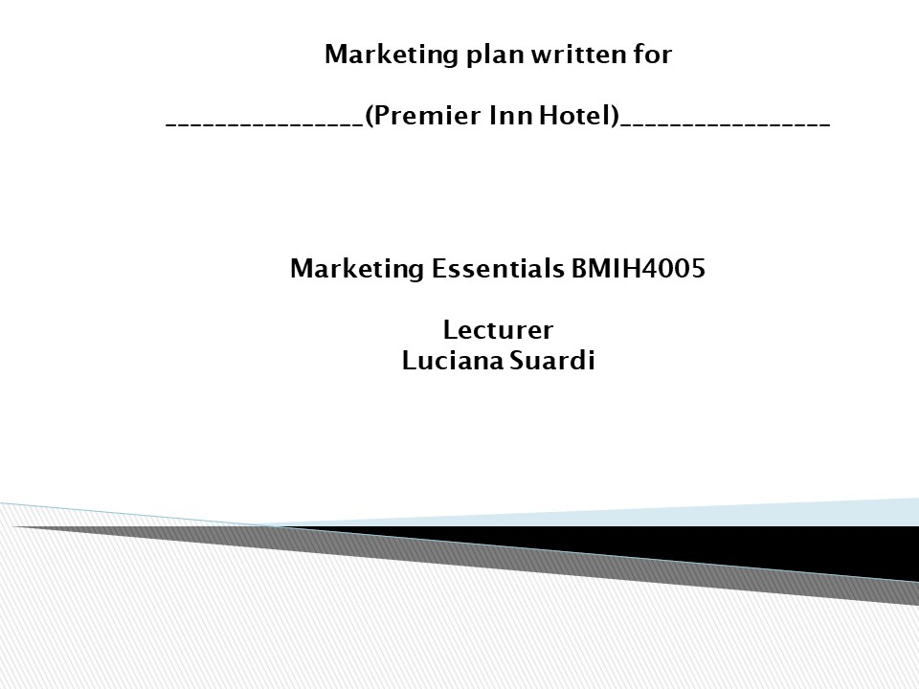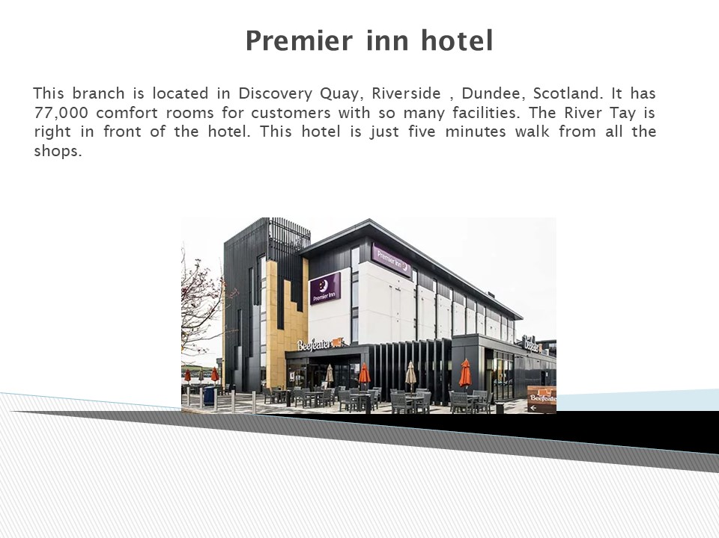
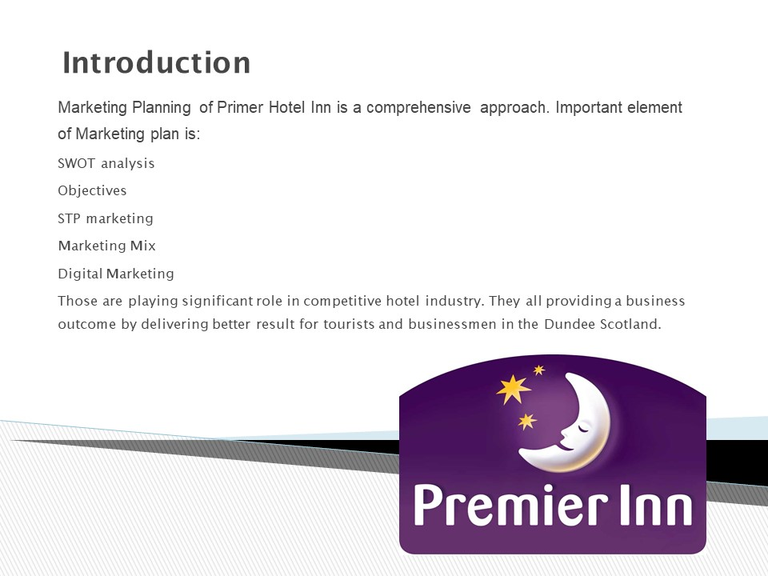
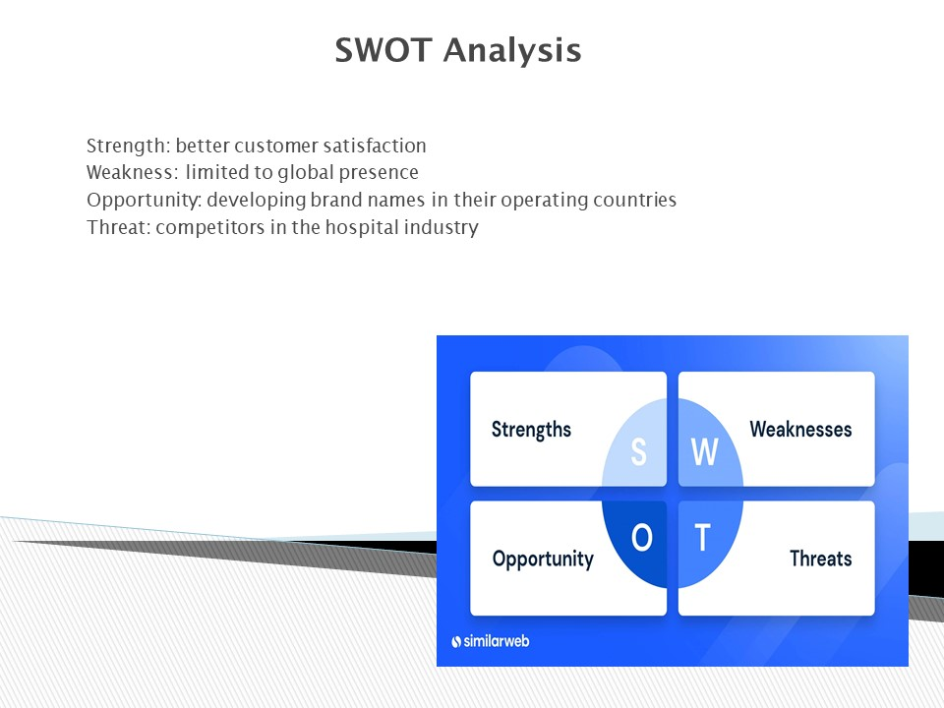
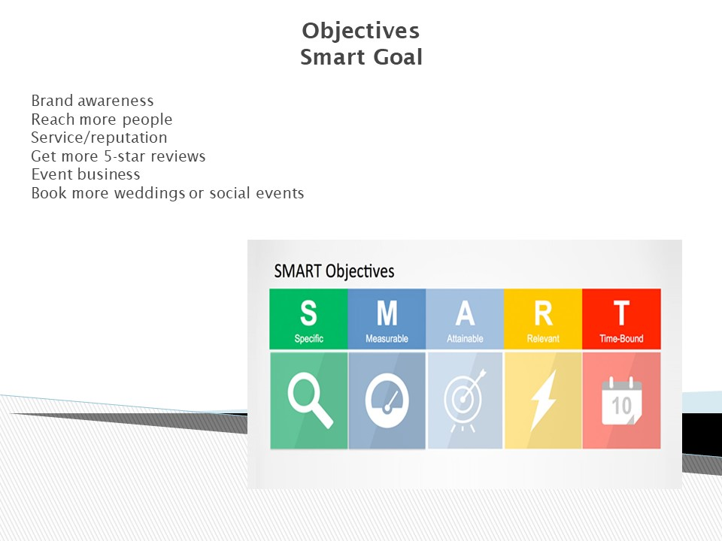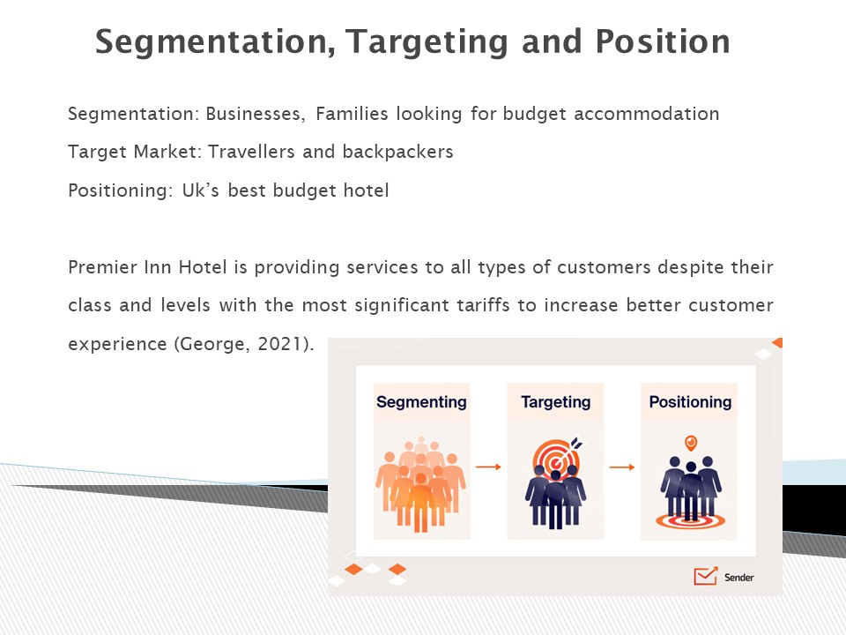
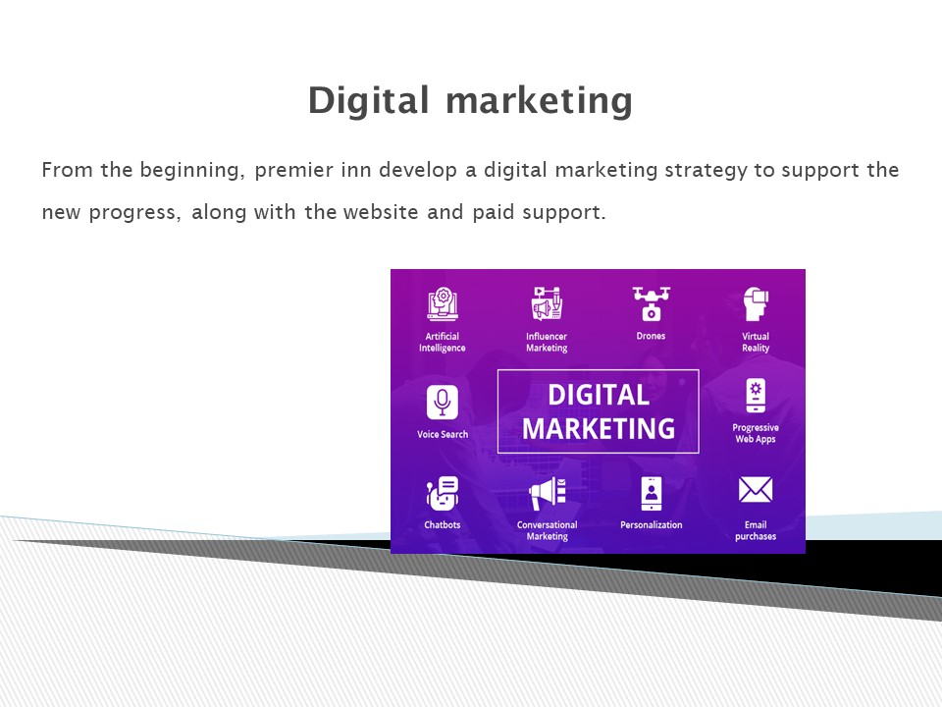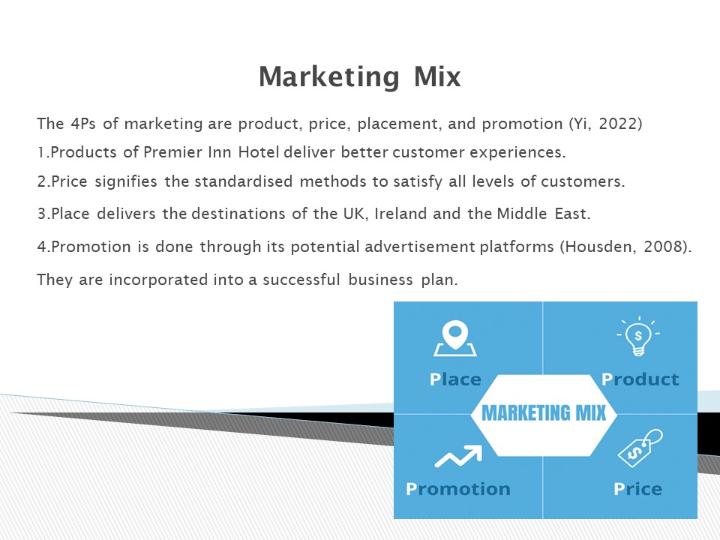
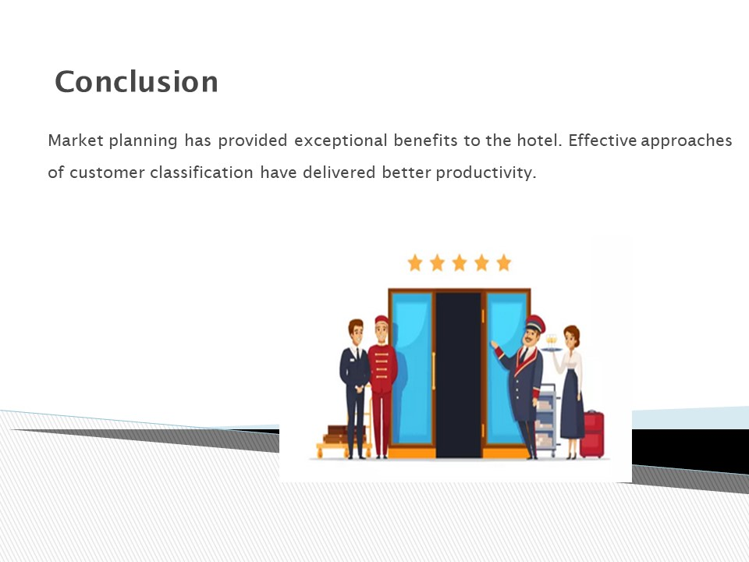
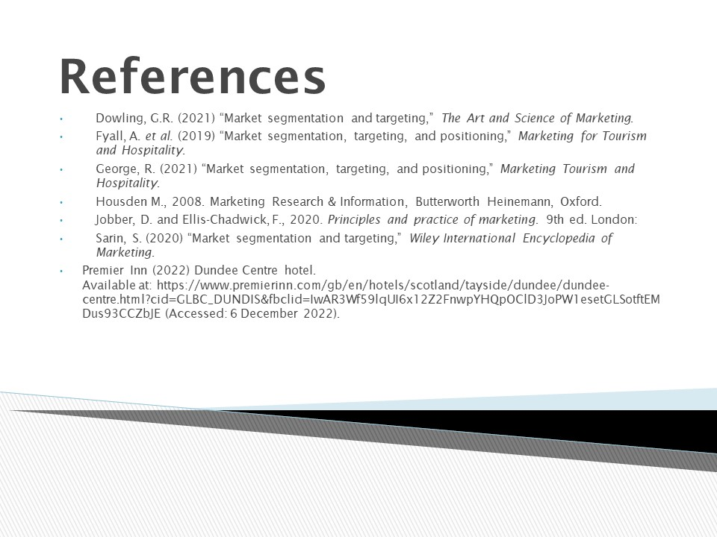
Appendix 2

