Strategic Management Assignment 1 2023 IKEA Customer Service



Module Name: Strategic Management
Name: Vikalp Vidish
Student Number: 2218769

Table of Contents
1. Executive Summary 2
2. Introduction 3
2.1 Report Remit 3
2.2 Background of the Organization 4
2.3 Definitions of Major Concepts 5
3. Main Body 11
3.1 External Analysis 11
3.3 Corporate Social Responsibility (CSR) and Sustainability 19
4. Strategic Options and Recommendation 20
5. Conclusion 20
6. References 21

List Of Figures
Fig 1: IKEA STORES……………………………………………………………………………………………………………………………..4
Fig 2: 3 Organizational Strategy Levels Pyramid…………………………………………………………………………………5
Fig 3: Business Level Strategies………………………………………………………………………………………………………….6
Fig 4: PESTLE Model…………………………………………………………………………………………………………………………..7
Fig 5: Porter’s Five Forces Model……………………………………………………………………………………………………….8
Fig 6: Carroll’s CSR Pyramid………………………………………………………………………………………………………..……10
Fig 7: Ikea Group Worldwide Annual Revenue…………………………………………………………………………..…….12

1. Executive Summary
This report presents a comprehensive analysis of IKEA, focusing on its innovative customer service to create a better everyday life for as many people as possible. IKEA is a well-established multinational company known for its affordable, well-designed furniture and home furnishing products. The report examines the strategic management of IKEA, analysing its business-level strategy, competitive advantage, and customer service challenges.
The report starts with an introduction about the company, which is then followed by some major concept discussions like strategy, business-level strategy, and competitive advantage, providing a clear understanding of the analytical frameworks used. It then proceeds with an external analysis of the company, conducted using the PESTLE framework, which emphasises the importance of adaptability, innovation, and sustainability in response to political, economic, social, technological, environmental, and legal factors. IKEA's commitment to sustainability and responsible practises enhances its reputation among environmentally conscious consumers.
Following this, the report moves to the internal analysis, which utilises Porter's Five Forces framework to identify the competitive advantage of IKEA's business model. To maintain a competitive edge, IKEA must improve its online presence, address customer service issues, and maintain strong supplier relationships.
In conclusion, the report emphasises and discusses IKEA's need to prioritise innovative customer care to ensure future resilience and sustainable competitive advantage.
Based on the analysis, strategic recommendations are provided for IKEA to enhance its customer service and ensure long-term success. The company should focus on adapting to economic fluctuations, improving inventory management, and enhancing product quality. Investing in technology, online presence, and personalised experiences will help differentiate IKEA from competitors and improve overall customer satisfaction.

2. Introduction
IKEA is a multinational company based in Sweden known for its well-designed, affordable furniture and home furnishing products. It has a strong brand recognition, innovative furniture designs, and a vast global presence worldwide. The company's vision is to create a better everyday life for as many people as possible, and its business idea is to offer a wide range of functional home furnishing products at affordable prices.

2.1 Report Remit
In terms of strategic management, IKEA's business-level strategy focuses on offering cost leadership and differentiation through its unique furniture designs and low-cost production and retailing methods. It competes with various other companies and faces challenges in terms of supply chain management, product quality, and customer service.
The report begins with external analysis of IKEA using the PESTLE framework highlights the importance of being adaptable, innovative, and sustainable in response to the changing political, economic, social, technological, environmental, and legal factors (WallStreetMojo, 2022). The company's commitment to sustainability and responsible practices is commendable and can enhance its reputation among environmentally conscious consumers (Retail Insight Network, 2020).
Following the external analysis, the report explores the factors affecting the level of customer service through the internal analysis of IKEA’s business level strategy. To this end, the researcher uses Porter's Five Forces framework and identifies the competitive advantage of IKEA’s business model (Investopedia, 2023). To maintain a competitive edge, IKEA needs to improve its online presence, address customer service issues, and maintain strong relationships with suppliers.
In conclusion, the report also weighs in IKEA's Corporate Social Responsibility (CSR) efforts and sustainability initiatives that play a crucial role in enhancing the company's reputation and creating a positive impact on society and the environment. Moreover, the concept of CSR is explained using Carroll’s four-part pyramid (Carroll, 2016). IKEA's commitment to ethical practices, employee empowerment, and sustainable sourcing is essential for long-term success (Baraka and Farkh, 2021).

2.2 Background of the Organization
IKEA is a multinational company based in Sweden that designs and sells furniture, kitchen appliances, home accessories, decoration, and a variety of other products and home services. It is renowned worldwide for its "Assemble and Install-It-Yourself" furniture (Ozturkcan, 2020). The name of the company is based on the initials of founder Ingvar Kamprad, Elmtaryd, the farm on which he grew up, and Agunnaryd, the nearby village. The first IKEA store was opened in Älmhult, Sweden, in1958 (IKEA, 2023c).
IKEA's vision is to create a better everyday life for as many people as possible (IKEA, 2019). The business idea of the company is to offer a wide range of well-designed, functional home furnishing products at prices so low that as many people as possible will be able to afford them. As of 2023, the company has 460 stores in 62 markets worldwide (IKEA, 2023a).

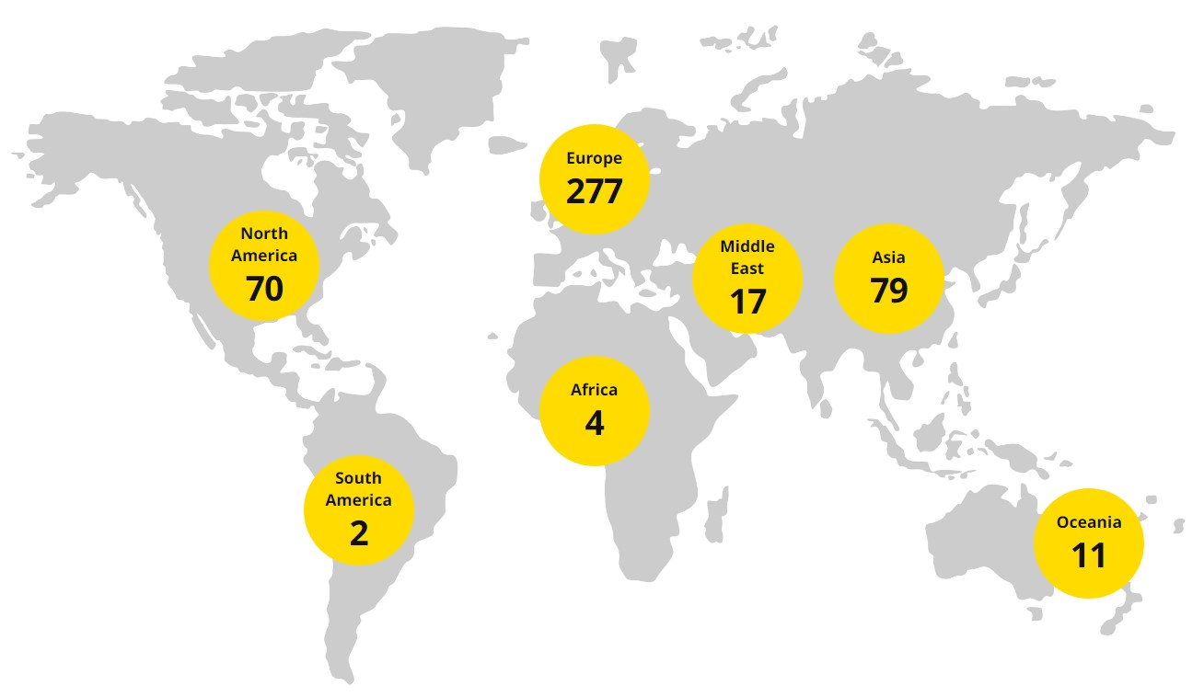
Fig 1: IKEA STORES (IKEA, 2023a)

Moreover, IKEA is mostly recognised for its minimalist interior designs, modernist furniture designs, and immersive shopping concepts built around showrooms with staged room settings where buyers can engage with the products in person. The company has constantly placed a strong emphasis on selling its goods at incredibly low rates. IKEA introduced innovations such as flat packs, which cut costs associated with production and shipping, and the "showroom-warehouse" idea, which cut costs associated with retailing (Baraldi, 2008).

2.3 Definitions of Major Concepts
Strategy
The strategy of the firm is determined by how well its internal capabilities and its external relationships complement one another. It explains how it responds to its suppliers, consumers, competitors, and the social and economic environment within which it operates (Lynch, 2018).
The management of an organization's resources to accomplish its goals and objectives is known as strategic management. It entails establishing goals, examining the competitive environment, analysing the internal organization, reviewing strategies, and ensuring that management implements the strategies across the entire organisation (Kenton, 2023).

Business Level Strategy
A business strategy, also known as a competitive strategy, is often developed at the divisional level and places an emphasis on enhancing the competitive position of a company's products or services in the particular market or industry segment served by the division (Farida and Setiawan, 2022).

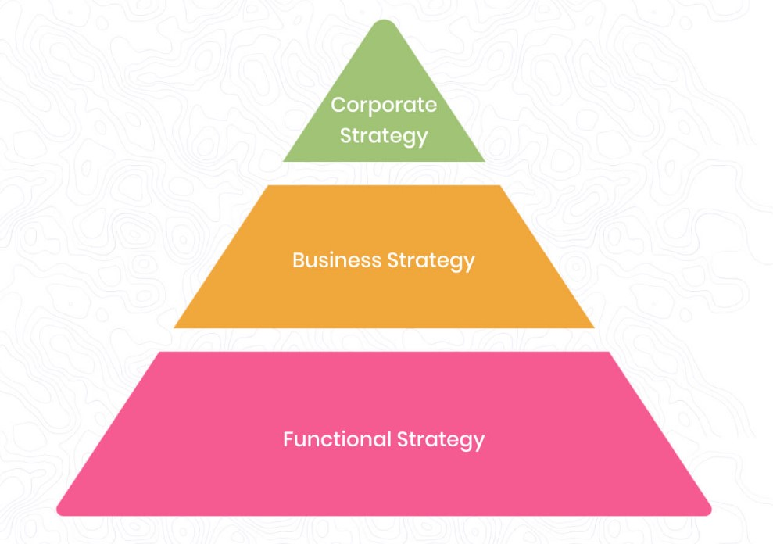
Fig 2: 3 Organizational Strategy Levels Pyramid (Wright, 2022)
In addition, the goal of a business-level strategy is to distinguish the firm's position from that of its competitors. A firm must choose if it wants to conduct tasks differently or perform completely distinct tasks in order to position itself differently from rivals. The path that provides the direction of the actions that organisation leaders should take is defined by strategy (Seker, 2020).
The five main business-level strategies are as follows:
- Cost Leadership: It means competing on the basis of price with a variety of companies.
- Differentiation: It means competing by utilising a good or service with completely unique features.
- Focused differentiation: It means competing not only through differentiation (uniqueness of product or service) but also by choosing a tiny segment of the market to focus on.
- Focused low-cost: It means competing not just on price but also by choosing a tiny portion of the market to focus on.
- Integrated low-cost differentiation: It means utilising both differentiation and low cost to compete (Leonard, 2019).

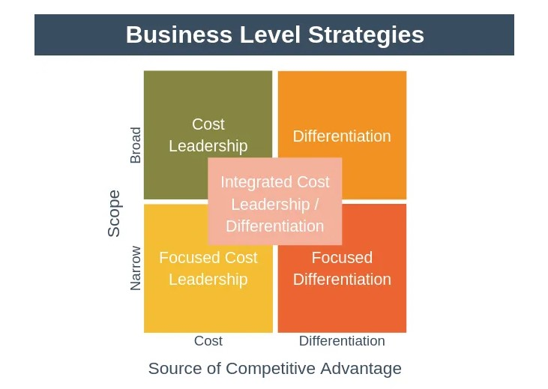
Fig 3: Business Level Strategies (Seker, 2020)

Competitive Advantage:
The term "competitive advantage" refers to the different ways that a company can manufacture goods or provide services better than its competitors. It enables a company to generate value and achieve superior margins for the company and its shareholders. It is something that is unique to a business or company and is difficult to reproduce. Internally generated value is what distinguishes the company from its competition (Peterdy, 2023).
Comparative advantage and differential advantage are the two main types of competitive advantage.
- Comparative Advantage: The ability of a company to produce something more efficiently than a competitor, which results in higher profit margins, is known as comparative advantage.
- Differential Advantage: When a company's products are regarded as both distinctive and of greater quality than those of a competitor, this is known as having a differential advantage (Twin, 2023).

Models Used:
The different models that are used for the external and internal analysis of Nike are PESTLE and Porter’s Five Forces respectively.

PESTLE Model:
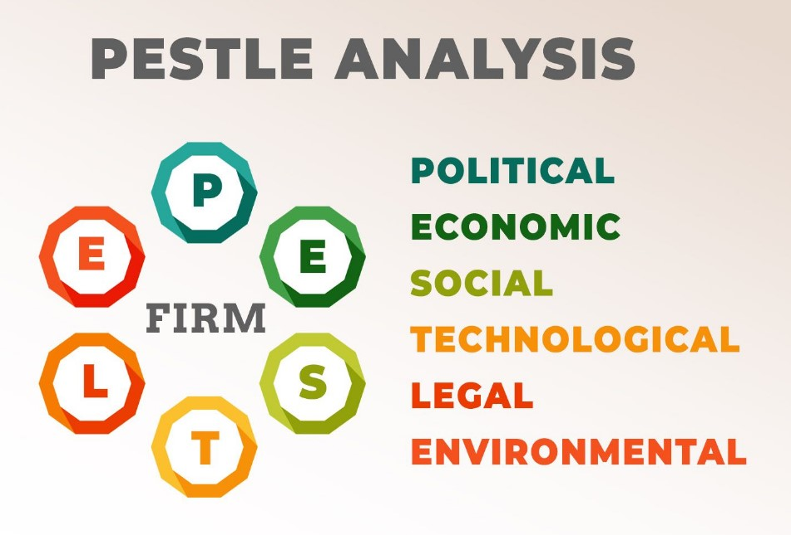
Fig 4: PESTLE Model (Mishra, 2020)
PESTLE Analysis is a strategic tool that examines the external environment of a company. It consists of political, economic, social, technological, legal, and environmental factors. Such a study makes it easier to identify opportunities and business threats and aids in strategic decision-making. Additionally, it provides insight into the macro-environmental factors that affect how a specific business operates. These factors may have both negative and positive effects on the business (WallStreetMojo, 2022).
Limitations of PESTLE Analysis:
A PESTLE analysis can have drawbacks in addition to its numerous potential advantages. Some of the drawbacks are mentioned below:
Constant Reviewing Due to Changing Environment: Because of how dynamic these environments are, the analysis can become outdated in a matter of days or even hours. In order for the analysis to be successful and accurate, management must continue to review the results of the model (Jain, 2023).
Data Overload and Risk of Inaccuracy: There is a significant amount of external data collection involved, and there is a chance of collecting unintended data, which is once again crucial to the business (Fairlie, 2023).
Dynamic Nature of Political Environment: The government policies, laws, rules, and taxes of the government have an impact on the political environment. These policies might alter at any time and can impact the accuracy of the analysis (OEM NEWS, 2022) .

Porter’s Five Forces Analysis:

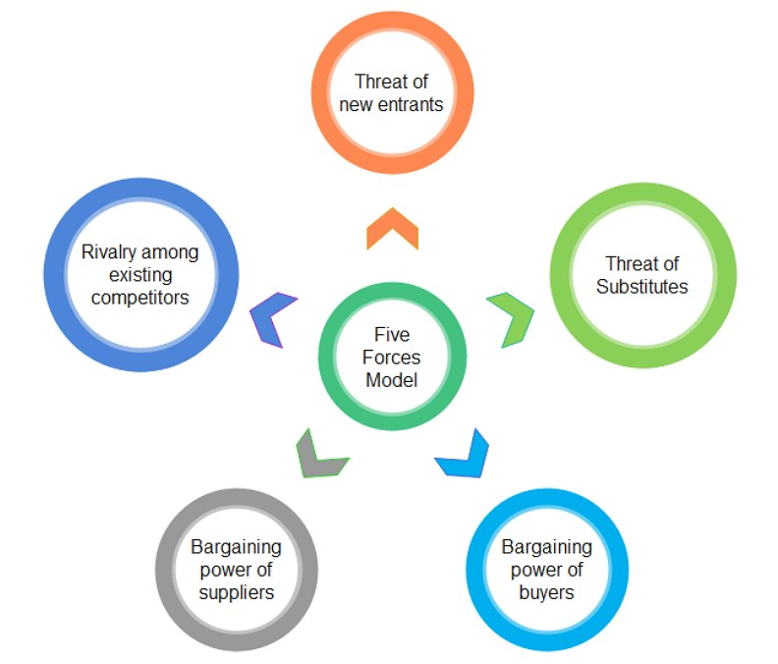
Fig 5: Porter’s Five Forces Model (Edrawsoft, 2023)

An industry's strengths and weaknesses can be determined by analysing the five competitive forces identified and analysed by Porter's Five Forces model. This model was created by Harvard Business School professor Michael E. Porter in 1979. It is a commonly used framework for accessing the competitive forces that influence a range of business sectors (Investopedia, 2023). The threat of new entrants, the bargaining power of buyers, the bargaining power of suppliers, the threat of substitutes, and competitive rivalry are the five forces present in Porter's 5 Forces" model (Harvard Business School, 2021).

Limitations of Porter’s Five Forces Framework:
This framework has stood up well over time and is still a necessary component of the coursework for business classes. However, there are a few blind spots, which are listed below:
Backward Looking: The model is backward-looking, which limits the relevance of its results to the short term, and the effects of globalisation only further compound this limitation.
Individual Company Analysis: Another major flaw is the tendency to utilise the five forces to analyse a particular company rather than a broad industry, which is what the framework was designed for (Beattie, 2022).
External Environmental Elements: Lack of consideration of factors related to the external environment is another drawback of Porter's five forces approach. External environmental factors refer to a broader set of economic, political, social, and technological variables that might have an effect on an industry's or market's competitive dynamics (Mohammed, 2023).

The CSR Pyramid or Carroll’s Four-Part Pyramid:
According to the original definition of Carroll’s four-part definitional framework, corporate social responsibility (CSR) incorporates the ethical, legal, economic, and discretionary expectations that society has of organizations at a given point in time. Carroll restructured the four-part definition of CSR in the form of a pyramid, which is also known as the CSR pyramid or Caroll’s four-part pyramid (Carroll, 2016).

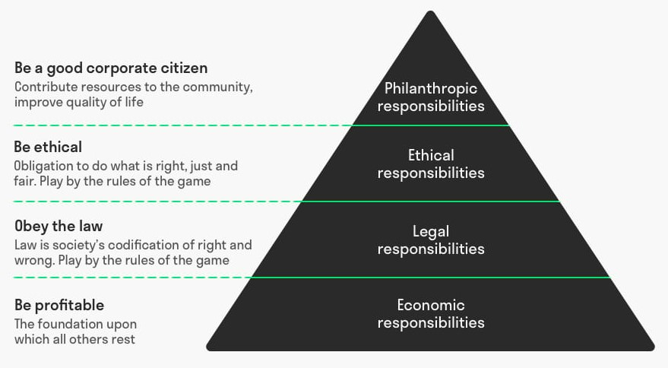
Fig 6: Carroll’s CSR Pyramid (Janse, 2020)

A business's primary responsibility is to be profitable, and this is represented at the lowest level of the pyramid. Without profit, employees will lose their jobs as the company will not be able to pay their workers.
The legal obligation of the business, i.e., to obey the law, is depicted on the second level of the pyramid. Since this shows how the companies conduct their business in the market, this becomes one of the most important responsibilities out of the four levels (Thacker, 2019).
Apart from obeying the law, the company should also conduct its business ethically. Avoiding harm, being fair in all situations, and doing the right thing are described in the ethical layer of the pyramid (Thomasnet, 2021). Being ethical shows the stakeholders that the company has some moral values and also provides consumers with confidence and comfort in purchasing goods and services from the company. Treating employees properly and being environmentally friendly are some examples of ethical responsibilities (Thacker, 2019).
The responsibility of bringing about a larger positive change that businesses can achieve through their operations is represented by the top layer of the pyramid and is known as philanthropic responsibilities. Promoting sustainable business and donating to charities are some examples of philanthropic responsibilities (Scoocs, 2023).

3. Main Body

3.1 External Analysis
External Analysis refers to the analysis of the macro environment. The general environment that can impact the working of businesses is known as the macro environment. These factors are generally not controllable and indirectly influence the organization (Surbhi, 2020).

IKEA’s PESTLE Analysis
PESTLE analysis of IKEA provides details about the external political, economic, social, technological, environmental and legal factors affecting the organization and its future expansion.
Political Factors:
IKEA is a multinational company with operations in many countries. It has 458 stores and 50 online marketplaces worldwide. In 2021, about 775 million people visited IKEA stores (Statista, 2022b). IKEA's success, profitability, and longevity can all be strongly impacted by the political environment. Regulations related to data privacy, consumer rights, and employment practices can impact how IKEA delivers services to its customers.
Other political factors that may have an impact on its operations and standard of customer care include lobbying in the domestic market, bureaucracy, corruption, and import restrictions (Mwende, 2021).

Economic Factors:
IKEA's customer service may be affected by economic variables such as inflation, income levels, and unemployment rates. Customers may seek more reasonably priced goods and anticipate better value during economic downturns. The company generated a global revenue of approx. 45 billion euros in financial year 2022. The value of Ikea global furniture market is 557 billion US dollars and its brand value is 23.4 billion US dollars (Statista, 2022b).
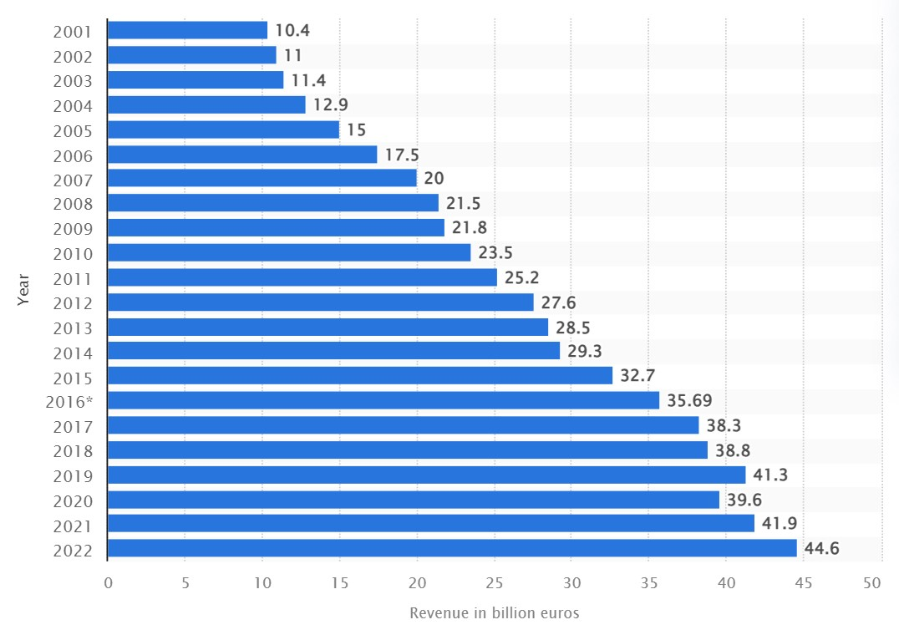
Fig 7: Ikea Group Worldwide Annual Revenue (Statista, 2022a)

Since 2008, IKEA, one of the biggest privately held businesses in the world, has dominated the furniture retail industry. International regulations have an impact on it, and it is susceptible to the global economy. IKEA achieved €41.3 billion in global revenue in 2019, during the COVID pandemic, but company profitability decreased by 3% as a result of rising material, shipping, and logistics costs (Mcfarlane, 2022).
IKEA was negatively impacted by the lockdowns brought on by COVID-19 in numerous ways throughout the year 2020. According to IKEA's financial report, 75% of its locations were closed for an average of seven weeks in 2020, and the retailer's revenues fell to 39.6 billion as compared to 41.3 billion in 2019. IKEA stores saw a drop in customer traffic from 1 billion in 2019 to 825 million in 2020 (IKEA, 2020a).
As a result of COVID-19, fundamental marketing principles became dynamic and altered the marketing landscape, forcing IKEA to enhance its entrepreneurial abilities and hypermobility by adjusting to shifts and creating new marketing strategies (He and Harris, 2020). Although IKEA's physical stores reopened, online sales continued to be strong, indicating a shift in consumer purchasing behaviour brought on by the pandemic and lockdowns, where people preferred the constant availability of IKEA product browsing online. IKEA has trained and hired employees to handle consumer communication online (Ding, Liu and Xu, 2021).
In 2022, IKEA increased prices in the UK for some products by up to 80% due to rising raw material and transportation expenses as well as the conflict in Ukraine. The company struggled to keep shelves full, and online sales were down by 10 percent from the 2021 fiscal year. IKEA lost almost 10,000 jobs as a result of leaving Russia and Belarus due to the conflict in Ukraine. In spite of persisting uncertainties, the organisation is still committed to meeting customer needs and is focused on providing good customer service. This decline in online sales is a probable indicator that customers might be moving to alternate resources and brands to fulfil their needs (Murphy, 2022).

Social Factors:
The COVID-19 crisis has influenced customer behaviour and, in turn, the effectiveness of marketing and the quality of customer service. Similarities between how marketing is used during and after the COVID-19 crisis and how it is done during economic downturns can be seen. However, it also exhibits traits that set it apart from economic downturns, namely changes in purchasing patterns across categories and a quicker transition from offline to online behaviours. This change is the result of a reassessment of life priorities by the customers due to the pandemic (Hoekstra and Leeflang, 2020).
During COVID-19, Ikea's e-commerce completely broke down. Closing Ikea storefronts and social isolation in the months following COVID-19 forced customers to place pre-orders online and pick them up in person, a process Ikea refers to as "Click & Collect." Ikea claims that throughout this time, its online business has doubled. But Ikea has dealt with several customer complaints due to a lack of capacity to handle them. The main cause of this problem boils down to a poor inventory management system in terms of getting updated. The company doesn’t seem to actually know how many items need to be replenished (Wilson, 2020).
In China, Ikea has observed a considerable amount of shrinkage in consumer size after being fined by the Chinese authorities more than 2.6 million RMB, or $409,140, between 2017 and 2021 due to reasons related to anything from substandard products to false marketing (Dao, 2022).

Technological Factors:
Ikea's online store was already quite poor, but it got badly affected during COVID-19. Poor administration of IKEA’s e-commerce website led to subpar customer service (Wilson, 2020).
To improve customer service IKEA is collaborating with Google Cloud to take advantage of the opportunities it sees in developing fresh, original digital experiences for customers who are investing more in their home interiors since the onset of the COVID-19 pandemic (Preez, 2020).
The most recent uses of cutting-edge technology, such as virtual reality (VR), augmented reality (AR), and mixed reality (MR), aim to enhance customers’ satisfaction and expectations when they experience products virtually, particularly in the Covid-19 epidemic era. IKEA has released the IKEA Place application, which is considered one of the first AR applications in the home furnishing industry. IKEA Place can address one of consumers' top worries, which is determining whether the furniture they are considering purchasing would suit their room's dimensions (HAN and Cho, 2022).

Environmental Factors:
IKEA has established a goal to become circular and climate-positive, and resource-regenerative while expanding its business (IKEA, 2022). IKEA stated in its FY20 Sustainability Report that it had lessened the COVID-19 pandemic's consequences by supporting and protecting the livelihood and health of its customers, co-workers, suppliers, and communities throughout the IKEA value chain (IKEA, 2020b).
IKEA has demonstrated a strong commitment to sustainability, placing them well positioned for the green recovery. More than 700,000 solar panels that power their stores are just one example of the investments they have made in sustainability across their whole business and supply chain. The business purchases all of its cotton from growers who adhere to higher standards for cotton and who employ less water, energy, fertiliser, and pesticide use. Analysing each stage from farm to fork, or in this case, farm to furniture, is essential to its sustainability plan (Retail Insight Network, 2020).
In 2021, according to a report from the London-based organisation Earthsight, a review of the supply chain for some of Ikea's most well-known children's furniture, including sundvik beds and flisat dollhouses, revealed that some of the pine wood is likely to have come from Russian logging companies in Siberia that frequently violated Russian environmental laws intended to protect the vast boreal forests. However, Ikea later declared, that it was temporarily ceasing to utilise wood in its products from sanitary logging in the Russian Far East and Siberia and that it would work to improve its oversight over supply chains (Lehren, Luce and Schecter, 2021).

Legal Factors:
All businesses are vulnerable to legal challenges, and legal difficulties have a significant impact on the development of a company. In every nation where it conducts business, IKEA must abide by a number of rules and regulations. To guarantee that the company's products fulfil quality and safety requirements, it is vital to comply with consumer protection laws and safety regulations. Additionally, in the nations where it conducts business, IKEA is required to abide by labour regulations governing the minimum wage, working conditions, and employee rights.
In accordance with current government and hygiene laws, IKEA co-workers and outside partners underwent routine COVID-19 testing. The company use to notify everyone who has come into contact with the affected employee while at work if there is a suspicion that one of their co-workers is infected. In this instance, every co-worker is sent for testing, after which they are all paid during the quarantine period by the employer (IKEA, 2019b).
According to a BBC report, IKEA in the UK cut sick pay for unvaccinated employees who needed to isolate themselves due to COVID exposure and, in some situations, for employees who tested positive. According to the company, unvaccinated workers who test positive and do not have any mitigating circumstances will be compensated according to the company's sick pay policy. Unvaccinated workers who are compelled to isolate because they have been classified as close contacts without any mitigating circumstances may now only get the statutory sick pay (SSP) minimum of £96.35 a week (Hotten, 2022). This might have caused legal implications if not executed properly due difference in employee’s salary.

Critical Analysis of PESTLE Framework
As per the PESTLE analysis, IKEA needs to remain adaptable, innovative, and sustainable in its approach to business. IKEA can navigate challenges, maintain its market position, and continue to be a leader in the furniture retail industry by leveraging technology, improving inventory management, and prioritizing customer needs. Additionally, reinforcing its commitment to sustainability and responsible practices will bolster the company's reputation and appeal to environmentally conscious consumers. Moving forward, IKEA's success in an ever-changing market depends on a comprehensive understanding of the political, economic, social, technological, environmental, and the legal landscape.

3.2 Internal Analysis
Internal analysis can be performed by analysing of the micro environment. The nearby environment, like competitors, suppliers, customers and the market under which a company operates can be termed as microscopic environment. These factors are controllable but only to some extent. It can directly impact the functioning of an organization (Surbhi, 2020).

IKEA Porters 5 Forces Analysis:
To analyse the impact of the micro environment and competitive environment on IKEA, Porters 5 Forces analysis is performed.

Threat of New Entrants:
The threat posed by new competitors to IKEA can be categorised as being relatively moderate. The below mentioned factors makes it difficult for new entrants to compete with IKEA:
Economies of scale:
According to Statista, IKEA was the eighth most valuable retailer in the world in 2022, making it the most valuable furniture retail brand, valued at over 23 billion US dollars. The company has 50 e-commerce markets and 458 physical locations throughout the world. A global revenue of nearly 45 billion euros was generated by the company (Statista, 2022b). IKEA's enormous economies of scale make it less vulnerable to new entrants in the market.
Brand recognition:
Over the years, IKEA has expanded quickly and is now among the biggest furniture merchants in the world. IKEA's brand value was 17.4 billion dollars as of 2022 (Faria, 2023). The business places a lot of emphasis on marketing and advertising initiatives. The company promotes its name through print, TV, and internet advertisements as well as display advertising on hoardings and billboards (Dudovskiy, 2022a). It is difficult for new entrants to spend so much resources in marketing and promotion. Thus, IKEA's branding is not significantly threatened by new competitors.
Innovative Furniture Design:
In order to free up space in the warehouse and lower the cost of production and delivery, IKEA launched innovative transformations like flat packs (Singh et al., 2021). IKEA is considered one of the most innovative companies as it is constantly evolving and innovating new products (Jakesong, 2021). Hence, it is difficult for new entrants to compete with IKEA in terms of innovation with limited resources.
Even though IKEA's economies of scale, brand recognition, and innovation function as entry hurdles, there are still some elements that can draw new players to the retail market for furniture and home accessories. The growing trend towards online retail is one likely factor (Hivelr, 2023). It is getting simpler for new entrants to develop an online presence and compete with major brick-and-mortar retailers as e-commerce continues to rise (Moore, 2022).

Threat of Substitutes:
As of 2023, the threat of substitutes for IKEA can be considered moderate to high.
Presence of Alternatives:
Ikea-style furniture and home decor alternatives can be ordered online from Amazon, Walmart, Wayfair and more. These stores carry designs that are comparable to the Toftlund, Poang, Billy, and other popular styles from Ikea (Lehmann, 2022).
Preowned Furniture as a Substitute:
The furniture preowned sector could generate $16.6 billion in sales by 2025, up 70% from 2018, according to analysts at Kaiyo, an online marketplace that resells pre-owned furniture (Crawford, 2021). The idea of used or second-hand furniture is another factor that adds to the threat of substitutes. More customers are considering purchasing used furniture or repurposing existing pieces as sustainability becomes more important. This trend allows customers to find more cost-effective options while also having less of an impact on the environment (Young, 2022).

Bargaining Power of Buyers:
The level of bargaining power of buyers for IKEA can be considered relatively high due to the abundance of options available (Medlock, 2021). This empowers them to seek better value for their money and easily switch to alternative brands or retailers if they find similar products elsewhere at a more favourable price or with better service.
Below are some of IKEA’s drawback that leads to high bargaining power of buyers and can make them switch to alternate brands.
Poor Services:
Customers upset that their goods did not arrive on time or were damaged have given IKEA 90% negative ratings in 2020. Disgruntled customers criticised the retailer in hundreds of scathing reviews posted on the feedback site Trustpilot. In November 2020, 336 out of 373 reviews were rated as 'bad', with customers angry about deliveries not showing up, despite often paying an additional £40 for allocated delivery slots (Johnston, 2020).
Product Quality Issue:
IKEA sells certain items that are of poor quality, though at a cheap price. The company's effort to keep production costs down has had an adverse effect on the output and quality of the final product (Hughes, 2021). IKEA particle board furniture, which is then covered in different coloured wood veneers, typically causes the most problems for customers. While this contributes significantly to each product's affordability, it also increases the likelihood that some products will deteriorate, break, chip, and scrape (Clark, 2022).
Product Shipping Issues:
One of the biggest issues with IKEA is poor product delivery. In some cases, customers had to wait for days before receiving their products. As per a report published in CBS News, IKEA’s supply change shortage is one of the main reasons for the shipping delays (Layne, 2021).

Bargaining Power of Suppliers:
IKEA's suppliers have low bargaining power. The following factors relate to the bargaining power of suppliers:
Enormous Supplier Size:
The company has around 1,600 suppliers, and about 1,000 of them are suppliers of furniture for homes. The remaining suppliers operate in a range of sectors, including those that provide components, transportation, food, and other services (IKEA, 2021).
IKEA manufactures some of its items internally, but the vast majority (89%) are purchased from external suppliers across the world. The company buys from several suppliers around the world, and no individual supplier accounts for more than 10% of purchases. Thus, the bargaining power of suppliers has a detrimental impact due to the miniature size of suppliers in relation to IKEA (Dudovskiy, 2022b).
Strong Bond with Suppliers:
At IKEA the average length of supplier relationship is 11 years (IKEA, 2021). Working with suppliers, according to the organisation, entails more than just ensuring that all production and operations are conducted responsibly. In order to build lasting relationships for the future, IKEA makes sure that its suppliers share its goal. IKEA claims that when a supplier and a business collaborate and have the same objectives, they are not simply buyers and suppliers but also partners in growth (IKEA, 2023b). The strong relationship and the partnership approach, as a result, encourage new suppliers to connect with the company and thus diminish the bargaining power of suppliers.

Competitive Rivalry:
IKEA faces intense competition due to the presence of companies that provide similar goods and services (Bhasin, 2023). IKEA's market share may drastically decline if rivals can offer cheaper rates or attractive offers. In the same way, problems with the supply chain or the quality of the company's products may result in increased competition. Improving online presence can also help Ikea to compete with rivals. Here is a description of these problems:
Increased Competition:
IKEA is competing with companies like Wayfair and Amazon, who have strong eCommerce infrastructure and can steal IKEA's clients (Hughes, 2022). IKEA is also facing competition from more established companies like Walmart and Target. IKEA's top competitors also include unique brands like Jysk, Kartell, and Williams-Sonoma (Business Strategy Hub, 2021).
Supply Chain and Product Quality:
Consumers might change their preference and can choose alternate brands instead of IKEA due to constant supply chain and product quality related issues. The COVID-19 pandemic, the Suez Canal blockage, and even Brexit have all caused huge issues for the supply chain, and these disruptions can result in increased competition due to higher product costs. Moreover, it can also cause delivery delays, damage to IKEA's reputation, and poor customer experience (Adams, 2022).

Improving Online Presence:
IKEA can distinguish itself from rivals in the market by investing smartly towards improving its online presence. This can be achieved by personalizing the website as per their requirement and it can be accomplished by offering personalized product suggestions and targeted promotions. In addition to this, it is important to have an optimized mobile-friendly application to access the website. Moreover, use of Artificial Intelligence can further improve the online presence (Cimmino, 2023).

Critical Analysis of Porters Five Forces Framework
The Porter's Five Forces analysis of IKEA highlights various aspects affecting the company's customer service. While the threat of new entrants is relatively moderate due to IKEA's economies of scale, brand recognition, and innovative furniture design, the growing trend of online retail may give opportunities to new competitors. The threat of substitutes for IKEA is moderate to high, with alternatives like Amazon and Walmart offering similar furniture and home decor styles. Customer bargaining power is relatively high due to the abundance of options available, and poor services, product quality issues, and shipping problems have led to negative customer experiences. On the supplier side, IKEA's suppliers have low bargaining power due to the company's large supplier base and strong relationships. Lastly, intense competitive rivalry in the furniture retail industry can pose challenges for IKEA, but the company can enhance its customer service by improving its online presence through personalization and the use of Artificial Intelligence.

3.3 Corporate Social Responsibility (CSR) and Sustainability
A continued commitment by an organization to behave in an ethical manner and contribute to the development of the economy while also enhancing the quality of life of its employees, the local community, and the larger society is represented by CSR (Lindgreen and Swaen, 2010).
To support the different fields related to CSR, Ikea took several initiatives and engaged in activities such as empowering and educating employees and resolving issues related to minority and gender equality within the company. Within its range of operations, IKEA has acknowledged sustainable sourcing as an additional issue related to CSR (Baraka and Farkh, 2021).
IKEA has invested a lot of money to make sure that all of the materials used in its products come from ethically and sustainable sources. Despite this, the business has been accused of obtaining some of its raw materials, particularly wood, through unlawful forestry practises (Cain, 2022). Enhancing the reusability of their raw materials and assuring customers and investors of their commitment to ending this practise would undoubtedly boost their brand's reputation and business revenues (Pereira, 2023).

4. Strategic Options and Recommendation
By implementing below recommendations, IKEA can improve its customer service, sustain its market position and drive long-term success while staying true to its vision of creating a better everyday life for as many people as possible.
First of all, the company must focus on providing innovative customer care by remaining adaptable and innovative in its approach to business. Economic variables like inflation and unemployment rates can influence customer behaviour, and IKEA should adjust its offerings to cater to customer needs during economic downturns.
Also, the company needs to enhance its inventory management system to ensure that products are readily available and minimize shipping delays. IKEA can implement Amazon company inventory system as amazon leads in inventory management (ReliantFunding, 2023). By providing better services and timely deliveries, IKEA can enhance customer satisfaction and loyalty.
Additionally, IKEA should focus on improving product quality to reduce customer complaints and negative reviews. Moreover, IKEA should invest in improving its online presence, offering personalized experiences, and using AI to better engage with customers, thus improving overall customer service (Curial, 2023).

5. Conclusion
In conclusion, based on the analysis of external and internal factors, it is evident that IKEA needs to prioritize innovative customer care to ensure future resilience and sustainable competitive advantage. The company should remain adaptable and responsive to political changes, economic fluctuations, and digital transformation trends. By investing in technology, such as VR, AR, and MR, IKEA can enhance the online customer experience and improve satisfaction.
Sustainability is a crucial aspect for IKEA's success, and the company's commitment to circularity, climate positivity, and resource regeneration should be strengthened. Communicating these efforts to environmentally conscious consumers will boost the brand's reputation and appeal.
To address internal challenges, IKEA must improve inventory management to ensure product availability and minimize shipping delays. Enhancing product quality will reduce customer complaints and contribute to higher satisfaction and loyalty. Investing in online presence, personalization, and AI engagement will help differentiate IKEA from rivals.
Overall, by incorporating these strategies, IKEA can position itself as a leader in the furniture retail industry, withstand market fluctuations, and thrive in an ever-changing business landscape. Emphasizing customer satisfaction, sustainability, and technological advancements will be key to securing a sustainable competitive advantage for IKEA in the future.

6. References
Adams, H.S. (2022). IKEA, Epicor & the supply chain crises impact on furniture. [online] supplychaindigital.com. Available at: https://supplychaindigital.com/logistics/ikea-epicor-the-supply-chain-crisis-impact-on-furniture (Accessed 3rd July 2023).
Baraka, A. and Farkh, H. (2021) ‘The Influence of Corporate Social Responsibility on Financial Performance: The Case of IKEA’, Journal of Service, Innovation and Sustainable Development, 2(2), pp. 98-113.
Baraldi, E. (2008) ‘Strategy in Industrial Networks: Experiences from IKEA’, California Management Review, 50(4), pp. 99-126. Available at: https://journals.sagepub.com/doi/abs/10.2307/41166458?journalCode=cmra (Accessed 6th July 2023).
Beattie, A. (2022) The Pitfalls of Porter’s 5 Forces. [online] Investopedia. Available at: https://www.investopedia.com/articles/investing/103116/pitfalls-porters-5-forces.asp (Accessed 13th July 2023).
Bhasin, H. (2023) Ikea competitors [online] Marketing91. Available at: https://www.marketing91.com/ikea-competitors/ (Accessed 9th July 2023).
Business Strategy Hub (2021) IKEA Competitors & Alternatives. [online] Business Strategy Hub. Available at: https://bstrategyhub.com/ikea-competitors-alternatives/ (Accessed 2nd July 2023).
Cain, A. (2022) Ikea has come under fire over allegations it’s eating up ancient forests in Romania. [online] Business Insider. Available at: https://www.businessinsider.com/ikea-romania-forests-deforestation-allegations-environment-report-2022-2 (Accessed 2nd July 2023).
Carroll, A.B. (2016) ‘Carroll’s Pyramid of CSR: Taking Another Look. International Journal of Corporate Social Responsibility’, [online] 1(3), pp.1–8. Available at: https://jcsr.springeropen.com/articles/10.1186/s40991-016-0004-6/ (Accessed 18th July 2023).
Cimmino, G. (2023) 4 Ways To Improve Your E-Commerce Customer Experience In 2023. [online] Forbes. Available at: https://www.forbes.com/sites/forbesagencycouncil/2023/03/14/4-ways-to-improve-your-e-commerce-customer-experience-in-2023/?sh=6fab25a82809 (Accessed 2nd July 2023).
Clark, L. (2022) The Pros And Cons Of Buying Home Decor From IKEA. [online] House Digest. Available at: https://www.housedigest.com/1098381/the-pros-and-cons-of-buying-home-decor-from-ikea/ (Accessed 2nd July 2023).
Crawford, E. (2021) Secondhand furniture becoming first choice, new study finds. [online] Furniture Today. Available at: https://www.furnituretoday.com/design-trends/secondhand-furniture-becoming-first-choice-new-study-finds/ (Accessed 8th July 2023).
Curial, S. (2023) How AI will impact ecommerce in 2023. [online] TechRadar. Available at: https://www.techradar.com/opinion/how-ai-will-impact-ecommerce-in-2023 (Accessed 20th July 2023).
Dao (2022) IKEA fails to please Chinese consumers despite promising a price increase lower than the global average. [online] Dao Insights. Available at: https://daoinsights.com/news/ikea-fails-to-please-chinese-consumers-despite-promising-a-price-increase-lower-than-the-global-average/ (Accessed 19th July 2023).
Ding, D., Liu, X. and Xu, H. (2021) ‘Sustainable Competitive Advantage: Case Studies of Dell, Ikea and Byte Dance’, 6th International Conference on Modern Management and Education Technology. University of Manchester, 12th October. Atlantis Press.
Dudovskiy, J. (2022a) IKEA Marketing Strategy - Research-Methodology. [online] Research-Methodology. Available at: https://research-methodology.net/ikea-marketing-strategy/ (Accessed 23rd June 2023).
Dudovskiy, J. (2022b) IKEA Porter’s Five Forces Analysis - Research Methodology. [online] Research-Methodology. Available at: https://research-methodology.net/ikea-porters-five-forces-analysis (Accessed 8th July 2023).
Edrawsoft (2023) Free Editable Five Forces Diagram Examples [online] EdrawMax Online. Available at: https://www.edrawmax.com/article/five-forces-diagram-examples.html#5 (Accessed 13th July 2023).
Fairlie, M. (2022) What is a PEST Analysis? [online] Business News Daily. Available at: https://www.businessnewsdaily.com/5512-pest-analysis-definition-examples-template.html (Accessed 7th July 2023).
Faria, J.(2023) IKEA's brand value worldwide from 2016 to 2022. [online] Statista. Available at: https://www.statista.com/statistics/980112/brand-value-of-ikea-worldwide/ (Accessed 23rd June 2023).
Farida, I. and Setiawan, D. (2022) ‘Business Strategies and Competitive Advantage: The Role of Performance and Innovation’, Journal of Open Innovation: Technology, Market, and Complexity, 8(3), pp.1-16. Available at: https://www.sciencedirect.com/science/article/pii/S2199853122007648 (Accessed 6th July 2023).
HAN, S.Y. and Cho, Y.C. (2022) ‘Exploring CRM through Technology-enabled Experience in Virtual Environment: The Era of COVID-19’, Journal of Industrial Disribution & Business,13(4), pp. 1-14. Available at: https://archives.kdischool.ac.kr/handle/11125/43135 (Accessed).
Harvard Business School (2021) The Five Forces. [online] Harvard Business School. Available at: https://www.isc.hbs.edu/strategy/business-strategy/Pages/the-five-forces.aspx (Accessed 13 July 2023).
He, H., & Harris, L. (2020) ‘The impact of Covid-19 pandemic on corporate social responsibility and marketing philosophy’, Journal of Business Research, 116, pp. 176-182.
Hivelr (2023). IKEA: Porter’s Five Forces Industry and Competition Analysis. [online] Hivelr. Available at: https://www.hivelr.com/2023/06/ikea-porters-five-forces-industry-and-competition-analysis/ (Accessed 8th July 2023).
Hoekstra, J.C. and Leeflang, P.S.H. (2020) ‘Marketing in the era of COVID-19’, Italian Journal of Marketing, 2020(4), pp. 249-260. Available at: https://link.springer.com/article/10.1007/s43039-020-00016-3 (Accessed).
Hotten, R. (2022) ‘Ikea cuts sick pay for unvaccinated staff forced to self-isolate’, BBC News, 11th January. Available at: https://www.bbc.com/news/business-59930206 (Accessed).
Hughes, J. (2021) IKEA SWOT Analysis: What Are Its Biggest Threats? [online] Business chronicler. Available at: https://businesschronicler.com/swot/ikea-swot-analysis/ (Accessed 2nd July 2023).
Hughes, J. (2022). Ikea Competitors Analysis: How Does It Stand Out. [online] Business Chronicler. Available at: https://businesschronicler.com/competitors/ikea-competitors-analysis/ (Accessed 2nd July 2023).
IKEA (2019a). About IKEA. [online] Ikea.com. Available at: https://about.ikea.com/en (Accessed 6th July 2023).
IKEA (2019b) Information on coronavirus and IKEA operation. [online] Ikea.com. Available at: https://www.ikea.com/cz/en/customer-service/faq/faqs-about-coronavirus-and-ikea-operation-pub30f2a470 (Accessed).
IKEA (2020a) Download financial reports. [online] www.inter.ikea.com. Available at: https://www.inter.ikea.com/en/performance/download-financial-reports (Accessed).
IKEA (2020b) IKEA Sustainability Report FY20 Forestry goal and circular assessment of the product range. [online] Ikea.com. Available at: https://about.ikea.com/en/newsroom/2021/01/25/ikea-sustainability-report-fy20-forestry-goal-and-circular-assessment-of-the-product-range-achieved (Accessed).
IKEA (2021). For suppliers. [online] about.ikea.com. Available at: https://about.ikea.com/en/work-with-us/for-suppliers (Accessed 8th July 2023).
IKEA (2022) Sustainability | About IKEA. [online] Ikea.com. Available at: https://about.ikea.com/en/sustainability (Accessed).
IKEA (2023a) About us. [online] IKEA. Available at: https://about.ikea.com/en/about-us (Accessed 6th July 2023).
IKEA (2023b) Building a better business with suppliers. [online] www.ikea.com. Available at: https://www.ikea.com/us/en/this-is-ikea/about-us/our-suppliers-a-key-to-building-a-better-business-pub3b639e02 (Accessed 9th July 2023).
IKEA (2023c) The history of IKEA. [online] about.ikea.com. Available at: https://about.ikea.com/en/about-us/history-of-ikea (Accessed 6 July 2023).
Ingka Group. (2020) IKEA ends 2020 with India, Russia & China openings. [online] Available at: https://www.ingka.com/news/ikea-ends-2020-with-india-russia-china-openings/ (Accessed 2nd July 2023).
Investopedia (2023) Porter’s 5 Forces Explained and How to Use the Model. [online] Investopedia. Available at: https://www.investopedia.com/terms/p/porter.asp (Accessed 13th July 2023).
Jain, P. (2023) The Disadvantages of Using a PESTLE Analysis. [online] www.ehow.co.uk. Available at: https://www.ehow.co.uk/info_8468735_disadvantages-using-pestle-analysis.html (Accessed 7th July 2023).
Jakesong (2021) IKEA, the most innovative company. [online] Medium. Available at: https://medium.com/@jakesong22/ikea-the-most-innovative-company-2b66d7e83f81 (Accessed 9th July 2023).
Janse, B. (2020) What is Carroll’s CSR pyramid? Definition & practical examples. [online] toolshero. Available at: https://www.toolshero.com/strategy/carroll-csr-pyramid/ (Accessed 18th July 2023).
Johnston, H. (2020) IKEA hit with 90 per cent negative reviews from customers. [online] Mail Online. Available at: https://www.dailymail.co.uk/femail/article-9010793/IKEA-hit-90-cent-negative-reviews-customers.html (Accessed 1 July 2023).
Juneja, P. (2023) SWOT Analysis of IKEA. [online] Managementstudyguide.com. Available at: https://www.managementstudyguide.com/swot-analysis-of-ikea.htm (Accessed 2nd July 2023).
Kenton, W. (2023) Strategic Management. [online] Investopedia. Available at: https://www.investopedia.com/terms/s/strategic-management.asp (Accessed 6th July 2023).
Layne, R. (2021) Ikea sees supply-chain shortages stretching into mid-2022. [online] www.cbsnews.com. Available at: https://www.cbsnews.com/news/supply-chain-shortages-ikea-mid-2022/ (Accessed 2nd July 2023).
Lehmann, C. (2022) Ikea alternatives: Furniture and decor you can order online from Amazon, Walmart, Wayfair and more. [online] CBS News. Available at: https://www.cbsnews.com/essentials/ikea-alternatives-furniture-decor-order-online/ (Accessed 8th July 2023).
Lehren, A.W., Luce, D.D. and Schecter, A. (2021) Ikea kids’ furniture may be tied to illegal Russian logging, report says. [online] NBC News. Available at: https://www.nbcnews.com/science/environment/ikea-likely-sold-furniture-linked-illegal-logging-forests-crucial-earth-n1273745 (Accessed).
Leonard, K. (2019) Five Types of Business-Level Strategies. [online] Chron.com. Available at: https://smallbusiness.chron.com/five-types-business-level-strategies-781.html (Accessed 7th July 2023).
Lindgreen, A. and Swaen, V. (2010). Corporate Social Responsibility. International Journal of Management Reviews, 12(1), pp. 1-7. Available at: https://onlinelibrary.wiley.com/doi/epdf/10.1111/j.1468-2370.2009.00277.x?saml_referrer (Accessed 18th July 2023).
Lynch, R. (2018) Strategic management. 8th Ed. Harlow, United Kingdom ; New York: Pearson Education Limited.
Medlock, E. (2021) 19 Best IKEA Alternatives To Switch Things Up. [online] Homedit. Available at: https://www.homedit.com/ikea-alternatives/ (Accessed 8th July 2023).
Mishra, A. (2020) PESTLE Analysis Example. [online] Management Weekly. Available at: https://managementweekly.org/pestle-analysis-example/ (Accessed 7th July 2023).
Mcfarlane, G. (2022) How IKEA Makes Money. [online] Investopedia. Available at: https://www.investopedia.com/articles/investing/012216/how-ikea-makes-money.asp (Accessed).
Mohammed, S. (2023) Outdated Strategy: The Limitations of Porter’s Five Forces Today. [online] Medium. Available at: https://shahmm.medium.com/outdated-strategy-the-limitations-of-porters-five-forces-today-a8462c8d9c36 (Accessed 13th July 2023).
Moore, K. (2022) Retailers, Here’s Why Having a Brick-and-Mortar Store is a Competitive Advantage. [online] Shopify. Available at: https://www.shopify.com/retail/brick-and-mortar-competitive-advantage (Accessed 8th July 2023).
Murphy, N. (2022) Ikea raises prices by up to 80% in UK as transport and raw material costs surge. [online] The National. Available at: https://www.thenationalnews.com/business/2022/10/19/ikea-raises-prices-by-up-to-80-as-transport-and-raw-material-costs-surge/ (Accessed).
Mwende, S. (2021) POLITICAL/LEGAL ENVIRONMENT ON IKEA. [online] StudyExcell. Available at: https://studyexcell.com/political-legal-environment-on-ikea/ (Accessed).
OEM NEWS. (2022) How to conduct PEST or PESTLE Analysis: Advantages & Limitations. [online] Available at: https://oem.news/business/startup-basics/how-to-conduct-pest-or-pestle-analysis-advantages/ (Accessed 7th July 2023).
Ozturkcan, S. (2020) ‘Service innovation: Using augmented reality in the IKEA Place app’, Journal of Information Technology Teaching Cases, 11(1), pp. 8-13. Available at: https://journals.sagepub.com/doi/full/10.1177/2043886920947110 (Accessed 6th July 2023).
Pereira, D. (2023) IKEA SWOT Analysis. [online] The business model analyst. Available at: https://businessmodelanalyst.com/ikea-swot-analysis/ (Accessed 2nd July 2023).
Peterdy, K. (2023) Competitive Advantage. [online] Corporate Finance Institute. Available at: https://corporatefinanceinstitute.com/resources/management/competitive-advantage/ (Accessed 7th July 2023).
Preez, D. (2020) IKEA’s Chief Digital Officer discusses COVID-19 opportunities and diversity in digital. [online] Diginomica. Available at: https://diginomica.com/ikeas-chief-digital-officer-discusses-covid-19-opportunities-and-diversity-digital (Accessed).
ReliantFunding (2023) 5 Companies Who Best Manage Inventory [and what we have learned from them]. [online] Reliant Funding. Available at: https://www.reliantfunding.com/5-companies-who-best-manage-inventory-and-what-we-have-learned-from-them/ (Accessed 20th July 2023).
Retail Insight Network (2020) Covid-19: IKEA and Unilever show the green way forward. [online] Available at: https://www.retail-insight-network.com/comment/covid-19-ikea-unilever-green/ (Accessed).
Scoocs (2023) Is the Pyramid of Corporate Social Responsibility (CSR) still relevant in 2023? [online] SCOOCS. Available at: https://scoocs.co/pyramid-corporate-social-responsibility-still-relevant/ (Accessed 19th July 2023).
Seker, B. (2020) Business-Level Strategy. [online] Medium. Available at: https://baturseker.medium.com/business-level-strategy-7f065c5b904 (Accessed 6th July 2023).
Singh, P., Rao, K.S.S., Xuan, L., Kee, D.M.H., Min, F.J., Xuan, T.Y., Ing, T.S., Malhotra, K. and Pandey, R. (2021) ‘Key Determinants of International Retail Success: A Case of IKEA Retail’, International Journal of Tourism and Hospitality in Asia Pasific (IJTHAP), 4(1), pp. 18-33. Available at: http://ejournal.aibpmjournals.com/index.php/IJTHAP/article/view/1018/958 (Accessed 23rd June 2023).
Statista (2022a). Annual revenue of the IKEA Group worldwide from 2001 to 2022. [online] Statista. Available at: https://www.statista.com/statistics/264433/annual-sales-of-ikea-worldwide/ (Accessed 20th July 2023).
Statista (2022b) IKEA – Statistics & Facts. [online] Statista. Available at: https://www.statista.com/topics/1961/ikea/#topicOverview (Accessed).
Surbhi, S. (2020) Difference Between Micro and Macro Environment. [online] Key Differences. Available at: https://keydifferences.com/difference-between-micro-internal-and-macro-external-environment.html (Accessed 20th July 2023).
Thacker, H. (2019) Understanding the Four Levels of CSR - The CSR Journal. [online] The CSR Journal. Available at: https://thecsrjournal.in/understanding-the-four-levels-of-csr/ (Accessed 19th July 2023).
Thomasnet (2021) Staying Ethical with the Pyramid of Corporate Social Responsibility. [online] Thomasnet.com. Available at: https://www.thomasnet.com/insights/pyramid-of-corporate-social-responsibility/ (Accessed 19th July 2023).
Twin, A. (2023) Competitive Advantage Definition with Types and Examples. [online] Investopedia. Available at: https://www.investopedia.com/terms/c/competitive_advantage.asp. (Accessed 7 July 2023).
WallStreetMojo (2022) PESTLE Analysis. [online] WallStreetMojo. Available at: https://www.wallstreetmojo.com/pestle-analysis/ (Accessed 7th July 2023).
Wilson, M. (2020) Ikea’s e-commerce was already pretty bad. During COVID-19, it absolutely fell apart. [online] Fast Company. Available at: https://www.fastcompany.com/90547486/ikeas-e-commerce-was-already-pretty-bad-during-covid-19-it-absolutely-fell-apart (Accessed)
Wright, T. (2022) How to Create a Winning Business Level Strategy. [online] www.cascade.app. Available at: https://www.cascade.app/blog/business-level-strategy (Accessed 6th July 2023).
Young, A. (2022) Nine in ten consumers will buy second-hand to help environment. [online] Express.co.uk. Available at: https://www.express.co.uk/life-style/life/1615051/shopping-second-hand-environment-concerns (Accessed 08 July 2023).

