Academic and Employability Skills

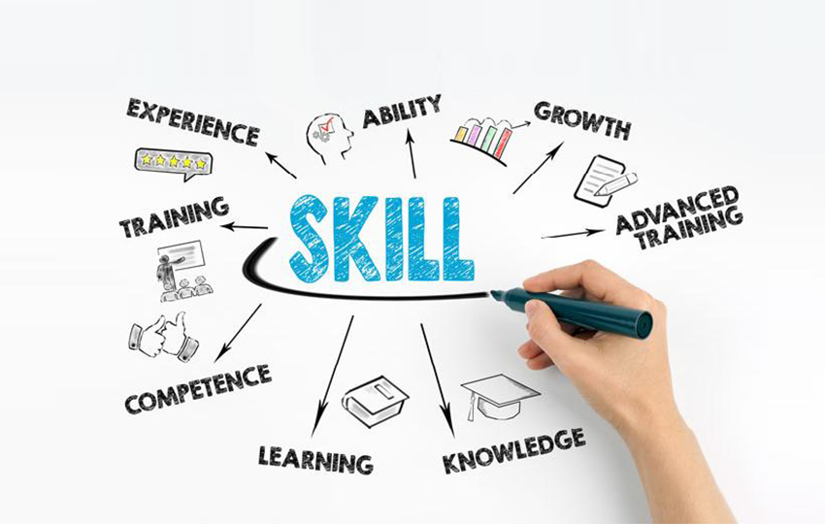

Date: 24/12/19
Student Name: Bocsenean Sabina
Module Name: Academic and Employability Skills
Module Code: BMSW4001_LON

Teacher’s Name – Anita Nan

Contents

Introduction 3
Discussion and the skills 3
Teamwork: 3
Learning skills: 4
Problem solving skills: 5
Paraphrasing 6
Summarizing 6
Collaboration: 7
Written communication 7
Conclusion 8
Reference List: 10

Introduction

I will write this report about 7 academic and employability skills. The task is to list and define 7 specific core skills one by one. The academic skills are also called study skills. The academic skills can be defined as approaches what we need to apply to learn. All of the 7 skills what I am going to write about are very crucial to get good grades on our assignments. They are also useful throughout our life as we always learn. To deal with assignments and take new information in, these academic skills are very important. We need to develop our academic skills as they make us to be more employable.

Discussion and the skills

Teamwork:

Definition: teamwork can be defined as a process. The process’s aim to achieve a goal by a group of people working together collaboratively.
In the school and in work employees need to work with a group of people. If the group of people have the same goal and have to work together, then it is teamwork. In the school students often get tasks to complete together with our class mates. At workplace employees have to work with our team members. Every part of business considers teamwork very important. Teamwork is a part of our life and part of the businesses. Both at work and in College it happens often that the people have to work together. The reason why is because more people can split the tasks between each other and achieve the goals together easier. Because people have different strengths and skills. Variety of skills and strengths together can help achieve the goals quicker and more effectively. When more people have to work together, conflicts can arise. Therefore, to become a good team player, other skills are necessary as well. For example, being able to handle conflicts, giving and receiving constructive and critical feedback from and to others.
I think I have good teamworking skills, I am able to work with a group of people. I always listen to others, always consider others’ ideas, not just my own, because it can be useful. I need to improve on this skill, because I do not always share my opinion. Working with others can help us to improve on our communication skills as well.

Learning skills:

Definition: It can be described as a term. This term describes some tasks. In learning process need to rely on other skills. For example, managing time, taking notes, reading effectively, studying, writing etc. Learning skills are also called as study or academic or research skills. Learning skills helps us to develop and wider soft and hard skills.
Employees need this skill in the context of our course in the school and in work, too. Learning skills help us to adapt new ways of working in new work places. Indeed, if at work there is new process gets implemented, good learning skills helps us to adapt quicker. The employers not always only interested in our good exam results. They also look for candidates who can learn quickly and who are positive about the learning process. Learning skills allows us to analyse and understand the feedbacks what we get. If given feedback is understood, then our future performance can be improved . Learning skills are also important in terms of managing our time better and planning our schedule. That is important in our personal life, at school and in work as well.
If my learning skills are not appropriate, I will miss the deadlines and I can fail, too. Some people have weaker learning skills. Some people do not use appropriate learning techniques. If our learning skills are inappropriate, we cannot improve on our performance. Continuous learning is important, because everything is changing. Indeed, when we get a new job, we need to learn new products and processes. We can get dismissed or fired if we cannot adapt and learn the new processes. I believe my learning skills are satisfactory. Though, I need to improve. I need to be able to take more precise notes in the class. With taking good notes, I will be able to lower the time spent on self-studying at home. Also, if our learning skills are good, we can easier have a logical argument.

Problem solving skills:

Definition: it is an ability to deal with the issues and problems. This skill refers to our ability to solve a problem. The problem solving skills enables us to deal with issues in a timely manner. Also, in an effective way, without obstacles. Good problem solving skills involves:
- Finding out what the problem is
- Finding out solutions to solve it
- Finding out alternative solutions
- Selecting the best alternative
- Implementing the approach to solve the problem.

Problem often are faced, they can be big or small. If problem solving skills are owned , can overcome the issues effectively. It is an unpleasant situation when we have problems. Problems may lead to us failing to achieve what we want. Good problem solving skills is an ability to act in a timely manner to eliminate the issues. Employees can come across problems at work, in personal life and in school as well. If have the skills to find solutions to solve the problem, then can be more successful. Success can help us to lower our stress level.
Lacking problem solving skills can most likely to fail in certain situations. If do not develop problem-solving skills, school can be failed, and work as well. For example, I am working in Creams and I have to serve customers. I think my problem solving-skills are good enough. Dealing with customers is difficult as they always have complaints and issues. I always have to think critically and quickly. I need to find solutions to keep the customers happy. Otherwise I would lose my job. Indeed, I would be very stressed. If a problem occurs, I find out what the cause of the problem could be. Then I think what solutions can be used.

Paraphrasing

Definition: It is an academic skill. Paraphrasing means to write something down with using other words. Using someone else’s work by using different words. The aim of paraphrasing is to achieve better clarity. Paraphrasing is repeating something either by writing or speaking but in a shorter form. To make the original text’s meaning clearer.
It is unethical to use someone else’s work and pretend like it was ours. Both in business or academic life it is unethical and it is a fraud. Student get penalized if he do not use references. Paraphrasing skills helps to reduce the similarity when work is upload on Turnitin. Also, paraphrasing skills are important as it helps to use words to express someone else’s work. For example, when we do group work. Or when we have to write a report to our boss. In that case, we have plenty people sharing their ideas. If we paraphrase the numerous ideas, we can summarize the plenty conversations and lower the length of the discussion. Paraphrasing also helps us to avoid using so many quotations when we write an assignment.
If we do not excel in paraphrasing, we can fail on our assignments. I have only started to study here in the UK. My paraphrasing skills are not the best yet. I am reading articles and books to learn the best approaches. I can reword a sentence. For example, I change the tense from active to passive. I use synonyms as well. However, I am still learning how to put the citation inside the texts.

Summarising

Definition: taking so many information and making it shorter. Creating another version which only covers the main points. For example, writing a summary of a whole book. Only writing down the main happenings, the starting, the discussion and the conclusion in only one page instead of copying the whole book. Summarising can be also called as conclusion. With other words, the aim and point of the writing.
In the school, students always have strict word count on our assignment. Students cannot write as much as they want. That is why it is important to be able to shorten a text, need to shorten the central ideas. If students are good at summarising, that can help them to improve on their memory. They read an article or a book and write down the main points and ideas in a shorter way. Shorter, but in a meaningful way. Summarising skills enables them to ignore those extra information what are irrelevant.
Summarising can be learnt by practicing. I need to improve on my summarising skills. I often use long sentences. Some managers do not have time to listen to our long stories. We need to be able to go straight to the point. Without missing the main points but ignoring the irrelevant things.

Collaboration:

Definition: it is similar than teamwork. In the school or in work 2 or more people have to work together. Collaboration is a process when more people work together. They work together to achieve the same goal. To achieve the same goal more people complete the task together.
It is very unlikely when work have to be done on your own. Most of the workplace have numerous employees. Need to get along with colleagues. With collaborating with colleagues tasks can be completed quicker. More people have more good ideas, independently can often fail. Just one is not always enough on his own to finish the work or meet the goals. With collaborating skills can be more successful at work and in personal life. Some tasks at work cannot be done without others’ help.
I am a good team-player. I always help others. I prefer to work in teams rather than alone. We are all different. We all have different strengths. It can happen that I am weaker in something, but my colleague is better. And back and forth. With collaboration we can be successful and lower the risks of failing to complete a task or meeting an objective or goal.

Written communication

Definition: The ability to express ideas by writing. Written communication is the ability and skill to tell things to other people by writing.
There are situations when employees cannot talk to others. There are situations when they are not allowed to talk to others. For example, some authorities, companies, etc requires to send a written request, complaint, etc. In these scenarios, need to write. If employees have good written communication skills, they can avoid misunderstandings. At work, people may have to write reports, or they may have to answer a customer’s letter. With good written communication skills easier to the audience to understand points, requests, statements.
Indeed, at College, students need to write assignments, to avoid being unclear or vague, they need good written communication skills.
Without adequate written communication skills we can fail at school and at work as well. Unclear report or a letter to the council etc can lead to misunderstandings. It can lead to losing our job, losing customers, upsetting others, etc. English is not my first language. I am still learning. Though, I think my written communication skills have improved since I moved here. I still have to learn a lot. I need to improve on this skill. Written communication skills are essential in certain jobs. E.g: customer service, managerial level, etc.

Conclusion

This assignment was written about 7 important academic and employability skills. These skills are very important to achieve in school. If we finish the school and gain a diploma, we will become more employable. To get better jobs, we need to educate ourselves. Throughout the course in the school, we constantly develop some of our skills. These skills, for example, collaborating, team-working and written communication skills are essential in any job. We need to work with other people at work, we must be able to get on well with them, otherwise we cannot meet the objectives of the company. Teamwork makes completing the tasks easier.
We also need to communicate with the team-members effectively and clearly to avoid misunderstandings. Lacking these academic and employability skills can lead towards us not getting a job at all, or getting dismissed.
After defining these skills, I summarized my strengths and weaknesses. From the above analysed 7 skills, I think my strength are team-working and collaborating with others. I need to learn paraphrasing, but I think I am good at summarising. My biggest weakness is communication. Regardless my written communication skills are better than spoken, I need to learn so much.
Writing this assignment also made it clear to me that how important to always critically analyse ourselves. If we are not aware of our strengths and weaknesses, we cannot even make changes.

Reference List:

En.wikipedia.org. (2019) Study skills. [Online] Available at: https://en.wikipedia.org/wiki/Study_skills (Accessed: 5 December 2019).
Hind, D. and Moss, S. (2011) Employability skills. Houghton le spring: business education publ.
Zety. (2019) Teamwork Skills: definition, examples, best for your resume [+tips]. [Online] Available at: https://zety.com/blog/teamwork-skills (Accessed: 1 December 2019).
Library.leeds.ac.uk. (2019) Academic skills. [Online] Available at: https://library.leeds.ac.uk/info/1401/academic_skills (Accessed: 2 December 2019).
2011-2019, (2019) Learning Skills | skills you need. [Online] Available at: https://www.skillsyouneed.com/learning-skills.html (Accessed: 3 December 2019).

Dictionary.cambridge.org. (2019) PARAPHRASE | meaning in the cambridge english dictionary. [Online] Available at: https://dictionary.cambridge.org/dictionary/english/paraphrase (Accessed: 5 December 2019).



