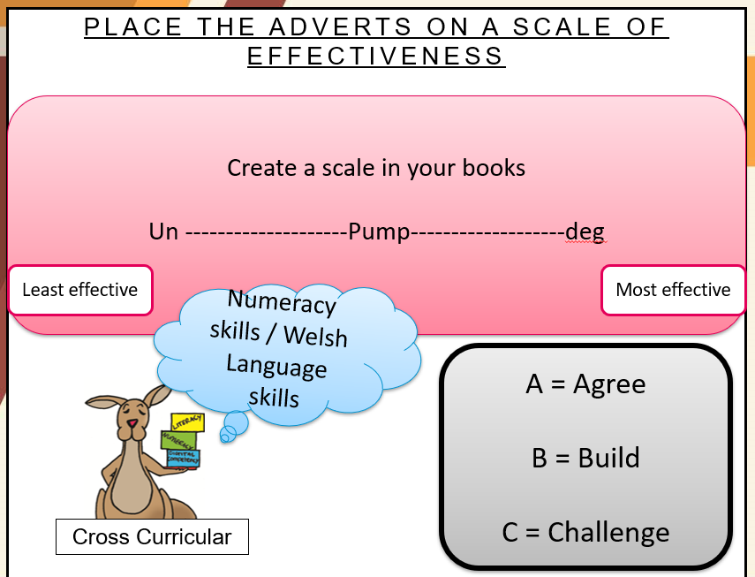
From a PowerPoint used in a lesson.

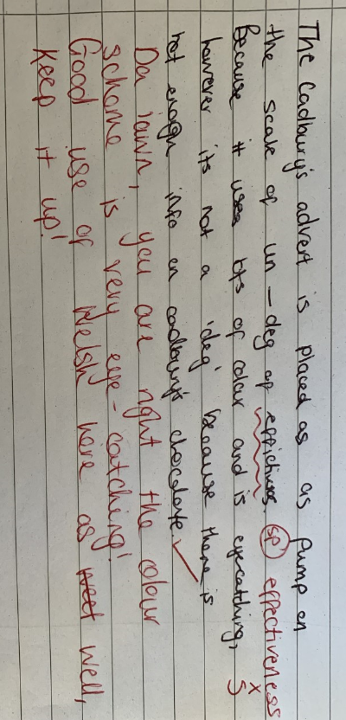
A learner’s work during the same lesson.

