List of Tables and Figures

Abstract

This paper aims to explore GIS-based modelling using MapInfo Pro™ v16.0 64-bit for the spatial measurement and evaluation of the pathogen Phytophthora ramorum. The boundary area for this study is the country of Wales.

Background

Geographical Information Systems (GIS) are an evolving technology that enable an amalgamation of geographical features with many different types of data. Modern systems allow the capture, storage, processing and analysis of geospatial data over an extensive application area. Entrenched in the science of geography, visualisation of data in the form of maps may convey relationships between the ‘what and where’ which may not have been evident from the raw data solely.

History of GIS

Prior to GIS application being conducted using computer, an early application of GIS was during the mapping of a cholera epidemic in 1854 by Dr John Snow. Often hailed as the ‘father of epidemiology’ but more recently as the ‘father of modern GIS spatial analysis’. His epidemiological application used data gathered on locations of houses where cholera case had emerged, marked as lines on a map, as well as mapping locations of the water pumps in the area. He later went on to attribute this data to different water companies as can be seen in Table 1.

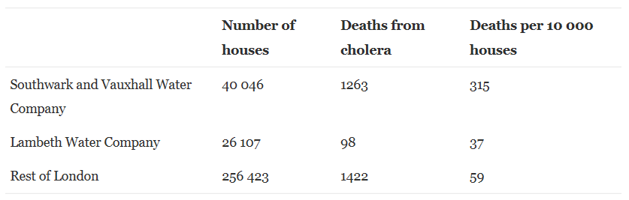
Table 1: Snow's analysis of the 1854 epidemic
Density hotspots were determined using areas of the highest concentrations of cases. He determined these cases were sited nearest to the Broad Street pump, a source of drinking water. The handle was removed from the pump, and the cases of cholera declined rapidly. Using mapping techniques, he concluded the correlation between outbreaks of the disease and spread with geospatial data. He also illustrated the water-borne origin of cholera, which was previously undiscovered. At the time this would have been a laborious task, but today things are different (Musa, et al., 2013)
Development of GIS then took off in the 1960s.
Today the combination of different sources of attribute information and numerical data, along with the ability to make geospatial queries has enabled fast visual presentation geographically, enabling geostatistical decision-making processes and monitoring more comprehensive.

Introduction

What is Phytophthora?

Phytophthora when translated from Greek literally means ‘plant destruction’ and it is sometimes referred to as the plant destroyer. A genus of more than 100 different species (Fera, n.d.) including Phytophthora infestans, the pathogen which was responsible for the Irish potato famine.
Phytophthora ramorum is a fungus-like oomycete pathogen and is classified as an oomycete (water mould), requiring a moist environment for active growth and reproduction.
Genetic analysis has identified four clonal lineages: EU1, EU2, NA1 and NA2 indicating P.ramorum infection occurs in Europe and North America at present. The most recent EU2 lineage has been found to be especially aggressive to larch (Harris & Webber, 2013). Distribution of this lineage as well as the distribution of the EU1 lineage is critical to effective management of P. ramorum (Forest Research, 2013).
P.ramorum was first discovered in the UK in 2002 on an imported Viburnum plant (Woodland Trust, 2019) and today is known to affect more than 150 species of plants causing extensive damage including some forest species (Forest Research, 2020). In the UK it is more commonly known as Ramorum blight or sudden larch death. In 2009, P. ramorum was found infecting Japanese larch (Larix kaempferi) in SW England, with further outbreaks discover primarily in the Afan Valley in Wales in 2010.

How has it affected the woodland in Wales?

Woodland coverage in Wales is estimated at 15% of the land area, compared to an EU average of 38%. The predominant woodland type in is Conifer, of which 2/3 is owned by the Welsh Government; while native woodland tends to be fragmented and unmanaged. A proportion of native woodland is classed as ancient woodland, existing for more than 400 years which is of high importance and irreplaceable (Welsh Government, 2018)
Prior to its discovery 5% of the total wooded area in the UK consisted of Larix spp. (approximately 154,000 hectares). In Wales alone, the total net area of larch which has been subject to SPHG control measures, including felling exceeds 12,000 Ha, with more than 8,000 Ha being Welsh Government Woodlands Estate (Forestry Commission England, 2019). It was once an economically important timber species, however much of this has been lost and it is no longer viable for use as a timber species due to the control measures it entails (Forest Research, 2020).
The data below shows the increase in cumulative area under Statutory Plant Health Notice (SPHN) (ha). It was compiled from NRW Situation Reports, 2010-2018 (Welsh Government, 2019).
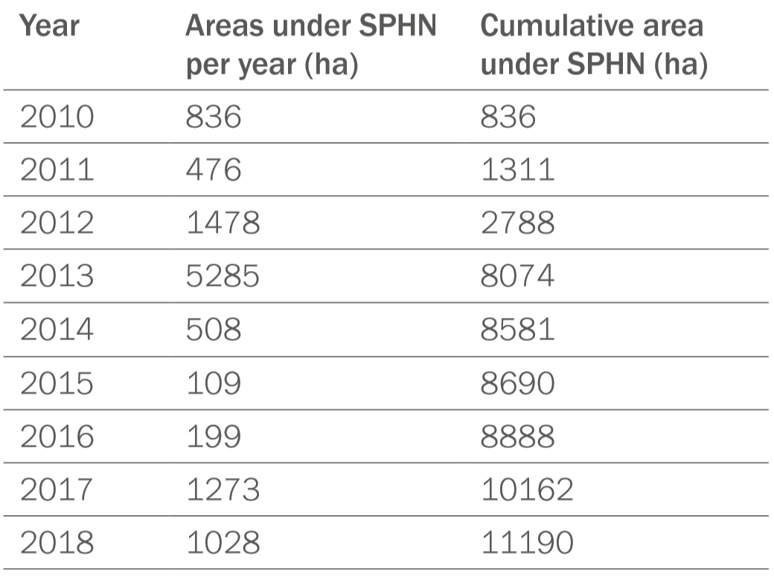
Table 2: Areas Under an SPHN or Notification Letter (Welsh Government, 2019)

As the disease has progressed and spread North into areas of Mid and West Wales, the strategy has been updated Creating a new Core Disease Zone (CDZ2) which incorporates Mid-West Wales from Brechfa to Dolgella (Welsh Government: Press release, 2019). This can be seen in Figure ? below with a larger version in Appendix?

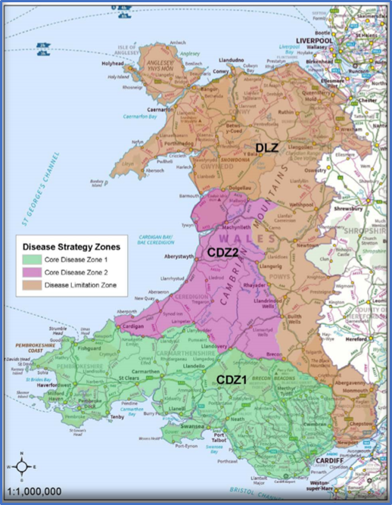
Figure 1: Phytophthora Ramorum DMZ’s (Welsh Government, 2019)
Table ? below
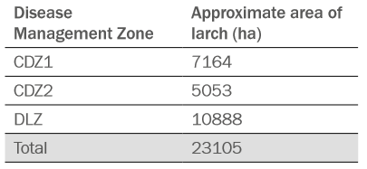
Table 3: Areas of known larch in each Disease Management Zone (Welsh Government, 2019)

Methods of Dispersal

It has a rapid life cycle and the ability to reproduce asexually; sporangia can be carried in windblown mists up to 4 miles away, and Zoospores are released when encountering plant tissue, but symptoms can be slow to appear. Spores can also persist in the soil for many years and survive harsh climatic conditions (CABI, 2019).
The plant trade, as previously mentioned has been attributed to the first discovery of P.ramorum.
Transmission can also occur via movement of infected material, or contaminated soil. Machinery, vehicles and footwear.
P.ramorum is a quarantine listed organism due to its ability to spread in the natural environment. It has been classed as invasive due to its ability to infect a broad range of susceptible plants (Fera, n.d.).

Host range

Aside from Larix spp the P.ramorum pathogen has a broad range of susceptible host plants in Wales, which includes ornamental and nursery grown species. Top hosts for Phytophthora include Rhododendron, Camellia, Viburnum, Taxus, Rubus and Prunus species (DEFRA, 2015).
The range seems to be constantly growing, for example, in 2015 infected sweet chestnut trees were found at a small number of sites in South-West England, mostly in Devon and Cornwall. (Woodland Trust, 2019). The broad range of hosts signals pathways for long-term dispersal and further spread of the P.ramorum pathogen.

There are a number plants which are susceptible to Phytophora pathogens, which can be seen in Appendix (RHS hosts). Top hosts in this list include

Policy and Regulation

The Plant Health (Phytophthora ramorum) (Wales) Order 2006 prohibits the introduction and spread of P.ramorum into and within Wales. Section 4 sets out that imports of material from the US which may be susceptible to P.ramorum, such as Camellia spp. and Rhododendron spp. require a phytosanitary certificate (Welsh Government, 2018). It is also subject to EU emergency measures (2002/757/EC) to prevent the spread within the EU under this order. The Plant Health (Forestry) (Amendment) (Wales) Order 2019 sets out requirements for plant passports in article 20 (UK Government, 2019).
The Woodland for Wales Strategy was first produced in 2001 and updated most recently in 2018. Tree health is the priority action in the current action plan. To meet legal requirements in the reduction of 80% of greenhouse gas emissions by 2050, as set out in the Environment (Wales) Act 2016, the strategy will aim to plant 2,000ha annually from 2020 (Welsh Government, 2018). The Welsh Government has a management strategy for P.ramorum, first published in 2014 and later updated in 2019 (Welsh Government, 2019).

Case Study: Phytophthora ramorum in Wales

This case study aims to evaluate the application of GIS in the outbreak of the pathogen P.ramorum. MapInfo® Pro is the desktop Geographic Information System (GIS) and GIS mapping application which will be used.
There are two basic types of data:
- Spatial – There are generally two types of stored spatial data; Vector and Raster. Vector data will contain geospatial locations or coordinates, usually X and Y, or another form of geospatial referencing. This data can create polygons, lines or sets of points for use in a GIS workspace. Raster data is scanned data, for example an image from a camera and the data format is usually .JPG, .GIF and .TIF. Raster data is useful for looking at continuous data (without boundaries) such as temperature, precipitation and soil pH. Spatial data provides us with a visualisation within an area.
- Attribute data – This data gives details of characteristics of a particular site, and data is usually in table format.

Boundary area

The boundary area is the country of Wales, United Kingdom, as can be seen in Figure ?
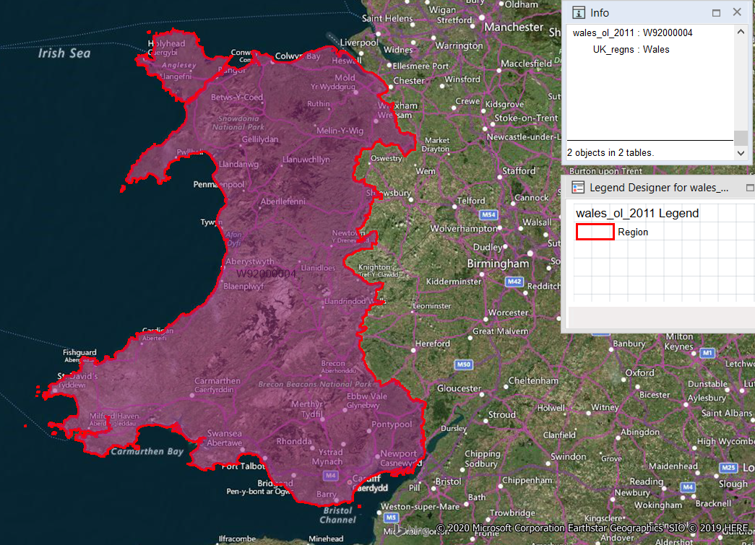
Figure 2: Boundary of Wales(Office for National Statistics, 2011)

Visual pattern in this spatial data suggest that P.ramorum prefers specific geological sites within Wales.

Infected Sites

The attribute data in this file, as well as giving geospatial location also tells us which sites are owned either privately, or by the welsh government (FCW).

Hotspot Density Mapping

A hotspot density map created from the infected sites data enables.
Point data sets are used in this process producing a layer of clusters in the data, which is then viewed by the user as radii (Pitney Bowes, 2017).
The map indicates the highest concentration of P.ramorum infections within Wales.

Roads, Rivers and Transport

To build a GIS workspace, the roads and rivers is a good place to start.
The mountains in Wales, for example in the Brecon Beacons act as a barrier to P.ramorum spread which supports literature that it prefers lower areas which are more humid.

Looking into a smaller more specific region on the map, which is sometimes referred to an area of interest (AOI) we can determine more detailed, site specific characteristics.
In South Wales which has the highest concentration of infected sites it could be possible that the docks in Swansea involved with plant trade could have introduced the pathogen this route.

Recreational Routes and Areas

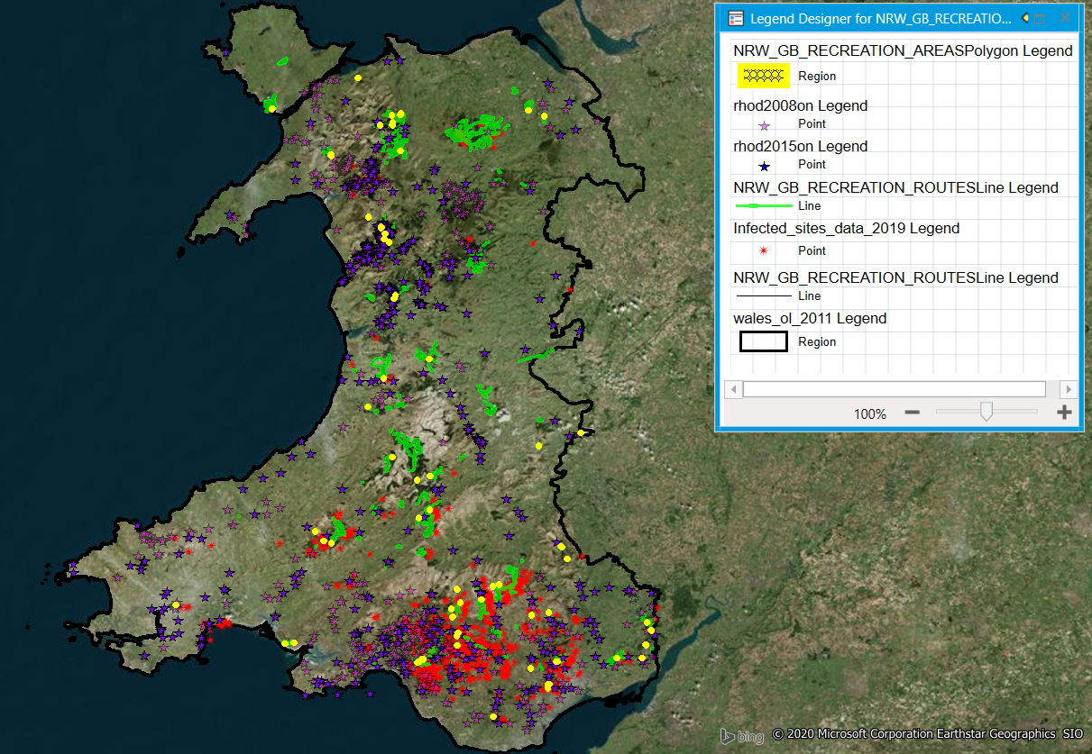
Natural Resources Wales (NRW)

Rhododendron ponticum

Rhododendron ponticum is a top host species for P.ramorum.

You can see, R.ponticum has followed along the road
The attribute data can help to determine.

Limitations

GIS software is expensive.
There is a limited amount of data available for use. Some datasets were available for purchase, however this would be expensive, especially as this data may prove inconclusive.
There were also problems with the GIS software, some files were far too large for the system to deal with which would end up with the system crashing and losing of any workspaces and loss of data.

Conclusion

GIS maps of Phytophthora ramorum enable the visual interpretation of an invasion geospatial information in epidemiological studies. The understanding of the relationships between spatial and attribute data can aid in the solving of complex problems today. This can aid the user determine where to focus resources to obtain the broadest results. It is an impressive tool which can aid in problem solving and in decision making processes.
GIS has an expansive application area. Multiple layers of data can be managed and enhanced, and ultimately analysed which can aid in the assessment of issues in real time, as well as make predictions on future scenarios.
The opportunity to increase species diversity and redesign our woodlands has arisen as a result of the felling Larch across Wales. The future resilience of our woodlands can be protected and enhanced with careful planning, of which GIS can be an aid. Furthermore, for the sake of Future Generations, a more diverse environment can create employment opportunities and help to mitigate the impacts of climate change.
As the old saying goes ‘a picture is worth a thousand words’ (Wright, 2017). GIS is essentially a framework for gathering, managing and analysing information from a variety of sources. Using GIS is an invaluable tool which can enable the user to build a workspace to educate others or inform importance research as well as evaluate relationships of different geographical features.

Future recommendations

Continuing aerial service to monitor the spread of the pathogen, to determine the extent of infected woodland over time.
Increasing biosecurity measures, especially along recreational routes and areas, as this was identified as a primary source of spread in Wales.
Eradication programme and increased awareness of the impact of Rhododendron ponticum across Wales, concentrating foremost in the DLZ. This invasive plant species has a negative affect on our native flora and fauna, as well as acting as a host for P.ramorum. Increased surveillance on other host species would also be useful as is being doing in Scotland.
Replanting using a mixture native vegetation and plants which show resistance to P.ramorum. Natural Resources Wales has identified nearly 40 trees which would be suitable for restocking having shown some resistance to P.ramorum, including our native oak, Quercus robur. Other resistant species have been announced by the (RHS Advisory Service, 2017) as you can see in the table below, including Betula nigra, Gingko biloba and Liquidambar.

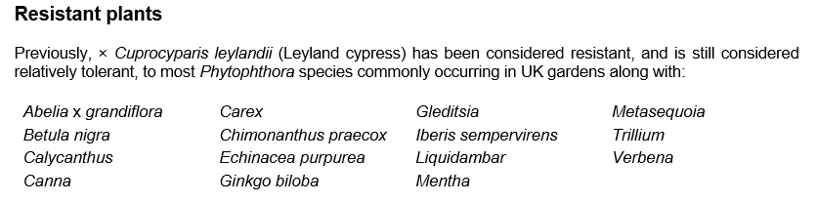
Table 4: Resistant Plants (RHS Advisory Service, 2017)

Furthermore, improved integration of data sources and information sharing across various sectors, stakeholders as well as with business and the public could aid in making GIS more user friendly.

Appendix A
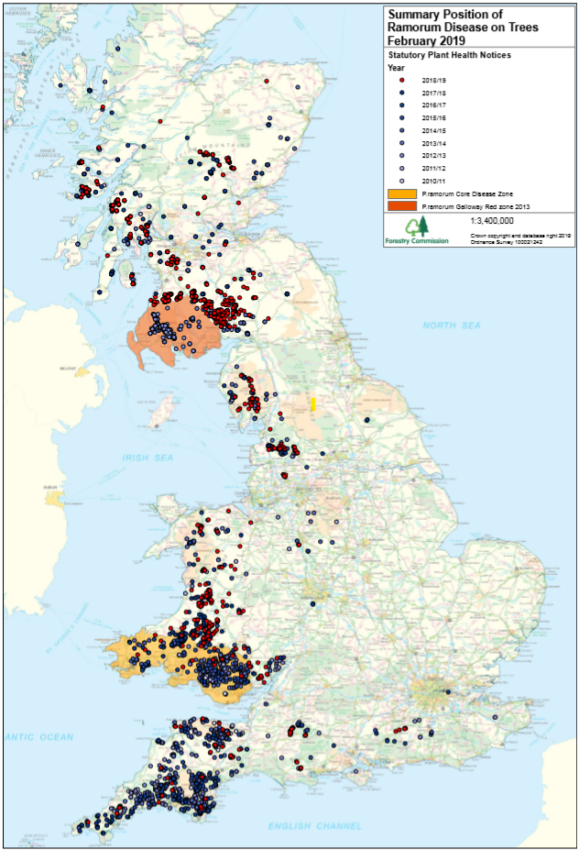
Figure 3: Summary Position of Ramorum Disease on Trees February 2019 (Forest Research, 2020)

Appendix B
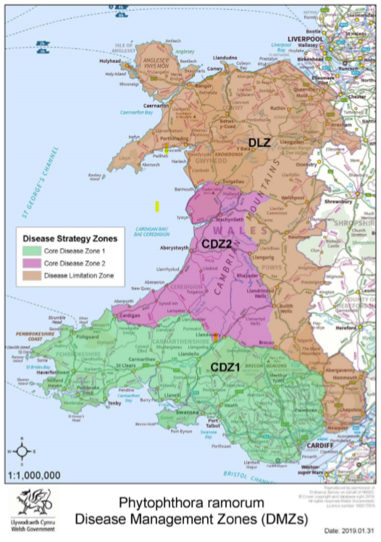
Figure 4: Phytophthora ramorum Disease Management Zones (Welsh Government, 2019)

