

Postgraduate/Distance Learning
Assignment coversheet & feedback form

THIS SHEET MUST BE THE FIRST PAGE OF THE ASSIGNMENT YOU ARE SUBMITTING (DO NOT SEND AS A SEPARATE FILE)

For completion by the student:
Student Name: Barbara Werther-Rosenow

Student University Email: 2219165@student.uwtsd.ac.uk
Module code: HPCA 7015  Module title:  Foundations in Cultural Astronomy and Astrology | Student ID number:  2219165 |  |  | Educational support needs:  Yes/No  No
Assignment title:
Essay based on a Sky Journal

Assignment due date: 1 December 2022
This assignment is for the 1st x 2nd 3rd 4th 5th 6th module of the degree

1st

I confirm that this is my original work and that I have adhered to the University policy on plagiarism.
Signed …Barbara Werther-Rosenow…………………………………………………………
Email submission:if you are submitting this form via email, please tick this box □x
(as a substitute for your signature) to confirm that you agree to the above declaration.
Assignment Mark
1st Marker’s Provisional mark
2nd Marker’s/Moderator’s provisional mark
External Examiner’s mark (if relevant)
Final Mark

NB. All marks are provisional until confirmed by the Final Examination Board.

For completion by Marker 1 :
Comments:

Marker’s signature: |  |  | Date:
For completion by Marker 2/Moderator:

Comments:

Marker’s Signature: |  | Date:
External Examiner’s comments (if relevant)

External Examiner’s Signature: |  | Date:
Essay based on a Sky Journal: The Moon and its Phases related to a Statement by Van Gogh
(Word count 2100)

Charting the Moon’s phases over the last month was more challenging than I anticipated. Though I associated the Moon with the night that is not, I learned, always when it is visible. Though I have been fascinated by the Moon for as long as I can remember, I have, apparently, never paid close enough or careful enough attention to it, to comprehend exactly what the Moon does in the sky.
I realized that on some days the Moon rises around sunrise and sets close to sunset which means the Moon is out during the day. While the Moon is very prominent in the night sky, during the day the Moon is so inconspicuous that it will almost certainly be overlooked by people casually glancing at the sky. Brunner writes, ‘the moon is actually part of the daytime sky as often as the nighttime sky, even if it is hardly noticed or sometimes mistaken for a cloud’. It was difficult for me to locate the Moon in the daytime sky even though I knew it was there and I was actively searching for it. I had to look for the Moon very carefully, systematically, and often repeatedly even when searching in the correct section of the blue sky with the help of a compass and google. The crescent Moon in the daytime sky looked insignificant and considerably smaller than it did the same night when I caught it low on the horizon setting soon after the sun. It was undoubtedly the contrast of the bright Moon against the night sky that made it feel bigger; strong contrasts attract attention. Painters have known this for centuries, applying tenebrism, chiaroscuro and complementary contrasts to their paintings, and filmmakers commonly use strong light and dark contrasts for dramatic effects. It is no wonder that we associate the Moon with the night and not with the day when the Moon is barely visible in the sky. It is the nighttime Moon that affects us strongly and that has become the thing of myth and lore.
Meanwhile, the Moon though visible from earth, is markedly absent from the night sky when out during the day except for fluctuating windows before sunrise or after sunset. Before starting this project, I thought the Moon was only absent from the sky for approximately three days around the new Moon, but I have realized that the Moon is absent from the night sky for much longer periods. While the Moon was on its diurnal schedule, Mars and Jupiter took center stage in the dark night sky which was effectively indistinguishable from the new Moon phase. All this was reversed the closer the Moon reached toward fullness. Moonrise happened in the early evening and the Moon was visible throughout most of the night, dominating the night sky with its brightness, and then setting close to sunrise. The Moon’s seemingly erratic course and continuous transformation makes the Moon appear mysterious and captivating, and it explains why the Moon exerts such a powerful pull on us, something described by Paul Bogard from personal experience. Our fascination with the Moon, however, reaches far back in time. Jules Cashford even presents the Moon as somehow entangled with human consciousness’.
A highlight of my month watching the Moon, was the total lunar eclipse on November 8. The sky was dark and clear and visibility, therefore, close to perfect. The eclipse happened between 3 and 6 am in my location and I saw everything but the very last phase of the eclipse because the Moon by that time had dipped behind buildings and out of view. The Moon was completely obscured except for one little sliver at the bottom edge when I last saw it. What was particularly stunning about the total eclipse was the fact that I was able to witness essentially all the different Moon phases over the span of just a few hours. Darkness slowly descended on the Moon from above until only a little sliver was left, passing through the different shapes the Moon transforms into over the course of a month. Since an eclipse is a gradual obscuring, it was, however, more like the waning phases of the Moon. Watching the eclipse was an amazing experience and I now understand why eclipses have captured people’s imagination but also why they may have instilled fear given that the bright full Moon is engulfed by darkness. An eclipse certainly combines beauty, terror and awe into what Edmund Burke called the sublime.
My focus on the Moon over the last few weeks, took me outdoors in the middle of the night on multiple occasions which was in itself a very profound experience; the unusual silence and the enveloping darkness not only softened the edges of the world around me and turned my attention inward but also heightened my senses and put me ever so slightly on edge. Burke writes that ‘night adds to our dread’. Gazing up at the sky in solitude further amplified and intensified the experience. I was fortunate to experience numerous clear skies in which the entire night sky came to life presided over, at most times, by the Moon in its various phases; I could not help but think of Van Gogh who was fascinated by the night and painted many nightscapes. Lifting my gaze toward the night sky opened me up toward the infinite, awe-inspiring vastness of the cosmos as I am sure it did for Van Gogh. His magical, iconic painting The Starry Night is proof of that. Most of the time, however, we all tend to look straight ahead toward ever new goals while keeping our gaze directed at the path below us for fear of stumbling stones. Living life this way may strike us as ordinary and dull or even depressing, that, at least, seems to be what Van Gogh meant when he admonishes us to be ‘clearly aware of the sky’ for that can turn the mundane into enchantment ‘after all’. He is particularly fond of the night sky writing that ‘the night is much more alive and richly colored than the day’.
Enchantment is something special, something often lacking in our ordinary world and our habitual life. It is a wonderful, marvelous experience though as Patrick Curry points out not a state we can (safely) maintain for long. However, there would be something desperately amiss if we never experienced it. In The Starry Night, Van Gogh gives us a glimpse of his own enchanting experience before the night sky. Enchantment is an extraordinary experience which makes us see the world in a different way, and as such it is difficult to capture in normal language. Van Gogh developed a new pictorial language of strong contrasts and exuberant swirly lines which gestured at the intensity of his experience of the world. Ulisses Barres de Almeida writes, the ‘inspiration man has before certain special phenomena of reality is always an inspiration to create, to imprint in the world the personal mark of the experience’. That is certainly what Van Gogh did. His aim was to ‘leave some memento [of gratitude] in the form of drawings and paintings’. Looking up at the sky at night, I also felt the cosmos sing to me, enchantment contains the French word ‘chanter’. It is something neither the sky journal nor this text can express adequately, and it may not be something that can ever be fully expressed. However, a different more poetic language may at least gesture toward it. That, in any case, is what I attempted in the following poem.
Lifting our gaze to the sky with openness and humility, has the power to enchant us, and to inspire us with not only awe but also with wisdom. Psychologists Keltner and Pfiff establish that the ‘self-transcendent emotion of awe is a moral grounding of wisdom’ which they associate with the experience of nature, beauty, patterns of light and dark, and especially with vastness. Looking at the mysterious, ever-changing Moon before its vast cosmic backdrop is most certainly an enchanting and awe-inspiring experience. I am certain that Van Gogh would nod his head in agreement.

My Ode to the Moon

Grand Queen of the Night,
I curtsey to you,
who outshines
as crown jewel of the dark sky
all the stars
in glorious cosmic
boundlessness
timelessness
vastness,
of the heavens
who holds her court
of phenomenal splendor on
exceptional
full days
of the lunar calendar
and then
disappears
from view
without trace.

Tracking you, Moon,
following your course
like traces on bone
Where are you?
meandering
wandering
luminary
always on the move
Where are you?
hiding,
shining,
shifting shape,
in the shadows
of consciousness
lunatic
capricious
unpredictable
rising
setting
in the unconscious
New Moon.

There you are
hanging in the sky
enveloped in the rain
damp plants and
morning dew
dancing with the clouds
playing hide and seek
behind clouds and underneath my feet
looking in the mirror of the waters
reflecting
kaleidoscopic
the ocean above
the ocean below
drawn to one another
by an invisible
force
tides coming and going
rolling in, rolling out,
in, and out,
in, and out….
like a rhythmic cyclical song with endless verses
soft silvery lightness set
against dark skyscape
bright orange pinkness
a full phase Moonrise
in autumn
time

Total eclipse of your light
one night
a shock, a surprise, a delight
to those who are aware of your dare in the sky
and not asleep in their beds
no Moon light in the night
of the Full Moon
a month in a day
inmost essence on display
exposed
made known
to the world.
Ominous
prophecy
magical
visionary
mystery
in plain sight
receptacle
of dreams, dripping down
sweetest of nectar,
intimations of the dark
night of the soul.

Conversing dancing relating
as you move though the signs
Pisces
Virgo
Gemini …….
gathering convening, at times
in special celestial places
with other wandering stars:
Saturn,
distant and dull
Mars,
fiery red flame in the sky
Jupiter,
bright and light in the night
twinkling star Sirius and
all those lost
to the artificial light of the night
or those deep in the milky way
not visible to bare eyes
only felt in some strange way,
in sympathetic waves
magical magnetism
cosmic quantum exchanges
through all time and all space
in a leap of faith
with the sun
a sharing of light
a celestial dance
in regular mathematical formation
a harmony
a serenade
a nocturne
to the stars
and to the
Moon.

Hiding in the blue sky
a tiny sliver curved like
the horns of the cow
engendering the bull
the mother the son
every year in the spring
in a perpetuity of life
eternally searching for
the hare,
a man in the Moon,
a snake on the prowl.
How many days
to begin all over again
this enthralling miracle
in the sky
similar but never the same
in suspense until the end
of our days.

References

Barres de Almeida, Ulisses, ‘What are these Sparks of Infinity Clarity? And what am I? So I pry’, Culture and Cosmos, 16:1 and 2 (2012) 19-29

Bogard, Paul, ‘The Path and Pull of the Moon’, Creative Nonfiction, 36 (2009), 28-36

Brunner, Bernd, Moon. A Brief History (New Haven, Connecticut: Yale University Press, 2010)
Cashford, Jules, The Moon: Myth and Image (New York: Four Walls Eight Windows 2003)
Curry, Patrick, Enchantment. Wonder in Modern Life (Edinburgh: Floris Books, 2019)
Gogh, Vincent van, and Ronald de Leeuw, The Letters of Vincent Van Gogh (London: Penguin Books, 1997)
Vincent van Gogh: The Letters, ‘Letter 676, 8 September 1888, Vincent van Gogh to Theo van Gogh’ http://vangoghletters.org/vg/letters/let676/letter.html [accessed 22 November 2022]

Keltner, Dacher and Paul K. Pfiff, ‘Self-Transcendent Awe as a Moral Grounding of Wisdom’, Psychological Inquiry, 31:2 (2020), 160-163

The Originals: Classic Readings in Western Philosophy (lumenlearning.com), ‘Edmund Burke- On the Sublime’ http://courses.lumenlearning.com/suny-oneonta-classicreadings/chapter/edmund-burke-on-the-sublime/ [accessed 20 November 2022]

Primary Source- Sky Journal (not sure if this is supposed to be attached but here it is just in case)

October 19 Moon rise is very late at night or rather early in the morning. The moon phase is a waning crescent, and the moon is a thin sliver. It looks like an elegant, slightly tilted bowl, hanging on the right side of the mostly absent moon disk. The moon is rising from the South-East. I have to wait a long time from actual moonrise for the moon to appear above the trees and buildings in my neighborhood. Standing outside in the middle of the night in the dew-covered grass with the dark sky above me, is an interesting and very powerful experience. The usually hectic world is asleep. Everything is peaceful and quiet, but my eyes probe the shadows around me as much as they probe the sky above me. Are the two somehow connected? They are certainly connected in my experience of them.

October 20 Moonrise is even later in the night, at 5 am it’s actually very early in the morning. Before moonrise the sky is again dark with many stars, like an absent moon, a new moon. The absence of the moon is palpable. I downloaded a star app and with the moon absent I am looking at other celestial objects in the night sky. I discover that the brightest ‘stars’ in the night sky are actually planets. Jupiter appears very bright while Mars has an obvious reddish tinge. The twinkling star in the sky turns out to be Sirius. I have always wondered about this star, but never knew its name. Thanks app! The night sky is truly wonderous. I am upset that my eyesight is not the best and I feel certain that I am missing out on a lot that other people can see. Being shortsighted distant objects are often too small to see. I think I will purchase a telescope to continue looking at the sky after this project ends in more depth and clarity.
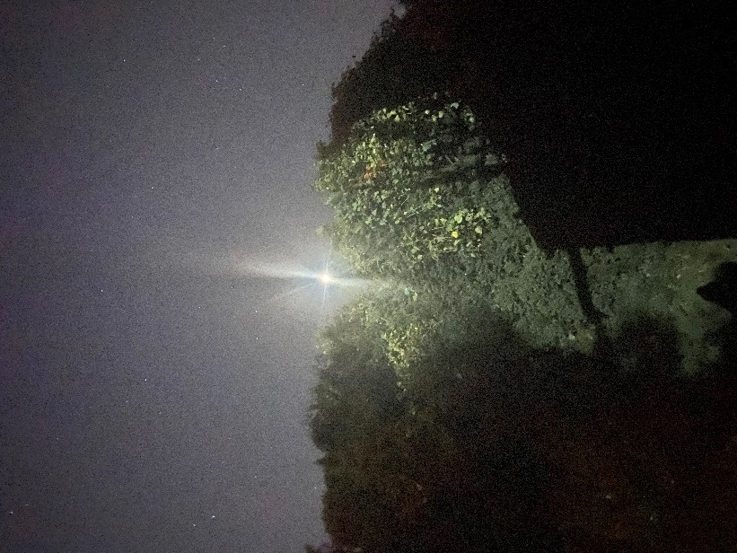

October 21 Another dark sky full of stars with an absent moon. I observe the moon during the initial stages of its rise toward zenith, long before it sets on the other side of the sky. Moonrise is occurring in the Eastern sky while the moon sets on the Western horizon. It comes creeping up at around 5am over buildings and trees in the neighborhood though actual moonrise is earlier.
Tonight, I am also focusing on the constellations that are lined up in the sky. My new app is pointing them out to me though I don’t see all the stars that make them up. I blame my eyesight though some of the stars may now be too faint to see because of light pollution. It’s very interesting though, how close the constellations are to each other in the sky, they nearly overlap! Capricorn, Aquarius, Pisces… I guess this is the ecliptic?! I never fully understood that concept until maybe now. I see Jupiter, Mars and the moon interacting with the constellations. Seeing this occurring in the sky and not just in an astrological chart is quite amazing. Though I am interested in astrology, I am not an astrologer, and I find the difference between tropical and sidereal zodiacs confusing. What I am seeing in the sky does not actually correspond to the astrological chart. Mars isn’t really in Taurus though in the sky he most definitely is. Mars appears to be right between the horns of the bull in the sky (at least according to the app) but Mars is in Gemini.
October 23 and 24 There is thick cloud cover. There is no sight of the moon, not even a glimpse.
October 25 There is thick ocean fog today. This does not happen very often, and it is quite fascinating. The sky is making itself very visible, even palpable, as the fog creeps over the ground and much of the physical world disappears into it. Light bounces off the fog in very strange ways. The new moon, however, is going by unnoticed. It is completely hidden behind the clouds.
October 27 The night is super clear, there are many stars and a conspicuously absent moon though the moon should be visible again today as a waxing crescent. The moon is and has been out during the day, though I could not locate it in the sky today. I will look more closely tomorrow. Somehow, I did not think to look for the moon in the day sky up until now since I associate the moon with the night and not the day. Very interesting! I guess I was also having too much fun exploring the night sky.
October 28. The moon is out mostly during the day and not at night. I capture a photo with the moon barely visible in the still light early evening sky. After sunset I see the moon playing hind and seek with the clouds before it sets. The moon sets quite soon after the sun not to rise again until late next morning. The moon is a very thin shiny waxing crescent. It is more upright, still on the right side of the moon disk, but it looks a bit less like a bowl than before, I think. My photos are mostly just showing an undefined splotch of light in the sky, and though I did attempt do make a few simple drawings, they are of no help here either.
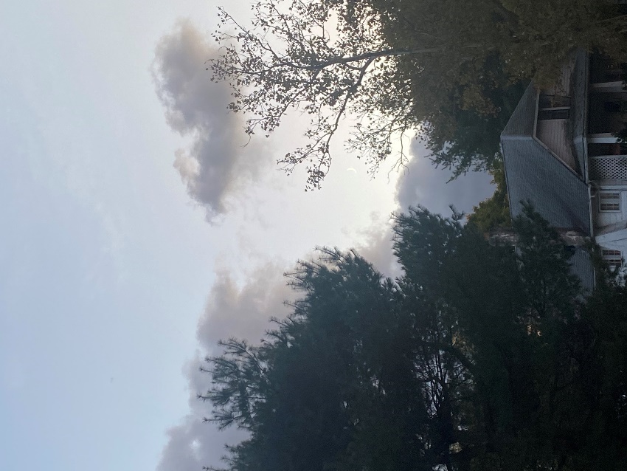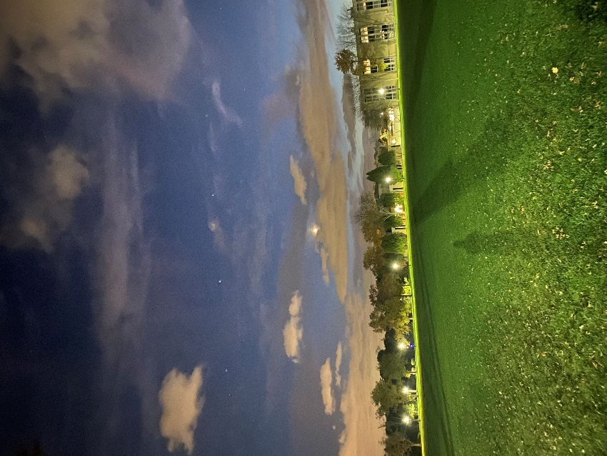

October 29 I am focusing on the moon during the day because this is when it is actually out, though very difficult to see, barely visible. I search the sky, I carefully scan every part of it, it feels like some kind of trick image - Find Waldo!- and finally there it is. The moon is hanging in the middle of a vast deep blue sky. It is getting a little thicker around the waist. The crescent is filling out. The moon is again setting soon after the sun.
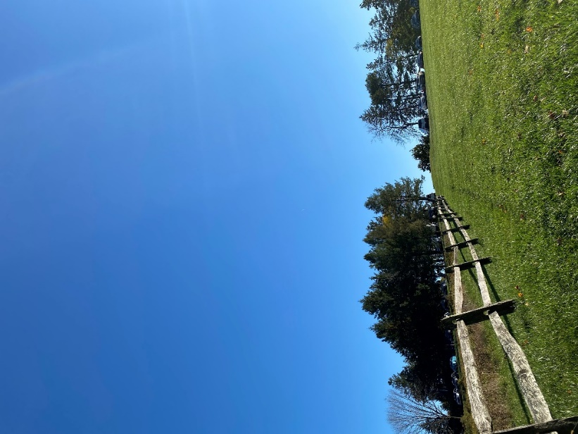
October 30 The night sky is pitch dark. I missed the moon in the night sky today. It set quite a bit before midnight, and I went outside a little too late. Many stars compensate for the absence of the moon. They are more visible because the moon is absent. The moonlight (or its absence) definitely affects the way the stars and planets appear in the sky, especially when they are close to the moon. Jupiter and Mars are very visible today. The moon will rise at around noon tomorrow.
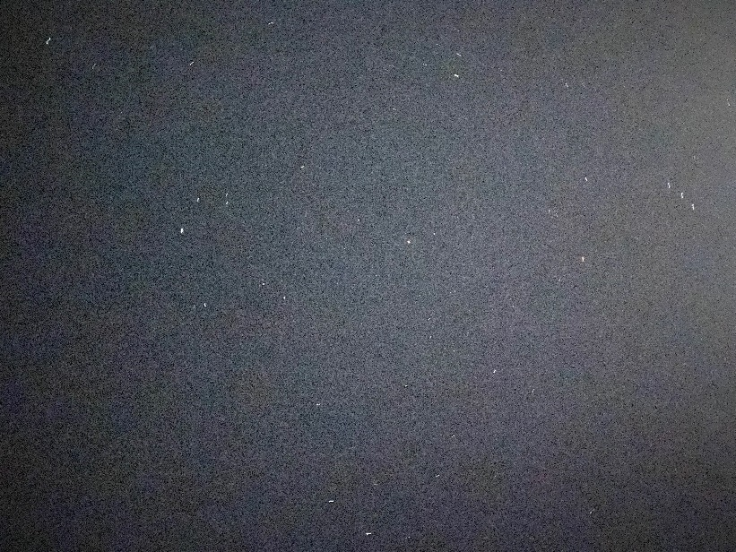

November 1 The moon is filling out. It has reached the first quarter. The moon is still also visible during the day though things are clearly shifting. The moon is rising much closer to sunset though still during the day. I catch a shot with the moon on its way toward zenith in the still bright blue sky with the sun about to set almost opposite it. The sun and the moon appear approximately equal in size if I imagine the moon as full. As the sun sets, the moon becomes visibly more prominent in the sky by the second and soon it is reflecting the now absent sun’s rays. My photo is taken during a beach walk so I watch the spectacle in the sky for quite a while. The moon is hanging over the Atlantic, with nothing blocking my view of it, while the sunset in the West is squarely blocked by apartment buildings. I vaguely think that I should come to the ocean more often (which is very close to where I live) to capitalize on this unobstructed view of the moon. So far, I have seen the moon a considerable amount of time after its actual rise because buildings block the view until it is quite high in the sky.
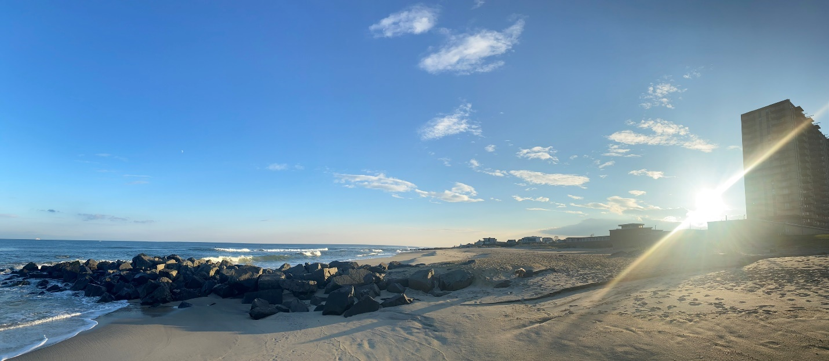

November 3 Today the moon is rising in the early evening together with Jupiter. The moon is visibly filling out and it outshines Jupiter in the sky. I feel honored to witness their joint rise, it somehow makes me feel good, even happy. I later look up the astrology of this conjunction on google and it says, that ‘moon conjunct Jupiter transit makes you feel happy and content’. Very cool!
November 4 The moon rises again in the early evening accompanied by a very strange phenomenon. There is a line of clouds in the sky, something I have never seen before, that looks as if the shoreline of the nearby ocean had been lifted into the sky. It seems as if the ocean in the sky is communicating with the ocean down the road. The moon sits very comfortably right by that heavenly shoreline. The moon is quasi dipping its ‘feet’ into this heavenly ocean and this celestial event somehow seems to be a sign. I understand why the Babylonians and Egyptians (and many other cultures) saw omens in the sky. What I am seeing here, certainly seems to be one, particularly since I was vaguely thinking about going to the beach to look at the moon the other day and now here is this ‘ocean’ in the sky speaking to me, maybe. Chance, synchronicity?! In any event, I think I really should head down to the shore soon to observe the moon from the beach.
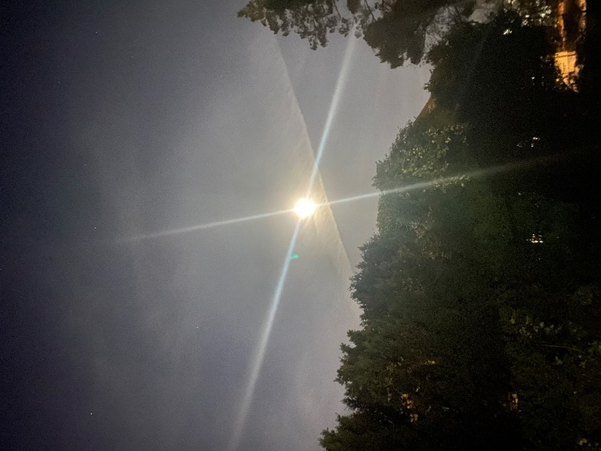
November 6 Today the close to full moon is high in the sky at midnight framed by billowy clouds. It is quite a spectacle in the sky. It’s as if the clouds were surrounding the moon like a halo or maybe the moon is the queen and the clouds the courtiers!? I know we humans like to see images of things all around us, even where there aren’t any. It’s innate and surely what people did millennia ago when they looked up at the sky. From my point of view in the yard, there is also a tall tree pointing toward the moon! What may it be saying to me, or am I eavesdropping on a conversation between the tree and the moon, and the clouds…… In the evening, the moon sets just before sunset, still peeking out from among the clouds every so often as it sets, as usual, on the Western horizon but also out of my view, as usual, behind buildings.
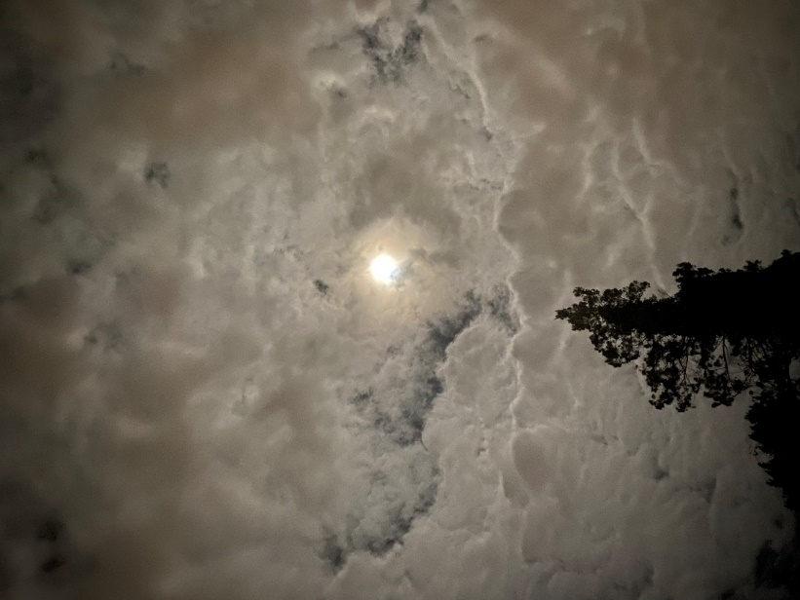
November 8 The moon is full today and I know that there is going to be a total lunar eclipse between 3 and 6 am. The sky is clear, and I decide to stay up. I witness the spectacle in the sky all by myself during the quietest period of the night while all around me people are asleep and probably, for the most part, oblivious to the eclipse. The eclipse is spectacular, awe inspiring, somehow very hard to put into words. I know that the ancients saw eclipses as bad omens and I understand why a total lunar eclipse can appear frightening since darkness is quite literally engulfing the bright light of the full moon. I don’t feel scared, I think it is quite beautiful but there is definitely something portentous happening in the sky. Somehow, I wonder what the animals think about this!? I am very happy I stayed up and went outside at regular intervals for extended periods of time to witness the entire process. Darkness slowly covered the moon light until there was only a tiny sliver left. Unfortunately, my photos just show an undefined splotch of light in the sky. The only photo that shows something, though what it shows is strange, is the last photo I take of the eclipse before it disappears from view. The moon likely darkened completely but the neighbor’s house blocked the view. Few people in this built-up area would have been able to follow this celestial spectacle to the natural horizon.
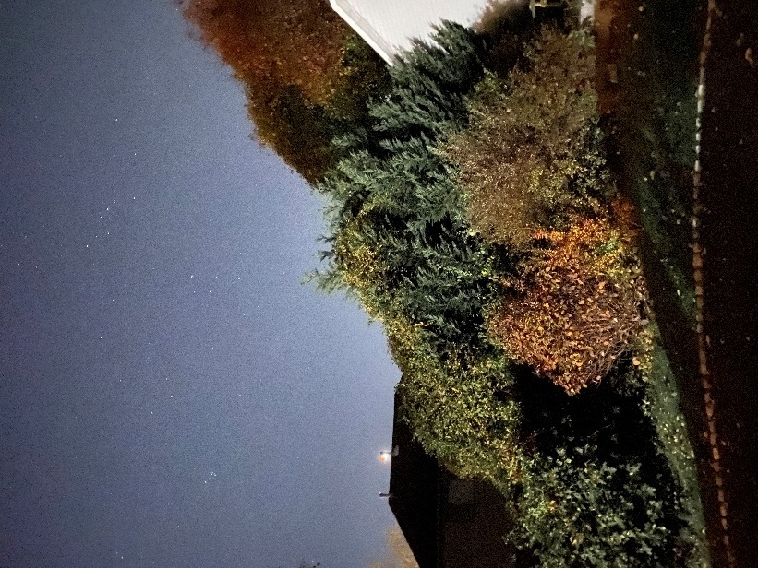

November 9 Today is the day I finally go to the ocean to observe a close to full moon rise over the ocean with nothing to block my view. The sky is clear though there are a few clouds close to the horizon. I am at the beach before moonrise and look at the dark night sky with the help of my app. It shows me the position of Saturn and I am actually able to see the planet for the first time ever. It is very faint, dull, dim, and distant but, nevertheless, there it is. Without the app, I would never have been able to see it! Thanks app! And then, here comes the moon, lalalala. Oh wait, that’s the sun! I am sure there are songs to the moon, but right now I can’t think of one. The moon looks very different so close to the horizon compared to when it is in a higher position in the sky above all the buildings and trees. That’s what I have seen so far. Now I see a crisp orange moon bathed in pinks and light oranges with shades of blue, grey, and black around it. The moon is in an aureole of its own colorful light immersed in the dark night sky. I witness the moon coming up over the ocean. At first, I am not sure if that faint light over in the North-East is the first glimpse of the moon, but then a slight curve becomes visible, and the light intensifies. The moon disk pushes up over the horizon gradually but quite quickly. Within minutes it is sitting over the horizon line. What an amazing spectacle! I am sitting alone on the beach, it seems nobody else is interested in the moonrise, though there are a few people walking along the boardwalk. I hear their voices, but I am not sure if they are looking in the right direction, if they see what I see. I wait a while longer, and the moon gradually loses its colorful hues as it rises higher. Later that same night, I see the moon in the sky as a silvery disc. None of those bright colors have accompanied the moon up into the sky. I guess it is only close to the horizon that the sun and the moon put on this multicolored spectacle and something we will therefore miss if our view is blocked. I know that I can never see a sunset over the Atlantic from where I am located on the East coast, only sunrises. The sunset is always over land and mostly over buildings in this very built-up area. Sunsets are only visible over the ocean from the Westcoast. I had never thought about the moon before - it appears our (Western) culture places more emphasis on the sun (Watching the sun rise and set is a thing but does anybody watch the moon rise and set and then sing songs about it?!) - but I guess the same applies to it. Very interesting!
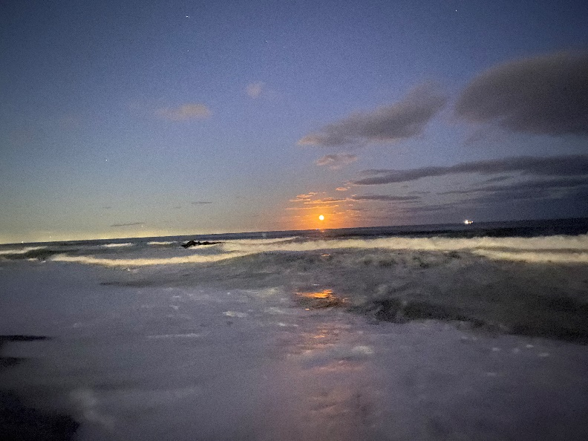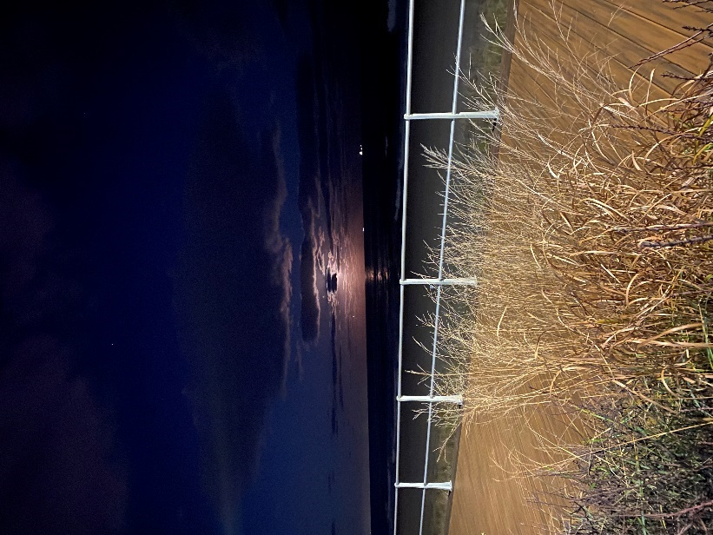
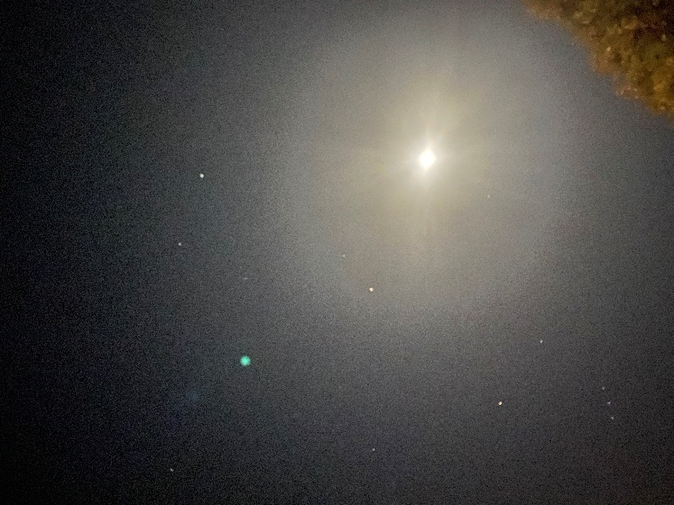
November 10 I go down to the ocean for another moonrise over the ocean because yesterday was simply too beautiful. Today there are some light hazy clouds in the sky, but the moonrise is still very clear with all the edges in the moon, the clouds, the ocean just a little softer than yesterday. The moon pushes up over the horizon in just a minute or so in full view. I filmed the process today though none of my photos and videos can do reality any justice. It’s not even close! Close to the horizon there are occasional wisps of clouds that cover parts of the moon for a couple of moments as it rises higher up into the sky. Jupiter is already high in the sky welcoming the moon. Mars is rising right after the moon but is comes up over the horizon very discreetly, even secretively or simply outshone by the brightness of the close to full moon. I waited quite a while longer at the beach because my app told me that Mars was about to rise, and I wondered if I would be able to see the reddish planet rise above the ocean. Alas, that did not happen. Maybe, the moon light was too close and too strong for Mars. Unlike, the sun and the moon, it skipped over the horizon without any fanfare though it turned characteristically red later in the night as it rose higher into the sky.
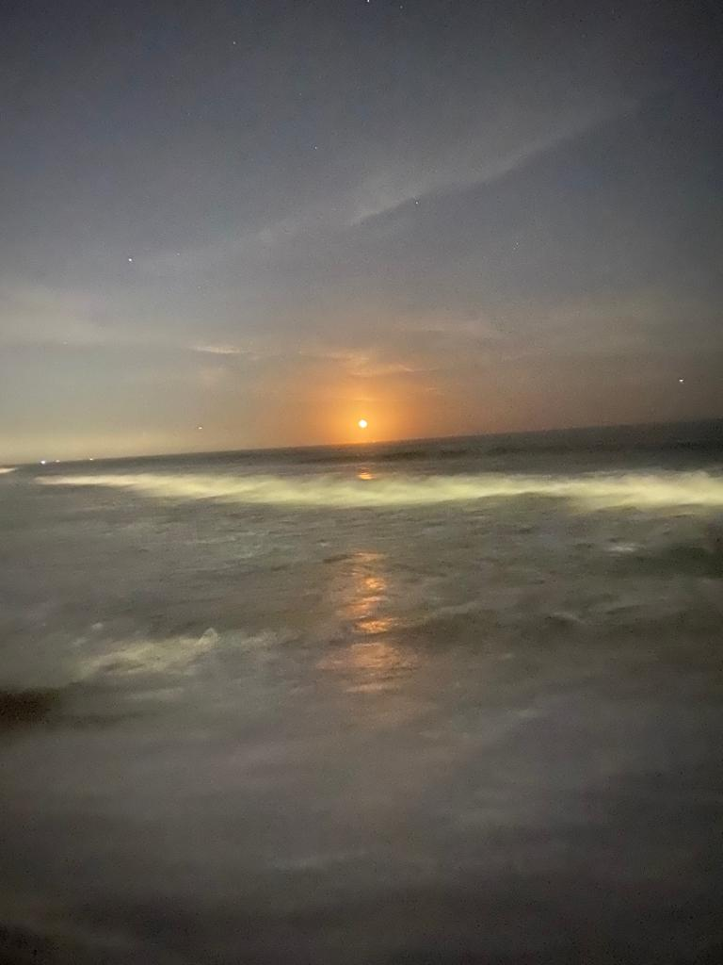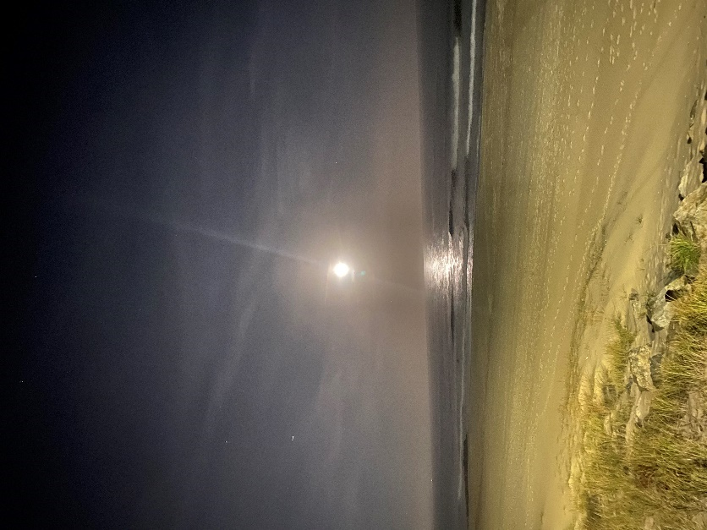
November 11 Today the moon is peeking out from a dense layer of clouds. It’s as if the clouds parted just enough to let the moon shine through! A silvery moon among a sky full of white clouds but the moon still stands out because of its brightness and relative fullness. It’s due to the moon that the surrounding clouds are even lit up and appear white at night when our ground-level world usually looks grey. The sky appears fragmented by the clouds which are very close to each other without fully touching. The narrow spaces between the clouds create an interesting pattern in the sky amplified by the moon. Could it possibly be fractal? Even if not, the clouds and the moon are quite stunning!
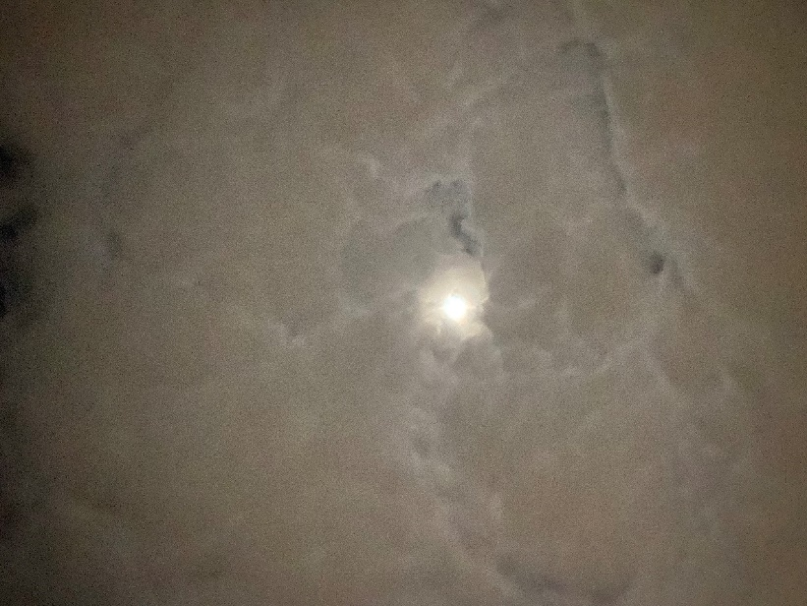

November 13 It’s pouring rain and the sky is completely covered in clouds. The moon is hiding behind them and invisible today.
November 14 I am again faced with an overcast sky and some rain. The only thing I can see are clouds.
November 15 Today the sky is clear again! The moon has considerably shrunk to about half of its size, but it is still illuminating the night sky surrounded by some clouds. Mars is bright in the sky too in an area of the sky with no clouds. There are also many other stars in the sky. It’s quite spectacular once again!
November 16 It’s raining the sky is overcast with no moon in sight. Today is the last quarter phase of the moon.
November 17 In the first part of the night, there is no moon as it gradually shifts toward its diurnal phase. It is dark and cold out and there are a lot of stars visible in the sky. I think more than before but these kinds of things are hard to verify; neither my photos nor my memory can be trusted here. Later in the night the sky fills with interesting clouds and the moon now and again peeks through them. It is rarely fully visible, but it is very clear that the moon has shrunk a lot. My phone camera is on strike today.
November 18 The moon is close to what it was at the beginning of my observations. I think it’s still a bit fatter than it was at the end of October, but it is once again in bowl shape though of a slightly different orientation; if my memory can be trusted, that is.
November 19 The moon is rising shortly before sunrise in the North-Eastern sky in crescent shape in another period of diurnal visibility. I notice that the moon shifted its rising point along the horizon from South-East to North-East over the course of the month. So, transformations of the moon are not only of appearance and time but also of location! This is another very interesting fact about the moon! I recently read the suggested article about Stonehenge (which I visited for the first time this summer) and it mentioned the changing rising and setting positions of the moon along the horizon. I never consciously noticed these shifting positions or maybe I just never paid attention to them?! In any case, I find it fascinating. I wonder if the other planets and the sun also shift along the horizon over time. I assume they do, and I also assume that people throughout time would have wondered at the workings of the (night) sky the way I am now and that this wonder would have led to the gradual understanding of patterns and regularities. I am still amazed how precise the knowledge of the ancients was (I am thinking of Ptolemy here though the builders of Stonehenge may have known much more than they are generally given credit for. I would not be at all surprised!) who like me looked at the sky without a telescope. This month-long close observation of the sky was most definitely an amazing experience which in some form I am sure to continue.

Bernd Brunner, Moon. A Brief History (New Haven, Connecticut: Yale University Press, 2010), p. 2.
Paul Bogard, ‘The Path and Pull of the Moon’, Creative Nonfiction, 36 (2009), 28-36.
Jules Cashford, The Moon: Myth and Image (New York: Four Walls Eight Windows 2003), p. 11.
The Originals: Classic Readings in Western Philosophy (lumenlearning.com), ‘Edmund Burke- On the Sublime’ http://courses.lumenlearning.com/suny-oneonta-classicreadings/chapter/edmund-burke-on-the-sublime/ [accessed 20 November 2022].
Ibid. section III, obscurity.
Gogh, Vincent van and Ronald de Leeuw, The Letters of Vincent Van Gogh. London: Penguin Books, 1997, p.392.
Vincent van Gogh: The Letters, ‘Letter 676, 8 September 1888, Vincent van Gogh to Theo van Gogh’ http://vangoghletters.org/vg/letters/let676/letter.html [accessed 22 November 2022].
Patrick Curry, Enchantment. Wonder in Modern Life (Edinburgh: Floris Books, 2019), p. 123.
Ulisses Barres de Almeida, ‘What are these Sparks of Infinity Clarity? And what am I? So I pry’, Culture and Cosmos, 16:1 and 2 (2012) 19-29 (28).
Gogh, Vincent van, and Ronald de Leeuw, The Letters of Vincent Van Gogh. London: Penguin Books, 1997, p.229.
Dacher Keltner and Paul K. Pfiff, ‘Self-Transcendent Awe as a Moral Grounding of Wisdom’, Psychological Inquiry, 31:2 (2020), 160-163 (160).
Sky Journal, November 6
Sky Journal, October 28, 29 and November 19
Sky Journal, October 19
Sky Journal, October 28
Sky Journal, November 9 and 10
Sky Journal, November 4
Sky Journal, November 9 and 10
Sky Journal, November 10
Sky Journal, November 8
Sky Journal, November 4, 6, 8
Sky Journal, October 19, 28
Sky Journal, October 21
Sky Journal, November 9
Sky Journal, October 20, 21, 30 and November 3, 15
Sky Journal, October 20, 30 and November 3, 10
Sky Journal, October 20
Sky Journal, November 1
Sky Journal, October 29

