Assignment 1 Object Analysis: Cyprus by Lizzie Mansfield
The object that I have chosen to do an analysis on is the one from Cyprus. The museum accession number for the object is 74.51.795. The object is available to be viewed at Gallery 173 in the Met Fifth Avenue. I decided to choose this object because it immediately piqued my interest from being patterned the way it was, and its shape is intriguing and quite unique looking.
The Cypriot object is called Terracotta zoomorphic askos with antlers and is described as a vessel. It is classed as a vase. It is made of terracotta. It is dated from around 1725 to 1600 BCE. The period it is from is Middle Cypriot III. The object’s dimensions are that the height is 14.6 cm or five and three-quarter inches. The Cypriot object is in the form of a four-legged animal and it has markings that give it the appearance of an animal, such as an eye marking. It appears as though the markings on the object were made by painting them on. It is believed to have been designed after the native deer in Cyprus at the time, as bones of untamed deer were found at ancient sites on the isle. The object is said to have been from the ancient city of Idalion in Cyprus (Metropolitan Museum of Art, 2000). The main colour of the vessel is cream or off white and the painted markings on it are light brown. The vessel is in relatively good condition and is entirely intact. It is slightly chipped though and some of the painted markings are worn away in places. I suspect that the colour of the vessel has faded dramatically and that the painted markings used to be a much richer hue.
Askos is the word for tube in Ancient Greek and this word is specifically used to label ancient pottery vessels that are used to hold and pour oil. The main reason that the people poured oil out of the askos was to refill their oil lamps. Therefore, it is assumed that this was what this object’s function was in antiquity.
The period of Middle Cypriot III was a part of the Middle Bronze Age in Ancient Cyprus. At around 2500 BCE, the Bronze Age began in Ancient Cyprus. The Bronze Age is split into three phases, Early Bronze Age or Early Cypriot c.2500-1900 BCE, Middle Bronze Age or Middle Cypriot c.1900-1650 BCE and Late Bronze Age or Late Cypriot c.1650-1050 BCE. Each phase is also divided into sub phases. Early Bronze Age and Middle Bronze Age both have three sub phases. However, Late Bronze Age has eight sub phases. The Middle Cypriot III period was from about 1725 to 1650 BCE. The Bronze Age is when the production of metalwork and pottery really took off. Different types of pottery were made in each different phase of the Bronze Age. The Middle Bronze Age introduced a new type of pottery called White Painted (The University of Melbourne Cypriot Collection, 1987). These were pottery that had the main body of the vessel as white and were decorated with painted straight-lined markings in either brown or red. This description of White Painted pottery confirms that the Cypriot object is definitely one of these types of pottery. Also, in the period of Middle Cypriot, there was a fair amount of trading going on. Ancient Cyprus was known for being the place to trade, as it was easily accessible to other countries. However, trade had only relatively just begun in the Middle Bronze Age. Cyprus had just begun to reach out to Crete and other countries such as Greece, Southern Anatolia, Egypt, Palestine and Syria. But there was still trade occurring between the different countries. The products that were being traded the most was Cypriot pottery because Ancient Cyprus was renowned for its unique pottery. So other pottery vessels similar to this one were probably being traded around at the time. In addition, new funeral rites were being introduced in the Middle Bronze Age. Before this time the only funerary practice was simply burying the deceased person’s body in a burial pit. However, in the Middle Cypriot period, the people began to use a different type of burial practice. They introduced the method of placing the body of the deceased into a rock cut tomb. With this also came the practice of putting things in the tomb with the body. They placed items such as pottery vessels into the rock cut tombs. Therefore, the Cypriot object may have been used like this or other askos could have been placed in the tombs.
As I mentioned before, the object is thought to have come from the city of Idalion in Ancient Cyprus. Ancient Cyprus was very well known for its rich copper reserves and its production of pottery. In fact, the reason why people first settled there was because of how much copper there was. In addition, Cyprus was named either after the Latin word for copper or after another name for the Greek goddess Aphrodite, who was born on the island and was heavily worshipped there. Now Idalion was one of ten ancient cities in Cyprus. Idalion was the centre of the copper trade at the time in Ancient Cyprus. Moreover, Idalion was also the main site where the goddess Aphrodite was worshipped in Ancient Cyprus (Biblical Archaeology Society, 2020).
In conclusion, the Cypriot object called an askos and is used in the storage and pouring of oil. This could be used in different functions, such as the household. It is White Painted pottery and could have been used in burial rites.
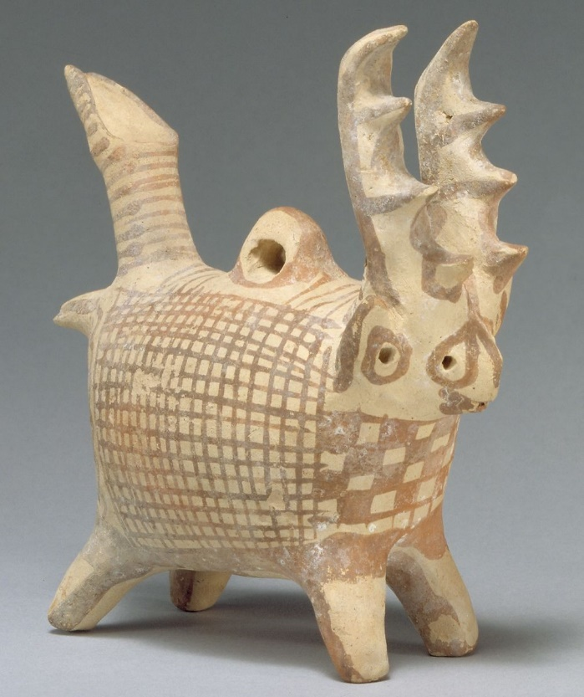

Metropolitan Museum of Art: https://www.metmuseum.org/art/collection/search/240382, 03/04/2020.

Bibliography
Metropolitan Museum of Art (2000) Terracotta zoomorphic askos (vessel) with antlers. Available at: https://www.metmuseum.org/art/collection/search/240382 (Accessed: 3 April 2020).
The University of Melbourne Cypriot Collection (1987) Chronology of Ancient Cyprus. Available at: https://pdfs.semanticscholar.org/548a/66a47ff4c05f15d09cd17300b95e16bdd29e.pdf (Accessed: 3 April 2020).
Biblical Archaeology Society (2020) Idalion. Available at: https://www.biblicalarchaeology.org/dig/idalion/#detailsSec (Accessed: 3 April 2020).

