Jalal Ahmed

Student ID: 171 2852

Professional Career Development BMSK4005

Assignment 1
Lecturers: Mary March Sylvia Hoffmann

Contents
Introduction 3
My skill gaps 3
Strengths and my weakness 3
Background theory 3
Kolb’s learning cycle 3
Honey and Mumford 4
Activists 5
Theorists 5
Pragmatist 5
Reflectors 5
How I am going to plan my development 5
Johari window 6
SWOT Analysis 7
How the real world expectation will affect my learning 7
Where I hope to go next in terms of career progression 8
A brief plan of what I hope to get done 8
Conclusion 9
Works Cited 9

Introduction
In this module I have learned about things I can do to improve my professional development, in essence to acquire skills that will enable me get a job more easily. And I have been encouraged to use the things I learn in class in my daily life to gradually develop the skills needed.
This report will be a note book of my development during the course of this module. I will organise the report in the following sections: my skill gaps, how to improve those gaps, what factors could affect my development, proposed solutions, the effectiveness of my solutions, results and lastly the things still missing.

My skill gaps
My skills gaps are quite large. The following is a list of the main think I think is hampering my employability chances.
- My English speaking or writing skills can use a significant amount of improvement.
- My numerical skills are ok, I can perform simple arithmetic operations, but the moment that is elevated to anything more complex such as taxes or large accounting summations I find it difficult to keep up.
- My presentation skills although having seen some improvement since starting university could still use a significant amount of further training.

Strengths and my weakness
My age is also something of a concern for many employers out there. Being old is not something I have control over, however, some people will still see hiring an older employee as a disadvantage. However, with age one gains more personality traits such as responsibility, the ability to lead a team, being reliable for the rest of the team and being a presented as responsible face for leaising with clients.
The difficulty here is somewhat related to the skill gaps above. Once my English and presentation skills develop sufficiently I will be able to turn this to an advantage.
I will discuss my strengths and weaknesses more in depth in the next sections of this report.

Background theory
In class we learned about a few different learning style. In the following section I will give brief descriptions for two of these, namely Kolb’s learning cycle and Honey and Mumford’s model. These two take different routes of approaching the same problem, while Kolb’s cycle gives an overall overview of how learning is done Honey and Mumford’s model gets more in depth as to how individual people learn best.

Kolb’s learning cycle
Kolb proposed that learning new skills and adapting exiting knowledge can be generalized and summarised into four main parts and that these parts interact with each other such that one builds on the next. (J D Wallace, 2015) These parts are:
- Experience
- Reflection
- Conceptualisation
- Planning
The idea behind his learning cycle is as follows. A person undergoes an experience this can anything from a physical sensation or a realization about how something works or some telling him someone he did not know before. This experience leaves an impression on the learner that eventually triggers the next stage of learning cycle which is reflection. (Muhammad Rais, 2017)
During the reflection stage the learner draws from his memory the key things about his experiences and reflects upon them. These reflections include comparing the new information with existing information and trying to find any improvements or critically analyse if the new information from the new experiences are in effect worst than what he knows. Once the reflection and analysis of the new experiences are done, the learned moves on to the conceptualization stage. (Striling, 2013)
In the conceptualization stage the learner tries to use the information that he accumulated during the reflection stage and tries apply the new information to different problems. In other words, the learner tries to generalize the information he got from his experiences. (Fewster-Thuente & Batteson, 2018)
The final stage in Kolb’s learning cycle is the planning stage. In this stage the learner tried to devise means to test his new knowledge. This knowledge is tested in light of new experiences to either validate or discredit what he learned. (Spalding, 2018)
The cycle can summarised by the following diagram.
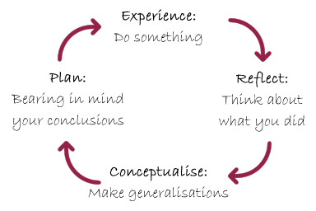
Figure 1 – Kolb’s learning cycle adapted from (SfL, 2019)
As can be seen in the diagram, once the learner goes past the planning and testing stage he is going back to the experiencing stage. Where he would now experience new information gathered from the tests he conducted.
Explained in abstract terms, Kolb’s cycle can seen strange but in reality it is how most of learn as babies and the basis for the scientific method. Observe, analyse, test. Kolb simplifies and explains some the fundamental mechanics better. (GÜNEŞ, 2017)

Honey and Mumford
Unlike in Kolb’s model, Honey and Mumford allow a bit more freedom to the learners in the way learn. This is, in Kolb’s model it is assumed that learning happens cyclically and not much attention is given to the details of how the learning takes place. In this sense, Kolb’s model is somewhat incomplete as it only gives the general overview and does not address the needs of individual learners. (Cuevas, 2015)
Honey and Mumford instead argue that people can learn more effectively if they are allowed to acquire the learning experiences in the way they find best. The four main ways they suggest that people learn are: by actively doing something, by theorising about how something works , by being allowed to put their ideas to practise in a concrete scenario and lastly by reflecting on why or what something is and by observing what other people do. (Mumford, 1997)

Activists
These are people who learn from actually doing something. It is a common occurrence to teach children by letting them do things and experiencing them first hand. This is in large part the definition of what it means to activist learner, you feel more comfortable actually doing things and learning and gathering information as you progress. (Savcı, 2018)
Activist type learners are generally open minded, as they need to be able to try out new things and allow them selves to get involved fully in the activity they are doing with any bias.

Theorists
People who are more comfortable with this learning style tend to prefer to understand the “why” of something happening are called theorists.
They learning patch usually involves making mental models of what is happening and testing their theories to see if they match their mental models. It is preferred to analyse and organise information they acquire in a logical and systematic way.

Pragmatist
Pragmatists are people who find it easier to learn something by seen something done in an actual working environment.
They can be thought of a midway between activists and theorists as they combine some elements of theorising and actively experimenting in the real world.
In summary, pragmatists learn best by taking some time if needed and actually testing a theory in the real world by doing activities and or experiments. (O'Mahony, 2016)

Reflectors
These are the most abstract learner amongst the four classified by Mumford and Honey. Reflectors learn by watching others and analysing and thinking about what happened. (Lim, 2017) Generally they will avoid getting involved in an activity and watch from a distance what actions others are taking and what are the positives and negatives of those actions.
Reflectors usually like to discuss their learning experiences with others and also get feedback from their peers.

How I am going to plan my development
My first proposed step to improving my skill gap is to carry out an analysis of myself and see which of the learning methods fits best to me. Once this is done I can then tailor it to my specific needs. For this purpose I will try to use the Johari Window method that learned in class.
It will have a some blind spots as I do not have feedback from others in it. However, it should be a good starting point.
Later I will analyse the finding of the Johari window using a SWOT analysis.

Johari window
Before we begin the analysis it a good idea to briefly explain what a Johari Window is. It was a technique proposed by pscychologists Joseph Luft and Harrington Ingham that helps someone visualize and better understand the relationship they have with themselves and others around them. (Luft & Ingham, 1955)
It is defined by characterizations of a person based on what they know and what other know about them. The window is divided into four quadrants: open, blind spot, hidden and unknown.
The open quadrant are filled with descriptions of self that the subject in question knows. In other me defining myself.
The blind spot is the quadrant where others define the subjects qualities.
The hidden quadrant is filled with the qualities that both the subject and others know about him.
Lastly, the known quadrant should be filled with information that neither the subject or others know about him.
Obviously, a full complete analysis is not possible for current events as the unknown quadrant can not be filled in. However, doing a Johari window in retrospect, after the events can be a nice way to exemplify what it does. (Vleuten, 2017)
Following is an example a of a Johari window that I found for Harry Potter.
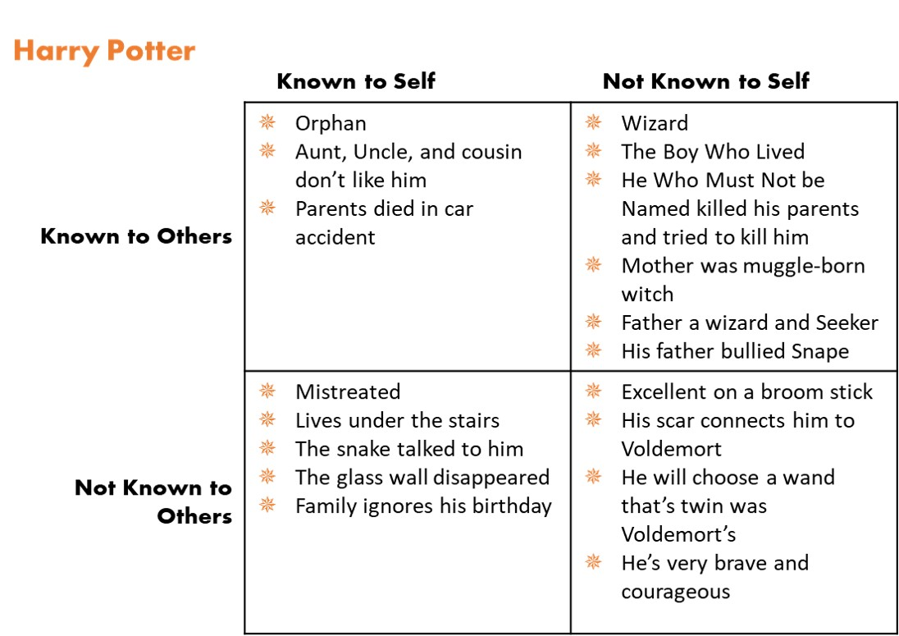
Figure 2 – A simple Johari window exemplifying Harry Potter’s qualities (adapted (Evers, 2018)
The following Johari window is simple example using myself as the subject of the analysis.
 | Known to self | Unknown to self
Known to others | Willing to improve  Outgoing and confident  Friendly and helpful towards others | Blind spot
Unknown to others | Taking concrete steps to improve  Nervous around new people  Always wandering if people ask me for help for ulterior reasons | Unknown
Table 1 – Johari window using myself as the subject
From this we can see that for current problems we can not know the full window. The blind spot in these situations can addressed by asking for feedback from peers on what adjectives do they think describe, compare them with the ones I know about myself and the filling in the quadrant.
The unknown quadrant is one that is much harder to fill in. It requires a combined effort to explore these and often enough time for them to be evident.

SWOT Analysis
SWOT analysis have been used through out the semester in class to help analyse problem situations. This is a type analytical tool designed to help carry out realistic and fact and information based analysis of the strengths and weaknesses of a person or an organisation. (MT, 2019) In here, I will use to assess my own strengths and weaknesses.
Strengths | Weaknesses
My main strength is my willingness to learn and proactive attitude towards this  Helpful peers that have given good advice and shown examples of to get things done well  Having some reasonable amount of free time to focus on self development. | My age, not necessarily that I can’t learn as easily, but I have many other responsibilities to attend to  My main disadvantage is not being able to speak English very well. Writing is ok with help from google translate.  My presentations skills  Numerical skills
Opportunities | Threats
I have some free time and good support from friends, I can use this extra time and support to get ahead in my studies and learning in general  Many of my weaknesses are linked to bad English speaking ability. Fixing this would help fix many other problems. | Sometimes family or children commitments take a lot of my time for self development. I worry that this could become a bit problem.  I worry in my mind that because I am in my fifties, even after I go through all this self development, there could be little chance for me to get to use my skills in a working environment.
Table 2 – A SWOT analysis of myself

How the real world expectation will affect my learning
As I mentioned in the threats section of my SWOT analysis, I do fear that the real world bias towards older people in the workforce, that despite developing my skills to an employable level I might not be able to get a job that I want.
With this in mind I have been trying to apply to some jobs while I am still in university, so I can at least get a taste of the interview process and just generally how recruiters treat candidates.
Most of the applications have been for entry level clerk type jobs in offices, as a secretary or receptionist. However, these applications have had little success, usually I do not even get a reply from them.
I understand why they do this, most of these companies have much younger people applying for them with the younger staff the managers need to worry less. Be in terms of family holiday needs, medical reasons, just simply generally being better with computer related tasks, etc. And when they have ample offering of cheap young labour it makes little business sense to hire someone older for that same position.
It is saddening and it does affect motivation and moral strength to some extent and in the long I worry that will slow down my career development. However, these factors are beyond my control and as such, although it may be a good idea to keep these reminders close at hand, there isn’t much point worrying about them.

Where I hope to go next in terms of career progression
My goal at the end of the studies in university is to be able to apply to the jobs that I am currently applying, but with more success. Another alternative that I am looking towards is also instead to try to move forward in my current job as kitchen staff and use my new skills to apply for managerial positions within the restaurant and catering business.
My main focus at the moment and one of the riving factors for me taking this university course is to develop the skills and competencies to transition from manual work to desk work in the near future as I can slowly feel the effects of age having an impact on me.
My goals for achieving this are more or less straight forward, the first thing I need to make sure is that my spoken English skills keep improving. Once I get past this hurdle many other issues such bad presenting skills will hopefully sort them selves out with time.
After that it’s a matter of being sufficiently persuasive at interviews.

A brief plan of what I hope to get done
Here is a simple time line of how I hope to achieve my goals for self development. This time line is a basic guide because I know circumstances in the real world will move many of the dates back and forth a few times through the years.
Goals | Time
Finishing the first year of university and progress on to the next stage | Shortly – Summer 2019
Finish off the university program, up to and including a masters degree.  However, this time line is very likely to change. If I have to pause the course or fail a year, this will definitely change | 2019-2013
Develop English speaking skills sufficient for class presentations  -forcing myself to speak English more often and use in everyday conversations not just when at work  -watching more English TV youtube | Present – summer 2020
Improving my basic maths skills | Present – early 2020
Improve English skills enough to have professional discussions and presentations | Present – 2023
Keep looking for other ways to improve my personal development | Present - ongoing
Table 3 – a simply time line of what and when I hope achieve it by

Conclusion
In summary of this report I can say that during classes we learned about how people learn new things, we covered many theories on how people learn and I explained them in this report. I also gave example of how these learning styles can are applied in practice.
I provided a clear as I could, plan of what skills I am missing for my personal development and how I plan to improve upon this. The final test of my personal development will be if I can maintain the things discussed in this report as time goes on.

Works Cited
Cuevas, J. (2015). Is learning styles-based instruction effective? A comprehensive analysis of recent research on learning styles. Sage Journals.
Evers, B. (2018). Retrieved from https://aneclecticmuse.blogspot.com/2018/11/character-development-using-johari.html
Fewster-Thuente, L., & Batteson, T. J. (2018). Kolb's Experiential Learning Theory as a Theoretical Underpinning for Interprofessional Education. Journal of Allied Health.
GÜNEŞ, M. H. (2017). An Experimental Study About The Application of Kolb's Learning Cycle on Biology Lesson. Kastamonu Education journal.
J D Wallace, D. B. (2015). The Handbook of Communication Training: A Best Practices Framework for Assessing and Developing Competence.
Lim, H.-W. (2017). KOREAN EFL STUDENTS’ LEARNING STYLE PREFERENCES AND THEIR. Int. J. of Pedagogies & Learning.
Luft, J., & Ingham, H. (1955). The Johari window, a graphic model of interpersonal awareness. Proceedings of the western training laboratory in group development.
MT. (2019). Retrieved from https://www.mindtools.com/pages/article/newTMC_05.htm
Muhammad Rais, F. A. (2017). Learning Style in Teaching: An Effort Understanding the Characteristics of Learners in Early Learning. Internation Conference on Education, Science, Art and Technology.
Mumford, A. (1997). Putting learning styles to work. Gower.
O'Mahony, S. M. (2016). Association between learning style preferences and anatomy assessment outcomes in graduate‐entry and undergraduate medical students. Anatomical Sciences Education.
Savcı, S. (2018). The relationship between learning styles and academic performance in TURKISH physiotherapy students. BMC Medical Education.
SfL. (2019). Retrieved from https://skillsforlearning.leedsbeckett.ac.uk/preview/content/models/02.shtml
Spalding, A. (2018). Eight important things to know about the experiential learning cycle. Australian Educational Leader.
Striling, A. E. (2013). Applying Kolb's Theory of Experimental Learning to Coach Education. Journal of Coaching Education.
Vleuten, C. (2017). Uncovering the unknown: A grounded theory study exploring the impact of self-awareness on the culture of feedback in residency education. Medical Teacher.

