

Task 1 – Reading Task Template
Upload your photo of your A3 in-class notes here:
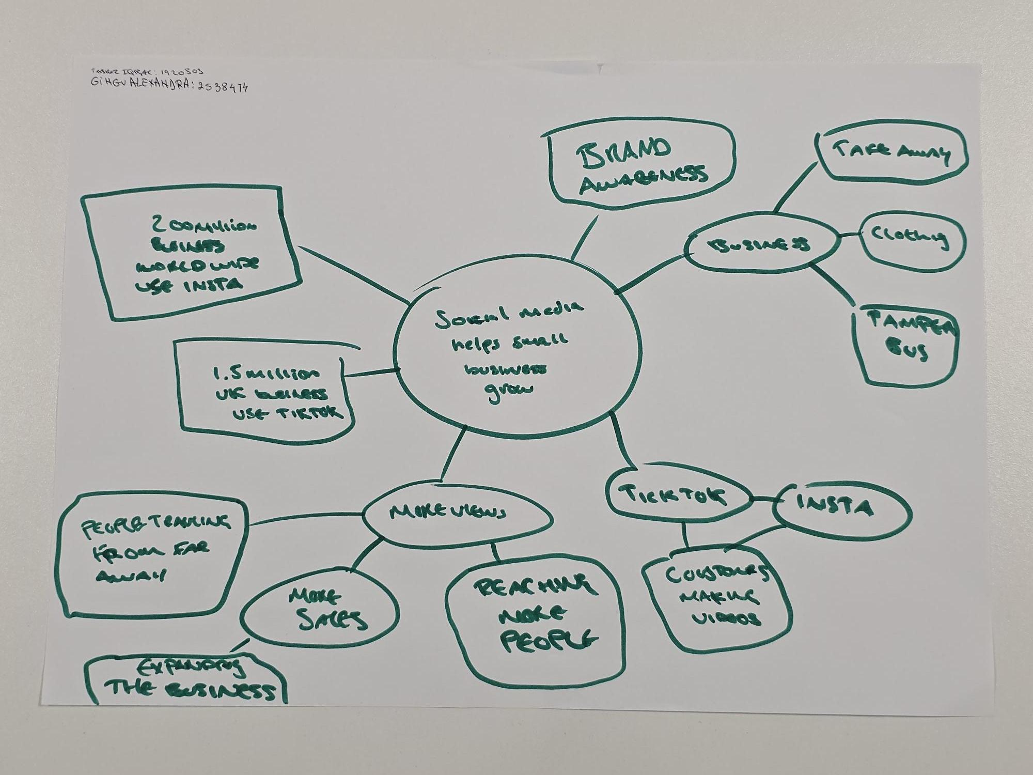

1. Answer these questions using the sentence starters below
a. What is the main idea of the text?
The main idea is how social media such as TikTok, Instagram can have a positive effects on businesses.
b. What are two key points?
One key point is the amount of people social media can reach
Another key point is how small businesses can grow after a viral video and the amount of people it can reach World wide.
c. What part of the text did you find most important? Why?
The most important part is how different businesses find success, for example the Love Pamper Bus, it was meant to be just for weekends but because of the viral videos they now do it full time all around Essex.
d. Was anything unclear or difficult to understand?
No, I feel as the information provided in the article was decent and covered what needed to covered but, if they gave sales figures it could give a deeper understanding from what they started from and where they are now.
e. How did your group help you understand the text better?
My group helped me by talking about what was written and how they understood the text giving a broader view.
3. One sentence reflection
Question: What did you find challenging about this task?
The hardest part was, getting started but once the ball got rolling it got easier. But checking spelling and trying to figure out what some words mean was a bit challenging.

