Wellington’s Mistakes
A Critique of the Iron Duke during the Waterloo Campaign
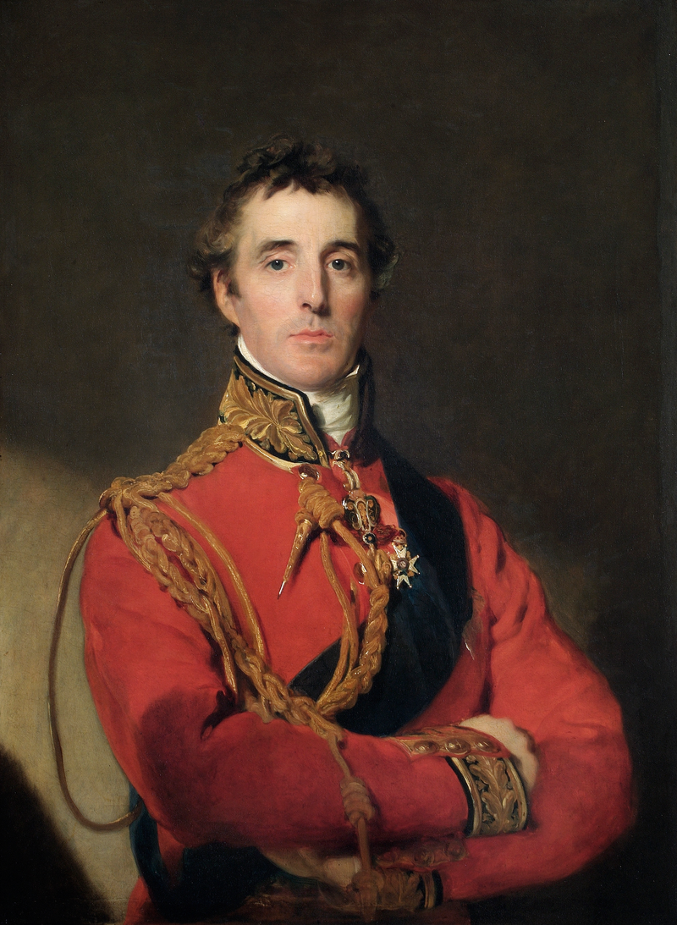

Dissertation submitted in partial fulfilment
of a B.A. (Hons) in Conflict and War

University of Wales Trinity St David
May 2018
By
Rory David McDonald Butcher
1500043

Author Declaration

This work has not been previously accepted in substance for any degree and is not being concurrently submitted for candidature for any degree

Signed……………………………. (candidate)
Date……………………….

Statement

This thesis is the result of my own investigation, except where otherwise stated. Other sources are acknowledged by explicit references and a Reference List is appended.

Signed……………………………. (candidate)
Date……………………….

Contents
Abstract iv
Acknowledgements v
Author’s Notes vi
Introduction 1
Aims and Methodology 3
Aims 3
Historiography and Originality 4
Methodology 5
Chapter 1 – Wellington’s Career 8
A Biography 8
His Military Career 10
Chapter 2 – The Deployment at Hal 14
Understanding the Deployment 14
The Critique 16
Chapter 3 – Outnumbered at La Haye Sainte 20
Why there? 20
Examining the Defence 22
Chapter 4 – The Duke and the Europeans 25
The Prussian Promise 25
The Dutch-Belgian Denigration 26
Analysing the Promise 27
The Dutch-Belgians: An Unfair Assessment 29
Conclusion 32
List of Maps
Figure 1. The Prelude to Waterloo 35
Figure 2. Waterloo on the Morning of the 18th June 36
Figure 3. The Farmhouse of La Haye Sainte 37
Figure 4. The Situation at Dawn on 17th June 38
List of Appendices
Appendix 1. The Order of Battle of the Anglo-Allied Army 39
Bibliography 44

Abstract

This dissertation endeavours to attempt an unusual feat in English speaking historiography: a critique of the Duke of Wellington’s strategy during the Waterloo Campaign. For the simple reason of his success, the Anglo-Allied Commander-in-Chief rarely draws any criticism for his decisions, actions, and conduct during the campaign, yet he still requires a careful and considered assessment. This dissertation aims to provide such an assessment, drawing on recently translated works from the other nationalities present and by re-examining the already much investigated narratives posited by other historians.
With a battle of such complexity, the potential mistakes made by the Duke have been narrowed to his choice to deploy over a division of troops away from the main battlefield at Hal on the 18th June; the decision to only garrison the central farmhouse of La Haye Sainte with 400 men; and his conduct regarding both Prussian support and his interactions with the Dutch-Belgian troops under his command. Effort has been made to utilise the now vast resource of documentary evidence from the campaign – from the ordinary British soldier, right up to the official Prussian general orders.
History requires balance in order to present the truth of events, and this dissertation aims to provide such balance to one of Britain’s most iconic military figures.

Acknowledgements
This dissertation owes much to the support of my friends, family, and academic colleagues over the past few years. My work methods usually devolve into a frantic rush, with this being no small exception, and so I am endlessly grateful to those who are able to put up with me around this time. Particular mention must go to my family for indulging my Napoleonic habit (both academically and recreationally), and to my wonderful girlfriend Emma for her never-ending patience for my historical interests. My friends here at university have helped me grow into a person I am now happy to be (with apparently a reasonable writing style), and so I am thankful especially to Dave R, Dave M, Ollie, Sam, Aaron, Sean, Justin M, Alaw, Alex E, Ben B, Joe, Emily, and of course the others my brain fails to remind me of as I write this now. Special mention also to my compadres across the pond, who have rescued many memories of 2017: Yianni, Taro, Madison, Antonio, Evan, Annabel, Jay, and Jemma.

With regard to the actual content of this dissertation, and largely my degree, I owe a great deal to my personal tutor, supervisor, and programme director Dr Lester Mason. His enthusiasm for military history, and for my writing, has helped me to enjoy the sometimes-laborious process of producing scholarship; and to enjoy my time at UWTSD as an academic institution. I am also grateful to the other lecturers I have had the privilege to study under in Lampeter – Dr Alexander Scott, Dr Harriet Webster, Dr Paul Wright, Dr Ralph Häussler, and Dr Errietta Bissa – and to those I had the privilege to learn from whilst in Vancouver – Dr Cedric Bolz, Dr Robin Wylie, Dr Peter Prontzos, and Dr Denis McKim. Special mention must go to Cedric for the laughs and learning I experienced in his classes. My support tutors, Hock Lim and Dinah Mulholland, have been invaluable in supporting me in my studies in Lampeter, and have been so helpful with regard to my dyspraxia.
For procuring specific resources, I must offer my thanks to Gaye Morgan and Gabrielle Matthews of the Codrington Library, Oxford, and to the Bodleian Library staff for facilitating my research there. Loans of books from Matt Ring and Stephen Barker were also crucial in specific elements of my research, and for that I am also grateful.

I owe much to all those mentioned here, and those I have failed to include. Thank you.
Author’s Notes
Abbreviations
Capt./Lt.-Col./Maj.-Gen./Lt.-Gen – Captain/Lieutenant-Colonel/Major-General/Lieutenant-General.
KGL – King’s German Legion
X/Y^{th} – Battalion/Regiment
LD – Light Dragoons
RA/RHA – Royal Artillery/Royal Horse Artillery

Notes on Terminology
Anglo-Allied Army – Wellington’s force at Waterloo was not purely English, or British, and so for that reason this term has been used to denote the army controlled by the Duke.
Battles – The Battles of Waterloo, Quatre Bras, Ligny, and others, are mostly referred to as the place name alone.
Commanders – Surnames have been used when discussing all commanding officers bar Wellington and Napoleon.
Corps – Armies were organized into Corps, then Divisions, then Brigades. Effort has been made to refer to Brigades or Divisions where possible.
Dates – Due to the fact that the days of interest all took place in the same month, June 1815, the exact date has been given in most circumstances.
House of Orange – The Royal House of the Netherlands, of which the British monarchy were blood relations.
Low Countries – The region encompassing modern Belgium, the Netherlands, Luxembourg, and parts of northern France.
Names – They have been rendered in the original language where possible, with the notable exception of Hal (or Halle in several accounts), to achieve consistency.

Introduction
The armies are to be put in motion immediately. We set off for Brussels in a day or two, the duke will have a command of at least 120,000 men and I dare say we shall have the first run at Boney.
- Lieutenant Colonel John Fremantle in a letter to his uncle, 19th March 1815.
The Battle of Waterloo has remained a milestone in British, and European, history for over two centuries. The four days of hostilities between the 15th and 18th of June 1815 are etched in Britain’s consciousness to the extent that the site of Napoleon Bonaparte’s loss is still used as a byword for failure. In fact, study of the campaign has frequently resulted in studies of Bonaparte’s actions during that summer – his decision to entrust Marshal Grouchy with a third of his army, and the order for Marshal Ney to lead that fateful cavalry charge against the redeploying Allied forces, are often depicted, perhaps not unfairly, as being the main causes of the French defeat. Bonaparte’s career as both general and politician was over, and for that reason do many histories set him as the key figure in the narrative. However, the Anglo-Allied army was the victorious force, and Arthur Wellesley, the Duke of Wellington, the victorious commander – yet even now there emerges a problem. As the hero of the Peninsula, and then Waterloo, the Duke of Wellington was not openly criticised for any of the decisions made during the Waterloo Campaign. He remains so. Troops deployed away from the battle at Hal, the distinct lack of a garrison at La Haye Sainte, and the Duke’s conduct throughout the campaign with regards to his allies, all merit a detailed analysis to determine their impact on the battle. At best, this lack of attention is a mere gap in the historiography; but at worst, this betrays a serious failing of the historical establishment in assessing one of Britain’s foremost public figures. Other iconic victories in British history have drawn attention in this manner: the Normandy landings attract criticism for the inefficient destruction of German fortifications, whilst the Crimean campaign of the 1850s is subjected to intense scrutiny.
For this reason, this dissertation shall aim to redress this balance – and assess the Duke of Wellington’s decisions throughout the Waterloo Campaign, with an emphasis on decisions which could be examined as errors in judgement. For despite the result of the confrontation which took place that June, even the Duke himself was aware of the tense nature of the hostilities, commenting that ‘I have never been so close to defeat.’ For this reason, the actions of the Duke must be taken into account – just as the actions of Bonaparte are. The eventual decisive victory should not negate discussion of any errors, or mistake, Wellesley made during the campaign. He understood that had he lost it would have been the talk of London: he is noted to have said to troops on the 18th ‘we must not be beat – what will they say in England?’ For that reason, an analysis and critique of his strategy, along with a study of his military career to provide context, is direly needed; and that is what this dissertation shall endeavour to provide.

Aims and Methodology
Aims
The aim of this dissertation is to provide a balance to the British historiography of Waterloo; this more revisionist subject therefore requires a different approach to standard analyses of the Duke of Wellington’s strategy. The battle holds a special place in the identity of this Sceptred Isle and is, one could argue, the most famous battle in history. It is certainly the victim of the adage that the victors write the history; Sale’s more recent work on the last half hour of the day’s events makes that crystal clear. The Lie at the Heart of Waterloo was also written with a similar objective in mind – to reassess the battle, with care taken to examine how close L’Empereur really was to taking the field.
With so much about the battle and the campaign, it becomes crucial to narrow the scope of this analysis – accordingly the realm of discussion has been reduced to three identified points. These points are the deployment of 17,000 troops under Prince Frederick of Orange at Hal, away from the main battlefield; the comparatively small and unsupported deployment of light infantry in the chateau of La Haye Sainte; and the Duke’s relationship with his Prussian, Dutch, and Belgian allies throughout the campaign. to ensure a focused and concise argument, these shall be divided into the three main analytical chapters of the dissertation, with research questions for each topic.
These questions shall be: were the points mistakes, errors, or neither? Were any errors or mistakes avoidable? And what impact did these decisions have upon the campaign and battle? By using these questions as a method for examining each point in turn, a fair analysis, and therefore an equal comparison, shall be achieved. However, first must an error and a mistake be defined. Despite the fact that the Oxford English Dictionary’s first entry for an error is ‘a mistake’, the difference is more nuanced than this suggests. The second entry is ‘the condition of being wrong in opinion or conduct’ – this is the definition which shall be henceforth used – and means that an error is decision which does not result in success. Many famous blunders might have the term error applied to them, particularly the Charge of the Light Brigade in late 1854. Famously, the order Lord Raglan gave to the cavalry was misinterpreted due to the height of the surrounding terrain – and he was forced to watch as the error he had made led over 100 men to their deaths. A mistake would be the repeat of the error, while expecting different results. So whilst it might be an error to launch an infantry attack at a slow pace, and to find it fails, it would be a mistake to then reattempt it with the same conditions. The question shall then be, for this dissertation’s purposes, to ascertain whether the reserve deployment, unsupported fortifications, and relations with allies, were elements where errors were made by Wellington previously in his career, and whether these had any impact on the Waterloo campaign.
Historiography and Originality
A criticism of any victor is always a niche subject matter, since victors are invariably those who write their own narrative. The Duke of Wellington is no exception and, although he cannot be personally held responsible for the Anglo-centric nature of many histories, is rarely found to be the centre of any criticism – in the event that Wellington is judged as having committed any variety of errors, excuses are made in his defence. Even within weeks of the battle, officers were writing to justify the complete inaction by the Allies until the 15th June, saying that there were ‘many in the army who thought that Bonaparte would hardly be bold enough to move against the Prussians, and expose himself to an attack from us… and there were very few who believed he could assemble an army sufficiently strong enough to attack both if united’. Due to the simple lack of dedicated critiques of Wellington, much of the initial research has been inspired and directed by the 1895 edition of E. L. S. Horsburgh’s Waterloo: a Narrative and a Criticism, with particular heed paid to the author’s work on the reserve stationed at Hal, and the quality of the foreign divisions under Wellington’s command. There is also a large analysis of the offensive action launched by the French troops under the command of Grouchy at Wavre which, being both a tangent and mostly irrelevant to the immediate question of Wellington’s competence, shall be disregarded.
The greatest risk with tackling historiography in this manner is in attacking a strawman, an idea or generalisation, rather than actual historiographical content. For this reason, it is crucial that key proponents of the Wellingtonian icon be identified, and specifically examined. Amongst others, these are the biographies of the man by Richard Holmes, Elizabeth Longford, Peter Snow, and Arthur Bryant. This shall be furthered by including the relevant passages from memoirs, such as those by Rifleman Costello of the 1/95th Rifles, and Private O’Neill of the 28th Gloucestershire – these soldiers’ accounts can give insight into the reputation of the Duke, and whether the troops believed he had made poor decisions at the time.
Methodology
There have been many revisionist histories of the battle itself, with several making their debut for the bicentennial commemorations of the day three years ago. The sheer saturation of the historiography by new and old historians alike, all striving to give their new perspective on the events, has led to reliance on oft-used scholarship. In particular, the Waterloo Dispatch is the focus of much, as it is Wellington’s official account of the battle published in The Times. However, and to the joy of many a Napoleonic historian, along with the addition of histories of Waterloo, has also come an influx of newly translated source material. When Hofschröer expressed his frustration with the common Anglo-centric perspective in his 1998 history of the ‘German Victory’, and stated that he challenged ‘much of what is often accepted as fact in the English-speaking world’, the access to French, German, Dutch, and Flemish accounts of the battle was woefully limited. When writing this dissertation in 2018, not only has access to the Prussian accounts become greater as a result of Hofschröer’s work, but also the new German accounts published by Gareth Glover in his Waterloo Archive; a reprint of an early 20th century work The Belgians at Waterloo (one of the only published volumes currently examining this particular nation’s contribution); collations of letters written by both sides; official despatches from both sides; and even a faithfully transcribed edition of the letters and memoirs of one of Wellington’s aide-de-camps John Fremantle have all become available. Mark Adkin’s 2001 work The Waterloo Companion has also proven invaluable in attaining accurate information regarding troop numbers, deployments, and so forth. In short, the source material now accessible for a fairer hearing of the Duke’s potential failings is far greater than even a decade ago, and so must be the focus of the analyses.
Having already briefly mentioned the various perspectives, it is also important for an academic to acknowledge their own, for fear of letting it unreasonably colour their work. The lectures Thomas Carlyle gave in 1840 are often attributed as being the first example of a historian’s articulation of ‘Great Man Theory’ – the idea that history is shaped by the actions of specialist and successful people in their own fields. The original argument follows that God ordained Great Men to be heroes, and through their own leadership qualities they were granted the ability to influence their world for the better. Whilst this logic may seem dated, and there has been much work done since these lectures to instead argue that these so-called Great Men are products of their society, it remains relevant to a dissertation on Waterloo for one simple reason. The names which are eternally attached to that weekend in June 1815 are not King George III, or other members of high society; nor are they the names of those ordinary men who fell on the field of battle. Indeed, Wellington’s despatch published in The Times only gives the list of wounded and dead officers, with no thought paid to the thousands of ‘scum’, as the Duke put it, lost that day. Those whose names matter in battle are the generals – and perhaps this is most clear at Waterloo, that Napoleon is best associated with the events. Wellington and Blücher of course are likewise relevant, for the reason alone that they were Commander-in-Chief of their respective forces, as is true for any military engagement throughout history. George Washington’s name lives on in the annals of the American Revolution, just as Arthur Wellesley’s title lives on in British culture as being the victor of Waterloo.
For this reason, the Great Man Theory must remain, at least in principle, the primary approach to this dissertation’s examination of the Waterloo campaign. That is not to say that this theory is not used without misgivings, as it particularly fails to understand major societal shifts - however its use in this scenario is well-suited for, whilst the confrontation with Napoleon was inevitable, Wellington’s personal achievement in confronting and halting the French advance was nevertheless a crucial aspect of Napoleon’s eventual defeat.

Chapter 1 - Wellington’s Career
A Biography
Born Arthur Wesley on 1st May 1769, the youngest of five sons, the Duke of Wellington later described his young self as ‘a dreamy, idle and shy lad’. His military career was only settled on for him following his father’s death, and his elder brother Richard, the new Lord Mornington, took the reins of the now bankrupt family estate. It was decided by his mother that, left with no other choice, ‘my awkward son Arthur… is food for powder and nothing more’. After a year spent in education in France, his commission as an Ensign in an infantry regiment was secured; the next six years of his career saw him rise through the ranks at frequent intervals. This rise was further enabled by his brother, until in 1793 Arthur was made Lieutenant-Colonel of the 33rd – without having seen a shot being fired, or any formal training. At this point the war against revolutionary France began to require the increased deployment of British soldiers and, after a short foray in the Low Countries, the new Colonel Wellesley (a change made to his birth name) found himself being posted to India to aid in the expansion of the East India Company’s trading interests. It was during his time in India, in the Fourth Anglo-Mysore (1798-99) and Second Maratha War (1803-05), that Wellesley started learning the art of warfare.
With his brother, Mornington, made Governor-General of India, Wellesley was given increased responsibility right from his arrival in Calcutta. His first taste of combat on the subcontinent was in 1798 at Mallavelly, and then in 1799 at Seringapatam, where the importance of reconnaissance was impressed upon the young colonel: his command of a night attack against fortified defenders left him with 25 casualties, and the air of failure surrounding him. Then left as Governor of the region for the next three years, he achieved the rank of Maj.-Gen. in early 1802 – and later that year Wellesley was transferred to engage the Maratha Empire’s forces. It was in 1803, near the village of Assaye, that he fought what he later referred to as his greatest victory. Facing a force of superior numbers, and with seemingly no other route to engagement than across a bridge, Wellesley deduced from the surrounding villages that a ford existed downriver – his use of the terrain concealed his far smaller column as it flanked, and then drove off, the native army.
After his part in expeditions to Denmark and the Low Countries, the landmark campaign in the now Lieutenant-General’s career began in 1808. Under his temporary command, the expeditionary force into Portugal defeated the French twice – at Roliça, and then Vimeiro. These crushing defeats, at which Wellesley perfected his use of ridges to protect lines of infantry, were rendered futile as a result of his superior officers’ decision to sign an armistice. The mission a failure, and one of Britain’s foremost generals (Sir John Moore), struck down in the retreat, Wellesley returned to the Iberian Peninsula the next year to continue the offensive against Napoleonic France. His time spent on previous campaigns had given him lessons in what he needed: intelligence, battlefield experience, and the knowledge of how to command armies. This proved vital in the following months and years, as one by one the Marshals of France fell to the Anglo-Allied army – his first two years were spent on the offensive, until the newly awarded Viscount Wellington was forced to rely on the fortified Lines of Torres Vedras. From then on, his advance did not falter until he had reached France.
The Peninsular War ended in early 1814 when, with the armies of the Sixth Coalition encroaching from every side, Napoleon Bonaparte abdicated. By this point the now Duke of Wellington had taken part in battles against 9 Marshals of France; he not only defeated each one, but also Joseph Bonaparte. Wellington had become a master of both tactics and strategy, and begun to understand the Napoleonic style. This style, best exemplified at Wagram, was to probe, feint, outmanoeuvre the enemy’s position – and then exploit the gaps which formed as the opposing force rushed to deal with the assault. Having encountered this in Spain, when Napoleon returned in 1815 to resume his conquest of Europe, the Duke was ready, and picked his ground on the 17th June for that reason.
His Military Career
The relevance of an overview of the Duke of Wellington’s military career is thus: several of his decisions and actions during the Waterloo Campaign can be traced to previous moments in his life. Moments that must be examined, in order to give context for the summer of 1815.
One subject which shall be discussed in this dissertation shall be the reserve held behind the Allied line at Hal, to defend against any flanking manoeuvre by the French army. To attain any judgement on the validity of this course of action, it must be decided whether it was unusual for the Duke to decide to use reserves as a guard against flanking manoeuvres, and whether these reserves had been a useful deployment. The most obvious example of deployment of reserves for this purpose is at the Battle of Salamanca. On 22nd July 1812 Marshal August Marmont, having been engaged in a competition of movement for five days with the Duke’s forces, deployed for battle on the greater of the two hills surrounding the town of Arapiles. The Duke was maintaining his position on the lesser of the hills, but bringing up troops to support his stand – Marmont misjudged the dust cloud as a full retreat and, with much of what became the Duke’s right flank obscured by forest, ordered a flanking march to be undertaken by two divisions, who soon spread out by nearly 2 kilometres. The Duke’s 3rd division, under Maj.-Gen. Pakenham, was acting as a reserve, until it became clear they could engage the vanguard of the first French division. Pakenham was ordered to ‘drive everything before you’. The rest of the Anglo-Allied army moved to engage the centre of the French column, and did so shortly after the 3rd division hit the French advance. The reserves that the Duke had used in this instance were to be held as reserves in the main battle line – easily available in the event of their necessity. They were also, although unintentionally, used to prevent the flanking manoeuvre, to great success. For this reason, it must be noted that Wellington had prior knowledge of the use of reserves in this manner, leading to his deployment of several divisions at Hal behind his main line, at Waterloo, on 18th June 1815. While not a perfect comparison, it sets the precedent required to understand the Duke’s decision.
The subject of unsupported fortifications, as shall be discussed later in regard to La Haye Sainte, is also one which requires careful attention. The Battle of Talavera is an example which can be utilised to examine the Duke’s strategies of occupying small fortifications as part of his battle line, and how he supported them. Talavera was fought shortly after Wellington’s force had marched to join a Spanish army under General Cuesta, in late July 1809. They encountered the French force under Marshal Victor to the north of Talavera, and immediately deployed stretching north from the town; the Spanish took the right flank, the British the left. The British force were anchored by an redoubt in the centre, their front along the ‘rivulet’ Portina, and the left occupying another hill, the Medellin. With Wellington aware that his left was to be the key in the ensuing battle, the Medellin was garrisoned by elements of the 1st, 2nd, and 3rd Divisions, from the moment deployment was begun on the 27th July. However, due to a series of errors, only four exhausted battalions of the 1st Division, and two wounded battalions of the 3rd were left on the forward slope of the Medellin; that evening a French attack was launched in an attempt to displace this measly defence. With Wellington missing, it took the quick response of General Hill to foil the French attack. The Medellin wasn’t adequately defended, and the Duke had paid 800 lives for it. This exemplifies the Duke’s awareness of the importance of fortifications and terrain – having garrisoned both the central redoubt, and the hill on his right. However, it also exemplifies the gap in his knowledge, and the power of miscommunication. The German battalions left on the Medellin’s front had marched 2 hours more than the main army through an erroneous order, and were then tasked with fighting a skirmish. 50% of the Germans stationed there became casualties; and not until Hill had launched his counter-attack did Wellington become aware of the situation. This becomes relevant when considering the fortification of La Haye Sainte at Waterloo – undermanned and under supported, it fell to the order for General Picton to advance to prevent the farmhouse being lost in the early afternoon of the battle.
Wellington’s relationship with his allies, and their troops, must also be examined. At Waterloo, the British troops made up 36% of the force controlled by Wellington; 22% of the entire Allied armies. The Coalitions were consistently of vital use to the Duke in his wars on the continent, and in India, and there is much material documenting his attitudes to troops under his command, and those he worked alongside. His most notable associations were the sepoys he made use of on the Indian subcontinent, and his Spanish and Portuguese allies in the Iberian Peninsula – and he frequently commented on his impatience with these local troops. Indian sepoy troops were the major constituent of the armies Wellington commanded whilst in the region; this became so famous that Napoleon regarded the Duke as a ferocious ‘sepoy general’, and although intended as an insult it is clear that the Indian levies were far better fighting men than the Corsican appreciated. Wellington voiced his opinion of the Indian troops in a memorandum of 1805, discussing the exchange of Caribbean troops with Indian sepoys. He not only suggested that Caribbean troops ‘could not perform the duties of the sepoys better, or so well, as these have always performed them’, but that Indian soldiers ‘have never failed me’. And although still a product of his class, which is evident in his dismissal of them compared to British troops, the Duke maintained throughout this career that the sepoys were competent and worthy troops.
His Portuguese allies were proven to be invaluable in combat, yet his disregard for their quality was palpable. Respect was shown for Portuguese civilians, as ‘a friendly country’ they were acting as generous hosts. Yet in April 1811 he issued a general order for ‘officers of regiments of Portuguese troops…to oblige their men to keep themselves clean… [the Duke] observed the shameful state in which the regiments are’. He finishes by stating that unless their discipline and appearance improves he shall dismiss them as being unworthy of serving. This judgement was undermined throughout the remainder of the Peninsular War when, by late 1811, the 22,000 Portuguese troops made up one third of the Anglo-Allied army.
However, the Duke reserved most contempt for the Spanish he served alongside, entreated with, and commanded. He was frequently put in positions where reliance on Spanish support became necessary – and was frequently disappointed. At Talavera, not only did five thousand troops cast aside their arms and position and flee, but following the battle the junta of Estremadura completely failed to arrange the transportation of the supplies they had promised him. One of Wellington’s adjutants commented that ‘the Portuguese, bad as they are, are angels compared with the Spaniards’; and over three years later the Duke was facing exactly the same problems, as he wrote to his brother in August 1812 complaining that he was ‘without assistance of any kind from the Spaniards’. This was the norm for much of his time in the Peninsula as he passed through Spain, with the exception of several competent commanders, and can probably go some way towards explaining why, in 1815, Wellington’s opinion of the Dutch and Belgians was not the most welcoming. His aide noted that in their tour of the troops, of the Belgians ‘there are considerable doubts’ – whilst the Duke himself expressed his concern that the Prince of Orange, the senior Dutch commander, would begin the attack on Napoleon ‘before the other Allies were ready’.

Chapter 2 - The Deployment at Hal
In May 1815, as he was passing through where the battle on the 18th June would take place, one of Wellington’s artillery officers commented on ‘Hal, a position in which we may have a contest: that is, should Napoleon… advance to attack us.’ It is clear that from the commencement of the campaign, there was a great concern for a French invasion through several regions of what had become the southern area of the United Netherlands; although the crossing made by the French forces at Charleroi on the 15th had taken the Allies by surprise, the Duke of Wellington had been prepared to fight a battle at Mont St Jean for some time. It is, as Adkin remarks, possible that the Duke had intended to deploy on the ridge which became the French position, but he had still been anticipating a confrontation with Napoleon south of Brussels. In the evening of the 17th June, the order was given for Prince Frederick to take a detachment of between 10,000 and 18,000 of the Allied force, comprising of elements of Lord Hill’s corps, General Colville’s division, and several additional brigades of Netherlanders, to a position directly in front of Hal – some 7 miles from where the main Allied army was deployed on the Mont St Jean ridge. The question, then, to be raised about this deployment, is to establish the reasons they were placed so far from the actual battlefield – with even 10,000 gone from Wellington’s force, this could have had serious repercussions on the reserves available to him on the 18th. This question is not usually asked, since the Duke was able to best Napoleon, yet the potential consequences require this decision be examined.

Understanding the Deployment
The troops put under the nominal command of Prince Frederick of the Netherlands were of mixed quality. The 1st Netherlands Division, nearly 7000 men, were of a nationality which had already proven themselves at Quatre Bras, yet were clearly deemed to be less important by the Duke than other Dutch-Belgian brigades. The Dutch West Indian Brigade were likewise unenthusiastic, and so it was left to Johnstone’s understrength 4th Brigade to stiffen the resolve of the troops stationed so far from the main battle line. As Adkin observes, they did not see combat – in fact it is unlikely they would have even heard the guns firing at the main battle line. These reserves found no use during the Battle of Waterloo, unlike the example of Salamanca previously raised. On that occasion, the reserves set aside were able to play a decisive, although unexpected, part in the battle. It is clear the deployment at Hal was intended to provide a further part for these reserves, especially in the eventuality of defeat as a rear-guard. The difference this time, however, was twofold. The first was that being so far from the battlefield itself relegated this division and a half to a supporting role at best since, as became clear to the Prussians and the Allies by mid-afternoon on the 18th, the French were not advancing on Wellington’s right flank; the second was that had Wellington required their presence at the Mont St Jean ridge, this would have been a hard struggle. 7 miles on roads described as ‘almost impassable for carriages’ would have taken hours – considering it took Bulow’s Corps 5 hours to cover the 2 miles from their camp at Dion-le-Monte to Wavre. These soldiers could have been used to great effect as reserves in the battle itself, yet were stationed so far from the action they were of no use on the 18th June.

With this in mind, it is also important to understand why the Duke had situated these troops where he did. Figure 1 displays the contemporary geography of southern Belgium, with the rivers, major towns, and roads marked. Mont St Jean is located on the main route north into Brussels from France, and from Charleroi; Wavre, where Grouchy finally engaged the Prussians on the afternoon of the 18th, controls the eastern route to Brussels. Hal is not only on the closest route to Brussels to the immediate west of Quatre Bras, but also grants access further west still to the port of Ostend. This, combined with the threat a French force would have been able to prove both to Brussels, and the British supply lines, seems ample justification for a deployment. As one observer to the campaign comments, ‘the necessity of occupying the great highroad by Halle [sic]… cannot be questioned, and thus…a further retreat was provided for.’ By controlling this position, any attempt made by Napoleon to thrust west would have been countered, if only for long enough to alert the main Allied army, and had Wellington been forced to retire his flank would have been secure.
This is especially important given that the Prussians were engaged with French troops at Wavre at approximately the same time as their arrival at Waterloo. Intelligence was crucial, and with reports of an attack by the enemy at Wavre, it is of no surprise that Wellington kept the detachment in position throughout the day. In fact, it seems that even on the night of the 17th, the Duke was anticipating that Napoleon would order troops to the west, given that his order to Frederick specified that he was ‘to defend [the position] as long as possible’. Wellington had made the judgement that Napoleon, the self-professed master of deployment and manoeuvre, would almost certainly be advancing around his flank by one method or another. The fact that the issue of this detachment’s position is defended by practically every analysis of the Duke’s strategy says a lot for how historians since have considered the justification of the decision.

The Critique
However, the Duke had never fought the L’Empereur himself before. Horsburgh uses the phrase ‘biassed [sic] by a preconceived opinion’ to describe Wellington’s judgement that a French force would advance up the west road, and through Hal. The decision to place almost 20% of his force at a place where they could not, in any way, influence the battle must be assessed properly. In this instance, a full critical analysis, to a similar standard as Horsburgh, is not possible. It is, however, still important to understand the main criticisms of the deployment at Hal.
The first of these is that Hal, whilst at the juncture of the major roads to the west of the Mont St Jean ridge, was so far from the main battle line. In the eventuality that Napoleon had advanced along the road from Nivelles, to have engaged the force positioned in and around Hal and Turbize, this force would have been all but cut off by the Forest of Soignies, and the weathered roads. Napoleon famously criticised Wellington’s tactical blunder of deploying with a forest to his rear, as it would obstruct a retreat – it was then posited by the Baron de Jomini that the routes through the forest to the north would have sheltered any withdrawal. This may be true, but not so to the north west. Towards Hal, this would have meant a hard, perilous, and slow journey across countryside, short of roads (see Fig. 1) – all with the knowledge that a fight would be ahead of them. With the Prussians have been advancing at speeds as low as 1 mile an hour, it would have been late afternoon by the time Wellington’s force could have assisted Frederick in his defence. Had they been placed further south, not only would a French advance have been checked sooner – Frederick would not have been left alone.
The far greater argument against his deployment at Hal is, as articulated by Horsburgh, the ‘apparent oversight in placing the 18,000 Dutch and Hanoverians at a fixed point…instead of gradually, as the fight wore on, drawing them nearer and nearer.’ This must be analysed further since, had Wellington failed in his endeavour to check Napoleon at Waterloo, this would have been the nail in his coffin at home. During the night of the 17th, no French movement was detected by the Hal contingent – or at the very least, none which would have suggested the presence of enough men to force the position. From then on, as far as can be told, the Hal detachment was effectively forgotten about; throughout the daylight hours of the 18th there was ample opportunity to give the orders to bring them closer, but nothing. Wellington sent one letter at 3am warning that if ‘the enemy will turn us at Hal’ the Bourbon family should flee for the coast, then nothing. It is clear that by 6pm on the 18th, the Duke would have been aware of the action at Wavre, and of Bülow’s men engaging the French at Plancenoit, and known that the force in front of him was the main drive in Napoleon’s advance. More of the main Allied force was covering the position past the Chateau de Hougoumont, as one observer noted that ‘the extremity of the right wing was stationed at Merbe Braine. The enclosed country and deep ravines round the village protected the right flank, and rendered it impossible for the enemy to turn it’. With no chance of any French force aiming to flank around Wellington’s right, there was no reason to keep Frederick’s forces out of the fight. Had they been gradually brought forward, by late afternoon it would have been obvious that their presence was not required to guard the far right.

With men so short on the ground by the arrival of the Prussians in the late afternoon, it is a wonder that the Duke did not utilise the men he had left at Hal. The main problem with any analysis of the battle is that hindsight grants the modern historian access to information unavailable to commanders at the time. With that in mind, even research at this level indicates little in the way of actual evidence for a French advance through Nivelles and onto Hal. Wellington had previous experience of the deployment of reserves far from the battle line, as demonstrated by Salamanca, but in this instance the two are incomparable. At Salamanca his reserve was deployed to take it out of the potential action; the troops at Hal were positioned in such a way as to offer no direct support on the 18th June, and were failed by the Duke in that they were not redeployed to act in another capability. For these reasons, the deployment of such a large contingent of his army at Hal should be judged to be an error on the Wellington’s part. It is also important to note that leaving them fixed to their position was avoidable. An order sent even by 4pm on the 18th could have brought this detachment into contact with the French left wing at a crucial moment, along with bolstering the hotly contested Hougoumont. An avoidable decision which did not provide a positive outcome and, had events transpired differently, could have resulted in a dangerous conclusion – yet didn’t. This error had little impact on the battle itself since, as history attests, the Allies were victorious. The error made did not decisively and negatively impact the overall strategy, and thus can be assessed as an error of little consequence.

Chapter 3 - Outnumbered at La Haye Sainte
On the morning of the 18th June, Wellington had deployed his troops as detailed in Figure 2. With the vast majority of his army sheltered behind the ridge, the Duke was left with three complexes in front of the natural shield he had made his own. L’Chateau de Hougoumont lay to the west, the farms of La Haye and Papelotte to the east; the walled farmhouse of La Haye Sainte lay next to the main route north in the middle of the field. While one veteran described it as ‘strongly occupied’, the compound which dominated the central approach towards the ridge was garrisoned by 400 light infantrymen of the KGL, under Major Baring. Hougoumont was protected directly by nearly 4000 men of the Guards Division, along with an additional 1000 Jägers. La Haye Sainte was the most vulnerable position on the battlefield, yet had the most diminished detail assigned to its protection. When combined with the controversy surrounding its lack of supply throughout the day, this farmhouse becomes important to analyse with regard to the Duke’s errors.

Why There?
With the battlefield decided upon, and the ridge at Mont St Jean manned by the entirety of the Anglo-Allied army, it became clear that the walled farmhouse of Le Haye Sainte was in need of a detachment to protect it. Thankfully, the house itself was covered by an orchard to its south, and a sandpit to the north – as in Figure 3. The 1/95th was positioned in this sandpit; Bijlandt’s Dutch-Belgian brigade to the east; the 2nd Light Battalion of the KGL, under the aforementioned Baring, was positioned in the house proper. These men were dependent not only on the control of the forward element of the ridge, to avoid being cut off, but also on supplies being hastened down to them under the direct bombardment of the Grand Battery. This bombardment in particular was to hit Bijlandt hard throughout the day, described by one German stationed in the farmhouse as an ‘incessant buzz’, and proved a major thorn in the side of those resupplying La Haye Sainte. The positioning of soldiers in this way, forward of the main line and undermanned for the task ahead of them, mirrors the decision made at Talavera, as previously explored. On that occasion, the men stationed on the Medellin were incorporated into the battle line, yet upon finding themselves under attack were given support from General Hill. In this way, the Duke was clearly planning to support those at La Haye Sainte as and when necessary – but not to heavily garrison it initially. The difference between the Medellin and La Haye Sainte is that the Germans placed in the fortification this time had not seen combat, at Quatre Bras, let alone marched 2 hours out of their way unnecessarily. These men were eager for battle.
Wellington had made it clear in his stratagem that he was going to maintain his position on the ridge – it both hid his troop dispositions from Bonaparte, and served the more obvious purpose of protecting the army from any artillery barrages. La Haye Sainte was therefore crucial in this instance to prevent the French advance through the valley progressing unhindered, along with the challenge to the ridge position such an advance would provide. The Duke, however, appears to have believed that Hougoumont would be the more important fortification. Pioneers charged with the improving of the defences which would later prove invaluable were sent to the compound on the western flank and, while their work here did aid in the struggle surrounding Hougoumont, their work would have been equally as, if not more, beneficial had their efforts been concentrated in the centre. This underwhelming support combined with the burning of the southern barn door, left the position woefully unprepared for the force it was to act as a breakwater for. The Duke clearly did not expect the French effort to come at his centre – and why should he? Either forcing a French division between him and the Prussians, or turning his flank to the west, would seem to have been preoccupying his thoughts far more than any assault along the main road north.

Examining the Defence
However, the decision that was made not to provide Major Baring with a more adequate number of troops and cartridges, with which to arm these troops, was to cost the Duke heavily. The barrage endured by those stationed around the farmhouse exacted a heavy toll – Bijlandt’s brigade, after enduring the attentions of 84 cannon for an hour, was forced to withdraw in disorder. With this main supporting element gone, it was left to the 400 German light infantry left in La Haye Sainte itself. It is a feat of sheer brilliance that these men held out against the oncoming French brigades for as long as they did. On the morning of the 18th, each man of the KGL detachment in the farmhouse was carrying his standard 60 cartridges – this gave Baring a defensive capability of 24,000 rounds. With the addition of the two companies of reinforcing riflemen from the 1st Light Battalion of the KGL, this brought Baring’s total up to 34,200 shots by the mid-afternoon. Yet within minutes of the Germans coming under fire, requests were sent for more ammunition, to no avail. At this point, Adkin’s calculations in this matter are crucial: if the riflemen had been able to maintain their two rounds a minute average, they would have been empty in half an hour. Not only were Baring’s men firing in an effort to conserve what ammunition they had access to, but they also had a limited number of vantage points at which to attack their foe. As Horsburgh observes, ‘the dauntless tenacity with which it was held as long as it was possible to hold it has never been called in [sic] question’ – so why raise La Haye Sainte in this dissertation? Quite simply because Wellington chose not to aid the gallant veteran. Compared to Hougoumont, which received 13 companies of Coldstream and Scots Guards throughout the close fought contest in and around the complex, the only supporting troops sent to Baring’s aid were by his divisional commander Lt.-Gen. Alten, and then by the corps commander the Prince of Orange. Additional troops were redirected from Hougoumont, a musket-armed company of Nassauers, yet there is no evidence to suggest Wellington himself gave the order. It appears that once the main army had been deployed the Duke all but forgot about the small detachment he had left in the centre of the crowded battlefield – and whilst in the Waterloo Dispatch the Duke does mention the occupying of the farmhouse, it is almost an afterthought in his description of the battle:
[Bonaparte’s] attack upon the right of our centre was accompanied by a very heavy cannonade upon our whole line, which was destined to support the repeated attacks of cavalry and infantry, occasionally mixed, but sometimes separate, which were made upon it. In one of these the enemy carried the farm house of La Haye Sainte, as the detachment of the light battalion of the German Legion, which occupied it, had expended all its ammunition; and the enemy occupied the only communication there was with them.
Whether unintentionally or by design, with the latter seeming the more likely, the failure to adequately garrison and continually ensure that Baring had suitable numbers of soldiers is practically every nail in the coffin of the KGL’s defence of La Haye Sainte. The frustration Baring must have been enduring is horrifying when one considers that not only had their pioneers been redirected the night before, but over 2000 of the central French assault were directly engaged with the troops in the farmhouse. Of the 437 2nd Light Battalion KGL, 202 of them were killed in action, 46% of their strength; the supporting KGL Line Battalion lost a further 32% as their advance was flanked by cavalry. La Haye Sainte fell because it had been abandoned by its commander.

As can be seen, the potential error or mistake in decision making with regards to La Haye Sainte is what caused the position to be undermanned and undersupplied in the face of outrageous odds. The decision not to provide engineering support to the fortification, in favour of its sister fortification on Wellington’s right, is one of the two obviously avoidable steps in this situation, the other being not to provide enough supplies and troops to the defenders. How avoidable these steps were is simple – the former would have been solved if anyone on the staff had understood that the centre of the battlefield was going to be heavily pressed, the latter would have been solved through a number of modifications. The first would have been to avoid deploying supporting troops on the front slope, the second would be, quite simply, to station more men and ammunition in the farmhouse. It is also clear that, had La Haye Sainte been properly garrisoned, it would have held off the entire day. It took the French assaults 5 hours to pierce the fortification and wrest control from the Germans inside. With more men, it could have massively delayed, or even prevented, the Imperial Guard’s final advance. This is drifting into speculation, however. The main issue to discuss in this instance is whether the lack of soldiers could be considered an error or mistake. It can be seen that earlier in Wellington’s career he made a decision to leave a fortified position undermanned, and likewise in this circumstance this action was equally taken. The definition of an error is of a deviation from intended accuracy. Examining the garrison under Baring, it is clear that they were not expected to hold off a fully committed French assault for the entire day. That the 800 men who passed into that farmhouse held for so long is a wonder in and of itself. Yet when assessing whether La Haye Sainte was a mistake or error, it must be concluded that neither term is applicable in this instance. This was neither a deviation, nor a repetition of this deviation. La Haye Sainte’s part happened as Wellington intended.

Chapter 4 - The Duke and the Europeans
As much as Waterloo occupies an iconic position in the British psyche, many historians would have the public believe that the other European nations involved have as much claim to the victory. There has been a recent move, starting in the late 1990s with Peter Hofschröer, to bring the efforts of the German, Dutch-Belgian, Prussian, and other nationalities to the attention of the wider historical community. These revisionist histories write about what they feel is ignored. Hofschröer’s work primarily focusses on the Battles of Ligny, Wavre, and the Prussian involvement at Plancenoit on the 18th June; however, there is still a lack of research into the Dutch and Belgian contributions to the Anglo-Allied army, although they are mentioned more frequently than before in even Anglo-centric histories. This somewhat neglected component of the campaign has led to a further neglect in analysis of Wellington’s involvement in the issues which shall now be discussed.
The first is the promise made by the Duke on the 15th June, thanks in part to the working assumption that the Duke had that the Prussians would unconditionally come to his aid; the second is the disdain Wellington, and much of his staff, had for Dutch-Belgian troops throughout the campaign, even after the heroic performance of Bijlandt’s brigade at Quatre Bras. These two elements could have had as much of an impact as anything explored thus far yet do not often attract the focus of academic studies.

The Prussian Promise
The former element, the assumed co-operative and supportive role the Prussians would play in the campaign, is one which has attracted much commentary, but not much analysis. The iconic promise which Wellington made to August von Gneisenau, that he would give aid to the Prussian forces at Ligny ‘provided I am not attacked myself’ is observed in Longford’s original biography of Wellington. Her following description of Quatre Bras does not make mention of this promise again, with only a brief observation of the Prussian rider’s announcement that the Prussians were not expecting to defeat Napoleon at Ligny, and why should she have? The Duke’s promise to send reinforcements was made in good faith, to a good ally. Upon meeting Wellington, Generalfeldmarschall Prince Leberecht von Blücher had found a kindred spirit in the Irish commander – despite their nations’ differing interests in the direction of the Waterloo campaign, they were commanding officers who got on. This camaraderie left the men nominally in charge of the two Allied armies in a positive position; with co-operation a far easier objective than it otherwise could have been, a plan was set from the commencement of the campaign to bring the two forces together. Together they outnumbered Napoleon, and so the combining of the mighty armies would have enabled a proper challenge to L’Empereur. The missive Wellington sent to Blücher on the evening of the 17th then makes perfect sense within the context of this mutual understanding.
If the enemy do not straightaway attack Nivelles…the Duke will be in the neighbourhood of Nivelles tomorrow to support Your Highness; or should the enemy have already attacked Your Highness, to fall on his flank or on his rear as shall have been agreed.
The promise the Duke then made in person is a mere continuation of this codified commitment to support his Prussian colleague. It was also made before Wellington was aware of Ney’s assault on Quatre Bras – and so his ability to fulfil his end of the bargain was beyond his control by the time he intended to. The intention had always been honourable.

The Dutch-Belgian Denigration
The other significant element of this analysis is the dim view the Duke and his English staff took of the Dutch-Belgian troops under their command. A brief aside before this section is commenced: at this period of time, Belgium was not independent. Following Napoleon’s abdication, the Congress of Vienna decided to reunite the Low Countries into one nation – the United Kingdom of the Netherlands. Whilst the House of Orange, the sovereigns in Holland, would continue to reign as monarchs, Belgium would be integrated into the new country to act as a barrier against French expansion. For this reason, Belgian troops were technically Dutch, although many had previously fought for the French. Some historians choose to refer to them as purely Dutch troops, this dissertation shall refer to them as Dutch and Belgians, or Dutch-Belgians, for simplicity.
This said, the reason for Wellington’s disdain should be apparent. With men serving under him who, until the previous year, had been fighting for the enemy, it is no small wonder that they were not best received. Complaining privately of his ‘infamous army, very weak and ill-equipped, and a very inexperienced staff’, the Duke himself made his perception of the quality of the Dutch-Belgian infantry clear by interspersing their potentially traitorous brigades with his own trustworthy British soldiers. The Dutch-Belgian contingent comprised 15% of his army, over 20,000 men, and it is possible that the sheer variety of language and ethnicity of this contingent made categorising them all under one banner an impossibility. Several Belgian units were even wearing uniforms resembling the French. It is clear that these would not have been Wellington’s first, or indeed second, choice as even by Waterloo, he was still making comments about their unsuitability for combat. One observer noted that the Duke, almost with disgust, exclaimed to foreign officers that it was ‘with these that I must win the battle’, after witnessing the flight of Nassauers from the orchard of Hougoumont. The fact of the matter is that the Duke had little faith in the Dutch-Belgian soldiers in command, and thus was concerned greatly with either their ability to stand and fight, and their potential to desert him.

Analysing the Promise
However, these two elements must be examined for their effects were wide-reaching. The promise made by Wellington is a challenge to a historian because, despite the seemingly inoffensive nature of his failure to actually send troops to aid the Prussians at Ligny, this appears to have been the last straw in Gneisenau’s damning opinion of the Anglo-Allied commander. Gneisenau was Blücher’s Chief of Staff but, more importantly, took charge of the Prussian Army when Blücher had become incapacitated during the Battle of Ligny. This led to one of the turning points in the campaign. Gneisenau famously distrusted the Duke: his view was of a man hell bent on glorifying Britain alone, having experienced Wellington the Politician in the early stages of the Congress of Vienna. This distrust meant that it is of no surprise that his choice for the retreat route was intentionally away from the Duke’s force. Whilst covering their withdrawal from Ligny westwards would allow the Prussian army to yet have a part to play in the Waterloo Campaign, the rage-fuelled Chief of Staff began to order a Prussian retreat to Liege, eastward. Not only would this route have taken them out of the combat zone, but would have left Wellington to face Napoleon alone. Blücher had been promised as many as 20,000 men by the Duke, under false pretences. For, despite the insistence throughout the day that Ligny would see Anglo-Allied troops from Quatre Bras, none materialised. And not only did none materialise, but there were not 20,000 allied troops available at all until nearing nightfall, by which point Ligny had been evacuated of nearly every Prussian who had fought.
As well intentioned as Wellington may have been in his desire to aid his comrades from across the Rhine, his refusal to admit that support would not be possible is likely to have caused Blücher to have chosen Ligny to make his stand against Bonaparte – in a bad position, against a numerically superior foe. Gneisenau himself makes this observation in his biography of his superior officer, with his frustration at Wellington almost palpable. The decision to promise troops he could not guarantee the presence of would therefore have been the end of the campaign, were it not for the Prince’s timely arrival with a ‘thirst for bloody vengeance’ before Gneisenau could fully order a Prussian withdrawal east. The fight against Napoleon had been monumentally jeopardised; all because the Duke had made a rash promise and not been willing to make his allies aware of his inability to provide what he had vowed to.

The Dutch-Belgians: An Unfair Assessment
The other discussion to be had in this chapter surrounds how accurate the dismissal of Dutch-Belgian troops as potential traitors and incompetent soldiers really was, and whether it was fair to have held this view. Important to understand at this point is that the comment mentioned above by Wellington was made in the April of 1815, as he had commenced the difficult task of integrating the Dutch-Belgians. This was before these men had ‘exceeded expectations… and occasionally gave glimpses of conspicuous gallantry.’ And had his observations during the campaign become more positive in their assessment of the Netherlanders, then one could assume that his initial disdain for them was merely due to his lack of experience with them. However, as the most recent history of the Dutch involvement at Waterloo explains, Wellington not only refused to acknowledge the actions of both Bijlandt’s brigade and Chassé’s division at Quatre Bras and Waterloo respectively, but also drew contemporary criticism for the ‘little recognition…rendered in official reports for Dutch-Belgian soldiers.’
For context, Maj.-Gen. Bijlandt’s brigade had suffered over 500 casualties at Quatre Bras, having been engaged in that battle for over 3 hours effectively on their own. The brigade was then placed behind La Haye Sainte on the 18th June, on the front side of the ridge, where they were forced to suffer 2 hours of bombardment from the French artillery before being forced to face off against the advance of 28 battalions of infantry. Their treatment at this juncture was to be booed off by Highland troops. In fact, having seen the display the Dutch had put on so far throughout the campaign, upon witnessing the flight of Nassauers who were pushed back to the walls of Hougoumont, the Duke was heard to ask ‘do you see those fellows run? Well, it is with these that I must win the battle’. Lt.-Gen. Chassé’s division, the 3rd Netherlands Infantry, were held in reserve for much of the day – perhaps explaining why they find themselves ignored from almost every Anglophone retelling of the battle. When they did go into action, it was not at the behest of Wellington. Chassé noted that he observed the British infantry withdrawing from their positions behind the right, concurrently with the Imperial Guard’s advance up the aforementioned ridge. In response, he ordered his artillery forward before personally leading his division, sabre in hand, downhill into the Guard’s attack. The commanding officer of the 33rd testified to being saved ‘by a heavy column of Dutch infantry’, and it becomes clear that this forward movement is what precipitated the mass advance of the Allied army. What is clear from these examples is that not only did the Dutch-Belgian soldiers prove their capability on the battlefield, but that this capability was ignored. And even after the campaign was done, Wellington not only refused to ever give these gallant soldiers the acclaim they deserved - he even got Chassé’s name wrong.
Suffice to say, the debate over Wellington’s dependence on his European allies is a crucial one. Hofschröer’s revisionist histories with a German agenda offer the narrative that Waterloo was solely a German victory; biographies of Wellington offer the story of Prussian aid and a grateful English commander. The research questions are therefore an integral part of this analysis.
The Prussian promise was, decidedly, avoidable. Had Wellington remained less steadfast to his insistence that he would provide support, not only would Ligny have not been fought, but Gneisenau may not have made the decision to retreat east. Much is hypothetical in this scenario, yet it appears that Blücher’s sudden appearance is the only event which kept the Prussian army available for the 18th June. The vow Wellington made also clearly had a decisive impact. It completely turned the Prussian Second-in-Command against him and caused the mauling of his allies at Ligny on the 16th. And was this false promise an error, or a mistake? As a historian, it is hard to fully judge this, as we do not have access to Wellington’s uncodified thoughts. It seems logical to accept that the Duke fully intended to honour his promise; his awareness of his actual ability to fulfil the promise is what caused the failure. So in this instance, the error would be for the Commander-in-Chief to not be aware of the position of his forces.
The disregard for his Dutch-Belgian subordinates is entirely another matter. His dismissal of these troops initially could be taken as understandable – even the King of the Netherlands may have doubted their competence, and the Prince of Orange worried for the loyalty of the Belgian contingents - and for that reason it was not completely avoidable. Its negative impact on the battle, however, is a likelihood. The Duke made the decision to place most of the Dutch-Belgians, the unreliable cohort, in his deployment at Hal. By the 18th, many of his Dutch units had proven their ability at Quatre Bras, and so his specific exclusion of them at Waterloo speaks volumes for how little he wanted to modify his perception of them. Of course, even in position at Hal they could still have contributed (see The Deployment at Hal). The last question to address is therefore the categorisation of error and mistake and whether they apply. Having already investigated Wellington’s previous dealings with native troops, and his superior view of British soldiers, it is clear that the Duke held the ideal that many other nations provided armies of inferior quality to Britain. It is also clear that this applied to India, the West Indies, and the Netherlands. The Duke was proven wrong in India on many occasions, with the sepoy performance at Assaye being particularly noteworthy, and he was proven wrong in Belgium. His denigration of these men, who only wished to serve their new country, was a mistake.

Conclusion
There is a vast amount of material to examine when considering any element of the Battle of Waterloo, much less an element as understudied as the possibility of incompetence on behalf of the Duke of Wellington. The matter is further complicated by the fact that the man on trial in this regard was the victor – and so this dissertation has run the risk of falling into the historiographical trap of a counterfactual, even hypothetical, narrative and analysis. Nevertheless, the sheer lack of recent substantial work criticising the Duke demands an amendment, and thus the Duke has attracted the attentions of this research. The thesis and the primary focus has been to assess several of the key decisions and components of Wellington’s strategy and conduct during the Waterloo Campaign; of course this has remained centred on the eponymous battle itself, yet the objective has been to include sections of the campaign which often go unsaid in histories and analyses. The secondary objective has been to use a variety of sources, particularly from those outside the Anglophonic sphere of influence, and to use these to make informed judgements about potential effects of the decisions examined.
With that in mind, there are many key points during the campaign which could be chosen for criticism – enough to fill a book. Therefore, those identified were decided to be those which have historically attracted the most scholarly research works. The most obvious of these was the division deployed under Prince Frederick at Hal and, as explained previously, this is also the element with the most defence historiographically. However, this defence has for the most part consisted of the simple argument that Wellington was concerned for his flank, but that he won and so assessment of the decision is utterly futile. This same logic is often also applied to the decision to proportion such a small number to the protection of La Haye Sainte. The logic behind his distrust of the Dutch-Belgians normally fails to even register in a historian’s narrative, save for a brief commentary that he did, indeed, not wholly intend to rely on his allies. The logic behind excusing the Duke’s failed promise to assist the Prussian commander is best summarised by Blücher himself; in his Order of the Day on the 18th, he simply stated that ‘I shall once more lead you against the enemy…we shall defeat him for we must.’ There was no second chance, and the Corsican Tyrant needed to be stopped. The Prussians had upheld their end of the bargain, and that was all that need be understood.
The analysis has concluded that several of the aforementioned points are deserving of the label of error or mistake. The Deployment at Hal was an error, yet an error with little actual impact directly on the battle. To avoid the realm of alternate history this dissertation cannot but pose an unprovable hypothesis – that it would have taken the Prussians not sending a single man to Waterloo for the men at Hal to have been a waste of resources, and in that eventuality, it is not unwise to presume the Duke would have brought them back into the fight. The understaffing of the farmhouse-fortress of La Haye Sainte has been determined to require neither label of error or mistake, for the simple fact of its location. No reasonable amount of men garrisoned in that forward position could have stemmed the tide of so much French attention, due to its relatively small size and its isolation from the remainder of Wellington’s coalition forces. An error requires a deviation from the intention, and there is no possible way that the Duke could have intended it to hold out against the assaults for as long as it did. His surprise that Hougoumont had been held the entire day by ‘these brave troops’ is clear, and so logically he cannot have expected the same from La Haye Sainte. And of course his relationship with the Europeans is the final aspect of this dissertation’s critique. His distrust of the Dutch-Belgians, while understandable, was unfounded by the 18th June – and with existing evidence of his prejudice against all but British troops it is clear that this was a mistake which had plagued his career. It also likely prevented soldiers who would have stood their ground being used in their proper place. The promise to the Prussians could justifiably be considered rash, but was not the consequence of malicious intent, and so was, at best, an error.
And so concludes this brief critique of the Anglo-Allied commander at the pinnacle of his career. Waterloo is a battle with much work already done analysing the movements, actions, and decisions of those in command – however, the historiography of the campaign requires more additions, particularly on the contributions of those nations who did not name a public building after the great victory in southern Belgium, in order to be able to provide a truly balanced and reliable account of the events. The Duke clearly was far from perfect, and yet escapes criticism almost entirely due to his success. There is therefore certainly more research to be done on the competence of all generals involved, and victory should exclude no man from harsh judgement; not even the Duke of Wellington.

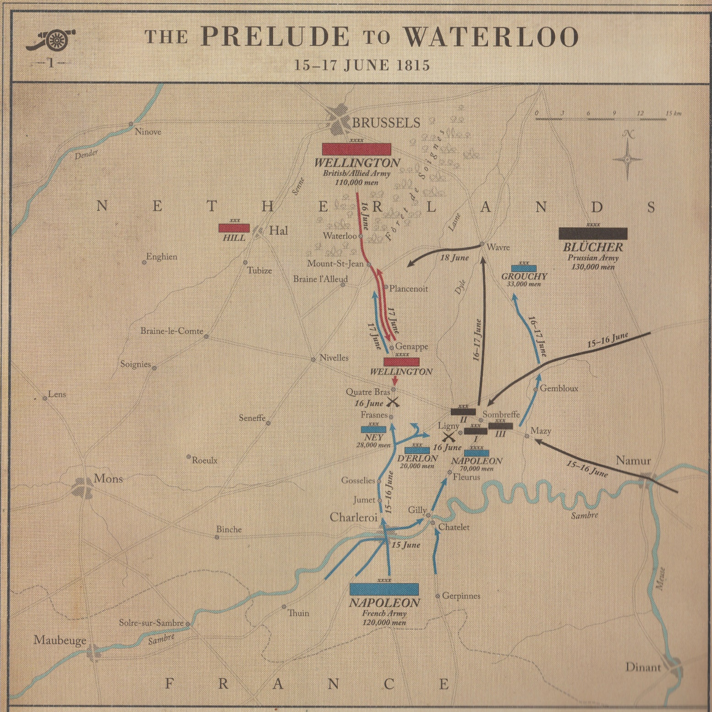
Figure 1 – The Prelude to Waterloo
Source: Dan Snow and Peter Snow, The Battle of Waterloo Experience (London: André Deutsch, 2015)

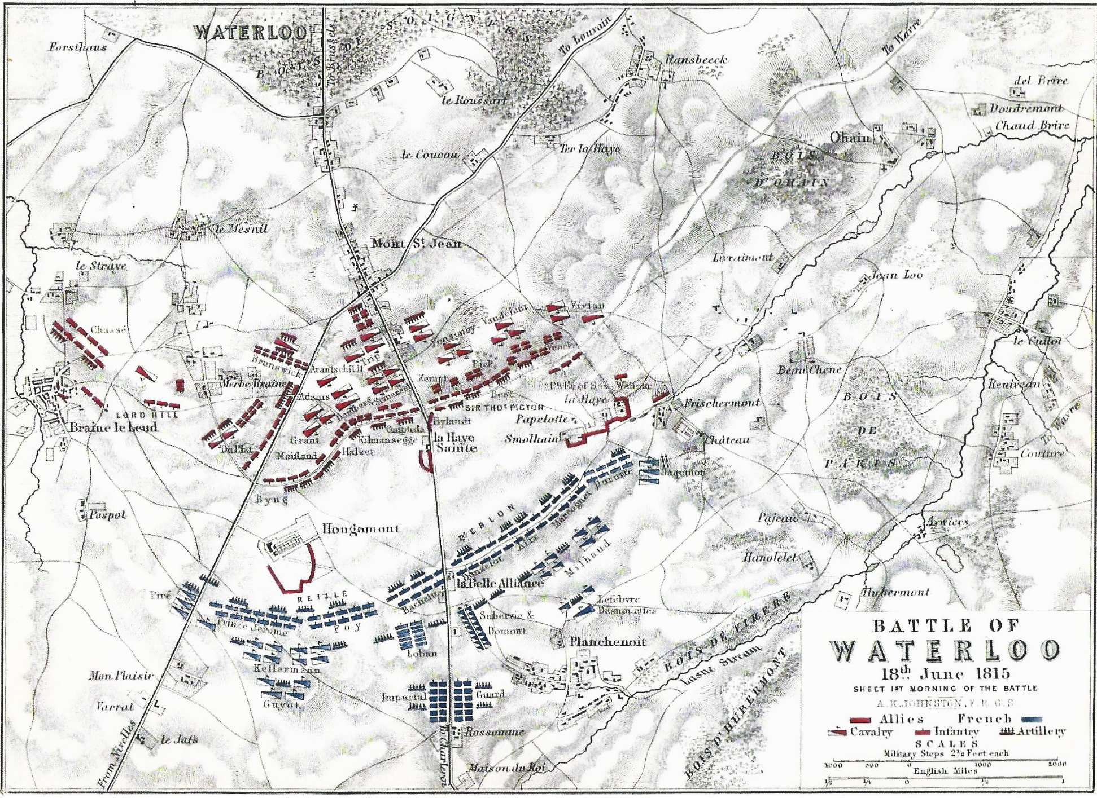
Figure 2 – Waterloo on the Morning of the 18th June
Source: Alexander Keith Johnston, The Battle of Waterloo, 18th June 1815. Sheet 1st, Morning of the Battle (Edinburgh: William Blackwood & Sons, 1855)
Figure 3 – The Farmhouse of La Haye Sainte
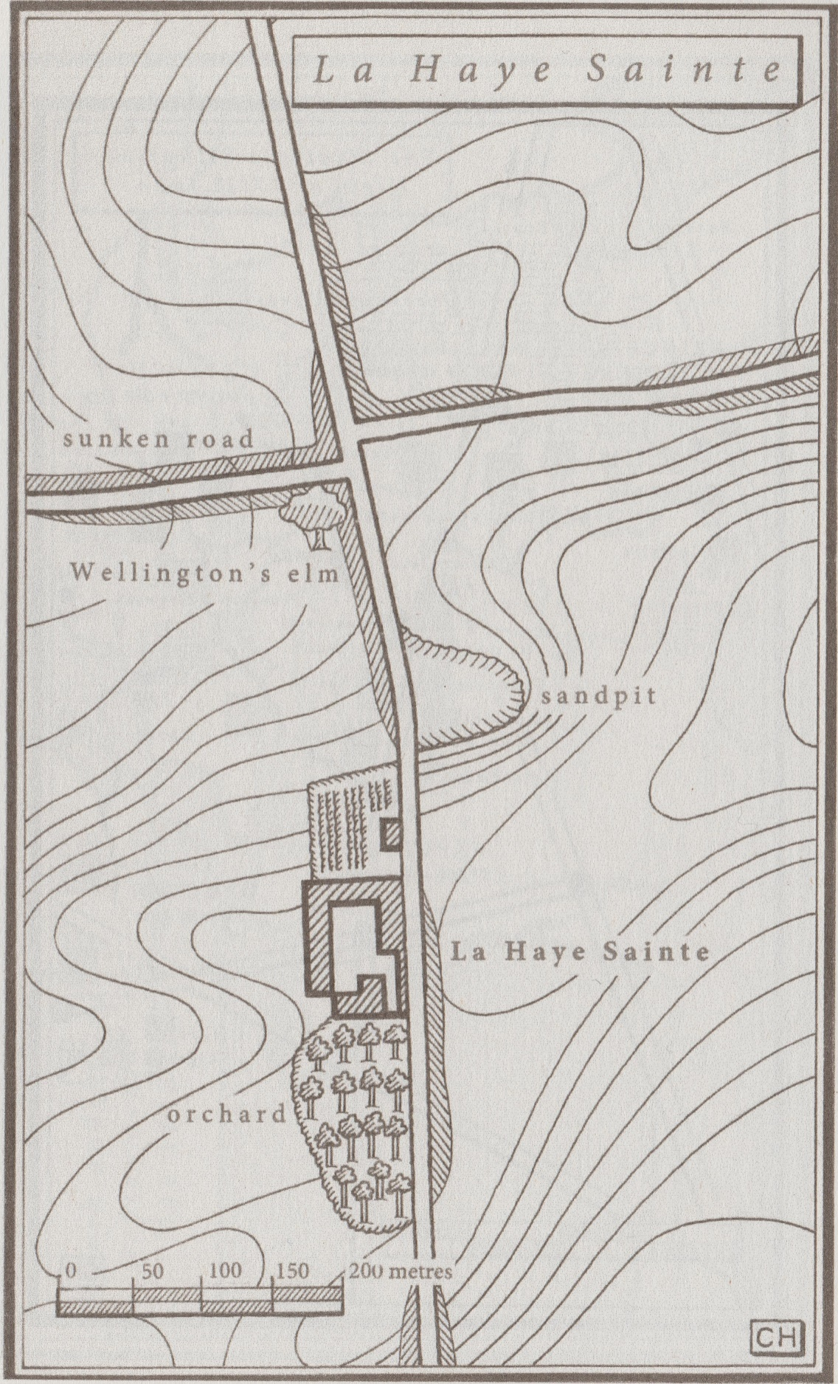

Source: Simms, The Longest Afternoon, p. xvii.
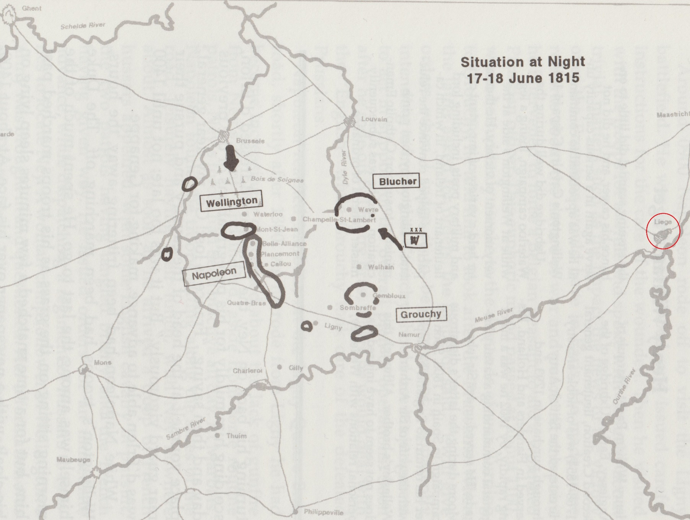
Figure 4 – The Situation at Dawn on 17th June

Source: Nofi, The Waterloo Campaign, p. 138. Liege is marked in red.

Appendix 1 – The Order of Battle of the Anglo-Allied Army
The Full Order of Battle at the Commencement of the Waterloo Campaign, with troop numbers on the 18th June. Source: Adkin, Companion, p. 38-50. The forces detached to Hal are marked with red font.
I Corps, commanded by General Prince William of Orange
Officer & Division |  | Officer & Brigade |  | Officer & Regiment/Battalion/Battery
Maj.- Gen. Sir George Cooke | 1st “Guards” Division. 4266 men at Waterloo. | Maj.-Gen. Peregrine Maitland | 1st Brigade | Lt.-Col. Henry Askew | 2/1st Regiment of Foot Guards
 |  |  |  | Lieut.-Col. William Steward | 3/1st Regiment of Foot Guards
Maj.- Gen. Sir George Cooke | 1st “Guards” Division. 4266 men at Waterloo. | Maj.-Gen. Sir John Byng | 2nd Brigade | Lt.-Col. James Macdonnell | 2/Coldstream Regiment of Foot Guards
 |  |  |  | Second Maj. Francis Hepburn | 2/3rd Regiment of Foot Guards
Maj.- Gen. Sir George Cooke | 1st “Guards” Division. 4266 men at Waterloo. | Lt.-Col. Stephen Adye | Artillery | Capt. Charles Sandham | Sandham’s Battery, Royal Artillery
 |  |  |  | Capt. Heinrich Kuhlmann | Kuhlmann’s Battery, KGL
Lt.-Gen. Sir Charles Alten | 3rd British Division. 8091 men at Waterloo. | Maj.-Gen. Sir Colin Halkett | 5th Brigade | Lt.-Col. Alexander Hamilton | 2/30th (Cambridgeshire)
 |  |  |  | Lt.-Col. William Elphinstone | 33rd (1st Yorkshire, West Riding)
 |  |  |  | Lt.-Col. Charles Morice | 69th (South Lincolnshire)
 |  |  |  | Lt.-Col. William Harris | 2/73rd (Perthshire)
Lt.-Gen. Sir Charles Alten | 3rd British Division. 8091 men at Waterloo. | Brevet Col. Baron Christian von Ompteda | 2nd Brigade, King’s German Legion | Lt.-Col. Louis von dem Bussche | 1st (Rifles) Light Battalion
 |  |  |  | Major Georg von Baring | 2nd (Rifles) Light Battalion
 |  |  |  | Lt.-Col. Wilhelm von Linsingen | 5th Line Battalion
 |  |  |  | Lt.-Col. Johann van Schroeder | 8th Line Battalion
Lt.-Gen. Sir Charles Alten | 3rd British Division. 8091 men at Waterloo. | Maj.-Gen. Friedrich von Kielmansegg | 1st Hanoverian Brigade | Lt.-Col. Wilhelm von Langrehre | Field Battalion Bremen
 |  |  |  | Major Carl von Bulow | Field Battalion 1st Duke of York’s
 |  |  |  | Lt.-Col. Baron Friedrich von Wurmb | Light Battalion Grubenhagen
 |  |  |  | Lt.-Col. August von Klencke | Light Battalion Lüneburg
 |  |  |  | Major Julius von Schkopp | Field Battalion Verden
 |  |  |  | Capt. de Reden | Field Jaeger Bat.
Lt.-Gen. Sir Charles Alten | 3rd British Division. 8091 men at Waterloo. | Lt.-Col. John Williamson | Artillery | Major William Lloyd | Lloyd’s Battery, Royal Artillery
 |  |  |  | Capt. Andreas Cleeves | Cleeves’ Battery, King’s German Legion
Lt.-Gen. Baron Hendrik Sedlnitsky | 2nd Dutch Division. 7620 men at Waterloo. | Maj.-Gen Willem van Bijlandt | 1st Brigade | Lt.-Col. Johann Grunebosch | 27th Light Battalion
 |  |  |  | Lt.-Col. Frederik van den Sande | 7th Line Battalion
 |  |  |  | Lt.-Col. Jan Westenberg | 5th National Militia Battalion
 |  |  |  | Lt.-Col. Hendrick Singendonck | 7th National Militia Battalion
 |  |  |  | Lt.-Col. Wijlbrandis de Jongh | 8th National Militia Battalion
 |  |  |  | Capt. Emmanuel Stevenart | Artillery Battery
 |  |  |  | Capt. Adriaan van Bijleveld | Horse Artillery Battery
Lt.-Gen. Baron Hendrik Sedlnitsky | 2nd Dutch Division. 7620 men at Waterloo. | Col. Friedrich von Goedeck | 2nd Brigade | Major Johan Sattler | 1, 2, & 3/2nd Nassau Infantry Regiment
 |  |  |  | Col. Bernhard of Saxe-Weimar-Eisenach | 1 & 2/28th Orange-Nassau Regiment
 |  |  |  | Capt. Emilius Bergmann | Volunteer Jager Company
 |  |  |  | Col. Hendrik Trip | Artillery Battery
Lt.-Gen. Baron David Chassé | 3rd Dutch Division. 7146 men at Waterloo. | Col. Hendrick Detmers | 1st Brigade | Lt.-Col. Desire Arnould | 35th Light Battalion
 |  |  |  | Lt.-Col. Johannes Speelman | 2nd Line Battalion
 |  |  |  | Lt.-Col. Ricard van Molencate | 4th National Militia Battalion
 |  |  |  | Lt.-Col. Adolphus van Thielen | 6th National Militia Battalion
 |  |  |  | Lt.-Col. Nicolas van Stolz Wieling | 17th National Militia Battalion
 |  |  |  | Major H. Boelaard | 19th National Militia Battalion
 |  |  |  | Capt. Carel de Bichin | Horse Artillery Battery
Lt.-Gen. Baron David Chassé | 3rd Dutch Division. 7146 men at Waterloo. | Maj.-Gen. Alexander d’Aubremé | 2nd Brigade | Lt.-Col. Charles Goethals | 36th Light Battalion
 |  |  |  | Lt.-Col. E. P. l’Honneux | 3rd Line Battalion
 |  |  |  | Lt.-Col. Daniel O. Bagelaar | 12th Line Battalion
 |  |  |  | Lt.-Col. Frederik Aberson | 13th Line Battalion
 |  |  |  | Lt.-Col. Niels van Malz Wieling | 3rd National Militia Battalion
 |  |  |  | Lt.-Col. Gebhardt Fanus Brade | 10th National Militia Battalion
 |  |  |  | Capt. Johannes Hendrik Lux | Artillery Battery

II Corps, commanded by Lieutenant-General Lord Rowland Hill
Officer & Division |  | Officer & Brigade |  | Officer & Regiment/Battery
Lt.-Gen. Sir Henry Clinton | 2nd British Division. 7992 men at Waterloo. | Maj.-Gen. Frederick Adam | 3rd Brigade | Lt.-Col. Sir John Colborne | 52nd (Oxfordshire) Light Infantry
 |  |  |  | Brevet Col. Thomas Reynell | 71st (Glasgow Highland) Light Infantry
 |  |  |  | Brevet Lt.-Col. Amos Norcott | 2/95th (Rifles)
 |  |  |  | Brevet Lt.-Col. John Ross | 3/95th (Rifles), 2 companies
Lt.-Gen. Sir Henry Clinton | 2nd British Division. 7992 men at Waterloo. | Lt.-Col. Georg du Plat | 1st Brigade, King’s German Legion | Major Frederich von Robertson | 1st Line Battalion
 |  |  |  | Major Georg Muller | 2nd Line Battalion
 |  |  |  | Lt.-Col. Frederich von Wissel | 3rd Line Battalion
 |  |  |  | Major Frederich Reh | 4th Line Battalion
Lt.-Gen. Sir Henry Clinton | 2nd British Division. 7992 men at Waterloo. | Lt.-Col. Hugh Baron Halkett | 3rd Hanoverian Brigade | Lt.-Col. Frederich von der Schulenberg | Landwehr Battalion Bremervörde
 |  |  |  | Major Baron Louis von Münster | Landwehr Battalion 2nd Duke of York’s
 |  |  |  | Major Baron Clamor von dem Bussche-Hünefeld | Landwehr Battalion 3rd Duke of York’s
 |  |  |  | Major Frederich von Hammerstein | Landwehr Battalion Salzgitter
Lt.-Gen. Sir Henry Clinton | 2nd British Division. 7992 men at Waterloo. | Lt.-Col. Charles Gold | Artillery | Capt. Samuel Bolton | Bolton’s Battery, Royal Artillery
 |  |  |  | Capt. Augustus Sympher | 1st Troop Sympher’s Battery, King’s German Legion
Maj.-Gen. Sir Charles Colville | 4th British Division. 3900 men at Hal. | Lt.-Col. Sir Hugh Mitchell | 4th Brigade. 2007 at Waterloo. | Major Francis Tidy | 3/14th (Buckinghamshire)
 |  |  |  | Brevet Col. Sir Henry Ellis | 1/23rd (Royal Welch)
 |  |  |  | Lt.-Col. Sir Hugh Mitchell | 51st (2nd Yorkshire, West Riding)
Maj.-Gen. Sir Charles Colville | 4th British Division. 3900 men at Hal. | Maj.-Gen George Johnstone | 6th Brigade | Major Charles MacAlister | 2/35th (Sussex)
 |  |  |  | Lt.-Col. John Waldegrave | 54th (West Norfolk)
 |  |  |  | Lt.-Col. Henry Austin | 2/59th (2nd Nottinghamshire)
 |  |  |  | Lt.-Col. Sir William Douglas | 1/91st (Argyllshire)
Maj.-Gen. Sir Charles Colville | 4th British Division. 3900 men at Hal. | Maj.-Gen. Sir James Lyon | 6th Hanoverian Brigade | Major Wilhelm Schnehen | Field Battalion Calenberg
 |  |  |  | Lt.-Col. Gideon von Benoit | Field Battalion Lauenburg
 |  |  |  | Major Christian Croupp | Landwehr Battalion Bentheim
 |  |  |  | Lt.-Col. Otto von Grote | Landwehr Battalion Hoya
 |  |  |  | Major Julius Brinckmann | Landwehr Battalion Nienburg
Maj.-Gen. Sir Charles Colville | 4th British Division. 3900 men at Hal. | Lt.-Col. James Hawker | Artillery | Capt. Joseph Brome | Brome’s Battery, Royal Artillery
 |  |  |  | Capt. Carl von Rettberg | Rettberg’s Hanoverian Foot Artillery
Lt.-Gen. John Stedman | 1st Dutch Division. 10421 men at Hal. | Maj.-Gen. Ferdinand d’Hauw | 1st Brigade | Lt.-Col. Stefan van Hulstein | 16th Light Battalion
 |  |  |  | Lt.-Col. Ernst de Man | 4th Line Battalion
 |  |  |  | Lt.-Col. Pieter Arnold Twent | 6th Line Battalion
 |  |  |  | Lt.-Col. Johan Jacobus Simons | 9th National Militia Battalion
 |  |  |  | Lt.-Col. Willem Poolman | 14th National Militia Battalion
 |  |  |  | Lt.-Col. Pieter Christiaan Colthoff | 15th National Militia Battalion
Lt.-Gen. John Stedman | 1st Dutch Division. 10421 men at Hal. | Maj.-Gen. Dominique Johann de Eerens | 2nd Brigade | Lt.-Col. HSH Prins August van Arenberg | 18th Light Battalion
 |  |  |  | Lt.-Col. Willem Kuijck | 1th Line Battalion
 |  |  |  | Lt.-Col. Frederik Guicherit | 1st National Militia Battalion
 |  |  |  | Lt.-Col. Albert Willem van Bazel | 2nd National Militia Battalion
 |  |  |  | Lt.-Col. Frederik Willem van Ommeren | 18th National Militia Battalion
 |  |  |  | Capt. Pieter Wijnands | Artillery Battery
Lt.-Gen. John Stedman | 1st Dutch Division. 10421 men at Hal. | Lt.-Gen. Baron Carl Heinrich Wilhelm Anthing | Indies Brigade | Maj.-Gen. Gerard Busman | 1 & 2/5th East Indian Regiment
 |  |  |  | Col. Heinz Willem Rancke | 10th West Indies Light Battalion
 |  |  |  | Lt.-Col. Frederik Knotzer | 11th West Indies Light Battalion
 |  |  |  | Col. W. Schenck | 19th & 20th Light Battalion, 4 companies
 |  |  |  | Capt. Carl Jan Riesz | Artillery Battery

Cavalry Corps, commanded by Lieutenant-General Sir Henry Paget, the Earl of Uxbridge
Officer & Division |  | Officer & Brigade |  | Officer & Regiment/Battery
Lt.-Gen. Sir Henry Paget, the Early of Uxbridge | Anglo-Allied Cavalry Corps. 9155 men at Waterloo. | Maj.-Gen. Lord Edward Somerset | 1st (Household) Cavalry Brigade | Lt.-Col. Samuel Ferrior | 1st Regiment of Life Guards
 |  |  |  | Lt.-Col. Richard Fitzgerald | 2nd Regiment of Life Guards
 |  |  |  | Lt.-Col. Sir Robert Chambre Hill | Royal Regiment of Horse Guards
 |  |  |  | Lt.-Col. William Fuller | 1st King’s Dragoon Guards
Lt.-Gen. Sir Henry Paget, the Early of Uxbridge | Anglo-Allied Cavalry Corps. 9155 men at Waterloo. | Maj.-Gen. Sir William Ponsonby | 2nd Union Brigade Cavalry | Lt.-Col. Arthur Clifton | 1st (Royal) Dragoons
 |  |  |  | Lt.-Col. James Inglis Hamilton | 2nd (Royal North British) Dragoons, the Scots Greys
 |  |  |  | Lt.-Col. Joseph Muter | 6th (Inniskilling) Dragoons
Lt.-Gen. Sir Henry Paget, the Early of Uxbridge | Anglo-Allied Cavalry Corps. 9155 men at Waterloo. | Maj.-Gen. Sir Wilhelm von Dörnberg | 3rd British Brigade | Lt.-Col. Johann Bulow | 1st Light Dragoons, KGL
 |  |  |  | Lt.-Col. Karl von Jonquieries | 2nd Light Dragoons, KGL
 |  |  |  | Lt.-Col. John Dawson, Earl of Portarlington | 23rd Light Dragoons
Lt.-Gen. Sir Henry Paget, the Early of Uxbridge | Anglo-Allied Cavalry Corps. 9155 men at Waterloo. | Maj.-Gen. Sir John Ormsby Vandeleur | 4th British Brigade | Lt.-Col. James Wallace Sleigh | 11th Light Dragoons
 |  |  |  | Lt.-Col. The Hon. Frederick Cavendish Ponsonby | 12th (Prince of Wales’) LD
 |  |  |  | Lt.-Col. James Hay | 16th (Queen’s) LD
Lt.-Gen. Sir Henry Paget, the Early of Uxbridge | Anglo-Allied Cavalry Corps. 9155 men at Waterloo. | Maj.-Gen. Sir Colquhoun Grant | 5th British Brigade | Lt.-Col. Sir Edward Kerrison | 7th (Queen’s Own) Hussars
 |  |  |  | Lt.-Col. Leighton Dalrymple | 15th (King’s) Hussars
 |  |  |  | Lt.-Col. August von Linsingen | 2nd Hussars, KGL
Lt.-Gen. Sir Henry Paget, the Early of Uxbridge | Anglo-Allied Cavalry Corps. 9155 men at Waterloo. | Maj.-Gen. Sir Richard Hussey Vivian | 6th British Brigade | Lt.-Col. George Quentin | 10th (Prince of Wales’ Own) LD
 |  |  |  | Lt.-Col. The Hon. Henry Murray | 18th (King’s Irish) LD
 |  |  |  | Lt.-Col. August von Wissell | 1st Hussars, KGL
Lt.-Gen. Sir Henry Paget, the Early of Uxbridge | Anglo-Allied Cavalry Corps. 9155 men at Waterloo. | Brevet Col. Sir Friedrich von Arentsschildt | 7th British Brigade | Lt.-Col. Patrick Doherty | 13th Light Dragoons
 |  |  |  | Lt.-Col. Lewis Meyer | 3rd Hussars, KGL
Lt.-Gen. Sir Henry Paget, the Early of Uxbridge | Anglo-Allied Cavalry Corps. 9155 men at Waterloo. | Col. Albrecht von Estorff | 1st Hanoverian Brigade. 1231 men at Hal. | Lt.-Col. Ferdinand Graf von Kielmansegge | Prince Regent’s Hussars
 |  |  |  | Lt.-Col. August von dem Bussche | Bremen & Verden Hussars
 |  |  |  | Lt.-Col. Georg von Hake | Duke of Cumberland’s Hussars
Lt.-Gen. Sir Henry Paget, the Early of Uxbridge | Anglo-Allied Cavalry Corps. 9155 men at Waterloo. | Lt.-Col. Sir Augustus Simon Frazer | Attached Artillery | Major Robert Bull | I (Bull’s) Troop, RHA
 |  |  |  | Lt.-Col. James Webber Smith | F (Webber-Smith’s) Troop, RHA
 |  |  |  | Lt.-Col. Sir Robert Gardiner | E (Gardiner’s) Troop, RHA
 |  |  |  | Capt. Edward Charles Whinyates | 2nd Rocket (Whinyates’) Troop, RHA
 |  |  |  | Major William Ramsay | H (Ramsay’s) Troop, RHA
 |  |  |  | Capt. Alexander Mercer | G (Mercer’s) Troop, RHA
Lt.-Gen. Jean Antoine de Collaert | Dutch Cavalry Division. 3305 men at Waterloo. | Maj.-Gen. Albert Dominicus Trip van Zoudtlandt | 1st Heavy Cavalry Brigade | Lt.-Col. L. Coenegracht | 1st Carabiniers
 |  |  |  | Col. J. B. d. B. de Basisque | 2nd Carabiniers
 |  |  |  | Lt.-Col. C. M. Lechleitner | 3rd Carabiniers
Lt.-Gen. Jean Antoine de Collaert | Dutch Cavalry Division. 3305 men at Waterloo. | Maj.-Gen. Baron Charles de Ghigny | 2nd Light Brigade | Lt.-Col. Johan Renno | 4th Light Dragoons
 |  |  |  | Lt.-Col. I. L. Baron Duvivier | 8th Hussars
Lt.-Gen. Jean Antoine de Collaert | Dutch Cavalry Division. 3305 men at Waterloo. | Maj.-Gen. Jean Baptiste, Baron van Merlen | 3rd Light Brigade | Lt.-Col. E. A. J. G. de Corbais | 5th Light Dragoons
 |  |  |  | Lt.-Col. J. W. F. Boreel | 6th Hussars
Lt.-Gen. Jean Antoine de Collaert | Dutch Cavalry Division. 3305 men at Waterloo. | Major von Cramm | Cavalry of the Brunswick Corps | Major von Cramm | 2nd Hussars
 |  |  |  | Major Carl Pott | Uhlans, 1 squadron
Lt.-Gen. Jean Antoine de Collaert | Dutch Cavalry Division. 3305 men at Waterloo. |  | Attached Artillery | Capt. Abraham Petter | Half Battery Horse Artillery
 |  |  |  | Capt. A. R. W. G. van Pittius | Half Battery Horse Artillery

Reserves, commanded by Field Marshal Sir Arthur Wellesley, the Duke of Wellington
Officer & Division |  | Officer & Brigade |  | Officer & Regiment/Battery
Lt.-Gen. Sir Thomas Picton | 5th British Division. 6724 men at Waterloo. | Maj.-Gen. Sir James Kempt | 8th Brigade | Col. Sir Charles Paul Benson | 1/28nd (North Gloucestershire)
 |  |  |  | Brevet Lt.-Col. John Hicks | 1/32nd (Cornwall)
 |  |  |  | Lt.-Col. Neil Douglas | 79th (Cameron Highlanders)
 |  |  |  | Brevet Col. Sir A. F. Barnard | 1/95th (Rifles)
Lt.-Gen. Sir Thomas Picton | 5th British Division. 6724 men at Waterloo. | Maj.-Gen. Sir Dennis Pack | 9th Brigade | Lt.-Col. Colin Campbell | 3/1st (The Royal Scots)
 |  |  |  | Lt.-Col. Sir Robert Macara | 42nd (Royal Highland), the Black Watch
 |  |  |  | Lt.-Col. J. M. Hamerton | 2/44th (East Essex)
 |  |  |  | Lt.-Col. J. C. of Fassifern | 92nd (Gordon Highlanders)
Lt.-Gen. Sir Thomas Picton | 5th British Division. 6724 men at Waterloo. | Col. Ernst von Vincke | 5th Hanoverian Brigade | Major Georg von Hammerstein | Landwehr Battalion Gifhorn
 |  |  |  | Major Julius von Strube | Landwehr Battalion Hameln
 |  |  |  | Major Georg von Rheden | Landwehr Battalion Hildesheim
 |  |  |  | Major L. G. von Westphalen | Landwehr Battalion Peine
Lt.-Gen. Sir Thomas Picton | 5th British Division. 6724 men at Waterloo. | Major Heinrich Heise | Artillery | Capt. Thomas Rogers | Roger’s Battery, RA
 |  |  |  | Capt. Wilhelm Braun | Braun’s Hanoverian Foot Artillery
Lt.-Gen. Sir Lowry Cole | 6th British Division. 5158 men at Waterloo. | Maj.-Gen. Sir John Lambert | 10th Brigade | Lt.-Col. Francis Brooke | 1/4th (King’s Own)
 |  |  |  | Major John Hare | 1/27th (Inniskilling)
 |  |  |  | Major A. R. Heyland | 2/40th (2nd Somersetshire)
 |  |  |  | Lt.-Col. Henry Milling | 2/81st (Loyal Lincoln Volunteers)
Lt.-Gen. Sir Lowry Cole | 6th British Division. 5158 men at Waterloo. | Col. Charles Best | 4th Hanoverian Brigade | Lt.-Col. Ludwig von Ramdohr | Landwehr Battalion Lüneburg
 |  |  |  | Major Ferdinand von Schmid | Landwehr Battalion Munden
 |  |  |  | Major Claus von Reden | Landwehr Battalion Osterode
 |  |  |  | Major Christoff von der Decken | Landwehr Battalion Verden
Lt.-Gen. Sir Lowry Cole | 6th British Division. 5158 men at Waterloo. | Major Heinrich Bruckmann | Artillery | Capt. George W. Unett | Unett’s Battery, RA
 |  |  |  | 2nd Captain James Sinclair | Sinclair’s Battery, RA
Major Percy Drummond | British Reserve Artillery |  |  | Lt.-Col. Sir Hew D. Ross | A (Ross’) Troop, RHA
 |  |  |  | Major George Beane | D (Beane’s) Troop, RHA
Lt.-Gen. HSH the Duke of Brunswick | Brunswick Corps. 6244 men at Waterloo. | Lt.-Col. Wilhelm Treunch von Butlar | 1st Brigade | Major Frederich von Pröstler | Guard Battalion
 |  |  |  | Major von Holstein | 1st Light Infantry Battalion
 |  |  |  | Major Heinrich von Brandenstein | 2nd Light Infantry Battalion
 |  |  |  | Major von Ebeling | 3rd Light Infantry Battalion
Lt.-Gen. HSH the Duke of Brunswick | Brunswick Corps. 6244 men at Waterloo. | Lt.-Col. Frederich von Specht | 2nd Brigade | Major Metzner | 1st Line Battalion
 |  |  |  | Major von Strombeck | 2nd Line Battalion
 |  |  |  | Major Gustavus von Normann | 3rd Line Battalion
Lt.-Gen. HSH the Duke of Brunswick | Brunswick Corps. 6244 men at Waterloo. | Major August Mahn | Artillery | Capt. Manfred von Heinemann | Heinemann’s Horse Artillery Battery
 |  |  |  | Capt. Johann Moll | Moll’s Artillery Battery
 |  | Maj.-Gen. Baron August H. E. von Kruse | Nassau Reserve Brigade | Col. Ernst von Steuben | 1/1st Nassau Regiment
 |  |  |  | Major Adolph von Nauendorf | 2/1st Nassau Regiment
 |  |  |  | Major Frederich von Preen | 3/1st Nassau Regiment

Bibliography
Images
Johnston, Alexander Keith, The Battle of Waterloo, 18th June 1815. Sheet 1st, Morning of the Battle (Edinburgh: William Blackwood & Sons, 1855)
(Front Page) Lawrence, Thomas, The Duke of Wellington in Kauffman, C.M., Catalogue of Paintings in the Wellington Museum, Apsley House, eds. Susan Jenkins and Marjorie E. Wieseman (London: English Heritage and Paul Holberton, 2009)
Snow, Dan and Snow, Peter, The Battle of Waterloo Experience (London: André Deutsch, 2015)

Primary Sources
An Officer on the Staff, An Account of the Battle of Waterloo, fought on the 18th June 1815, by the English and Allied Forces, commanded by the Duke of Wellington, and the Prussian Army, under the orders of Prince Blücher, against the Army of France, commanded by Napoleon Bonaparte, eds. Samuel Goswell and James Ridgeway, fourth edn (London: James Ridgeway, 1815)
Anonymous, A Sketch of the Battle of Waterloo (Brussels: Gérard, 1842)
Anonymous, The Battle of Waterloo, seventh edn (London: John Booth, T. Egerton, Manners and Miller, 1815)
The Autobiography of Sergeant William Lawrence, ed. George Nugent Bankes (London: Sampson Low, Marston, Searle, and Rivington, 1886)
Bathurst, Henry, 3rd Earl Bathurst, “British Killed & Wounded”, The Times, 22nd June 1815, p. 3.
Cooper, John S., Fusilier Cooper: Experience in the 7th (Royal) Fusiliers During the Peninsular Campaign of the Napoleonic Wars and the American Campaign to New Orleans, paperback edn (London: Leonaur Ltd., 2007)
Costello, Edward, Rifleman Costello (London: Leonaur Ltd, 2005)
Frazer, Sir Augustus Simon, Letters of Colonel Sir Augustus Simon Frazer KCB, commanding the Royal horse artillery in the army under the Duke of Wellington: written during the peninsular and Waterloo campaigns (London: Longman, Brown, Green, Longmans, & Roberts, 1859)
War, ed. Lawrence Freedman, second edn (Oxford: Oxford University Press, 2011)
Wellington’s Voice: The Candid Letters of Lieutenant Colonel John Fremantle, Coldstream Guards, 1808-1837, ed. Gareth Glover (London: Frontline Books, 2012)
The Waterloo Archive Volumes 1-6, ed. Gareth Glover (Barnsley: Frontline Books, 2010-13)
von Gneisenau, August, The Life and Campaigns of Field-Marshal Prince Blücher, trans. J.E. Marston (London: Constable and Company Ltd., 1996)
Green, William and Smith, Harry, Bugler and Officer of the Rifles (London: Leonaur Ltd., 2005)
The General Orders of Field Marshal the Duke of Wellington, KG., &c., in Portugal, Spain, and France, from 1809 to 1814; in the Low Countries and France, in 1815; and in France, Army of Occupation, from 1816 to 1818, ed. John Gurwood (London: W. Clowes and Sons, 1837)
The Dispatches of Field Marshal the Duke of Wellington, during his Various Campaigns, in India, Denmark, Portugal, Spain, The Low Countries, and France Volume II, ed. John Gurwood (London: Parker, Furnivall, and Parker, 1844)
Hamilton, Anthony, On Campaign with Moore and Wellington: The Experiences of a Soldier of the 43rd Regiment During the Peninsular War (London: Leonaur Ltd., 2009)
de Jomini, Baron, The Art of War, trans. W.P. Craighill & G.H. Mendell, new edn (Philadelphia: J.B. Lippincott & Co., 1862)
Kershaw, Robert, 24 Hours at Waterloo (London: WH Allen, 2014)
von Müffling, Friedrich, A Sketch of the Battle of Waterloo, seventh edn (Brussels: H. Gérard, 1875)
O’Neil, Charles, Private O’Neil (London: Leonaur Ltd., 2007)
Waterloo Letters, ed. H.T. Siborne (Barnsley: Frontline Books, 2015)
Wellesley, Sir Arthur, the Duke of Wellington, “My Lord”, The Times, 22nd June 1815, p. 2.

Scholarship
Adkin, Mark, The Waterloo Companion (London: Aurum Press Limited, 2001)
Baker-Smith, Veronica, Wellington’s Hidden Heroes: The Dutch and Belgians at Waterloo (Oxford: Casemate Publishers, 2015)
The Oxford Illustrated History of the British Army, eds. Ian Beckett and David Chandler (Oxford: Oxford University Press, 1994)
The Oxford History of the British Army, eds. Ian Beckett and David Chandler, paperback edn (Oxford: Oxford University Press, 1994)
Bell, David A., The First Total War, paperback edn (London: Bloomsburg, 2008)
Boulger, Demetrius C., The Belgians at Waterloo, facsimile edn (Uckfield: The Naval & Military Press Ltd., 2015)
Fighting Techniques of the Napoleonic Age, eds. Robert B. Bruce, Iain Dickie, Kevin Kiley, Michael F. Pavkovic, Frederick C. Schneid (London: Amber Books Ltd., 2007)
Bryant, Arthur, The Great Duke (London: Collins, 1971)
Burnham, Robert & McGuigan, Ron, The British Army Against Napoleon: Facts, Lists, and Trivia 1805-1815 (London: Frontline Books, 2010)
Chesney, Charles, The Waterloo Lectures (Barnsley: Frontline Books, 2015)
Clarke, Stephen, 1000 Years of Annoying the French, second edn (London: Black Swan, 2015)
Clayton, Tim, Waterloo: Four Days that Changed Europe’s Destiny, paperback edn (London: Abacus, 2015)
David, Saul, Military Blunders (London: Constable, 2012)
David, Saul, All the King’s Men: The British Soldiers from the Restoration to Waterloo (London: Viking, 2012)
Edwards, Peter, Talavera: Wellington’s Early Peninsula Victories 1808-9 (Marlborough: The Crowood Press Ltd., 2005)
Edwards, William, Notes on European History, Volume 3, second edn (London: Rivingtons, 1928)
Harvey, Robert, The War of Wars: The Epic Struggle between Britain and France, 1789-1815, paperback edn (London: Constable, 2007)
The Oxford Paperback Dictionary, ed. Joyce M. Hawkins, third edn (Oxford: Oxford University Press, 1991)
Hinton, Mike, “Reporting the Crimean War: Misinformation and Misinterpretation”, 19: Interdisciplinary Studies in the Long Nineteenth Century, 20, (2015) [online]. Available https://www.19.bbk.ac.uk/articles/10.16995/ntn.711/ [Accessed 21st December 2017]
The Oxford Book of Military Anecdotes, ed. Max Hastings (Oxford: Oxford University Press, 1985)
Hofschröer, Peter, 1815: The Waterloo Campaign. The German Victory (London: Greenhill Books, 1999)
Peter Hofschröer, 1815: The Waterloo Campaign. Wellington, his German Allies, and the Battles of Ligny and Quatre Bras (London: Greenhill Books, 1999)
Holmes, Richard, Wellington: The Iron Duke, seventh edn (London: Harper Perennial, 2007)
Horsburgh, E.L.S., Waterloo: A narrative and a criticism (London: Methuen & Co., 1895)
Hussey, John, Waterloo: The Campaign of 1815, Volume 2 (Barnsley: Greenhill Books, 2017)
James, Lawrence, The Iron Duke: A Military Biography of Wellington (London: Weidenfeld & Nicolson Ltd., 1992)
Keegan, John, A History of Warfare, second edn (London: Pimlico, 2004)
Kelly, W.H., The Battle of Wavre and Grouchy’s Defeat, facsimile edition (Tyne & Wear: Worley Publications, 1993)
Laffin, John, Tommy Atkins, second edn (Stroud: The History Press, 2012)
Livesey, Anthony, Battles of the Great Commanders (London: Book Club Associates, 1987)
Longford, Elizabeth, Wellington: The Years of the Sword, second edn (London: Panther, 1972)
Mallinson, Allan, The Making of the British Army, second edn (London: Bantam Press, 2011)
British Military Greats, eds. Annabel Merullo and Neil Wenborn, paperback edn (London: Cassell Illustrated, 2005)
Nofi, Albert A., The Waterloo Campaign (London: Greenhill Books, 1993)
Parkinson, Roger, The Hussar General: The Life of Blücher, Man of Waterloo (London: Peter David Limited, 1975)
Perrett, Bryan, The Battle Book, fifth edn (London: Arms and Armour Press, 1998)
Roberts, Andrew, Napoleon & Wellington (London: Hachette UK, 2010)
Sale, Nigel, The Lie at the Heart of Waterloo¸ second edn (Stroud: Spellmount, 2014)
Simms, Brendan, The Longest Afternoon: The 400 Men who decided the Battle of Waterloo (London: Penguin Books, 2015)
Spector, Bert Alan, “Carlyle, Freud, and the Great Man Theory more fully considered”, Leadership, 12, 2016(2), pp. 250-260
Snow, Peter, To War with Wellington, paperback edn (London: John Murray, 2011)

Wellington’s Voice: The Candid Letters of Lieutenant Colonel John Fremantle, Coldstream Guards, 1808-1837, ed. Gareth Glover (London: Frontline Books, 2012), p. 197.
Robert B. Bruce, et al, Fighting Techniques of the Napoleonic Age: 1792 – 1815 (London: Amber Books Ltd., 2008), p. 64-6.
The Oxford Illustrated History of the British Army, eds. Ian Beckett and David Chandler (Oxford: Oxford University Press, 1994), p. 298; Mike Hinton, “Reporting the Crimean War: Misinformation and Misinterpretation”, 19: Interdisciplinary Studies in the Long Nineteenth Century, 20, (2015) [online]. Available https://www.19.bbk.ac.uk/articles/10.16995/ntn.711/ [Accessed 21st December 2017].
Bryan Perrett, The Battle Book: Crucial Conflicts in History from 1469 BC to the present (London: Brockhampton Press, 1998), p. 312.
The Oxford Book of Military Anecdotes, ed. Max Hastings (Oxford: Oxford University Press, 1985), p. 237.
Nigel Sale, The Lie at the Heart of Waterloo¸ second edn (Stroud: Spellmount, 2014), p.15.
The Oxford Paperback Dictionary, ed. Joyce M. Hawkins, third edn (Oxford: Oxford University Press, 1991), p. 271.
Ibid.
Saul David, Military Blunders (London: Constable, 2012), p. 23.
An Officer on the Staff, An Account of the Battle of Waterloo, fought on the 18th June 1815, by the English and Allied Forces, commanded by the Duke of Wellington, and the Prussian Army, under the orders of Prince Blücher, against the Army of France, commanded by Napoleon Bonaparte, eds. Samuel Goswell and James Ridgeway, fourth edn (London: James Ridgeway, 1815), p. 6.
Peter Hofschröer, 1815: The Waterloo Campaign. The German Victory (London: Greenhill Books, 1999)
Peter Hofschröer, 1815: The Waterloo Campaign. Wellington, his German Allies, and the Battles of Ligny and Quatre Bras (London: Greenhill Books, 1999), p. 17.
Bert Alan Spector, “Carlyle, Freud, and the Great Man Theory more fully considered”, Leadership, 12, 2016(2), pp. 250-260, p. 250.
Ibid., p. 253.
Henry Bathurst, 3rd Earl Bathurst, “British Killed & Wounded”, The Times, 22nd June 1815, p. 3; The Oxford History of the British Army, eds. Ian Beckett and David Chandler, second paperback edn (Oxford: Oxford University Press, 1996) p. 145.
Robert Harvey, The War of Wars: The Epic Struggle between Britain and France, 1789-1815, paperback edn (London: Constable, 2007), p. 871-2. The Russians and Austrians had each promised 150,000 men, although their actual invasion force was approaching 425,000. It was, however, still in the process of being mobilised to the French border.
Elizabeth Longford, Wellington: The Years of the Sword, second edn (London: Panther Books Ltd., 1972), p. 38.
Richard Holmes, Wellington: The Iron Duke, seventh edn (London: Harper Perennial, 2007), p. 9.
Saul David, All the King’s Men: The British Soldier from the Restoration to Waterloo (London: Penguin Books, 2012), p. 320.
Holmes, Wellington, p. 41. The decision was made to revert to the archaic spelling by his brother, Richard.
Longford, Wellington, p. 96-7.
Perrett, The Battle Book, p. 33.
Peter Edwards, Talavera: Wellington’s Early Peninsula Victories 1808-9 (Marlborough: The Crowood Press Ltd., 2005), p. 101.
Peter Snow, To War with Wellington, paperback edn (London: John Murray (Publishers), 2011) p. 96.
Ibid., p. 197.
Anthony Livesey, Battles of the Great Commanders (London: Book Club Associates, 1987), p. 100-7.
Ibid., p. 113.
John S. Cooper, Fusilier Cooper: Experience in the 7th (Royal) Fusiliers During the Peninsular Campaign of the Napoleonic Wars and the American Campaign to New Orleans, paperback edn (London: Leonaur Ltd., 2007), p. 23.
Edwards, Talavera, p. 174-5.
The Autobiography of Sergeant William Lawrence: A Hero of the Peninsular and Waterloo Campaigns, ed. George Nugent Banks (London: Sampson Law, Marston, Searle, & Rivington, 1886), pg. 54.
Robert Burnham & Ron McGuigan, The British Army Against Napoleon: Facts, Lists, and Trivia 1805-1815 (London: Frontline Books, 2010), p. 220.
Mark Adkin, The Waterloo Companion (London: Aurum Press, 2001), p. 37, 65.
Andrew Roberts, Napoleon & Wellington (London: Hachette UK, 2010), p. 74-9.
The Dispatches of Field Marshal the Duke of Wellington, during his Various Campaigns, in India, Denmark, Portugal, Spain, The Low Countries, and France Volume II, ed. John Gurwood (London: Parker, Furnivall, and Parker, 1844), p. 1468-70.
David, All the King’s Men, p. 375.
The General Orders of Field Marshal the Duke of Wellington, KG., &c., in Portugal, Spain, and France, from 1809 to 1814; in the Low Countries and France, in 1815; and in France, Army of Occupation, from 1816 to 1818, ed. John Gurwood (London: W. Clowes and Sons, 1837), p. 240.
Arthur Bryant, The Great Duke (London: Collins, 1971), p. 282.
Anthony Hamilton, On Campaign with Moore and Wellington: The Experiences of a Soldier of the 43rd Regiment During the Peninsular War (London: Leonaur Ltd., 2009), p. 55; Lawrence James, The Iron Duke: A Military Biography of Wellington (London: Weidenfeld & Nicolson Ltd., 1992), p. 140-1. General Cuesta even abandoned the British wounded left on the field.
Wellington’s Voice, ed. Glover, p. 48; Bryant, The Great Duke, p. 328.
Wellington’s Voice, ed. Glover, p. 204; Veronica Baker-Smith, Wellington’s Hidden Heroes: The Dutch and Belgians at Waterloo (Oxford: Casemate Publishers, 2015), p. 65.
Sir Augustus Simon Frazer, Letters of Colonel Sir Augustus Simon Frazer KCB, commanding the Royal horse artillery in the army under the Duke of Wellington: written during the peninsular and Waterloo campaigns (London: Longman, Brown, Green, Longmans, & Roberts, 1859), p. 516.
Adkin, Companion, p. 118.
E.L.S. Horsburgh, Waterloo: A narrative and a criticism (London: Methuen & Co., 1895), p. 275; Tim Clayton, Waterloo: Four Days that Changed Europe’s Destiny, paperback edn (London: Abacus, 2015), p. 352; John Hussey, Waterloo: The Campaign of 1815, Volume 2 (Barnsley: Greenhill Books, 2017), p. 33-4.
Baker-Smith, Hidden Heroes, p. 10.
Adkin, Companion, p. 49.
W.H. Kelly, The Battle of Wavre and Grouchy’s Defeat, facsimile edition (Tyne & Wear: Worley Publications, 1993), p. 104-6.
An Officer on the Staff, An Account, p. 10.
Kelly, Wavre, p. 104-5.
Anonymous, A Sketch of the Battle of Waterloo (Brussels: Gérard, 1842), p. 120.
Kelly, Wavre, p. 109; Snow, To War, p. 298-9. Conflicting reports from the British fail to give an accurate time of arrival for the Prussians, although between 4 and 5pm seems likely. The French attacked Thielmann at 4pm.
Hussey, The Campaign, p. 34.
Napoleon, “Maximes”, War, ed. Lawrence Freedman (Oxford: Oxford University Press, 1994) pp. 214-217, p. 215. Napoleon wrote in his maxims that the art of war is to ‘deploy one’s troops in such a way that they are everywhere at once’.
Horsburgh, A Criticism, p. 281.
Baron de Jomini, The Art of War, trans. W.P. Craighill & G.H. Mendell, new edn (Philadelphia: J.B. Lippincott & Co., 1862), p. 183.
Clayton, Four Days, p. 430.
Horsburgh, A Criticism, p. 282.
Hussey, The Campaign, p. 69.
Ibid., p. 55.
A Sketch, p. 7.
Charles O’Neil, Private O’Neil (London: Leonaur Ltd., 2007), p. 186.
Robert Kershaw, 24 Hours at Waterloo (London: WH Allen, 2014), p. 156.
David, All the King’s Men, p. 465-6.
Brendan Simms, The Longest Afternoon: The 400 Men who decided the Battle of Waterloo (London: Penguin Books, 2015), p. 14-15.
The Waterloo Archive Volume V: German Sources, ed. Gareth Glover (Barnsley: Frontline Books, 2013), p. 42.
Hofschröer, Ligny & Quatre Bras, p. 243-5. It transpires that most of the Legion spent the day marching, and then acted as a rearguard.
Hussey, The Campaign, p. 118.
Hofschröer, The German Victory, p. 59.
Baker-Smith, Hidden Heroes, p. 115.
Adkin, Companion, p. 415.
Ibid.
Horsburgh, A Criticism, p. 274.
Albert A. Nofi, The Waterloo Campaign (London: Greenhill Books, 1993), p. 198.
Adkin, Companion, p. 377.
Arthur Wellesley, The Duke of Wellington, “My Lord”, The Times, 22nd June 1815, p. 2.
Burnham & McGuigan, The British Army, p. 225.
Adkin, Companion, p. 376.
Hofschröer, The German Victory, p. 15.
Clayton, Waterloo, p. xiv is a good example of a history published for the bicentennial of the battle, which makes an effort to briefly examine the Dutch-Belgian, and German, soldiery.
Longford, Years of the Sword, 1972, p. 513.
Harvey, War of Wars, p. 873.
David, All the King’s Men, p. 448. Napoleon’s advance through Charleroi is likely the decision which prevented the uniting of the allied forces any sooner than the 18th.
Roger Parkinson, The Hussar General: The Life of Blücher, Man of Waterloo (London: Peter David Limited, 1975), p. 218.
William Edwards, Notes on European History Volume III, second edn (London: Rivingtons, 1928), p. 531.
Harvey, War of Wars, p. 876.
Horsburgh, A Criticism, p. 297.
Baker-Smith, Hidden Heroes, p. 43.
Adkin, Companion, p. 184.
Clayton, Waterloo, p. 372.
Hofschröer, Ligny & Quatre Bras, p. 326.
Ibid., p. 331.
Parkinson, Hussar General, p. 228. See Fig. 4.
James, Iron Duke, p. 252.
August von Gneisenau, The Life and Campaigns of Field-Marshal Prince Blücher, trans. J.E. Marston (London: Constable and Company Ltd., 1996), p. 407. His exact wording is that success for the Prussians ‘seemed to depend on the arrival of the English troops’.
Parkinson, Hussar General, p. 229.
Horsburgh, A Criticism, p. 301.
Baker-Smith, Hidden Heroes, p. 161.
Demetrius C. Boulger, The Belgians at Waterloo, facsimile edn (Uckfield: The Naval & Military Press Ltd., 2015), pp. 17-20.
Baker-Smith, Hidden Heroes, pp. 113, 116.
James, Iron Duke, p. 258.
David, All the King’s Men, p. 468.
Adkin, Companion, p. 41.
Baker-Smith, Hidden Heroes, p. 134.
Ibid., p. 135.
Arthur Wellesley, The Duke of Wellington, “My Lord”, The Times, 22nd June 1815, p. 2. It is famously given as General Vanhope, of which there was no officer serving, and the Duke never once admitted fault.
Hofschröer, Ligny & Quatre Bras, p. 349; Adkin, Companion, p. 73. With 31,000 men gone in 3 days, the Prussians suffered 85% of Allied casualties on the 16th.
Baker-Smith, Hidden Heroes, p. 20, 22.
David, All the King’s Men, p. 356. Indian losses made up 2/3 of the British casualties.
Holmes, Wellington, p. 236; Elizabeth Longford, Wellington, fourth edn (London: Abacus, 2012), p. 304. Both iconic biographies of the Duke; whilst both mention the reserve held at Hal, neither analyses the decision for more than a paragraph.
Parkinson, Hussar General, pp. 232-3.
See Figure 2. At best it is ¼ of a mile from the ridge to the farmhouse.
An Officer on the Staff, An Account, p. 54.

