Effects of diet on depression and anxiety in adolescence - A Systematic Review

This systematic review investigated the relationships between diet quality, depression, anxiety, and associated symptomatology. Depression and anxiety disorders, commonly known as common mental disorders (CMDs), are a prominent source of worldwide disability and economic burden (Whiteford et al., 2015). Despite an ever-evolving evidence basis, technology and medical improvements for treatment and management, and better access to mental health care, the population burden of CMDs does not seem to be decreasing and may, in fact, be growing (Jorm et al., 2017).

Introduction
Beardsley. B (2015) states that while the link between poor nutrition and mental health is well understood, few individuals are aware of the relationship between nutrition and mental health. Most people tend to think of mental health as being either physiological or emotionally based. Contrarily, diet may have a significant impact on the development, severity, and persistence of mental health issues. Many of the readily observable dietary habits that characterise mental health problems and depression have many similarities. Poor appetite, skipping meals, and a predominance of sugary foods are a few examples. A growing field called nutritional neuroscience is providing insight on how diet affects human brain, behaviour, and emotions. According to the majority of data, healthy food consumption appears to be one of the most important protective factors against mental health disorders (Jacka et al. 2011; McMartin et al. 2013; O'Neil et al. 2014). A number of Western and non-Western studies have discovered that abnormal dietary habits may indicate poor mental health in young people, including depression, anxiety (Jacka et al. 2013; Kulkarni et al. 2015; Lien 2007; Lien et al. 2006; Oddy et al. 2009; Takaoka and Kawakami 2013; Weng et al. 2011), and suicidal behaviour (Lien et al. 2006; Wang et al. 2011)
Depression and anxiety are the most prevalent mental health issues globally (Friedrich MJ., 2017). Subclinical symptoms of depression and anxiety influence the well-being and functioning of a huge percentage of the population (Johnson J, 1992).
As a result, new techniques to treating clinically recognised and subclinical depression and anxiety are required. The connections between diet and mental health have received a lot of attention in recent years. Adherence to healthy or Mediterranean dietary patterns—high consumption of fruits, vegetables, nuts, and legumes; moderate consumption of poultry, eggs, and dairy products; and only occasional consumption of red meat—has been linked to a lower risk of depression, according to epidemiological research (Lassale C., 2019). The nature of these relationships, however, is muddied by the evident possibility of reverse causation between nutrition and mental health. Fluctuations in food choices or preferences in reaction to our temporary psychological condition, such as "comfort foods" in times of low mood or hunger changes due to stress, are frequent human experiences.

The general population's food consumption pattern in many Asian and American nations shows that they are often low in numerous nutrients, including vital vitamins, minerals, and omega-3 fatty acids. (American psychiatric A. 2000). The degree of deficit in these nutrients is a noticeable aspect of the diets of people suffering from mental illnesses (American psychiatric A 2000). Daily supplementation of important nutrients has been shown in studies to be useful in lowering patients' symptoms. (Shaheen Lakhan SE, Vieira KF. 2008). Amino acid supplements have also been reported to ease symptoms, since they are converted too neurotransmitters, which reduce depression and other mental health issues Shaheen Lakhan SE, Vieira KF. 2008). Fortunately, nutritional supplement/treatment, is developing as a result of growing scientific data. This research may be useful in treating or mitigating all forms of mental health Shaheen Lakhan SE, Vieira KF. 2008).
When we look closely at the diets of individuals struggling with mental health problems, there tends to be a trend that their nutrition is far from optimal. These individuals usually make poor eating choices and choose products that may aggravate depression. Recent data reveals a relationship between low serotonin levels and suicide (Mann JJ. 1990). Lower levels of this neurotransmitter are thought to contribute to a general insensitivity to future consequences, activating hazardous, impulsive, and violent actions that might end in suicide, the ultimate act of inwardly directed impulsive anger (Mann JJ. 1990). Mental health problems are characterised by significant symptoms such as increased unhappiness and stress, lack of appetite, depression, and loss of interest in pleasure activities. If no immediate therapeutic intervention is provided, this illness may have a variety of implications (Mann JJ. 1990). Patients suffering from depression have a higher suicidal inclination and are thus often treated with antidepressants and/or psychotherapy (Brown GL, et al. 1982). Neurotransmitter deficiencies, such as serotonin, dopamine, noradrenaline, and -aminobutyric acid (GABA), are often related with depression (Stockmeier CA, et al. 1997)

Several studies have shown that the amino acids tryptophan, tyrosine, phenylalanine, and methionine may help treat a variety of mood disorders. (Firk, 2007; Leonard, 1997; Petty, 1995; McLean ,1994). Tryptophan, a precursor of serotonin, is normally converted to serotonin when taken alone on an empty stomach. As a result, tryptophan may promote sleep and relaxation. This means that increasing serotonin levels leads to less depression caused by serotonin deficits (National Institute of Mental Health, 2008). Dopamine and norepinephrine are produced from tyrosine and their precursor phenylalanine. (Hoes MJ, 1982).

The need to investigate this relationship in adolescents is strong; approximately 30% of adolescents have mental health issues, evidence suggests that health behaviours during this life stage are typically poor, and the transition phase of youths may present unique opportunities for interventions to improve diet and mental health (Corder et al., 2017; Gustavson et al., 2018; Kimokoti et al., 2012; Winpenny et al., 2018). As a result, the aim of this study is to review and analyse the effects diet has on mental health in adolescence. The study will focus on the following research questions.

- Is there a relationship between diet quality, depression, and anxiety in adolescence?
- What does the existing evidence suggest about dietary pattern, depression, and anxiety, independent of each other, in adolescence?

Methodology
This systematic review used research databases PubMed, google scholar & Science Direct to find all relevant literature regarding the topic ‘Effects of diet on depression & anxiety’

Search Strategy
The search was carried out using the following combinations of key terms: children OR adolescent OR teenager OR adolescence OR young person OR 11-17 years old AND diet OR nutrition OR diet pattern OR food pattern OR healthy eating OR fruit OR vegetable OR fast food OR western diet AND depression AND anxiety. As mental health conditions overall are linked to adolescents there was a range of date regarding all mental health conditions. However, diet and its relationship with depressive & anxiety disorders was the primary objective of this review.

Inclusion criteria
The following studies were eligible for inclusion in this review:
1. In the English language

2.It is available in full text (including abstracts of meetings, etc.).

3.Included in the sample children and young people aged 17 and under.

4.Study designs included case-control studies, cross-sectional studies, epidemiological cohort studies, and experimental trials.

5. Investigated the relationship between nutrition, dietary pattern, diet quality, and internalising disorders (including low mood, depressive or anxiety symptoms and emotional problems).

6.Diet or nutritional intake assessed through self-report (FFQ, diet records) or controlled weighed food records, as well as observation or use of biological markers.

7.Diet quality is determined by calculating scores based on food frequency data, or diet quality and diet patterns are defined as overall habitual dietary intake.

8.Internalising disorders are assessed through self-report, doctor's diagnosis, medical records, interviews, or depression/anxiety rating scales.

Exclusion Criteria
The following were the exclusion criteria:

1.Studies focusing on eating disorders or dietary limitation for weight loss.

2.Reported internalising condition as a secondary issue to physical health issues (e.g. diabetes and heart disease).

3.Studies in which only pregnant women participate.

4.Animal research.

5.Studies that concentrated on certain nutrients.

6.Studies in which all participants were over the age of 18.

7.Mental health data restricted to behavioural or conduct measures (externalising problems).

Data Analysis

Data Extraction and Synthesis
Following deduplication, the titles and abstracts of the retrieved papers were separately evaluated by two reviewers. Studies that clearly satisfied the exclusion criteria were not considered further. To assess ultimate eligibility, full-text articles considered appropriate for review were sourced and read in full. Reviewers used a standardised technique to extract data from the included studies in a systematic manner. Study features (author, year, nation, setting, and length) were extracted, as were participants, study aims/design, food and mental health measurements, and major conclusions. Findings were classified into diet, mental health, and diet-mental-health associations, and data were synthesised by mental health outcomes.

Data Selection
A total of 4348 studies were discovered using the search strategy's key words. After narrowing the search, 4119 studies were eliminated, leaving 70 potentially useful studies. When determining eligibility, we read through each study and eliminated any that did not meet the criteria. The method for selecting the final 19 studies for the systematic review is depicted in Fig 1.
Fig . 1
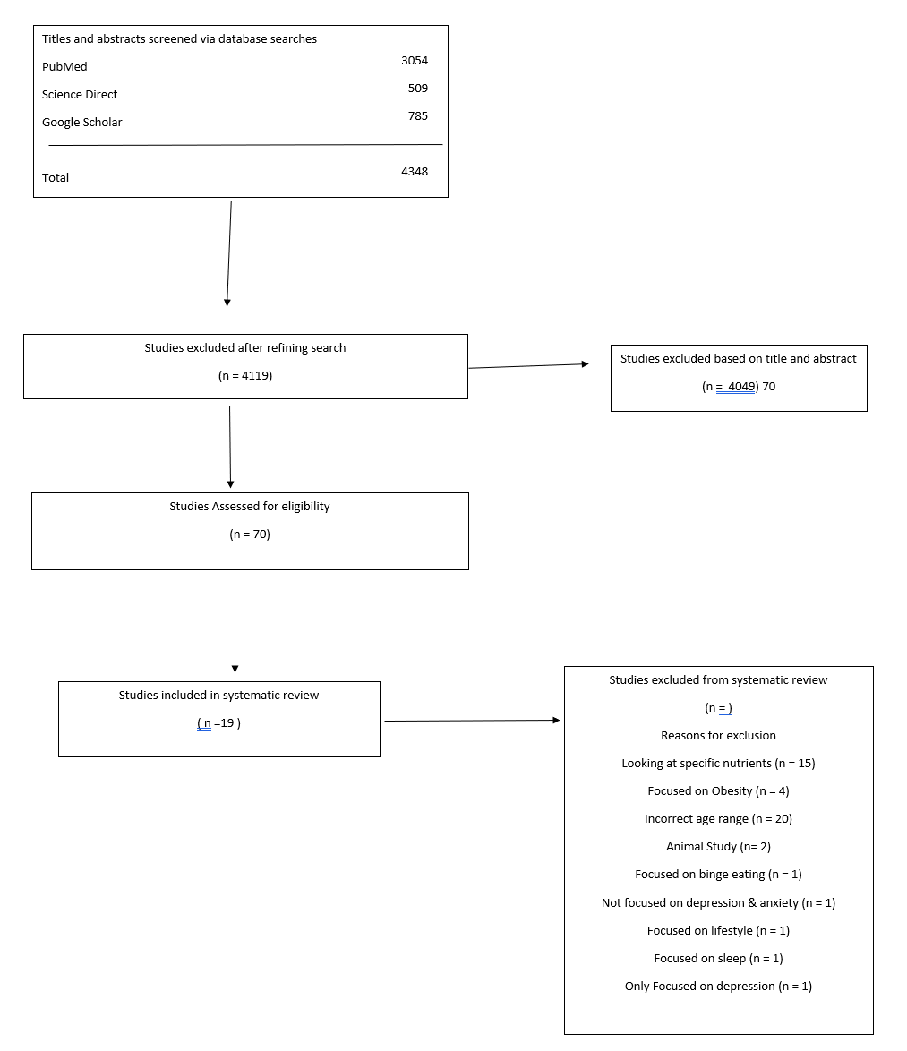

References

Bonny Beardsley. Depression and nutrition. Available from: http://www.healingwell.com/LIBRARY/depression/beardsley/.asp.

Brown GL, Ebert MH, Gover PH, Jimerson DC, Klein WJ, Bunney WE, et al. Aggression, suicide and serotonin: Relationships to CSF amine metabolites. Am J Psychiatry. 1982

Corder K., Winpenny E., Love R., Brown H. E., White M., van Sluijs E. M. (2017). Change in physical activity from adolescence to early adulthood: A systematic review and meta-analysis of longitudinal cohort studies. British Journal of Sports Medicine

Firk C, Markus CR. Serotonin by stress interaction: A susceptibility factor for the development of depression? J Psychopharmacol. 2007

Friedrich MJ. Depression is the leading cause of disability around the world. JAMA 2017

Johnson J, Weissman MM, Klerman GL. Service utilization and social morbidity associated with depressive symptoms in the community. JAMA 1992

Jorm, A. F., Patten, S. B., Brugha, T. S., & Mojtabai, R. (2017). Has increased provision of treatment reduced the prevalence of common mental disorders? Review of the evidence from four countries. World Psychiatry

Lassale C, Batty GD, Baghdadli A, et al. Healthy dietary indices and risk of depressive outcomes: a systematic review and meta-analysis of observational studies. Mol Psychiatry 2019

Leonard BE. The role of noradrenaline in depression: A review. J Psychopharmacol. 1997

Mann JJ, Arango V, Underwood MD. Serotonin and suicidal behavior. Ann N Y Acad Sci. 1990

McLean A, Rubinsztein JS, Robbins TW, Sahakian BJ. The effects of tyrosine depletion in normal healthy volunteers: Implications for unipolar depression. Psychopharmacology. 2004

Murray CJL, Lopez AD. The global burden of disease. World Health Organization. 1996

Petty F. GABA and mood disorders: A brief review and hypothesis. J Affect Disord. 1995

Shaheen Lakhan SE, Vieira KF. Nutritional therapies for mental disorders. Nutr Jr. 2008

Stockmeier CA. Neurobiology of serotonin in depression and suicide. Ann N Y Acad Sci. 1997

Whiteford, H. A., Ferrari, A. J., Degenhardt, L., Feigin, V., & Vos, T. (2015). The Global burden of mental, neurological and substance use disorders: An analysis from the global burden of disease study 2010

