Student Name | Aneesah Zubair
Student Number | 1809520
Module Name | Strategic Management
Module Code | BMSW6104
Lecture Name | Paul Bocij
Submission Date | 29/07/2021



https://www.bing.com/images/

Table of content…………………………………………………………
Introduction …………………………………………………………..…………………….Page 3
Strategic management benefits Figure 1)…………………………………………………………………..……..…………..………Page 3
Overview of Morrison’s Figure 2) ……………………………………………………………………………………………..…Page 4
Morrisons advantages and disadvantages…………………………………………….Page5
Morrisons vision statement……………………………………………………………… Page5
Morrisons marketing strategy porters 5 forces Figure 3)……………………………………………………………………………………..……Page5/6
Morrisons current corporate strategy Figure 4)……………………………………….……………………………………………………Page7

SWOT analysis………………………………………………………..…………………..Page8/9
Pestel analysis ……………………………………………………………………….Page10/11/12
Competitor’s………………………………………………………………………………..….Page 12
Environment scanning……………………………………………………………………..Page12
Stake holder analysis Figure 5) ………………………………………………………………………………………………..…Page13
Factors to consider Figure 6)……….………………………………………………………………………………….Page13/14
Sustainable Strategy Figure 7)………………………………………………………… Page 14/15
conclusion …………………………………………………..……………………………….Page16
References……………………………………………………………..………………….Page17

Introduction.
The aim of this report will be to analyse a retail business organisation, current strategic direction. Furthermore, applying the accurate models, theories, and methods . This report will be looking into critically analysing the external and internal environment with the aim of identifying the organisations strength and weaknesses by applying the Tool SWOT analysis and also the PESTLE Analysis. Moving forward ,will look upon creating a new action plan /strategic strategy in order for the organisation to achieve further profitable goals within the marketing and strategic management sector.

Strategic Management benefits.
In simple terms strategic management refers to the plans that a business develops attain its end goals. Strategies are developed to achieve competitive advantages and increase profitability. However, if the strategies provided are not accurate it may have a negative impact upon the organisation in regards of the market share and the competition with other rivalry organisations , therefore it is mandatory to apply the correct strategy for the organisation to gain profit and be successful upon the market trading sector. Strategic direction for Organisational strategy is about fulfilling the method's human needs, it's vital since people follow the direction, employ resources, and offer talents to the business also they're the ones that implement the strategies, as Gratton (2000) has stated the following, There is no great strategy, just great execution. Strategic management refers to the processes that frequency operation management's analysis of the institution's operating environment prior to formulating a strategy, as well as the strategy's implementation and control plans.

Figure 1)
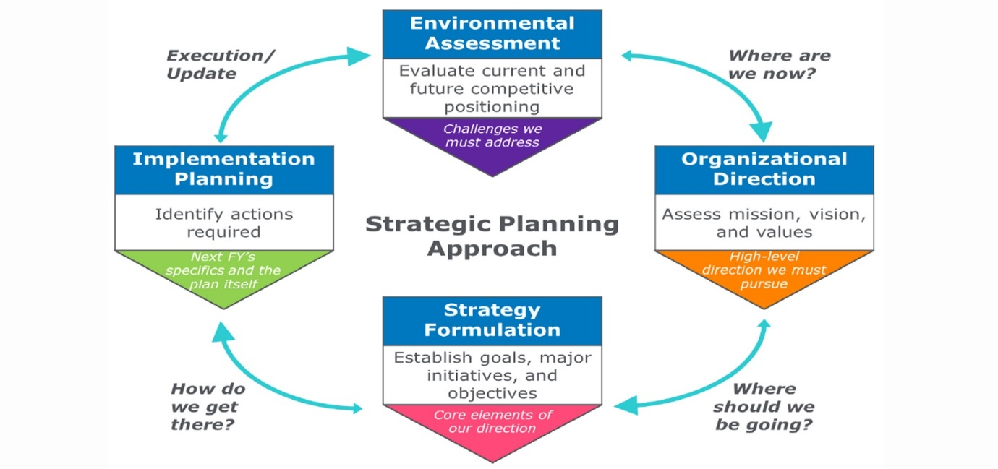https://www.consysa.com

Overview of Morrisons.
Down below is a picture of one of the business organisation Morrisons branch.
Figure 2)

https://www.wincantonwindow.co.uk/

Morrison was founded by William Morrison in the year 1899, In Bradford, he built his first business in 1961. Moving forward, Morrison purchased Safeway, and by early 2005, Morrison had grown to become the UK commerce company's fourth largest supermarket. It has 403 locations around the United Kingdom. Morrison's primary business is food and grocery.
Moreover, Morrisons employs over 470,000 people and generated over £ 54 million in profit in 2009, with nine million customers visiting every day. Morrisons is among the world's largest retail enterprises, employing over 470,000 people and generating over £ 54 billion in revenue. It has a total of 4,331 locations in 14 countries. The corporate headquarters are in Hertfordshire, England, and operates primarily in the United States, Europe, and Asia. Pending sales net includes more than 960 Express stores, with over 7000 products.

Morrisons advantages and disadvantage’s
It is well-known for providing high-quality products at reasonable pricing. Morrisons has a competitive advantage over some of its industry rivals by becoming a food specialist and having its own freshly made food items. Morrisons has been in the supermarket business for over a century. Moreover, although several supermarket CEOs suggest, they risk truck congestion and agricultural products decomposing before it reached us in the case of a no-deal Brexit, having a significant supplier and manufacturing base in the UK, as well as good connections with those suppliers built up over many years, will be a key benefit for the corporation.
However Organizational culture, Morrisons' workforce is largely comprised of locals with only a small number of employees from different ethnic origins. Lack of diversity makes it much more difficult of various cultural backgrounds to acclimatise to their new workplace, resulting in potential loss. Moving forward Morrisons' CEO appeared searingly honest while discussing the company's down falls, He considers the rest of the economy has been striving hard to overcome industry risks, with such a concentration upon loyalty programmes and personalised price promotions. Morrison, on the other hand, has been unable to fully participate due to outmoded IT equipment and processes. Therefore, the business organisation has been fully analysed and vast majority of the IT systems have been updated, regardless of the factors of Morrisons discovering their technology disadvantages at a later stage. The organisation has still managed to maintain the organisations business strategic direction.
Morrisons vision statement.
Morrison's vision statement seems to be to be said deliver customer’s the cheapest deal on their weekly shopping to many of its consumers, regardless of where they live. Morrison's objective is to be known as the "Food Specialist for Everyone." It differentiates itself from the major competition as a food specialist by having a wide range of products where Morrisons is a place each individual is welcomed and acknowledged. Morrisons 2019 have stated the following, we care more and try harder. We value, attract, and promote exceptional talent while also caring for our communities and the environment. However, Morrisons can also look upon a new development in order to attract more customers. The organisation has also stated , to become more competitive, you must assist customers in making every pound go even further, giving them more money mostly on products they need and want on a regular basis. Several of our customers' favourite items continue to see price increases and product specifications improvements.
Morrisons marketing strategy/ Porters 5 Forces
The following seems to be the Morrisons marketing strategy's promotional and advertising strategy: Morrisons' industrial strategy coordinates with its suppliers to ensure that British agriculture remains profitable and efficient. Customers benefit from lower costs on a consistent basis, as well as higher quality and a broader range of products. According to Lee, N., 2020. In the case of Morrisons, marketing plays a vital role in a variety of situations, Marketing is responsible for monitoring with various departments inside the organisation to make improvements and adjustments. Strengthening the customer base, constructing a market-leading assortment, and providing high-quality produce are indeed ways of improving the shareholder value.
Morrison’s are offering the greatest fresh produce in the UK, as well as an excellent value and an engaging shopping experience. Morrisons have stated the following Enhancing productivity: Morrisons' multiple manufacturing produce facilities would launch a unique solution to boost efficiency. Reducing expenses throughout the supply chain to improve network efficiency. Creating numerous things by harnessing its vertical integration and fresh, also value credentials to develop a truly unique and captivating fresh food experience, offering customers great deals and providing the best customer satisfaction level. Moving forward the Porter Five Forces is indeed a complete and accurate strategy framework which transitioned strategic choices the strategy was found M. Porter has identified five forces in 1979 to help comprehend those 5 major competitive forces affect an industry. Beyond analysing current competition The Porter Five Forces framework examines how Morrison can create a sustainable competitive advantage in the Retail industry. Major commercial competitors’ innovative ideas as well as new approaches, exerting strain on Morrison through lower pricing strategies, cost reductions, and delivering new value propositions to customers. Morrison should therefore manage several of these obstacles even while constructing effective barriers to maintain its competitive advantage. Down below navigates the key aspects of the Tool porters 5 forces. Figure 3)
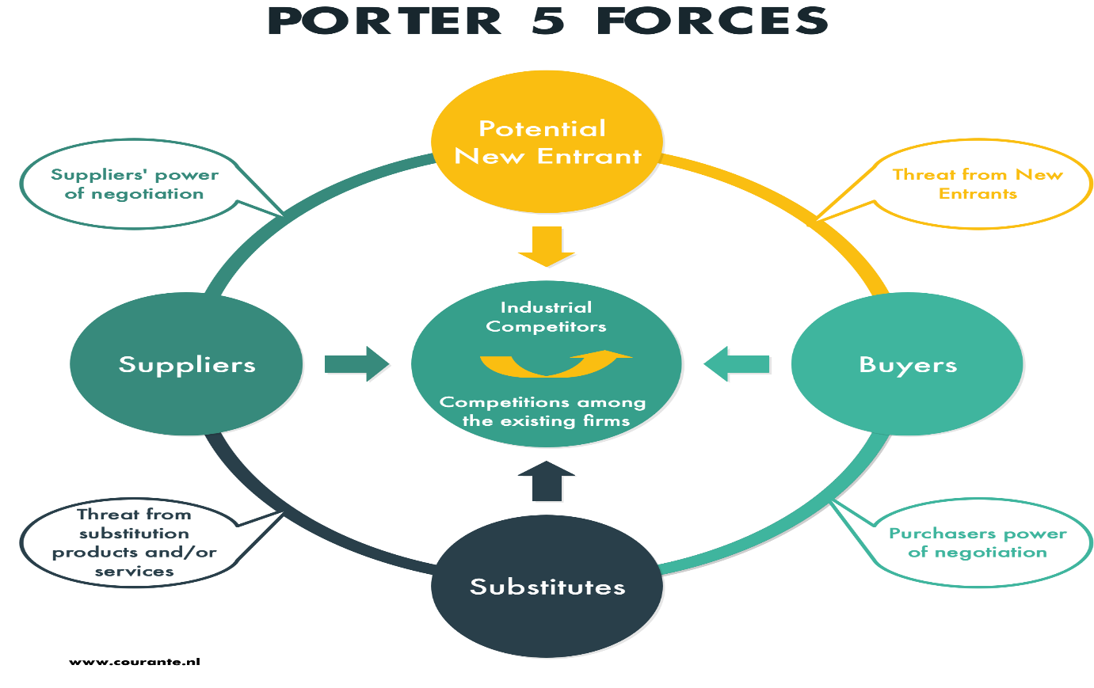

www.bing.com/images
Moving forward by identifying innovative services and products. New models not only bring in new customers, consider giving current users a reason to continue purchasing Morrison products. Through increasing profitability, it is sufficient to decrease the fixed cost per unit. Capacity building and investing in research and development new entrants are less likely to enter a fast-changing industry. According to Li, S., 2021., The importance of marketing and sales in marketing strategies cannot be overstated. Morrisons must use both direct and indirect marketing to reach their target market. Morrisons is known to take competitive advantage of modern technology for an effective marketing role, resulting in a better corporate image and higher turnover. This strategy has been able to achieve its corporate goal of being first in retail company with profit if its marketing strategy.
Figure 4)

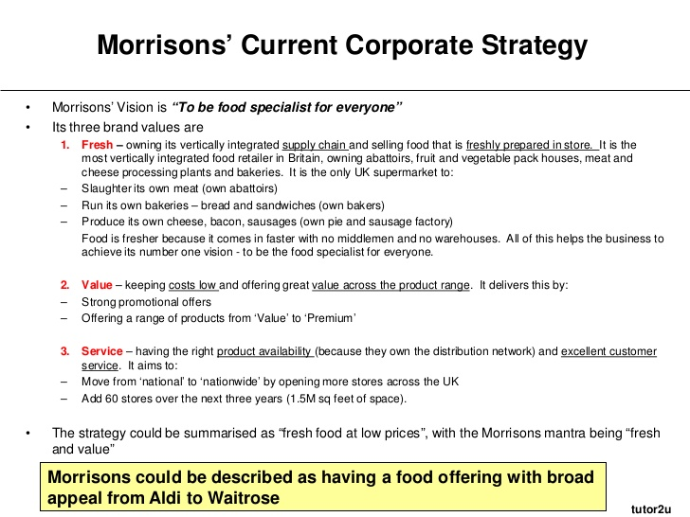

The image above is the Morrisons corporate strategy and it analyses the key points of their vision statement and the organisations value services. The organisation takes great pride of the fact of serving fresh produce for the customers regardless of the Brexit, the organisation has still managed to sell fresh products. According to research Morrisons seems to be the youngest of the Biggest Companies supermarkets, and it is acknowledged as being in a much better position to deal with Brexit than its competitors. Morrison's is a vertically integrated business that manufactures roughly 25% of what it sells (including around 50% of its own-label products) and claims that two-thirds of its merchandise are British.

Analysis of the External factors of Morrisons SWOT Analysis.
Albert Humphrey, who led a project at Stanford University in the 1960s and 1970s using data from leading corporations associated through long-term planning processes, is known for developing the strategy.
Therefore, the SWOT analysis is a strategic planning tool that Morrisons managers apply in order to conduct a strategic analysis of the company. SWOT analysis stands for the following ,strategy for analysing Morrisons' current Strengths (S), Weaknesses (W), Opportunities (O), and Threats (T) in its current business environment.
Morrisons, as one of the leading firms in its industry, acquires numerous strengths that enable it to thrive in the market. These advantages not only assist this to establish its existing market share, but also to gain entry upon creating new ones. According to extensive research conducted by Fern Fort University, some of Morrisons' strengths are as follows:

●Excellent Performance in Developing Markets.
● Morrisons has developed expertise in entering and succeeding in new markets.
●The expansion has assisted the organisation throughout creating new revenue streams and diversifying the economic cycle risk in the markets in which it operates.
●Morrisons has made significant investments in creating a strong brand portfolio over the years.
●Increased customer satisfaction level – thanks towards its dedicated customer service management department, the company has been able to achieve a competitive edge in the market among current customers and good shareholder value between several potential clients.
●Strong dealer community – the organisation has developed a cultural understanding among distributors and retailers where certain dealers not only promote the company's products but also invest in.

Morrisons weakness within the external factors.
Morrisons' weak points are indeed areas where they can improve, such as their Marketing Strategy, which has been extensively highlighted as promoting and making the correct choices. By analysing Morrisons' weaknesses, the organisation can make a significant successful improvement by using SWOT analysis to generate significant advantage and strategic positioning. The following are the main weakness of Morrisons.

● The marketing plan was insufficient.
●Regardless of the fact that the product is a sales success, its positioning awareness and creative selling proposition are not well defined, which could lead to competitive threats in this market. There is indeed a significant rate of resignation in the workforce, especially when compared to other organisations in the business. Morrisons has a greater overall performance of the organization than other supermarkets.
●investment in new technologies is required.
●Given the scale of expansion and the various geographies into which business plans to expand, Morrisons should therefore invest more in technology to integrate processes across the platform. Reportedly, technology investment also isn't keeping pace with the company's vision.
●Financial planning is ineffective and inefficient.

Opportunities of Morrisons.
●The marketing strategy allows Morrisons to be able to boost its competitiveness in contrast to its competitors because of the reduction of competitors' advantages.
●Environmental policies that are new – All industry participants will face competition because of the new opportunities. Morrisons has a tremendous potential to capitalise on its technological edge and increase market share in this market area.
●Result in a dilution of competitors' advantages, allowing Morrisons to increase its competitiveness in comparison to its competitors.
●New environmental policies – The new opportunities will create competition for all industry participants. It represents a fantastic opportunity for Morrisons to capitalise on its advantage in new technology and gain market share in the market segment.

Threats of Morrisons.
● A growing trend toward individualism in the economy may prompt other government agencies to respond courteously, limiting overseas sales.
● Longer term a competitor's or market disruptor's technological advances could pose a serious threat to the sector
● The organisation has built several items over the years therefore, there isn't really a consistent supply of unique products.
●Distinct countries have different liability laws, and Morrisons could be vulnerable to a lot of liability claims if policies in those markets change.
●The demand for highly profitable products is seasonal, and any unforeseen event during the peak season could have a short- to medium-term impact on the company's profitability.
●Intense competition - Consistent profitability has increased the number of competitors.
The Given above statements of each element of the of the SWOT analysis the above, corporate executives allocated significance to each internal firm strength and weakness. business may also evaluate the possibility of events occurring in the future and the intensity of potential impact on the organization's business. This is known as Weighted SWOT analysis. It is preferable to performing a simplistic SWOT analysis due to the SWOT Analysis allows the business organisations Morrisons managers to focus on the most critical factors while understating the unimportant ones. It also solves the long list problem, in which firms develop a lengthy list although none of the factors are considered critical.

Morrisons PESTLE
PESTEL analysis is a strategic technique for evaluating an organization's macroenvironment. this tool is known to be an acronym which is an acronym for Political, Economic, Social, Technological, Environmental, and Legal elements which will have an impact on Morrison's macroenvironment. Modifications in macro-environmental factors can have a substantial impact not just on Morrison Supermarkets, but also on other retail players. These can affect a corporation's strategic advantage as well as the Consumer Services industry.

Political factors of Morrisons.
Upon analysing the aspects that can affect Morrison Supermarkets' long-term profitability in a certain region or market, political concerns were indeed crucial. Morrison Company is a multinational corporation with operations in more than an industry ranging, Its environmental risk categories include systemic political and environmental risks. Individuals can prosper in such a vibrant Retail market.
Economic factors
The consumer spending and foreign exchange rate and economic are largely decided macroenvironmental factors such as inflation rate, savings rate, interest rate, foreign exchange rate, and business cycle Whereas the firm's micro-environmental competitive advantage has an impact on its long-term competitive advantage. Morrison Supermarkets can anticipate the company's future growth by looking at external factors such as the country's growth rate and economic growth.
Social factors
Social structure is a way of doing business in an organisation, have an influence on the community of an entire organisation in an environment. The demographic's collective perceptions and opinions contribute significantly upon how marketers at Morrison. Supermarkets understand the sale services offered and market accounted for Retail industry consumers. Morrisons leadership is influenced by social factors. Down below are some of the key elements of Morrisons social factors.
●Demographic psychographics and skill level
●In society, there is indeed a class structure, a hierarchy, and a power structure.
●Morrison Supermarkets Plc's education level as well as education standard.
● The arts and culture (gender roles, social conventions etc.) The attitude of curiosity and the wider nature of civilization Whereas some societies grow business, others do not. Patterns of behaviour (wellbeing, et cetera)

Technology factors
In such a short period of time innovation can undermine an industry's pricing model and market trends. It has been stated by the following Phan, S., 2021., It is critical to innovate continuously and consistently, not only to achieve maximum potential profits but also analyse and maintain the accurate updated data, to achieve of becoming a dominant player, minimise fragmentation in the near future. There are multiple innovative products that are completely operational which will allow Morrisons to keep up to data with the current Technology strategies to attract more customers.
Furthermore as previously mentioned, opponents' recent technological advancements and achievements, business happen across it in a technological advances that's already growing in popularity within Morrisons organisations sector, Morison’s may pay an closer attention upon on how popular it is and how rapidly it is expanding and impacting their competitors' profits. This would be the level correct method of any weakness to observed within the technical field if not met to standards the company may return effectively to the innovation. According to the following Simões, E.N., 2020, Acquisition of Safeway, Morrisons reduced its technology in order to cut costs, which was critical for expansion. Morrisons also intends to provide excellent and faster customer service, to launch "Pegasus," a cutting-edge technology that includes an automated data ordering system and a new integrated till system.
Economic
Instead of selling low-cost, non-biodegradable plastic shopping bags increase the profitability of long-lasting reusable shopping bags. Morrisons can boost revenues even while assisting in the fight against global climate. The vast majority of Morrison's Economics’ key aspects are listed below.
● In the retail industry the skill level of the workforce is quite high.
●The economy's degree of education, labour costs, and productive capacity stage , recession, recovery, and rate of economic growth
●Invest a percentage of someone’s income.
Additionally before committing to the purchase of a new idea generated in an existing market, the organization must critically assess the environmental criteria that are needed to conduct in these areas. The following are some of the environmental considerations that a corporation should consider advance,
● Temperature, Climate Changes, Air Pollution Regulations, Air and Water Pollution Regulations in the Retail Industry, Recycling
●Inside the Consumer Services industry, environmental services are available.
●Perceptions of “green” or “environmental” items; endangered species; renewable energy perceptions and supporting.

Legal
Morrisons seems to have its own energy-saving policy, which facilitates the government in reducing pollution. Morrisons, also as public company, adheres to the legal basis while doing business. In what seems like several nations, the legal structure and organisations are insufficient to protect an institution's intellectual property. It has been stated the following , Nguyen, C., 2019. , Prior to actually entering such markets, an investor should carefully take into account its opportunities because doing so could result in the extortion of the institution's special formula and as a consequence, along with the company's overall significant advantage. Competition legislation in the retail industry throughout the country Down below are Morrison legal key aspects, leadership should examine when getting into a strategic partnership.
●Discriminatory laws
●Trademarks
● Data and consumer protection
● Employment legislation
Competitors .
To be more competitive, business should empower customers in making every pound go even further, saving them money on the products they want and need daily. According to Lozano, A., 2019., Several of our customers' favourite items continue to see price increases and product specifications improvements. Morrisons have a lot of competitors therefore Enhanced customer service will assist upon paying close attention to Morrisons customers to create improvements throughout the spectrum. As well as the helpful and cheerful professionals available whenever and wherever they are required. Morrison’s are known to always improving their offers and deals successfully keeping their customers satisfied . Many customers can now choose from a variety of online and home delivery alternatives.
Environmental scanning.
Morrisons were named the winner after judges selected it from a group of 23 organisations for their initiative to reduce 9000 tonnes of plastic each year, by completely reducing or recycling it. Morrison’s have also stated the following, The plantations we work with are a good decision maker as well as the output device; caring for such elements is It's equally as important as caring for the animals they care after or the employees they employ. Several of the farms out of which we source have large-scale renewable energy projects in the works, generating energy for their communities utilising solar, wind, and biomass power. Another area where the farms that serve us have excelled is biodiversity. View all of our Sustainable Farming products.
It has been stated by the following Muniz, R., 2017.,What is observed are widely accepted, intermittent, and non-institutionalized procedures. The whole informality needs to extend beyond the performance evaluation to include the tie line by professionals to obtain entry to relevant data.

Stakeholder Analysis.
The key managers at Morrisons are known to be the customers ,competitors’ colleagues and the suppliers, non-government and the government cooperates. Stakeholder analysis is taken into key consideration as the stakeholder analysis has a major impact upon the business organisation. This strategy is often applied to help assist Morrisons vast majority of the time for the business make the accurate decisions making process according to Balabanova, D., 2020.,A stakeholder is anyone who is affected by the business; they can be internal or external, and then they can be in interaction with them during a frequent or infrequent basis. Morrisons stake holder analysis. Moving forward down below is Morrison’s stake holder analysis.
Figure 5)
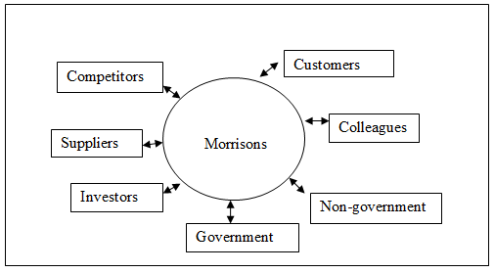
/www.bing.com/

Factors to consider whilst forming organisations strategic plans for Morrisons .
The accurate process to develop a business strategy to face various challenges such as adjustment on both the internal and external elements of strategic management. Morrisons may take leadership style, into consideration for the company to concur there cultural understanding barriers that the company face, whilst working with multi-cultural/ diverse individuals the organisation Morrisons may apply the industry lifecycle which creates the ability of a better understanding and behave according. This method also allows organisations to plan out their accurate strategic plans. According to Blundo, D. 2021., in order to understand the cultural aspects within a organisation ,organisations must consider applying strategic development methods and aspects to be able to structure and analyse cultural difference brought, and that industry will face. These decisions could be quick and instinctive, untainted by economic forces. Morrisons during developing the organization's strategic plans it has been stated by the following Akue, M.R., 2019,Environmental scanning difficulties, challenges relating to resources required, targets, stakeholders to be involved, management responsibilities and culture, and so on. down below is the industry life cycle which clearly indicates the main key points of the Emergence, Growth, Maturity and Decline.
Figure 6)
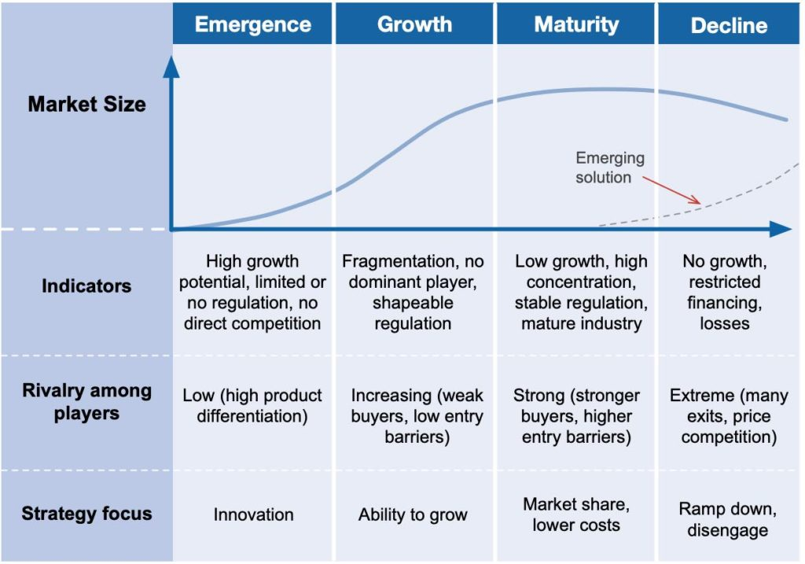

Substantiable strategy for the long- term future of the organisation / Recommendations.
In this part of the assignment the main key adjectives is to develop a business plan for Morrisons, however this assignment will not be applying one main strategic development method to create a plan. Multiple strategies will be applied in order to create an accurate plan for the organisation. The organisation Morrisons may consider Nemours strategic suggestions such as applying the Ansoff matrix theory down belove is a diagram of the tool. This method is used to develop a market.

Figure 7)
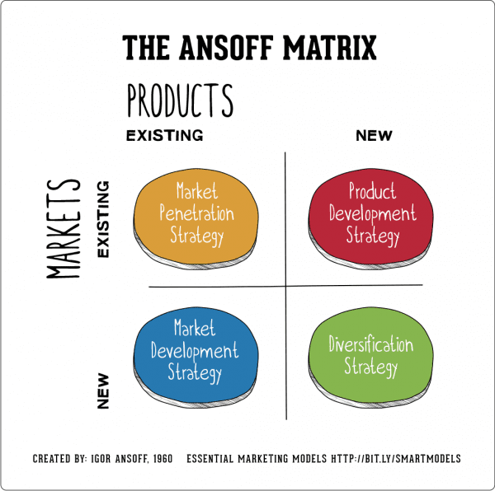
This theory assists upon creating a better understanding within the organisations four key aspects which will be to analyse the Growth strategy, product development, industry development plan, and diversification strategy are all important factors to consider when determining market share. Morrisons for example, is a UK-based company but mostly because they provide many star buys goods they can also apply this method to update and add new features to attract more customers and the existing customers will be satisfied through the business new transition through the organisations updated techniques. Moving forward one of the key aspects of the Ansoff matrix allows the ability to analyse major risks that organisations may face through the internal and external factors this method will can be applied within the Morrisons strategic development plan to achieve further growth within the business organisation.
In the 1970s, the Boston Consulting Group developed the BCG Matrix, which is a business strategy. The life cycle of products is the foundation of this business technique. Moving forward the BCG matrix can be applied whilst developing a strategic business plan for Morrison. This technique will allow the organisation to develop more growth within their market share this method will also create the ability to assist Morrison’s of making the accurate decisions regarding their services that should remain or the ones that need to be removed for the business to gain additional investments within new updated future products. It has been stated by the following Lin, K.S., 2019, this business method is a powerful concept, and if properly implemented, it can assist a company to increase and track its market share and growth. Most organizations, local and global, must have some type of business plan or model on which to base their products, and by maintaining an optimum level of inventory and what customers want organizations, may enhance their profits. Therefore, this method also can be added within the Morrison’s strategic development business plan.

Conclusion.
This assignment has critically analysed Morrison’s main key aspects and the organisations current strategic plans. Morrisons vision statement was also researched the swot and pestle analysis have had a huge impact in order to create the accurate strategic development , efficient plan for the organisation. The most suitable strategies that were found to be beneficial for the organisation was the Ansoff matrix and the BCG matrix strategy. The overall leaning outcomes of this assignment has provided knowledgeable strategic development methods that can be applied throughout any business platforms regardless of the business being a large/small organisation all the above methods can be applied in order for any organisation to grow and be successful globally.

References.
Anderson, J.E., Hughes, M.Ü. and Nguyen, C., 2019. The highs and lows of startups in the Cannabis industry: A PESTLE analysis of the current issues. In Business Forum (Vol. 27, No. 2, p. 26).
Akue, M.R., 2019, July. Renewal of Design Teaching Resources by the Practice of Environmental Scanning. In Proceedings of the Design Society: International Conference on Engineering Design (Vol. 1, No. 1, pp. 559-568). Cambridge University Press.
Borges, N. and Janissek-Muniz, R., 2017. The Environmental Scanning as an Informal and Individual Practice in Organizations. In A view based on the Illusion of Control's Theory. In: Congresso IFBAE.
Balane, M.A., Palafox, B., Palileo-Villanueva, L.M., McKee, M. and Balabanova, D., 2020. Enhancing the use of stakeholder analysis for policy implementation research: towards a novel framing and operationalised measures. BMJ global health, 5(11), p.e002661.
Chiu, C.C. and Lin, K.S., 2019, July. Rule-based BCG matrix for product portfolio analysis. In International Conference on Software Engineering, Artificial Intelligence, Networking and Parallel/Distributed Computing (pp. 17-32). Springer, Cham.
Chen, L., Wang, M., Cui, L. and Li, S., 2021. Experience base, strategy‐by‐doing and new product performance. Strategic Management Journal.
Ferrari, A.M., Volpi, L., Settembre-Blundo, D. and García-Muiña, F.E., 2021. Dynamic life cycle assessment (LCA) integrating life cycle inventory (LCI) and Enterprise resource planning (ERP) in an industry 4.0 environment. Journal of Cleaner Production, 286, p.125314.
Hooley, G., Nicoulaud, B., Rudd, J. and Lee, N., 2020. Marketing strategy and competitive positioning. Pearson UK.
Morgan, N.A., Whitler, K.A., Feng, H. and Chari, S., 2019. Research in marketing strategy. Journal of the Academy of Marketing Science, 47(1), pp.4-29.
Salinas Jr, C. and Lozano, A., 2019. Mapping and recontextualizing the evolution of the term Latinx: An environmental scanning in higher education. Journal of Latinos and Education, 18(4), pp.302-315.
Simões, E.N., 2020. A decision support system application module-for PESTLE analysis-competitive intelligence algorithm (Doctoral dissertation).
Phan, S., 2021. The effect of PESTLE factors on development of e-commerce. International Journal of Data and Network Science, 5(1), pp.37-42.

.

