Module: Human Resource Management
Assignment 1: Employee Engagement and Employee Involvement (Raspberry Pi Foundation)
Student number: 1706958
Student Name: Rhian Davies
Tutor: David Griffiths
Date: 11th March 2018

Contents
1. Introduction……………………………………………………………………… page 3
2. Employee Engagement, Motivation and Employee Involvement…………… page 3
  - Volunteer Engagement………………………………………………………page 4
  - Motivation and Employee Involvement …………………………………….page 5
  - Summary of Employee Engagement, Motivation and Employee Involvement page 6
- Importance of HRM…………………………………………………………….. page 6
  - Strategic HRM (SHRM)…………………………………………………….. page 7
  - Ulrich Model…………………………………………………………………. page 7
  - Harvard Model………………………………………………………………. . page 9
Recommendations…………………………………………………………………... page 10
Recommendations 1…………………………………………………………….. page 10
Recommendations 2…………………………………………………………….. page 11
Conclusion…………………………………………………………………………... page 11
References…………………………………………………………………………... page 12
Appendices………………………………………………………………………….. page 14
Appendix 1……………………………………………………………………. …Page 14

Introduction

Raspberry PI Foundation is a UK based charity that was created in 2008 with the mission “to further the advancement of education of adults and children, particularly in the field of computers, computer science and related subjects” (Raspberry PI Foundation, 2017). The trading arm of Raspberry PI Foundation focusses on selling low cost but high performance computers, providing income for them to pursue their goals of education in digital making. Although the business does conduct transactions in the private sector, it also has many volunteers working to enhance ‘digital literacy’ (Moorhead, 2012) via afterschool clubs and youth centres and ultimately stands in the third sector. The company merged with Code Club and CoderDojo, two other non-profit organisations that have the same mission and this has increased their volunteer work force.
This report has been brought together as a request from the managing director, who wishes to make changes to the human resource sector in a hope to achieve greater employment engagement and involvement. Due to the increasing numbers of volunteers, recommendations will be put forward in order to produce strategies in which these can develop. Moreover, a discussion will be provided into the advantages of engagement and also the problems that can occur when achieving this goal.
Employee Engagement, Motivation and Employee Involvement
To examine the importance of implementing a strategy to improve employee engagement at Raspberry Pi, it is essential to gain an in-depth understanding of what the concept represents.
A simple way of defining employee engagement (EE) is ‘the extent to which line managers gain commitment from employees’ (Heery & Noon, 2009). However, Kahn (1990) elaborated on this statement by encapsulating EE as harnessing employees so that they are physically, cognitively and emotionally stimulated during their work. The Chartered Institute of Personnel and Development (2006) also state that EE involves three areas: physical, cognitive and emotional state. They understand these dimensions as being: involved emotionally in ones work, cognitively as working hard and focussing and physically being willing to stay late and work extra for an employer (Kumar & Kumar Sia, 2012). Due to Raspberry Pi having a large volunteer workforce, it would be appropriate to assume that the emotional dimension is one which encourages the cognitive and physical dimension. This is because various qualitative studies concluded that ‘altruism, social contact, personal interests, and emotional need are among the themes of volunteer motivation’ (Yeung, 2014). This distinct area of engagement can be defined as ‘volunteer engagement’ and can encapsulate volunteers psychologically connecting with their role more over physically engaging (Kahn, 1990).
Volunteer Engagement
Volunteer engagement, which relies on emotions, is an important concept to consider when implementing a HR strategy as it has a direct correlation on retention of volunteers (Boezeman & Ellemers, 2007). The issue of turnover is imperative to the Raspberry Pi as it is found that in 2017 the average turnover rate for the volunteer sector was 10.7% one of the highest of all sectors (Murphy, 2017). This high level of volunteer turnover can put a strain on the HR department, provides loss of talent and derails focus and staff moral (Anvari et al, 2013). Talent loss will also be a critical issue for Raspberry Pi as the jobs that they expect the volunteers to participate in are high skilled and technical. It is therefore imperative that volunteers are engaged, involved and motivated.

Motivation and Employee Involvement
When analysing employee involvement (EI) to provide recommendations for HR reform for Raspberry Pi, as previously mentioned, it is vital to consider the emotional connection when discussing volunteers. However, EI is usually defined as participation of employees that have been initiated by the employer or managers within the business (Heery & Noon, 2009). EI methods can include team meetings, brainstorming and appraisals. These techniques are usually based on task based areas and are used to improve working procedures and environments (Heery & Noon, 2009). Although on face value these aspects seem to stem from physical engagement, EI works in parallel with volunteer motivation by providing volunteers and employees a sense of belonging and empowerment (Kular et al, 2008). These factors can be associated with the levels on Maslow’s Hierachy of Needs:
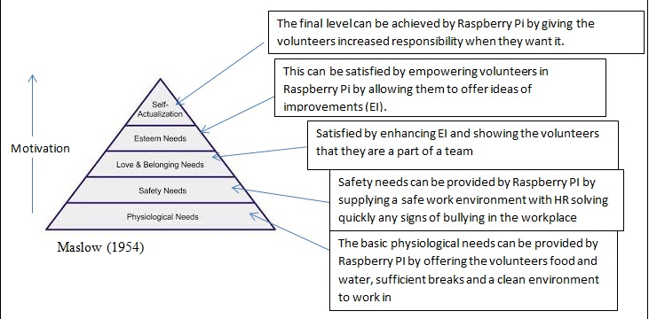

Maslow’s suggested that humans needs can be categorised in to five levels all of which the lower had to be fulfilled before moving on to the higher (Lester, 2013). As shown by diagram there are ways in which Raspberry Pi can conduct their working environment in order to satisfy these levels. This is important as reaching each level improves motivation, which in turn increases productivity, develops ideas and decreases staff turnover (Adair, 2009). Although Maslow’s Hierarchy of Needs is useful in showing how volunteers at Raspberry Pi could be motivated, Maslow (1954) himself did not see that motivation should be created by treating staff fairly and well. He proposed that a satisfied need is not a motivator and so the hierarchy should be used as a theoretical tool rather than an ongoing framework (Barrett, 2007).
Summary of Engagement, Motivation and Involvement
Employee engagement, involvement and motivation are all associated in a tangled web of reliance. Employee involvement ensures that volunteers are engaged with their work and in turn engagement increases motivation. These concepts working together is vital in ensuring volunteer productivity in Raspberry Pi is high, volunteer turnover is low and paid and volunteer staff can work hand in hand effectively.
With the third sector facing challenges such as greater expectations by millennials, technological advances such as crowdfunding which allow people to decide more directly what charities they support and reduction of funding (Warley, 2017), it is integral for Raspberry Pi to keep their talented volunteers. Within a talent led, knowledge based economy this importance is even more exasperated with companies desperate to find valued employees, keeping talented volunteers and employees with Raspberry Pi becomes a greater, more vital task.
Importance of HRM
HRM has been a feature of numerous studies in the improvement of staff retention and overall company performance (Chan et al, 2004). These ‘theoretical and empirical studies have been carried out with the view that people are valuable resources for business success, and can be the source of sustainable competitive advantage for a firm’ (Wei et al, 2005). With this in mind, the HRM department can be integral in creating strategies in order to improve EE, EI and motivation and in turn increase performance, lower staff turnover and increase flexibility at Raspberry Pi.
Strategic HRM (SHRM)
Guest (1987) argued that there were four main principles of SHRM; integration of employment activities into overall business strategy, high employee commitment to organisational goals, high quality staff to produce a high quality product and flexibility to adapt to change (Saunders et al, 2007). These principles directly relate to Raspberry Pi’s goal to enhance EE and EI, this is because reaching these goals will positively correlate with the organisational strategy of ‘putting the power of computing and digital making into the hands of people all over the world’ (Raspberry PI Foundation, 2017) by having high quality volunteers and employees to provide this service.
Ulrich Model
Using the Ulrich model is one way in which Raspberry Pi can utilise SHRM to improve EE and EI. The Ulrich model separates the HR function into four areas in order to improve overall business performance.
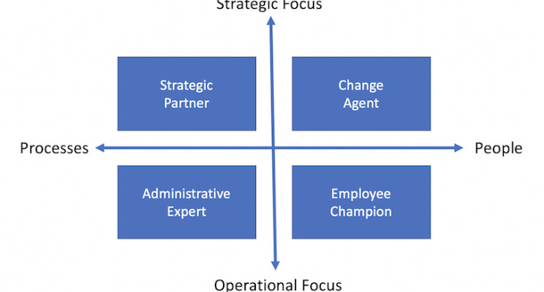(Ulrich, 1997)
This model can also be called Business Partnering which incorporates its ideas of ‘HR business partners working closely with business leaders and line managers to build capabilities, plan and manage talent, and develop approaches that achieve shared organisational objectives.’ (CIPD, 2015). As the managing director has advised that a new organisational objective is to provide a higher level of EE and EI, for all the advantages previously mentioned, separating the HR functions into distinct areas can produce focus on this achievement. It can also allow HR professional with different skills to be in an area which they can perform to a greater ability.
The problems that can occur with this model are that although the conceptual organisational structure is simple, the finer details such as cost allocation to the sectors can make it more complicated and in turn it can take a long time to implement (Bastow, 2015). As EE and EI are vital in maintaining motivation and retaining talent the managing director may want a strategy to be implemented quickly and to be cost effective.
Another issue with the Ulrich model is that its rigid organisational structure can reduce flexibility (Turner, 2017). With the VUCA conditions that Raspberry Pi will be experiencing in the third sector, it is important that any HR model is able to adapt to situational factors.
Harvard Model
The Harvard Model of HRM takes into consideration situational factors, stakeholder interests and long term interests when looking at strategies (Beer et al, 1984). This neo-puralist model recognises all the stakeholders within the business including the importance of employees. This is important as it depicts that employees are essential in making organisational outcomes. The Harvard reiterates the importance of EI and EE as motivated staff members are more likely have higher organisational commitment (Al Madi, 2017). Moreover, the Harvard Model envisages situational factors as an area which can affect HRM hence being more open to outside influences which are important to Raspberry Pi.
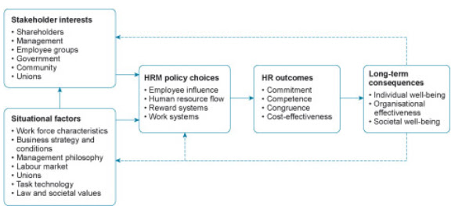(Boselie, 2015)
The Harvard Model can be described as ‘Soft HRM’ this means that it suggests that employees are assets that should be rewarded and nurtured (Beer et al, 1984). This model would be effective in Raspberry Pi as the employees and volunteers are at the essence of their goals. This is even more so in their technological educational area as the skills needed by each volunteer and employee are fundamental and probably unique. Moreover, using the Harvard Model and ‘Soft HRM’ would increase performance and would help retain staff as it uses EE and EI into its HRM policy choices (Boselie, 2015).
However, ‘Soft HRM’ does provide issues. This is because nurturing volunteers and employees too much can result in people taking advantage and leaving the company at a disadvantage. Another model which counteracts this issue is the Michigan Model of HRM. This model uses ‘Hard HRM’ as a basis for its structure which states that employees are to be employed as cheaply as possible and to be under in-depth scrutiny of their work performance. Although using this model would mitigate the possibility of Raspberry Pi being taken advantage of, it would be ineffective with volunteers as they do not receive any financial incentive to work at the company so are more likely to leave the organisation if they do not feel they are being treated fairly.
In conclusion, it is clear that there is not one model that provides a ‘best fit’ for Raspberry Pi. However, the Harvard Model does provide a basis in which the HR sector can strategise and grow. Moreover, all models can be adapted to various business situations and do not need to be used as a structure but more as guidelines to make HRM more effective.
Recommendations
- The first recommendation to increase EE and EI in Raspberry Pi is to hold bi-annual events for volunteers and employees to interact and socialise in a relaxed environment. This not only gives them a sense of belonging and a way of socialisation of the groups, it also provides societal wellbeing as depicted in the Harvard Model. Moreover, to motivate employees and volunteers it is important to have contact with other members that have similar interests. In addition, this event could also offer a suggestion box or a brainstorming section, where the staff members are able to express how they feel their jobs could be improved. Giving them this empowerment and a ‘make a difference’ opportunity will increase their motivation and increase productivity.
- The second recommendation would be to implement an online interface where Raspberry Pi staff and volunteers could have a log in. On this, news of the organisation, achievements and a messaging platform for members to interact and to share ideas. This not only improves EE by giving the employees interaction with the company at all times and keeping them in tune with the common goal but also allows them to be involved with new ideas and events. It would also be a way in which Raspberry Pi can show the employees the difference they are making in communities and this in turn will motivate them and increase performance.
Conclusion
It can be seen from this paper that employees are very important to achieving the objectives of Raspberry Pi. Having the staff engaged and involved within the company is vital to ensure that there is less staff turnover and higher performance levels. It is also necessary for Raspberry Pi to look at the structure of the HRM in order to make the changes needed in order to enhance engagement. Although this structure does not need to clone one of the commonly used models it can be adapted from them to ensure longevity in an uncertain environment.

References
Adair, J., 2009. Leadership & Motivation : the Fifty - Fifty Rule and the Eight Key Principles of Motivating Others; London, London: Kogan Page.
Al Madi, Faisal. (2017). The Impact of Employee Motivation on Organizational Commitment. European Journal of Business and Management. 19. 134-145.
Anvari, R., JianFu, Z., & Chermahini, S. (2013). Effective strategy for solving voluntary
turnover problem among employees. Procedia – Social and Behavior Sciences,
129.
Barrett, G., 2007. Legal and Logical Limitations in Applying Social Science to Business. International Journal of Business, 12(1), pp.73–75,88–91,95–96,98–116.
Boezeman, EJ, Ellemers, N (2007) Volunteering for charity: Pride, respect, and the commitment of volunteers. Journal of Applied Psychology 92: 771–785.
Broselie, P. (2015) Covering all the bases: multi-stakeholder HR: www.hrmagazine.co.uk/article-details/covering-all-the-bases-mulit-stakeholder-hr

Chan, L.L.M., Shaffer, M.A. and Snape, E. (2004) 'In Search of Sustained Competitive Advantage: The Impact of Organizational Culture, Competitive Strategy and Human Resouree Management Practices on Firm Performance', International Journal of Human Resource Management, 15(1): 17-35.
Chartered Institute of Personnel and Development . (2006) How engaged are British employees. London: CIPD. Accessed 24th April 2018
CIPD (2015) Employee Engagement: www.cipd.co.uk/hr-resources/factsheets/employee-engagemetn.aspx
Guest D (1987) Human Resource Management and Industrial Relations Journal of Management Studies 24, 503-521

Heery, E. & Noon, M. (2009). employee engagement. A Dictionary of Human Resource Management, pp.124 A Dictionary of Human Resource Management.
Kahn, W. A., 1990. Psychological conditions of personal engagement and disengagement at work. Academy of Management Journal, Volume 33, pp. 692-724
Kular, S., Gatenby M., Rees, C., Soane, E. and Truss, K (2008). Employee Engagement: A Literature Review. Kingston University.
Kumar, R. & Sia, S.K. (2012). Employee Engagement. Management and Labour Studies, 37(1), pp.31–43.
Lester, D., 2013. Measuring Maslow's Hierarchy of Needs. Psychological Reports, 113(1), pp.15–17.
Li-Qun, W, & Chung-Ming, L 2005, 'Market orientation, HRM importance and competency: determinants of strategic HRM in Chinese firms', International Journal Of Human Resource Management, 16, 10, pp. 1901-1918, Business Source Complete, EBSCOhost, viewed 29 April 2018.
Maslow, A. H. (1954) Motivation and personality. New York: Harper & Row.
Moorhead, J. (2012). Raspberry Pi device will 'reboot computing in schools'. Available: https://www.theguardian.com/education/2012/jan/09/raspberry-pi-computer-revolutionise-computing-schools. Last accessed 10th April 2018.
Murphy, N. (2017). Labour turnover rates 2017. Available: https://www.xperthr.co.uk/survey-analysis/labour-turnover-rates-2017/162496/. Last accessed 14th April 2018.
Raspberry PI Foundation. (2017). Raspberry PI Strategy 2018-2020. Available: https://static.raspberrypi.org/files/about/RaspberryPiFoundationStrategy2018%E2%80%932020.pdf. Last accessed 10th April 2018.
Saunders, Mark, Lewis, Philip & Millmore, Mike, 2007. Strategic Human Resource Management
Ulrich, D., Younger, J.,Brockbank., & Ulrich,M (1997) HR Talent and HR Competencies

Wei, L.Q. and Lau, C.M., 2005. Market orientation, HRM importance and competency: Determinants of strategic HRM in Chinese firms. The International Journal of Human Resource Management, 16(10), pp.1901-1918.

Yeung, A., 2004. The Octagon Model of Volunteer Motivation: Results of a Phenomenological Analysis. Voluntas: International Journal of Voluntary and Nonprofit Organizations, 15(1), pp.21–46.

Appendices

Appendix 1

