Shannon Wallace (1901768)
[Company name] [Company address]
Internet Technology and security

Contents
Introduction 2
What is BYOD? 2
Advantages 2
Disadvantages 2
POLICY 4
Introduction 4
Data Flow Diagram 5
CoffeeCapulus Network Design 6
Mobile device management software 7
The countermeasures 8
References 9

Introduction
CoffeeCapulus is a company that offers cloud services and is a company that offers people to bring their device using their wireless-based system. However, there is a lot of security issues that could happen. Users can access the network using their devices due to the system. If policies are not set out correctly or followed this could be a major security issue. This report is going to be recommendations of guidelines, and software for the staff.
Multiple policies are important.
- Device management policy
- Security policy
- End-User Policy
- Network policy
Policies are there to tell people and how can you increase security by having policies it allows people to know why and why it is there for. Guidelines are to increase security by even more depth. It allows you to keep you safe by giving you information.

What is BYOD?
Bring your device is allowing users to work with their device. Devices such as laptops, tablets and a mobile phone. ForcePoint a website online defines BYOD as “Employees using personal devices to connect to their organizational network and access work-related systems”[3]

Advantages
- Productivity – Productivity is increased due to people feeling comfortable and knowing how to work their device. For example, if you were asked to go on a mac but you only have used windows then this is going to acquire training because they are completely different.
- Flexibility – Flexibility is an increase because they can work at any time because of their device being connected to the network and allows people to easily access and get on with work.
- Training cost – training cost is reduced because they are using their device which they feel more comfortable with. For example, you would have to train someone to use a certain device and this would require time and money.
- Technology cost – Company does not have to offer people PCS/LAPTOPS when they can just bring their device so this would lower cost for the company. They do not need to upgrade or get their PC tested to see if it is safe.

Disadvantages
- Cost of equipment not available – Certain employees may not have their device and may not afford a suitable device.
- Major security issue – BYOT is a major issue. Every device is accessing the network. It is transferring files, and much more. The network will have to block inappropriate websites for staff to do work. They will have to make sure that every staff device has a firewall, and that the device does not have a virus
- Traffic – The traffic of the network is different and will require more due to staff using personal devices. Staff can have multiple devices such as a mobile phone and a laptop and this would increase network traffic causing it to be slow compared to other networks.

Research on more information – Advantages and disadvantages
Personal Choice[4]
This is an advantage because the user knows how to use their devices and it improves productivity.
Better work-life balance[4]
You can use the device at home and have the equipment already so if you wanted to do work at home you will not have an issue.
Loss, theft or damage[4]
This is a disadvantage when a device is stolen or lost. You can lose your work, and this increases the risk to the company and then the user would have to purchase a new device.

Accessing unsecured WI-FI

This is a disadvantage because employees could go to airport and this would be unsecured wi-fi. “They’ll access unsecured Wi-fi connections at airports, coffee shops, stores or even their own home. Unsecured networks can provide hackers with easy access to your company’s system or networks”.[5] It is important that data is encrypted due to these problems that can occur.

POLICY

Introduction
This document is a Network Security Policy for CoffeeCapulus. This document policy is for everyone at CoffeeCapulus. The policy is here to keep the end-users and the company safe. You will have to connect your device to the network after that the network team at CoffeeCapulus will have to allow you access.

For the safety of the network, there are requirements needed to make sure that network security is safe and not easily broken through. Before you can connect to the network with your devices you will need to get approved by the network team at CoffeeCapulus once approved CoffeeCapulus will be allowed access to administer and monitor the device when connected to CoffeeCapulus network.

There is a certain amount of access that you are allowed on the network. For example, a client will only be allowed to access the network. Staff will be given more access for them to move folders, etc. This will allow staff to easily work and students to work.
CoffeeCapulus data security is that you can only access information when connected to the network. This to make sure that information is kept safe and will stay there.
There are different kind of information which can be accessed through the network and they have different levels of importance so certain data will only be allowed access when connected to the network. If the staff leaves the network team has access to monitor and to remote so when you have connected their certain things that are disabled for the security of the company and your device. For example, USB ports. USB ports can be a risk to the security of the company due to leak data, or a virus could be on it. Another example, moving folders on a guest account. You will not be allowed to do this. It is a risk to the company and should be disabled.
The devices and operating systems that are allowed on the network are:
- Mobile phones
- enterprise 5.0, Windows10 and apple ios 10.7+
- Tablets
- enterprise 5.0+, Windows10 and apple ios 10.7+
- Laptops
- version 10.7
- 10
Only certain operating systems are supported due to other operating systems are not being updated and if the system is not kept up with updates it is a risk of a virus getting into the network. An example, windows 7, ios 8, android older versions. Anything that the operating systems company is not keeping up to date is a risk to the companies’ safety. Staff will be given a unique username and password for them to access the network and will be given privileges as stated above.

The password will be a default password and then will have to change their password every 30 days. The password will have to meet the standard requirement for a password. The requirement is that the password must have a capital letter, a symbol, a number and must be a minimum of 8 characters long. For example, Cisco!12 You should not share your password with other people.
- Change password regularly
- Don’t use dob/mother/father/personal information as passwords

If a staff leaves the company, or loses, or stolen their device. The company will have to remotely access to remove the privileges and will have to monitor it carefully.
Data is encrypted when a device is not connected to the CoffeeCapulus network.
The network team will cap the bandwidth the staff and the company can access due to downloading, broadcasting, etc. This will prevent the network from crashing, and this will prevent people from abusing the network such as activity. Suspicious activity is a staff using the network to watch YouTube or to access Facebook. That is abusing the network. There are the different staff – such as the network team will have more access than stock staff. So certain job roles will have more access. The network can be slow down by users using the network inappropriately and therefore we monitor the network to keep users and the company safe.
A company will ban certain websites and if you find a way to pass this then you are breaching the policy. The network policy has some serious breaches such as
- The viewing company banned websites – as mentioned above.
- that would be banned would be inappropriate websites
- Accessing information/data without authorization
- Attempting to hack
If a user is breaching a policy the network team would know. The users are monitored which means whatever they do that is logged and if any user is caught then they have kicked off the network. However, if you are the staff you will be kicked off the network, and you will be most likely to lose your job. If a policy is breaching the network team would know. The users are monitored which means whatever they do that is logged and if any user is caught then they have kicked off the network. However, if you are the staff you will be kicked off the network, and you will lose your job. The computer misuse act in 1990 and the data protection act 1998 is a UK law. If you are caught breaching, you are breaking UK law.

Data Flow Diagram
The data flow diagram is simplistic. The staff and customers are separated as users on the network due to certain job roles that will have privileges while customers will only be connected to the network.
The diagram is showing how the network would work and then the cisco packet tracer is how it is set up.
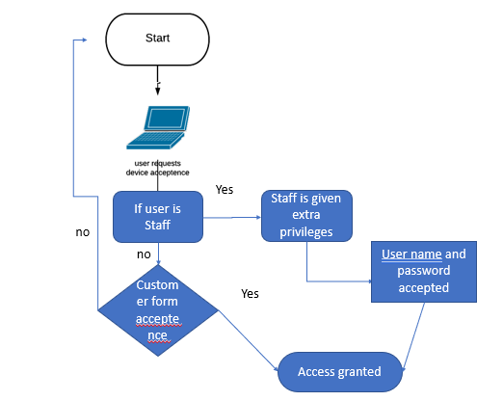

CoffeeCapulus Network Design
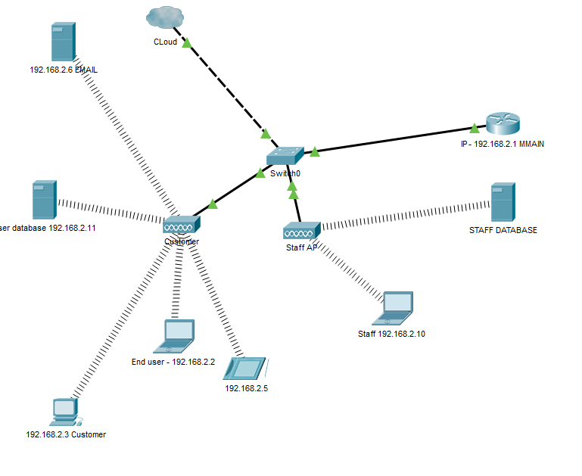
The network design has a staff access point and a customer access point. A router, a cloud, and a switch. All the devices are wireless because it brings your own technology. You will only need to be connecting a tablet, a phone or a laptop. It is an expanding company and it is a cloud wifi service.

Mobile device management software
I recommend Cisco Meraki mobile device management. It is a cloud management service. The software is suitable cloud service which matches the company. It can manage a big company network and able to make sure that the network is safely secured by having its on VPN.
They offer:
- Ability to complete lock down and erase the entire device[1]
This can be a strategy to if someone at coffeecapulus loses their device or get stolen. This will make sure that data is not leaked.
- Diagnostic tool for the network [1]
Shows the problems on the network and can solve them quickly with this useful tool.
- Disconnect any device [1]
If a device get stolen or loss they can easily disconnect the device and the staff member.
- Set a bandwidth [1]
If the staff or the customer has a set bandwidth they can’t abuse the internet such as downloading videos, etc
- Control all the devices within the network[1]
This would be a good feature for the network. Allow you to easily to monitor the devices by having access.
- Restrictions[1]
Restrictions is needed on a secured network this prevent users from doing inappropriate things on the network and this will also make sure the staff is doing their job.
- Email configuration[1]
- Software deploy[1]
This allows everyone at coffeecapulus to make sure that everyone has the software and allows the users to have the right equipment.
- Security compliance[1]
They support android enterprise5.0+[1]
Chrome OS[1]
Ios9+[1]
Macos10.7+[1]
Windows 10[1]
According to CISCO MERAKI they have these features
- Seamless onboarding[2]
Seamless onboarding is “Encourage devices connecting to corporate wi-fi to enrol into systems manager.” Meaning that they have to enrol into the systems manager before they can access the internet.
- Secure wi-fi[2]
“The wifi is encrypt between a user’s device and access point”[2] it increases security on the network by encrypting the data which increases security of the disadvantage of BYOD has.
- Hassle-free VPN[2]
The software offers a VPN which also increases security it encrypts your traffic online. “The hassle-free vpn is deployed into the client VPN directly to devices enrolled on the system manager”[2]
- Provision[2]
This software help improves it offers a lot of different operating systems, and devices. It also offers different ways of dealing with a device that get loss or stolen. Also it protects data when they disconnect from the network by encrypting data.
It allow users to be in groups and when in groups certain groups are restricted from accessing certain stuff, and content.
- Monitor[2]
“Locate and track laptops and mobile devices anywhere in the world. Get real time visibility on device health, security posture and software and hardware inventory for your entire fleet of devices”[2]. This improves security by system manager by monitoring your device. This increases network security.
- Secure[2]
“Protect devices and their data with encryption enforcement, enterprise remote wipe, and integrated network access control”[2]
They offer a secure byod environment[2]
They allow users to use their personal device to access corporate assets.
Cisco Meraki is a suitable software for the network from the research done and it has provided information that points out the faults on a BYOT network. From the research done it has provided the features and how users are safe such as VPN. It is important that you have the right software with the right features for the network. Comparing to other software’s this is the suitable software with more features. They allow you to monitor and remote access devices which provide security.

The countermeasures
When network not configured properly you will run into issues like the HTML does not work or the email service does not work. They must be configured because there are protocols. Protocols allows the data to transfer information. There are different kind of protocols such as SMTP and POP3 they need to be activated on the network, so it allows email to go transfer back and fore.
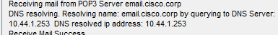

There is another protocol called FTP and it is considering to be insecure. It stands for file transfer protocol. When transferring files on a network you would need to make sure that the files are getting encrypted. It is a huge risk of data leakage if not configured properly. Firewalls increase security on the network it stops anything trying to access the network.
If the network isn’t configured properly it easy for people to access the network. Encryption is needed on the network to prevent users from attempting to hack the network. Here is an example. It shows all the passwords because the data is not encrypted.
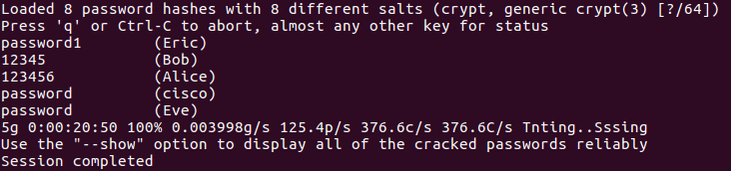
Users can also use remote access if not configured properly – setting a password.
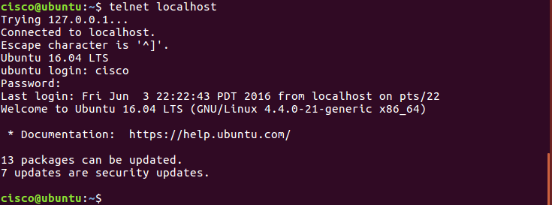
Depending on how you configure the network there are certain protocols that are more weak than others at security however more suitable in another situation. Such as WEP/WPA/telnet and many more protocols. It is important that when configuring a network that you use the certain protocols. It increases security as an example above you can see a network which is not configured probably. When manging a device SSH is considered a secure protocol because it requires a password unlike telnet.

References

[1] | “sysems manager,” CISCO, [Online]. Available: https://meraki.cisco.com/lib/pdf/meraki_datasheet_sm.pdf. [Accessed 14 4 2020].
[2] | “CISCO MERAKI,” CISCO, [Online]. Available: https://meraki.cisco.com/products/systems-manager. [Accessed 14 04 2020].
[3] | “What is BYOD?,” Forcepoint, [Online]. Available: https://www.forcepoint.com/cyber-edu/bring-your-own-device-byod. [Accessed 14 04 2020].
[4] | A. Paul, “BYOD advantages and disadvantages,” FieldserviceNew, 28 10 2014. [Online]. Available: https://www.fieldservicenews.com/blog/advantages-disadvantages-byod. [Accessed 14 04 2020].
[5] | “BYOD in the workplace:benefits, risks and insurance Implications,” Huffpost, [Online]. Available: https://www.huffpost.com/entry/byod-in-the-workplace-ben_b_10973342?guccounter=1&guce_referrer=aHR0cHM6Ly93d3cuZ29vZ2xlLmNvbS8&guce_referrer_sig=AQAAACj7UkS1FHgnzH9rCdF88h7zJSdYkqpMeheHK63ZH-PiYE3pbEBAy1ae6qnM7bxuarn63rr3YTIstgLgpJW_omMYsXUZ-0H9PudDhzQUsv. [Accessed 06 December 2017].

marking criteria and Student FEEDBACK

This section details the assessment criteria. The extent to which these are demonstrated by you determines your mark. The marks available for each criterion are shown. Lecturers will use the space provided to comment on the achievement of the task(s), including those areas in which you have performed well and areas that would benefit from development/improvement.

Common Assessment Criteria Applied (Assignment 1) | Marks available | Marks  awarded
1. Engagement with Literature Skills
Extent of research and/or own reading, selection of credible sources, application of appropriate referencing conventions.
You have used only websites for your referencing and did not engaged with any academic peer review article to make your work credible. Websites require careful consideration. Key concept considered. Try utilising the University online resources and journals. (Grade mark: 50.00%) | 15 | 7.5
2. Knowledge and Understanding Skills
Extent of knowledge and understanding of concepts and underlying principles associated with the discipline.
You have demonstrated knowledge and understanding. However, see comment above which is lacking in this report. You have not used the IEEE report formatting. (Grade mark: 50.00%) | 15 | 7.5
3. Cognitive and Intellectual Skills
Analysis, evaluation and synthesis; logic, argument and judgement; analytical reflection; organisation of ideas and evidence
Your report explain the relevant areas for this assignment; policy, DFD, network design, etc. No conclusion written. (Grade mark: 52.50%) | 40 | 21
4. Practical Application Skills
Deployment of methods, materials, tools and techniques; application of concepts; formulation of innovative and creative solutions to solve problems.
Your practical design works when pinging some end devices. However, no countermeasures/security measures implemented on core devices such as the switches and routers.  (Grade mark: 50.00%) | 20 | 10
5. Transferable Skills for Life and Professional Practice
Attributes in professional practice: individual and collaborative working; deployment of appropriate media; presentation and organisation.
Your work could do with formatting alignment/justify to make it look more professional. Some grammatical errors; see report for more comments. (Grade mark: 50.00%) | 10 | 5

Assignment Mark (Assessment marks are subject to ratification at the Exam Board. These comments and marks are to give feedback on module work and are for guidance only until they are confirmed. ) | Late Submission Penalties (tick if appropriate) |  | 51%
 | Up to four weeks late |  | 51%
 | First Attempt? |  | 51%

