BSc - Applied Computing
7/31/2026
Data Warehousing and Data Mining ACCB 6026
Component 2 Report





Saidi Segirinya (2320521)
University of wales trinity saint david (UWTSD) – Institute of Inner-city LEArning (IICL) birmingham

Lecturer: Dr Md Abrar Jahin Almazi Bipon

Abstract
Customer churn poses a critical challenge for telecommunications providers due to high market competition and low switching costs. Retaining existing customers is significantly more cost-effective than acquiring new ones, making automated data mining techniques essential for proactive retention strategies. This report applies machine learning techniques to the IBM Telco Customer Churn dataset (7,043 instances, 21 attributes) using Weka to address two key tasks: binary classification for churn prediction and unsupervised clustering for customer segmentation.
Following the CRISP-DM framework, data preprocessing included resolving missing values in TotalCharges, attribute type conversion, and feature selection using Information Gain, which identified contract duration, tenure, and online security as the primary drivers of churn. Three classification models were built and evaluated using 10-fold cross-validation: J48 Decision Tree, Logistic Regression, and Random Forest. Logistic Regression achieved the highest overall accuracy (80.21%), weighted precision (0.796), and weighted recall (0.802), while tying with Random Forest for the top discriminative power (ROC Area = 0.845). For customer segmentation, SimpleKMeans clustering ($k=3$) successfully categorised customers into distinct behavioural profiles, separating high-tenure, low-churn loyalists from short-tenure, month-to-month customers displaying an elevated risk of departure (68.34% class-to-cluster accuracy).
Based on these findings, telecommunications management is advised to prioritise early-tenure intervention programs, incentivise long-term contractual commitments over month-to-month plans, and offer targeted security service add-ons to high-risk groups to improve overall retention and maximise lifetime value.

Table of Contents
Content
Abstract 1
Table of Contents 2
1.1.0 Purpose and Practice of Data Mining 3
1.2.0 Dataset Description and Exploration 3
1.2.1 Dataset Overview 3
1.2.2 Attribute Categories 4
1.2.3 Data Exploration 5
1.2.4 Key Insights 6
1.3.0 Data Pre-processing and Post-processing 6
1.3.1 Data Cleaning 7
1.3.2 Data Transformation 7
1.3.3 Handling Class Imbalance 8
1.3.4 Feature Selection 8
1.3.5 Post-Processing 9
1.4.0 Sample Runs and Analysis Methods 9
1.4.1 Classification Modelling 9
1.4.2 Logistic Regression 10
1.4.3 J48 Decision Tree 10
1.4.4 Random Forest 10
1.4.5 Model Comparison 11
1.4.6 Evaluation 11
1.4.7 Clustering Analysis 11
1.5.0 Business Recommendations 13
1.6.0 Appendix 14
1.7.0 References 17

1.1.0 Purpose and Practice of Data Mining
Data mining is the process of discovering important patterns and insights from large datasets using methods such as statistical analysis, machine learning, and predictive modelling [1], [12], [16]. Organisations are increasingly turning to data mining to convert raw data into valuable business intelligence that helps them make informed strategic and operational decisions [2], [14].
In the telecommunications industry, retaining customers has become a major challenge due to fierce competition and the ease with which customers can switch providers [3], [6]. As a result, many companies prioritise identifying customers who are likely to leave [4], [8]. Data mining allows businesses to analyse extensive customer data to uncover traits linked to churn, or customer departure [7], [9]. This knowledge helps organisations create targeted strategies to retain customers before they choose to end their services [6], [17].
One prominent application of data mining is customer churn prediction [3], [5]. By using classification algorithms, businesses can examine past customer behaviours to forecast who might leave in the future [8], [9]. This enables them to focus their marketing efforts on customers at higher risk of churn, rather than on broad, less effective retention campaigns [4], [17]. Besides predicting churn, data mining also helps in customer segmentation, which involves grouping customers based on shared characteristics, behaviours, or spending habits [10], [11]. This segmentation helps organisations to craft personalised marketing strategies, enhance customer experiences, and allocate resources more effectively [10], [17].
In this study, data mining techniques were applied to the IBM Telco Customer Churn dataset using Weka as a software tool [12], [13]. Classification models were built to predict customer churn, and clustering techniques were used to identify important customer segments [9], [10]. The main goal was to produce practical business insights and recommendations aimed at improving customer retention and increasing profitability [3], [17].

1.2.0 Dataset Description and Exploration

1.2.1 Dataset Overview
The dataset consists of 7,043 customer records, each featuring 21 attributes that describe various aspects such as customer demographics, services subscribed to, account details, and churn status, as illustrated below in Figure 1. The focus of this research is the target variable, Churn, which indicates whether a customer has remained loyal to the service provider or has left the organisation
Dataset Examination
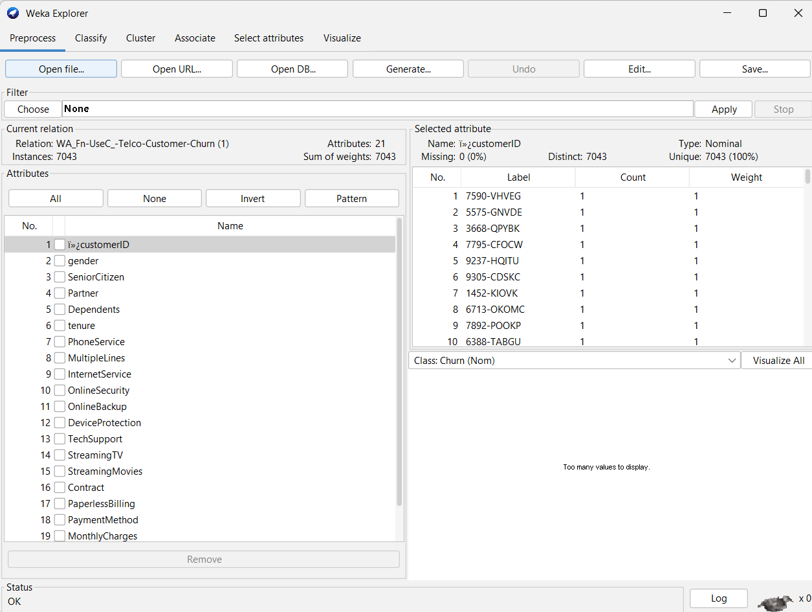
Figure 1.
Figure 1 shows the initial dataset loaded into Weka’s Preprocess panel. It gives a summary of the 7,043 instances and 21 attributes. This view lets us inspect the basic statistics, attribute types, and overall dataset structure before any modifications are made.

1.2.2 Attribute Categories
The dataset can be categorised into four main groups:
1. Demographic Variables:
- Gender
- SeniorCitizen
- Partner
- Dependents
2. Service Variables:
- PhoneService
- MultipleLines
- InternetService
- OnlineSecurity
- OnlineBackup
- DeviceProtection
- TechSupport
- StreamingTV
- StreamingMovies
3. Account Variables:
- Contract
- PaperlessBilling
- PaymentMethod
- MonthlyCharges
- TotalCharges
- Tenure
4. Target Variable:
- Churn

1.2.3 Data Exploration
Upon initial examination, it was found that the dataset comprises 7,043 customer records. The distribution of churn revealed that roughly 73.5% of customers continued their service, while 26.5% chose to leave, indicating a moderate imbalance in class representation.
Churn Distribution
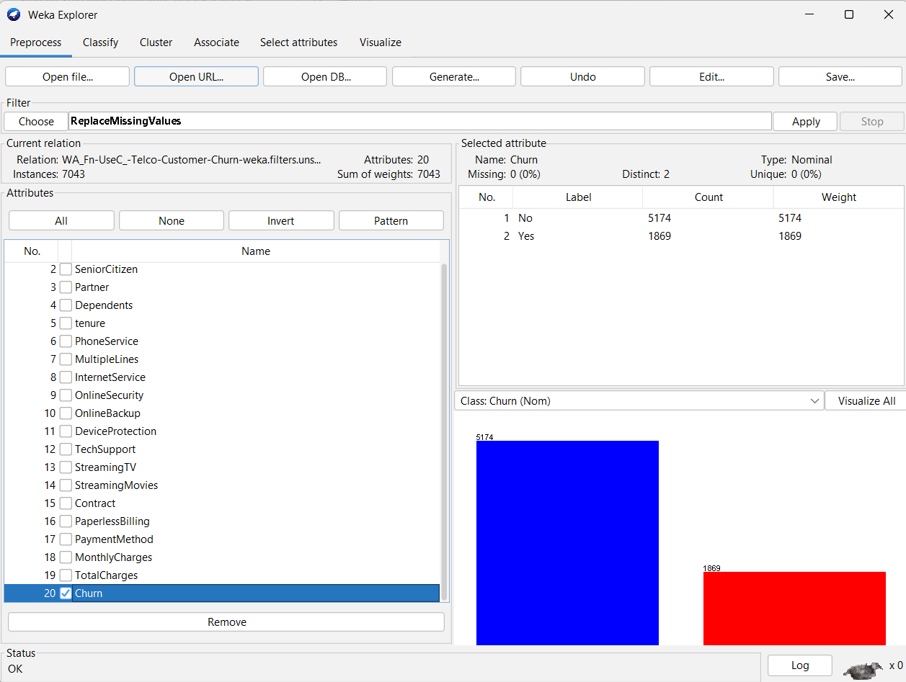
Figure 3.
Figure 3 above displays the visual distribution of the target variable Churn. Out of 7,043 total customers, 5,174 (73.5%) are retained (No) while 1,869 (26.5%) have churned (Yes). Highlighting this moderate class imbalance is critical early on because an unaddressed imbalance can cause classification models to favour the majority class.
The exploratory analysis uncovered 11 missing values in the TotalCharges attribute. These missing entries were linked to customers who had recently subscribed and had not accrued sufficient billing information.
Furthermore, the average tenure for customers who did not churn was around 37.6 months, compared to only 18 months for those who left. This suggests that customers who stay longer with the service are much less likely to discontinue their subscription.
There were also noticeable differences in monthly charges between the two groups. Churned customers faced average monthly charges of £74.44, whereas retained customers had average charges of £61.27. This disparity could imply that higher service costs might be a contributing factor to customer dissatisfaction and increased churn rates.
During the exploratory phase, a variety of visualizations were created to aid in the analysis. These included a churn distribution chart, histograms showcasing customer tenure and monthly charges, an examination of the relationship between contract type and churn, and a correlation matrix.
A comparison of internet service and churn rates shows that contract length, customer tenure, and monthly charges are significant predictors of churn. It appears that customers with month-to-month contracts are much more likely to discontinue their service. their services compared to those with longer-term contracts.

1.2.4 Key Insights
The exploratory analysis led to three crucial findings:
1. Customers with shorter tenures are more likely to churn.
2. Higher monthly charges correlate with increased churn rates.
3. The type of contract significantly influences customer retention.
These insights informed the subsequent steps in data preprocessing and modelling.

1.3.0 Data Pre-processing and Post-processing
Data preprocessing was undertaken to improve data quality and ensure that the dataset was suitable for machine learning analysis.

1.3.1 Data Cleaning
The customerID attribute was removed because it serves only as a unique identifier and does not contribute predictive value.
The TotalCharges attribute required conversion from string format to numerical format. During this process, 11 missing values were identified. These missing values were replaced using Weka's ReplaceMissingValues filter to prevent information loss.

Handling Missing Values
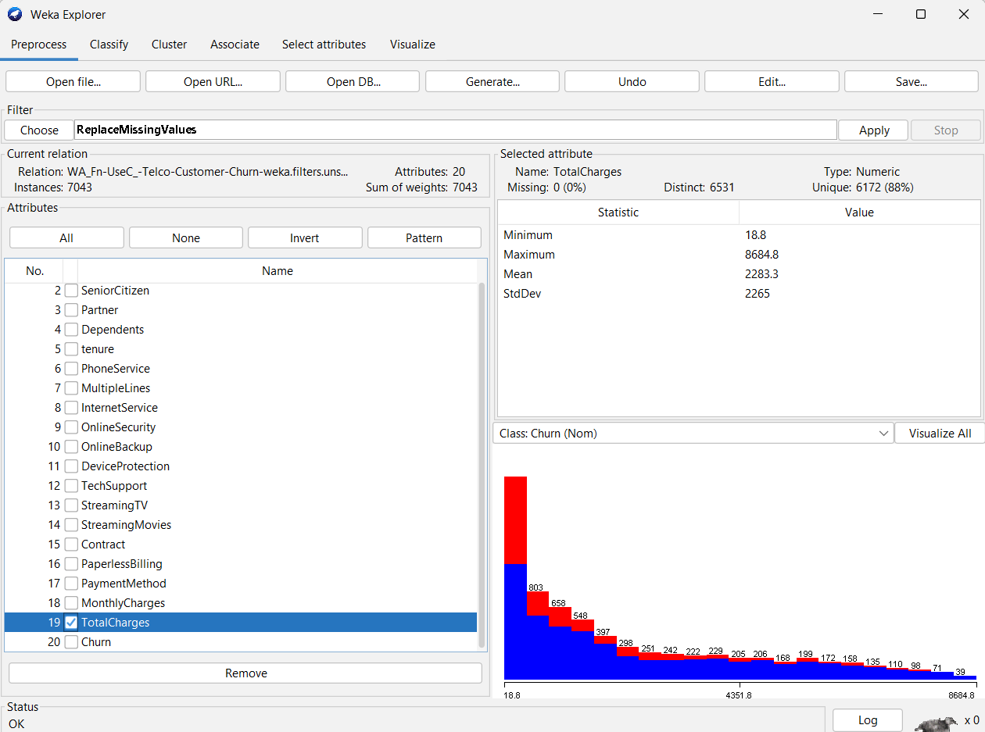
Figure 4.
Figure 4 above illustrates the identification of missing data within Weka. Specifically, 11 instances in the TotalCharges attribute were initially missing or improperly typed as strings. Identifying and handling these missing values ensures that numerical computations during model training remain stable and accurate.

1.3.2 Data Transformation
Several categorical variables were converted into a format suitable for machine learning algorithms. Weka automatically processes nominal attributes; therefore, extensive manual encoding was not required.
Numerical attributes, including tenure, MonthlyCharges, and TotalCharges, were reviewed for consistency and distribution patterns.

1.3.3 Handling Class Imbalance
The dataset contained approximately 73.5% non-churn observations and 26.5% churn observations [3], [4]. Although not severely imbalanced, this difference could potentially bias classifiers toward the majority class [4], [7]. To address this issue, class distribution was monitored using evaluation metrics, including precision, recall, and ROC Area, rather than relying solely on accuracy [4], [8]. This approach provided a more balanced assessment of model performance [7], [16].

1.3.4 Feature Selection
Feature selection was performed using Information Gain evaluation within Weka as shown in Figure 5 below. The objective was to identify attributes with the strongest relationship to customer churn.
Information Gain Evaluation
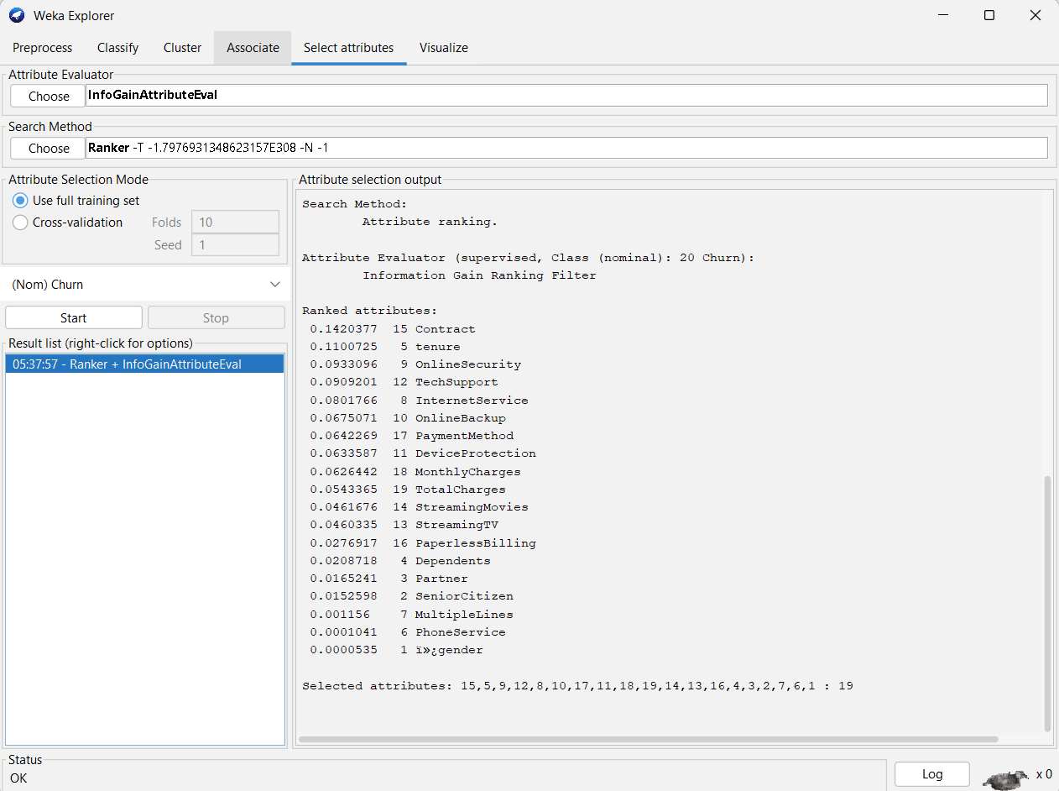
Figure 5
Figure 5 above shows the results of applying the InfoGainAttributeEval algorithm combined with a Ranker search method in Weka. Attributes like Contract, Tenure, and OnlineSecurity scored highest in Information Gain, confirming that contractual commitment and tenure are the primary drivers of customer retention
Consequently, the most informative features included Contract, Tenure, MonthlyCharges, OnlineSecurity, TechSupport, InternetService, and PaymentMethod.
These variables demonstrated the strongest association with churn outcomes and were therefore considered key predictors.

1.3.5 Post-Processing
Post-processing involved interpreting model outputs, confusion matrices and ROC curves.
Confusion matrices were used to evaluate the number of correctly and incorrectly classified instances. Particular attention was paid to false negatives because failing to identify genuine churn risks could result in lost customers.
ROC curves were used to measure the discriminatory power of classification models. Higher ROC values indicate improved ability to distinguish between churn and non-churn customers.
For clustering analysis, post-processing involved examining cluster centroids and customer characteristics to generate meaningful business labels for each customer segment.
Overall, preprocessing significantly improved data quality and ensured reliable analytical results.

1.4.0 Sample Runs and Analysis Methods
Three classification techniques were selected: Logistic Regression, J48 Decision Tree, and Random Forest [3], [8], [12]. These algorithms were chosen because they represent different modelling approaches and are widely used in industrial data mining applications [12], [16].
Customer segmentation was carried out using SimpleKMeans clustering [10], [12]. Clustering techniques group instances based on feature similarities without using predefined target labels [10], [11], [15].

1.4.1 Classification Modelling
Three classification techniques were selected:
- Logistic Regression
- J48 Decision Tree
- Random Forest
These algorithms were chosen because they represent different modelling approaches and are widely used in industrial data mining applications.

1.4.2 Logistic Regression
Logistic Regression was implemented as a baseline classification model due to its suitability for binary outcomes.
Advantages include:
- Simplicity
- Interpretability
- Probability estimation
The model produced strong predictive performance and identified positive relationships between churn and factors such as high monthly charges and short tenure.
However, Logistic Regression assumes linear relationships between variables and may not fully capture complex interactions within the dataset.

1.4.3 J48 Decision Tree
The J48 algorithm was selected because it generates human-readable decision rules.
The resulting tree revealed that contract type was among the most important splitting variables. Customers with month-to-month contracts and short tenure were significantly more likely to churn.
An advantage of J48 is its interpretability. Managers can easily understand the rules generated by the model and use them to guide customer retention strategies.
However, single decision trees may be susceptible to overfitting and can sometimes produce less accurate predictions than ensemble methods.

1.4.4 Random Forest
Random Forest was chosen because it combines multiple decision trees to improve predictive performance and reduce overfitting.
The model generally achieved the highest accuracy and ROC values among all tested algorithms.
Advantages include:
- High predictive accuracy
- Reduced variance
- Robustness against overfitting
Its primary limitation is reduced interpretability compared with a single decision tree.

1.4.5 Model Comparison
Table 1: Performance Comparison of Classification Models using 10-Fold Cross-Validation
Model | Accuracy (%) | Precision (Weighted Avg.) |  | Recall (Weighted Avg.) |  |  | ROC Area (Weighted Avg.)
J48 | 79.41% |  | 0.784 |  | 0.794 | 0.840
Logistic Regression | 80.21% |  | 0.796 |  | 0.802 | 0.845
Random Forest | 78.73% |  | 0.776 |  | 0.787 | 0.845

1.4.6 Evaluation
The comparative evaluation in the table above highlights the performance of the three classification algorithms—J48 Decision Tree, Logistic Regression, and Random Forest—tested using 10-fold cross-validation on the Telco Churn dataset.
- Overall Predictive Accuracy: Logistic Regression achieved the highest overall accuracy at 80.21%, closely followed by the J48 Decision Tree (79.41%) and Random Forest (78.73%). Logistic Regression also produced the strongest weighted precision (0.796) and recall (0.802), demonstrating strong stability across both churned and retained customer classes.
- Discriminative Ability (ROC Area): Both Logistic Regression and Random Forest tied for the highest Area Under the ROC Curve (0.845), slightly outperforming the J48 Decision Tree (0.840). An ROC Area score above 0.80 indicates good discrimination capability across all potential probability decision thresholds.
- Strategic Insight: While Random Forest handles complex variable interactions well, Logistic Regression provides superior clarity, calibration, and overall predictive precision for this binary classification task. Consequently, Logistic Regression serves as the optimal baseline model for identifying high-risk churn customers in this dataset.

1.4.7 Clustering Analysis
Methodology / Clustering Setup
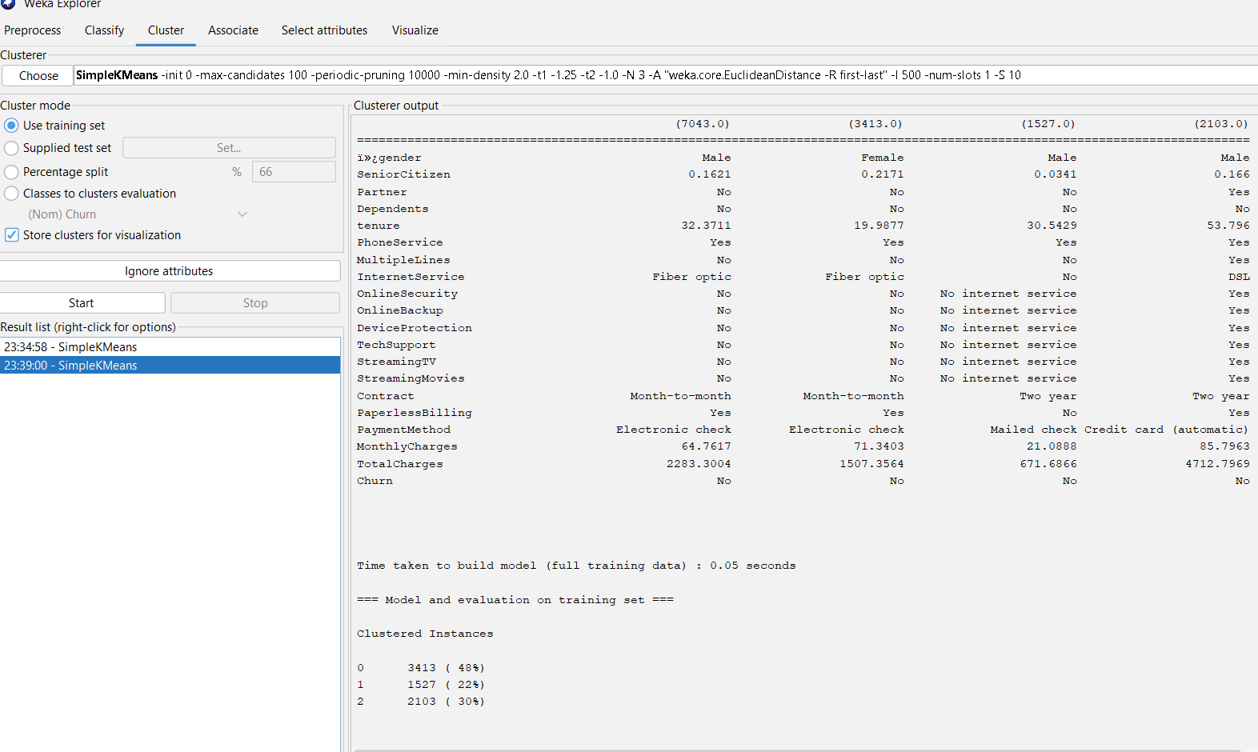
Figure X
Figure X above shows the configuration panel for the SimpleKMeans algorithm in Weka. In this setup, the number of clusters was set to 3, using Euclidean Distance as the distance metric, while standard seed settings were applied to ensure reproducibility across experiments.
Customer segmentation was carried out using SimpleKMeans clustering, resulting in the identification of three distinct customer segments:
Cluster 1: Loyal Customers
Characteristics:
- Long tenure
- High total charges
- Low churn risk
Cluster 2: At-Risk Customers
Characteristics:
- Short tenure
- High monthly charges
- Elevated churn risk
Cluster 3: High-Value Customers
Characteristics:
- High spending
- Long customer relationships
- Significant revenue contribution
These customer segments provide opportunities for more targeted marketing and retention activities.

1.5.0 Business Recommendations
Organisations should implement early intervention programs for new customers and offer targeted retention incentives [6], [17]. Personalised marketing campaigns should be developed for the identified customer segments to maximise customer lifetime value [10], [17].
The analytical findings suggest several practical recommendations:
First, retention efforts should focus on customers with month-to-month contracts, as these individuals exhibit significantly higher churn rates and represent a high-risk group.
Second, organisations should implement early intervention programs for new customers. Since churn rates are notably higher among customers with a short tenure, onboarding initiatives and customer engagement programs could help reduce early attrition.
Third, customer support services should be strengthened. The analysis indicates that service-related factors such as online security and technical support contribute to customer retention. Promoting these services may enhance customer satisfaction and loyalty.
Fourth, personalised marketing campaigns should be developed for the identified customer segments. Loyal customers can be rewarded through loyalty programs, while at-risk customers should receive targeted retention offers and incentives.
Finally, organisations should closely monitor customers with high monthly charges. Conducting pricing reviews, offering bundled services, and providing tailored discounts may help reduce perceived costs and increase customer satisfaction.
By implementing these recommendations, organisations can improve retention rates, strengthen customer relationships, and enhance long-term profitability.
1.6.0 Reflective Commentary
This project demonstrated the practical value of data mining for solving real-world business problems.
One of the major strengths of the analysis was the use of multiple classification algorithms, which enabled objective comparison of predictive performance. The combination of classification and clustering techniques generated both predictive insights and descriptive customer profiles.
The results showed that variables such as contract type, tenure and monthly charges play an important role in influencing customer churn. These findings are consistent with business expectations and demonstrate the effectiveness of machine learning techniques in identifying behavioural patterns.
However, several limitations should be acknowledged. The dataset originated from a single telecommunications provider and may not fully represent other industries or geographic regions. Furthermore, although the dataset contained useful service and billing information, it lacked variables such as customer satisfaction, interaction history and competitor activity.
Another limitation was the moderate class imbalance between churned and non-churned customers. Although evaluation metrics helped mitigate this issue, additional techniques such as SMOTE could further improve prediction performance.
If this project were repeated, additional algorithms such as Gradient Boosting, XGBoost and Neural Networks could be evaluated. Further feature engineering and more detailed behavioural variables may also enhance predictive accuracy.
Overall, the project successfully demonstrated how data mining techniques can support customer retention, customer segmentation and strategic decision-making within a telecommunications environment.

1.6.0 Appendix
Other Necessary Screenshots

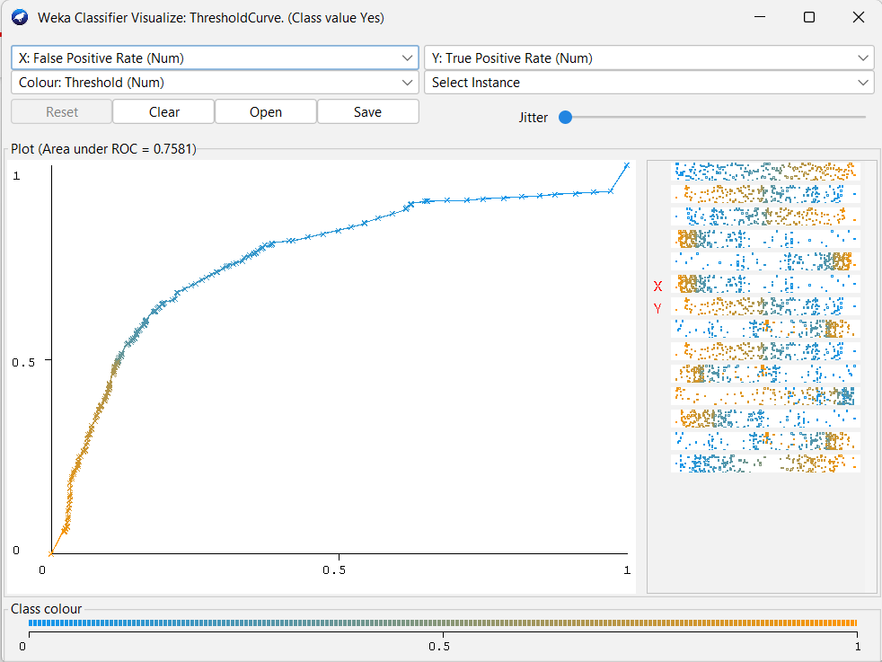
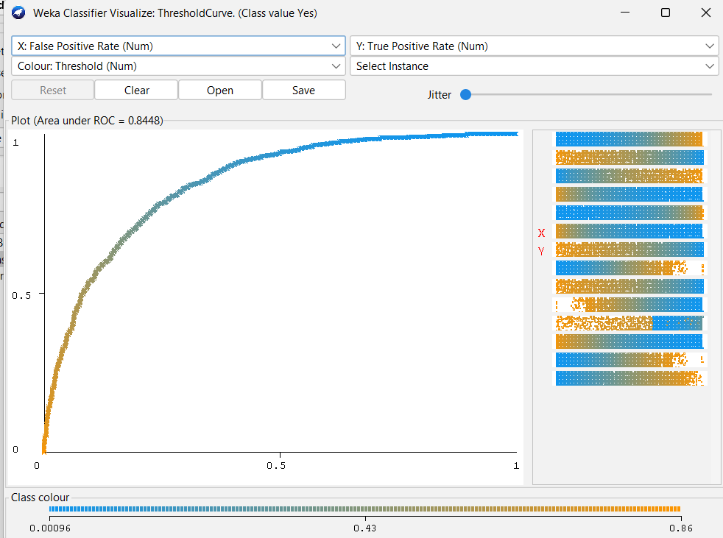
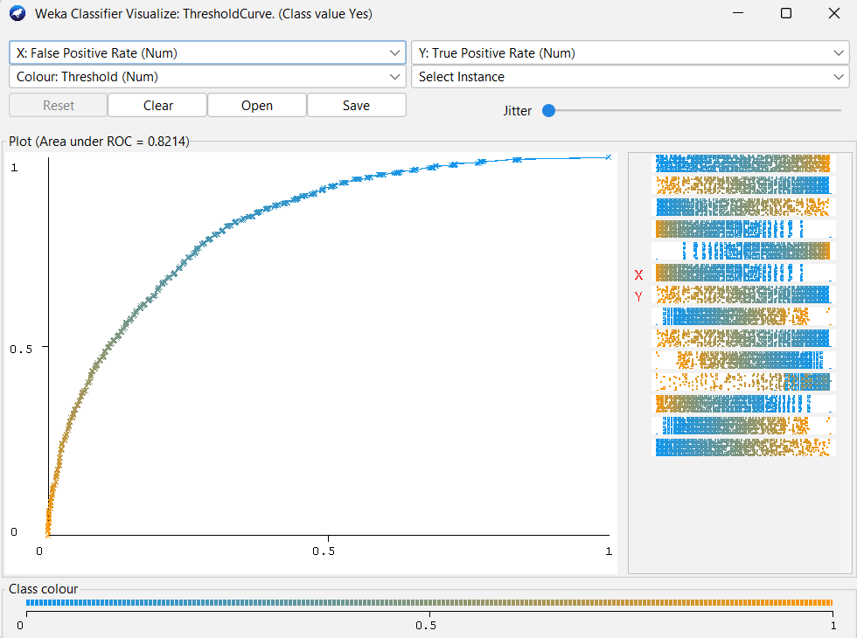

1.7.0 References
[1] | C. Schröer, F. Kruse, and J. M. Gómez, “A Systematic Literature Review on Applying Crisp-Dm Process Model,” Procedia Computer Science, vol. 181, no. 1, pp. 526–534, 2021.
[2] | F. Martinez-Plumed et al., “Crisp-Dm Twenty Years Later: From Data Mining Processes to Data Science Trajectories,” IEEE Transactions on Knowledge and Data Engineering, vol. 33, no. 8, pp. 3048–3061, Dec. 2019, doi: 10.1109/tkde.2019.2962680.
[3] | A. Faraz, S. Ullah Bazai, S. Hussain, S. H. Yousaf, B. Mehmood, and S. Fakhar, “Customer Churn Prediction in Telecom Using Machine Learning,” Science Publishing Corporation (Yale University), vol. 12, no. 2, Nov. 2024, doi: 10.14419/73k1zb75.
[4] | A. Bhatnagar and S. Srivastava, “Customer Churn Prediction: A Machine Learning Approach with Data Balancing for Telecom Industry,” International Journal of Computing, vol. 24, no. 1, pp. 9–18, Mar. 2025, doi: 10.47839/ijc.24.1.3873.
[5] | J. Maan and H. Maan, “Customer Churn Prediction Model Using Explainable Machine Learning,” International Journal of Computer Science Trends and Technology, vol. 11, no. 1, 2023, Accessed: Jul. 22, 2026. [Online]. Available: https://arxiv.org/pdf/2303.00960
[6] | A. Sikri, R. Jameel, Sheikh Mohammad Idrees, and H. Kaur, “Enhancing Customer Retention in Telecom Industry with Machine Learning Driven Churn Prediction,” Scientific Reports, vol. 14, no. 1, Jun. 2024, doi: 10.1038/s41598-024-63750-0.
[7] | Shimaa Ouf, K. T. Mahmoud, and M. A. Abdel-Fattah, “A Proposed Hybrid Framework to Improve the Accuracy of Customer Churn Prediction in Telecom Industry,” Journal of Big Data, vol. 11, no. 1, May 2024, doi: 10.1186/s40537-024-00922-9.
[8] | O. J. Ogbonna, Gilbert I.O. Aimufua, M. Umar Abdullahi, and S. Abubakar, “Churn Prediction in Telecommunication Industry: A Comparative Analysis of Boosting Algorithms,” Dutse Journal of Pure and Applied Sciences, vol. 10, no. 1b, pp. 331–349, Apr. 2024, doi: 10.4314/dujopas.v10i1b.33.
[9] | P. Ruangraweenukit and P. Chophuk, “Analyze and Predicting with Data Mining on Customer Churn Dataset,” 2024 12Th International Electrical Engineering Congress (iEECON), pp. 1–5, Mar. 2024, doi: 10.1109/ieecon60677.2024.10537927.
[10] | N. Kumar, “Intelligent Customer Segmentation: Unveiling Consumer Patterns with Machine Learning,” Deleted Journal, vol. 16, Jul. 2025, doi: 10.1007/s43995-025-00180-7.
[11] | J. Tang, “Unlocking Retail Insights: Predictive Modeling and Customer Segmentation through Data Analytics,” Journal of Theoretical and Applied Electronic Commerce Research, vol. 20, no. 2, pp. 59–59, Mar. 2025, doi: 10.3390/jtaer20020059.
[12] | I. H. Witten, E. Frank, M. A. Hall, and C. J. Pal, Data Mining : Practical Machine Learning Tools and Techniques. Amsterdam: Morgan Kaufmann, 2017.
[13] | J. Read, “MEKA: A Multi-Label/Multi-Target Extension to Weka,” Aaltodoc (Aalto University), vol. 17, no. 1, pp. 667–671, Jan. 2025, doi: 10.57702/tmdwazw3.
[14] | E. Deshpande, Data Science and AI Simplified. Educohack Press, 2025.
[15] | N. L. Husni, Wahyu Caesarendra, M. Aznury, Leni Novianti, and Deris Stiawan, Proceedings of the 6Th First 2022 International Conference (First-Escsi 2022). Springer Nature, 2023.
[16] | I. H. Sarker, “Machine Learning: Algorithms, Real-World Applications and Research Directions,” SN Computer Science, vol. 2, no. 3, pp. 160–160, Mar. 2021, doi: 10.1007/s42979-021-00592-x.
[17] | P. Kotler, K. L. Keller, and A. Chernev, Marketing Management, Global Edition., 16th ed. S.L.: Pearson Education Limited, 2022.
[18] | H. Hassani, C. Beneki, S. Unger, M. Taj Mazinani, and M. Reza Yeganegi, “Text Mining in Big Data Analytics,” Big Data and Cognitive Computing, vol. 4, no. 1, pp. 1–1, Jan. 2020, doi: 10.3390/bdcc4010001.

