LCMB 7000
HUMAN RESOURCE MANAGEMENT

Student Name:Mandeep Kaur saggu
Student Id:2218282

Introduction
The human resource manager plays an important function in any organization. In managing employees at the workplace and handling their grievances human resource department is significantly important. HR functions are tasked to ensure that all business objectives are achieved by implementing effective recruitment and selection strategies and supporting the employees to perform effectively. This project report will provide insights into how the role of human resources has changed over a period and provide an evolution of how it is impacting the implementation of sustainable human resources management.

Change in Role of HR
Over the period, the role of human resources has changed drastically. In the modern world, human resource managers are focusing more on employee needs and trying to create effective workplaces. HR consists of a broad range of functions, such as recruiting, selecting, onboarding, managing performance, planning for career development, and rewarding employees. HR plays a crucial role in the success of company objectives when it is informed by the prevailing change in the business environment (Patrick & Mazhar,2021). An HR department's role is to coordinate resources, facilitate the implementation of change, and mitigate employee resistance to it. HR's role has evolved from being involved in delivering changes and making sure colleagues are considered throughout the process, to being a go-to resource when changes are made. In addition, companies' strategies change when faced with uncertainty, such as COVID-19. A large number of organizations shifted toward digital markets due to COVID-19, but start-ups and small businesses had difficulties because of funding shortages. In addition, they require employees capable of shifting towards digital innovation. Most companies have trouble retaining highly skilled employees. The HR manager has to hire the best-skilled workers at a low cost, which is a burden for him or her.

New Role of HRM
- People require sophisticated HRM skills to overcome upheavals caused by changes in the environment.
- HRM is perceived as a core activity, shaping an organization's values, rather than being an isolated function.
- Instead of internal transfers, share personnel with firms that are strategic partners, such as important clients or suppliers.
- It is encouraged to encourage independence in employees so that they can develop their careers elsewhere, possibly returning after a few years.
- Encourage employees to develop self-marketing, networking, and consulting skills so that they can reach out to others and recognize new opportunities for themselves and the company.

Different Aspects related to Change
In HR, candidates are sourced, interviewees are supported, new employees are onboarded, and training and development are organized for all employees. Human Resources conduct inductions and set up meetings with stakeholders to ensure colleagues feel welcomed and supported in the organization. Positive relationships between the organization and colleagues are crucial to its overall performance. As part of its efforts to resolve internal issues, HR employs transparent and ethical processes that comply with local employment laws. A proactive policy implementation program is also implemented by HR to minimize the risk of future occurrences. Human Resource Management has also been affected by the volatile market.
By contributing to the development of competent teams and inspiring employees, the HR department will ensure that it remains relevant in the organization. In contrast to the past, the Human Resources department nowadays determines its priorities and needs and does not receive directives unless they are aligned with the company's strategy. Today, the Human Resources department sits at the corporate level and contributes and recommends business processes, business solutions, and business approaches which are likely to improve employees' performance and contribute effectively to organization performance in today's changing environment. HRM metrics, strategic direction, and measurements are included in this new paradigm shift in the role of Human Resource Management. An organization must have an effective and modern HRM function, which includes the following functions:
The first-line HR manager role of the Head of Department and the strategic business partner role of HR managers
Human Resource managers must now partner with line managers in the people management role as their focus is shifting from HR managers to strategic business partners. As the HR managers take on the business partner role with the line managers in driving the people management agenda, they are now playing a more strategic role in the daily running of the organization. Employees are the backbone of any organization, which is why organizations are putting a greater focus on them by having HODs take on the role of line managers. In this role, they have direct contact with their employees and are the first point of contact and support for any issues relating to people management. Additionally, they are responsible for ensuring that superior-quality employees are continuously developed and retained.

Changing role of HR as a result of technology
Employee communication, file storage, and performance analysis are changing due to technology. HR practices can be made more efficient by using technology effectively. Poorly managed, it can impede the management of a company's human resources. With the advancement of technology, the workplace has been changing as work is made faster and more convenient (Fenech, Baguant, & Ivanov, 2019).
Moreover, in the working section, the technologies like computers, tablets, and social networks have greatly contributed. The Human Resource Management (HRM) process covers activities like recruiting, training, developing, rewarding, and motivating people within the organization, and thanks to technology, most of these processes are now automated, thus making them more efficient. An organization that operates in a dynamic environment may be impacted more by information technology. Human Resources practices and processes have become more efficient and effective as a result (Deshpande, 2021).

Implementation of sustainable HRM globally
The functions of human resources are critical to supporting the organization’s goals for improving its effectiveness, managing corporate governance issues, and realigning its future direction and vision for new ways to operate. Human Resources can also serve as a moral compass for the organization by advocating policies and practices that are environmentally friendly and humane. These goals are not easy to achieve, but HR can facilitate communication between managers and employees as well as influence the culture of the organization. In a recent study about the practices of Top Employers, 92% of the companies placed a high value on social responsibility. To make these goals actionable, many organizations rely on employee engagement. A key contribution HR can make to facilitating sustainable business practices is in this area. Without the involvement of HR teams in engaging employees in the sustainability project, it would be nearly impossible for businesses to achieve their sustainability goals (Dvorakova, 2020). It has been challenging, however, to implement sustainable HRM as a result of changes in HR's role in recent years. Keeping the firm agile and competitive is the challenge of HR sustainability. The human resources management strategy supports a high-performing organization's competitive edge. There may be a variety of challenges, including:
- Lack of organizational support: Susiatabible HRM has also been universally acknowledged as a major challenge due to a lack of organizational support. Almost all personnel in the higher management. There is a lack of interest among industry owners when it comes to specific issues, such as green HRM practices since they believe compliance with health and safety measures and corporate social responsibilities is sufficient.
- Conducting an energy audit: Businesses can save money and reduce usage by consulting with most local utilities on-site. The most common suggestions include: improving insulation, installing timers to automatically turn off lights, using energy-efficient light bulbs, and keeping the temperature at a comfortable level (Kaur & Aggarwal, 2019).
- High costs of practicing: A major challenge in applying sustainability practices in organizations is the high costs of practicing sustainable practices in HRM. In addition, it is mentioned that the owners of organizations prefer to analyze the monetary benefit of every initiative or function; as a result, they do not want to incur expenses if they see that the outcome isn't practical. Thus, the cost of implementing green practices is high and most organizations see it as a long-term cost, however, since we are unable to demonstrate to senior management any tangible benefits from implementing them, such as improved unit output or profit, there isn't much of a return. Therefore, such initiatives are prohibited.
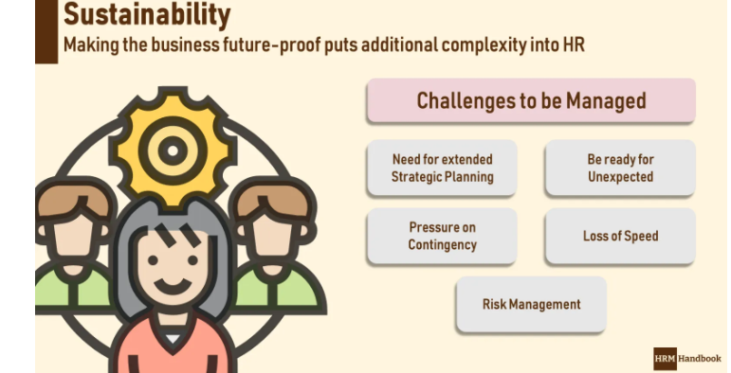

Sustaining the Sustainability Agenda
- By improving the culture of the company with its people: People who are involved in a corporate culture creation process gain a sense of belonging and form a bond with that company. Creating a corporate culture where everyone can contribute to the organization's success requires HRM to listen to suggestions and requests from employees and implement changes together.

- Create volunteering opportunities: Building stronger ties and working as a team are two benefits of encouraging people to donate to good causes. Human Resources should provide opportunities for employees to volunteer and organize campaigns so that they can support other people and organizations (Moallemi, Malekpour, Hadjikakou, & Szetey, 2020).

- Include sustainability in performance goals: In addition to being sustainable, the structure being built also helps people feel safe. By including sustainability requirements in corporate performance goals, HRM accelerates the development of this culture and facilitates the development of a roadmap in the minds of employees.

- Train about corporate culture: Providing training to explain corporate culture allows the vision and goals of the organization to be adopted quickly. HRM must define the impact of the company's operations on the environment and the role of its employees in the achievement of corporate goals (Mazur, Sustainable Human Resource Management and Its Models, 2017).

Models of Sustainable HRM
The Three Pillars Model of Sustainable HRM
As per this model, Sustainability human resource management has the following underlying objectives: increasing the employability of employees, enhancing individual responsibility, and maintaining a work-life balance. If individuals and companies work together, these objectives can be achieved. Human resource management is therefore not only about the company, but also about the individual. By managing human resources sustainably, individual needs are satisfied and the competitiveness of a company is maintained. In the following paragraphs, they explain why Sustainable HRM models include these three elements (Mazur, Sustainable Human Resource Management and its Models, 2017).
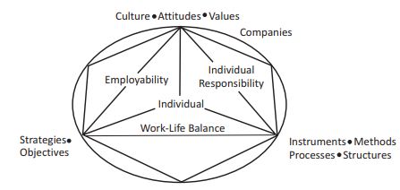
Model of Sustainable Human Resource Management
The holistic model of Sustainable HRM
As per this model, Listed below are Sustainable HRM's four perspectives.
HRM as a practice is to be made more social through the sociological approach, as its name suggests. There is a strong focus on continuity in this particular model of administration. Employees, employers, and society all have interests and involvement that are intertwined (Mazur,2017).
An employee's psychological approach is based on what he or she considers relevant to his or her work. The key points of this model include work-life balance, autonomy, self-development, employability, and dialogue (Lapiņa, Maurāne, & Leontjeva, 2013).
The link between Green HRM and strategic HRM is the main focus of the strategic viewpoint on Sustainable HRM. In particular, the topics of adaptability, employee turnover, employee assessments, and recruiting and selection will be examined in traditional HR spheres. (Mazur,2017).
Last but not least is Green HRM, which discusses how management and employees view the triple bottom line's environmental component and what components of HRM might make an organization more environmentally friendly.
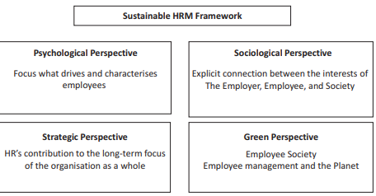

Maximizing the impact of sustainable HRM
Nevertheless, to maximize the potential of the growing influence of Sustainable HRM, I must ensure that the organizations where I work have shifted from Hard HRM to Sustainable HRM models. Additionally, a policy of high-involvement relationship management will have to be implemented to implement the Human Relations and Industrial Relations model. Additionally, I think businesses should make use of their resources, skills, and experiences in a way that will help them address some of the major societal problems that affect the economy, society, or environment, such as climate change, movement of people, corrupt practices, water, deprivation, pandemics, and youth unemployment (Dwivedi & Gaidhani, 2021).
The implementation of Green workplace practices should also be encouraged through HRM as a means of embedding Green values across an organization.
Nevertheless, I firmly believe that it is crucial to create a sense of awareness of the impact of business on people beyond organizational boundaries and current timeframes so that the Green HRM can be implemented effectively. With the help of the organization, I have contributed to a better understanding of the concept of Sustainable HRM and highlighted how HRM's purpose is transforming in the quest for sustainability by classifying different types (Aust, Matthews, & Muller-Camen, 2020).

Sustainable HRM at Amazon
As an example, Amazon implemented sustainable human resources management through the adoption of HRM strategies and practices that enabled them to achieve financial, social, and environmental goals over a long-term time horizon by ensuring an impact both inside and outside the organization. Furthermore, Amazon has developed innovative technology to improve transportation efficiency and set up more distribution centers to shorten delivery distances. One billion tons of climate pollution is produced by shipping every year, which is equivalent to the entire country of Germany. To transport goods on ships by 2040, Amazon has committed to using only zero-carbon-dioxide fuels. Furthermore, Amazon has committed to reducing carbon emissions by 50 percent by 2030
Moreover, Amazon also believes that High rates of turnover threaten a company's success. The frequent and regular loss of employees causes significant financial losses for companies due to the cost of replacing employees and loss of efficiency. Low engagement and active disengagement are also threats. For this purpose, Amazon building a strong culture and making investments that will attract and retain the talented employees we need today and in the future. For instance, during COVID Amazon area manager Janelle H. MADE Amazon’s commitment to keeping their employees safe (Aro-Gordon, 2022).

Conclusion
For every organization to be successful and efficient, HR plays a crucial role. It is not necessary to spend a lot of money or time on training your company's future leaders. Through COVID-19, a necessity for managing the implementation of plans was demonstrated. There have been many technological advances in terms of employee motivation over the past few decades, but the models from the past, such as the holistic HRM model and the three pillars model of sustainable HRM, are still followed by most companies today. In this case, "Old is Gold" proves to be true. Additionally, we've demonstrated that to effectively design and deploy Sustainable HRM systems and help address today's major sustainability concerns; a shared meaning of the purpose of HRM is required. This enables us to pinpoint the goal that HRM can successfully advance. The green benefits of recycling, upgrading heating and cooling systems, and reducing carbon emissions are natural gas companies begin recycling and upgrading equipment. HR professionals should provide a constant calendar of activities by incorporating environmental management into their way of doing business. Going green also helps businesses improve their public image, and good public image and impression can have a significant impact on business earnings.

References
Aro-Gordon, S. (2022). Sustainable HRM Practice and Organisational Excellence: An Empirical Analysis. SDMIMD Journal of Management, 125-140.
Aust, I., Matthews, B., & Muller-Camen, M. (2020). Common Good HRM: A paradigm shift in Sustainable HRM? Human Resource Management Review, 1-11.
Deshpande, D. (2021). Role of Technology in Managing HR. Research gate, 1-11.
Dvorakova, Z. (2020). Sustainable human resource management in a time of global uncertainty. Current Problems of the Corporate Sector, 1-8.
Dwivedi, A., & Gaidhani, S. (2021). GREEN HRM: AN ORGANIZATION STRATEGY OF GREENING PEOPLE FOR SUSTAINABLE DEVELOPMENT AND ITS IMPACT ON THE ORGANIZATION’S PERFORMANCE. International Journal of Multidisciplinary Educational Research, 1-6.
Fenech, R., Baguant, P., & Ivanov, D. (2019). THE CHANGING ROLE OF HUMAN RESOURCE MANAGEMENT IN AN ERA OF DIGITAL TRANSFORMATION. Journal of Management Information and Decision Sciences, 22 (2), 1-10.
Kaur, S., & Aggarwal, K. (2019). GREEN HRM: ISSUES AND CHALLENGES CONFRONT BY THE ORGANIZATIONS. International Journal for Research Trends and Innovation, 4 (3), 1-6.
Lapiņa, I., Maurāne, G., & Leontjeva, O. (2013). Holistic Human Resource Management Model towards Sustainable and Sophisticated Business. The 17th World Multi-Conference on Systemics, Cybernetics, and Informatics.
Mazur, B. (2017). Sustainable Human Resource Management and its Models. International Journal of Contemporary Management, 211–223.
Mazur, B. (2017). Sustainable Human Resource Management and Its Models. International Journal of Contemporary Management, 16 (3), 1-11.
Moallemi, E. A., Malekpour, S., Hadjikakou, M., & Szetey, K. (2020). Achieving the Sustainable Development Goals Requires Transdisciplinary Innovation at the Local Scale. Science Direct, 3 (3), 300-313.

