BMIH4003 Hospitality & Guest Services

Topic
The role and importance of quality service, hospitality and guest services in the hospitality industry at Hotel Indigo

Marina Boeva
Student ID :2246384
The module title : Hospitality and Guest Services BMIH4003
Tutor : Charlotte Joyner
Word count , ex 1684
References & In-text citations

Slide 1:

Slide 2:
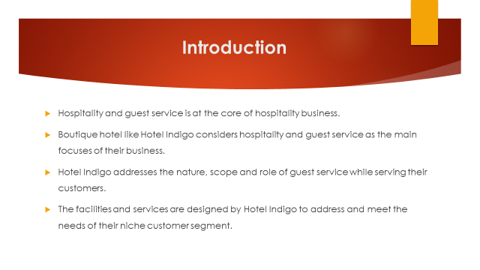
Speaker note: Hotels play an important role being the key member of hospitality industry where there are different categories of hotels that target specific customer segments and offer services and amenities based on the needs of its guests. From that perspective, boutique hotel belongs to luxury category where guest look for unique hospitality experience. According to Loureiro et al. (2019), boutique hotels are characterized by its small size and personalized guest service where aesthetic design defines the uniqueness and differentiated facilities for ensuring unique experience of its guests. From the perspective, Hotel Indigo offers personalized service to its guests and the establishments are individually-owned and represented with unique designs that reflect the distinctive culture of the locales and also the quality excellence. The facilities and ambience created by Hotel Indigo in its every establishment is unparalleled from other hospitality brands as well as its own establishments.
Slide 3:
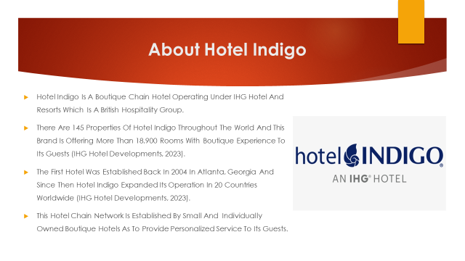
Speaker note:
Hotel Indigo is one of the global brands of boutique hotel that started its journey back in 2004 under the InterContinental Hotel Group to offer luxury accommodation ad hospitality experience to the guests. Over the period, this hotel brand became very successful as it can be seen that the brand expanded its operation in 20 different countries in this globe and established 145 properties. The aim of Hotel Indigo is to serve its guest with unique facilities and to experience neighborhood experience in locals (IHG Hotel Developments, 2023).

Slide 4:
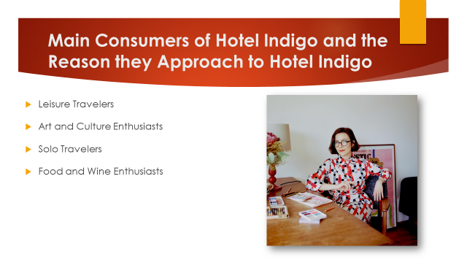
Speaker note:
- Leisure Travelers: Hotel Indigo target this kind of customers as they look for intimate and distinctive accommodation option for their leisure. Parolin and Boeing (2019) mentioned that leisure travelers mostly loom for opportunities to experience local cultures and also consider best quality of services to facilitate their experience. The leisure travelers prefer Hotel Indigo as it designs its hotels to experience the local culture and vive being with in the locale and offer excellent accommodation facilities to complement that experiment.
- Art and Culture Enthusiasts: The individuals who are passionate to art and culture and look for places to explore the art, history and culture, prefer boutique hotels. In terms of Hotel Indigo, it can be seen that every establishment of Hotel Indigo is designed around the people, places and traditions to ensure that the guests can thoroughly experience these.
- Solo Travelers: This type of customers are one of the main customers of boutique hotels as they look for comfort and safety while their goal is to explore new destinations and experience the local culture, hospitality and ambiences.
- Food and Wine Enthusiasts: Boutique hotels offer excellent quality food and wine collections that to make its guests enjoy their time while experiencing the neighborhood of the locales. For example, Hotel Indigo East End offers a great opportunity to its guest for experiencing traditional winemaking process as well taste the best wines along with its excellent hospitality (Hotel Indigo East End, 2016).

Slide 5:
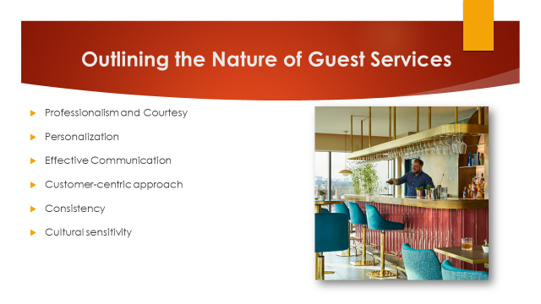
Speaker note:
- Professionalism and courtesy is at the key characteristic of every boutique hotel where Hotel Indigo has set a new level of excellence and efficiency by accommodating skilled professionals who treat every guest with professionalism and courtesy.
- Personalization is another fundamental characteristic of boutique hotels as the guest look of individualized service where their priorities and preferences are valued most (Dall’Agnol and Nakatani, 2018). Indigo is best on this occasion as every establish of this hotel is designed to accommodate the diversity and flexibility of every guest.
- Effective communication is essential in guest service as to understand the needs of customers and meet their needs. Hotel Indigo not only focuses on impersonal communication but also they try to communicate with their guests through the neighborhood experiences as to ensure a unique experience.
- Customer-centric approach is also an important attribute of guest service where it can be seen that Hotel Indigo designed its facilities and offerings to value its customers most.
- Consistency plays another attribute of excellent gust service. In terms of Indigo, it can be seen that the brand maintains its standard of service quality throughout its every establishment where the key factor of consistency is unique neighborhood experience.
- Cultural sensitivity is essential nature for excellent guest service and it is extremely important for brands like Indigo that has its establishments in different countries where local culture and social environment facilitates the gust experience.

Slide 6:
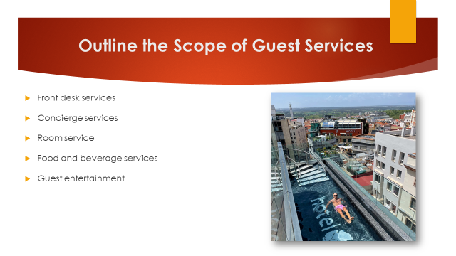
Speaker note:
- Front desk services: In this area, the guests expect convenient services where first impression is created by front desk services. In terms of Hotel Indigo, it can be addressed that smooth and convenient front desk service is ensured to each guest where the preferences of guests are valued most.
- Concierge services: This area of guest service demands effective communication and interpersonal interaction with guests as to ensure a great hospitality experience to them by assisting them in managing travel plans, transportation, tours and recommending local attractions and places to have great experience (Vallen, 2019). Indigo has specialty in concierge services as they put their establishments with a locale to ensure its guests can experience local culture heritage and the hospitality of the neighborhoods.
- Room service: Room service is an integral part of guest service where in boutique hotel like Indigo excellent room service is provided as complementary to ensure higher level of customer satisfaction.
- Food and beverage services: This is another scope for guest service in hospitality business and it is ensured in different ways by different types of hotels. In the case of Indigo as a boutique hotel, they provide both inclusive and exclusive food and beverage experiences to its guests. The guests can also experience local food and beverages to explore new sites of the locations.
- Guest entertainment: This is another scope of guest service where the boutique hotels like Indigo set its goal to introduce the local culture and heritage with its guests to entertain them. In terms of Indigo, it has seen that this brand emphasizes art and aesthetic architectural design along with local neighborhood hospitality to entertain its guest.
Slide 7:
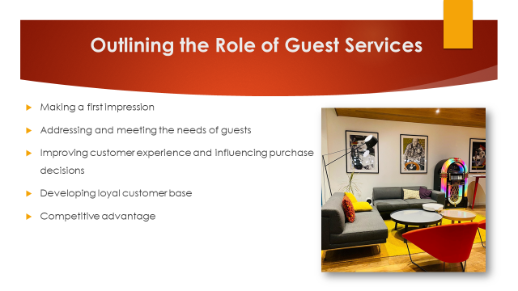
Speaker note:
- Making a first impression is one of the key role of guest service where excellent service with professionalism and unique experience to customers defines the impression. On that occasion, Hotel Indigo emphasizes on eye catching and unique architectural design along with excellent location to impress its guests.
- Addressing and meeting the needs of guests is an important activity in guest service to ensure that guests are satisfied by meetings their needs. In this regard, Indigo has advantages as it serves niche customer segments and they know exactly what their customers look for. Indigo prioritizes neighborhood experience along with the facilities to experience local cultures and personalized service to meet diversified needs of its guests.
- Improving customer experience and influencing purchase decisions is ensured by hotels by incorporating changes and improvements in its facilities and guest services. Indigo is not an exception rather it offers personalized service to ensure their guest experience new things every time when they take their hospitality.
- Developing loyal customer base is a very important task in guest service as to ensure that the guests repeat their visits to the hotels and also recommend others for visiting (Rather, 2018). On that occasion, Indigo develop and maintain regular interaction and attachment with their guests and value their feedbacks to ensure that guests become loyal to their brands.
- Creating competitive advantage is an important role for guest service where the utilization of resources is ensured and unique selling propositions are developed as much as possible. Offerings luxury with unique neighborhood experience along with aesthetic ambiance is the competitive advantage of Hotel Indigo.

Slide 8:
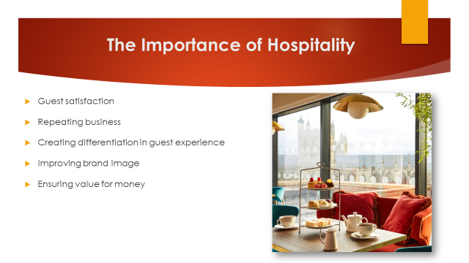
Speaker note:
- Hospitality is important for greater guest satisfaction as hospitality in hotel industry is at the core of its business where hospitality is ensured by offering excellent guest experience (Hemmington, 2007). In terms of Hotel Indigo, it can be seen that distinctive and unique guest experience is the basics of their hospitality.
- Hospitality defines the growth of business where customers consider the quality of hospitality for making repetitive purchase decisions that helps hotels in repeating their business.
- Creating differentiation in guest experience is ensured by distinctive hospitality experience where boutique hotel like Indigo considers it as the main theme of their business strategies.
- Hospitality of hotel businesses determines the brand value and it can be seen that leading brands emphasizes hospitality most while develop their offerings. For example, guest visits Indigo Hotels for having the unique hospitality experience that they cannot find in other categories of hotels.
- The quality of hospitality defines the value for money to a guest as in can be found that luxury hotel brands distinct themselves from other hotels by offerings more then the expectations of their guests and that ensures the value for their money.

Slide 9:
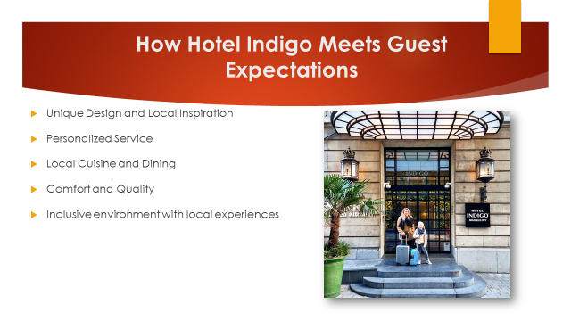
Speaker note:
- Unique design of Indigo hotels is the key factor to attract their guest and by offerings aesthetic design including architectural design and interior, Indigo ensures that their guest can enjoy something unique that they expect. Along with that, another common expectation is that to experience the local culture where neighborhood experience it put at the centre of that experience by Indigo to meet this expectation.
- Being a boutique category hotel, gusts naturally expect unique service and Indigo meet that expectation by offering personalized service so that diversified needs can be met.
- Guest of Indigo expect of experience local cultural vide being within that experiment where Indigo offers local cuisine and dining to meet that expectation.
- Comfort and quality is also expected by guest of Indigo where the company ensures excellent guest service and luxury to meet this expectation.

Slide 10:


