

University of Wales Trinity Saint David
School of Engineering

Structural Integrity and Material Evaluation
Peter Charlton
Laser Doppler Vibrometer – Brake Disc Modal Analysis (ACEA7013)

Taylor Winter 1901843
Automotive Engineering
19/02/2023

Abstract
The study analyses the resonant frequencies of the Caterham brake disc, revealing multiple frequencies at varying amplitudes that can lead to increased vibrations, noise, and reduced braking performance. The lowest frequency resonance of 0.1kHz is of particular concern due to its high magnitude, but further investigation into the sources of resonance and potential contributing factors can minimize the effects and improve safety. In alignment two, resonant frequencies at 0.1kHz and 0.4kHz can lead to undesirable noise, decreased braking performance, and dangerous driving conditions. Alignment three shows less accuracy, with resonant frequencies not matching those of the first two alignments, and interference from another surface due to the alignment being through the middle of the brake disc. The frequencies recorded at 0.125kHz, 0.4kHz, and 0.9kHz may still cause vibrations and noise, emphasizing the importance of addressing these resonances for optimal brake performance and longevity. The analysis of the Sports 2000 brake disc indicates that resonant frequencies at 0.1kHz, 0.5kHz and 3kHz can be observed with smaller amplitudes, and the largest frequency peak for this brake disc is at around 0.17kHz. Overall, the results suggest that the Sports 2000 brake disc is less susceptible to resonant frequencies compared to the Caterham brake disc. Further investigation into the sources of resonance and potential contributing factors, such as the design and materials of the brake disc, is crucial to minimize the effects of resonance and improve the overall performance and safety of brake discs.

Table of Contents
Abstract 2
Table of Figures 4
Table of Tables 5
Apparatus 6
1 Introduction 8
2 Literature Review 9
2.1 Laser Doppler Vibrometer 10
2.2 Doppler Effect 10
3 Methodology 12
4 Measurements and Graphs of Raw Measurements 13
4.1 Alignment 1 13
4.2 Alignment 2 13
4.3 Alignment 3 14
4.4 Sports 2000 Brake Disc 15
5 Results and Discussion 16
5.1 Alignment 1 16
5.2 Alignment 2 18
5.3 Alignment 3 21
5.4 Sports 2000 Brake Disc 23
6 Conclusion 27
Bibliography 28

Table of Figures
Figure 1: Solenoid Exciter. 6
Figure 2: PolyTec LDV (PolyTec, 2019). 6
Figure 3: Caterham Brake Disc (Caterham, 2018). 6
Figure 4: Sports 2000 Brake Disc (JapEuro, 2020). 7
Figure 5: Clamped Brake Disc with Aligned Solenoid Exciter and LDV. 12
Figure 6: Two-Dimensional Alignment. 12
Figure 7: Alignment 1 13
Figure 8: Alignment 2 13
Figure 9: Alignment 3 14
Figure 10: Alignment 1: 1 17
Figure 11: Alignment 1: 2 17
Figure 12: Alignment 1: 3 18
Figure 13: Alignment 1: 4 18
Figure 14: Alignment 1: 5 18
Figure 15: Alignment 2: 1 19
Figure 16: Alignment 2: 2 19
Figure 17: Alignment 2: 3 20
Figure 18: Alignment 2: 4 20
Figure 19: Alignment 2: 5 20
Figure 20: Alignment 3: 1 21
Figure 21: Alignment 3: 2 21
Figure 22: Alignment 3: 3 22
Figure 23: Alignment 3: 4 22
Figure 24: Alignment 3: 5 22
Figure 25: Sprots 2000 Brake Disc: 1 23
Figure 26: Sports 2000 Brake Disc: 2 23
Figure 27: Sports 2000 Brake Disc: 3 24
Figure 28: Sports 2000 Brake Disc: 4 24
Figure 29: Sports 2000 Brake Disc: 5 24
Figure 30: Sports 2000 Brake Disc: 6 25
Figure 31: Sports 2000 Brake Disc: 7 25
Figure 32: Sports 2000 Brake Disc: 8 25
Figure 33: Sports 2000 Brake Disc: 9 26
Figure 34: Sports 2000 Brake Disc: 10 26

Table of Tables
Table 1: Alignment 1 Results 13
Table 2: Alignment 2 Results 14
Table 3: Alignment 3 Results 14
Table 4: Sports 2000 Brake Disc Results 15

Apparatus
The following apparatus were used for this investigation:
- Solenoid Exciter
- PolyTec LDV
- PSV Acquisition Presentation
- Caterham brake disc
- Sports 2000 brake disc
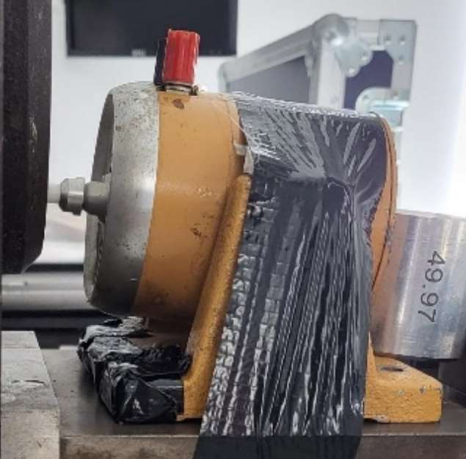
Figure 1: Solenoid Exciter.
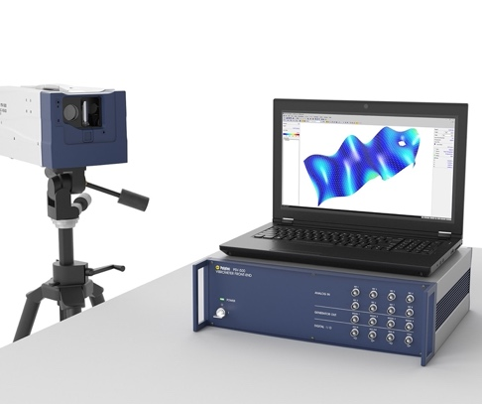
Figure 2: PolyTec LDV (PolyTec, 2019).
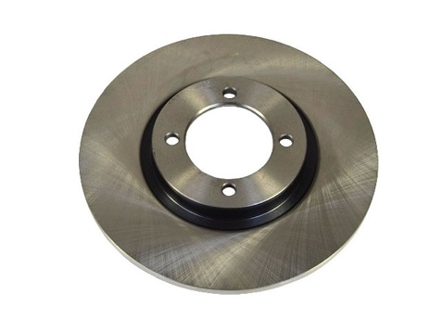
Figure 3: Caterham Brake Disc (Caterham, 2018).
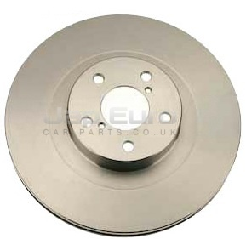
Figure 4: Sports 2000 Brake Disc (JapEuro, 2020).

1 Introduction
The PolyTec Scanning Laser Doppler Vibrometer (LDV) is a powerful tool used in all areas of engineering to measure the dynamic behaviour of structures. In this assignment, this technology has been utilised to monitor and determine the resonant frequency modes and shapes of a brake disc. The excitation source will be a solenoid actuator driven from the LDV function generator. This experiment will involve the identification of the component’s main harmonic resonant modes and shapes, along with an explanation of the limitations of the study.

The operation of the Laser Doppler Vibrometer System involves shining a laser beam onto the surface of the component being tested. As the component vibrates, the laser light is reflected back to the LDV sensor, and the system measures the frequency and amplitude of the vibrations. By scanning the laser beam across the surface of the component, the LDV can create a map of the vibrations, allowing us to identify the resonant modes and shapes of the brake disc.

Recent publications on LDV in the automotive industry have shown the technology's potential for identifying and diagnosing faults in vehicle components such as brake discs, engine mounts, and suspension systems. By using LDV technology, engineers can gain valuable insights into the behaviour of these components and optimize their performance.

In this report, a detailed description of the acquisition processes and key parameter values used during the acquisition process will be provided. Also identify the limitations of this study and explain the challenges and difficulties encountered during the experiment. Finally, a comprehensive analysis of the data obtained, including the identification of the brake disc's main harmonic resonant modes and shapes.

2 Literature Review
Laser Doppler Vibrometer (LDV) technology has been used in the automotive industry to measure and analyse the vibrations and acoustic characteristics of different vehicle components. Recent research in LDV automotive publications has focused on various applications of LDV technology for automotive testing and development.

One area of research includes the use of a tracking laser Doppler vibrometer (TLDV) for measuring vibrations in automotive components. The TLDV uses a Lagrangian approach, which continuously tracks a moving target point with the measurement laser spot to reduce speckle noise caused by relative motion. This allows for the measurement of vibrations under simulated operative conditions. The study focuses on three applications in the automotive field: the side-wall vibration of a rolling tire, the out-of-plane vibration of a timing belt, and the rubber blade vibration of complex motion windscreen wipers (Castellini & Montanini, 2002).

LDV technology has become an important tool for measuring the dynamic behaviour of automotive components, including belts. Recent studies have shown that LDV can be used to measure transverse vibration and acoustic radiation of automotive belts, which can provide valuable information for improving the design and performance of the belt system (Sante & Rossi, 2001).

Another publication written by the SAE (Society of Automotive Engineers) explores a new method of LDV by combining the technology with optical derotator. Laser Doppler Vibrometry (LDV) has been widely used for non-contact vibration measurements for over 20 years. Scanning LDVs (SLDVs) are used for mapping vibration patterns of full areas by steering the laser beam across the surface. However, SLDVs are limited to stationary or smoothly rotating objects. The Derotator overcomes this limitation by maintaining a fixed position of the SLDV laser beam in the rotating coordinate system of the test object, allowing measurement of complex noncontinuous structures. The paper explains the basic principle of derotated SLDV measurement and presents two applications in the automotive industry. The first application measures the Operational Deflection Shape (ODS) of a rotating disk with and without derotating, while the second application troubleshoots a pump rotor by identifying its critical speed and corresponding ODS (Johansmann, et al., 2011).
Overall, recent LDV automotive publications have focused on utilizing the technology for a range of applications, including EV noise and vibration analysis, durability testing, brake system development, and active noise control system development. The use of LDV technology is becoming increasingly important in the automotive industry as vehicles become more complex and require more precise testing and development.

2.1 Laser Doppler Vibrometer
A Laser Doppler Vibrometer (LDV) system is a non-contact vibration measurement technique that uses the Doppler effect to measure the velocity of an object's surface vibration.

The basic operation of an LDV system involves emitting a laser beam onto the surface of the object being measured. The laser beam is then reflected back to the LDV sensor by the surface of the object. As the surface vibrates, the reflected laser beam undergoes a frequency shift due to the Doppler effect. This shift in frequency is proportional to the velocity of the surface vibration.

The LDV sensor detects the frequency shift of the reflected laser beam and uses it to calculate the velocity of the surface vibration. By measuring the velocity of the vibration at multiple points on the surface, the LDV system can create a map of the vibration pattern and identify any areas of high or low vibration (PolyTec, 2018).

2.2 Doppler Effect
The Doppler effect is a phenomenon where the observed frequency of a wave (such as sound, light or radio waves) changes when there is relative motion between the source of the wave and the observer.

The effect can be observed when a source emitting waves is moving towards or away from an observer. When the source is moving towards the observer, the observed frequency of the waves is higher than the emitted frequency, and when the source is moving away from the observer, the observed frequency is lower than the emitted frequency.

For example, when a siren on an ambulance approaches an observer, the observer hears the sound at a higher frequency (i.e., a higher pitch) than the actual frequency emitted by the siren. As the ambulance moves away, the observer hears the sound at a lower frequency (i.e., a lower pitch) than the emitted frequency. This is due to the Doppler effect (Britannica, 2023).

3 Methodology
The methodology for this investigation is as follows:
- Secure brake disc into clamp and ensure that the solenoid exciter and the LDV are properly aligned. This can be seen below in figure 5.
- Open the PSV Acquisition application and input the system parameters.
- Perform a two-dimensional alignment and establish desirable scan points (Seen in figure 6 below).
- Initiate the scanning process and store all of the raw data.
- This can then be loaded into the PSV Analysis Program.
- Indicate the frequency ranges and choose the appropriate peaks from the set-up menu.
- Observe and document the outcomes for future analysis.
- Steps 1-7 can then be repeated for the second brake disc, system parameters may differ at this stage.
- Finally, compare the results while making comments on resonant frequency and vibration modes.
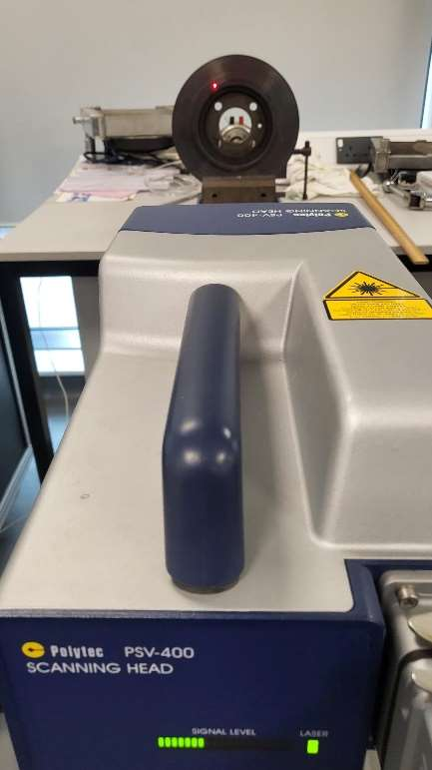
Figure 5: Clamped Brake Disc with Aligned Solenoid Exciter and LDV.
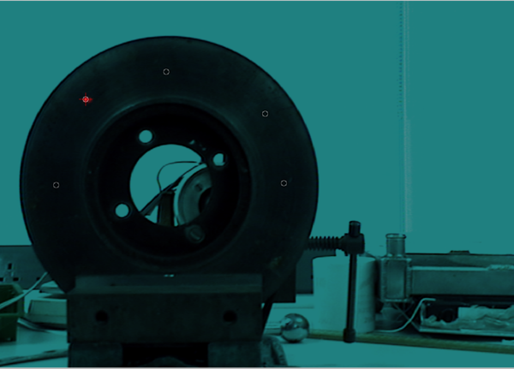
Figure 6: Two-Dimensional Alignment.

4 Measurements and Graphs of Raw Measurements

4.1 Alignment 1
Figure 7 below shows the LDV setup for the first alignment, table 1 below shows the raw data of the frequencies.
Figure 7: Alignment 1
Table 1: Alignment 1 Results
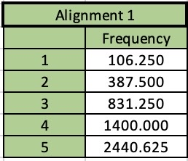

4.2 Alignment 2
Figure 8 below shows the LDV setup for the second alignment, table 2 below shows the raw data of the frequencies.
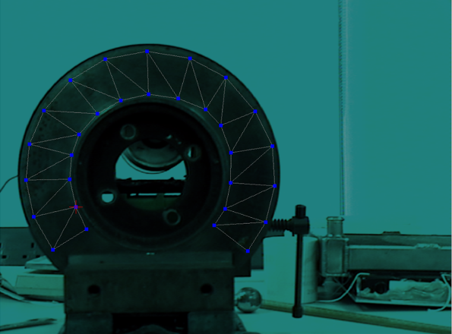
Figure 8: Alignment 2
Table 2: Alignment 2 Results
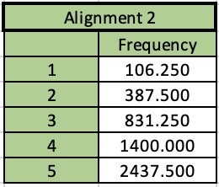

4.3 Alignment 3
Figure 9 below shows the LDV setup for the third alignment, table 3 below shows the raw data of the frequencies.
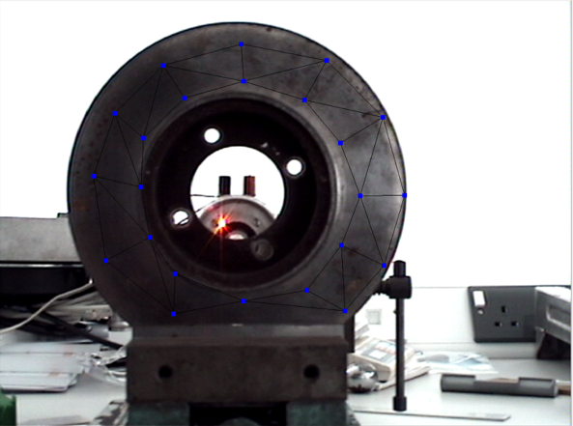
Figure 9: Alignment 3
Table 3: Alignment 3 Results
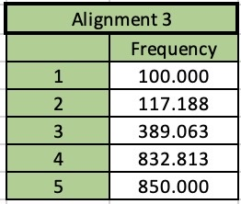

4.4 Sports 2000 Brake Disc
Table 4 below shows the raw data of the frequencies for the sports 2000 brake disc.
Table 4: Sports 2000 Brake Disc Results
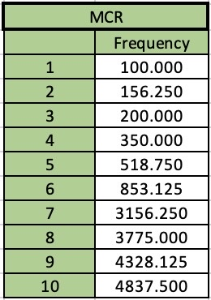

5 Results and Discussion
Resonance frequency modes refer to the natural vibrational modes of a physical system that are excited when the system is subjected to an external force at a particular frequency.
In other words, when a physical system is excited at its natural resonant frequency, it will vibrate with a larger amplitude than at other frequencies. This is because the energy of the external force, which is efficiently transferred to the system, therefore causing it to resonate.

In some systems, such as musical instruments or wind turbines, resonance frequency modes are desirable because they can enhance the efficiency of energy transfer or improve the quality of the sound produced. However, in other systems such as bridges or buildings, resonance frequency modes can be dangerous and lead to structural failure, especially if the frequency of external forces matches the system's natural resonant frequency.

Therefore, resonance frequency modes are an important consideration in the design and analysis of physical systems, and engineers and scientists often work to understand and control them to ensure safe and efficient operation of these systems (ECS Inc International , 2018).

5.1 Alignment 1
Figures 10 to 14 below show the results of the Caterham brake disc in alignment one (seen in figure 7). The first resonant frequency at this specific alignment can be seen at 0.1kHz at all five points. Four more resonant frequencies can be seen at 0.45kHz, 0.9kHz, 1.5kHz and 3kHz.

If the system experiences external forces at or near the resonance frequency, it can result in increased vibration amplitudes. This could be problematic as the vibration could cause damage to the system or affects its performance. If the resonance frequency and the systems operating frequency match, this can lead to unpredictable behaviour or system failure. Resonance can also cause noise and vibration that can be perceived as undesirable or distracting. Vibrations caused by resonance can accelerate wear and tear on the system's components, leading to increased maintenance and repair costs.

0.1kHz is the lowest frequency resonance recorded and this can cause increased vibrations in the brake disc, which could potentially result in undesirable noise and reduced braking performance. However, the effects may be less pronounced than at higher frequencies and as this is at the highest magnitude and the lowest frequency it is important to investigate the potential sources of the resonance, such as the design and materials of the brake disc, as well as any surrounding components that may be contributing to the vibration. By identifying and addressing these sources of resonance, it may be possible to minimize the effects of the 0.1kHz resonance and improve the overall performance and safety of the brake disc.

The resonance frequency of 0.45kHz can also cause significant vibrations in the brake disc. However, as this is at a much lower amplitude of about 180$μ$m/s, this is no cause for concern. As vibration increases with frequency, the recorded frequencies of 0.9kHz, 1.5kHz and 3kHz could be problematic, however, as the amplitude decreases with each frequency, this is not a huge cause for concern. Although further investigation into these higher frequencies may be beneficial to the longevity of the brake disc.
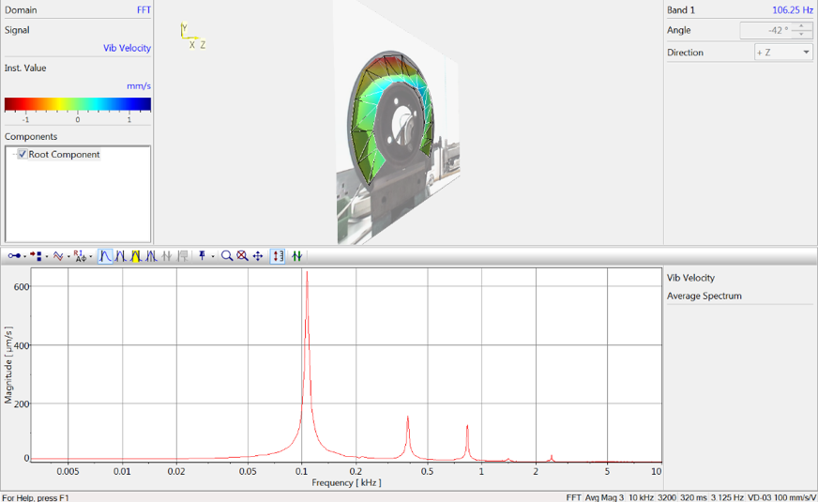
Figure 10: Alignment 1: 1
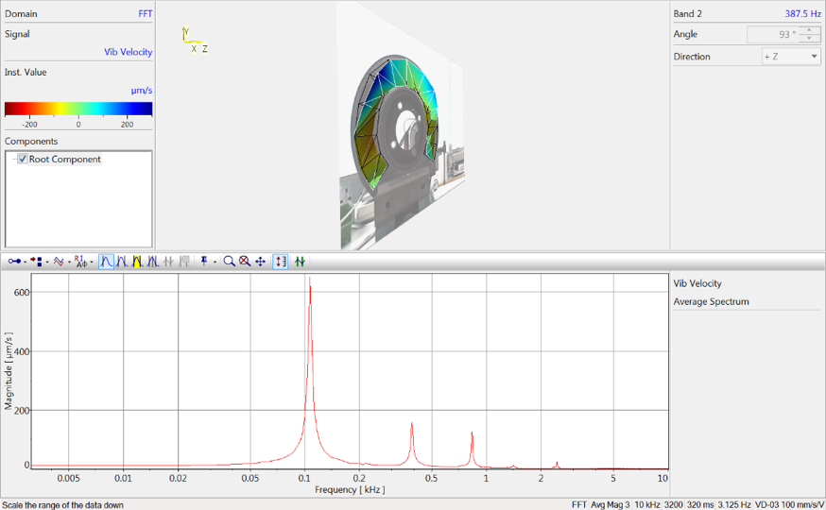
Figure 11: Alignment 1: 2
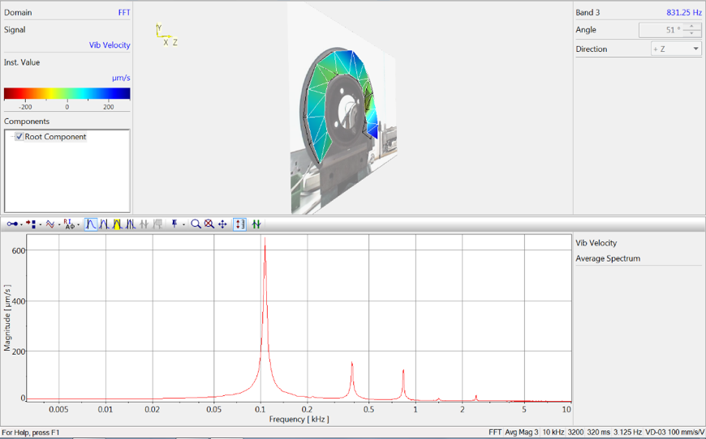
Figure 12: Alignment 1: 3
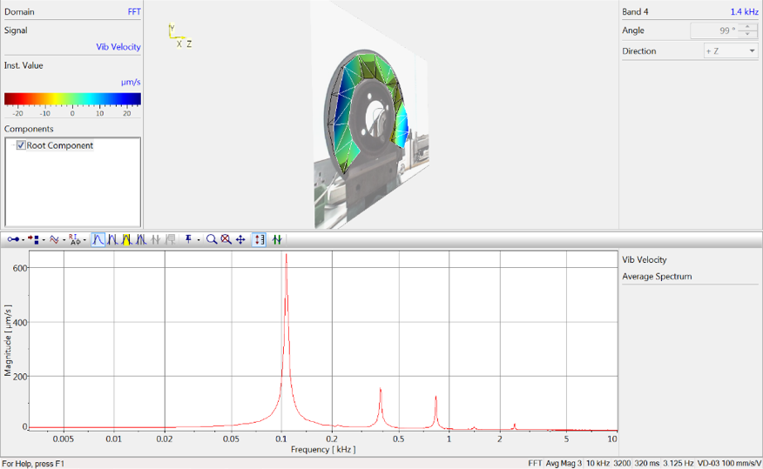
Figure 13: Alignment 1: 4
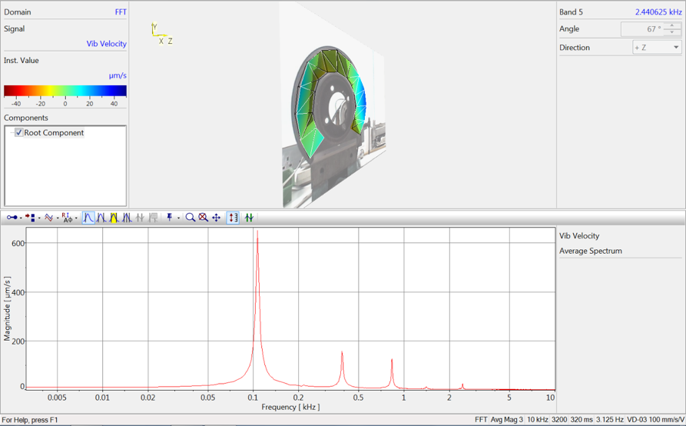
Figure 14: Alignment 1: 5

5.2 Alignment 2
Figure 15 to 19 below show the results of the Caterham brake disc in alignment two (seen in figure 8). For this alignment, only two definitive frequencies can be seen at 0.1kHz and 0.4kHz.

These frequencies can cause vibration and noise, which can result in a loud, squealing noise when the brakes are applied, which can be both annoying for customers and could be a potential sign of brake problems. Thermal stress may also be a problem, this is caused by the repeated heating and cooling of the disc as it vibrates. This could lead to cracking and even premature failure of the disc. Wear and tear can also be accelerated on the brake pads due to the vibrations. This is a much bigger issue as braking performance can be drastically affected, potentially leading to dangerous driving conditions.
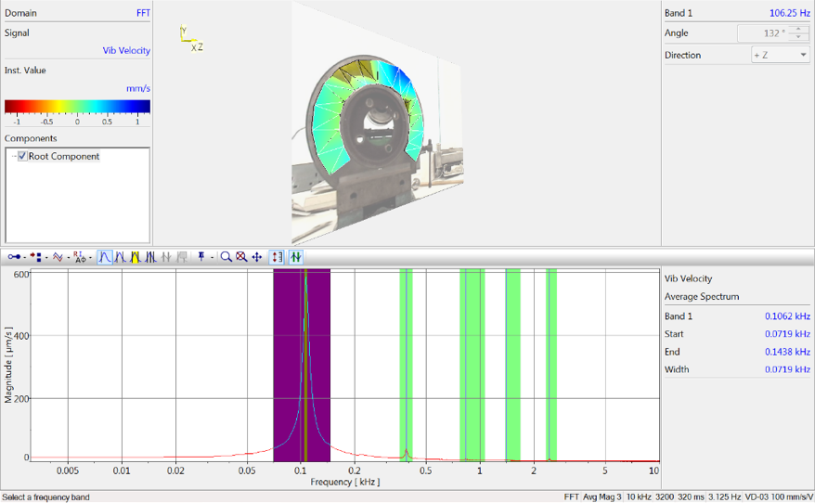
Figure 15: Alignment 2: 1
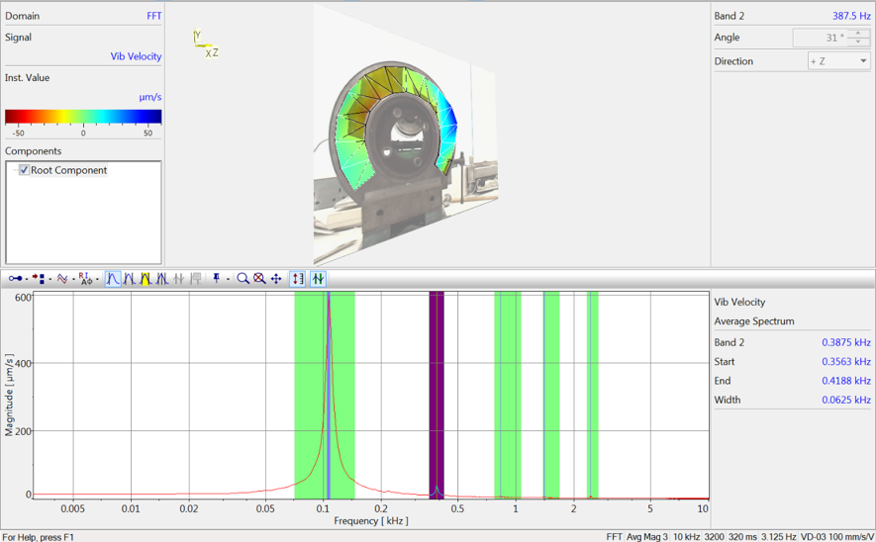
Figure 16: Alignment 2: 2
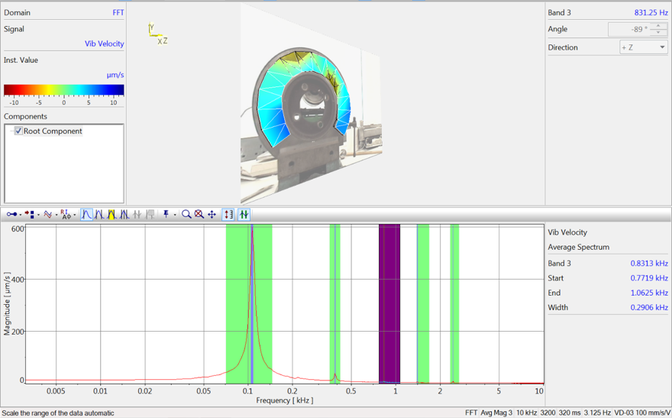
Figure 17: Alignment 2: 3
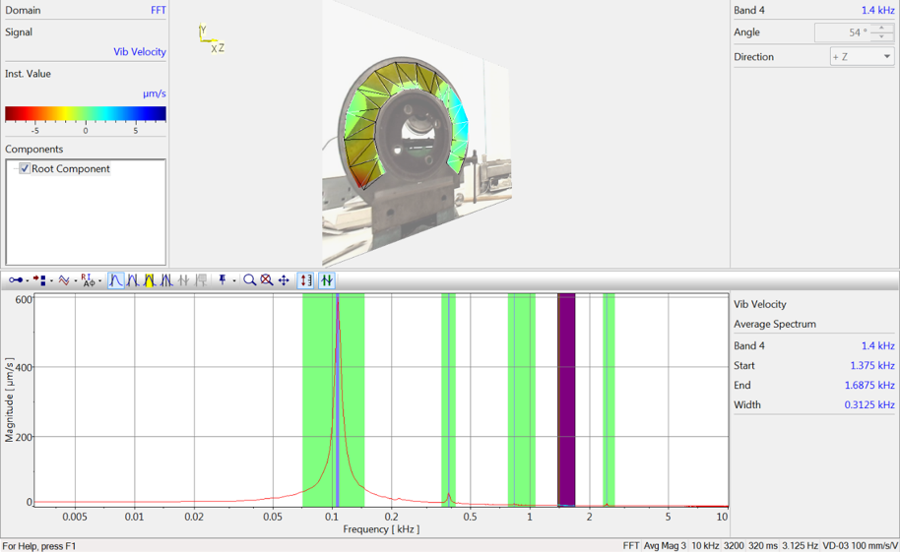
Figure 18: Alignment 2: 4
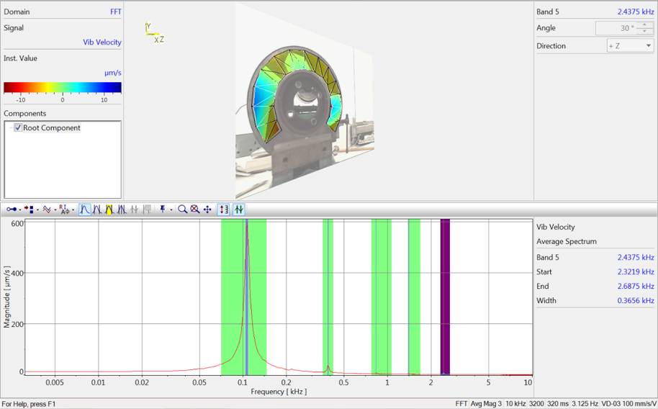
Figure 19: Alignment 2: 5

5.3 Alignment 3
Figure 20 to 24 below show the results of the Caterham brake disc in alignment three (seen in figure 9). This alignment seems to be less accurate as the main resonant frequencies do not match that of the first two alignments. As can be seen below the first frequency is at around 0.125kHz, the second can be seen at around 0.4kHz and the third can be seen at 0.9kHz. There are additional peaks which may suggest interference from another surface. Due to the alignment being through the middle of the brake disc, rather than on the actual surface, interference from the surface behind is highly likely.
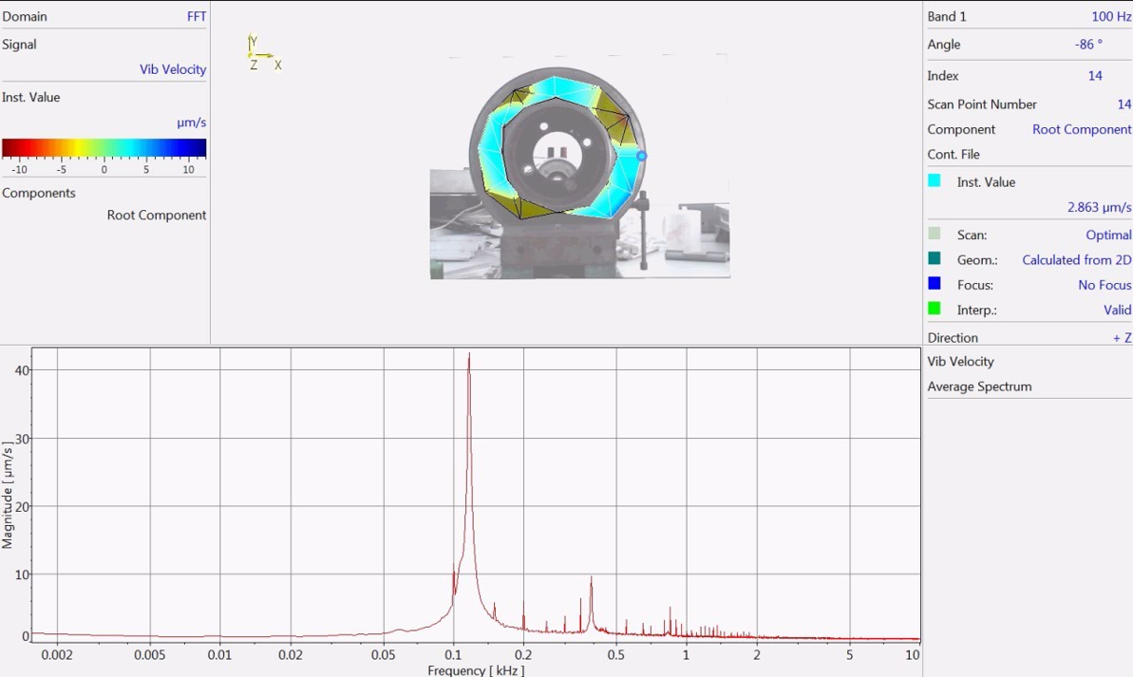
Figure 20: Alignment 3: 1
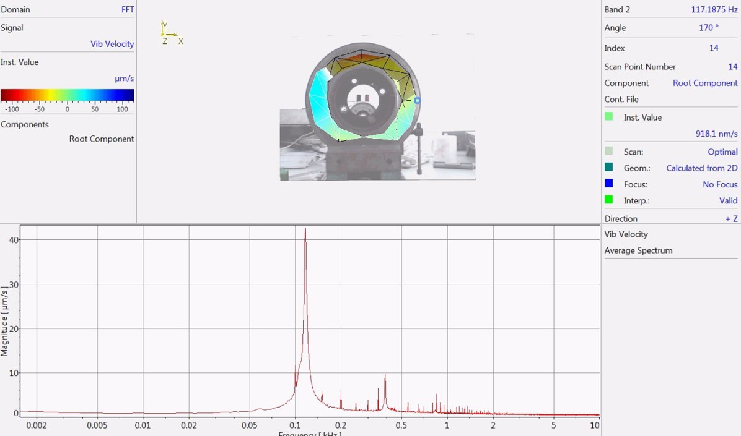
Figure 21: Alignment 3: 2
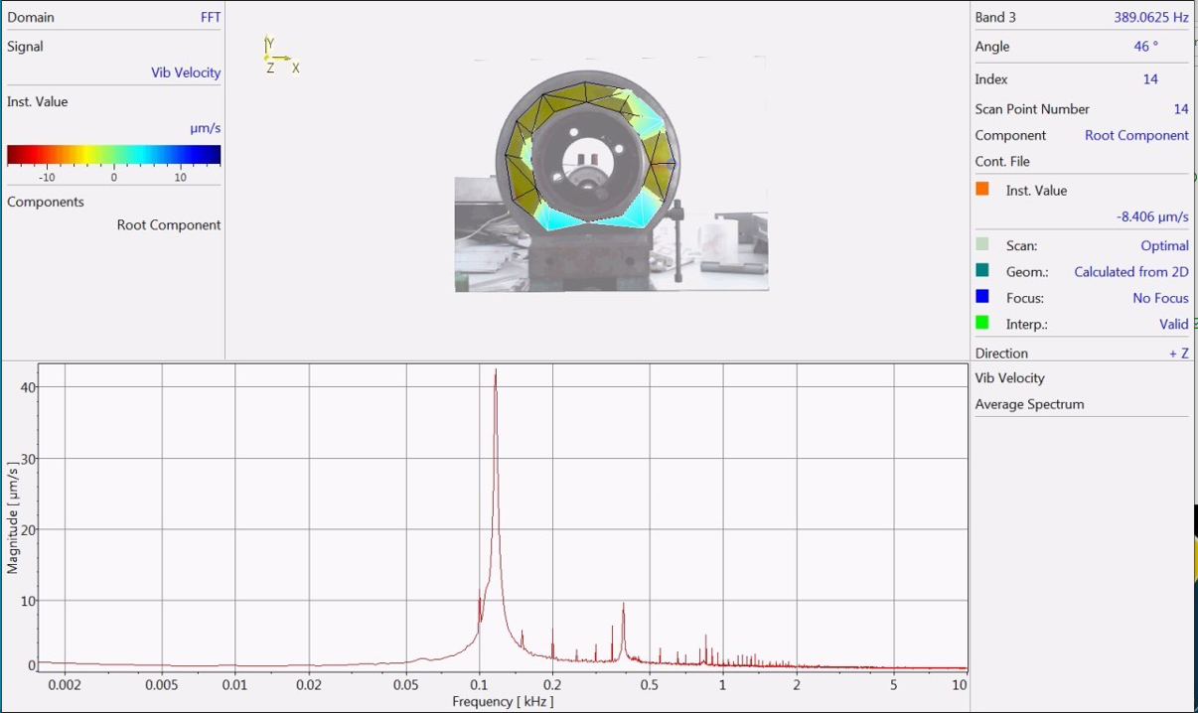
Figure 22: Alignment 3: 3
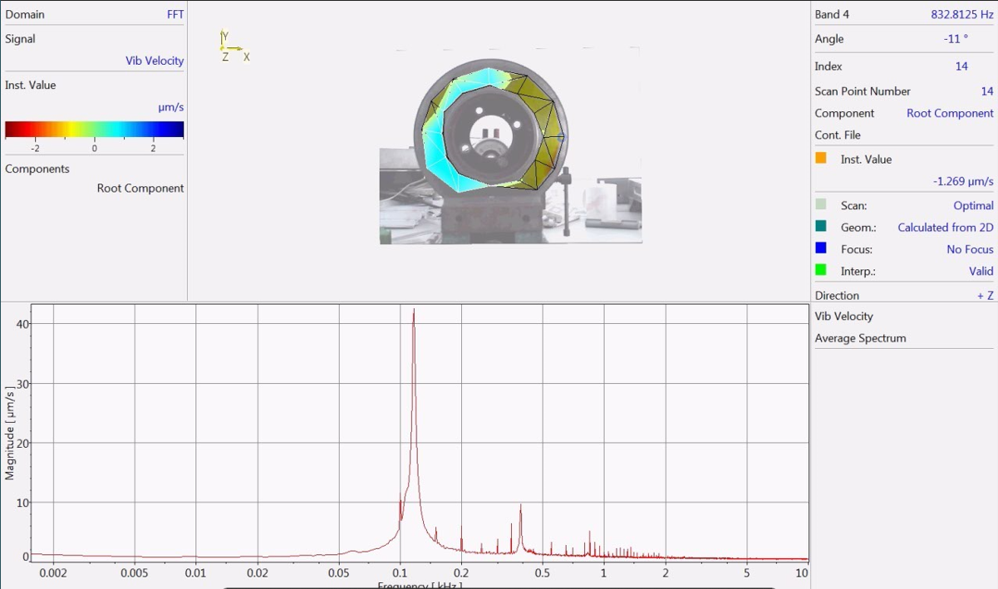
Figure 23: Alignment 3: 4
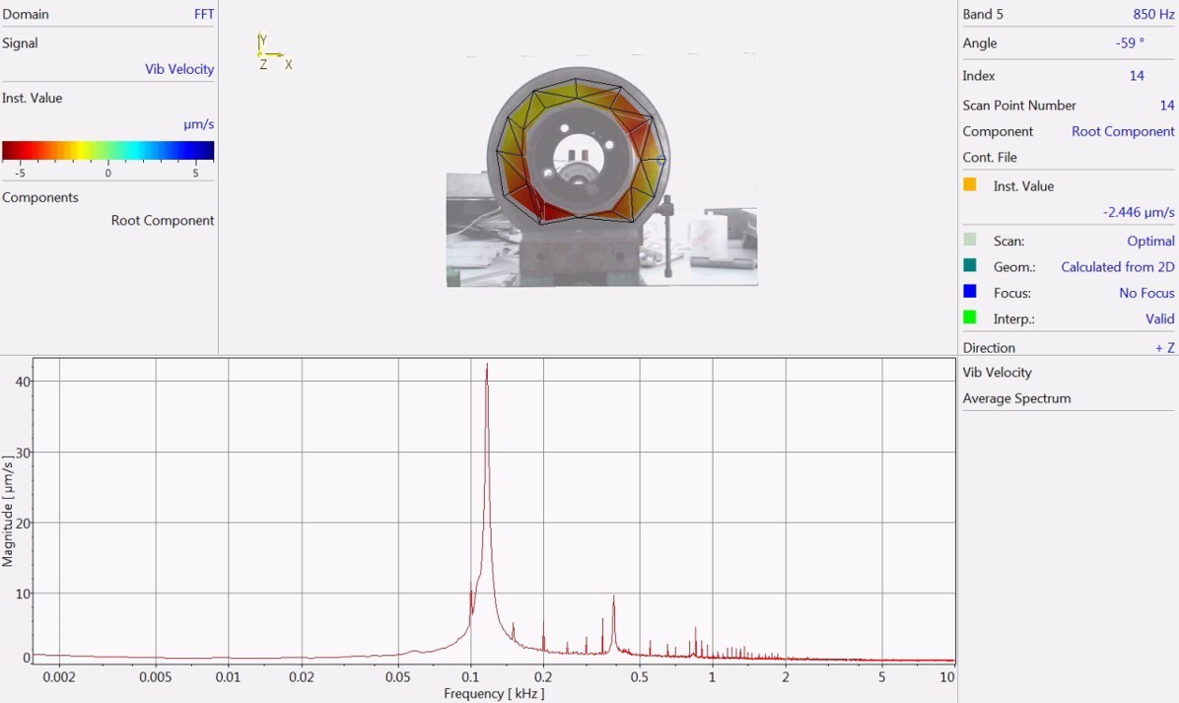
Figure 24: Alignment 3: 5

5.4 Sports 2000 Brake Disc
Figure 25 to 34 below show the results of the sports 2000 brake disc. As seen below the first frequency peak can be seen again at 0.1kHz, however, this disc brake has a considerably lower amplitude than the Caterham brake disc. The largest frequency peak for this brake disc can be seen at around 0.17kHz with a much lower amplitude of 60$μ$m/s. Higher frequencies can be seen around 0.5kHz, and 3kHz, again with very a small magnitude. Due to the difference in magnitude, a frequency of 0.17kHz may not cause significant effects on the brake disc. While it can still cause some vibration and noise, the small magnitude indicates that the effects may be less pronounced and not as concerning.
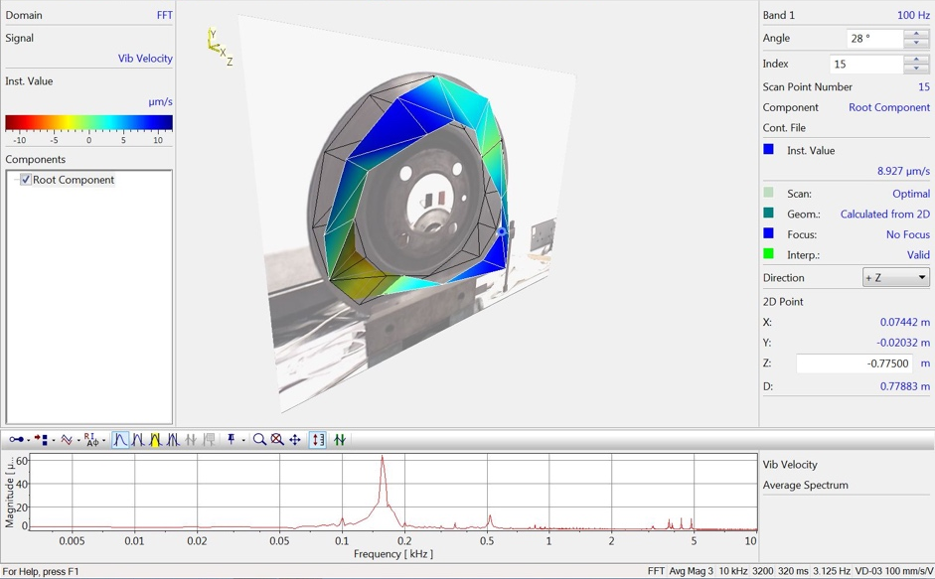
Figure 25: Sprots 2000 Brake Disc: 1
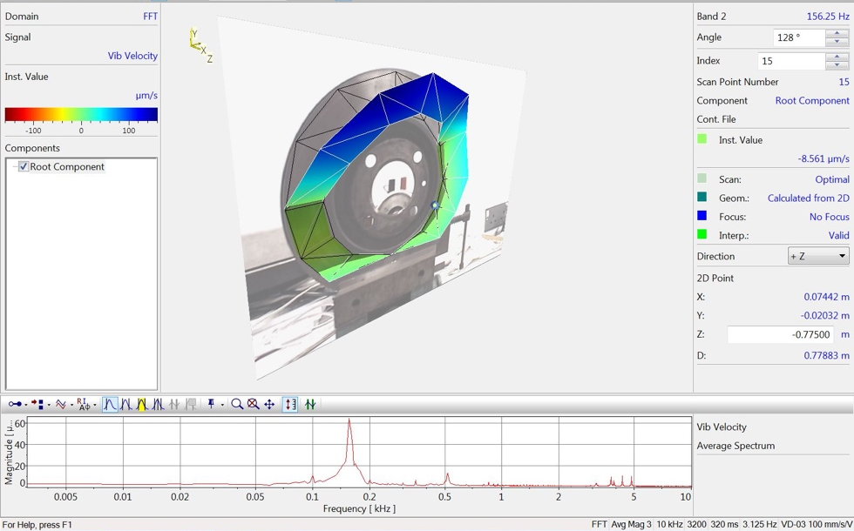
Figure 26: Sports 2000 Brake Disc: 2
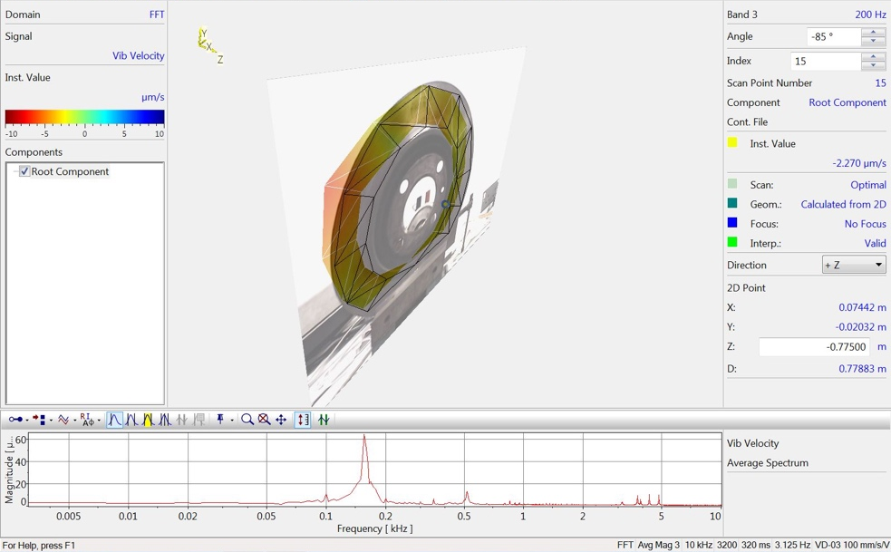
Figure 27: Sports 2000 Brake Disc: 3
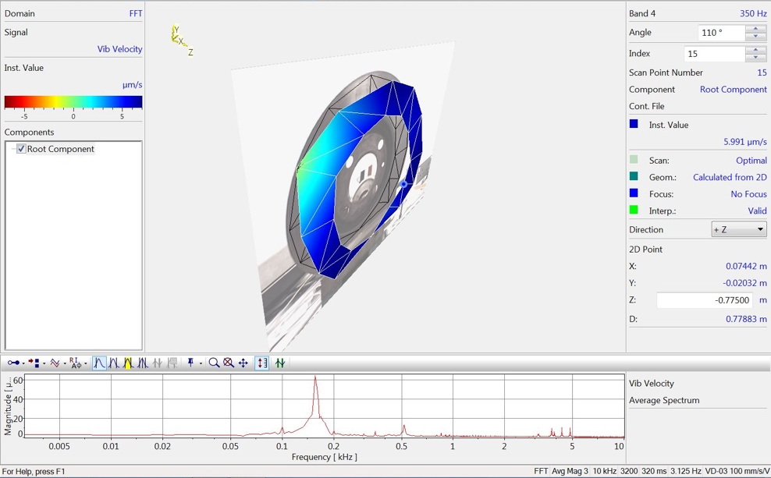
Figure 28: Sports 2000 Brake Disc: 4
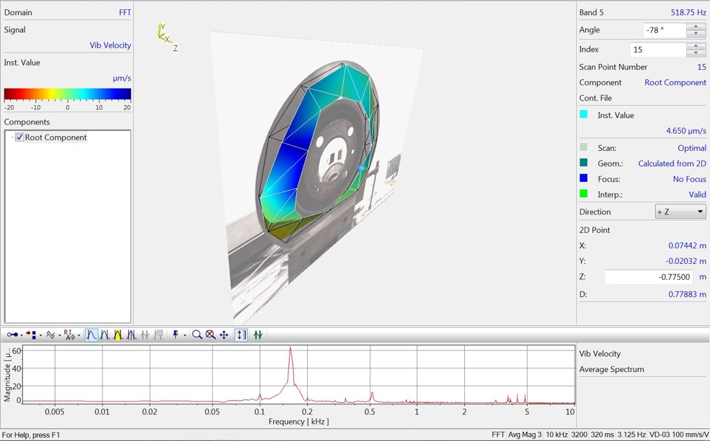
Figure 29: Sports 2000 Brake Disc: 5
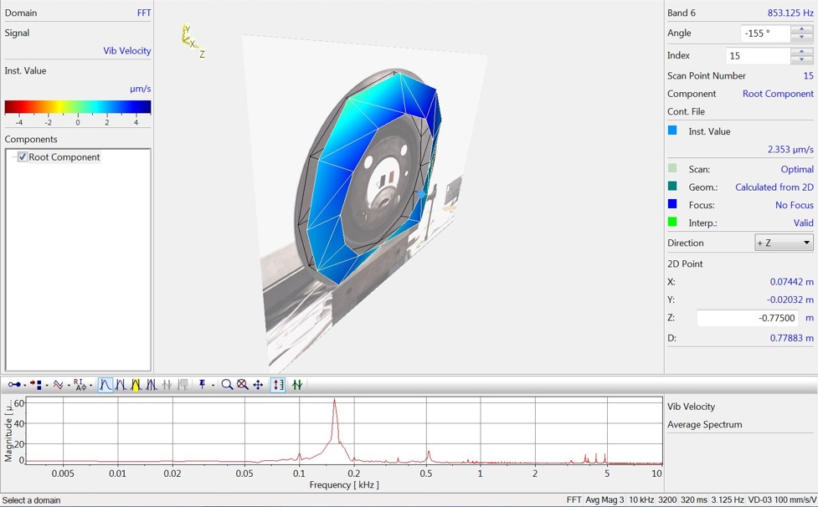
Figure 30: Sports 2000 Brake Disc: 6
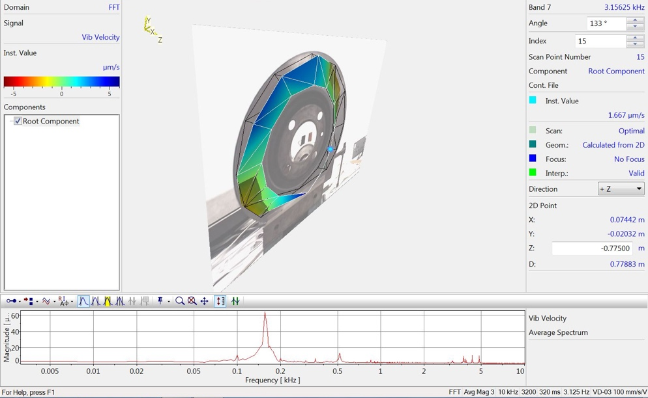
Figure 31: Sports 2000 Brake Disc: 7
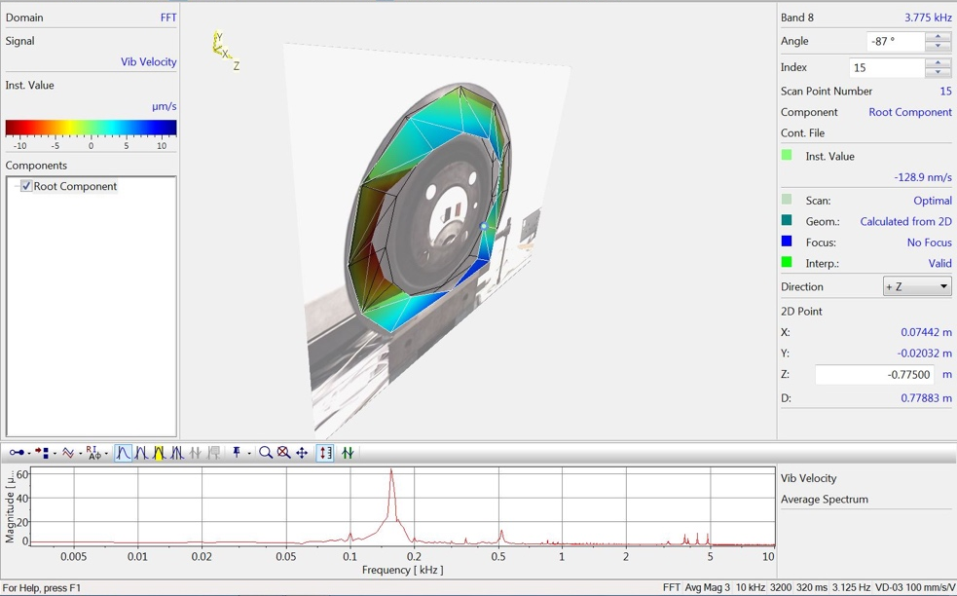
Figure 32: Sports 2000 Brake Disc: 8
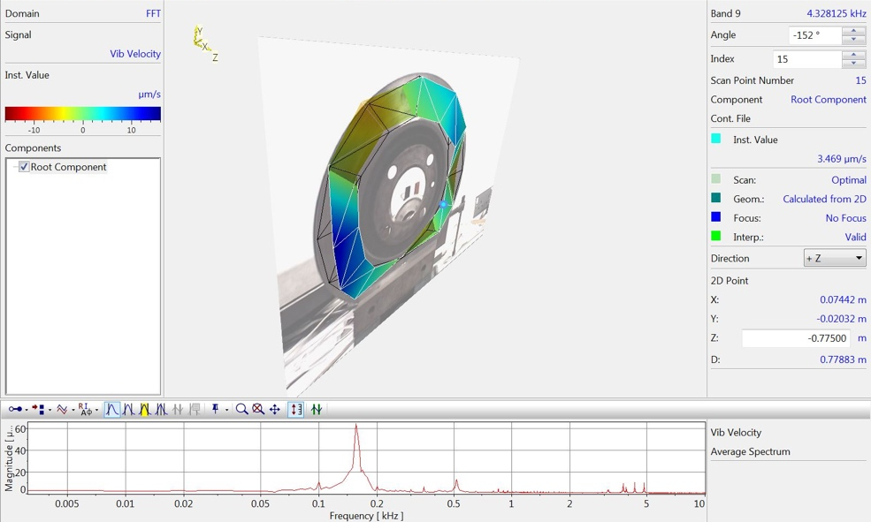
Figure 33: Sports 2000 Brake Disc: 9
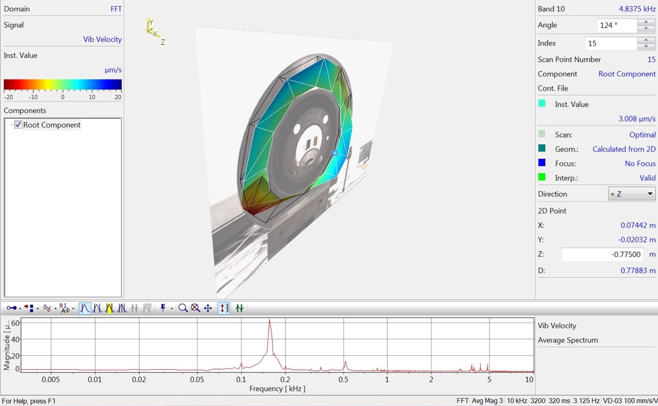
Figure 34: Sports 2000 Brake Disc: 10

6 Conclusion
In conclusion, the results of the analysis indicate that the Caterham brake disc exhibits multiple resonant frequencies at varying amplitudes. These resonances can potentially result in increased vibrations, noise, and reduced braking performance. The lowest frequency resonance of 0.1kHz is of particular concern, as it has the highest magnitude and can cause significant vibrations in the brake disc. However, the effects may be less pronounced than at higher frequencies. It is important to investigate the sources of resonance and potential contributing factors, such as the design and materials of the brake disc, to minimize the effects of resonance and improve the overall performance and safety of the brake disc. Further investigation into the higher frequency resonances may also be beneficial for the longevity of the brake disc.

The results of the Caterham brake disc in alignment two show that resonant frequencies at 0.1kHz and 0.4kHz can lead to undesirable noise, decreased braking performance, and potentially dangerous driving conditions. These frequencies can cause significant vibration and thermal stress, which can accelerate wear and tear on the brake disc and pads, leading to premature failure.

The results of the Caterham brake disc in alignment three suggest that the alignment is less accurate, as the resonant frequencies do not match those of the first two alignments. The additional peaks in the results suggest that there may be interference from another surface, likely due to the alignment being through the middle of the brake disc rather than on the actual surface. The resonant frequencies recorded at 0.125kHz, 0.4kHz, and 0.9kHz may still cause vibrations and noise.

The analysis of the Sports 2000 brake disc indicates that resonant frequencies at 0.1kHz and 0.17kHz can be observed with small amplitudes. The largest frequency peak for this brake disc was found to be at around 0.17kHz with a much lower amplitude of 60μm/s. While this frequency can still cause some vibration and noise, the small magnitude suggests that the effects may be less pronounced and not as concerning compared to the Caterham brake disc. Higher frequencies can also be seen at around 0.5kHz and 3kHz with very small amplitudes. Overall, the results suggest that the Sports 2000 brake disc is less susceptible to resonant frequencies compared to the Caterham brake disc.

Bibliography
Britannica, T., 2023. Britannica. [Online]
Available at: https://www.britannica.com/science/Doppler-effect
[Accessed 7 March 2023].

Castellini, P. & Montanini, R., 2002. Automotive components vibration measurements by tracking laser Doppler vibrometry: advances in signal processing, s.l.: IOP Publishing Ltd.

Caterham, 2018. Caterham Parts. [Online]
Available at: https://caterhamparts.co.uk/87-brake-discs
[Accessed 2 March 2023].

ECS Inc International , 2018. ECS Inc International. [Online]
Available at: https://ecsxtal.com/video-learning/what-is-resonant-frequency/
[Accessed 1 March 2023].

JapEuro, 2020. Jap Euro Car Parts. [Online]
Available at: https://www.japeurocarparts.co.uk/buy-brake-disc---front-3157-1353-1976-6-d
[Accessed 3 March 2023].

Johansmann, M., Fritzsche, M. & Schell , J., 2011. A New Method for Measurement of Rotating Objects Utilizing Laser Doppler Vibrometry Combined with an Optical Derotator with Focus on Automotive Applications, s.l.: s.n.

PolyTec, 2018. PolyTec. [Online]
Available at: https://www.polytec.com/uk/vibrometry/technology
[Accessed 2 March 2023].

PolyTec, 2019. PolyTec. [Online]
Available at: https://www.polytec.com/uk/vibrometry/products/full-field-vibrometers/psv-500-scanning-vibrometer
[Accessed 2 March 2023].
Sante, R. D. & Rossi, G. L., 2001. A new approach to the measurement of transverse vibration and acoustic radiation of automotive belts using laser Doppler vibrometry and acoustic intensity techniques, s.l.: IOP Publishing LTD.

