Question: Should response officers be double-crewed? Discuss the impact of single crewing on the wellbeing and safety of response officers.

Chapter 4: Data Analysis
4.1. Introduction:
The previous chapter outlined the chosen method for this research project as well as achieved objective 2 of this dissertation. This chapter aims to achieve the third objective:
To analyse the data collected to understand if there are any common themes and views on single crewing.
This chapter will attempt to provide the findings of the project where the data collected will be analysed and presented using a text narrative, supported by graphs and charts. An online questionnaire was created which generated responses from 52 participants enabling responses of the impact of single crewing on officers safety and wellbeing to be collected as well whether double crewing is the preferred choice by current serving response officers. The full questionnaire can be found in the Appendix section of this dissertation.
The target sample for this research was 100 participants from Gwent and South Wales police forces to understand their views on single crewing. Although this was not achieved, the researcher believes that the 52 responses collected is an acceptable number to analyse and present some common themes and address the gaps in the literature. It is hoped that by acquiring an understanding from those who have first hand experiences, the researcher can develop an idea of how officers can be better supported in terms of safety and wellbeing.
4.2. Data Analysis:
Data analysis is the process where a researcher combs through the data collected. One will examine, organise and transform a large amount of data to determine if there are any common themes, relationships or patterns (Bryman and Hardy, 2009). Any consistent or similar responses has the potential to support the researcher in answering the research question. The data collected was collected and analysed using the Microsoft Office Forms tool as this was deemed the most appropriate method by the researcher due to the response rate and ease of interpreting the results, rather than a more complex, systematic tool such as the Chi Square. Throughout this chapter, the data analysed will continually seek to address the research question for this project around the impact of single crewing on the wellbeing and safety of response officers and whether officers should be double crewed.

4.3. Demographics:
Demographic questions made up the first part of the questionnaire. This was in order to investigate if there were any significant differences in respondents’ views, in relation to their gender, age, length of service and force they belonged to. The questionnaire was shared on social media platforms in order to reach the targeted population. The data revealed that respondents were typically male, aged between 25-34, belonging to the Gwent police force, with less than 3 years service. For the purpose of this project, the demographic data that was deemed most relevant by the researcher was around gender and length of service.

The question around gender was to gauge whether there was any difference in the experiences by either group when single crewed in terms of more likely to be assaulted and crewing preferences. As outlined in the literature review, there is a general assumption in the police that women are more likely to be assaulted and less willing to attend calls alone. Although the majority of respondents were male (36) compared to female (16), the data revealed both groups reported similar experiences of assaults and the impact that this had on their wellbeing as well as similar views on crewing preference.

With regards to length of service, this question was included as the researcher wanted to understand if having less experience influences crewing preference and whether this has an impact on wellbeing and safety. The data revealed that most respondents with a length of service 3 years and under would prefer to be double crewed, stating safety, morale and confidence as the most common reasons for this.

4.4. Questionnaire Findings:

4.4.1. Officer understanding of why single crewing is common practice

4.4.1.1. Levels of Resource

When analysing the 52 responses, the data highlighted a popular viewpoint around the understanding of why single crewing is common practice. The most frequent answers included terms such as ‘staffing levels’, ‘limited resources’, ‘lack of manpower’ and ‘unable to recruit and retain’. This data is parallel with the evidence discovered in the literature review whereby single crewing is often regarded as efficient use of limited resources (Houndmont et al, 2017). The statistics from the data correlates this as respondents revealed that they are either frequently or always single crewed (see Figure 1).

Figure 1 - respondents answers to how frequently they are single crewed:
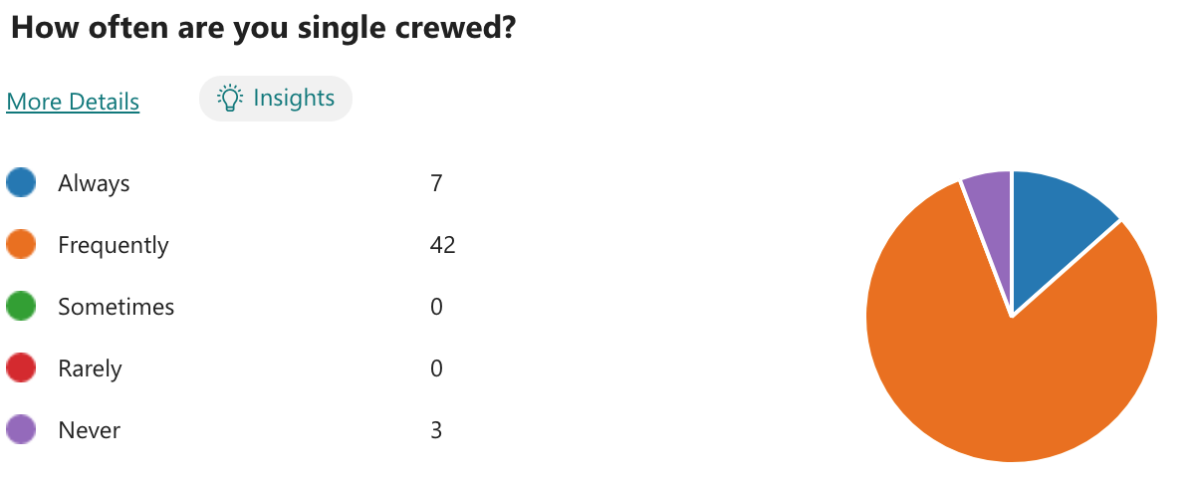

Although, as mentioned in the literature review, forces have a patrol policy that enables single crewing to become common practice, the current issues around staffing resources extend into double crewing at its basic operational standard which offered an interesting revelation. The data revealed that 41 out of 52 respondents reported times where they were supposed to be double crewed as per the force policy, but weren’t, due to ‘lack of resources’ and ‘shortage of officers’.
4.4.1.2. Public demand, visibility and crewing
When analysing the data, the second most common viewpoint around the reasons for single crewing was to meet public demand. Correspondingly, this was linked to the issue of resource where some respondents stated that low staffing levels meant single crewing is utilised to prioritise the response rate to calls whereas if double crewing is practised, it puts the response rate at risk. In turn, the responses received recognised that single crewing increases visibility with 46% agreeing with this statement. This information corresponds with the literature review that single crewing results in responses to more calls and the covering of more ground and greater visibility to more members of the public (Lincolnshire Police, 2021). In terms of safety and wellbeing which are the focal concepts of this project, the data revealed that respondents felt that single crewing, meeting public demand and appearing visible was at the expense of officer safety. Common statements from respondents around this included ‘stats are looked at far too much and officer safety is compromised for calls to be answered more frequently’ and ‘it’s to meet time standards officer safety is not considered’. This idea was highlighted in the literature review where single crewing is believed to achieve good measurable outcomes at the expense of officer safety.

4.4.2. Single crewing and officer safety
The data revealed that 51 respondents have either felt unsafe or somewhat unsafe when they have responded to a call single crewed, in combination with the revelation that respondents unanimously agreed that single crewing increases the chance of being exposed to danger. A further 17 respondents reported that they had been assaulted whilst single crewed in which 14 of these expressed that this had impacted on their health and wellbeing. These results supported and corresponded with research identified in the literature review. However, the researcher recognises that the framing of the question on assault and the ​​impact on health and wellbeing could have been framed better as it did not generate as much depth in the responses as hoped for analysis.

The literature review also highlighted that the likelihood of an officer being assaulted considerably increases during the evenings and at night-time, particularly on weekend shifts (Johnson, 2019). The data generated from this survey corresponds with this as 21 respondents agreed that they felt that they are more likely to be assaulted on a ‘supernoon’ shift, working 4pm-3am on weekends if single crewed (Figure 2).
Figure 2 - responses on which shift is more likely to result in officers being assaulted when single crewed.
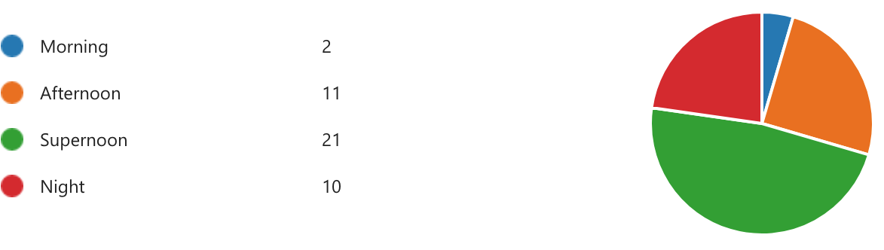

The data also revealed strong links between single crewing, safety and the inability to complete a comprehensive risk assessment. Many respondents expressed that many frequent incidents they respond to come with an element of unpredictability and officers' safety can never be guaranteed because of this. As one respondent stated, ‘single crewing can impact on situational awareness which in turn can impact on officer safety, double crewing can act as a visual deterrent’. This supports pre-existing evidence discussed in the literature review that single-crewed units cannot observe as much as two officers.

4.4.3. Single crewing and officer wellbeing
In order to gain perspectives on this theme, respondents were asked to grade the extent to which they agreed with a set of statements (Figure 3).

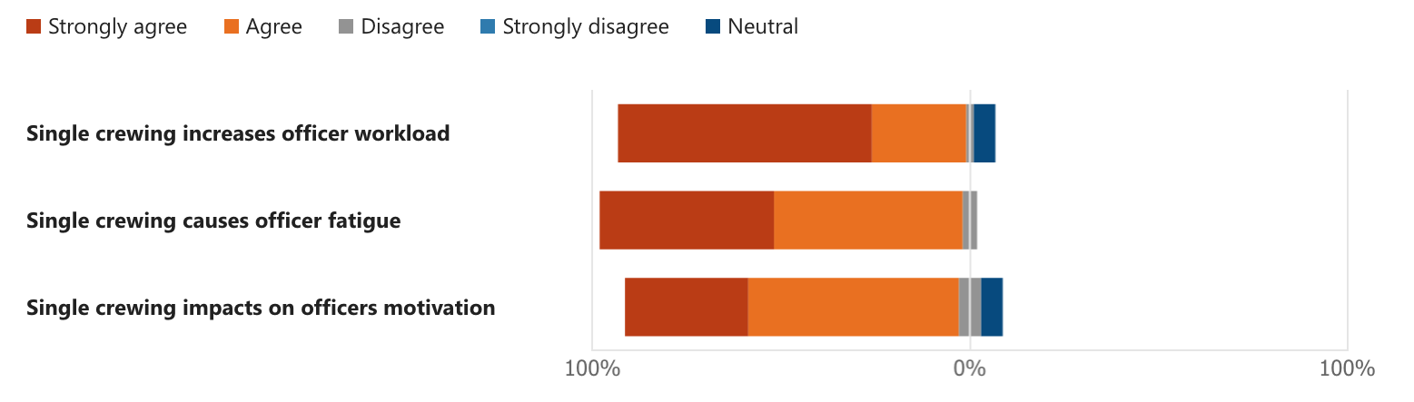
These statements were determined in the literature review as influential on the impact of single crewing on the wellbeing of officers. The data above correlates with these ideas, with the strongest view that single crewing increases officer workload. Responses frequently mentioned the words ‘burden’, ‘stress’ and ‘morale’ together in relation to the amount of paperwork and tasks an individual is required to complete due to single crewing, negatively impacting on their wellbeing whereas double crewing leads to a much ‘happier and efficient workforce due to sharing of the load and support mechanism for traumatic experiences’ one respondent revealed.

The data analysis also revealed a link between feelings of inexperience and wellbeing when single crewed. One respondent expressed that they felt ‘anxious’ due to single crewing as they feared they ‘may get something wrong’ or ‘miss something crucial to an investigation’ whereby having a partner can ‘improve confidence’ and you can ‘learn from one another’. Another respondent expressed that single crewing is essentially lone working and impacted their ability to build rapport with the team which impacted on their wellbeing. These views correlate as well as add further perspectives to those highlighted in the literature review. However, the researcher acknowledges that the respondents to this survey were relatively new to the role with most having experience of 3 years or less which may impact on the data collected.

4.4.4. Types of crime and crewing
The data revealed two consistent viewpoints on this theme which complement each other. Half of the respondents stated specific crimes that they believe require certain crewing deployment in order for officers to feel safer whilst the other half expressed that crewing deployment should go hand in hand with the grading of a call. The latter view is not something that was discussed in the literature review but is one that the researcher feels is both valid and useful for this project to answer the research question and make any recommendations.

4.4.5. Double Crewing
When analysing the 52 responses, it was very clear that response officers have a preference for double crewing due to the safety and wellbeing benefits. The survey revealed that 52 respondents believe double crewing is safer, in combination with the result that 50 respondents believe double crewing improves wellbeing. The most common reasons given were related to situational awareness and problem solving collectively, with many also expressing that this would also result in less assaults.

Figure 4 - pie chart to show how many officers would prefer to be double crewed more frequently
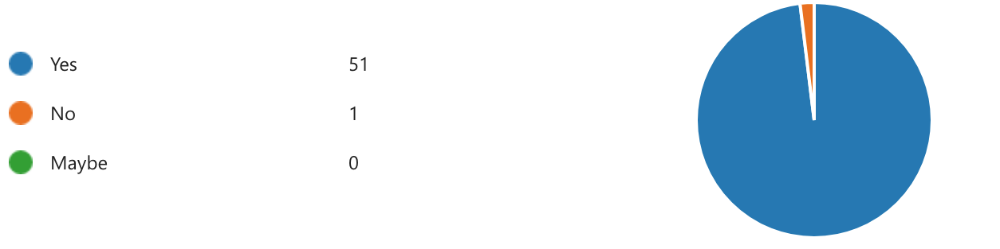
Figure 4 demonstrates that respondents would like the opportunity to be double crewed more frequently. Most respondents shared the same viewpoint that double crewing is not an effective use of resources all the time, but with regards to safety and wellbeing, double crewing should be the preferred deployment to emergency calls or those that carry a greater risk, which in turn improves ‘golden hour enquiries’.

4.5. Conclusion:
This chapter achieved the third objective of this project:
To analyse the data collected to understand if there are any common themes and views on single crewing.
In conclusion, the data for this research revealed that limited resources are currently having a huge impact on deployment within police forces in combination with the idea that serving officers believe the need to meet statistics is of greater importance than the safety and wellbeing of officers. The general consensus is that officers feel unsafe when single crewed, particularly during certain shifts, which may increase their probability of being assaulted. Moreover, single crewing increases officer workload as there is an expectation to attend more calls which comes with the burden of more tasks and paperwork. It has been suggested that double crewing should be considered more often, especially with regards to emergency calls and those crimes which carry a higher safety risk as double crewing comes with the benefit of greater situational awareness and collaboration to achieve the best possible outcome.

This chapter has successfully analysed the data and discovered what impact single crewing has on officers safety and wellbeing and how double crewing has a place to minimise risk. The last chapter will achieve the final objective of providing recommendations on the key issues discovered on single crewing and considerations for double crewing.
Word count: 2106
Bibliography:
Bryman, A. and Hardy, M. (2009) Handbook of Data Analysis. London: Sage Publications.

Houndmont, J., Elliot-Davies, H. and Donnelly, J. (2017) ‘Single crewing in English and Welsh policing: frequency and associations with violence towards and injuries in officers’, Policing and Society, 29(7), pp: 820-833. DOI: 10.1080/10439463.2017.1417990.

Johnson, L. (2019) Understanding Assaults against Police Officers: A study of conflict escalation in police encounters with the public. PhD Thesis. The University of Leeds. Available at: https://etheses.whiterose.ac.uk/25726/1/Johnson_LA_Law_PhD_2019.pdf (Accessed: 10 October 2023)
Lincolnshire Police (2021) Single Crewing Policy. Available at: https://www.lincs.police.uk/SysSiteAssets/foi-media/lincolnshire/policies/single-crewing-policy-pd-92.pdf (Accessed: 10 October 2023)

